Term Project Step 3

Burden Joshua

2022-06-04

# Legalization of Marijuana

## Introduction

With more and more states adding medical and recreational cannabis to their ballots, questions are now being asked more openly about the impact of cannabis on public health, crime statistics, and popularity of legalization. The data out there is sparse, but the data that has been collected could show trends and insights on the future of legislation and public sentiment of legalization, along with showing the potential for lowered crime and raised tax revenue in states and at the federal level.

## Research questions

I want to know, based on the data that is out there, if legalization of marijuana:

* Reduces the number of arrests of all nonviolent offenses significantly
* Would increase the tax income for states and government entities
* Would drug usage go down by making it legal
* What is the state tax collections for legal rec states vs med only vs no rec/med
* What is the public support for legalization

## Approach

I will look at the data that is out there for sales, crime, and public sentiment and see if there is anything that stands out to answer any of the questions above.

## How your approach addresses (fully or partially) the problem.

The data will tell me whether or not the any or all of my questions can be answered and if there is discrepancies in the data, more research might be conducted to see if there is correlation.

## Data (Minimum of 3 Datasets - but no requirement on number of fields or rows)

* <https://data.world/denver/marijuana-related-crime>
* <https://www.kaggle.com/datasets/tunguz/drug-use-by-age>
* <https://www.kaggle.com/datasets/mykeysw/marijuana-sales-forecasting-in-tx>
* <https://data.world/sya/marijuana-laws-by-state>
* <https://data.world/denver/marijuana-gross-sales>
* <https://data.world/health/support-for-legal-marijuana>
* <https://www.kaggle.com/datasets/terenceshin/historical-prices-for-biggest-weed-stocks>

## Bad dataset

* <https://data.world/opensavannah/cannabis-justice>

## Required Packages

* Gplot2

## Plots and Table Needs

* Histograms
* Scatter plots
* CDF
* Linear Regressions

## Questions for future steps

Is there more data out there that would help with this research, and how deep should these models go in terms of covering the questions?

# Step 2

### How to import and clean my data

Google is very good actually for making suggestions on cleaning datasets. That is my first step, by bringing these datasets into google sheets, I am effectively having google help me get the datasets clean. One other thing that I needed to do was to also parse what is important and what isn’t based on the datasets. There were quite a number of datasets that were not helpful or would be considered a large reach for the dataset to fit into the story, so I removed those datasets from the list of datasets I had. I also made the decision early on to remove header column names that either didn’t make sense or were not required for the dataset story.

### What does the final data set look like?

Summaries of the dataset, as to not get overwelmed by the vast amounts of data.

setwd('/Users/joshua/Documents/PERSONAL_GITHUB_REPOS/dsc520/TermProject')  
cosalesrev <- read.csv("data/cleaned_COMJSalesMonthReports2019.csv")  
cotaxrev <- read.csv("data/cleaned_COMJTaxMonthReports2019.csv")  
costatepop <- read.csv("data/cleaned_COCountyPop20142018.csv")  
drug_use <- read.csv("data/cleaned_drug-use-by-age.csv")  
crime_denver <- read.csv("data/cleaned_crime_marijuana.csv")  
legal_support <-read.csv("data/cleaned_legal_marijuana_support.csv")

### Summaries of datasets

# summaries of the datasets  
summary(cosalesrev)

## Month MedicalSales MSYearToDate RetailSales   
## Length:65 Min. :24082927 Min. : 25680596 Min. : 14022213   
## Class :character 1st Qu.:29238678 1st Qu.:100238704 1st Qu.: 44590853   
## Mode :character Median :32686869 Median :193094556 Median : 76018423   
## Mean :32736868 Mean :204611449 Mean : 70423116   
## 3rd Qu.:36010893 3rd Qu.:302926736 3rd Qu.: 96642441   
## Max. :41056948 Max. :445616062 Max. :114317739   
## RSYearToDate TotalSales TSYearToDate   
## Min. :1.402e+07 Min. : 45987045 Min. :4.656e+07   
## 1st Qu.:1.599e+08 1st Qu.: 78199969 1st Qu.:2.831e+08   
## Median :3.088e+08 Median :109222331 Median :5.399e+08   
## Mean :4.086e+08 Mean :103159984 Mean :6.132e+08   
## 3rd Qu.:5.775e+08 3rd Qu.:127706166 3rd Qu.:8.809e+08   
## Max. :1.214e+09 Max. :143107279 Max. :1.546e+09   
## TotalToDate   
## Min. :4.656e+07   
## 1st Qu.:1.047e+09   
## Median :2.644e+09   
## Mean :2.895e+09   
## 3rd Qu.:4.612e+09   
## Max. :6.705e+09

summary(cotaxrev)

## Month SalesTax LicenseFees SalesTaxFees   
## Length:65 Min. : 628947 Min. : 592661 Min. :1570401   
## Class :character 1st Qu.:1014752 1st Qu.: 972122 1st Qu.:2137462   
## Mode :character Median :1808419 Median :1063563 Median :3067394   
## Mean :1970529 Mean :1097654 Mean :3068184   
## 3rd Qu.:2763721 3rd Qu.:1221521 3rd Qu.:4016545   
## Max. :3692930 Max. :1663120 Max. :4892115   
## RetailSalesTax RetailExciseTax TotalTaxFees YearToDate   
## Min. : 1401568 Min. : 195318 Min. : 3519756 Min. : 3519756   
## 1st Qu.: 4394550 1st Qu.:2796865 1st Qu.:10856584 1st Qu.: 37511919   
## Median : 7746575 Median :4683825 Median :17694953 Median : 76306924   
## Mean : 8877802 Mean :4114956 Mean :16060942 Mean : 93255239   
## 3rd Qu.:14608085 3rd Qu.:5598581 3rd Qu.:21622509 3rd Qu.:134971077   
## Max. :18698640 Max. :7867853 Max. :26841073 Max. :266529637   
## TotalToDate   
## Min. :3.520e+06   
## 1st Qu.:1.260e+08   
## Median :3.555e+08   
## Mean :4.161e+08   
## 3rd Qu.:6.818e+08   
## Max. :1.044e+09

summary(costatepop)

## County X2014Pop X2015Pop X2016Pop   
## Length:64 Min. : 703 Min. : 689 Min. : 690   
## Class :character 1st Qu.: 5692 1st Qu.: 5736 1st Qu.: 5636   
## Mode :character Median : 14288 Median : 14358 Median : 14592   
## Mean : 83526 Mean : 85076 Mean : 86472   
## 3rd Qu.: 41946 3rd Qu.: 41975 3rd Qu.: 42592   
## Max. :664715 Max. :683081 Max. :696347   
## X2017Pop X2018Pop   
## Min. : 714 Min. : 762   
## 1st Qu.: 5837 1st Qu.: 5876   
## Median : 14747 Median : 15014   
## Mean : 87648 Mean : 88993   
## 3rd Qu.: 43202 3rd Qu.: 43666   
## Max. :705651 Max. :716492

summary(drug_use)

## age sample_size marijuana_use_by_percentage  
## Length:17 Min. :2223 Min. : 1.10   
## Class :character 1st Qu.:2469 1st Qu.: 8.70   
## Mode :character Median :2798 Median :20.80   
## Mean :3251 Mean :18.92   
## 3rd Qu.:3058 3rd Qu.:28.40   
## Max. :7391 Max. :34.00   
## marijuana_frequency_over_12_months  
## Min. : 4.00   
## 1st Qu.:30.00   
## Median :52.00   
## Mean :42.94   
## 3rd Qu.:52.00   
## Max. :72.00

summary(crime_denver)

## REPORTDATE OFFENSE_CODE OFFENSE_TYPE_ID OFFENSE_CATEGORY_ID  
## Length:1254 Min. :1006 Length:1254 Length:1254   
## Class :character 1st Qu.:2203 Class :character Class :character   
## Mode :character Median :2203 Mode :character Mode :character   
## Mean :2249   
## 3rd Qu.:2206   
## Max. :7399   
## NEIGHBORHOOD_ID   
## Length:1254   
## Class :character   
## Mode :character   
##   
##   
##

summary(legal_support)

## Year Month Asked_half_sample Yes_Legal   
## Min. :1969 Length:20 Length:20 Min. :12.00   
## 1st Qu.:1980 Class :character Class :character 1st Qu.:25.00   
## Median :2002 Mode :character Mode :character Median :34.00   
## Mean :1997 Mean :35.95   
## 3rd Qu.:2011 3rd Qu.:48.50   
## Max. :2016 Max. :60.00   
## No_Illegal No_Opinion Percent_Yes Percent_No   
## Min. :39.00 Min. :1.00 Length:20 Length:20   
## 1st Qu.:49.25 1st Qu.:2.00 Class :character Class :character   
## Median :63.00 Median :4.00 Mode :character Mode :character   
## Mean :60.50 Mean :3.45   
## 3rd Qu.:70.75 3rd Qu.:4.25   
## Max. :84.00 Max. :6.00   
## Percent_No_Opinion  
## Length:20   
## Class :character   
## Mode :character   
##   
##   
##

### glimpse of datasets

glimpse(cosalesrev)

## Rows: 65  
## Columns: 8  
## $ Month <chr> "Jan 2014", "Feb 2014", "Mar 2014", "Apr 2014", "May 2014…  
## $ MedicalSales <int> 32541720, 31738572, 34821878, 32686869, 31355208, 2995030…  
## $ MSYearToDate <int> 32541720, 64280292, 99102170, 131789039, 163144247, 19309…  
## $ RetailSales <int> 14022213, 14248473, 19881631, 20765986, 21375001, 2397808…  
## $ RSYearToDate <int> 14022213, 28270686, 48152317, 68918303, 90293304, 1142713…  
## $ TotalSales <int> 46563933, 45987045, 54703509, 53452855, 52730209, 5392839…  
## $ TSYearToDate <int> 46563933, 92550978, 147254487, 200707342, 253437551, 3073…  
## $ TotalToDate <dbl> 46563933, 92550978, 147254487, 200707342, 253437551, 3073…

glimpse(cotaxrev)

## Rows: 65  
## Columns: 9  
## $ Month <chr> "Feb 2014", "Mar 2014", "Apr 2014", "May 2014", "Jun 2…  
## $ SalesTax <int> 1330209, 1460429, 1569405, 1559710, 1569454, 1530968, …  
## $ LicenseFees <int> 592661, 857615, 902995, 761687, 940028, 1547853, 13795…  
## $ SalesTaxFees <int> 1922870, 2318044, 2472400, 2321397, 2509482, 3078821, …  
## $ RetailSalesTax <int> 1401568, 1434916, 1898685, 2217607, 2070577, 2473627, …  
## $ RetailExciseTax <int> 195318, 339615, 609907, 734351, 1135648, 969637, 13979…  
## $ TotalTaxFees <int> 3519756, 4092575, 4980992, 5273355, 5715707, 6522085, …  
## $ YearToDate <int> 3519756, 7612330, 12593322, 17866677, 23582384, 301044…  
## $ TotalToDate <int> 3519756, 7612330, 12593322, 17866677, 23582384, 301044…

glimpse(costatepop)

## Rows: 64  
## Columns: 6  
## $ County <chr> "Adams", "Alamosa", "Arapahoe", "Archuleta", "Baca", "Bent", …  
## $ X2014Pop <int> 479477, 15758, 617498, 12240, 3576, 5777, 312588, 61617, 1845…  
## $ X2015Pop <int> 489774, 15854, 628951, 12401, 3544, 5885, 318071, 64713, 1857…  
## $ X2016Pop <int> 497419, 16006, 637266, 12839, 3522, 5664, 321363, 66399, 1907…  
## $ X2017Pop <int> 503375, 16056, 643257, 13316, 3539, 5866, 322854, 68169, 1962…  
## $ X2018Pop <int> 511868, 16683, 651215, 13765, 3585, 5882, 326078, 69267, 2002…

glimpse(drug_use)

## Rows: 17  
## Columns: 4  
## $ age <chr> "12", "13", "14", "15", "16", "17",…  
## $ sample_size <int> 2798, 2757, 2792, 2956, 3058, 3038,…  
## $ marijuana_use_by_percentage <dbl> 1.1, 3.4, 8.7, 14.5, 22.5, 28.0, 33…  
## $ marijuana_frequency_over_12_months <int> 4, 15, 24, 25, 30, 36, 52, 60, 60, …

glimpse(crime_denver)

## Rows: 1,254  
## Columns: 5  
## $ REPORTDATE <chr> "2/27/2012", "8/6/2012", "9/18/2012", "8/19/2012",…  
## $ OFFENSE_CODE <int> 2203, 2203, 2203, 5707, 2203, 2203, 2203, 2203, 22…  
## $ OFFENSE_TYPE_ID <chr> "BURGLARY - BUSINESS BY FORCE", "BURGLARY - BUSINE…  
## $ OFFENSE_CATEGORY_ID <chr> "Burglary", "Burglary", "Burglary", "All Other Cri…  
## $ NEIGHBORHOOD_ID <chr> "montclair", "five-points", "hampden-south", "mont…

glimpse(legal_support)

## Rows: 20  
## Columns: 9  
## $ Year <int> 2016, 2015, 2014, 2013, 2012, 2011, 2010, 2009, 200…  
## $ Month <chr> "Oct", "Oct", "Oct", "Oct", "Nov", "Oct", "Oct", "O…  
## $ Asked_half_sample <chr> "no", "no", "no", "no", "no", "no", "yes", "yes", "…  
## $ Yes_Legal <int> 60, 58, 51, 58, 48, 50, 46, 44, 36, 34, 34, 31, 25,…  
## $ No_Illegal <int> 39, 40, 47, 39, 50, 46, 50, 54, 60, 64, 62, 64, 73,…  
## $ No_Opinion <int> 1, 2, 2, 3, 1, 3, 4, 2, 4, 2, 4, 5, 2, 4, 5, 5, 6, …  
## $ Percent_Yes <chr> "60%", "58%", "51%", "58%", "48%", "51%", "46%", "4…  
## $ Percent_No <chr> "39%", "40%", "47%", "39%", "51%", "46%", "50%", "5…  
## $ Percent_No_Opinion <chr> "1%", "2%", "2%", "3%", "1%", "3%", "4%", "2%", "4%…

### Questions for future steps.

I am in a situation where there is almost too much data, but not enough connections as there

### What information is not self-evident?

I was going to add this datasets to other states, but for many states there is not an aggregate set of information out there for just marijuana related offenses, and without being specific, it becomes difficult to see patterns and trends when the net is cast to wide.

### What are different ways you could look at this data?

Data like this is not very connected. Making a story out of the datasets requires looking at each dataset as a piece of a puzzle and not trying to force the datasets to work with each other but rather, answer a question and check if the answer relates to the next question.

### How do you plan to slice and dice the data?

For one set of data, I plan to see the sales trend for Colorado based on sales, and tax data. I will also look at if crime went up specifically in Denver, and then see if there is another data set out there to see if there is a relationship with higher sales, with uprising crime and youth uses.

### What types of plots and tables will help you to illustrate the findings to your questions?

barcharts and lineplots seem to make the most sense in these instances. I might also look at doing some data plotting with a scatterplot.

### Do you plan on incorporating any machine learning techniques to answer your research questions? Explain.

I am unsure at this time I will add a machine learning algorithm to these datasets. I would like to say yes, but I am still parsing data, and narrowing my search queries to something smaller than my original scope.

### Questions for future steps.

Is there more data out there that I just have not found yet that might give me a better and more up to date dataset for the questions I am posing?

## Findings

# Exploratory Analysis CO 2014-2019 marijuana sales & tax revenue  
cosalesrev <- read.csv("data/cleaned_COMJSalesMonthReports2019.csv")  
cotaxrev <- read.csv("data/cleaned_COMJTaxMonthReports2019.csv")  
# Visualize CO 2014-2019 monthly total marijuana sales as a time series  
cosalesrev.ts <- ts(cosalesrev$TotalSales, start = c(2014,1), end = c(2018,12), freq = 12)  
plot(cosalesrev.ts, xlab = "Time", ylab = "2014-2018 CO Monthly Total MJ Sales", bty = "l")

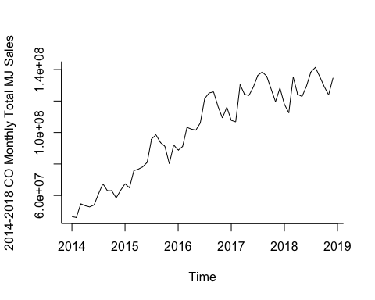

# Visualize CO 2014-2019 monthly total tax fees revenue as a time series  
cotaxrev.ts <- ts(cotaxrev$TotalTaxFees, start = c(2014,1), end = c(2018,12), freq = 12)  
plot(cotaxrev.ts, xlab = "Time", ylab = "2014-2018 CO Monthly Total TaxFees Rev", bty = "l")

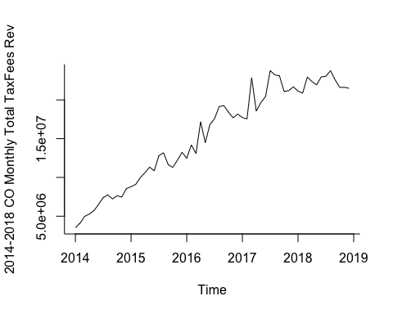

# Exploratory Analysis CO 2014-2018 marijuana sales & tax summaries  
cosalessummary <- read.csv("data/cleaned_COMJSalesSummary2019.csv")  
cotaxsummary <- read.csv("data/cleaned_COMJTaxSummary2019.csv")  
# Visualize CO 2014-2018 total marijuana sales summary by years as time series  
cosalessummary.ts <- ts(cosalessummary$TotalSales, start = c(2014), end = c(2018), freq = 1)  
cosalessummary.lm <- tslm(cosalessummary.ts ~ trend)  
plot(cosalessummary.ts, xlab = "Time", ylab = "2014-2018 CO Yearly Total MJ Sales", bty = "l")  
lines(cosalessummary.lm$fitted, col="blue", lwd = 2)

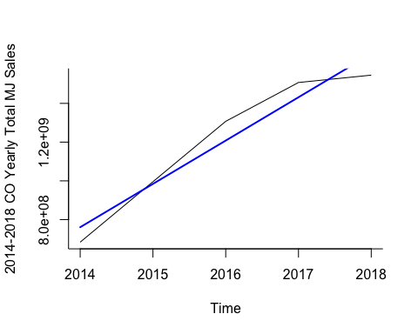

# Visualize CO 2014-2019 monthly tax summary by years as a time series  
cotaxsummary.ts <- ts(cotaxsummary$TotalTaxFees, start = c(2014), end = c(2018), freq = 1)  
cotaxsummary.lm <- tslm(cotaxsummary.ts ~ trend)  
plot(cotaxsummary.ts, xlab = "Time", ylab = "2014-2018 CO Yearly Total TaxFees Rev", bty = "l")  
lines(cotaxsummary.lm$fitted, col="blue", lwd = 2)

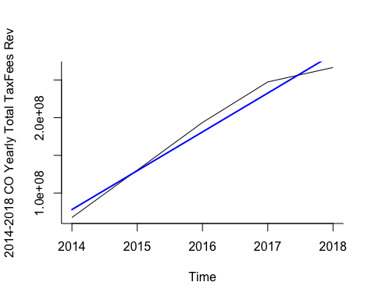

# Exploratory Analysis CO 2014-2018 population estimates  
costatepop <- read.csv("data/cleaned_COCountyPop20142018.csv")  
# Calculate 2014-2017 CO state pop from all CO counties   
Year <- c(2014,2015,2016,2017, 2018)  
Colorado <- c((sum(costatepop$X2014Pop)),(sum(costatepop$X2015Pop)), (sum(costatepop$X2016Pop)), (sum(costatepop$X2017Pop)), (sum(costatepop$X2018Pop)))  
# Create a 2014-2017 Colorado state pop df  
costatepop.df <- data.frame(Year,Colorado)  
# Visualize CO pop as a time series  
costatepop.ts <- ts(costatepop.df$Colorado, start = c(2014), end = c(2018), freq = 1)   
# The Linear trend line on CO Pop time series  
costatepop.lm <- tslm(costatepop.ts ~ trend)  
plot(costatepop.ts, xlab = "Time", ylab = "Colorado Pop", bty = "l")  
lines(costatepop.lm$fitted, col="blue", lwd = 2)

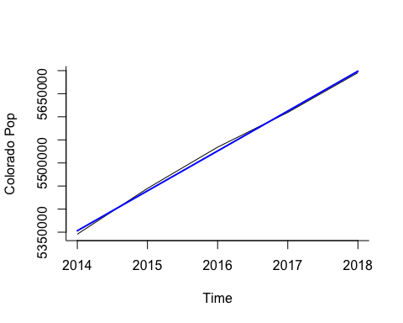

library(readxl)  
library(ggplot2)  
  
crime_denver <- read.csv("data/cleaned_crime_marijuana.csv")  
crime_denver[is.na(crime_denver) | crime_denver=="Inf"] = NA  
crime_stat = lm(OFFENSE_CODE~REPORTDATE, data = crime_denver)  
ggplot(crime_stat, aes(OFFENSE_CODE,REPORTDATE))+  
 geom_point() +   
 geom_smooth(method='lm', se=FALSE, color='turquoise4') +  
 theme_minimal() +   
 labs(x='Offense Code', y = 'Report Date' , title = 'Linear Regression model of Crime in Denver') +  
 theme(plot.title = element_text(hjust=0.5, size=20, face='bold'))

## `geom_smooth()` using formula 'y ~ x'

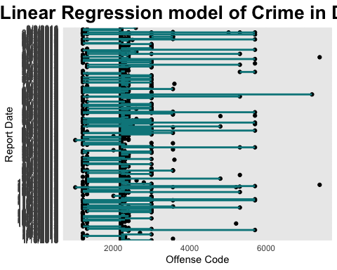

cleaned_drug_use <- read.csv("data/cleaned_drug-use-by-age.csv")  
summary(cleaned_drug_use)

## age sample_size marijuana_use_by_percentage  
## Length:17 Min. :2223 Min. : 1.10   
## Class :character 1st Qu.:2469 1st Qu.: 8.70   
## Mode :character Median :2798 Median :20.80   
## Mean :3251 Mean :18.92   
## 3rd Qu.:3058 3rd Qu.:28.40   
## Max. :7391 Max. :34.00   
## marijuana_frequency_over_12_months  
## Min. : 4.00   
## 1st Qu.:30.00   
## Median :52.00   
## Mean :42.94   
## 3rd Qu.:52.00   
## Max. :72.00

ggplot(cleaned_drug_use, aes(x=age, y=marijuana_use_by_percentage)) + geom_point() + geom_smooth(method=lm)

## `geom_smooth()` using formula 'y ~ x'

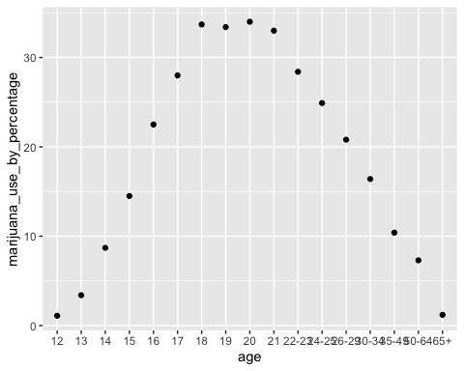

ggplot(cleaned_drug_use, aes(x=marijuana_use_by_percentage, y=age)) + geom_point() + geom_smooth(method=lm)

## `geom_smooth()` using formula 'y ~ x'

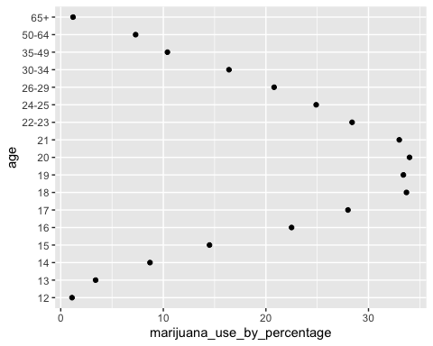

ggplot(cleaned_drug_use, aes(x=marijuana_use_by_percentage)) + geom_histogram()

## `stat_bin()` using `bins = 30`. Pick better value with `binwidth`.

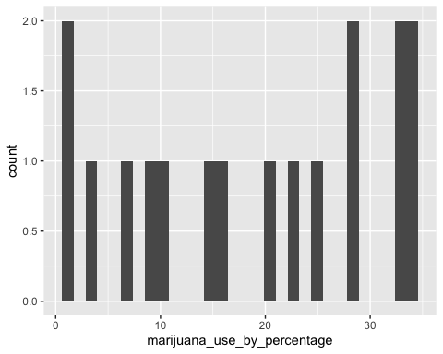

cleaned_support <- read.csv("data/cleaned_legal_marijuana_support.csv")  
summary(cleaned_support)

## Year Month Asked_half_sample Yes_Legal   
## Min. :1969 Length:20 Length:20 Min. :12.00   
## 1st Qu.:1980 Class :character Class :character 1st Qu.:25.00   
## Median :2002 Mode :character Mode :character Median :34.00   
## Mean :1997 Mean :35.95   
## 3rd Qu.:2011 3rd Qu.:48.50   
## Max. :2016 Max. :60.00   
## No_Illegal No_Opinion Percent_Yes Percent_No   
## Min. :39.00 Min. :1.00 Length:20 Length:20   
## 1st Qu.:49.25 1st Qu.:2.00 Class :character Class :character   
## Median :63.00 Median :4.00 Mode :character Mode :character   
## Mean :60.50 Mean :3.45   
## 3rd Qu.:70.75 3rd Qu.:4.25   
## Max. :84.00 Max. :6.00   
## Percent_No_Opinion  
## Length:20   
## Class :character   
## Mode :character   
##   
##   
##

head(cleaned_support)

## Year Month Asked_half_sample Yes_Legal No_Illegal No_Opinion Percent_Yes  
## 1 2016 Oct no 60 39 1 60%  
## 2 2015 Oct no 58 40 2 58%  
## 3 2014 Oct no 51 47 2 51%  
## 4 2013 Oct no 58 39 3 58%  
## 5 2012 Nov no 48 50 1 48%  
## 6 2011 Oct no 50 46 3 51%  
## Percent_No Percent_No_Opinion  
## 1 39% 1%  
## 2 40% 2%  
## 3 47% 2%  
## 4 39% 3%  
## 5 51% 1%  
## 6 46% 3%

library(patchwork)  
library(dplyr)  
  
ggplot(cleaned_support, aes(y=Yes_Legal, x=Year)) + geom_point()

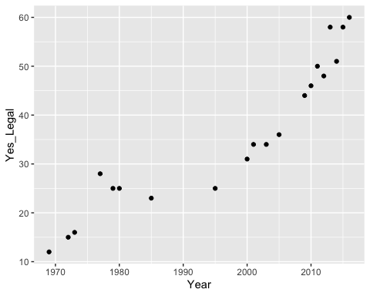

ggplot(cleaned_support, aes(y=No_Illegal, x=Year)) + geom_point()

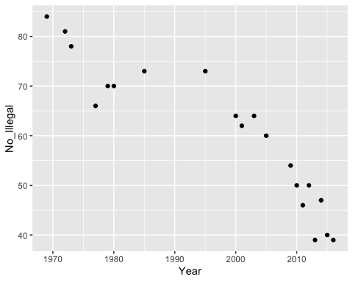

# Step 3

## Introduction

With more and more states adding medical and recreational cannabis to their ballots, questions are now being asked more openly about the impact of cannabis on public health, crime statistics, and popularity of legalization. The data out there is sparse, but the data that has been collected could show trends and insights on the future of legislation and public sentiment of legalization, along with showing the potential for lowered crime and raised tax revenue in states and at the federal level.

The data collected is attempting to find out if the sale and legality of cannabis shows an increase in crime and use in teens. The data collected shows the sales of cannabis based on annual sales since its legalization recreationally in 2014 in the state of Colorado, and the statistics of crime in the city of Denver. Data that did not support the investigation was scrubbed from the datasets and a new aggregate dataset was formed using the data that best fits the model example we are trying to follow. Results are interesting after running the models and building out visualizations. Some models were not as clean as I had hoped to be, but the linear regresssion lines did often model predictions accurrately with only a few outliers.

## The problem statement

The data required to answer the questions was not only sparse but also very difficult to parse through. The data in and of itself did not always correlate well with the questions being asked, along with the age old statement of causation does not equal coorelation often occuring. The issues that seemed to be the biggest is that the legalization of recreational marijuana in the state of Denver was the best kept up to date datasets but also tended to end the reporting at 2019. I was not able to find existing data that continued on past a certian point, nor was I able to find out how well the data was kept up. The data that I was able to find also delved into topics and subjects that was outside of scope for my initial line of questioning.

## How I addressed the Problem Statement

After cleaning the data as best as possible, piecing together ways to at least make a connection between datasets was the primary focus. It was difficult to parse through everything as the data was not initially related to each other and thus the data did not always play nice with the one another. Metrics also were an issue, but isolating and asking more specific questions made it easier to form the right philosophies and make it easier to understand the data.

## Analysis

From looking at the data, there seems to be little difference in crime related to the legaliziation of marijuana except for 22 instances from 2012 - 2016 and nearly all offenses were Possession, cultivation, or Sales charges. The data suggests that the most of the crimes were sales. The law in Denver states taht the sale of more than 6 ounces – 2.5 pounds of marijuana concentrate is a level 3 drug felony punishable by 2 – 6 years imprisonment as well as a fine between $5,000-$500,000. The sale of more than 2.5 – 25 pounds is a level 2 drug felony punishable by a sentence of 4 – 16 years and a fine of $ 3,000 – $ 750,000. The stats found did not however indicate what statute was broken nor did it display what the offense was other than a category_id and a offense code.

Another interesting finding is that the data suggests that public opinion for legalization had a converse relationship sometime between 1990-2000 (most likely sometime around 1995). The only other highest point was sometime in the late 70’s for a yes to legalization but was still nowhere near the amount of support in 1995. What happened at that time to change public perception is most likelly many factors that the data could not display nor suggest as to the reason why.

Also something to look at was that from a usage scenario by age, 18-21 year olds were the group most likely to use marijuana frequently. It tapers off the older one gets by average after the age of 21, while it tapers up at 12 years of age and use is as frequent as the 65 and older group.

## Limitations

The largest limitation I found with these data sets was that the data was large for the crime statistics but also was in a small area (Denver Area) and only covered crime from 2014-2016, where it accounted for all the crime reported such as car theft, homicide, and vandalism, etc.. but crime after legalization for possession and distrubition was lower and also there was not enough detail to describe the instances of why the crime was a crime in the first place. When looking at the datasets for how much revenue was produced, that dataset was the most informative, but also did not show much reason as to why crime and usage either increased or decreased based on the number of sales. The limitations that really stood out where that the data was not directly related as reports, and that all the data only focused on a specific angle of the questions that I was asking.

## Concluding Remarks

More research must be done with a broader net when gathering information on the impact of recreational sales of Cannabis and crime, usage by users. The research sets were interesting and the topic itself is an interesting question to see if it can be asked and solved. I believe that the data is out there currently, but aggregation of the data is sparce and other data sets seem to be focusing specifically on a broad range question analysis such as “How many people are using X Drug (cocaine, Methamphetamine, Marijuana, Alcohol, etc…)” than how many people are using Marijuana and commiting crimes that is more severe than a drug related offense.

I think though with the amount of research available that it would be hard to really say with confidence that the recreational sales of marijuana has done anything good or bad for the crime rate/ useage by people, as a model that could be used to predict the crime rate and usage in a newly legal state, but I am confident with the research available that there is at least an implication that with the legalization of Cannabis in a new state, crime related to Cannabis would lower, and usage might go up for those college age, meanwhile seeing a boom in financial resources collected by the state.