ASSIGNMENT 4

Joshua Burden

2022-04-24

# Markdown Basics

## Favorite Foods

1. Pizza
2. Quesadillas
3. BBQ Brisket

## Images

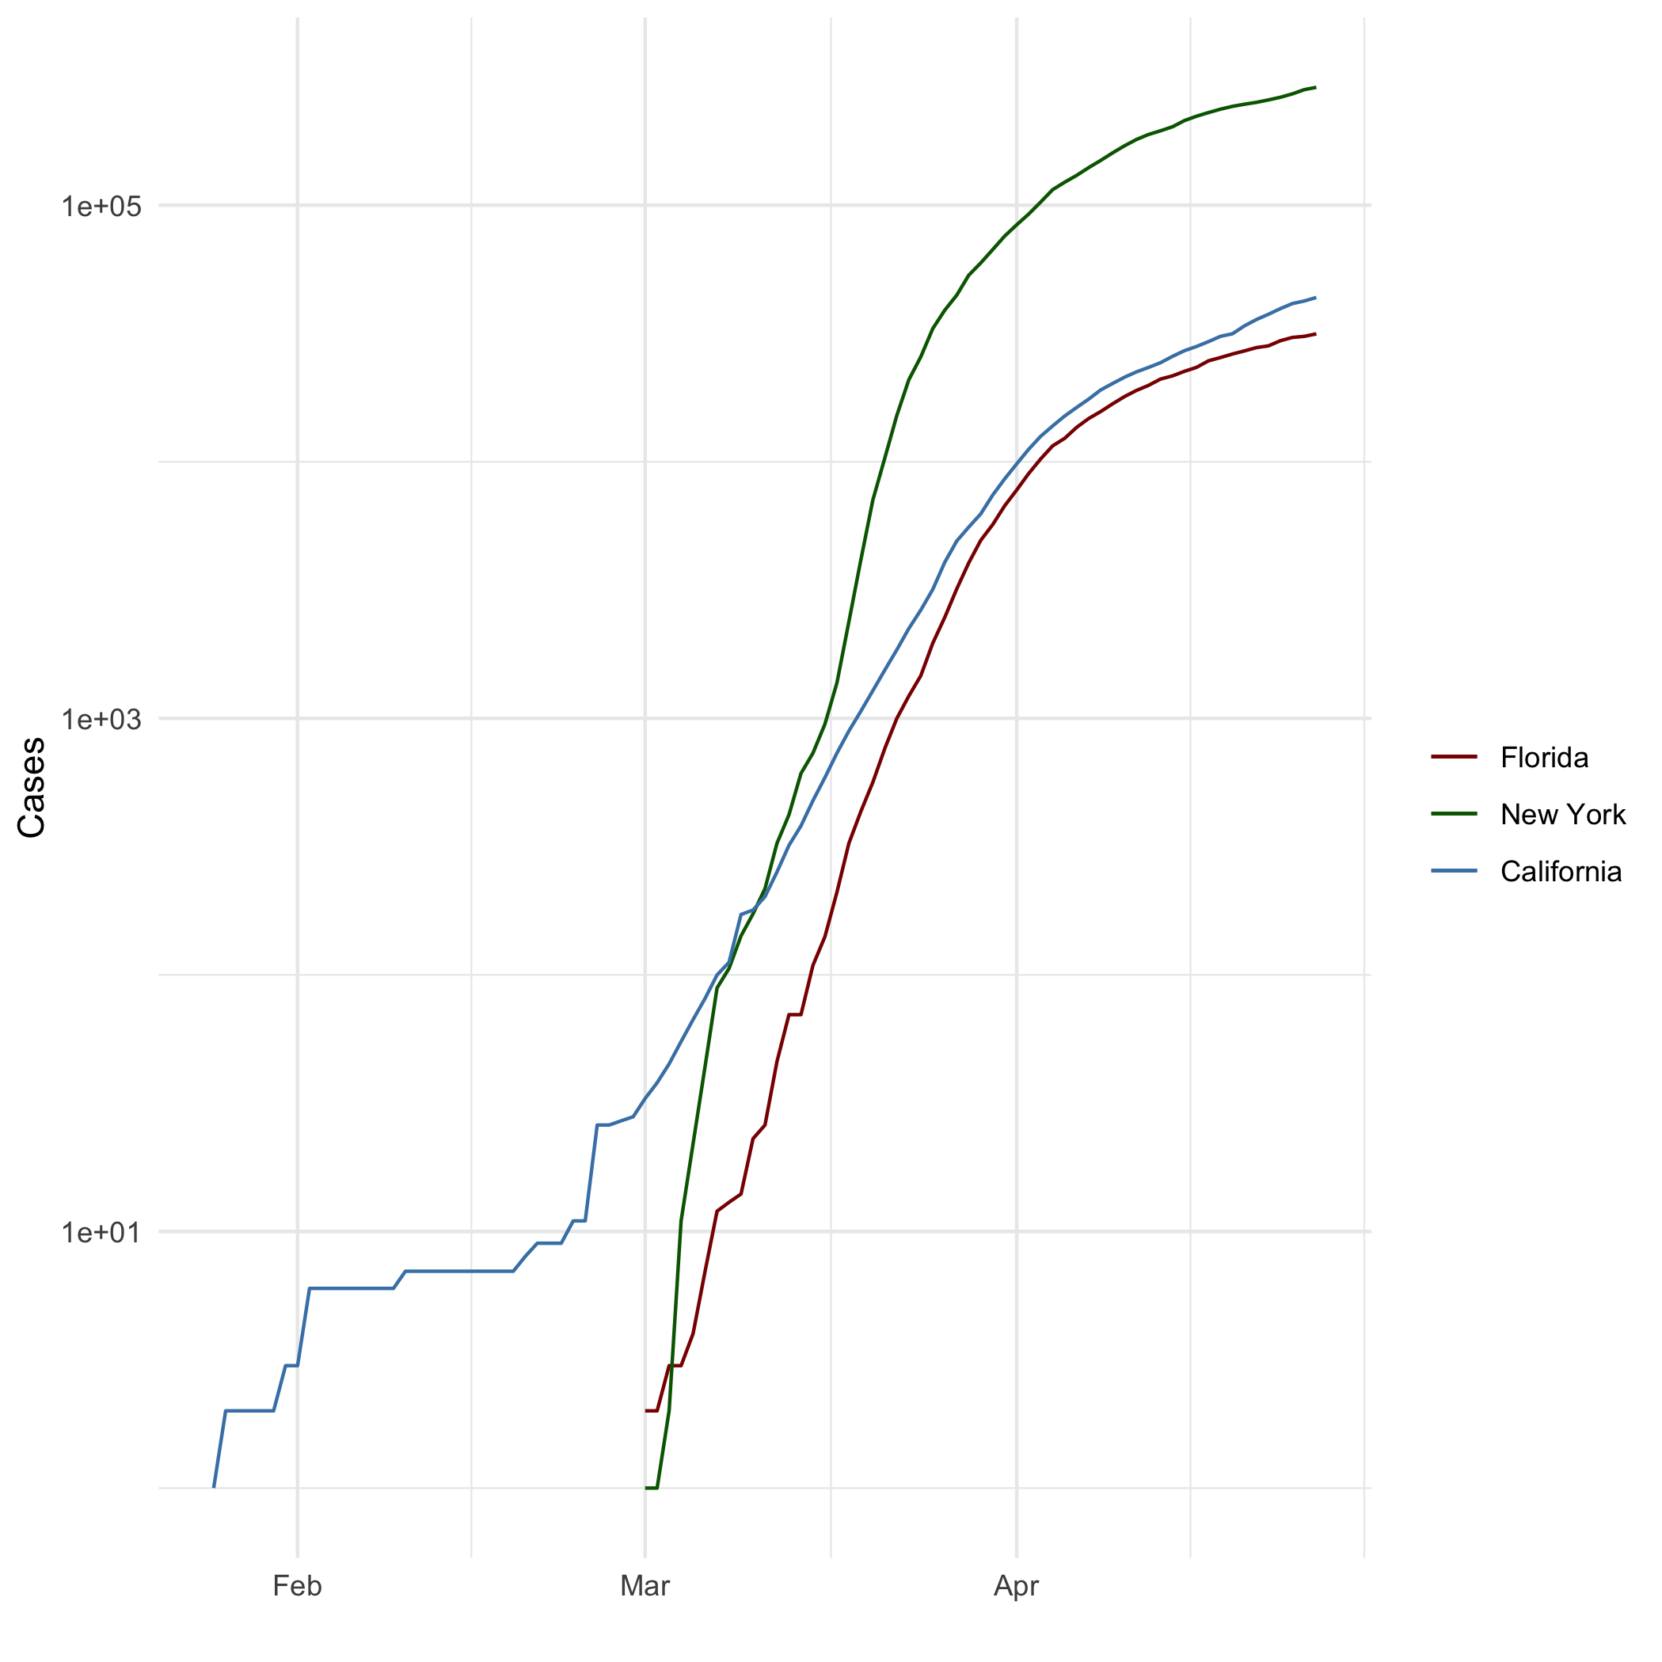

All Cases (Log Plot)

## Add a Quote

“Be strong I whispered to my wifi signal”

― White people from the Internet

## Add an Equation:

$$A_{m,n}=\left(\begin{matrix}a_{1,1} & a_{1,2} & ⋯ & a_{1,n} \\ a_{2,1} & a_{2,2} & ⋯ & a_{2,n} \\ ⋮ & ⋮ & ⋱ & ⋮ \\ a_{m,1} & a_{m,2} & ⋯ & a_{m,n}\end{matrix}\right)$$

## Add a Footnote

See footnote[1]

## Add Citations

* R for Everyone (Lander 2014)
* Discovering Statistics Using R (Field, Miles, and Field 2012)

# Inline Code

## NY Times COVID-19 Data

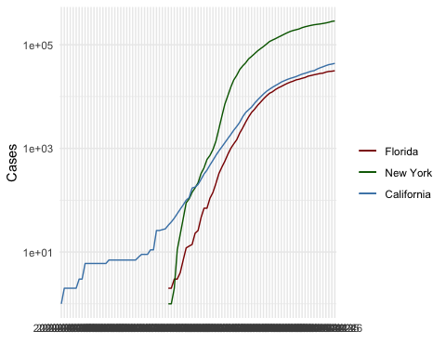

## R4DS Height vs Earnings

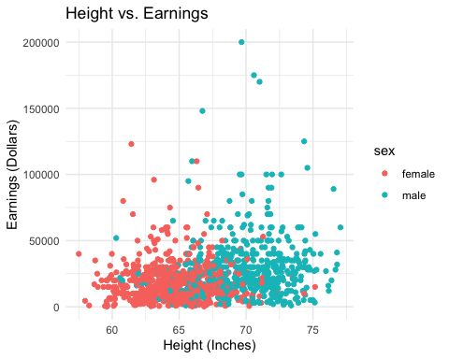

# Tables

## Knitr Table with Kable

knitr::kable(foods_df, caption = "Good foods")

Good foods

| name | kind | is_meat | is_fruit | weight |
| --- | --- | --- | --- | --- |
| Apple | Fruit | FALSE | TRUE | 200 |
| Banana | Fruit | FALSE | TRUE | 77 |
| Tomato | Fruit | FALSE | TRUE | 250 |
| Broccoli | Vegetable | FALSE | FALSE | 300 |
| Ham | Meat | TRUE | FALSE | 1600 |
| Gouda | Cheese | FALSE | FALSE | 1000 |

## Pandoc Table

library(pander)  
pandoc.table(foods_df, caption = "Good Foods")

##   
## ----------------------------------------------------  
## name kind is_meat is_fruit weight   
## ---------- ----------- --------- ---------- --------  
## Apple Fruit FALSE TRUE 200   
##   
## Banana Fruit FALSE TRUE 77   
##   
## Tomato Fruit FALSE TRUE 250   
##   
## Broccoli Vegetable FALSE FALSE 300   
##   
## Ham Meat TRUE FALSE 1600   
##   
## Gouda Cheese FALSE FALSE 1000   
## ----------------------------------------------------  
##   
## Table: Good Foods

# References

Field, A., J. Miles, and Z. Field. 2012. *Discovering Statistics Using r*. SAGE Publications. <https://books.google.com/books?id=wd2K2zC3swIC>.

Lander, J. P. 2014. *R for Everyone: Advanced Analytics and Graphics*. Addison-Wesley Data and Analytics Series. Addison-Wesley. <https://books.google.com/books?id=3eBVAgAAQBAJ>.

1. FootNote