|  |
| --- |
| Loughborough University |
| Task 2 User Guide |
|  |

|  |
| --- |
| Joshua Smith B221322, Igor Spirin B020777  3/7/2017[Pick the date] |

Contents

How to build 2

Interaction 3

Definitions that can be changed 3

Number of samples generated 3

Length of buffers 3

Length of filter 3

Filter values 3

Number of values in mean and variance calculation 3

Task Indication LEDs 4

User button LEDs 4

Getting the output 4

# How to build

1. Download **‘task2.zip’**
2. Extract the contents
3. Go to **‘RTX_filter’**
4. Open **‘task02.uvprojx’** in Keil uVision5

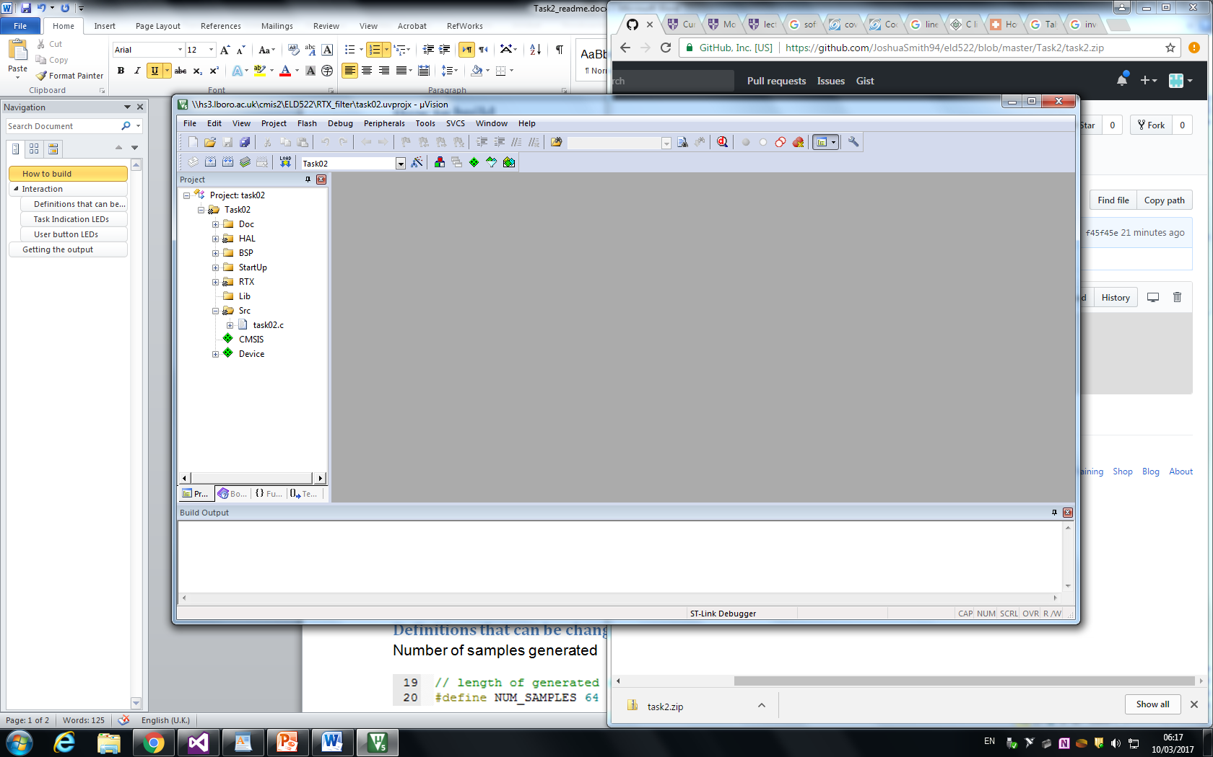

1. Right click on **‘Task02’** project folder then go to ‘Options for target Task02…’
2. Go to **‘Device’** tab and under **‘STM32F3 Series’** choose STM32F303VC
3. In the **‘Target’** tab, under **‘ARM Compiler’** select ‘V5.06 update 2 (build 183)’
4. Under the ‘Floating Point Hardware’ drop-down menu select ‘Not Used’

*This step is very important. If ‘Not Used’ is not selected, use of floats will result in stack overflow*

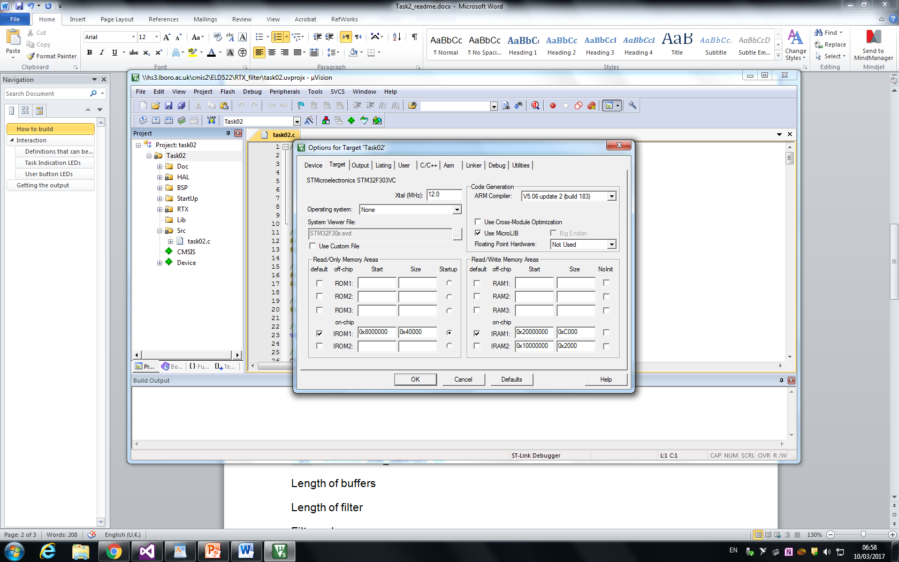

1. In the **‘Device’** tab choose **‘ST-Link Debugger’**

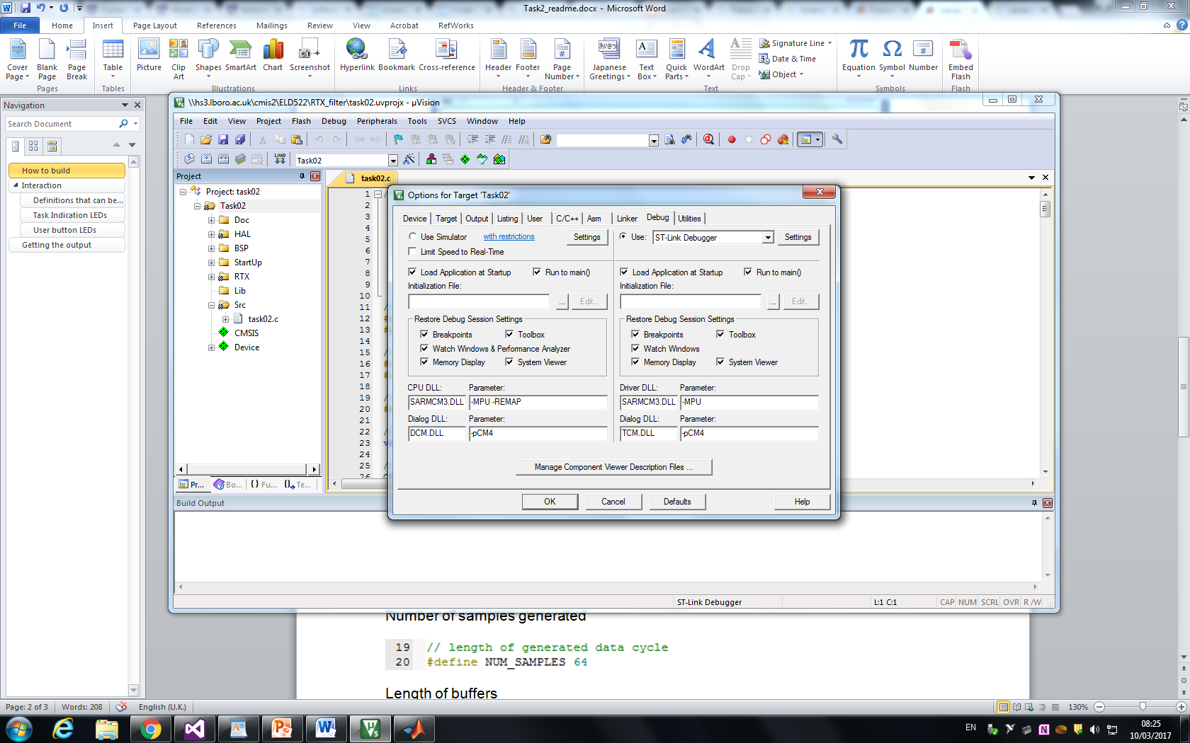

1. In the **‘Src’** subfolder locate and open ‘task02.c’
2. In order to build the code press F7
3. Upload the code to the board with Ctrl + F5

# Interaction

## Definitions that can be changed

Below are the line numbers and names of the definitions that can be changed.

### Number of samples generated



### Length of buffers

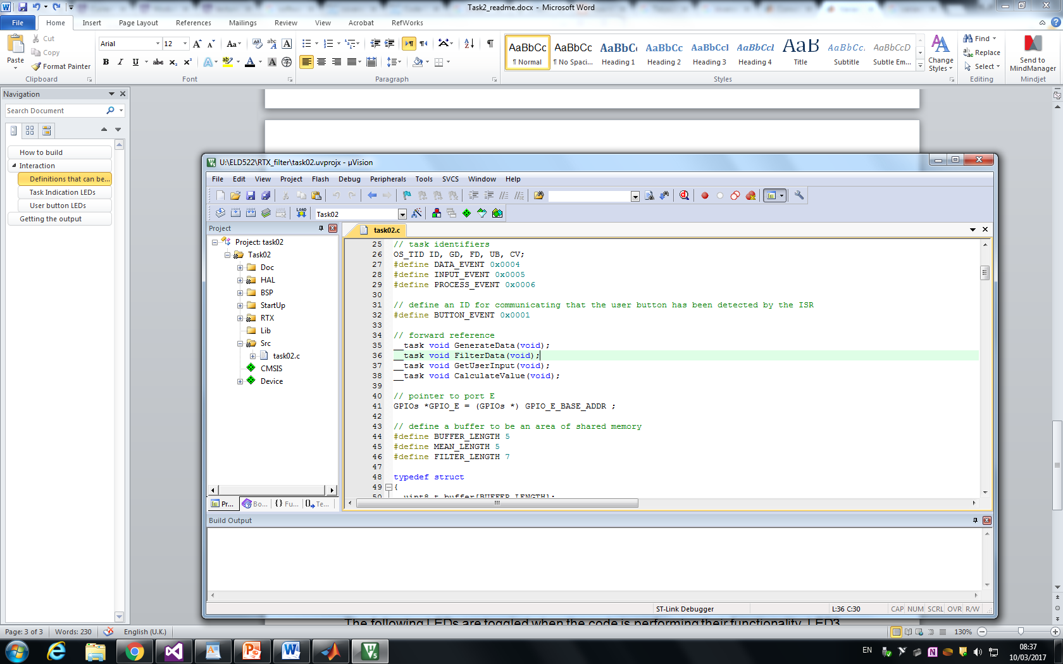

### Length of filter



### Filter values

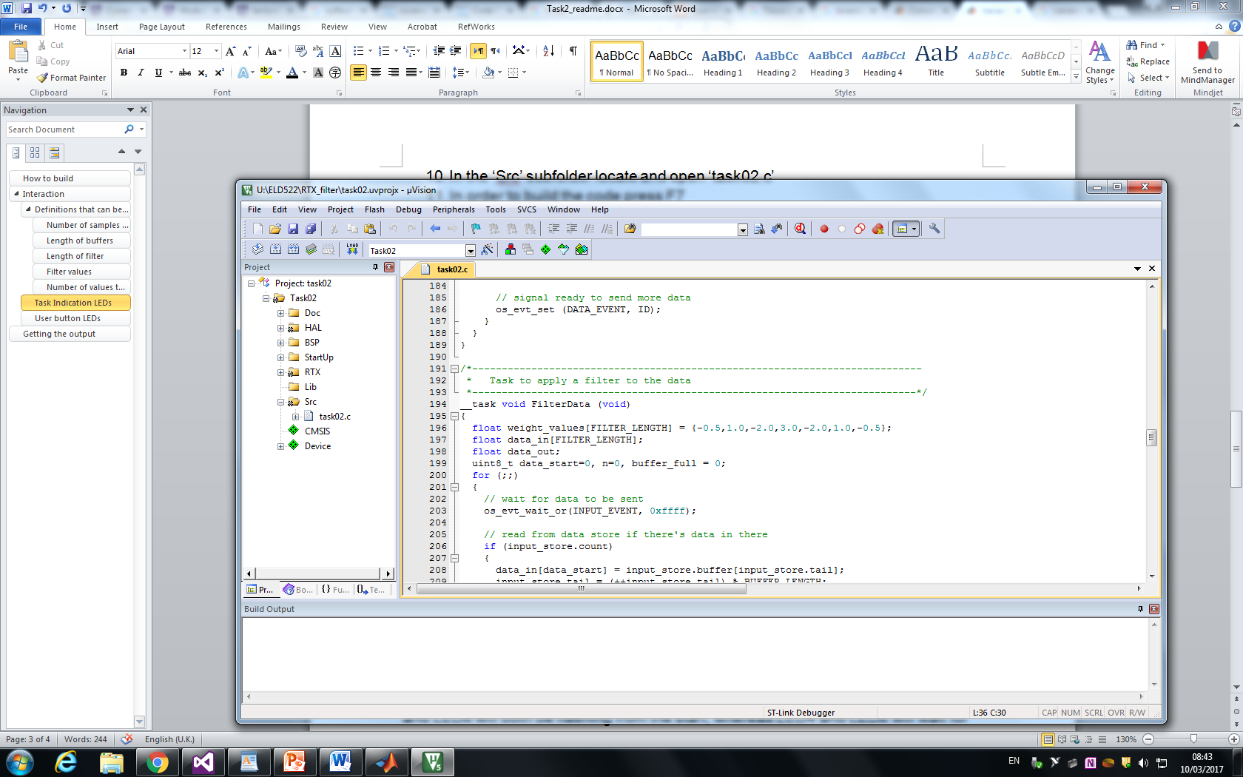

### Number of values in mean and variance calculation



## Task Indication LEDs

The following LEDs are toggled when the code is performing their functionality. LED3 and LED6 will both be flashing from the start, whereas LED4 and LED8 will wait for their input buffers to fill up before flashing.

|  |  |
| --- | --- |
| LED Number | Task Name |
| LED3 | GenerateData |
| LED6 | InputData |
| LED4 | FilterData |
| LED8 | CalculateValue |

## User button LEDs

The following LEDs change in response to the user input. The operation that is performed will cycle on each of the button press and will be indicated by the LED. Below is the table of LED states that represent a specific task.

|  |  |
| --- | --- |
| LED Number | Calculation being logged |
| LED5 | Mean |
| LED7 | Variance |
| LED5 and LED7 | Mean and Variance |

# Getting the output

The debugger screen can be accessed by pressing Ctrl + F5. Before doing this, place a breakpoint at line 300.

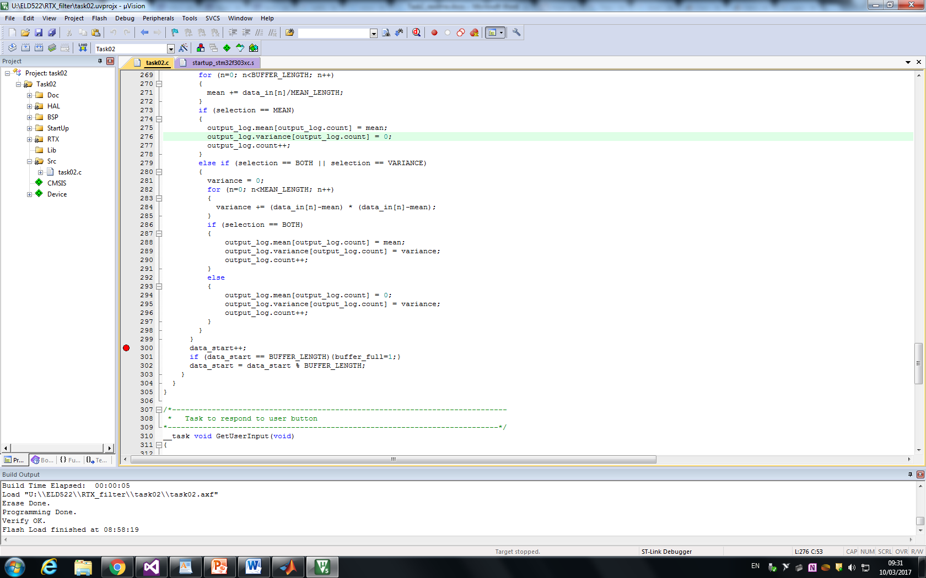

Upon uploading the code to the board, go to View -> Watch Windows ->Watch 1

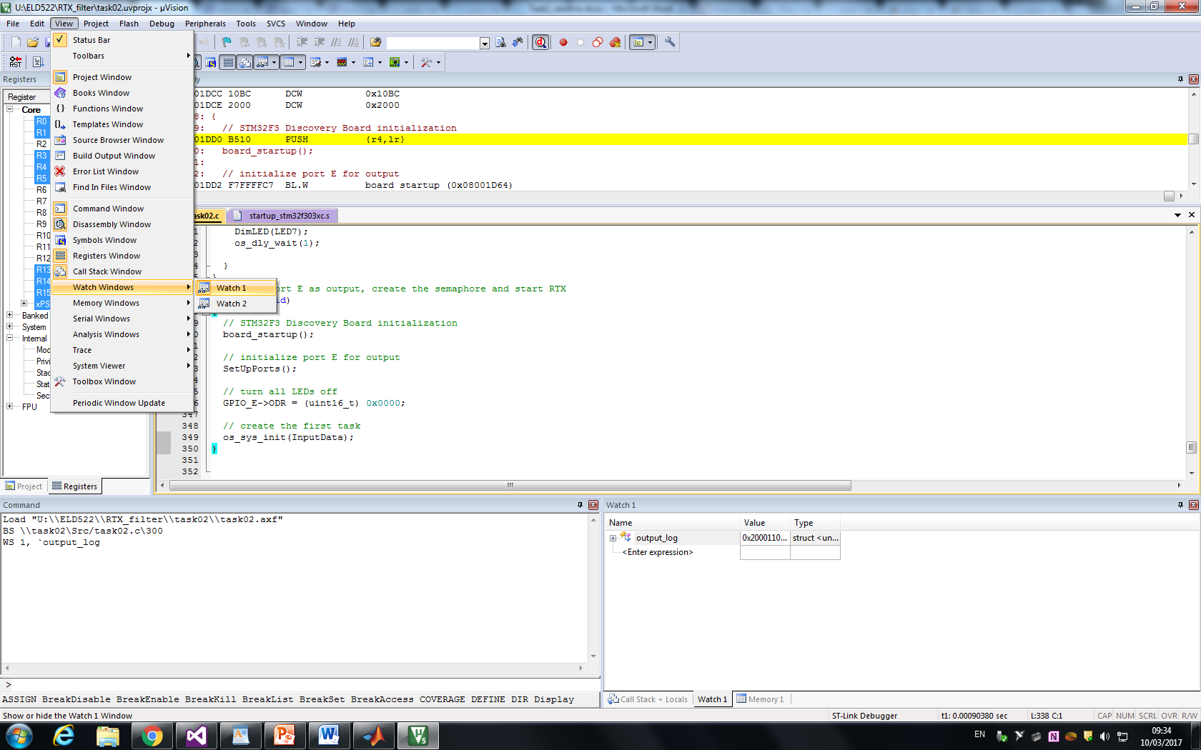

Now run the code by pressing **F5**. It will stop at the breakpoint. Expand **‘output_log’** in the **Watch 1** window to see the values stored in the buffers.

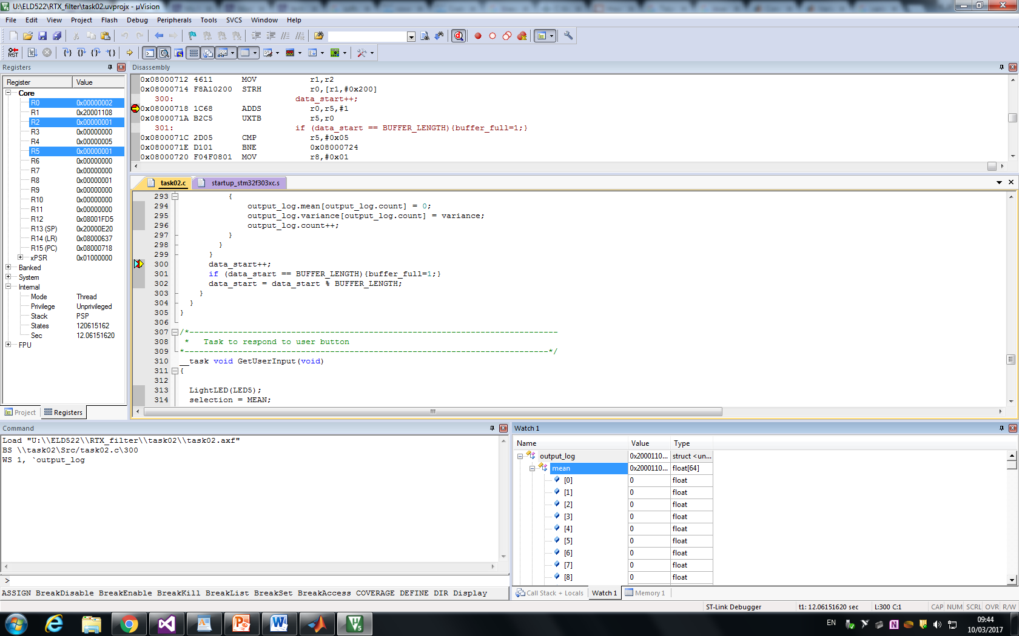

The code will output zeroes as it is mathematically true given the input data.