**Microprocessor Lab**

Laboratory Activity No. 2

**Arduino and Tinkercad Interface**

|  |
| --- |
|  |

Score

*Submitted by:*

**Tiu, Joshua Miguel Yaj A.**

**<Saturday 10:00-11:00> / <CPE 0412.1-1>**

*Date Submitted*

**30-09-2023**

*Submitted to:*

**Engr. Maria Rizette H. Sayo**

I. Objectives

This laboratory activity aims to implement the principles and techniques of hardware programming using Arduino through:

- creating an Arduino programming and circuit diagram.

II. Method/s

- Perform a task problem given in the presentation.

- Write a code and perform an Arduino circuit diagram of a ring counter that display

eight (8)LEDs starting from left.

III. Results

**TinkerCad**

**Exercise 1: Write a code that does a ring counter display for eight (8) LEDs starting from left.**

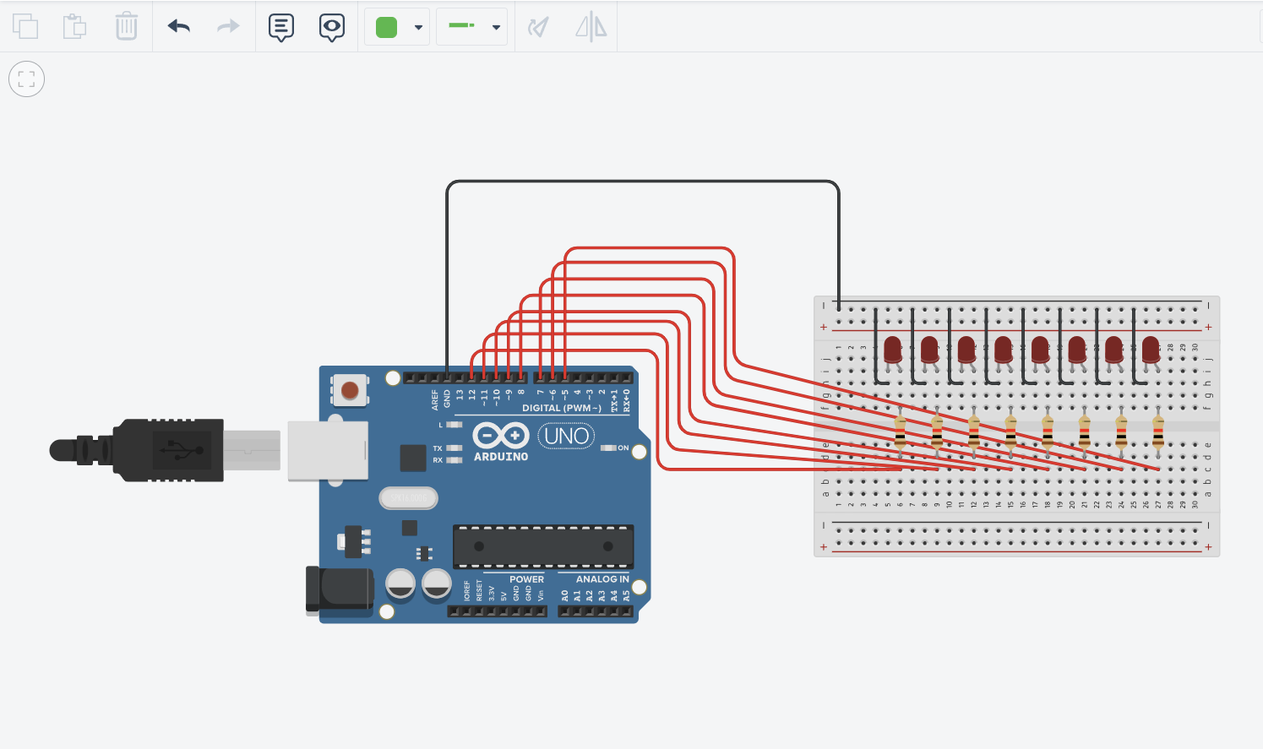

Figure No.1 Ring Counter Display Circuit Diagram

**Components Used**

1. 8 LEDs
2. Resistor
3. Breadboard

**CODE:**

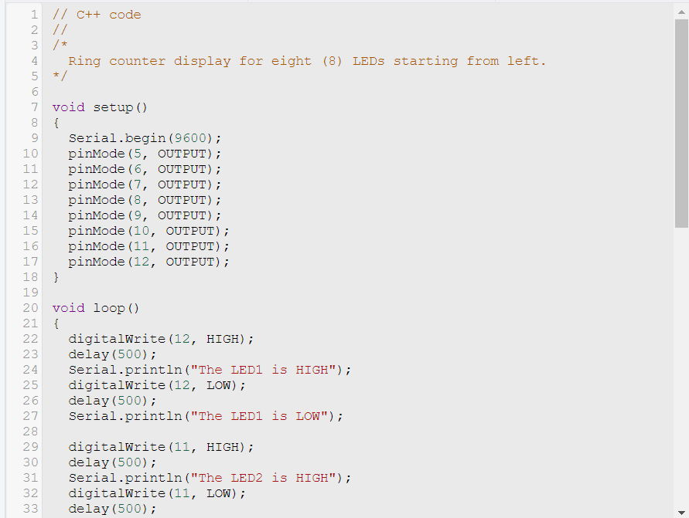

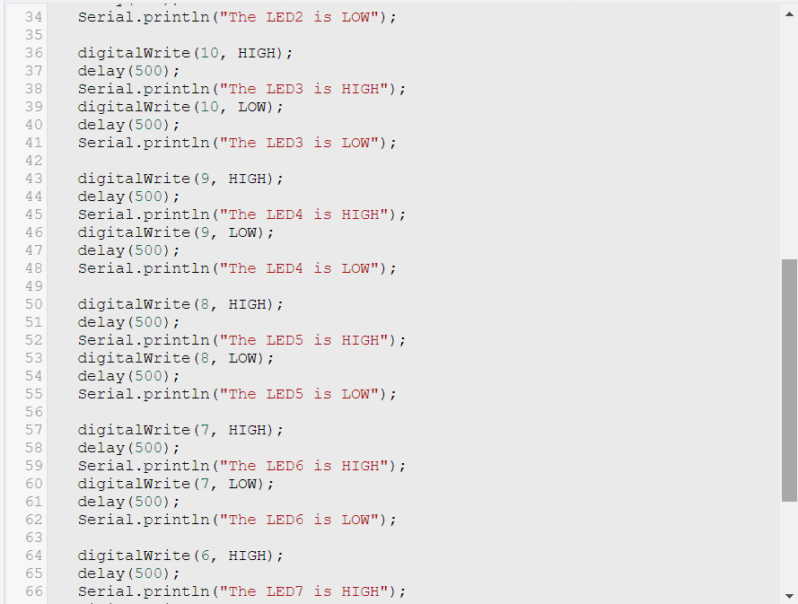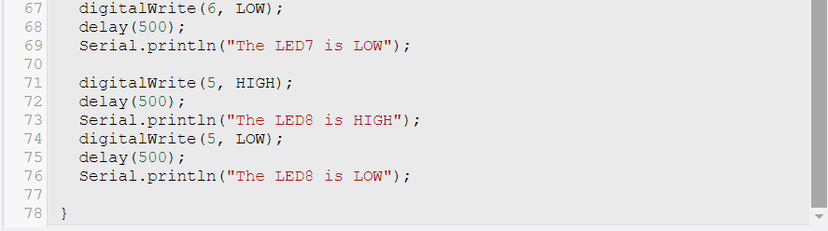

// C++ code

//

void setup()

{

for(int i=1;i<=8;i++)

pinMode(i, OUTPUT);

}

void loop()

{

for(int i=1;i<=8;i++)

{

digitalWrite(i,HIGH);

delay(500);

}

for(int i=1;i<=8;i++)

{

digitalWrite(i,LOW);

delay(500);

}

}

IV. Conclusion

This laboratory activity has given us a chance to learn and recreate a Ring Counter Display Circuit Diagram in Tinkercad. This activity helps us in the future to learn more about the fundamentals and basics of circuiting thru Tinkercad. This circuit started by gaining a deeper understanding of ring counters, which are sequential digital circuits. Ring counters have a distinct advantage in applications like display systems where we need sequential operation.

Overall, this laboratory activity provided a hands-on experience in designing, simulating, and understanding Arduino circuits overall. It reinforced our knowledge of digital electronics, sequential circuits, and the importance of precise timing.

In conclusion, this laboratory activity in Tinkercad was an educational and engaging experience that enhanced our understanding of ring counters and their applications and overall interface and circuit in general. It also improved our skills in circuit design, simulation, and troubleshooting, which are valuable in various fields of engineering, and especially in our field which is Computer Engineering.

**References**

[1] D.J.D. Sayo. “University of the City of Manila Computer Engineering Department Honor Code,” PLM-CpE Departmental Policies, 2020.

*<This is in a separate page>*