MTC GROUP – SUSTAINABILITY PAGE VISUAL CORRECTION GUIDE
IMPORTANT:
This document is based ONLY on the Sustainability page screenshots you provided.
Follow each section exactly. Each image shows the current design, and the text below it shows what to correct.
All images represent MTC Group of Companies operations (refineries, energy infrastructure, petroleum projects).

SECTION 1 – HERO
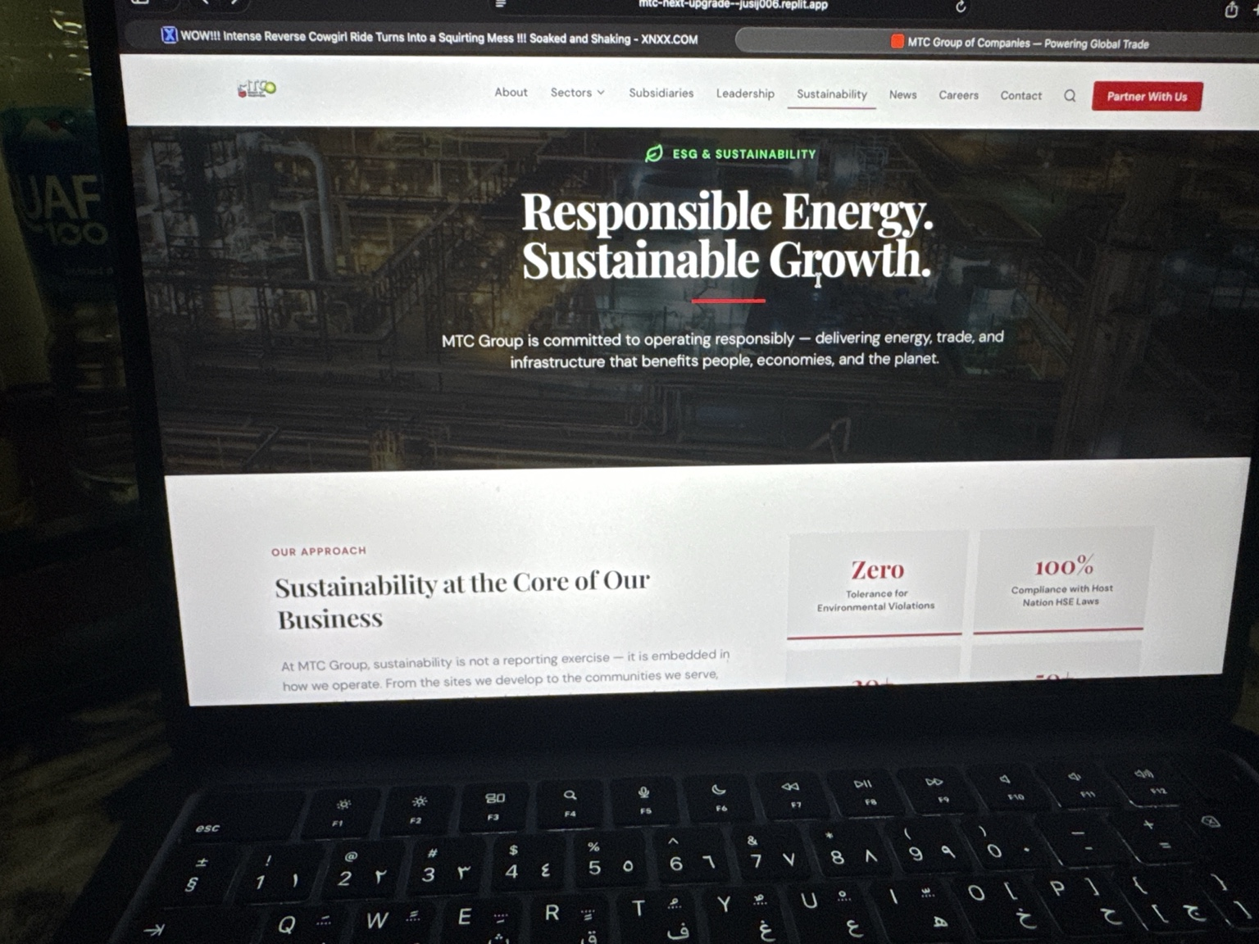
CORRECTION:
Replace title:
Delivering Sustainable Energy at Industrial Scale
Replace text:
MTC Group integrates sustainability across refinery operations, petroleum infrastructure, and global energy projects.

SECTION 2 – CORE BUSINESS
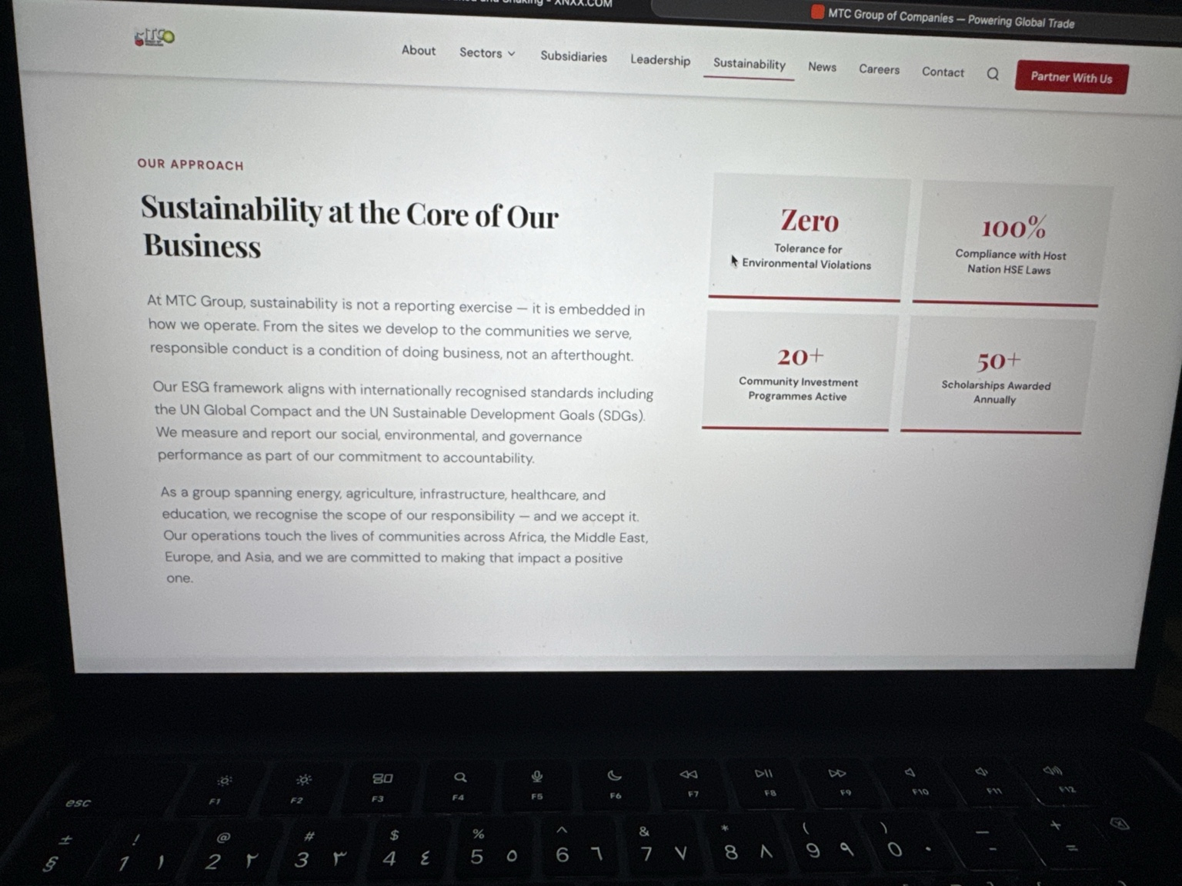
CORRECTION:
Replace text with:
Sustainability is embedded across refinery, oil & gas, and global operations with full ESG compliance.

SECTION 3 – METRICS
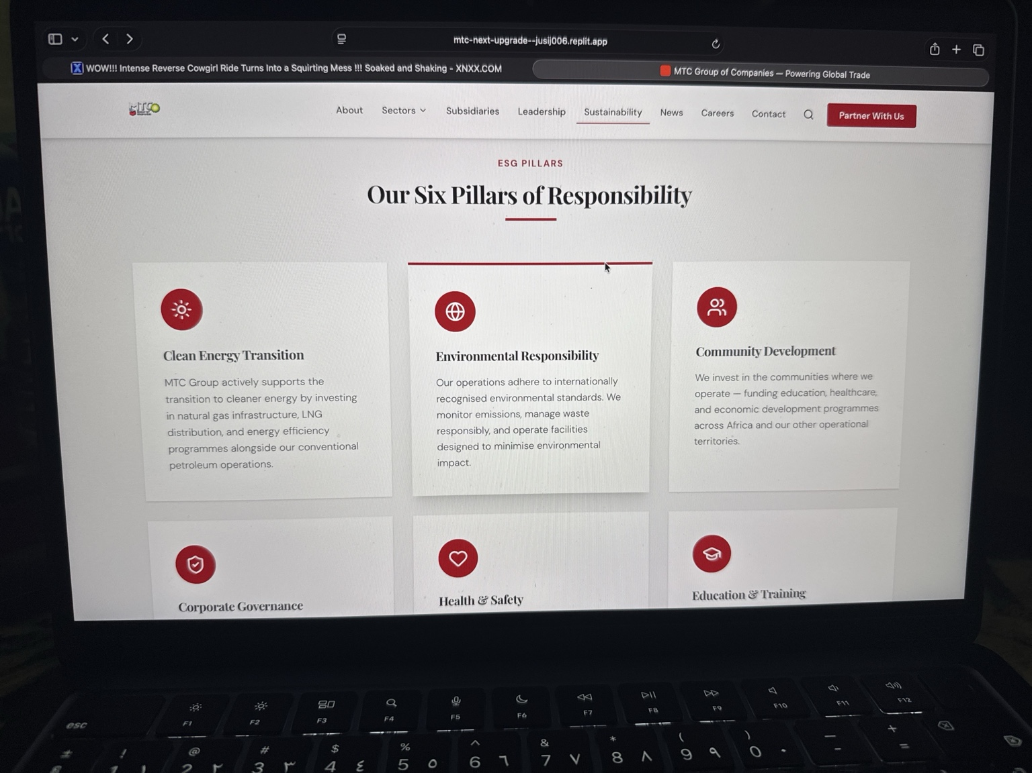
CORRECTION:
Replace metrics with:
10,000+ Workforce
Multi-Country Compliance
Zero Major Safety Incident Policy
50+ Community Projects

SECTION 4 – ESG PILLARS
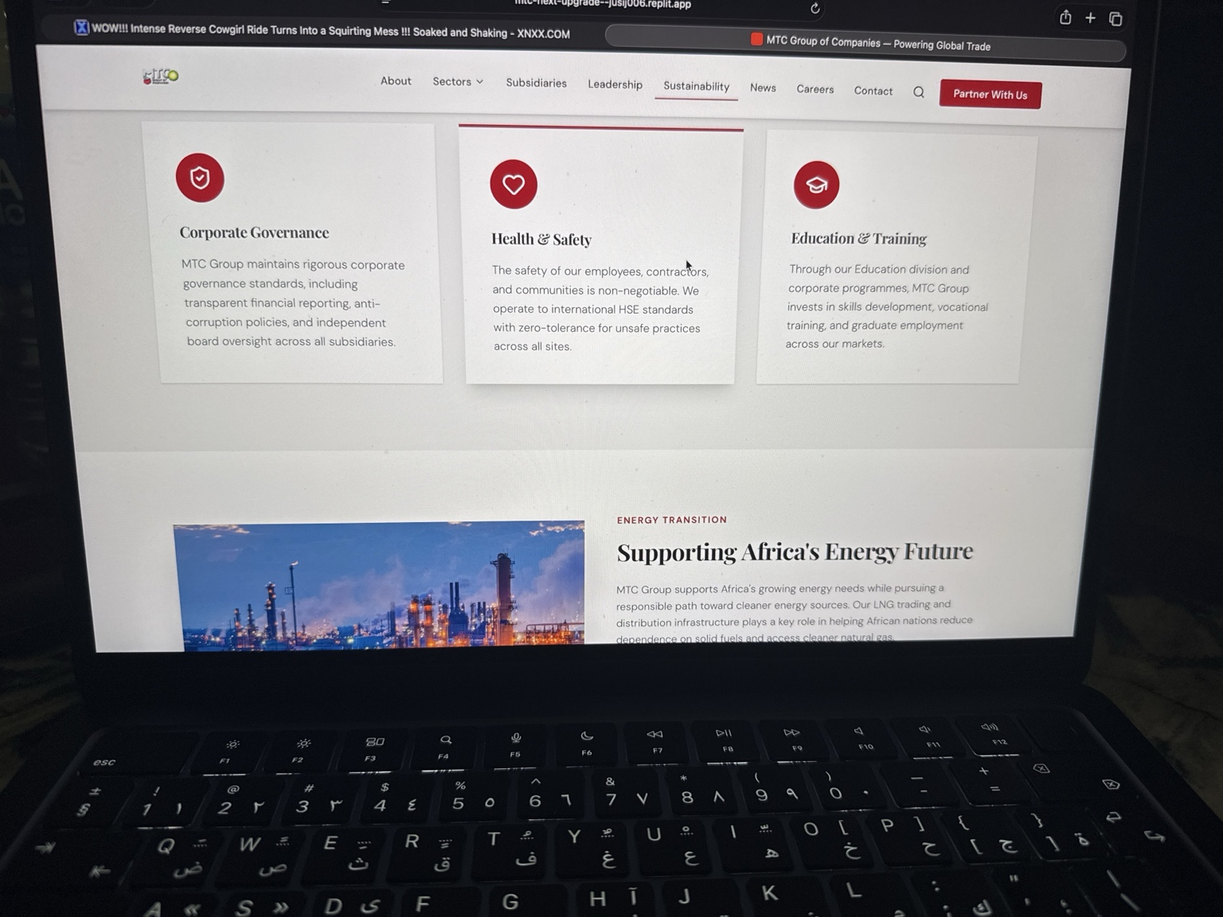
CORRECTION:
Upgrade all pillar descriptions to reflect refinery, oil & gas, safety, governance, and global operations.

SECTION 5 – ENERGY TRANSITION
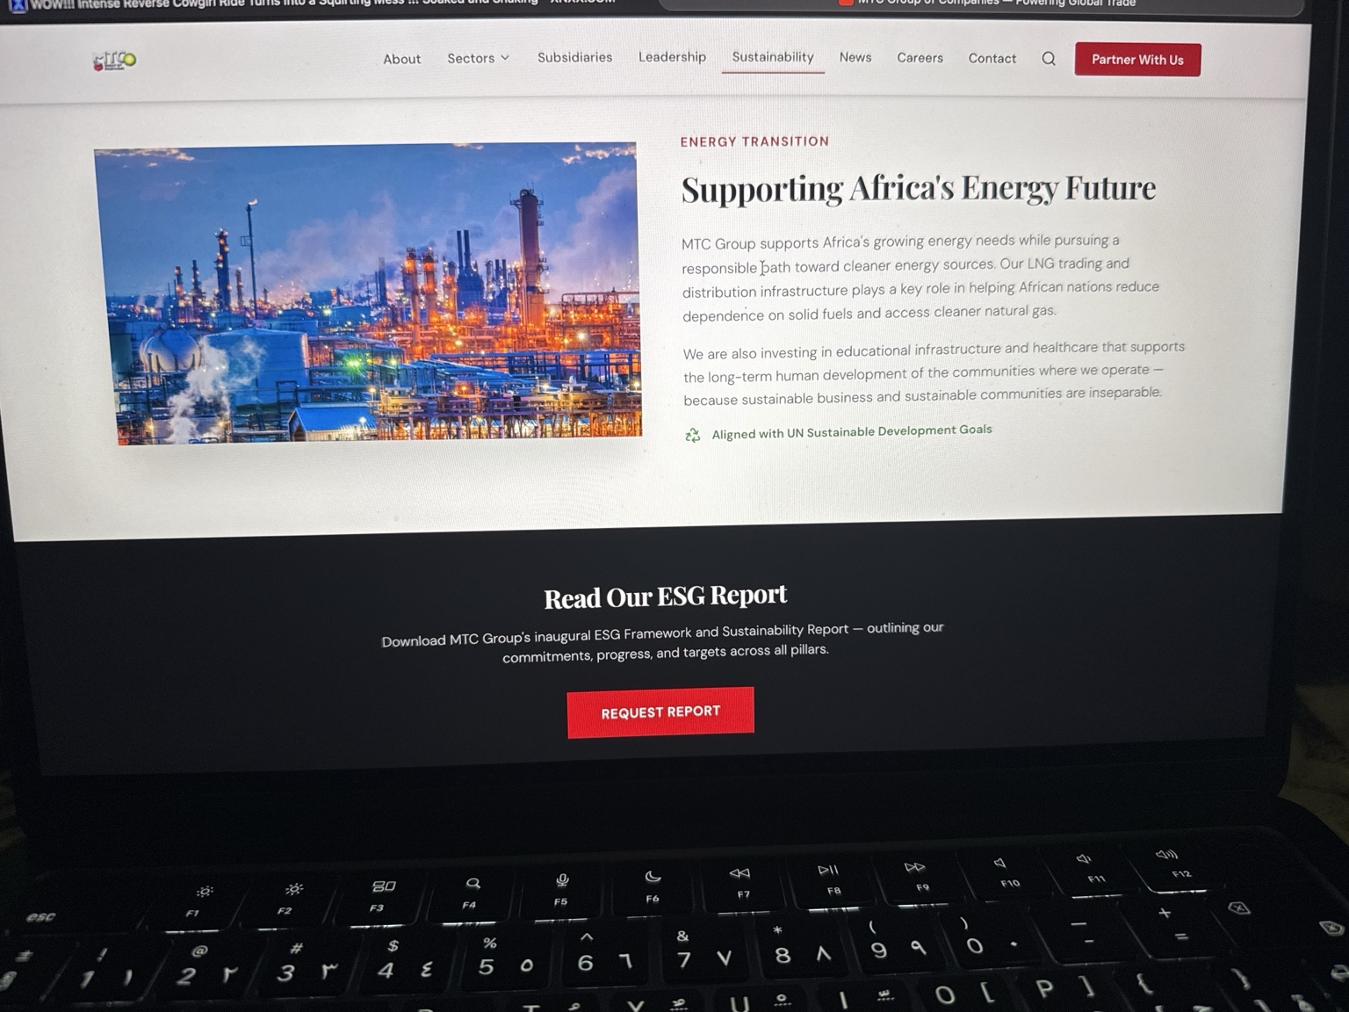
CORRECTION:
Replace title:
Supporting Global Energy Development
Replace text:
MTC supports global energy demand through refinery operations and infrastructure.

