MTC GROUP WEBSITE – CORRECTIONS & VISUAL GUIDE
This document provides corrections and visual guidance to ensure proper classification of images and content on the website.

1. ENERGY & PETROLEUM (REFINERY – CORRECT)
Images showing oil refineries, processing plants, tank farms, and petroleum facilities must be categorized under ENERGY & PETROLEUM.
These represent refinery operations, petroleum processing, and downstream oil & gas activities.
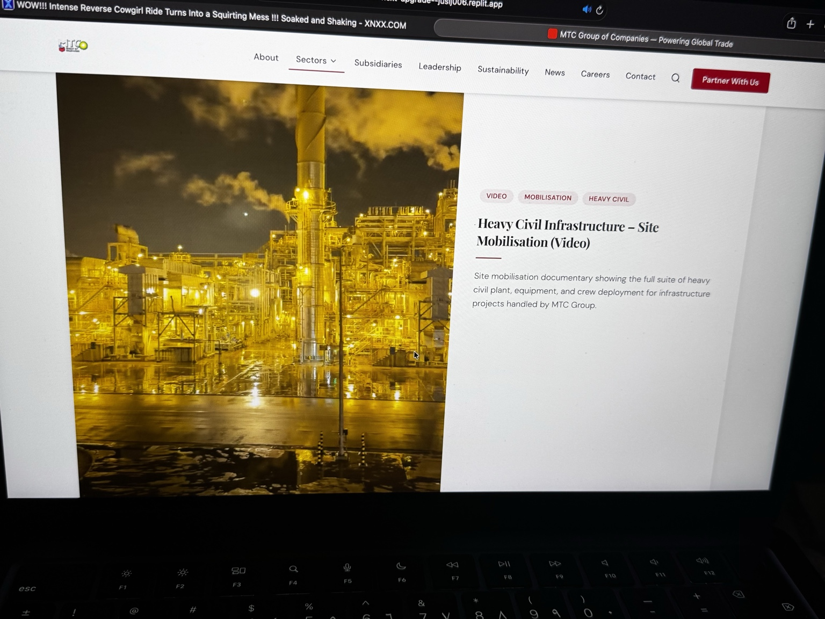
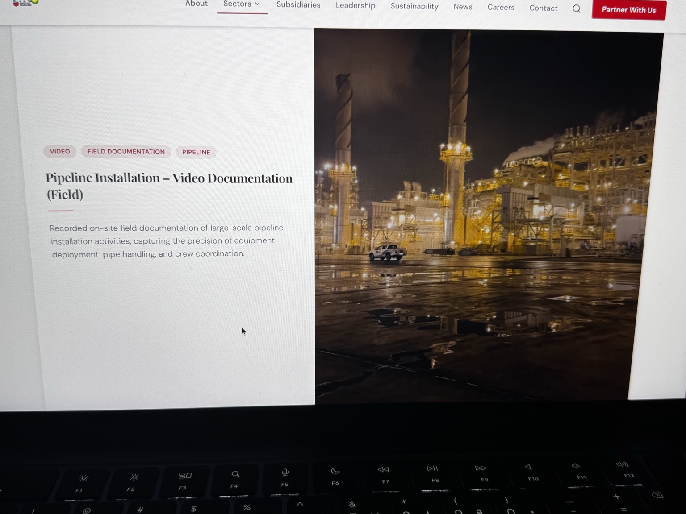
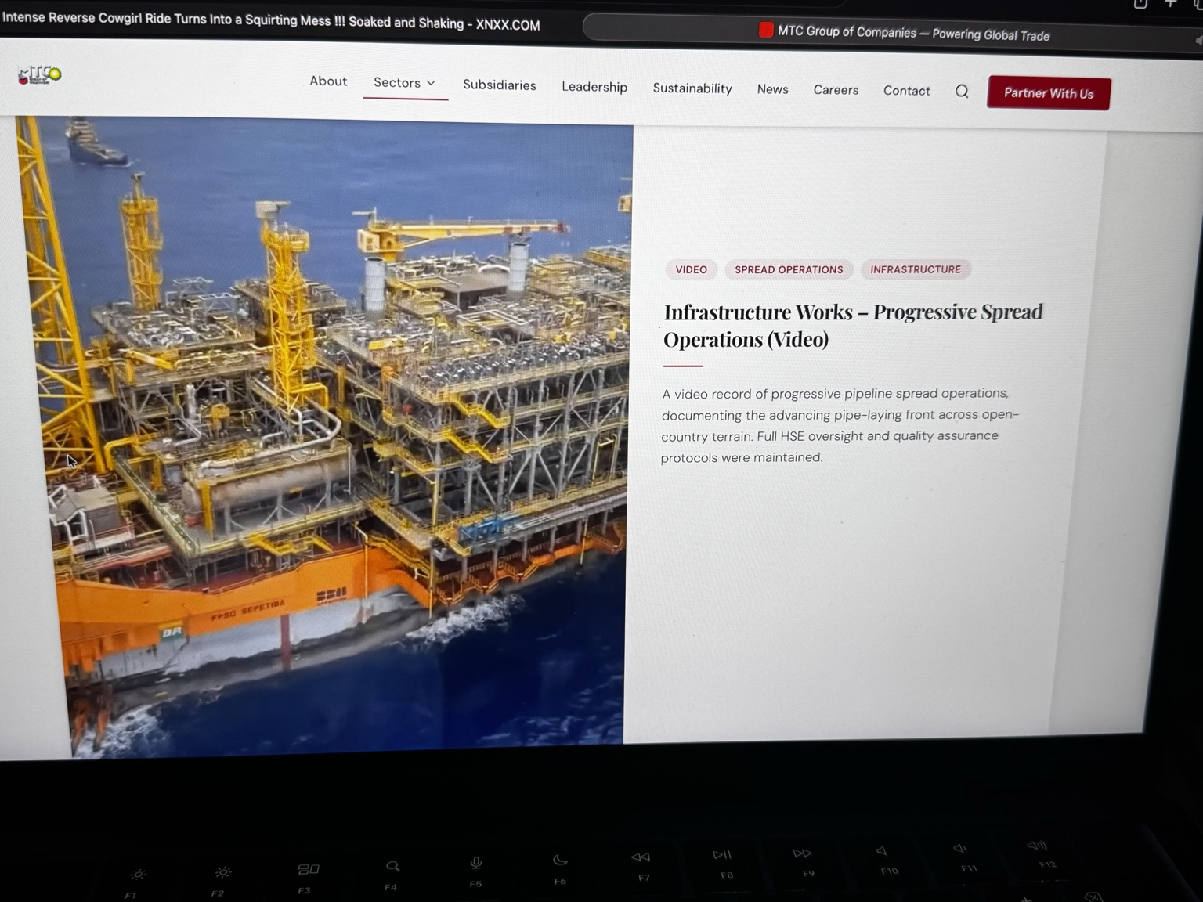
Correct Title Example:
Refinery Operations – Energy & Petroleum
Correct Description:
This section highlights MTC Group’s involvement in refinery operations, petroleum processing, and downstream energy infrastructure supporting large-scale fuel production and global supply.

2. INFRASTRUCTURE (NOT REFINERY)
Infrastructure refers to roads, bridges, and civil construction projects. Refinery images must NOT be placed here.
Examples of Infrastructure:
- Road construction
- Bridge development
- Civil engineering works

3. IMPORTANT CLASSIFICATION RULES
Any image showing:
- Refineries
- Oil plants
- Tank farms
- Fuel storage
Must be placed under ENERGY & PETROLEUM, not infrastructure.

