[richiechoy@gmail.com](mailto:richiechoy@gmail.com)

[joshua.v.sherman@gmail.com](mailto:joshua.v.sherman@gmail.com)

[John.Karaffa@ge.com](mailto:John.Karaffa@ge.com)    540-641-3230 Minden, NV is pacific time zone

[Richard.Choy@ge.com](mailto:Richard.Choy@ge.com)

Copied over the 2014 folder and made a new 2015 folder

* Generate Green Cards

1. Receive two spreadsheets

There are two agencies involved, LOA and RCSS

Use this template to put the information from the two agencies into one spreadsheet

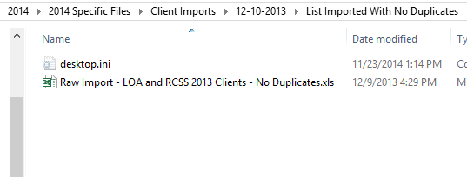

Open the project file

Rebuild the solution file

Run the code

Ignore this by clicking continue

