文章编号：（由编辑部填写） DOI:（由编辑部填写）
一种对时间敏感网络的帧的复制和消除的分析
钱时菲¹，罗峰²

（同济大学 汽车学院，上海 201804）

摘要：车载以太网以其高带宽和高通信速率将成为未来汽车骨干网络。为了满足汽车通信要求，网络需要具有无缝冗余特性。IEEE P802.1 CB是时间敏感网络活动项目之一，在任意地点对帧进行复制和消除以提高可靠性，从而为车载以太网提供无缝冗余特性。介绍了IEEE P802.1 CB的工作原理，包括网络拓扑、冗余标签、序列产生功能、序列恢复功能、超时机制和潜在错误检测。在Visual Studio中模拟了一个遵循IEEE P802.1 CB的网络，在CppUTest中测试了7种报文传输情景。结果表明当IEEE P802.1 CB应用于具有特定拓扑、可抵抗拥塞损失的网络时，可大幅提高网络的无缝冗余性能，尤其适合对时间要求严格的系统。
关键词：车载以太网，无缝冗余，帧的复制，帧的消除
中图分类号：U463.67 文献标志码：A

An Analysis of Frame Replication and Elimination for Time-Sensitive Networking
QIAN Shifei ¹, LUO Feng ²
(School of Automotive Studies, Tongji University, Shanghai 201804, China)
Abstract: Automotive Ethernet is becoming the backbone network of future vehicle because of its large data bandwidth and high communication speed. In order to satisfy the requirements of vehicle communication, the network needs the characteristic of seamless redundancy. IEEE P802.1 CB is one of the TSN (Time-Sensitive Networking) active projects, which provides seamless redundancy character for Automotive Ethernet by frame replication and elimination at flexible position to improve reliability. The operating principle of IEEE P802.1 CB was analyzed, including network topology, redundancy tag, sequence generation function, sequence recovery function, timeout mechanism and latent error detection. A network complying IEEE P802.1 CB was simulated in Visual Studio and 7 situations of packet transmission were tested in CppUTest. The results show that when IEEE P802.1 CB is used over a network that are fixed to a specific topology, and that are protected against congestion loss, it can substantially increase seamless redundancy character for the network and is especially suitable for time-critical system.
Key words: Automotive Ethernet; seamless redundancy; frame replication; frame elimination
With the increasing complexity of automotive network, traditional Controller Area Network (CAN) cannot satisfy internal communication bandwidth requirements such as enhanced safety and entertainment solutions [1]. So Automotive Ethernet is becoming the backbone network of future vehicle because of its large data bandwidth and high communication speed.
Automotive Ethernet needs several switches to deliver frames between end stations, for traditional Ethernet, if one switch fails, the frames will be lost, and several seconds are needed to find a new way for frame delivery. However it is unacceptable for vehicle communication because of its high importance for safety, so IEEE 802.1 Time-Sensitive Networking Task Group [2] is founded to make Automotive Ethernet satisfy the harsh requirements of vehicle communication.
IEEE P802.1 CB [3] is one of the TSN active projects, which provides seamless redundancy character for Ethernet network by frame replication and elimination to improve reliability [4]. IEEE P802.1 CB, provides increased reliability (reduced packet loss rates) for a stream by sequence numbering and replicating every packet, in the source end system and relay systems of the network, and eliminating those replicates in the destination end system and in other relay systems.
This paper first introduces the operating principle of IEEE P802.1 CB, including network topology, redundancy tag, sequence generation function, sequence recovery function, timeout mechanism and latent error detection function. Then a redundant network complying IEEE P802.1 CB is simulated in visual studio and tested through CppUTest [5]. Finally, a conclusion is given that when IEEE P802.1 CB is used over paths that are fixed to a specific topology, and that are protected against congestion loss, it can substantially increase seamless redundancy character for Ethernet network and is especially suitable for time-critical system.
- IEEE P802.1 CB operating principle
  - Network topology
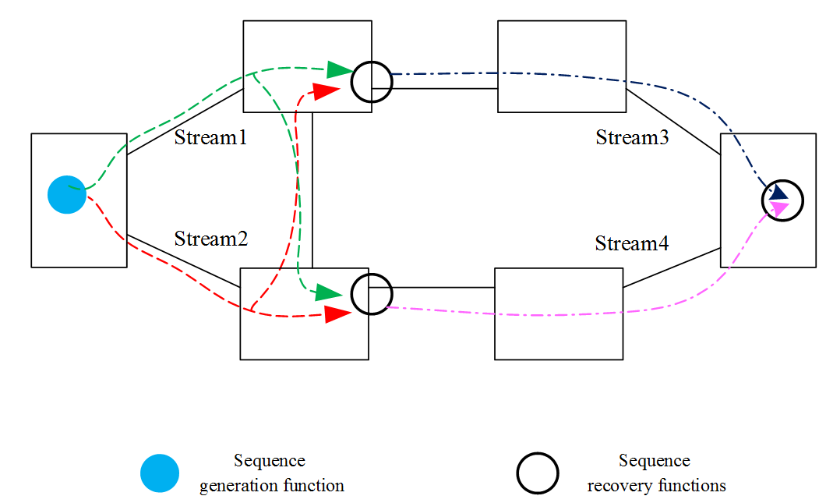
Figure 1. Topologies of IEEE P802.1 CB
Highly seamless communication with fault tolerance is one of the key requirements for Ethernet-based, mission-critical and real-time systems, such as substation automation system (SAS) networks and other industrial Ethernet networks [6].
IEEE P802.1 CB provides flexible topology for Automotive Ethernet, which means this standard will work on all LAN topologies. Figure 1 illustrates an example: a sequence number is generated and encoded into each packet in the leftmost box. Sequence recovery functions eliminate duplicate packets, and the non-duplicate packets are copied as a new member stream (with sequence numbers unchanged) at two intermediate points. The final two member streams are brought together and the duplicates are eliminated at the destination at right. This configuration protects against all 7 possible one-link failures, and against 16 of 21 possible two-link failures [4].
  - Redundancy tag
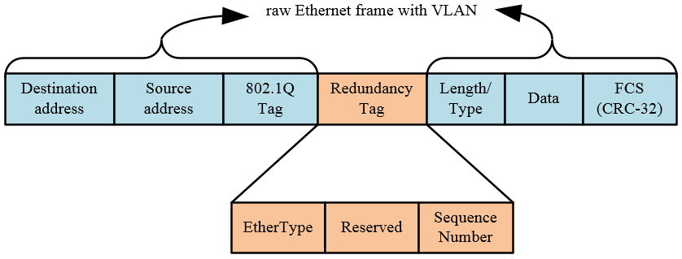
Figure 2. Ethernet frame with VLAN and redundancy tag
In this paper we use raw Ethernet frame with VLAN, in order to realize frame replication and elimination for seamless redundancy, a redundancy tag needs to be added into the Ethernet frame to support IEEE P802.1 CB, as illustrated in Figure 2. A redundancy tag consists of a tag protocol identifier EtherType and a sequence number. EtherType is a constant, and sequence number identifies the order in which the packet was transmitted relative to other packets in the same compound stream.
  - Sequence generation function
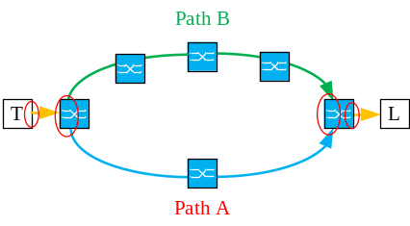
Figure 3. Example of IEEE P802.1 CB
Frame replication is realized by sequence generation function, it is called whenever the data request event occurs. It contains a counter, every time sequence generation function is called, the counter is incremented by one, and its value is copied to the sequence number of the redundancy tag of the packet, then the packet is passed to the next lower layer. If the counter exceeds its maximum value, it returns to zero.
For example, in Figure 3, the talker system T generates packets with consistent sequence number, and duplicates each packet to a packet pair, each packet pair have identical sequence number, they are sent separately through path A and path B to listener system L.
  - Sequence recovery function
Frame elimination is realized by sequence recovery function, it is called whenever the data indication event occurs. It operates on a merged set of member streams originally marked with sequence number values from a single instance of the sequence generation function. It evaluates the sequence number of a packet of one or more member streams passed up from the lower layers, in order to decide which packets to pass and which to discard.
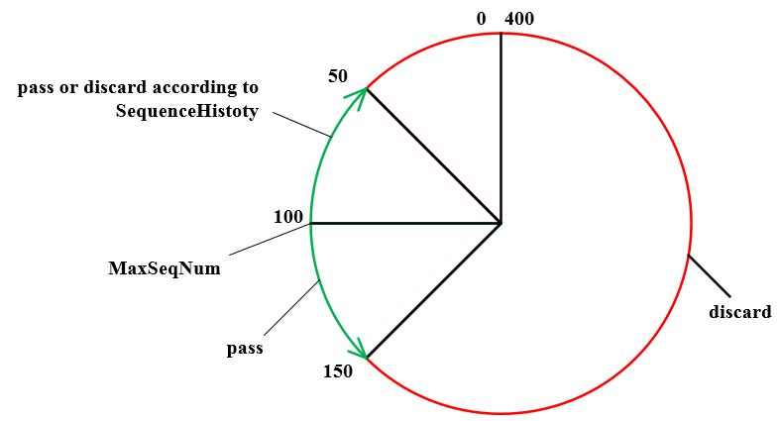
Figure 4. Vector recovery algorithm
Table 1. Sequence history
Sequence number | 100 | 99 | 98 | 97 | 96 | … | 50
Has been received or not | 1 | 0 | 1 | 0 | 0 | … | 0

Sequence recovery function has many sequence recovery algorithms, in this paper we use vector recovery algorithm. Vector recovery algorithm is illustrated in Figure 4, MaxSeqNum holds the highest sequence number value received. SequenceHistory is shown in Table 1, it maintains the history of the sequence number of recently received packets, its length is SequenceHistoryLength. SequenceHistory is a bit vector, with one bit for each value from 0 to (SequenceHistoryLength – 1), corresponding to sequence number from MaxSeqNum to (MaxSeqNum– SequenceHistoryLength + 1). A 1 in the SequenceHistory indicates that the corresponding sequence number has been received, and a 0 that it has not.
Immediately after the sequence recovery function is reset, it accepts the first packet received as valid. After the first packet has been accepted, if the sequence number of the subsequent packet is outside the window MaxSeqNum± SequenceHistoryLength, it will be discarded. If the sequence number of the packet is inside the window MaxSeqNum- SequenceHistoryLength, and its sequence number value has been seen before, it will be discarded, else it will be passed and SequenceHistory will be updated. If the sequence number of the packet is inside the window MaxSeqNum+ SequenceHistoryLength, it will be passed, moreover MaxSeqNum and and SequenceHistory will be updated.
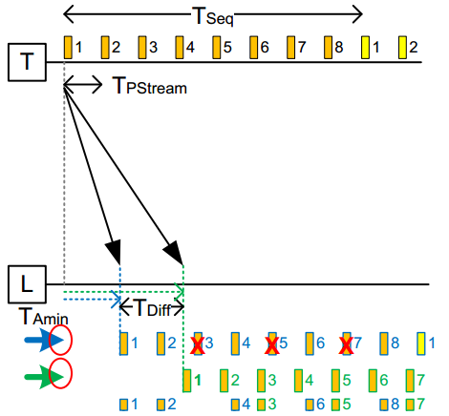
Figure 5. Seamless redundancy of IEEE P802.1 CB
The same example of Figure 3 is illustrated in Figure 5, there are 4 serials of packets in the picture, the first serial of packets represent the packets generated by the talker system T before they are split into path A and path B. The second and third serials of packets represent the packets of path A and path B received at the listener system L. Since there are more bridges in path B, the packets of path B arrive later than that of path A. The last serial of packets represent the packets passed up to the higher layer by the listener system L. The seamless redundancy character of this network is demonstrated as follows:
1) For duplicated packets with the same sequence number of path A and path B, the listener system L passes the earlier one and discards the later one, so IEEE P802.1 CB achieves zero delay switchover making it suitable for the time-critical system;
2) Although the packets with sequence number of 3, 5 and 7 are lost in path A, since the packets with the same sequence number in path B are not lost, so there are no packets lost in the view of the listener system L, therefore the redundancy character of the network is enhanced;
3) IEEE P802.1 CB dose not rely on higher layer protocols, it is transparent to the application.
  - Timeout mechanism
Each packet accepted and passed up the stack resets a timer, after reset it will tick down, when it turns to zero, meaning that no packet has been accepted during this time, the sequence recovery function will resets the algorithm, and the next packet received will be accepted. The timeout mechanism will resolve the following fault situations:
1) “Rogue” packets, meaning packets are discarded as invalid.
2) If a sequence recovery function somehow gets out of step with its corresponding sequence generation function, then after the specific time, the sequence recovery function will be reset and data will again be passed.
3) If a sequence generation function is reset, perhaps by rebooting a system, then sequence recovery functions that have not been reset are likely to discard packets until the timeout event has occurred.
4) If a talker or a relay system fails in such a way as to repeatedly transmit packets with the same sequence number, those packets will continue to be discarded, at least until the sequence number wraps around.
  - Latent error detection function
Latent error detection function monitors the managed objects associated with a single sequence recovery function, in order to detect the condition that relatively few packets are being discarded by that function. Latent error detection operates on the assumption that, in a properly functioning compound stream employing n paths into the current system, there will be n–1 packets discarded for every packet passed through the sequence recovery function. The latent error detection function issues a latent error signal when that assumption is violated.
- Simulation and test of IEEE P802.1 CB
In this paper, IEEE P802.1 CB is simulated and tested through visual studio and CppUTest, the test environment is illustrated in Figure 6. A network complying IEEE P802.1 CB is simulated in visual studio, then in CppUTest different packets are simulated and transmitted to the network, the test results are reported in CppUTest, including pass or discard the packets, reset or do not reset the algorithm, issue or do not issue the latent error.
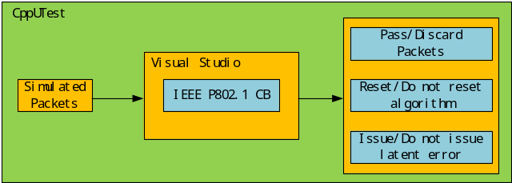Figure 6 Test environment of IEEE P802.1 CB
Visual studio is a fully-featured integrated development environment for android, iOS, Windows, web and cloud, in this paper a network complying IEEE P802.1 CB as Figure 4 is simulated, the simulation parameters of the network and packets are listed in Table 2 and Table 3, among them SequenceHistoryLength represents the size of sequence recovery window, timeout timer represents the timer which is reset after a packets is passed, latent error path represents the number of the path of the network, latent error difference represents the maximum allowed difference of the expected and actual discarded packet number.

Table 2. Simulation parameters of IEEE P802.1 CB network
SequenceHistoryLength | 100
Timeout timer | 10ms
Latent error path | 2
Latent error difference | 10

Table 3. Simulation parameters of packets
Packet | Source node | Destination node | Path | Sequence number
1 | T | L | A | 25
2 | T | L | A | 65450
3 | T | L | A | 130
4 | T | L | A | 15
5 | T | L | B | 25
6 | T | L | B | 15
7 | T | L | A | 30

CppUTest is a C /C++ based unit test framework for unit testing and for test-driving code, in this paper 7 situations of IEEE P802.1 CB are tested:
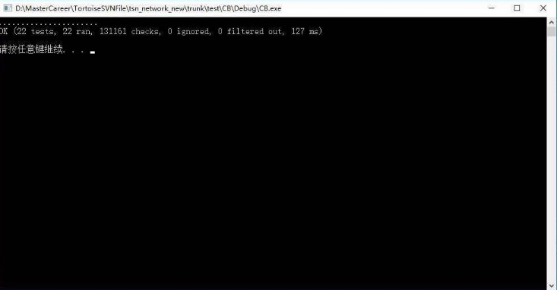
Figure 7 Test result of IEEE P802.1 CB
1) Test if the network can pass the first packet: transmit Packet 1 from node T to node L, check if Packet 1 can be passed;
2) Test if the network can discard the packet out of the sequence recovery window: transmit Packet 1, Packet 2 and Packet 3 in turn from node T to node L, check if Packet 2 and Packet 3 can be discarded;
3) Test if the network can pass the frame with sequence number in (MaxSeqNum- SequenceHistoryLength) window, and has not been seen before: transmit Packet 1 and Packet 4 in turn from node T to node L, check if Packet 4 can be passed;
4) Test if the network can discard the frame with sequence number in (MaxSeqNum- SequenceHistoryLength) window, and has been seen before: transmit Packet 1, Packet 4, Packet 5 and Packet 6 in turn from node T to node L, check if Packet 5 and Packet 6 can be discarded;
5) Test if the network can pass the frame with sequence number in (MaxSeqNum+ SequenceHistoryLength) window: ransmit Packet 1 and Packet 7 in turn from node T to node L, check if Packet 7 can be passed;
6) Test if the timeout mechanism can reset the sequence recovery algorithm and pass the packet again, when no packets has been passed, and the timeout timer ticks down to 0: first transmit Packet 1 from node T to node L, reset the timeout timer, then transmit Packet2 from node T to node L until timeout timer ticks down to 0, check if Packet 2 can be passed when the timeout event occurs;
7) Test if the latent error signal is issued during packets transmission from node T to node L: transmit packets from node T to node L, detect latent error every second: calculate the difference between (Passed Packets * (LatentErrorPaths - 1)) and (Discarded Packets), check if the difference is no more than (Latent error difference).
The test result is shown in Figure 7, which indicates that all test cases are passed, and IEEE P802.1 CB can realize seamless redundancy efficiently.
- Conclusions
This paper introduces the mechanism with which IEEE P802.1 CB realizes seamless redundancy for time-sensitive networking, including network topology, redundancy tag, sequence generation function, sequence recovery function, timeout mechanism and latent error detection. A network complying IEEE P802.1 CB is simulated and 7 situations are tested to demonstrate that IEEE P802.1 CB can provide seamless redundancy. In conclusion IEEE P802.1 CB is a redundancy method that:
1) Can be used with any topology;
2) Can realize seamless redundancy for the network;
3) Achieves zero delay switchover making it suitable for time-critical system;
4) Dose not rely on higher layer protocols;
5) Is transparent to the application.

REFERENCES
[1] Hank Peter, Müller Steffen, etc. Automotive Ethernet: In-vehicle Networking and Smart Mobility: Proceedings of the Conference on design, automation and test in europe, 2013; 1-2.
[2] IEEE Std, Time-Sensitive Networking Task Group. [Online]. Available: http://www.ieee802.org/1/pages/tsn.html
[3] IEEE Std, Frame Replication and Elimination for Reliability. [Online]. Available: http://www.ieee802.org/1/pages/802.1cb.html
[4] IEEE Std, Draft Standard for Local and metropolitan area networks —Frame Replication and Elimination for Reliability. [Online]. Available: http://www.ieee802.org/1/files/private/cb-drafts/d2/802-1CB-d2-3.pdf
[5] CppUTest unit testing and mocking framework for C/C++. [Online]. Available: http://cpputest.github.io
[6] Nsaif, S.A.; Rhee, J.-M. DVP: A Novel High-Availability Seamless Redundancy (HSR) Protocol Traffic-Reduction Algorithm for a Substation Automation System Network. Energies 2014, 7, 1792–1810.

