
THE CHAPEL OF FAITH, FUTA
Church Website & Platform
Project Documentation
“The just shall live by his faith.” Habakkuk 2:4
Version: 0.2
Date: October 2026
Prepared by: Joshua Mudana
Status: Draft for discussion with the Chapel
Interdenominational Chapel · Federal University of Technology, Akure · Ondo State, Nigeria

Contents
1. Executive summary and vision 3
2. Stakeholders and users 3
3. Feature specification 4
4. Live sermon recording from the church sound system 8
5. AI audio cleanup (“Loom-style”) 10
6. System architecture 13
7. Data model summary 15
8. API overview 15
9. Security and privacy 16
10. Deployment and hosting options 18
11. Roadmap 19
12. Admin user guide 19
13. Open questions for the Chapel 20
14. Sources 21
Document control
Version | Date | Author | Changes
0.1 | Oct 2026 | Joshua Mudana | Concept website and demo: public site, giving demo, prayer requests, counselling, messages, hymn book, Watch Live.
0.2 | Oct 2026 | Joshua Mudana | Admin panel, api.js data layer, API contract, daily devotion, home gallery, special events. New chapters: live sermon recording (Phase 2) and AI audio cleanup (Phase 3).

Figures marked (est.) are rough estimates that have not been checked against a supplier and should be confirmed before any budget is approved. Items marked to confirm are details only the Chapel can supply (see Section 13).

1. Executive summary and vision
The Chapel of Faith is the interdenominational chapel of the Federal University of Technology, Akure (FUTA), founded in 1984. Its congregation is mostly students and staff: young, mobile-first, and often away from campus during holidays and strikes. Today the Chapel reaches them through social media posts, WhatsApp forwards and an existing mobile app, but there is no single home where someone can watch the service, listen to last Sunday’s message, give a tithe, ask for prayer or book a counsellor.
This project builds that home: a modern website and platform for the Chapel, with an admin panel so the Chaplaincy and media team can keep it current without a developer. A working concept is already live at chapeloffaithfuta.sites.tab.bot, with every public feature running in demo mode.

1.1 What makes it one of a kind
- From the sound desk to the sermon library in one click. The media team presses Record in the admin panel, the browser captures the clean feed from the church amplifier, and the message is uploaded while the service runs, even through power cuts and network drops.
- AI cleanup built for our pulpit. A student-built model (Joshua Mudana’s module) removes “umm”, “ehm”, “ehn”, coughs, hum and long silences, levels the loudness, and writes the transcript, summary, chapters and scripture references. It is tuned for Nigerian English and Yoruba code-switching, and a person approves every edit before anything is published.
- Nigeria-first giving. Tithes, offerings and gifts through Paystack (cards, bank transfer, USSD), settling straight into the Chapel’s own account.
- Pastoral care that stays confidential. Prayer requests go only to the Chaplain; counselling can be booked anonymously; both are locked to the Chaplaincy office role.
- Daily devotion where people already are. Subscribers receive the devotion by email or WhatsApp every morning.
- Built to be extended. A clean, documented API (OpenAPI) means the site, a future mobile app and other tools all share one backend.

2. Stakeholders and users
Group | Who they are | What they need from the platform
Congregation | Students, staff and families who worship at the Chapel | Service times, live stream, past messages, hymns, giving, prayer requests, devotions, events
Visitors | New students, parents, guests and alumni | Who we are, where we are, when to come, a warm welcome (“Plan a visit”)
CYF (Chapel Youth Fellowship) | The youth arm of the Chapel and its leadership | Meeting times, current leaders, a join form, CYF events
Chaplaincy | The Chaplain, Assistant Chaplain and Chapel Secretary | Their profiles and contacts on the site; a private inbox for prayer requests and counselling bookings
Council of Elders | Elders serving the Chapel | Accurate profiles and roles; oversight of giving reports
Media team | Sound, camera and social-media volunteers | Record or upload messages, manage the gallery, run the live stream
Admins | Super-admin(s) appointed by the Chapel | Manage users and roles, settings, content and backups

3. Feature specification
Status uses three values. Live in demo: working today on the concept site, with demo data. In progress: being built now in the v0.2 frontend (admin panel and data layer), working in demo mode. Planned: designed in this document, not yet built. Everything reaches production only when the backend (Section 6) is connected.

3.1 Home
Purpose | Welcome, orient and invite: who we are, when we meet, what’s next.
Hero | Emblem, motto (Habakkuk 2:4), service times, “Plan a visit” and “Watch live” buttons, gentle animated light.
Countdown | Live countdown to the next Sunday service (9:00 AM, Africa/Lagos time).
Photo gallery | Slideshow of real photos from the media team. Slots photo-01.jpg … photo-08.jpg in assets/gallery/, plus photos uploaded through Admin → Gallery (caption, order).
Special events | Banner/carousel for any event flagged “special” and “featured on home”.
Scripture of the day | Rotating verse under the hero.
Status | Live in demo: hero, countdown, scripture. In progress: gallery, special-events banner.

3.2 About
Content | Interdenominational chapel of FUTA; founded 1984; 40 years of worship marked in 2024; the motto and crest.
Admin | Text and figures editable through Settings.
Status | Live in demo

3.3 Chaplaincy
Content | Profile cards for the Chaplain, Assistant Chaplain and Chapel Secretary: photo, name, title, short bio, office phone, email, office hours, office location.
Actions | “Book counselling” and “Prayer request” shortcuts from the Chaplain’s card.
Admin | Admin → Chaplaincy: edit each person, upload a photo. A change of Chaplain is one edit, live immediately.
Status | Live in demo (contacts are placeholders). Admin editing: In progress.

3.4 Council of Elders
Content | Grid of elder cards (photo, name, role/portfolio, department); tap for details and contact.
Admin | Admin → Elders: add, edit, delete and reorder; photo upload.
Status | Live in demo (names are placeholders). Admin editing: In progress.

3.5 CYF and its leadership
Content | About CYF (“Together we shall stand”), meeting times (CYF Service, Tuesdays 6:00 PM, to confirm), activities, socials, leadership cards (President, Vice President, Secretary and others).
Join form | Name, department, level, WhatsApp number, areas of interest (choir, media, drama, ushering, prayer, evangelism). Goes to the CYF leadership list in admin.
Admin | Admin → CYF: leaders (add/edit/reorder), meeting times, join requests.
Status | Live in demo (join form). Leadership editing: In progress.

3.6 Counselling booking
Areas | Spiritual guidance, academic stress, relationships and marriage, grief and family, career, other.
Form | Preferred date, time of day, session type (in person, phone, WhatsApp), optional note. Book anonymously hides the name; the person receives a booking reference instead.
Safety | A visible notice: anyone in danger contacts campus security or the FUTA Health Centre immediately.
Privacy | Visible only to the Chaplaincy office role (Section 9).
Status | Live in demo

3.7 Giving (Tithe, Offering, Gifts)
Flow | Choose Tithe, Offering, Gifts (or Building fund) → amount chips ₦1,000 / ₦5,000 / ₦10,000 / custom → name and email → Paystack checkout (card, bank transfer, USSD) → receipt.
Gateway | Paystack, in the Chapel’s own name (CAC/registration documents and church bank account). Money settles directly into the Chapel’s account; settlement timing is set by Paystack at onboarding (to confirm).
Fees | As checked on paystack.com/pricing on 9 Oct 2026 (local transactions): 1.5% + ₦100, the ₦100 waived for amounts under ₦2,500, fees capped at ₦2,000 per transaction. See the table below.
Security | The secret key lives only on the server. Every payment is confirmed by the signed webhook and a server-side verify call before it is recorded (Section 9).
Bank transfer | The Chapel’s account details are shown as an alternative (to confirm).
Status | Live in demo (test-mode checkout, no real charge). Real payments: Planned, Phase 1.

Worked fee examples from the published rate (amounts the Chapel receives before any settlement charges):
Gift | Fee | Chapel receives | How it is worked out
₦1,000 | ₦15 | ₦985 | 1.5%; ₦100 waived (under ₦2,500)
₦5,000 | ₦175 | ₦4,825 | 1.5% = ₦75, plus ₦100
₦10,000 | ₦250 | ₦9,750 | 1.5% = ₦150, plus ₦100
₦50,000 | ₦850 | ₦49,150 | 1.5% = ₦750, plus ₦100
₦200,000 | ₦2,000 | ₦198,000 | ₦3,100 by formula, capped at ₦2,000

An optional “cover the fee” checkbox lets a giver add the fee so the Chapel receives the full amount.

3.8 Prayer requests
Form | Name (optional), request, and a choice: keep private (Chaplain only) or share with the prayer team.
Routing | Saved to the database and emailed to the Chaplain’s address at once. The person sees “Sent to the Chaplain”.
Admin | Admin → Prayer requests (Chaplaincy office role only): mark as prayed for, archive.
Status | Live in demo (email fallback). Routing through the backend: Planned, Phase 1.

3.9 Messages (sermon library)
Public | Library of messages: search, filter by series, play in a mini-player, download.
Upload | Admin → Messages: upload an audio/video file, or paste a YouTube or Mixlr link; title, preacher, date, series, description, publish toggle.
Recording | Record straight from the church sound system (Section 4); manual upload always stays available.
Status | Live in demo (library, demo upload). Admin management and Record (beta): In progress. Hardened recording: Planned, Phase 2.

3.10 Hymn book
Public | Search by number or title; tap a hymn for its verses and chorus; text size controls for use during service.
Admin | Admin → Hymns: add/edit hymns; upload the full hymnal as a PDF. Only public-domain or licensed hymns are published.
Status | Live in demo (7 public-domain hymns)

3.11 Watch Live
Public | Live badge and embedded YouTube (or Facebook) Live player when the Chapel is streaming; countdown when it is not; past streams.
Admin | Settings: livestream URL, “live now” switch, live title.
Status | Live in demo (simulated live state)

3.12 Daily devotion and subscriptions
Public | Today’s devotion card (title, scripture, body, author), archive, and a subscribe form: name, email, optional WhatsApp number, delivery by email or WhatsApp, consent checkbox.
Delivery | A scheduled job sends each morning’s devotion to active subscribers. WhatsApp uses an approved message template; every message carries an unsubscribe link.
Admin | Admin → Devotions: write, schedule, publish. Admin → Subscribers: list, deactivate, export CSV.
Status | In progress (frontend, demo mode). Sending: Planned, Phase 1.

3.13 Events and special events
Public | Upcoming events list (weekly services and programmes); special events get a banner on Home.
Admin | Admin → Events: title, start/end, venue, description, banner image, “special” and “featured on home” flags.
Status | Live in demo (list). Admin and special banner: In progress.

3.14 Admin panel
Access | /admin/ with email and password; JWT session; three roles: super-admin (everything, users, settings), media (messages, recordings, gallery, events, hymns, live), chaplaincy office (chaplaincy, devotions, prayer requests, counselling, subscribers).
Screens | Dashboard (counts), Chaplaincy, Elders, CYF, Messages, Events, Devotions, Subscribers, Gallery, Hymns, Prayer requests, Counselling, Giving, Settings, Users.
Design | Same brand; collapsible sidebar on phones; image preview before upload; confirm dialogs and toasts.
Demo | Mock login admin@chapel.demo / demo1234 (demo only, never used in production).
Status | In progress (demo mode). Roles enforced by the backend: Planned, Phase 1.

3.15 Dark and light mode
Behaviour | Follows the phone’s setting on first visit; a toggle switches and remembers the choice.
Status | Live in demo

4. Live sermon recording from the church sound system
Status: Planned, Phase 2. A beta Record button is already in the v0.2 admin demo; this chapter specifies the production version. Manual upload (file or YouTube/Mixlr link) stays available at all times; recording is an extra way in, not a replacement.
The idea: in Admin → Messages the media team clicks Record. The screen asks them to connect the church sound system, then captures the same clean feed that goes to the whole auditorium. Because the audio comes straight from the mixer, there is no room echo, fan noise or crowd chatter that a phone on the pulpit would pick up.

4.1 Hardware path
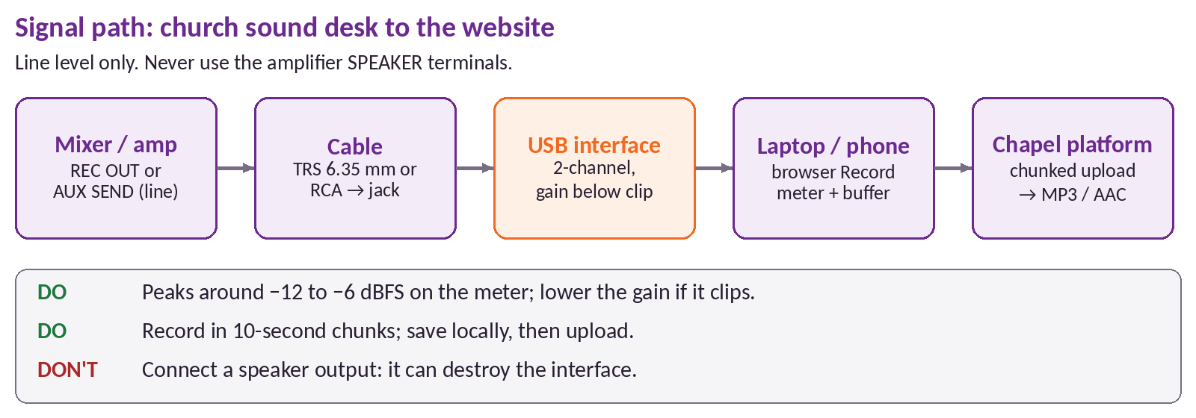
Figure 1. Signal path from the mixer/amplifier to the website
Step | What to use | Notes
1. Output | Mixer REC OUT (usually an RCA pair) or a spare AUX SEND (6.35 mm TRS), at line level | Set the aux send post-fader so the recording follows the main mix. Never use the amplifier’s speaker terminals.
2. Cable | RCA → 6.35 mm jack, or TRS → TRS, of a sensible length | Keep it away from mains cables to avoid hum.
3. Interface | A basic 2-channel USB audio interface with line/instrument inputs (est. US$60–180 class) | Class-compliant models work on laptops and many Android phones (USB-C OTG) without drivers.
4. Device | Laptop (preferred) or phone running Chrome/Edge; on battery or a UPS | Avoid the laptop’s 3.5 mm mic jack: it expects mic level and adds noise.
5. Levels | Interface gain so speech peaks around −12 to −6 dBFS on the on-screen meter | Turn the gain down if the clip light shows. Loud praise sections need more headroom than preaching.

Do not connect the amplifier’s speaker output to any input. Speaker lines carry amplified power and can destroy the interface or the laptop. Use line level only. If the only free output is too hot, use a DI box or an inline attenuator. A ground-loop hum (Nigeria’s mains is 50 Hz) is fixed with a DI box ground-lift or an isolator.

4.2 Browser flow
- Connect. A checklist screen with a diagram: “Insert the aux cable into the interface, plug the interface into this laptop, then press Continue.”
- Choose the input. The browser asks for microphone permission (getUserMedia). The app lists inputs with enumerateDevices and remembers the chosen device. Echo cancellation, noise suppression and auto-gain are switched off so the mixer’s sound is kept as it is.
- Check levels. A live level meter (Web Audio AnalyserNode) with peak hold and a red clip warning; a 10-second test recording to play back.
- Record. MediaRecorder records Opus in WebM (MP4/AAC on Safari) with a 10-second timeslice. Markers (“sermon starts”, “sermon ends”) can be dropped with one tap for later trimming. A Screen Wake Lock keeps the laptop awake.
- Save as you go. Each chunk is written to the browser’s IndexedDB with its sequence number, then queued for upload. Chunks are uploaded in order while the service runs.
- Stop and publish. On Stop, the app sends the remaining parts (the last part tells the server to assemble the file) and opens the message form (title, preacher, date, series), pre-filled with the date and the markers. The message is saved as a draft until someone publishes it.
- Resume. If the tab, browser or laptop dies, reopening Admin → Messages shows “Unfinished recording found: resume upload”. Nothing recorded is lost as long as the device’s storage survives.

4.3 Backend
Part | Design
Upload API | POST /messages/recordings (multipart: file, title, preacher, date, series, duration_seconds, device_label) creates a draft message. Long services go in parts: the same Upload-Id header on every part plus Content-Range; the server answers 202 per part and assembles on the last. A part resent after a drop simply overwrites the same range.
Storage | Chunks and the assembled original go to object storage (for example Cloudflare R2 or Backblaze B2), keyed recordings/{yyyy}/{id}/. The original is always kept.
Assembly | Parts are joined in byte order (WebM chunks are not playable on their own; only the joined file is), then a checksum is compared with the browser’s.
Transcoding | A background worker runs ffmpeg: MP3 (96–128 kbps mono) for downloads and AAC/M4A for streaming, loudness-normalised to −16 LUFS, plus a waveform JSON for the trim screen.
Metadata | Title, preacher, date, series, duration, size, checksum, markers, source (recorded or uploaded), processing status; linked to a Message record.

# example transcode step (worker)
ffmpeg -i original.webm -af loudnorm=I=-16:TP=-1.5:LRA=11 \
-ac 1 -c:a libmp3lame -b:a 96k message.mp3
ffmpeg -i original.webm -af loudnorm=I=-16:TP=-1.5:LRA=11 \
-ac 1 -c:a aac -b:a 96k message.m4a

Sizes (est.): Opus at 64 kbps is about 29 MB per hour, so a two-hour service is roughly 58 MB of raw chunks; a 96 kbps MP3 is about 43 MB per hour.

4.4 Failure handling
Failure | What the platform does
Power cut | Laptop on battery and the mixer on a UPS (recommended). Chunks already in IndexedDB survive; recording continues if the sound desk stays up; the resume prompt finishes uploads later.
Network drop | Recording never depends on the network. The upload queue retries with back-off and uploads everything once the connection returns, including after the service.
Cable or interface unplugged | The devicechange event raises a loud on-screen alert; the meter shows silence; the app offers to switch input without stopping.
Silence or clipping | Warnings if the level sits below −50 dBFS for 30 s or clips repeatedly.
Tab closed by mistake | A leave-page warning; unsent chunks stay in IndexedDB for resume.
Low storage | The app checks free browser storage before starting and warns if it is under about two hours of audio.

5. AI audio cleanup (“Loom-style”)
Status: Planned, Phase 3. Owner: Joshua Mudana. Joshua builds and trains this model as his own module. The platform integrates it through the contract in 5.4, so the model can improve without changing the website.

5.1 Goals
Goal | Target behaviour
Filler words | Remove “umm”, “uh”, “ehm”, “ehn”, “er” and similar hesitations, without touching real words.
Coughs and sneezes | Cut or soften coughs, sneezes and throat-clearing from the preacher and the room.
Long silences | Shorten pauses longer than a set limit (for example 1.2 s) while keeping deliberate dramatic pauses natural.
Noise and hum | Reduce background noise, generator noise and 50 Hz mains hum with its harmonics.
Feedback squeal | Detect narrow-band howl and notch or cut it.
Loudness | Normalise to −16 LUFS integrated (podcast standard), true peak at or below −1 dBTP.
Content | Transcript with timestamps, suggested title, summary, chapters and every scripture reference (for example “John 3:16”).
Control | A person reviews every proposed cut in the admin panel. Nothing is published automatically.

5.2 Suggested pipeline
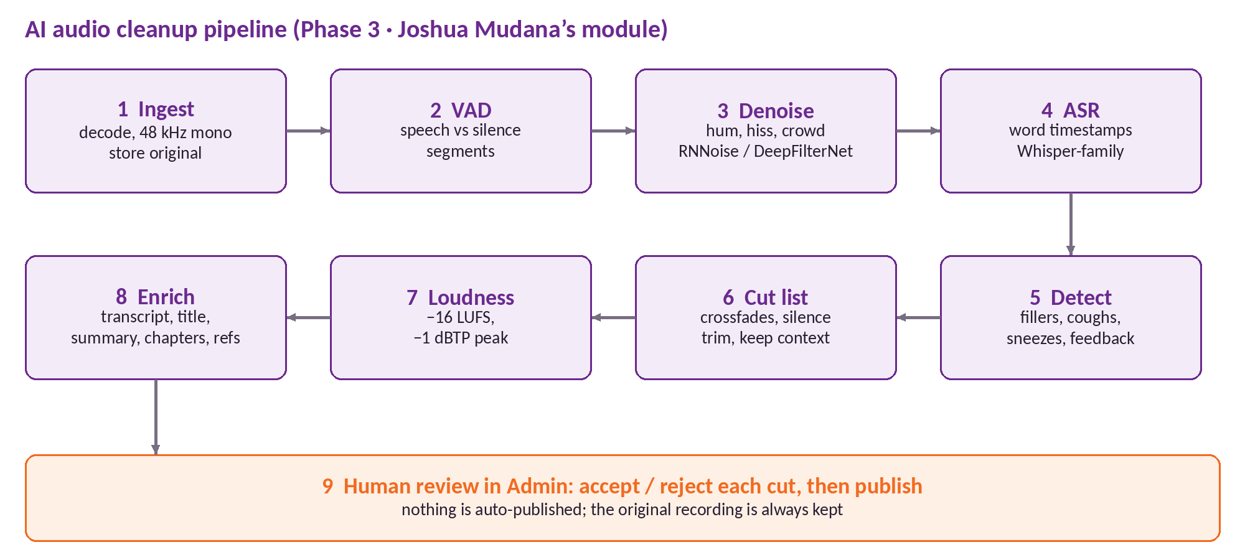
Figure 2. Suggested AI cleanup pipeline, ending in human review
Stage | Suggested approach (baseline Joshua can improve on)
Ingest | Decode with ffmpeg to 48 kHz mono WAV; keep the original untouched.
VAD | Voice activity detection (for example Silero VAD or WebRTC VAD) to segment speech, music and silence.
Noise suppression | Baseline with RNNoise or DeepFilterNet; notch filters at 50/100/150 Hz for hum. Apply gently: over-suppression makes voices sound robotic.
ASR | Whisper-family speech recognition with word timestamps (for example WhisperX-style forced alignment). Standard Whisper tends to leave fillers out of its text, so fillers need a verbatim-tuned model or the audio detector below. Nigerian English and Yoruba code-switching need fine-tuning on local recordings; public African-accented English corpora (for example AfriSpeech-200) can help, subject to their licences.
Detection | (a) A token classifier over the word stream for fillers and false starts; (b) an audio event model (for example a PANNs/YAMNet-style classifier; AudioSet includes Cough and Sneeze classes) for coughs, sneezes and feedback. Each detection gets a confidence score.
Cut list | Turn detections into an edit decision list: cut points at zero crossings, 10–30 ms crossfades, padding so words are not clipped, and no cuts inside Scripture readings or songs.
Loudness | Two-pass EBU R128 normalisation (ffmpeg loudnorm) to −16 LUFS, −1 dBTP.
Enrichment | A language model over the transcript for title, summary, chapters; a Bible-reference parser (book, chapter, verse) for scripture references.
Human review | Admin screen with the waveform: each cut highlighted with its type and confidence; play before/after; accept or reject one by one or by type; then render the final file.

5.3 Rules the module must keep
- The original recording is never overwritten; cleanup produces a new version with an edit list.
- Low-confidence cuts are proposed, not applied, and are shown first in review.
- A preacher’s words are never changed or generated; only removed hesitations, noise and silence.
- Publishing always needs a person to press Publish.

5.4 Integration contract
The website and backend talk to the cleanup module only through these calls. The module can run on the same server, a GPU machine or a hosted endpoint.
Call | Purpose
POST /messages/{id}/clean | In the v0.2 contract. Starts a cleanup job for a message’s original audio; returns 202 with a job (type clean_audio).
GET /jobs/{id} | In the v0.2 contract. Status queued, running, succeeded or failed; progress 0–1; result_url; error. Phase 3 adds the status needs_review.
Webhook → callback_url | Phase 3 addition. The module posts back when a job reaches needs_review, succeeded or failed, signed with HMAC-SHA256 in an X-Chapel-Signature header.
PUT /jobs/{id}/cuts | Phase 3 addition. Saves the reviewer’s decisions: accepted and rejected cut ids.
POST /jobs/{id}/render | Phase 3 addition. Renders the final audio from the accepted cuts; the result arrives by webhook.

POST /messages/42/clean
{ "remove_fillers": true, "remove_coughs": true,
"denoise": true, "replace_original": false,
// Phase 3 additions
"max_silence_ms": 1200, "target_lufs": -16, "language_hints": ["en-NG", "yo"],
"generate": ["transcript", "title", "summary", "chapters", "scripture_refs"],
"callback_url": "https://api.example.org/webhooks/cleanup" }
→ 202 { "id": "job_7f3a", "type": "clean_audio", "status": "queued", "message_id": 42 }

Webhook payload (needs_review)
{ "id": "job_7f3a", "message_id": 42, "status": "needs_review",
"cuts": [ { "id": "c1", "start": 312.48, "end": 312.91, "type": "filler",
"text": "umm", "confidence": 0.94 } ],
"outputs": { "preview_audio_url": "…", "transcript_url": "…/transcript.json",
"captions_url": "…/captions.vtt",
"title": "…", "summary": "…", "chapters": [ { "start": 0, "title": "…" } ],
"scripture_refs": [ { "ref": "Habakkuk 2:4", "at": 95.2 } ] } }

Direction | Formats
Input | Any ffmpeg-readable audio; preferred 48 kHz WAV/FLAC or the original Opus/WebM; mono or stereo.
Output | Cleaned master (FLAC), MP3 and M4A for the site, edit list (JSON), word-level transcript (JSON), captions (WebVTT), metadata (JSON).

5.5 Evaluation and data
Metric | What it measures
Filler precision / recall (F1) | Against human-labelled fillers on held-out sermons.
Wrong-cut rate | Real words cut per hour of audio; the most important number, target near zero.
Word error rate (WER) | Transcript accuracy, reported separately for English-only and code-switched (English/Yoruba) passages.
Audio quality | Listener ratings (MOS) from a small panel of members, plus an automatic quality score such as DNSMOS.
Loudness accuracy | Output within ±1 LU of −16 LUFS.
Reviewer acceptance | Share of proposed cuts accepted in admin; a rising rate shows the model is learning the Chapel’s style.
Speed | Processing time relative to audio length (real-time factor).

Data to collect. Original recordings of services, human labels for fillers, coughs and noise events (start, end, type), corrected transcripts, and the reviewers’ accept/reject decisions, which are free training labels. A first labelled set of 10–20 hours (est.) is a realistic start.
Consent. Before any recording is used for training, each preacher signs a short consent form stating the purpose, storage and the right to withdraw, in line with the Nigeria Data Protection Act. Training data is stored separately from the public library, and recordings of identifiable members of the congregation (for example testimonies) are excluded unless they consent.

6. System architecture
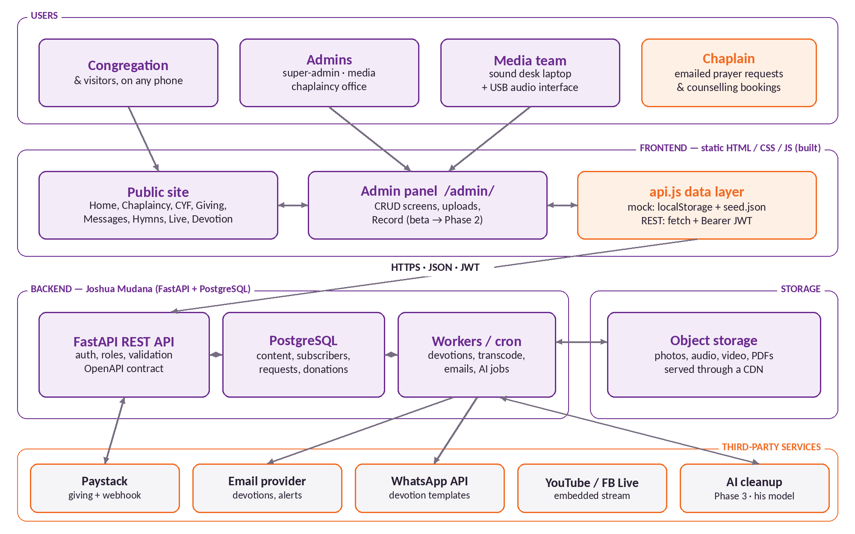
Figure 3. System architecture: static frontend, FastAPI backend, storage and third-party services
Layer | Technology | Responsibility
Frontend | Static HTML, CSS and JavaScript; no framework | Public site and admin panel; responsive, mobile-first; dark/light themes.
Data layer | api.js with two adapters, switched by CONFIG.API_BASE_URL | Empty URL: mock adapter (localStorage seeded from data/seed.json), so the demo works offline. URL set: REST adapter (fetch with a Bearer JWT) to the backend.
Backend (Joshua Mudana) | FastAPI (Python), SQLAlchemy/SQLModel, Alembic migrations | REST API per openapi.yaml, auth and roles, validation, webhooks, scheduled jobs.
Database | PostgreSQL | All content, subscribers, requests, bookings, donations, audit log.
Storage | S3-compatible object storage behind a CDN | Photos, audio, video, PDFs, recording chunks.
Workers | Background queue (for example Celery/RQ or arq) and a scheduler | Transcoding, devotion sends, emails, cleanup jobs.
Email / WhatsApp | Transactional email provider (for example Brevo or Resend); WhatsApp Cloud API | Devotions, receipts, Chaplain notifications. WhatsApp needs approved templates for messages sent outside a 24-hour conversation window.
Payments | Paystack (inline checkout, verify API, webhooks) | Tithes, offerings, gifts.
Live video | YouTube Live or Facebook Live embed | Streaming stays on those platforms; the site embeds the player.

Giving follows the standard Paystack pattern: the browser never sees the secret key, and a gift is recorded only after the server has verified it.
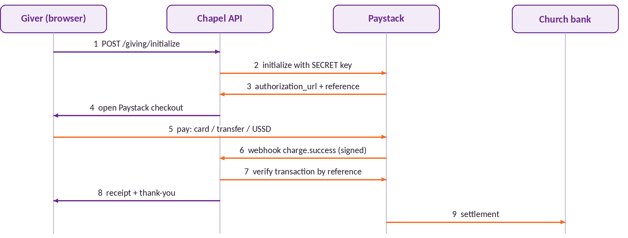
Figure 4. Giving flow with server-side verification

7. Data model summary
Suggested PostgreSQL tables (FastAPI-friendly, matching the API contract). All tables carry id, created_at and updated_at; times are stored in UTC and shown in Africa/Lagos time.
Table | Key columns
users | name, email (unique), password_hash, role (super_admin | media | chaplaincy), active, last_login_at
settings | key/value JSON: church name, motto, service times, venue, bank details, WhatsApp, contact email/phone, livestream URL, live_now, socials, Paystack public key
chaplaincy_people | position (chaplain | assistant_chaplain | secretary), name, title, photo_url, bio, phone, email, office_hours
elders | name, role, portfolio, department, phone, email, photo_url, bio, sort_order
cyf_leaders / cyf_meetings | name, role, department, level, phone, photo_url, sort_order / label, day, time
cyf_applications | name, department, level, whatsapp, interests[], status
messages | title, preacher, date, series, media_type, media_url, thumbnail, description, duration_s, source (upload | link | recording), published
recording_uploads | upload_id, message_id, total_bytes, received_ranges JSON, device_label, markers JSON, checksum, status
jobs | type (clean_audio, transcode), message_id, status, options JSON, progress, cuts JSON, outputs JSON, result_url, reviewer_id, error, finished_at
events | title, starts_at, ends_at, venue, description, banner_url, is_special, is_featured
devotions | date, title, scripture_ref, scripture_text, body, author, status (draft | scheduled | published)
subscribers / devotion_deliveries | name, email, whatsapp, channel, consent_at, active, unsubscribe_token / devotion_id, subscriber_id, channel, status, sent_at
gallery_photos | src, caption, sort_order
hymns | number, title, author, verses JSON, chorus, licence_note
prayer_requests | name (nullable), request (encrypted), share_with_team, status
counselling_bookings | reference, name (nullable), anonymous, topic, preferred_date, preferred_time, mode, note (encrypted), status
donations | reference (unique), purpose, amount_kobo, fee_kobo, name, email, channel, status, paid_at, raw_event JSON
audit_log | user_id, action, entity, entity_id, at, ip

8. API overview
The full specification is in API.md and openapi.yaml in the v0.2 source. The contract: JSON over HTTPS, UTF-8; times in Africa/Lagos; list endpoints take page (1-based), page_size (default 20, max 100) and q (search) and return {items, total, page, page_size}; errors return {detail}. Public GET endpoints need no token; every write needs a Bearer JWT except the public forms.
Resource | Endpoints | Access
Auth | POST /auth/login → JWT; GET /auth/me | Public login; token for /me
Uploads | POST /uploads (multipart) → {url, content_type, size} | Admin
Settings | GET, PUT /settings (merge update) | GET public; PUT super-admin
Chaplaincy | GET, PUT /chaplaincy | GET public; PUT super-admin, chaplaincy
Elders | GET, POST /elders; GET, PUT, DELETE /elders/{id}; PUT /elders/order | GET public; writes super-admin
CYF | GET, PUT /cyf; /cyf/leaders (CRUD + order); /cyf/applications | GET public; POST application public; rest admin
Messages | GET, POST /messages; GET, PUT, DELETE /messages/{id}; filters published, series | GET public (published only); writes media
Recordings | POST /messages/recordings (multipart; long files in parts with Upload-Id + Content-Range) | Media
Cleanup | POST /messages/{id}/clean; GET /jobs/{id}. Phase 3 adds PUT /jobs/{id}/cuts and POST /jobs/{id}/render | Media
Events | GET, POST /events; GET, PUT, DELETE /events/{id} | GET public; writes media, super-admin
Devotions | GET, POST /devotions; GET /devotions/today; GET, PUT, DELETE /devotions/{id} | GET public (published); writes chaplaincy
Subscribers | POST /subscribers; POST /subscribers/unsubscribe; GET list; GET /subscribers/export.csv | Subscribe/unsubscribe public; rest chaplaincy
Gallery | GET, POST /gallery; PUT, DELETE /gallery/{id}; PUT /gallery/order | GET public; writes media
Hymns | GET, POST /hymns; GET, PUT, DELETE /hymns/{id} | GET public; writes media
Prayer requests | POST /prayer-requests; GET list; GET, PUT, DELETE /prayer-requests/{id} | POST public; read chaplaincy only
Counselling | POST /counselling-bookings; GET list; GET, PUT, DELETE /counselling-bookings/{id} | POST public; read chaplaincy only
Giving | POST /giving/initialize; GET /giving/verify/{reference}; POST /giving/webhook; GET /giving/transactions | Initialize public; webhook signed by Paystack; list super-admin
Stats | GET /stats (dashboard counts) | Admin

9. Security and privacy

9.1 Admin authentication and roles
- Passwords hashed with Argon2id or bcrypt; never stored or logged in plain text. Minimum length and a lockout after repeated failed logins.
- JWT access tokens signed on the server. API.md suggests 8–12 hours to start; before launch, move to short-lived tokens (for example 30–60 minutes) with refresh, revoked when a user is deactivated. Two-factor login for super-admins is recommended.
- Roles are checked on the server for every request; hiding a button in the admin panel is not security. The v0.2 API.md names the roles admin, editor and media; this document recommends super-admin, media and chaplaincy office, so that prayer requests and counselling have a dedicated role. Align the two before the backend is built.
Area | Super-admin | Media | Chaplaincy office
Users and settings | Full | — | —
Chaplaincy, elders, CYF | Full | — | Edit chaplaincy
Messages, recordings, cleanup, gallery, hymns, live | Full | Full | —
Events | Full | Full | View
Devotions and subscribers | Full | — | Full
Prayer requests and counselling | Manage access only | — | Full (only role that reads them)
Giving reports | Full | — | —

9.2 Confidential pastoral data
- Prayer requests and counselling notes are encrypted at rest (field-level), readable only by the Chaplaincy office role, and every view is written to the audit log.
- Anonymous bookings store no name; the reference number is the only link. Data is kept only as long as needed (for example deleted 12 months after the session; the Chapel sets the period).
- Public forms are protected by rate limiting and a privacy-friendly CAPTCHA (for example Cloudflare Turnstile).

9.3 Subscribers and data protection
Nigeria’s data-protection law is the Nigeria Data Protection Act 2023 (which built on the earlier NDPR), overseen by the Nigeria Data Protection Commission. For this platform that means: a plain privacy notice; an unticked consent checkbox on the subscribe and join forms recording when consent was given; collecting only what is needed (email or WhatsApp number, first name); a working unsubscribe link in every message; export and deletion on request; and a breach-response plan with prompt notification to the Commission (check the current deadline).

9.4 Payments
- The Paystack secret key lives only in the server’s environment variables. The public key is the only key in the frontend.
- Every webhook is verified: the x-paystack-signature header must equal the HMAC-SHA512 of the raw body signed with the secret key. The server then calls Paystack’s verify endpoint, checks the amount and currency, and records the gift once per reference (idempotent).
- No card data ever touches the Chapel’s servers; Paystack hosts the checkout.

9.5 Operations
- HTTPS everywhere (HSTS), strict CORS limited to the site’s domain, security headers, dependency updates.
- Daily database backups (pg_dump) to separate object storage with 30-day retention; media storage versioned; a restore tested every quarter.
- Secrets in environment variables, never in the repository; separate test and live Paystack keys.

10. Deployment and hosting options
Budget-friendly options that work well for a Nigerian audience. All costs below are rough estimates (est.), not quotes; prices in US dollars change with the naira exchange rate and supplier pricing, so confirm before approval.
Component | Starter option | Growth option | Rough monthly cost (est.)
Frontend (static) | Cloudflare Pages, Netlify or GitHub Pages | Same, with a CDN | Free tier
Backend (FastAPI) | Render or Railway small instance | Small VPS (e.g. Hetzner, DigitalOcean) with Docker | US$5–25
PostgreSQL | Free tier of a managed Postgres (e.g. Neon, Supabase) | Managed Postgres or on the VPS | US$0–20
Object storage | Cloudflare R2 (no egress fees) or Backblaze B2 | Same, more storage | US$0–10
Email | Free tier of Brevo or Resend | Paid tier as subscribers grow | US$0–25
WhatsApp | WhatsApp Cloud API, approved templates | Same | Per message, by Meta’s rate card
Live streaming | YouTube Live (free) | Same | Free
AI cleanup | Run on demand on Joshua’s machine or a GPU host | Scheduled GPU jobs | US$0–30

Rough total (est.): US$5–40 per month at the start, rising with storage, email volume and GPU use. Local Nigerian hosts (for example Whogohost, Qservers, Truehost) can also host the site and register domains and accept naira payments.

10.1 Domain
- First choice: a university subdomain such as chapel.futa.edu.ng, requested from FUTA’s ICT unit (trusted, free, shows the Chapel belongs to FUTA).
- Alternatives: chapeloffaithfuta.org, or chapeloffaithfuta.org.ng through a NiRA-accredited registrar (availability not checked; est. ₦5,000–25,000 per year).
- The demo stays at chapeloffaithfuta.sites.tab.bot until the Chapel chooses.

11. Roadmap
Phase | Scope | Rough timeline (est.) | Done when
0. Concept (done) | Public site in demo mode, giving demo, demo videos | Oct 2026 | Shown to the Chapel
1. Site + admin + manual uploads | FastAPI backend and database, admin panel with roles, manual message upload, live Paystack, prayer and counselling routing, devotion emails, real photos and content | 6–8 weeks after approval | Chapel staff update the site themselves; first real gift received
2. Live recording | Record from the sound desk, chunked upload, resume, transcoding | 3–4 weeks after Phase 1 | A full Sunday service recorded and published from the desk
3. AI cleanup | Joshua’s model, review screen, transcripts, summaries, chapters | 2–4 months (research) | Reviewers accept most cuts; no real words lost
4. Mobile and community | Mobile app or installable web app with push notifications, member directory (opt-in), attendance (QR check-in), event registration, giving history | After Phase 3 | Agreed with the Chapel

The Chapel already lists an app on Google Play (package com.chapeloffaith.chapel_of_faith_app). Phase 4 should begin with a conversation with its maintainers, so the new app extends or replaces it on the same backend rather than competing with it.

12. Admin user guide
Sign in at /admin/ with your email and password. In the demo, use admin@chapel.demo / demo1234 (shown on the login screen). Every change appears on the public site straight away.
Screen | How to
Dashboard | See counts at a glance: messages, events, devotions, subscribers, new prayer requests and counselling bookings. Tap a card to open that screen.
Chaplaincy | Open Chaplain, Assistant Chaplain or Secretary → edit name, title, bio, phone, email, office hours → Upload photo → Save.
Elders | Add elder → fill name, role, department, contact, photo → Save. Drag (or use the arrows) to reorder. Delete asks you to confirm.
CYF | Edit leaders and meeting times the same way; open Join requests to see new members and mark them contacted.
Messages | Add message → Upload file, or paste a YouTube/Mixlr link, or Record (Phase 2) → title, preacher, date, series → switch Published on → Save.
Events | Add event → title, start and end, venue, banner → tick Special and Featured on home for the Home banner → Save.
Devotions | New devotion → date, title, scripture, body, author → Save as draft, Schedule, or Publish.
Subscribers | Search, deactivate on request, or Export CSV.
Gallery | Upload photos (resized automatically) → add captions → reorder; the first photos lead the Home slideshow.
Hymns | Add or edit a hymn (number, title, verses, chorus) or upload the hymnal PDF.
Prayer and counselling | Chaplaincy office only: read new items, mark prayed for / confirmed, archive.
Settings and users | Service times, bank details, WhatsApp number, livestream URL and the Live now switch. Users (super-admin only): invite, choose a role, deactivate when someone leaves.

13. Open questions for the Chapel
The concept site shows these as placeholders (a dashed gold underline). They are needed before launch.
# | Question | Current state
1 | Chaplain’s name and title | Very Rev. Chris Godspower, from FUTA news (2024); to confirm he is the current Chaplain
2 | Chaplain’s office phone, email and office hours; email for prayer requests | Placeholders
3 | Assistant Chaplain and Chapel Secretary: names, photos, contacts | Placeholders
4 | Council of Elders: names, roles, departments, photos, contacts (with their consent) | Placeholders
5 | CYF leadership names, and confirmation that CYF meets Tuesdays at 6:00 PM | Time inferred from CYF posts; to confirm
6 | Midweek service day and time; CYF Bible study day and time | Placeholders
7 | Church bank details for transfers and Paystack settlement (account name, bank, number) | Placeholders
8 | Official WhatsApp number (contact and devotion delivery) | Placeholder
9 | Who will be super-admin, media and chaplaincy-office users | To agree
10 | Livestream channel to embed (YouTube and/or Facebook) | Current YouTube channel linked; to confirm
11 | Hymnal: which hymn book, and permission for any hymns still under copyright | 7 public-domain hymns in demo
12 | Domain preference and whether FUTA ICT can provide chapel.futa.edu.ng | To decide
13 | Photos from the media team, and consent from people pictured | Placeholder images in demo

14. Sources
Fact | Source
Interdenominational chapel of FUTA | The Chapel’s YouTube channel, Facebook page and Google Play listing
Founded 1984; 40 years in 2024 | YouTube: “A Documentary of Chapel of Faith, FUTA: 1984–2024”
Chaplain (2024): Very Rev. Chris Godspower | futa.edu.ng news item 1005 (July 2024)
Sunday service 9:00 AM, Chapel of Faith Auditorium | Chapel Facebook and Instagram posts (2026)
CYF: “Together we shall stand”, Tuesday service | Instagram @cyf.futa and YouTube @cyffuta
Paystack fees (1.5% + ₦100, waiver under ₦2,500, cap ₦2,000) | paystack.com/pricing, checked 9 Oct 2026
Motto “The just shall live by his faith” (Habakkuk 2:4) | The Chapel’s emblem

