FOUNDATION DIPLOMA  DEGREE  MASTER

*Please tick* ✓ *or click if using MS WORD*

**Marks Breakdown**

Signature: **Total**

**For office use only** – Lecturer comments (if applicable)

Signature: **Total**

*I/We declare that:*

* *This assignment is my/our own original work, except where I/we have appropriately cited the original source.*
* *This assignment or parts of it has not previously been submitted for assessment in this or any other subject.*
* *I/We allow the assessor of this assignment to test any work submitted by me/us, using text comparison software for plagiarism.****(For more information, Please read the Academic Integrity Guidelines)***

**Name : Joshua Yeoh Keat Keong  
Student ID: 0135760  
Email : 0135760@kdu-online.com  
Mobile No: 0122612488 | Signature:  
Date: 6/11/2022**

Assignment Coversheet **Please complete all details required clearly.** For softcopy submissions,please ensure this cover sheet is included at the start of your document or in the file folder.

**Assignment & Course Details:**

|  |  |  |  |
| --- | --- | --- | --- |
| **Subject Code:** *(e.g. XCAT1234)* **XBGD10033N** | | **Subject Name** *(e.g. Fundamentals of Computing*)**:  Fundamentals of Game Technology** | |
| **Course** *(e.g. Bachelor in Computing)* : Bachelor of Game Development (Hons) | | | |
| **Lecturer Name:** Yap Chin Kein | | | |
| **Assessment Due Date:** *(dd/mm/yy)* | 9/11/22 | **Assessment Title:** | ShootEmUp Game |

SCCM/CSForm/Rev. Ver 2.4

**Name :  
Student ID:  
Email :  
Mobile No: Signature:  
Date:**

**Name :  
Student ID:  
Email :  
Mobile No: Signature:  
Date:**

**Name :  
Student ID:  
Email :  
Mobile No: Signature:  
Date:**

**Name :  
Student ID:  
Email :  
Mobile No: Signature:  
Date:**

**Name :  
Student ID:  
Email :  
Mobile No: Signature:  
Date:**

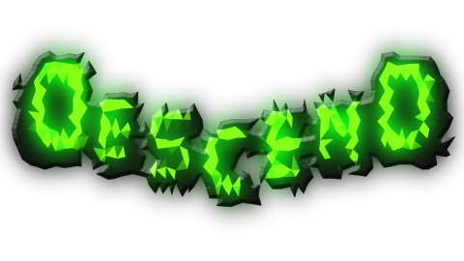

**Screenshots**  
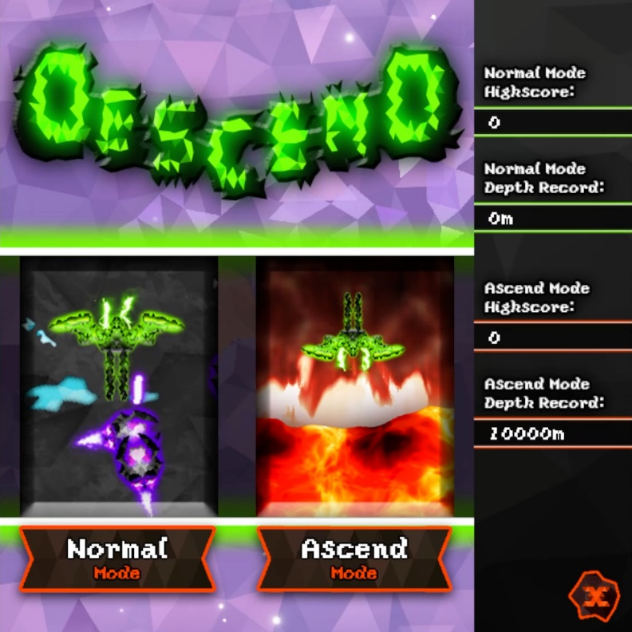**

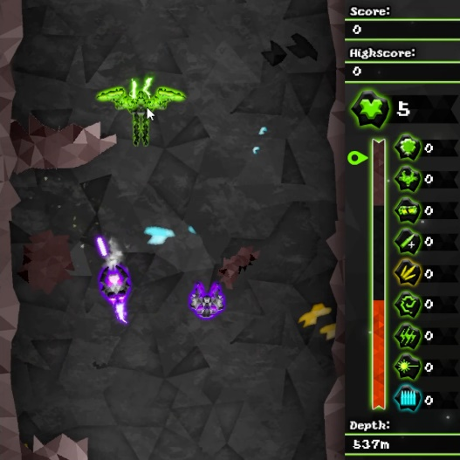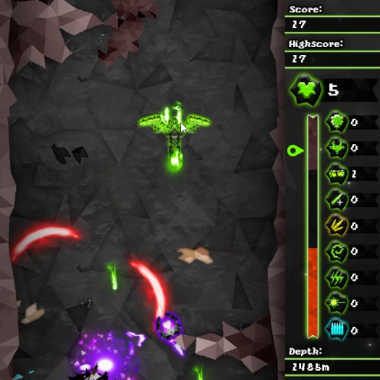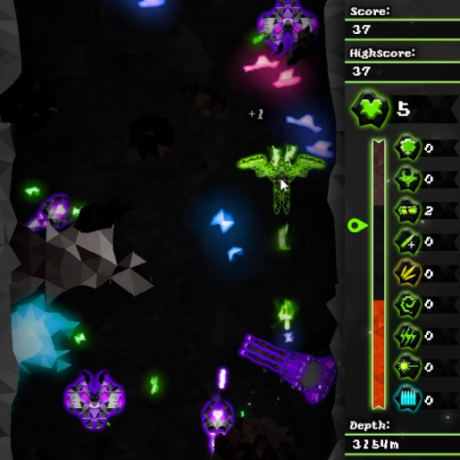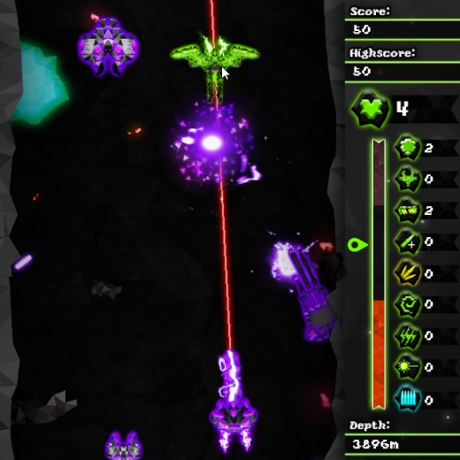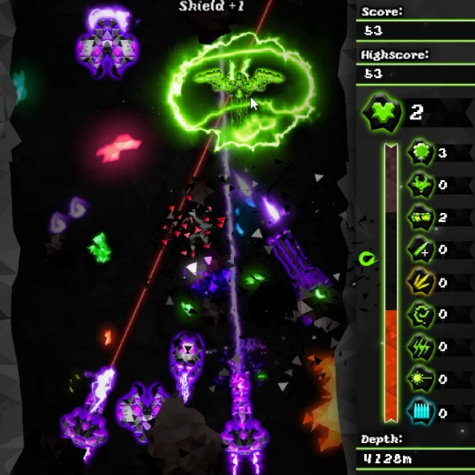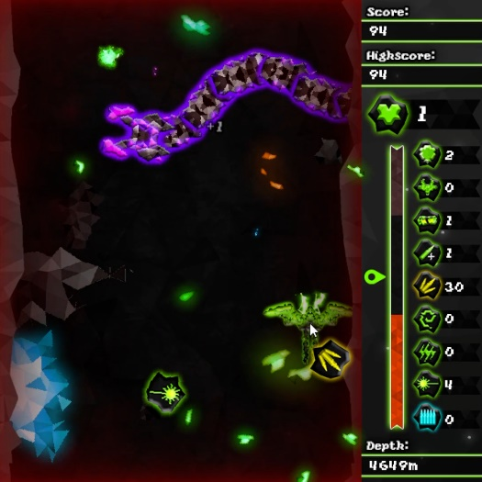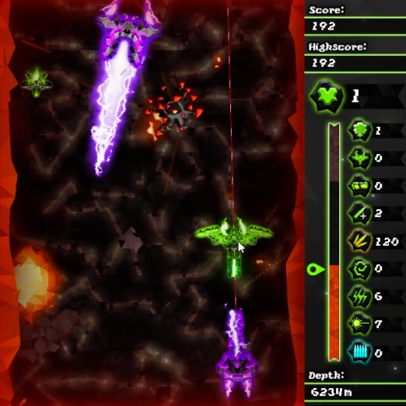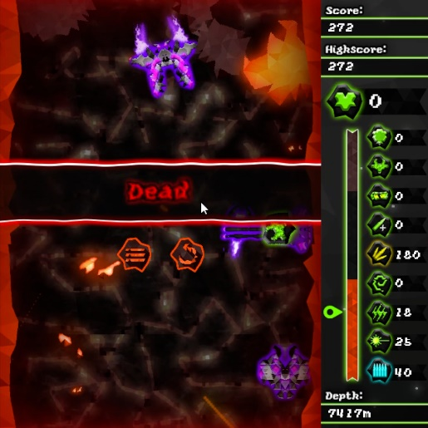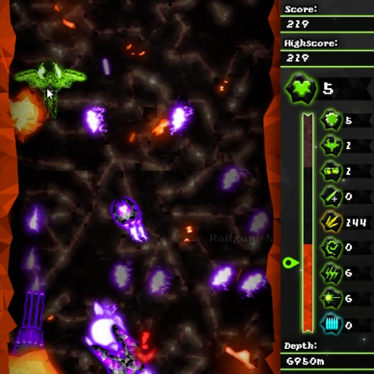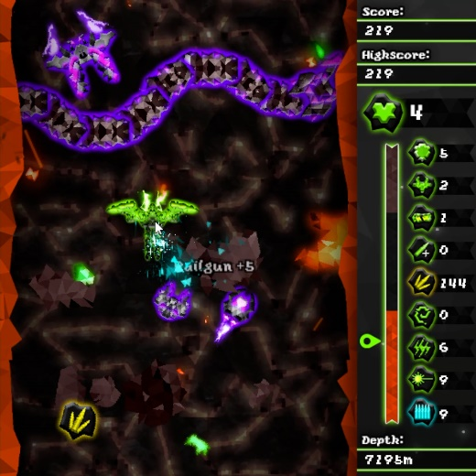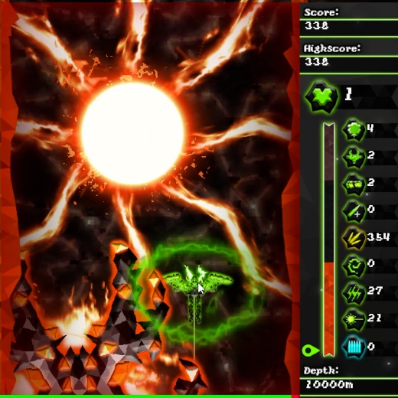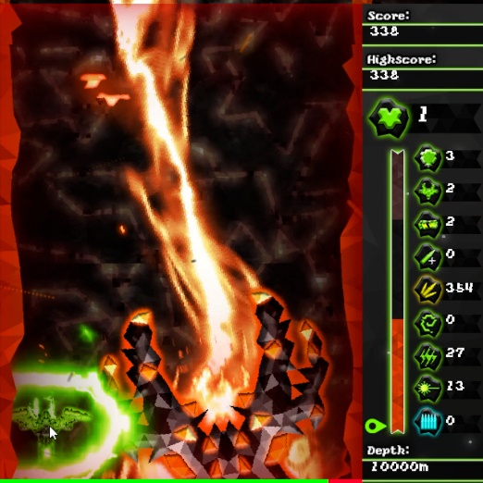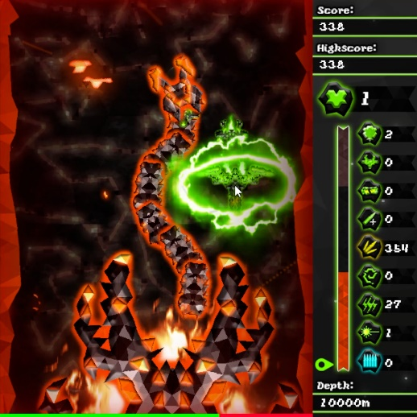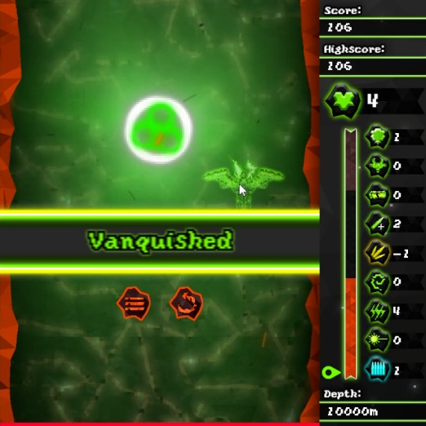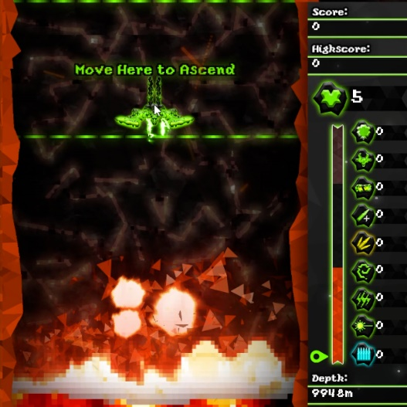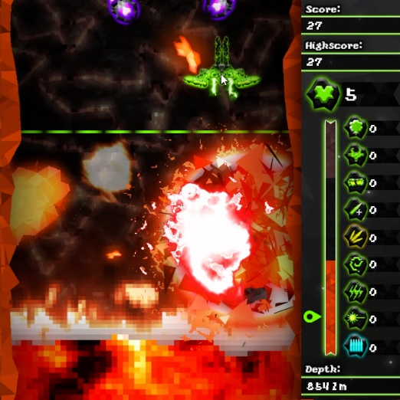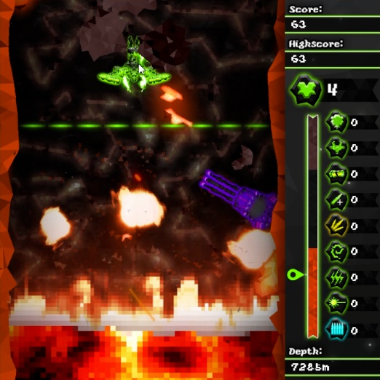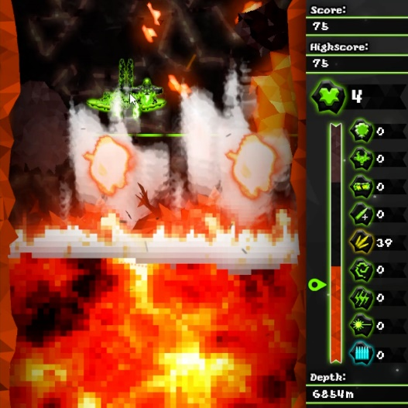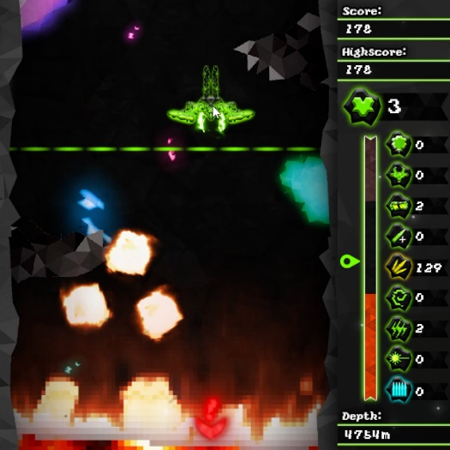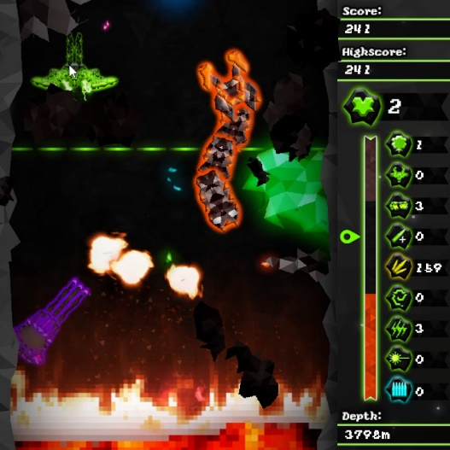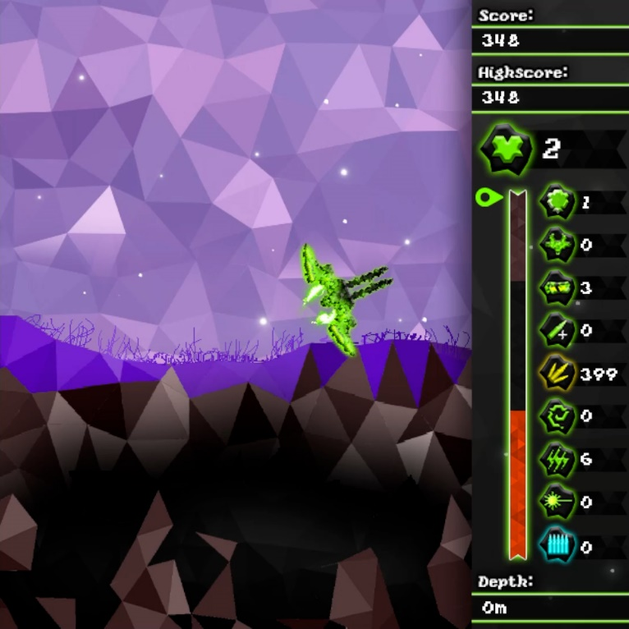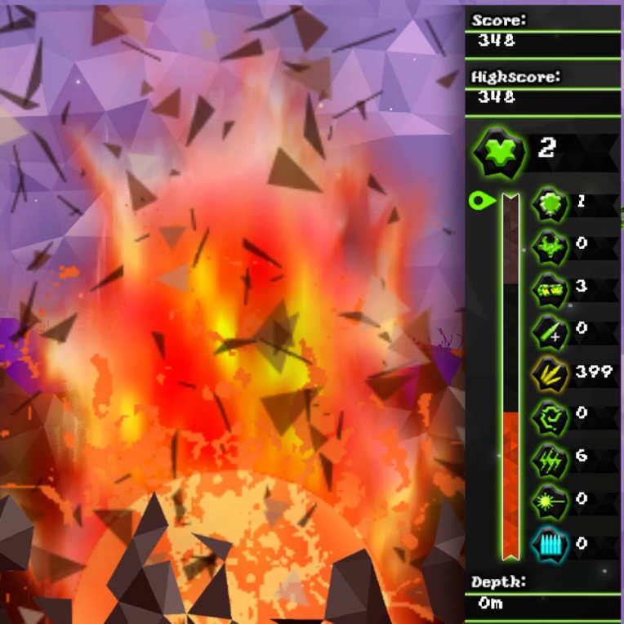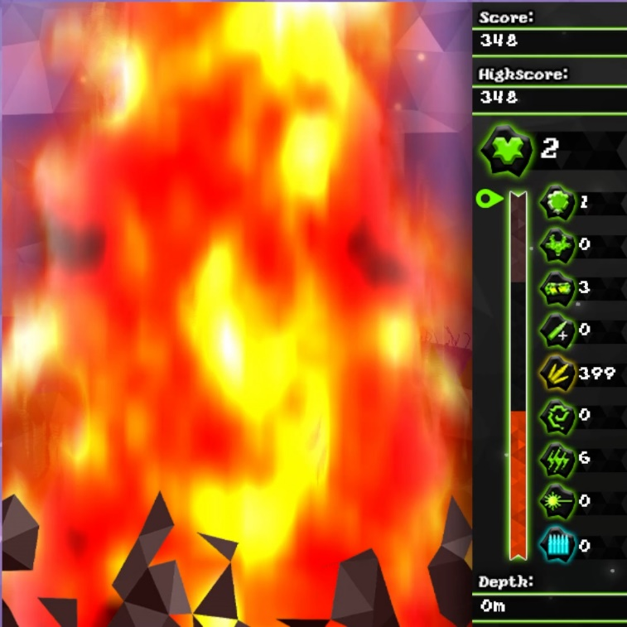

**Controls**

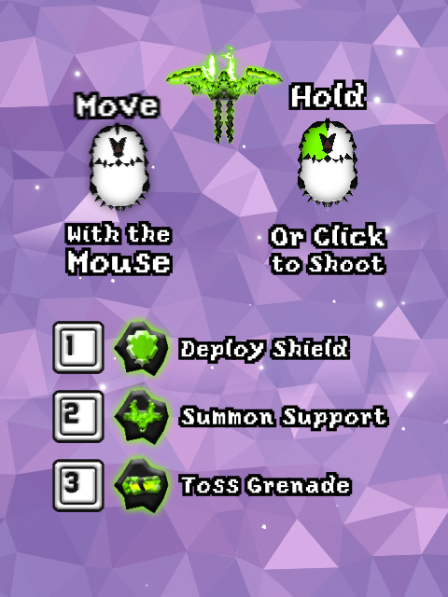

|  |  |
| --- | --- |
| **Input** | **Action** |
| Mouse | Movement |
| Left Click | Shoot |
| 1 | Deploy Shield |
| 2 | Summon Support |
| 3 | Toss Grenade |
| Esc/P/Tab/~ | Pause Menu |

**Rules/Gamemodes**

Descend is a Shoot’em Up game with 2 gamemodes. Normal mode and Ascend mode.

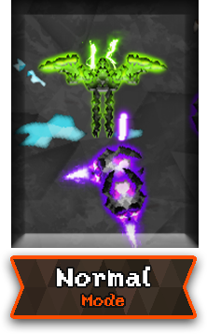

Normal Mode:

* Player must survive in a chasm full of enemies and beat the boss at the end to win.
* The progress is labelled as “depth”. The longer the player survives, the more depth will be travelled.
* Player has to reach from 0m to 10000m in depth. Speed is 27m per second. About 6 minutes to reach the end.
* New enemy types will appear the further the progress. They mostly spawn from the bottom of the screen
* The boss is at 10000m depth.
* The player must collect an item drop from the boss after defeating it to win.

Ascend Mode:

* Player must escape the erupting chasm.
* It is a chase gamemode. The player will be chased by rising magma from the bottom.
* Player now faces and moves upward. Starting from 10000m, player has to reach 0m.
* Player can escape the rising magma by progressing in depth. The magma rises slower than the player progressing.
* Unlike Normal mode, progressing can only be done if the player moves above the upper half of the screen, pass the green line. If not progressing, the magma will catch up with the player.
* The player moves at the speed of 37.5 m/s if progressing. About 4.5 minutes to reach the end if no stops.
* Enemies now spawn from the top of the screen. There is no boss at the end
* If the player is respawning, and the magma has already covered most of the screen, the magma will quickly lower to a certain level to give the player some temporary room to try again.



Player Lives:

* The player starts with 10 lives. Player loses lives by touching anything lethal.
* Extra lives can be found by killing enemies. It is a 1/100 drop.



Player Score:

* Player can earn score by collecting nuggets and gems dropped by most destructibles.
* A green nugget is 1 point. A green gem is 10 points.
* Nuggets have a chance to spawn as a gem at a 1/5 chance.
* There is a separate highscore for each gamemode.
* When dropped, it bounces around the screen and disappears after a few seconds.

Player Weapons:

Semi:

* The default weapon is semi firing gun
* Shoots a slow bullet every 0.4 seconds. Each bullet deals 1 damage
* Can be Upgraded



Burst:

* Shoots 3 bullets rapidly at a high velocity
* Each bullet deals 1 damage
* 30 ammo drop from Sidearm
* Can be Upgraded

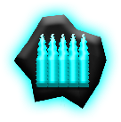

Auto:

* Shoots a bullet every 0.1 second at a high velocity
* Each bullet deals 1 damage
* 30 ammo drop from Frenzy
* Can be Upgraded

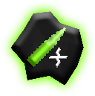

Upgrade:

* Upgrades only the bullet weapons such as Semi, Burst, and Auto
* Up to a five bullet spread per shot.
* Collect up to 4, then receive 100 score for any extra
* If player dies, Upgrade reduces by 1 level.
* 1/5 chance drop from Charger



Ricochet:

* Upgrades only the bullet weapons such as Semi, Burst, and Auto
* Allows bullets to bounce around 2 times
* 30 ammo drop from Worm



Shock:

* Shoots a sustained firing electricity
* Short ranged
* Hits through multiple targets
* Deals 1 damage every 0.1 second
* Consumes 0.1 ammo every 0.1 second
* 3 ammo drop from Ambusher

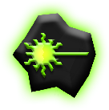

Railgun:

* Shoots a single beam in a straight line every 1.25 seconds
* Hits through multiple targets
* Each shot deals 10 damage
* 5 ammo drops from Sniper

Abilities:



Shield:

* Grants Immunity for 10 seconds
* 1/10 chance drop from big rocks
* 1/30 chance drop from medium rocks
* 1/60 chance drop from small rocks

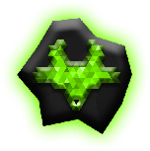

Support:

* Summons a support drone to help in the fight
* Maximum 2 drones at a time
* Moves about near the player
* Fires a straight beam every few seconds, deals 2 damage
* Disappears after player dies
* 1/20 chance drop from ZigZag

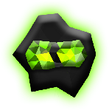

Grenade:

* Tosses a grenade in front
* Bounces around screen and objects
* Beeps for 2 seconds and explodes 8 waves in 8 directions
* Each wave deals 5 damage
* 1/5 chance drop from Mines

Enemies:



Zig Zag 1:

* Spawns below 0m in Normal mode and above 10000m in Ascend mode
* 2 HP
* Chases after and collides with the player.
* Sharply turns and changes direction every few milliseconds.



Zig Zag 2:

* Spawns below 0m in Normal mode and above 10000m in Ascend mode
* 2 HP
* Aims and moves to player
* Fires a bullet every few seconds



Charger:

* Spawns below 1250m in Normal mode and above 8750m in Ascend mode
* 5 HP
* Strafes left and right every few seconds
* Boosts up and down the screen in a straight line every few seconds
* High velocity and collides with the player

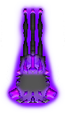

Sidearm:

* Spawns below 2500m in Normal mode and above 7500m in Ascend mode
* 5 HP
* Aims and Fires 3 bullets at the player every few seconds
* Spawns at the sides of the screen
* Stationary

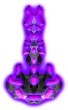

Sniper:

* Spawns below 3750m in Normal mode and above 6250m in Ascend mode
* 5 HP
* Aims and Fires a straight beam at the player every few seconds
* Aims with a red beam before firing
* Spawns at the sides of the screen in Ascend mode
* Stationary

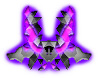

Ambusher:

* Spawns below 5000m in Normal mode and above 5000m in Ascend mode
* 5 HP
* Moves behind the player every few seconds
* Aims and Fires a sustained firing electricity for 3 seconds every few seconds
* Aims a red light before firing

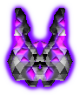

Frenzy:

* Spawns below 6250m in Normal mode and above 3750m in Ascend mode
* 5 HP
* Aims and Moves away from the player
* Sprays a number of bullets rapidly in a wide angle at the player every few seconds

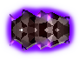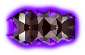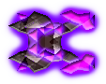

Normal Worm:

* Spawns below 3750m in Normal mode uncommonly
* 5 HP for Head, 3 HP for Body
* Spawns as a line of more than 3 segments
* Moves in a sine wave pattern
* Shoots a bouncing bullet in a random direction every few seconds
* Most of the body is destroys itself if head is destroyed
* Spawns at the sides of the screen
* Kills on touch

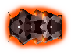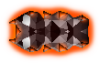

Magma Worm:

* Spawns from Boss and Magma
* Invulnerable, blocks bullets
* Kills on touch

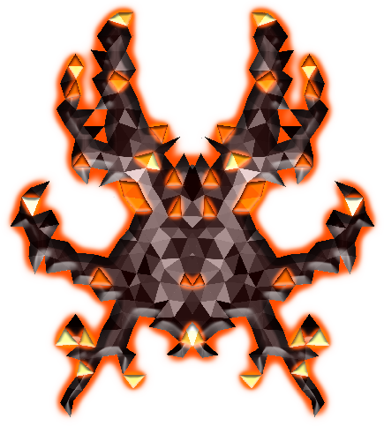

Boss:

* Spawns at 10000m in Normal mode
* 750 HP
* Strafes and Repeats a series of attacks
  + Aims and Fires Fireballs at the player that explode in 8 directions after a few seconds
  + Fires a sustained beam for 4 seconds and sweeps from side to side at a 90 degree angle
  + Aims and Fires Magma Worms at the player
  + Retreats and spawns random enemies for 10 seconds
* Drops an item on death to collect and win
  + Stencyl hates it and will crash when out of memory

Other Objects:



Rocks:

* Blocks the Player, bullets and some enemies
* Comes in Big, Medium, and Small sizes
* 5 HP Big, 3 HP Medium, 1 HP Small
* Can be broken into smaller pieces
* Moves with depth

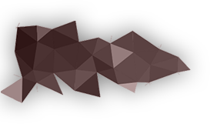

Spikes:

* Blocks the Player, bullets and some enemies
* Can be broken by some weapons and enemies
* Moves with depth

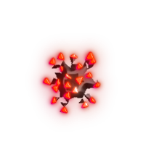

Mines:

* Explodes on colliding with Player
* Sometimes explodes when hit by bullets
* Explodes waves in 4 directions, can kill player and enemies
* Moves with depth

**Game Objects**

|  |  |  |  |  |  |  |
| --- | --- | --- | --- | --- | --- | --- |
| **Player** | **Enemies** | **Items** | **UI** | **Misc** | **Scenes** | **Behaviours** |
| Auto | Ambusher | Gems | AscendZone | lavaball | Chasm | Cannot Exit Screen |
| Burst | AmbusherShock | Pickup | loc | Lavamuzzle | Chasm ascend | Continuous Collision |
| Impact | Boss | PickupText | LoseTitle | magma | escapecutscene | Die On Leaving Screen |
| PillBomb | BossBeam | winball | LowHPWarning | volcano | MainMenu | EnemyiFrameManager |
| PillBomb explosion | BossBFG |  | menubtn | crater | Tutorial | Audio |
| PlayerExplode | BossBFGBeam |  | menubtn stay | forerocks |  | LoseMenu |
| PlayerMuzzleFlash | BossCharge |  | PauseBG | galaxy |  | PauseMenu |
| PlayerShield | BossMuzzle |  | PauseTitle | mine |  |  |
| Railgun | Charger |  | playbtn | minewave |  |  |
| Ricochet | EnemyBullet |  | retrybtn | ores |  |  |
| Semi | EnemyExplode |  | Retrybtn stay | Ores2 |  |  |
| Shock | EnemyMuzzle |  | sidepanel | rockbig |  |  |
| Support | Frenzy |  | warn | rockbreak |  |  |
| SupportExplode | Sidearm |  | WinTitle | rockmedium |  |  |
| SupportLaser | Sniper |  | AscendModeBtn | rocksmall |  |  |
| SupportMuzzleFlash | SniperRail |  | exitbtn | spike |  |  |
| Wave | WormBody |  | NormalModeBtn | Spike gem break |  |  |
|  | WormBullet |  | Sidepanel mm | Spike gems |  |  |
|  | WormHead |  | Strip mm | spikebreak |  |  |
|  | WormKiller |  | title |  |  |  |
|  | ZigZag |  | Tutorial Instruction |  |  |  |
|  |  |  | Volumebtn (unused) |  |  |  |
|  |  |  | Tutorial proceed |  |  |  |

**Credits:**

Stencyl

Adobe Photoshop – Art

Adobe After Effects – Animations & VFX

Various video games – Sound Effects

Audacity – Audio Converting/Editing

MP3 tag

LP Generator

Freesound.org

Flaticon

Lego Hero Factory Brain Attack Music

The Raid 2 – Motor Chase

Waterflame – Rocket Race

Sasha – LNOE

Demonicity - Fascist

**Pseudocode:**

The Player pseudocode

When created

* Make self always active
* Centerize x width
* Set opacity 100%
* Switch to idle animation
* Set iframe game var to true
* Create shield at center of self
* Play shield sound effects
* After 3 seconds:
  + Set iframe game var to false
  + Stop looping shield sound effect
* Set killsupports var to false
* Set supportcount var to 0
* Set all the shooting Boolean vars to true
* Loop player sndfx

Player movement

* Set player x and y game var to center of self
* If player is left of mouse, Move player right
* Otherwise If player is right of mouse, Move player left
* Otherwise make player stop
* If player is below mouse, Move player up
* If player is above mouse, Move player down
* Otherwise make player stop also

Shooting the weapons

* Shoot boolean var has to be true
* Left mouse btn has to be pressed
* Opacity of self has to be above 0 (not dead)

Shooting the Semi weapon

* Must have no other ammo
* Have Shoot cooldown of 0.4s using shoot Boolean var
* Create a muzzleflash at x and y of self
* Switch the animation of it to semi
* After muzzleflash, which is 0.1s, recoil the player
* Play sndfx
* Create bullet and repeat according to the number of upgrades + 1
* If have ricochet ammo
  + Deplete ricochet ammo by 1
  + Switch its anim to semi

Shooting the burst weapon

* Must have burst ammo
* Must have no other stronger ammo
* Shoot cooldown is 0.6s
* Similar to the semi pseudocode but repeat 3 times after 0.1s intervals
* Deplete burst ammo by 1
* Change anims to burst
* Play burst sndfx

Shooting the automatic weapon

* Must have auto ammo
* Shoot cooldown is 0.1s
* Similar to the semi pseudocode
* Deplete auto ammo by 1
* Change anims to auto
* Play auto sndfx

Shooting the shock weapon

* Must have shock ammo
* Must have no other stronger ammo
* Wiggle the player position
* When mouse btn is down, set shoot var to false
* Create the shock electricity at center of player and add a bit of y offset
* Loop shock sndfx
* Deplete shock ammo by 0.1 every 0.1s
* Stop shooting if mouse btn is released
* Stop shock sndfx

Shooting the railgun weapon

* Must have railgun ammo
* Must have no auto ammo
* Shoot cooldown is 1.25s
* Create muzzleflash and sndfx of railgun
* Deplete railgun ammo
* Recoil the player
* Shake the screen
* Create the railgun beam at center of player

Deploying the shield

* Shield btn must be pressed
* Must have shield ammo
* Must be alive (move than 0% opacity)
* Must not have iframe
* Set iframe to true
* Deplete shield ammo by 1
* Create the shield at center of player
* loop shield sndfx
* After 10 seconds, set iframe to false and stop sndfx

Summoning Support drone

* Support btn must be pressed
* Must have support ammo
* Must not have 0% opacity
* Support count must be less than 2
* Deplete support ammo by 1
* Increase support count by 1
* Create the support drone at player x and y position with y offset
* Player support sndfx

Tossing the grenade

* Grenade btn must be pressed
* Must have grenade ammo and not dead
* Shoot cooldown is 1s
* Deplete grenade ammo by 1
* Recoil the player
* Create the grenade and center of player position with offset
* Play grenade sndfx

When player dies

* Using a custom event
* If no shield, no iframe, and the game is not won yet
* Play die sndfx
* Stop player idle sndfx
* Set opacity to 0%
* Change anim to no collision box
* Kill all the supports
* Deplete bullet upgrade by 1
* Create explosion at center of player
* Play explode sndfx
* Pause the depth progression
* If player has more than 0 lives
  + Deplete 1 life
  + Create the player at top of the screen after 1s
  + Kill self
* If player has no more lives
  + Set lose var to true
  + Kill self after .9s
* If shield is up, play shield hit sndfx

When player collect items

* If collide with items actor group
* Increase player brightness by 50%
* Remove effects after 0.1s