**For office use only** – Lecturer comments (if applicable)

Signature: **Total**

**Marks Breakdown**

Signature: **Total**

**Name : Joshua Yeoh Keat Keong  
Student ID: 0135760  
Email : 0135760@kdu-online.com  
Mobile No: 0122612488 | Signature:  
Date: 2/10/2022**

**Name :  
Student ID:  
Email :  
Mobile No: Signature:  
Date:**

**Name :  
Student ID:  
Email :  
Mobile No: Signature:  
Date:**

**Name :  
Student ID:  
Email :  
Mobile No: Signature:  
Date:**

**Name :  
Student ID:  
Email :  
Mobile No: Signature:  
Date:**

**Name :  
Student ID:  
Email :  
Mobile No: Signature:  
Date:**

*I/We declare that:*

* *This assignment is my/our own original work, except where I/we have appropriately cited the original source.*
* *This assignment or parts of it has not previously been submitted for assessment in this or any other subject.*
* *I/We allow the assessor of this assignment to test any work submitted by me/us, using text comparison software for plagiarism.****(For more information, Please read the Academic Integrity Guidelines)***

FOUNDATION DIPLOMA  DEGREE  MASTER

*Please tick* ✓ *or click if using MS WORD*

Assignment Coversheet **Please complete all details required clearly.** For softcopy submissions,please ensure this cover sheet is included at the start of your document or in the file folder.

**Assignment & Course Details:**

|  |  |  |  |
| --- | --- | --- | --- |
| **Subject Code:** *(e.g. XCAT1234)* **XBGD10033N** | | **Subject Name** *(e.g. Fundamentals of Computing*)**:**  **Fundamentals of Game Technology** | |
| **Course** *(e.g. Bachelor in Computing)* :  **Bachelor of Game Development (Hons)** | | | |
| **Lecturer Name:**  **Yap Chin Kein** | | | |
| **Assessment Due Date:** *(dd/mm/yy)* | 12/10/22 | **Assessment Title:** | Pong Game |

SCCM/CSForm/Rev. Ver 2.4

**Main Menu Scene**

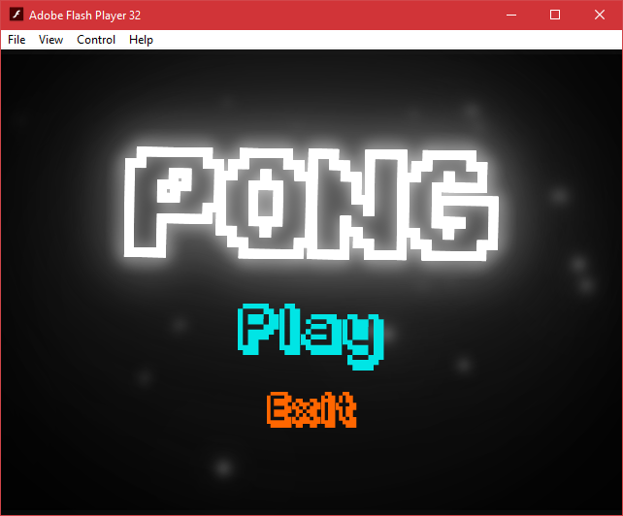

**Controls before starting**

|  |  |  |
| --- | --- | --- |
| **P1 Controls** | **Action** | **P2 Controls** |
| W | Move up | Up arrow |
| S | Move down | Down arrow |
| D | Shoot Wave | Left Arrow |
| Q | Shoot Ball Decoys | Page Down/End/Forward Slash |
| A | Shoot Brick | Right Arrow |
| Spacebar | Turbo Mode | Enter |
| Tab | Pause | P |
| 1 | Control Bot | 0 |

**During Gameplay**

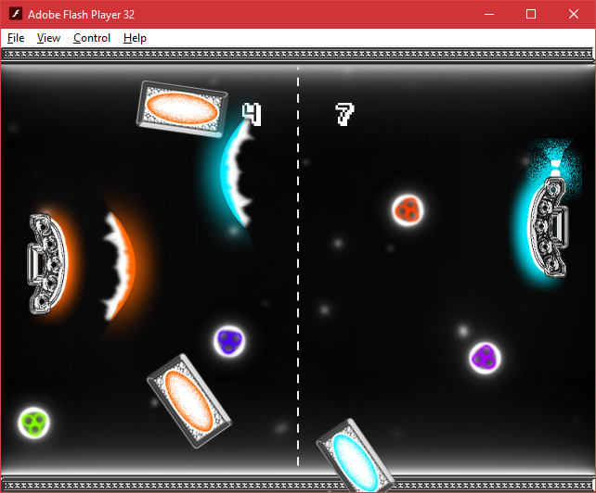

**Winner Scenes**

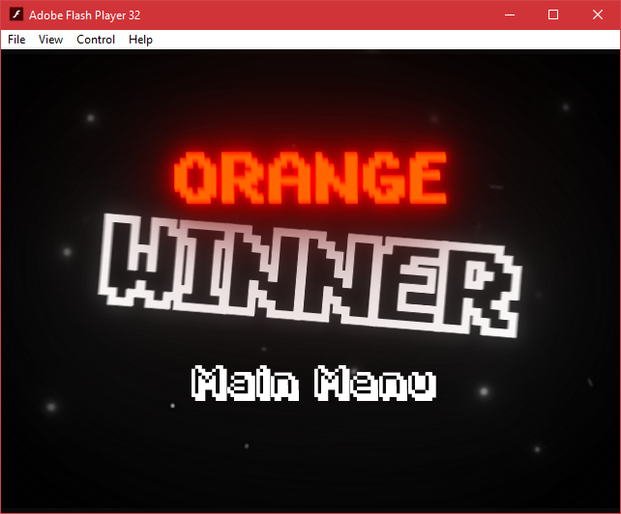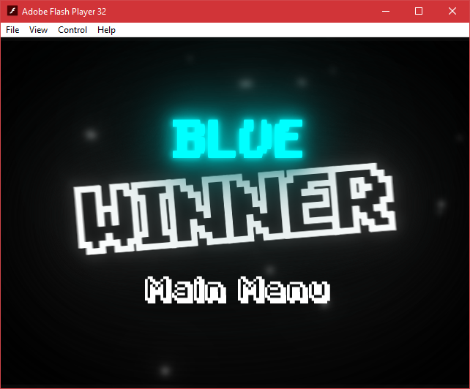

**Pausing the game**

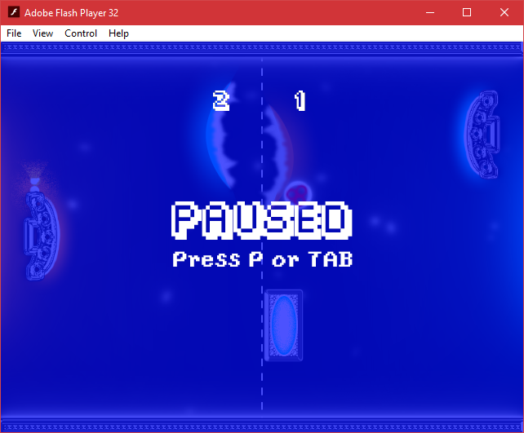

|  |
| --- |
| **List of Actors** |
| Ball |
| BallFake1 |
| BallFake2 |
| Brick1 |
| Brick2 |
| btnMainMenu |
| btnOk |
| btnPlay |
| btnQuit |
| Paddle1 |
| Paddle2 |
| Tutorial |
| Wave1 |
| Wave2 |

**Rules:**

Either player must reach a score of 15 to win. They earn 1 point for each ball is scored at the opponent’s goal.

The ball will increase in velocity the more times it hits the paddles.

**Player Ability features:**

Shoot Wave:

Shoot a wave in a straight line. Used to change the direction and push the ball from afar. Disappears after touching the ball. Has a 5 second cooldown after a shot.

Pseudocode:

When level is loaded

* Set wave cooldown attribute to 5

After every second

* If game has started and not paused
  + Subtract 1 from wave cooldown attribute

Check every tick

* If wave cooldown attribute is 0 or less and wave key is pressed
  + Set wave cooldown attribute to 5
  + Play paddle recoil animation
  + Play wave shoot sound effect
  + Create wave at x and y of paddle
  + set x speed to 50 for created wave

Shoot Bricks:

Shoot a brick in a straight line that stops before the middle line. Used to block and change the direction of the ball when it hits. Has a 1 second cooldown after a shot. Has a limited ammo reserve of 4 bricks per player.

Pseudocode:

When level is loaded

* Set brick cooldown attribute to 1

After every second

* If game has started and not paused
  + Subtract 1 from brick cooldown attribute

Check every tick

* If brick cooldown attribute is 0 or less and brick key is pressed
  + Set brick cooldown attribute to 1
  + Play paddle recoil animation
  + Play brick shoot sound effect
  + Create brick at x and y+70 of paddle

When brick is created

* Set x speed to 100 for brick

After every .1 second

* If x speed of brick is more than 0
  + Subtract 20 from current x speed of brick

Check every tick

* If x speed of brick is 0 or less
* Set x speed to 0 for brick

Create behaviour for ball colliding with brick:

When ball hits a brick

* Play brick hit sound effect
* Negate y speed of ball
* Set velocity of ball to 30 at a random angle between 30 and -30 degrees
* If turbo is bot active
  + Add 5 to current velocity speed

Check every tick

* If turbo is active
  + Change velocity to 150

Shoot Ball Decoys:

Shoot 2 fake balls at a random angle and speed to distract the opponent. Fake balls will not score points, and will disappear after hitting the opponent, or their wave and bricks. Has a 10 second cooldown after a shot.

Pseudocode:

When level is loaded

* Set fake ball cooldown attribute to 5

After every second

* If game has started and not paused
  + Subtract 1 from fake ball cooldown attribute

Check every tick

* If fake ball cooldown attribute is 0 or less and fake ball key is pressed
  + Set fake ball cooldown attribute to 5
  + Play paddle recoil animation
  + Play fake ball shoot sound effect
  + Create 2 fake balls at x+45 and random y between 15 and 115 of paddle

When fake ball is created

* Set a random velocity between 30 and 60 at a random angle between -75 and 75 degrees

When fake ball exits scene

* If x is 640 or more or if x is -85 or less
* Kill itself

When fake ball hits opponent’s paddle, wave, or brick

* Fade out over .25 seconds
* After .25 seconds
  + Kill itself

Create behaviour for fake ball movement

Check every tick

* If y of fake ball is less than -20 or more than 385
  + Play ball hit wall sound effect
  + Negate y speed for fake ball

Turbo Mode:

Speeds up the paddle movement speed of both players and the ball’s velocity. It lasts for 20 seconds, and has a 20 second cooldown after the effect ends.

Pseudocode:

When level is loaded

* Set turbo cooldown attribute to 20
* Set turbo mode attr to false
* Set turbo active attr to false

After every second

* If game has started and not paused
  + Subtract 1 from turbo cooldown attribute

Check every tick

* If turbo cooldown attribute is more than 0
  + Set turbo active attribute to false
* If turbo cooldown attr is 0 or less
  + Set turbo mode attr to true

When turbo key is pressed

* If game has started and not paused and turbo active is false and turbo mode is true
* Set turbo cooldown to 40
* Set turbo mode to false
* Set turbo active to true
* Play turbo sound effect
* Loop turbo music on channel 4
* Stop all sounds on channel 3
* Show turbo background layer
* Hide normal background layer
* Multiply current paddle velocity by 2.5
* After 20 seconds
  + Set turbo active to false
  + Play normal music on channel 3
  + Stop turbo music on channel 4
  + Show normal background layer
  + Hide turbo background layer
  + Change paddle velocity to 5

**Credits:**

Stencyl

Adobe Photoshop – Art

Adobe After Effects – Animations

Various video games – Sound effects

Monster Crafter OST – Music