PROFLOW - USER MANUAL
Written by: Derrick Abobo
Course: BIT
University: The Co-operative University of Kenya
TABLE OF CONTENTS
1. Introduction
2. Getting Started
3. How to Register
4. How to Login
5. How to Create a Task
6. How to View All Tasks
7. How to Update Task Status
8. How to Delete a Task
9. How to Filter Tasks by Priority
10. How to Use Dark Mode
11. How to Logout
12. Troubleshooting

1. INTRODUCTION
ProFlow is a collaborative task management web application designed to help teams organize, track, and complete tasks efficiently.
Features include:
- User registration and login
- Create, read, update, and delete tasks
- Assign tasks to team members
- Set priority levels (High, Medium, Low)
- Set due dates for tasks
- Filter tasks by priority
- Dark mode support
- Real-time task statistics
2. GETTING STARTED
To use ProFlow, you need:
- A computer with internet connection
- A modern web browser (Chrome, Firefox, Edge, or Safari)
- A valid email address
The application URL: http://localhost:3000 (or deployed URL)

3. HOW TO REGISTER
Step 1: Open your browser and go to http://localhost:3000
Step 2: Click the "Register" button at the top
Step 3: Fill in the registration form:
- Full Name: Enter your full name
- Username: Choose a unique username
- Email: Enter a valid email address
- Password: Create a strong password (at least 6 characters)
Step 4: Click the "Create Account" button
Step 5: You will see a success message. Click "Login" to continue.
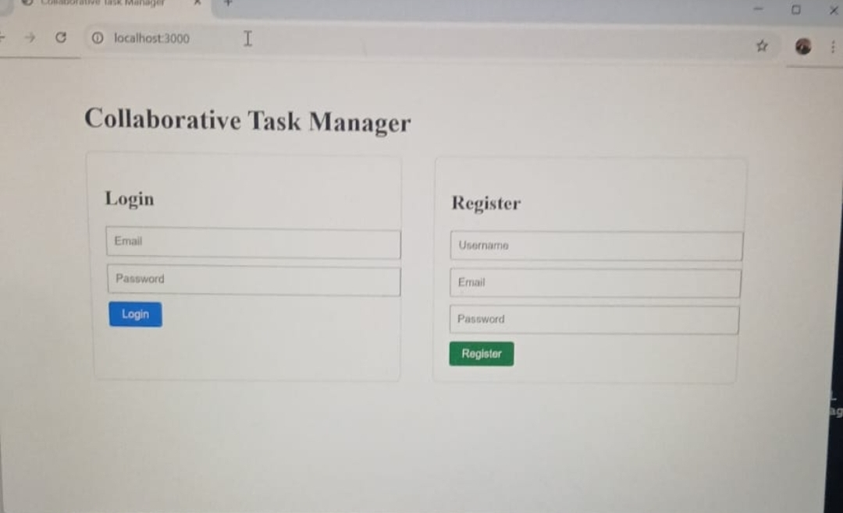

4. HOW TO LOGIN

Step 1: Open your browser and go to http://localhost:3000
Step 2: Enter your email address
Step 3: Enter your password
Step 4: Check "Remember me" if you want to stay logged in
Step 5: Click the "Login" button
Step 6: You will be taken to your task dashboard.
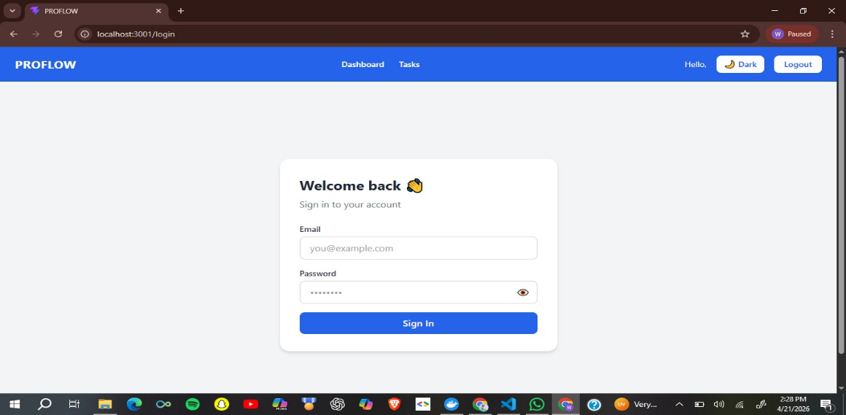

5. HOW TO CREATE A TASK
Step 1: After logging in, click the "+ New Task" button at the top right
Step 2: A popup window will appear. Fill in:
- Task title: Give your task a clear name
- Description: Add details about the task (optional)
- Priority: Choose High, Medium, or Low
- Due date: Select when the task should be completed
- Assign to user ID: Enter the ID number of the person responsible
Step 3: Click the "Create Task" button
Step 4: Your New task will appear in the task list.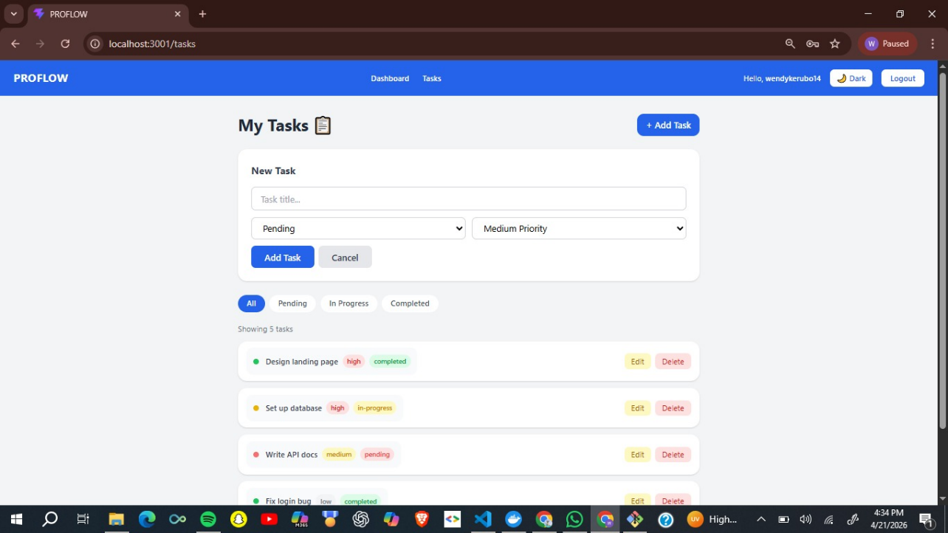

6. HOW TO VIEW ALL TASKS
After logging in, all your tasks are displayed on the dashboard as cards.
Each task card shows:
- Task title
- Description
- Priority badge (Red for High, Yellow for Medium, Green for Low)
- Current status
- Assigned person
- Due date
- Delete button
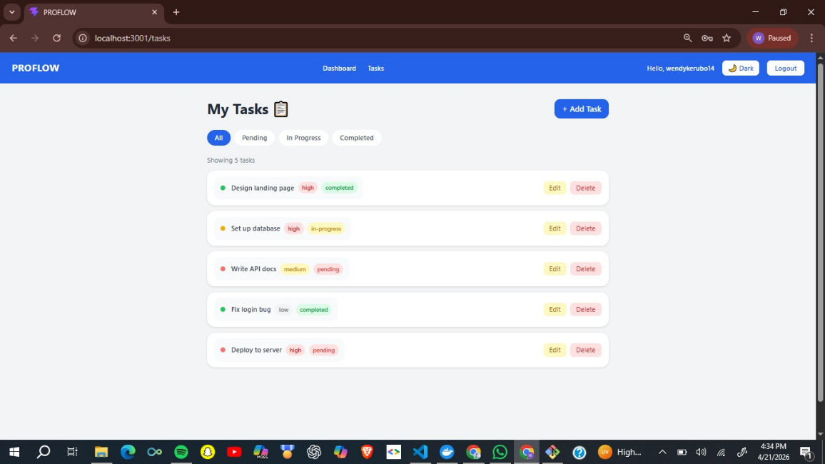

7. HOW TO UPDATE TASK STATUS
Step 1: Find the task you want to update
Step 2: Click the status dropdown on the task card
Step 3: Select one of three options:
- Pending (task not started yet)
- In Progress (working on it now)
- Completed (task is done)
Step 4: The status updates immediately
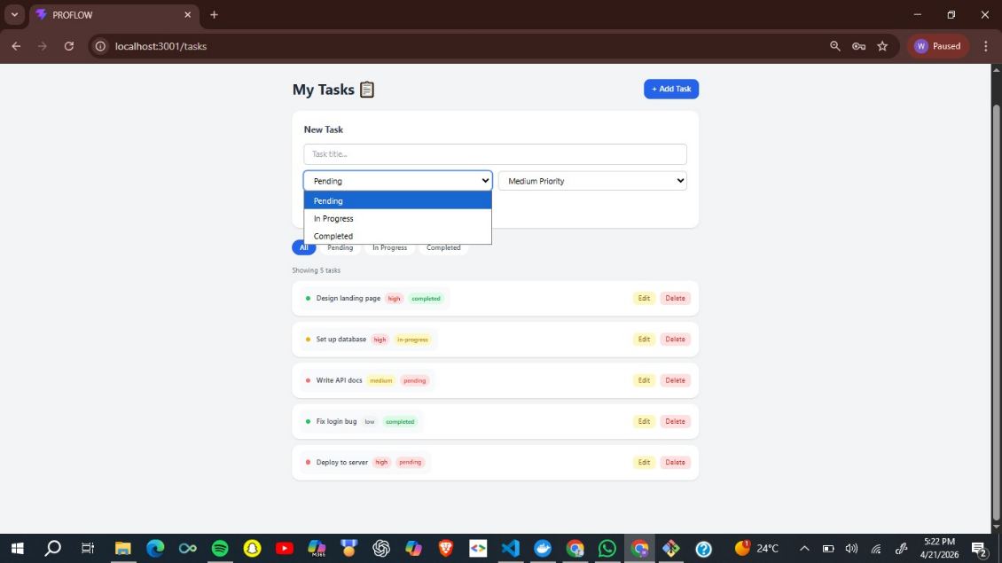

8. HOW TO DELETE A TASK
Step 1: Find the task you want to delete
Step 2: Click the red "Delete Task" button on the task card
Step 3: A confirmation popup will appear. Click "OK"
Step 4: The task is permanently removed.


9. HOW TO FILTER TASKS BY PRIORITY
Above the task list, there are filter buttons:
- All Tasks: Shows everything
- High Priority: Shows only High priority tasks
- Medium Priority: Shows only Medium priority tasks
- Low Priority: Shows only Low priority tasks
- Overdue: Shows tasks past their due date
- Completed: Shows only completed tasks
Click any button to filter your tasks instantly.
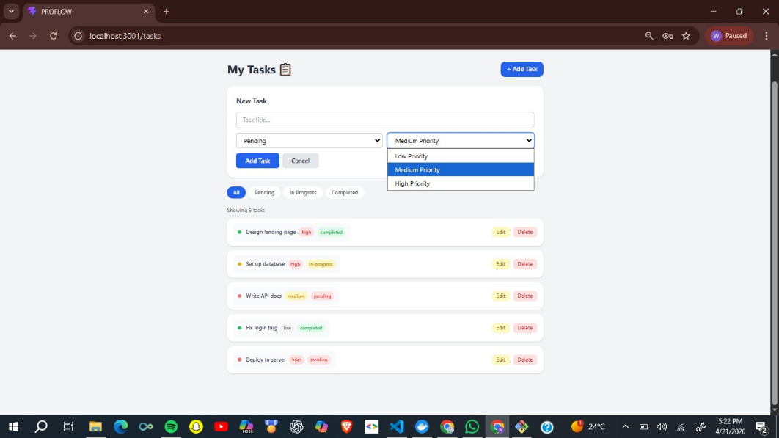

10. HOW TO USE DARK MODE
Step 1: Look at the bottom of the left sidebar
Step 2: Click the "Dark Mode" button (moon icon)
Step 3: The entire app switches to dark colors
Step 4: Click "Light Mode" (sun icon) to switch back

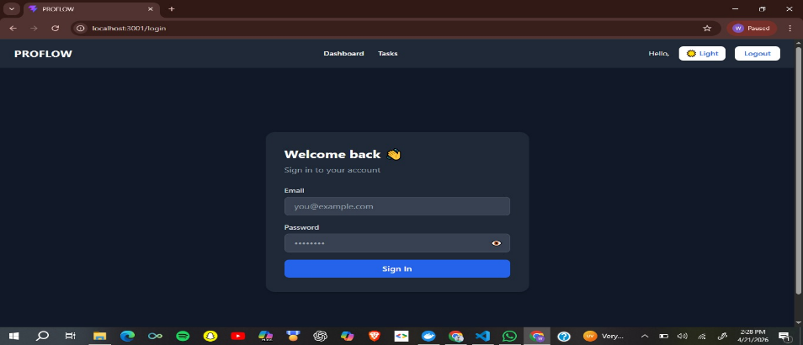

11. HOW TO LOGOUT
Step 1: Look at the bottom of the left sidebar
Step 2: Click the "Logout" button (door icon)
Step 3: You will be redirected to the login page
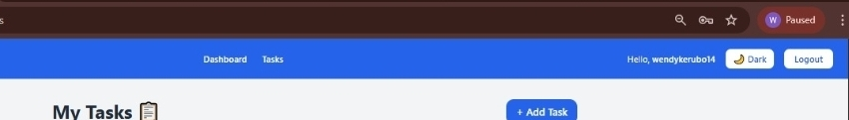

12. TROUBLESHOOTING
Problem: Cannot login
Solution: Check your email and password. Use "Forgot password" if needed.
Problem: App not loading
Solution: Make sure Docker is running. Restart the app.
Problem: Cannot create task
Solution: Make sure title is filled. Check if you are logged in.
Problem: Dark mode not working
Solution: Refresh the page. Clear browser cache.
Problem: Tasks not showing
Solution: Refresh the page. Check your internet connection.

END OF USER MANUAL

