1. Introduction
2. Methods
This analysis was conducted with very similar methods to Tuttle and Salvucci [2016], with a few changes. Atmospheric pressure was not included, as it was not found to have a significant effect on results. For inter-annual scaling, instead of using a very low frequency harmonic term, basis splines were used to provide linear inter-annual scaling. In Tuttle and Salvucci [2016] air temperature was used to determine if soil was frozen at the time of measurement, in our analysis the product of Rautiainen [2016] was used to determine the freeze-thaw status of soil for SMOS. For consistency, any days in a pixel determined to have frozen soil for SMOS were also assumed to have frozen soil for AMSR2 analysis.
The programs used for analysis were developed from descriptions provided in Tuttle and Salvucci Supplemental Materials [2017] and then tested against the 2016 analysis programs to ensure that they produced very similar results for the same data inputs, while having been developed separately.
2.1 Perturbation Calculation
The variables of soil moisture and precipitation are obviously intimately tied both to each other and to external variables. Both are related to overall weather and climate patterns very similarly, it is highly likely that any weather or climate event that increases precipitation events will also increase soil moisture events and vice versa. As well, though the time scale of the data used in this study is daily, the events that drive soil moisture and precipitation can be of a longer time scale. Weather events that drive increases in precipitation for example can come in timespans of multiple days due to clusters of weather patterns, seasonal effects in months, and annual changes. Therefore, if the raw soil moisture signal were used to model precipitation likelihood, it would appear to have a decent amount of predictive power. This is because the raw soil moisture signal contains the information of whether it rained the previous day, a parameterized version of that rain amount, the seasonal cycle information and annual trends, all of which are variables that would normally be used to model rainfall anyway. The effect observed from using the raw soil moisture signal then actually muddles the effect of the soil moisture itself with the external parameters that drive both soil moisture and precipitation.
The solution to this muddling of effects is to try to remove the other information from the soil moisture signal. In other words, to make a claim about the effect of the soil moisture, the soil moisture value has to be isolated from those external parameters that drive both soil moisture and precipitation time series. This analysis uses a calculated soil moisture perturbation to accomplish this isolation. The soil moisture perturbation (SM Pert) is defined as the residual between the measured soil moisture value by an instrument and a time dependent model that takes into account co-mingled parameters for precipitation and soil moisture.

$SM Pert=SM-sm($P) (1)
Where SM is the observed soil moisture value, sm(P) is some function that yields a soil moisture value time series and P is some set of varying size that contains co-mingled parameters.
As discussed in section 2.2, the Granger Causality framework analyzes the ratio of the predicted precipitation by a full model including the soil moisture signal, to the predicted precipitation by a restricted model of parameters, but not including the direct soil moisture signal. This approach yields the impact of the SM anomaly, as the difference in predictive power between a signal and a model of that signal must be due to the residuals between the signal and the model of the signal.
Perturbations were calculated in a few different ways, and achieved very similar results.
2.1.1 Seasonal Perturbations
One method of isolating the effect of soil moisture from co-mingled parameters is to generate a predictive model for soil moisture that takes into account the actual small timescale, seasonal and annual trends observed in the data and then subtract this model from the observed measurements. The predictive power of this model can then be judged against the power of the soil moisture signal itself. The ratio of those predictions yields information about the effect of the residuals between the signal and the model. This method produces what will be referred to as a Seasonal Model.
A predictive model for any potential geographic pixel cannot be easily known. A list of potential influences on soil moisture can however be easily known. In other words, the function sm(P) will be defined as the product of a vector of coefficients (noted as b) and a vector of parameters (noted as P) from a simple general linear model (GLM). It is far easier to state the possible influences on soil moisture than to determine the relevant influences on soil moisture.
This particular method of defining sm(P) and determining P was based on the methodology of Tuttle and Salvucci [2016], but the actual analysis code was written independently. The results of the newly written analysis code and the code used in Tuttle and Salvucci [2016], were compared for concordance to verify the methodology.
The vector P contains harmonic terms of six frequencies that model intra-annual trends such as seasonal effects, a set of basis splines that peak during the different years, and three different lengths of memory terms. The memory terms come from the observation that precipitation events can come in clusters. These are the small timescale or localized events referred to above, where simply knowing that it rained the previous day can influence the likelihood that it rains the next day. The analysis allows for the influence of precipitation (or lack of precipitation) on the previous day, the previous two days or the previous three days.
The vector then contains the possible parameters to be used to effectively model soil moisture or precipitation on a daily time scale. The analysis still tunes the coefficients vector b to each geographic pixel through running an all possible regression (APR) analysis. The APR was also used in Tuttle and Salvucci [2016]. An APR analysis runs each possible combination of parameters as the potential model in a GLM fit such that the number of models (N) is
$N=\sum_{k=1}^{n}{\left({n \atop k}\right)}$ (2)
Where n is the size of the vector P.
At each pixel, the soil moisture and precipitation occurrence data are regressed on each of the N possible models. The most parsimonious model from among the possible is selected using the Deviance Information Criterion (DIC) for precipitation occurrence GLM fits and soil moisture regressions independently. The DIC is calculated as:
$DIC=D\left(θ\right)+2p$ (3)
Where D(θ) is the deviance calculated during a generalized linear model fit and p is the effective number of parameters in the model. As p increases, the fit of the model should increase, decreasing D(θ), but being penalized as a term. Ultimately, the model with the minimum DIC is selected.
After APR analysis, two daily timescale models have been generated, one for modeling of precipitation occurrence probability, and the other for soil moisture value. While vectors of coefficients b have been generated for each of these regressions, they are ultimately discarded, the main result of the APR analysis is to determine the parameters of the two P vectors. The final model to be used to calculate the soil moisture model is actually the union of these two P vectors, and a new b vector will be calculated accordingly.
While the DIC is used to prevent overfitting of data, this analysis is actually fairly robust to the effects of overfitting. The model calculated is not actually used to gain information about any geophysical aspects of either precipitation or soil moisture. The model is used instead as a tool to remove information that comes from co-mingled external sources. The variable to be studied by the analysis is the set of perturbations about the calculated model, so moderate overfitting means that the variable used would have less potential predictive power and so only bias results towards false negatives, where no impact is observed but might exist. More dangerous would be to underfit the model, leaving more predictive power in the variable claimed to be soil moisture perturbations than exists in an actual signal of soil moisture perturbations. An extremely overfit model would potentially remove all predictive power form the variable, which would disrupt the analysis, but using this technique the perturbations are left as the result of a deliberately slightly overfit model that consists of parameters selected as relevant using the DIC, and parameters selected as relevant by the DIC in an intimately linked signal.
2.1.2 Moving Window Perturbations
While the perturbations used the impact factor analysis were generated from the seasonal model process described above, a comparison was also performed between the perturbations of SMOS product soil moisture and perturbations of AMSR-2 product soil moisture. This analysis involved calculating the correlation coefficient of the perturbations obtained when using soil moisture time series from the two sources.
Given the complexity of calculating the seasonal model and fit, as a protection other methods of calculating perturbations were employed when comparing the perturbations across sources to protect from any effect of any particular method. SM Pert was calculated in accordance with equation 1, but the term sm(P) was defined as a moving window operation. Three different calculations were used, where sm(P) was defined as a 30 day wide moving window which calculated mean soil moisture, median soil moisture, and mode soil moisture, yielding three new SM Pert time series for each pixel.
This method does not change the practical value of SM Pert, as it still describes how much more wet or dry the measurement is compared to the relative time period of when the measurement was taken. It does change the meaning, as the new sm(P) calculation does not contain any direct geophysical or climatological information. SM Pert is in this case the difference between any signal and a smoothed version of itself based on a particular window size.
2.2 Impact Factor and Granger Causality
The effect of soil moisture on precipitation event likelihood is difficult to classify as a unit. For this analysis, the effect is quantified by an Impact Factor that is calculated in a Granger causality framework.
Granger causality was developed as a technique to identify how well one signal can forecast another signal. Salvucci et al. [2002] described Granger causality in the context of soil moisture-precipitation feedback. Tuttle and Salvucci [2016] used the technique to calculate the effect of soil moisture on next day precipitation likelihood across the country using AMSR-E soil moisture product. This analysis followed the published methodology to calculate Impact Factors using the SMOS soil moisture product and AMSR2 soil moisture product.
Once the parameters of the full model for a pixel are chosen in the APR, two sets of coefficients are generated: one for the full model fit to precipitation occurrence and the other for the full mode along with the soil moisture signal fit to precipitation occurrence. Both are fit using a binomial probit generalized linear model (GLM fit). Two new predictive precipitation likelihood time series are generated by taking a normcdf of each of these coefficients multiplied by the parameters, accounting for the dispersion calculated in the GLM fit.
One time series is the predicted likelihood of a precipitation event using the chosen parameters and soil moisture, while the other is the predicted likelihood of a precipitation event using just the chosen parameters. New SM anomalies are generated as the residuals between the soil moisture signal and a seasonal fit model that is restricted to the seasonal harmonic terms. These perturbations are only used to define the results by where they fall on a plane with a vertical bar at the 50th quantile of residual values. A ratio of the predicted precipitation likelihood time series using the full model including soil moisture and the predicted precipitation likelihood time series using only the model parameters is then generated. The mass of the ratio with accompanying soil moisture anomaly above and below the 50th quantile of soil moisture anomaly are calculated. The impact factor of the pixel is the difference between these two masses.
Figure 1

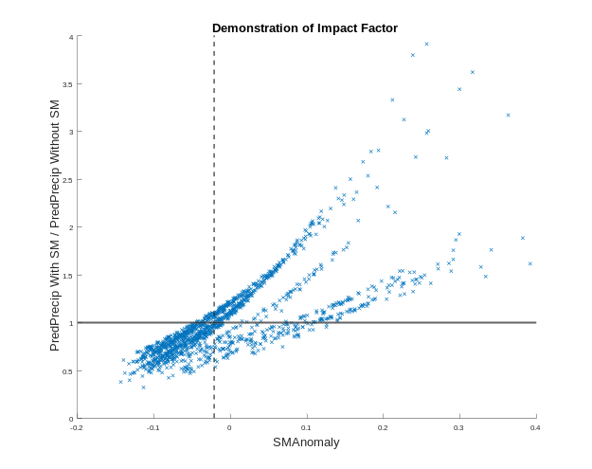

Figure 1 is a graphical representation of the above calculation. The y axis represents the ratio of the predicted likelihoods; the x axis represents the SMAnomaly on that day. They are separated by the 50th quantile of SMAnomaly. The difference of the mean of the data points to the right of that dotted line minus those to the left is the impact factor. It measures the effect of the severity of the SMAnomaly, including the sign. The sign of the impact factor is the same as the sign of the slope of a line through the two centers of mass to the left and to the right of the dotted line. Figure 1 shows a positive impact factor, where when the SMAnomaly is more positive, the inclusion of the soil moisture signal increases the predicted likelihood of precipitation.
2.3 Bootstrapping
The relationship between soil moisture and precipitation can cause endogeneity bias in regression, as there is an obvious auto-correlation between precipitation and soil moisture. Block bootstrapping is a statistical technique that recalculates the coefficients of the regression variables after resampling the time series according to methods described in D. Politis and H. White [2009]. The new coefficient is:
$$B=2b-b'$$
(3)
Where (b) is the original coefficient, and (b’) is the mean of the bootstrapped coefficients. This process was shown effective in simulated data prone to endogeneity errors, where soil moisture was calculated as a differential equation of incoming precipitation and outgoing drainage.
The final result of this analysis is based on the predicted precipitation likelihood, so the coefficients for the generated model are critical in understanding the final impact factor. The bootstrapping process keeps a consistent set of parameters, but repeatedly recalculates the coefficients of the model while shuffling the time series.
The time series cannot be resampled as individual points, as the individual days are not independent from one another. Instead the time series are resampled in blocks with a block size determined by an algorithm generated and published in D. Politis and H. White [2009]. A random position is chosen in the time series, and then the block sampled from that point is described by a geometric distribution with 1/block size as the parameter. This process is repeated 100 times.
The coefficients vector b is recalculated for each of these iterations, and then the final coefficient B is calculated according to equation 3. If the bootstrapping does nothing, b’ = b so B = b.
Bootstrapping is also used to determine the relative certainty of the calculated impact factor. A ksdensity function of the bootstrapped coefficients is generated, and the p value is generated accordingly.
3. Data and Processing
The United States was defined as the box from 25° to 53°
latitude
, -125° to -67° longitude for the purpose of acquiring data for this analysis.
The soil moisture data used in this study are from the level 3 product of the Soil Moisture Ocean Salinity (SMOS) satellite launched by the ESA, the Advanced Microwave Scanning Radiometer – Earth Observing System Sensor (AMSR-E) on the NASA Aqua satellite, and the Advanced Microwave Scanning Radiometer 2 (AMSR2) onboard the GCOM-W1 satellite.
SMOS data was received from a subset widget developed by the Centre Aval de Traitement des Donnees SMOS (CATDS) which processes L1B SMOS products from the ESA into L3SM product. The SMOS product used runs from January 15, 2010 to January 15, 2019 (3287 days). The end product of this widget is a pixelated map of soil moisture values over a selected area, including NaNs for areas that were not included in the particular pass.
The AMSR-E product is the same as was used in Tuttle and Salvucci (2016), acquired from an archive of the analysis used for that study. The AMSR2 product is the X-Band (10.65 GHz) product acquired from GES DISC.
The precipitation data comes from the North American Land Data Assimilation System Primary Forcing Data L4 Hourly 0.125 x 0.125 degree product (NLDAS).
For each set of data, due to the way that regression terms were defined, leap days were removed from the time series.
The soil moisture and precipitation data differ in two respects that make analysis difficult. They are on different time scales and measure pixel size differently. While the revisit time for the soil moisture measurements can be over a day, because they measure somewhere in the U.S. at least once a day, filling the non-measured areas with NaNs, they yield data structs that have a daily timescale. Although the time series of an individual pixel will not have numerical measurements at each daily entry. The precipitation data exists on an hourly timescale which introduces another complication in the timescale difference.
Although the soil moisture data is measured on a daily scale, it is a snapshot of soil moisture at a particular time, repeated with days in between. The first complication is taking that snapshot of soil moisture as representative of the daily soil moisture, defined as the time since the last snapshot of the daily soil moisture. The second is that while the time in between measurements is measured in days, the actual time of measurement doesn’t correspond to a typical definition of a day. The instruments have differing overpass times when they take the measurements. The precipitation has to be summed over a 24 hour period, but the borders of that 24 hour period are critical to this analysis.
Soil moisture and precipitation are linked and lagged signals, precipitation drives soil moisture. When trying to use Granger causality to measure the effect of soil moisture on next day precipitation likelihood, it is critical to ensure that the soil moisture measurement of a particular day has no information about the precipitation event it is trying to predict for the next day. So, with an overpass time of 1:30 PM for example, if a typical midnight to midnight day were used for precipitation, information about precipitation that happens after the soil moisture measurement can get consolidated into the day of the soil moisture measurement when that measurement can only measure the hours previous to it. Precipitation was then summed over a 24 hour period that ended just before the soil moisture measurement overpass time. This yielded daily sums of forcing information in 0.125 x 0.215 degree pixels.
The mapping of the two variables also requires adjustment. The precipitation measurement grid did not line up perfectly with the soil moisture measurement grids. The precipitation measurements were on a 0.125 x 0.125 degree square, while the soil moisture measurements were close to being on a 0.25 x 0.25 degree square (15 km spacing on a global cylindrical grid), but with a different alignment.
The precipitation measurements were on a much more fine resolution compared to the soil moisture measurements. The soil moisture measurements were projected onto the precipitation measurement grid. Each pixel of the soil moisture measurements had an associated coordinate for its center, as did the precipitation measurement pixels. The pythagorean distance was calculated from each precipitation pixel to each soil moisture pixel using these coordinates. A new map was generated with the same spacing and alignment as the precipitation measurements, where each pixel had the value of the closest soil moisture measurement. The average was taken of both the resulting soil moisture map and the existing precipitation map in 2x2 pixel blocks. In the averaging, NaN values were ignored. Resulting in data series of matching time and spatial scales.
The analysis does not comment on the magnitude of predicted precipitation, but only on occurrence likelihood. The forcing data used for precipitation is converted to occurrence data where precipitation is said to have occurred if the forcing is greater than 0.1cm.
The remotely sensed soil moisture values can have extreme error due to frozen soil. Accordingly, they were removed from the analysis. The AMSR-E data used air temperature data to determine if the soil was frozen. The SMOS product instead used the product of Al Bitar Ahmad et. Al [2017] which developed an algorithm for the SMOS product detecting the freeze thaw status of soil. The freeze thaw flag map was also projected onto the new grid, but instead of averaging over blocks, if any pixel in a block was flagged as frozen, the entire block would be flagged as frozen.
The flagged pixels were marked as NaN. The life of the AMSR2 instrument falls within the life of the SMOS instrument, so the same frozen map could reasonably be used for both. Though the two instruments have different overpass times, because the filtering marked any pixel flagged as either currently frozen or thawing from frozen, or freezing, it could be assumed that any pixel that would be flagged during the SMOS pass, would still either be frozen or freezing during the AMSR2 pass. The SMOS frozen soil map was then used to also filter frozen soil from AMSR2.
4. Results
Impact Factors were calculated using SMOS and AMSR2 instrument data. The AMSR-2 results featured in Figure 1 appear very similar to those found using AMSR-E in Tuttle and Salvucci (2016) while the results in Figure 1 found using the SMOS product appear very different in sign, but contain a similar pattern.
Figure 1
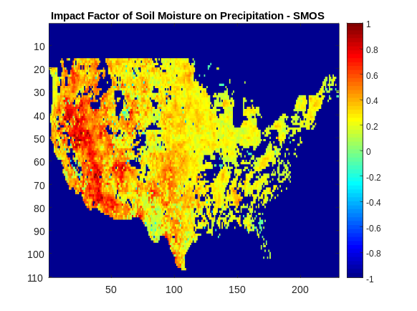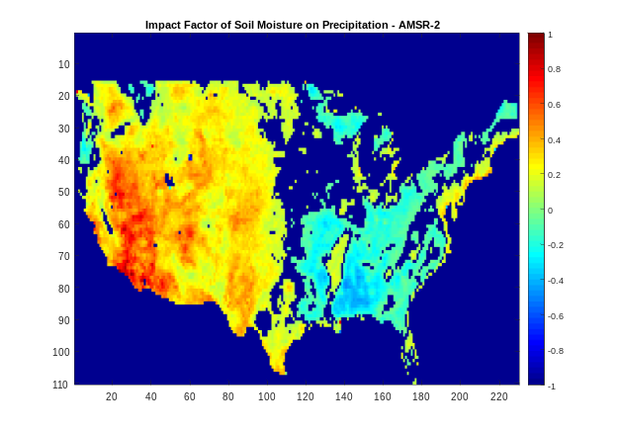
Figure 1 shows that the West-East gradient observed in previous analysis is preserved among instruments, in that generally the West produces a more positive impact factor than found in the East, excluding the pacific Northwest and the great lakes region. There are very different values between the two maps though, the one created using AMSR-2 features a West-East gradient that goes from positive to insignificant to negative moving West to East, while the one created using SMOS features a gradient that goes from very positive to slightly positive to close to zero over the same area. As well, the uncertainties of the two maps are different. While both produce confident results in the West, for AMSR2 and AMSR-E, the middle portion of the country are associated with higher uncertainty, and in SMOS, the Southeast and Appalachia regions are associated with more uncertainty.
Figure 2
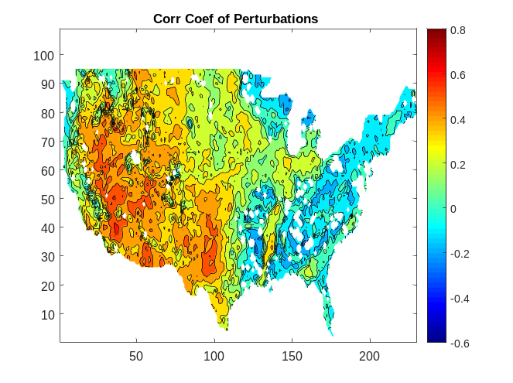
Figure 2 shows the correlation coefficient of AMSR-2 and SMOS perturbations across the U.S. Remarkably, the pattern found in the correlation coefficient between the perturbations around fitted models for the two instruments resembles the same pattern as found in the impact factor of AMSR products in that it features a West-East gradient going from positive to negative. This pattern of correlation coefficient is preserved when calculating perturbations with any of the previously discussed methods.
Figure 3
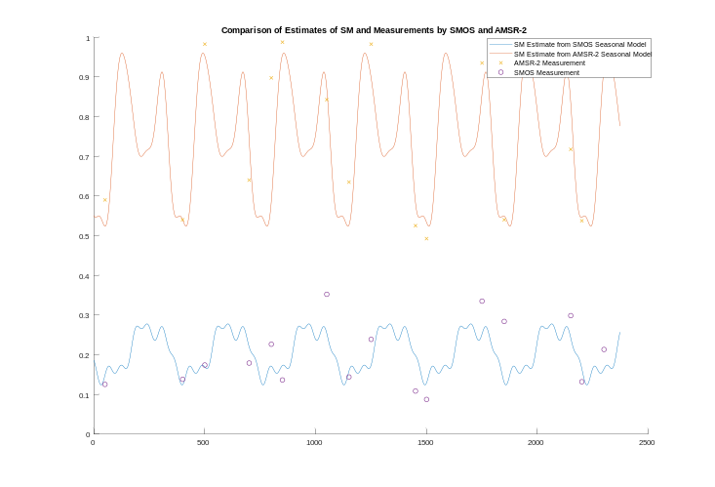
Figure 2 shows a time series for a pixel where the two perturbation signals have a very low correlation coefficient. The solid lines show the fitted model to the pixel, while the points are the actual measured value, filtered for readability. It can be seen that often when one instrument measures even far above its expected value based on the day of year, the other measures below that model. This figure allows for a more analytical understanding of the above map, individual perturbations can be seen where in one time series the perturbation is positive and in the other it is negative. The separation of the time series is due to a difference in units, the SMOS product produces a volumetric measurement of the water content of the soil, while the AMSR2 product produces a measurement of the saturation of soil with water. The perturbations having a different signs is interesting as the perturbations are calculated relative to their independent signal. Essentially, for them to disagree in sign indicates that when soil moisture is above expected value in one signal, it is below the expected value in the other.
5. Discussion
The robustness of this effect was tested by separating out seasons of the signals, using four different methods of calculating perturbations, capping and filtering the signals at a particular threshold to deal with possible saturation issues, and isolating the effect of whether or not it had rained near the time of the actual soil moisture measurement. The AMSR-2 signal seems to saturate seasonally, while the SMOS signal does not. This saturation did not actually affect the correlation between the perturbations, as after filtering the soil moisture signals based on a 10th – 90th percentile the same pattern was preserved.

Figure 4
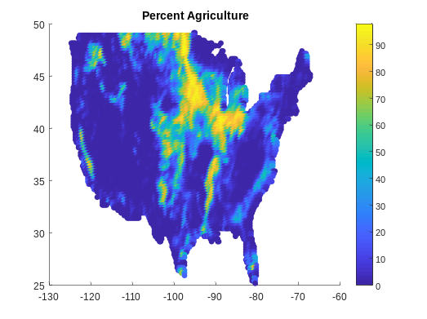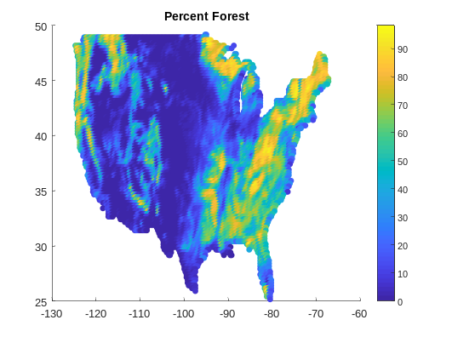
Figure 4 shows how much of the land cover type in a particular pixel is the titular land cover type among seven land cover types. It can be seen that the percent forest and percent agriculture maps closely resemble the correlation coefficient map. The correlation coefficient map features disagreement along Appalachia, along the Mississippi River, the great lakes region and the Pacific Northwest, which also feature dominant forest or agriculture land cover.
Figure 5
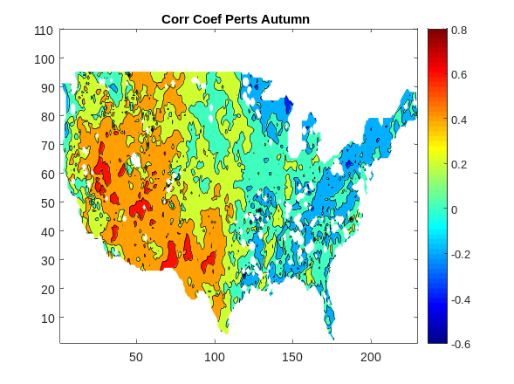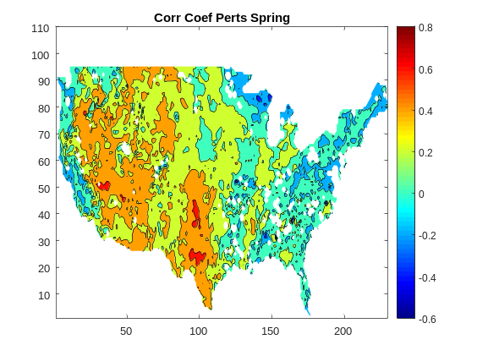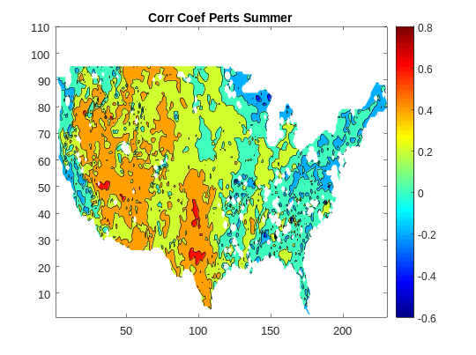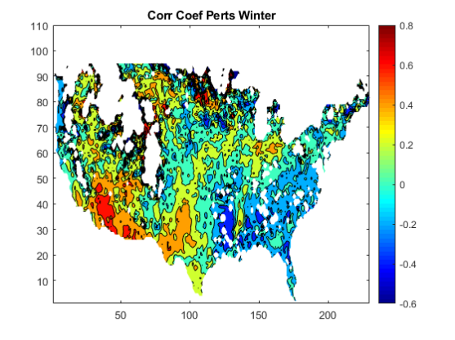

Seasonality was inspected both because it captures some of this saturation behavior, and if it is true that these instruments are being affected differently by dense vegetation, then seasonality can act as a proxy for the effect of that vegetation. If the dense forests of Appalachia are causing the negative correlation coefficient in that region, then that disagreement would likely be stronger in the Spring or Summer months rather than in the Winter. Winter is also a special case because while vegetation is more sparse, more data points are excluded proportional to total days in the season, due to frozen soil. So, it is important in the Winter months to pay special attention in this case to the Southern portion of Appalachia, which freezes less often than the Northern portion. Figure 5 shows the correlation coefficients between the perturbations of the soil moisture signals separated into three month periods.

Figure 5

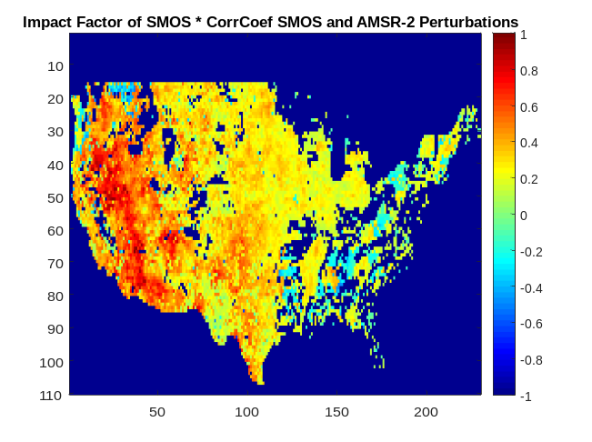
Figure 6 shows that when the impact factor map from SMOS, when multiplied by the correlation coefficient between SMOS and AMSR-2, begins to look very similar to the impact factor map found using AMSR-2. Land cover provides a possible explanation, in that it is reasonable that vegetation can impact calculations made using remotely sensed variables. Land cover could be affecting the instruments and how they measure soil moisture, or it could actually be affecting the soil moisture – precipitation likelihood. A possible explanation could be how vegetation moves water from different depths of soil to the air. The different wavelengths used by the two satellites also estimate soil moisture at different depths, which could explain some difference. As well why when SMOS is measuring a value above its expected soil moisture based on day of year, AMSR-2 is measuring a value below its expected value.

6. Conclusion
The impetus for this analysis came from the results of Tuttle and Salvucci (2016), which found a positive to negative impact factor gradient across the U.S. The goal was to perform a very similar analysis as was conducted then using new instruments. Our analysis has shown that although the sign of the impact of soil moisture on next day precipitation likelihood seems uncertain as using different data sources yields different results, the gradient of results persists and is remarkably robust. Regardless of whether the effect is ultimately positive or negative, it varies geographically in the contiguous U.S.
The same gradient appears to manifest not only in the Granger causality analysis, but also when examining the signals themselves using a correlation coefficient and when comparing with land cover maps. The similarity between the gradient and land cover maps seems reasonable, has not been heavily tested in this analysis, and motivates further study.

CATDS (2016). CATDS-PDC L3SM Filtered - 1 day global map of soil moisture values from SMOS satellite. CATDS (CNES, IFREMER, CESBIO).
http://dx.doi.org/10.12770/9cef422f-ed3f-4090-9556-b2e895ba2ca8
Al Bitar Ahmad, Mialon Arnaud, Kerr Yann H., Cabot Francois, Richaume Philippe, Jacquette Elsa, Quesney Arnaud, Mahmoodi Ali, Tarot Stephane, Parrens Marie, Al-Yaari Amen, Pellarin Thierry, Rodriguez-Fernandez Nemesio, Wigneron Jean-Pierre (2017). The global SMOS Level 3 daily soil moisture and brightness temperature maps. Earth System Science Data, 9(1), 293-315. Publisher's official version : http://doi.org/10.5194/essd-9-293-2017 , Open Access version : http://archimer.ifremer.fr/doc/00388/49941/

Maybe include a graph of the elements of the determined model?
Tuttle rse has a great table, copy that formatting – SM is technically daily even though there isn’t always a measurement
Probably need to apply the significance mask
Rigden
Cite how many types
I have a citation for this – what is my tense, I really need to decide

