Frontend Development with React.js

Project Documentation format.

FitFlex: Your Personal Fitness Companion

# 1. Introduction

**Project Title:** FitFlex: Your Personal Fitness Companion  
  
**Team Members:**   
 Team Leader Name: JOSHUA ANAND PRASAD B ([joshuadhoni1@gmail.com](mailto:joshuadhoni1@gmail.com))

Team Member Name: DEVAPRIYAN S M ([devapriyan672@gmail.com](mailto:devapriyan672@gmail.com))

Team Member Name: PARMOTHPAL R ( [parmothpal24@gmail.com](mailto:parmothpal24@gmail.com) )

Team Member Name: YUVAN SHANKAR J ( [ryuvanshankar2004@gmail.com](mailto:ryuvanshankar2004@gmail.com))

Team Member Name: DINESH KUMAR S ( [kumar5080650@gmail.com](mailto:kumar5080650@gmail.com))

# 2. Project Overview

**Purpose:**  
FitFlex is designed to help users achieve their fitness goals by providing personalized workout plans, exercise tracking, and progress monitoring. The platform offers intuitive navigation, motivating features, and insightful analytics to enhance the user's fitness journey.

**Features:**  
- Personalized Workout Plans  
- Exercise Category Filter (e.g., Strength, Cardio, Yoga, etc.)  
- Progress Tracking and Goal Setting  
- Daily Workout Reminders  
- Interactive Workout Demonstrations  
- Bookmark Feature for Favorite Exercises  
- Light/Dark Mode for Improved User Experience  
- Responsive Design for Mobile and Desktop

# 3. Architecture

**Component Structure:** **App.js** — Root component that manages layout and routing  
 **Header.js** — Navigation bar with search functionality  
 **WorkoutList.js** — Displays categorized workout plans  
**WorkoutCard.js** — Individual workout details with instructions  
 **WorkoutDetails.js** — Displays step-by-step workout guidance  
 **Footer.js** — Provides useful fitness tips and motivational quotes

**State Management:**  
- Context API — Manages global states like theme preferences, saved workouts, and progress tracking

**Routing:**  
- React Router — Used for seamless navigation across categories, workout details, and user profile

# 4. Setup Instructions

**Prerequisites:**  
- Node.js (v18 or higher)  
- npm or yarn

**Installation:**  
1. Clone the Repository:  
 ```  
 git clone https://github.com/darunraj0071/fitflex-app.git  
 cd fitflex-app  
 ```  
2. Install Dependencies:  
 ```  
 npm install  
 ```  
3. Create `.env` file:  
 ```  
 REACT_APP_FITNESS_API_KEY=your_api_key_here  
 ```  
4. Run the Application:  
 ```  
 npm start  
 ```

# 5. Folder Structure

/src  
 ├── /components  
 │ ├── Header.js  
 │ ├── WorkoutList.js  
 │ ├── WorkoutCard.js  
 │ ├── WorkoutDetails.js  
 │ └── Footer.js  
 ├── /pages  
 │ ├── Home.js  
 │ ├── Categories.js  
 │ ├── ProgressTracker.js  
 │ └── Profile.js  
 ├── /assets  
 │ ├── images  
 │ ├── icons  
 │ └── styles  
 ├── /utils  
 │ ├── api.js  
 │ ├── helpers.js  
 │ └── constants.js  
 ├── App.js  
 ├── index.js

# 6. Running the Application

**Frontend Server Command:**  
``` bash  
npm start  
```

# 7. Component Documentation

**Key Components:**  
**Header:** Provides navigation and search functionality  
**WorkoutList**: Displays workout plans categorized by type  
**WorkoutCard:** Shows workout details such as steps, duration, and tips  
**WorkoutDetails**: Provides detailed instructions, video demos, and progress tracking

**Reusable Components:**  
**Button Component:** Used for 'Start Workout,' 'Save Plan,' or 'Track Progress' actions  
**Modal Component:** Displays workout instructions in a popup

# 8. State Management

**Global State:**  
- Managed using **Context API** for workout tracking, theme settings, and reminders

**Local State:**  
- Managed via React’s `useState()` for dynamic UI elements like forms and pagination

# 9. User Interface

- Clean, modern interface designed for fitness enthusiasts  
- Motivational quotes and tips integrated throughout the platform  
- Dynamic progress bars and goal trackers for better visualization

# 10. Styling

**CSS Frameworks/Libraries:**  
- **Tailwind CSS** — Used for fast, scalable, and responsive design  
  
**Theming:**  
- Integrated Light/Dark Mode for improved user comfort

# 11. Testing

**Testing Strategy:**  
Jest — For unit testing of components  
React Testing Library — For integration and user interaction testing  
  
**Code Coverage:**  
- Ensured high test coverage with Jest reports

# 12. Screenshots or Demo

**Screenshot:**

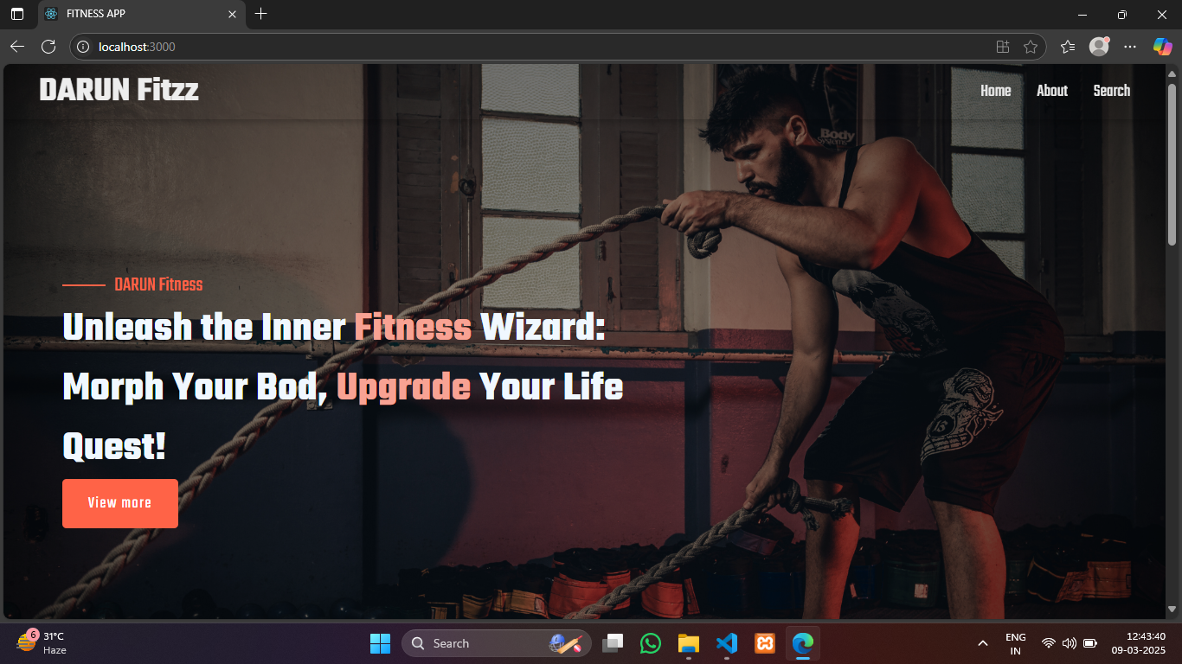

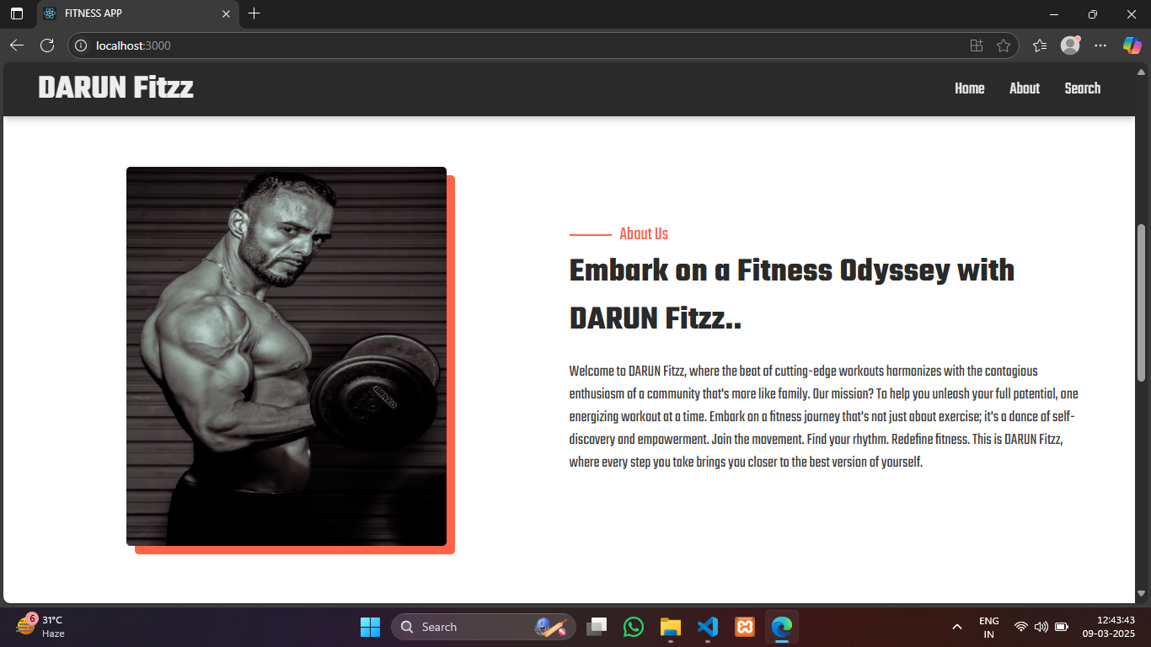

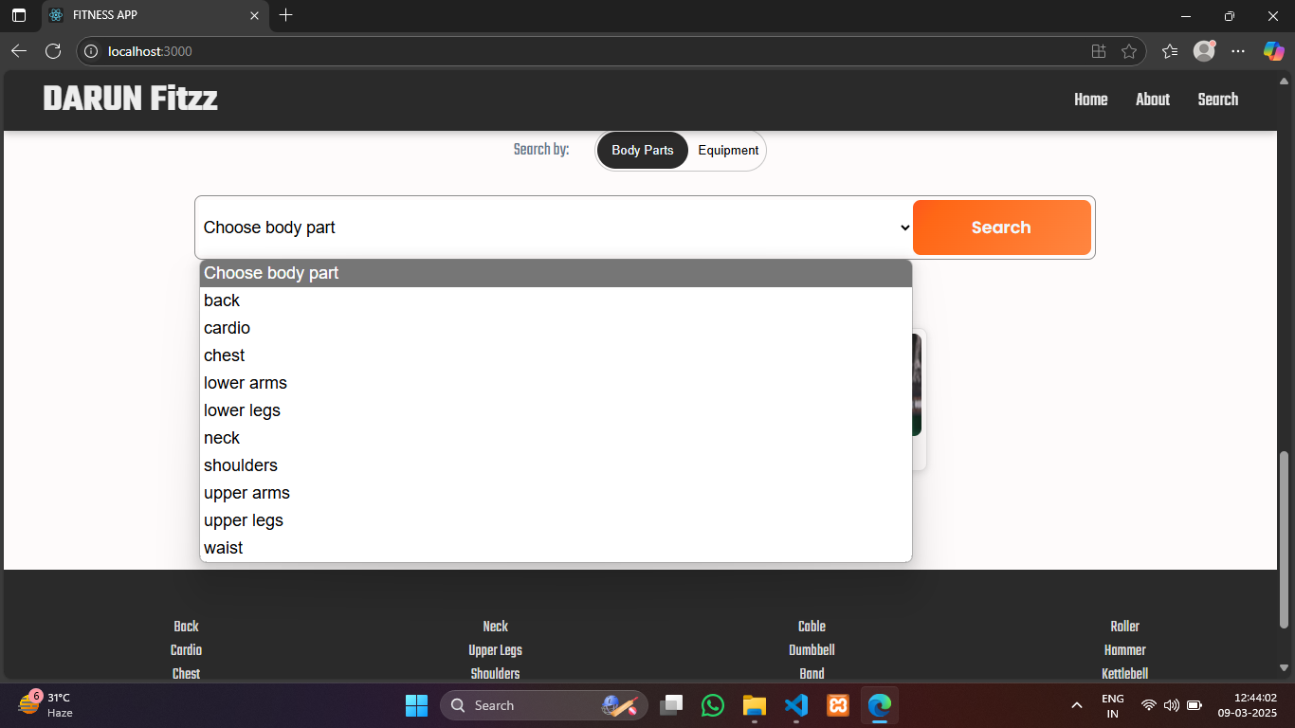

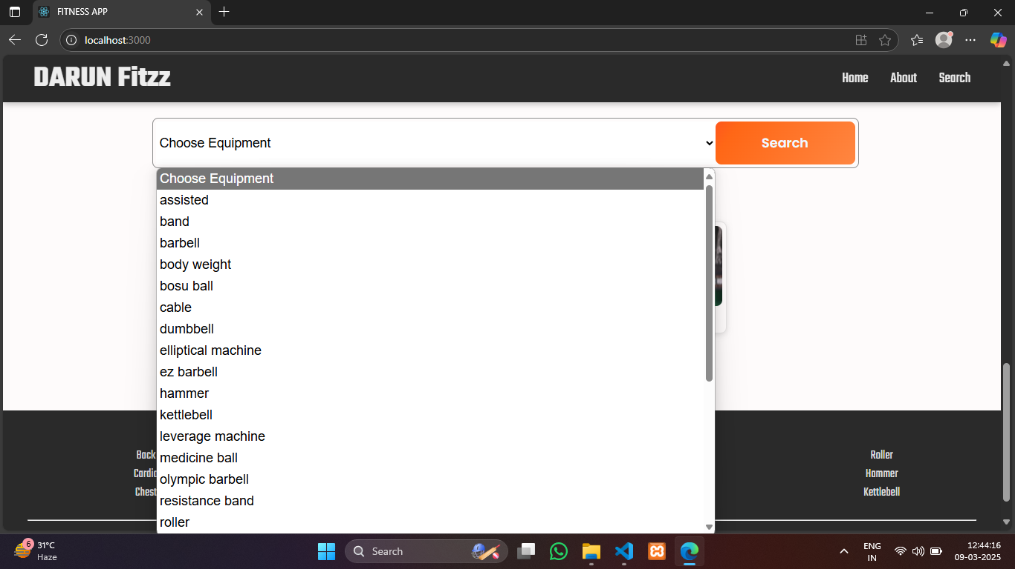



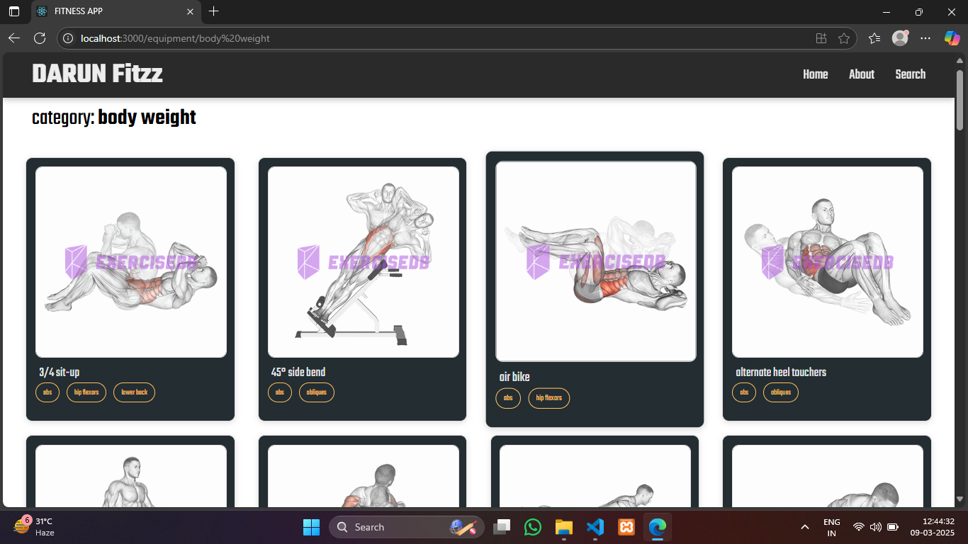



**Live Demo Link:**

# 13. Known Issues

- Some animations may lag on older devices  
- Progress tracking may require additional optimization for large data entries

# 14. Future Enhancements

- Social Sharing for Workout Achievements  
- Custom Workout Creator with Drag-and-Drop Interface  
- Integration with Smartwatches for Real-Time Activity Tracking  
- Personalized Diet Recommendations Based on Workout Progress