TripWise Enhanced Implementation - Part One
Updated Enhancement Document with Color-Coded Flowcharts, Results, Screenshots, Gantt, Critical Path, and PERT
Project Summary
TripWise was enhanced from a simple drive-versus-fly calculator into a more complete vacation decision-support platform. The updated version removes the Implementation Demo tab, adds a new Itinerary tab, supports typed starting location and destination fields with city/state autocomplete, adds trip type and travel style options, and generates a travel plan with hotel, pit stop, timeline, and checklist recommendations.
What Was Modified
Area | Simple Implementation | Enhanced Implementation | Color Code | Status
Navigation Tabs | Trip Overview, Costs, Recommendation, Hotel/Stops, Implementation Demo | Removed Implementation Demo and added Itinerary tab | Green = New Feature | Complete
Location Inputs | Limited dropdown-only city choices | Type any city/state with autocomplete city suggestions | Green = New Feature | Complete
Decision Logic | Basic drive/fly calculation | Preference-weighted scoring using cost, speed, flexibility, and comfort | Orange = Modified Logic | Complete
Travel Planning | Basic hotel and pit stop cards | Generated itinerary, timeline, checklist, and vacation-focused guidance | Green = New Feature | Complete
Design | Clean dashboard | More colorful, lively, vacation-style interface | Green = New Feature | Complete
Documentation | Basic implementation support | Updated color-coded flowcharts, screenshots, Gantt, critical path, and PERT | Blue = Original / retained structure | Complete
Color Key
Blue = original/retained simple implementation process. Green = new enhanced feature. Orange = modified recommendation or decision logic.
Operational Flowchart
The operational flowchart shows the user-facing changes. The green steps identify the new typed city/state fields, autocomplete support, hotel/stops, and itinerary workflow. The orange step identifies the modified preference-weighting step.
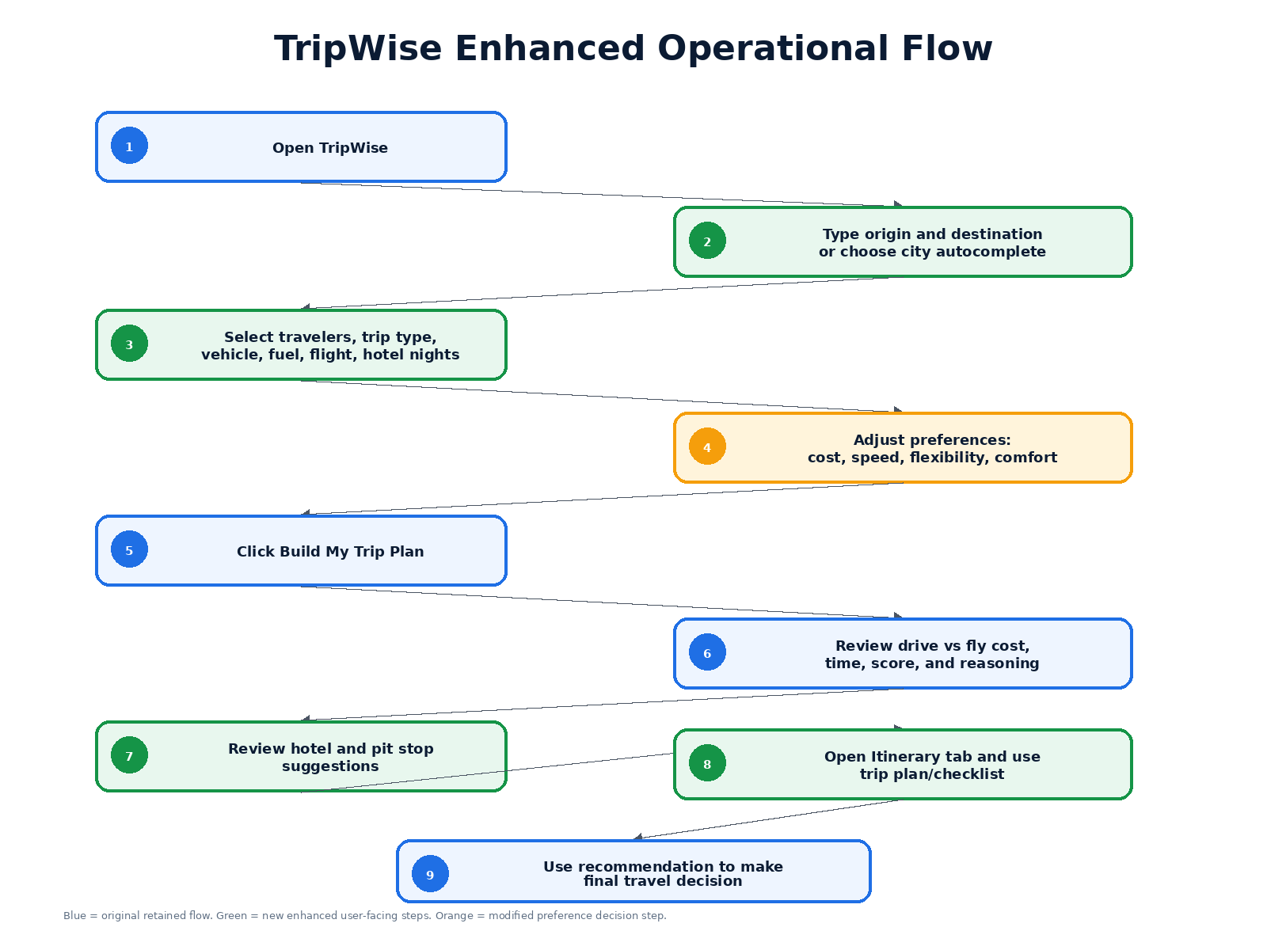

Technical Design Flowchart
The technical design flowchart shows how the updated HTML/CSS/JavaScript implementation processes the user's inputs. New modules include tab navigation, typed city/state input handling, autocomplete support, and itinerary generation. The decision engine was modified to apply preference-based weighting.
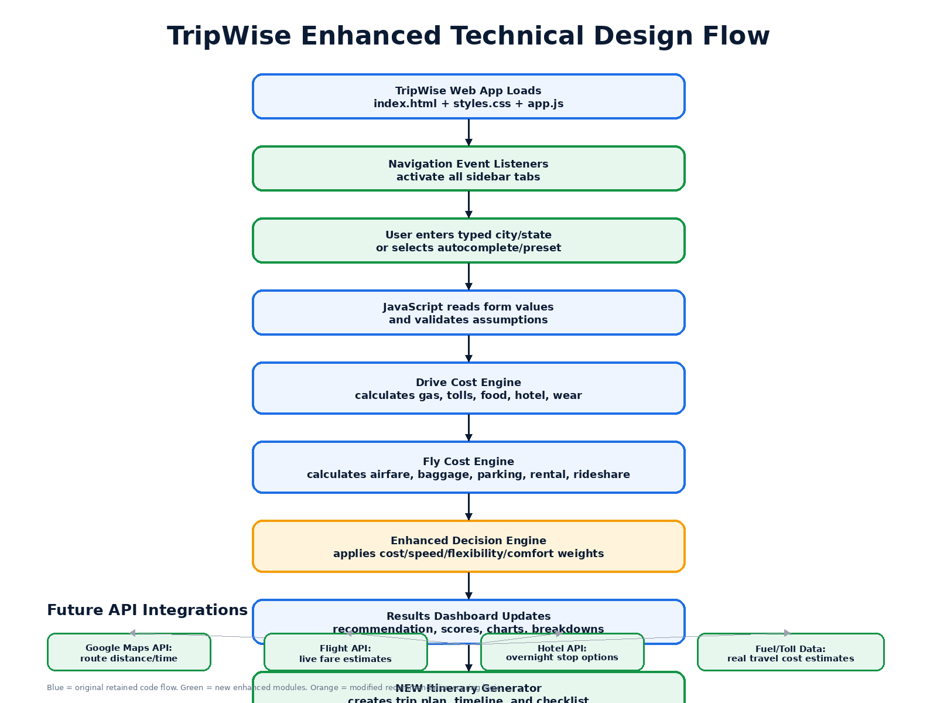

Functional Decomposition
The functional decomposition shows how the enhanced platform breaks into user input collection, drive calculation, fly calculation, enhanced scoring, recommendation display, itinerary generation, and supporting hotel/pit stop functionality.
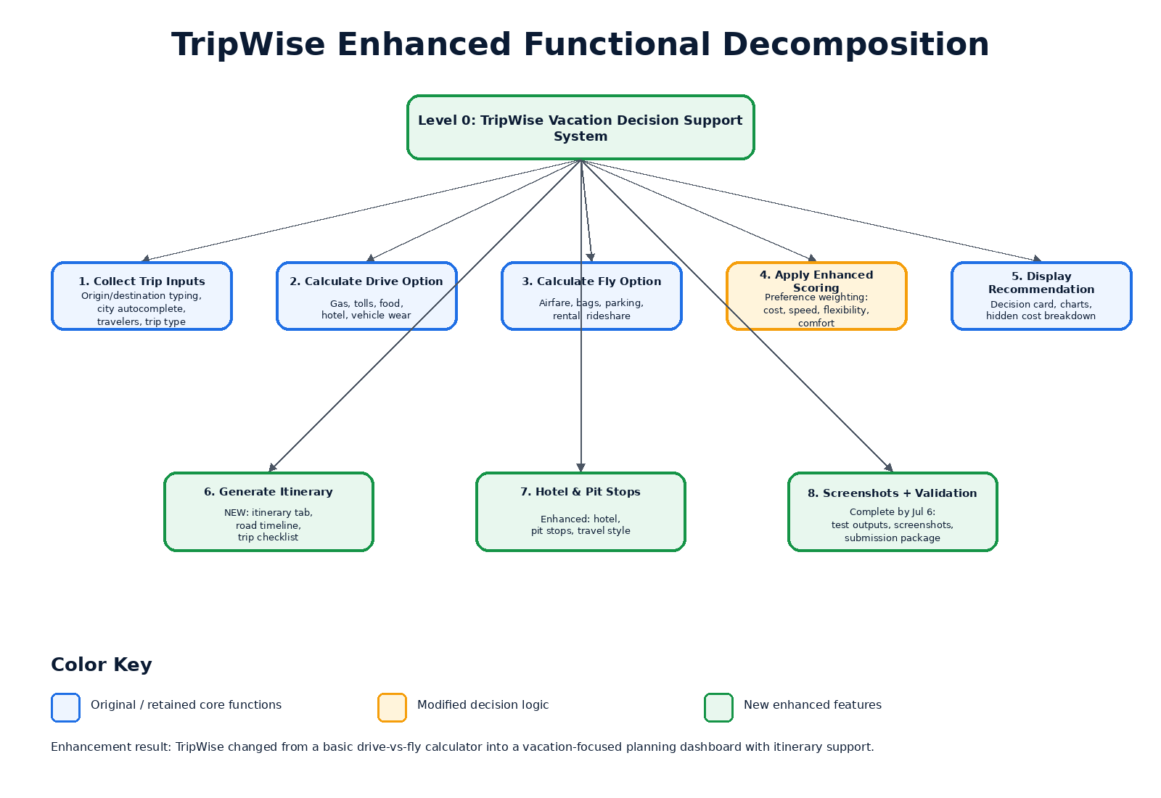
PERT / Critical Path
The updated PERT chart marks all enhancement tasks through July 6 as complete. The critical path is A → B → C → D → E → F, meaning the core enhancement sequence was requirements review, UI updates, typed inputs, preference engine, itinerary/vacation UI, and testing/screenshots.
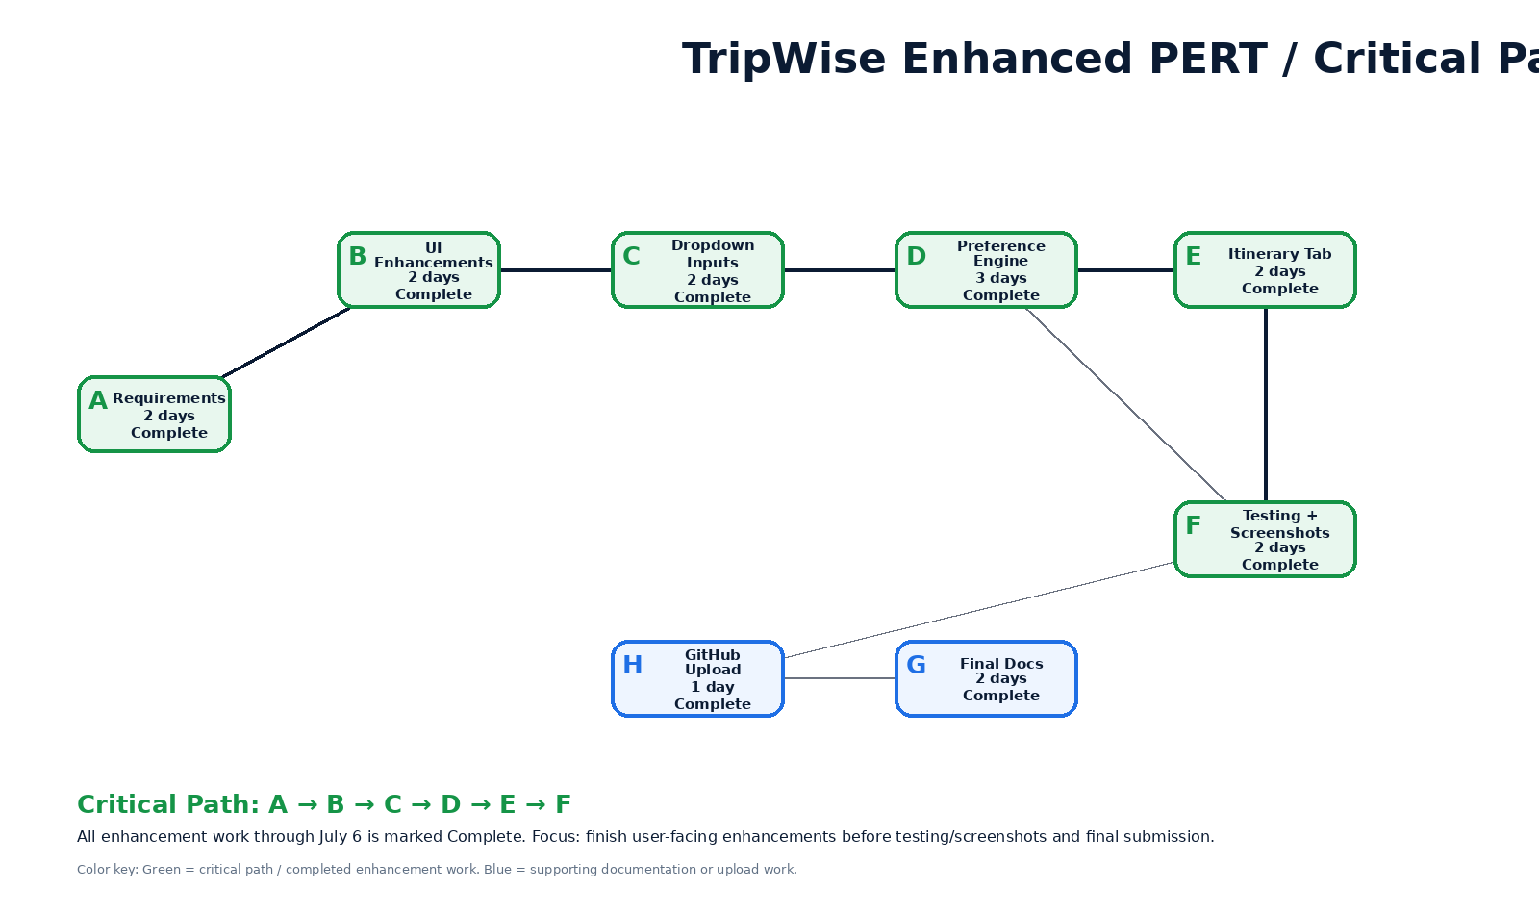

Results of Enhancement
The enhanced implementation produced a more useful website because the user can now type the starting location and destination instead of being restricted to a small dropdown list. All major tabs are functional, and the website now includes a full itinerary page that converts the recommendation into a practical travel plan. The recommendation is also more transparent because it explains cost savings, time difference, hidden costs, and preference impact.
Screenshots
Screenshot 1 confirms the updated Trip Overview page with typed locations, vacation styling, preference weighting, and the recommendation dashboard.
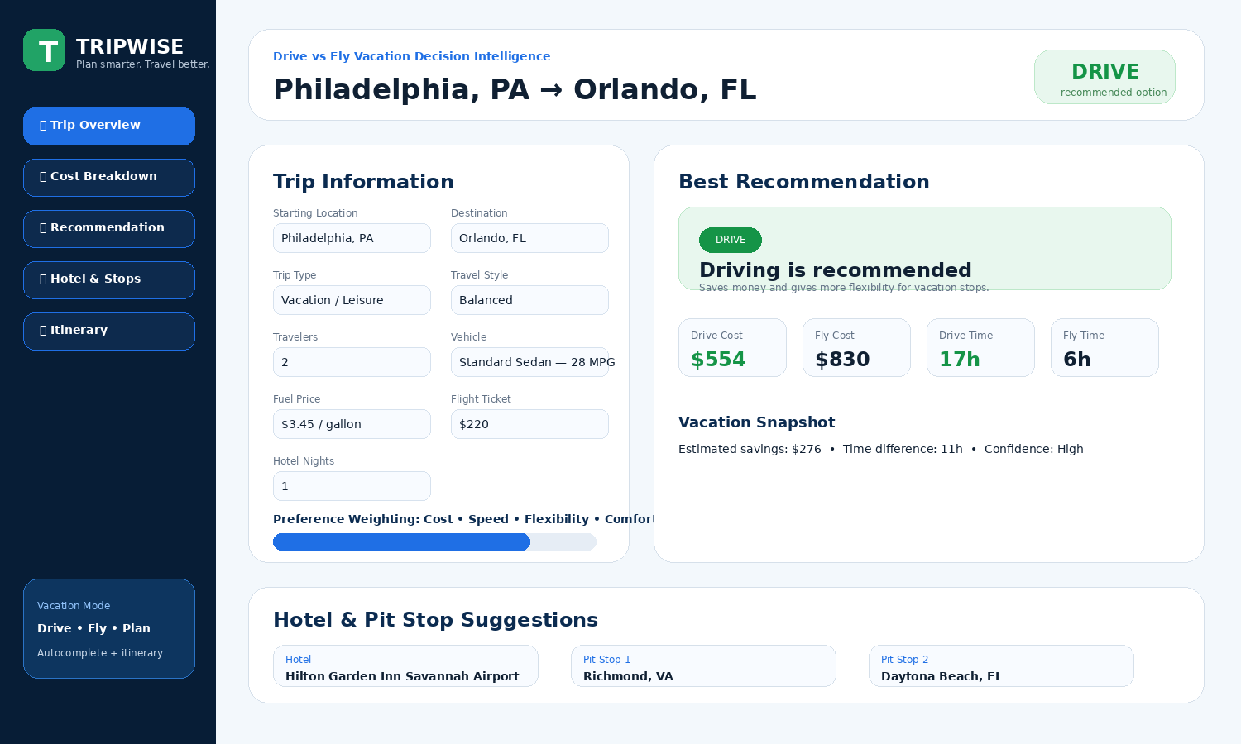
Screenshot 2 confirms the new Itinerary tab, which was added as an enhancement to make the website more useful for travelers.
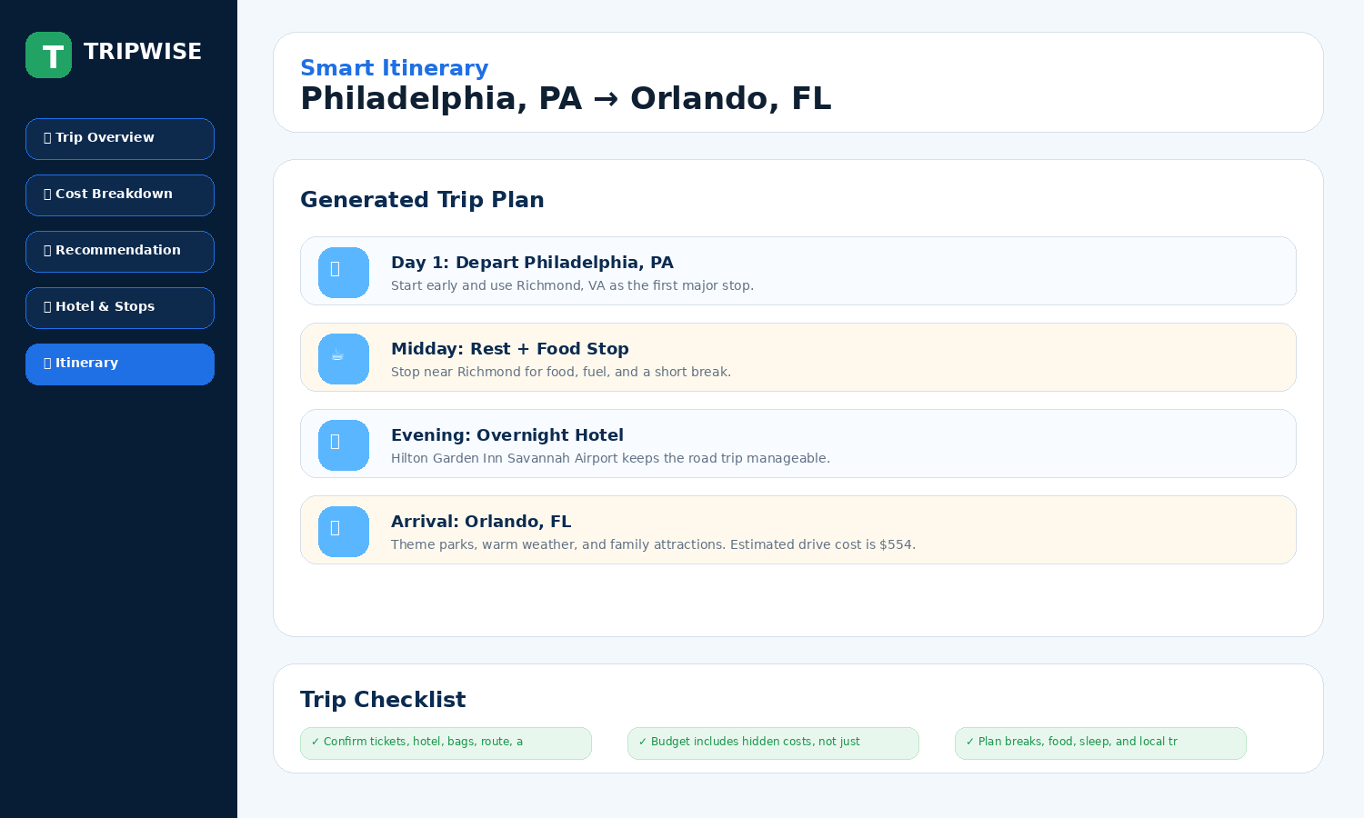
Completion Status Through July 6
All enhanced implementation tasks through July 6 are marked complete in the updated Gantt, Critical Path Analysis, and PERT workbook. The remaining action is to upload the final files to GitHub/Canvas and complete the self-reflection recording if it has not already been recorded.

