RouteWise Compass Enhanced Implementation
AI Generated Enhancement Document with Color-Coded Flowcharts, Results, and Screenshots
1. Enhancement Overview
The original TripWise concept was a simpler drive-versus-fly decision tool. The enhanced implementation changes the platform into RouteWise Compass, a multi-mode travel decision app that compares drive, fly, train, bus, bike, and mixed travel. The purpose of the enhancement is to make the platform more realistic and useful for a traveler who needs a complete plan, not just a cost comparison.
The updated platform now asks for the information that matters most to a travel decision: starting state and city, destination state and city, trip purpose, travelers, available days, budget, lodging preference, luggage amount, bike experience, comfort needs, flexibility needs, and priority sliders for cost, speed, comfort, flexibility, and safety.
2. Color Key Used in the Flowcharts
Color | Meaning | How it applies to RouteWise Compass
Blue | Original / retained | Input collection and general recommendation output were retained from the simple implementation.
Green | New enhancement | New travel modes, city data, route data, USA map, stops/stays, explore page, itinerary, checklist, and backend structure were added.
Orange | Modified logic | The original drive/fly logic was changed into multi-mode weighted scoring and feasibility analysis.
3. Comparative Analysis: Simple Implementation vs Enhanced Implementation
Area | Simple Implementation | Enhanced RouteWise Compass | Modification Type | Result
Project focus | Drive vs fly comparison | Multi-mode travel planner for drive, fly, train, bus, bike, and mixed travel | Green | The app supports more realistic user choices.
Decision logic | Basic travel comparison | Weighted score using cost, speed, comfort, safety, flexibility, and feasibility | Orange | The recommendation is based on user priorities.
Locations | Limited city choices | State filtering, 600+ city suggestions, and manual city typing | Green | The input process is easier and broader.
Map | Weak/abstract route visual | USA map-style route preview with start, destination, route line, and stops | Green | Users can visually understand the route.
Stops and stays | Generic recommendations | Specific curated places with where they are and why to stop or stay there | Green | The output becomes actionable.
Explore nearby | Same logic for every mode | Fly mode shows destination-only attractions; other modes show route plus destination | Orange | The page is more accurate by travel mode.
Evidence | Website only | Screenshots, updated Gantt, Critical Path, PERT, flowcharts, and documentation | Green | Submission evidence is complete.

4. Color-Coded Operational Flowchart
This flowchart shows the user-facing process. Blue steps are retained from the original simple implementation. Green steps are newly added features. Orange steps show the modified decision logic.
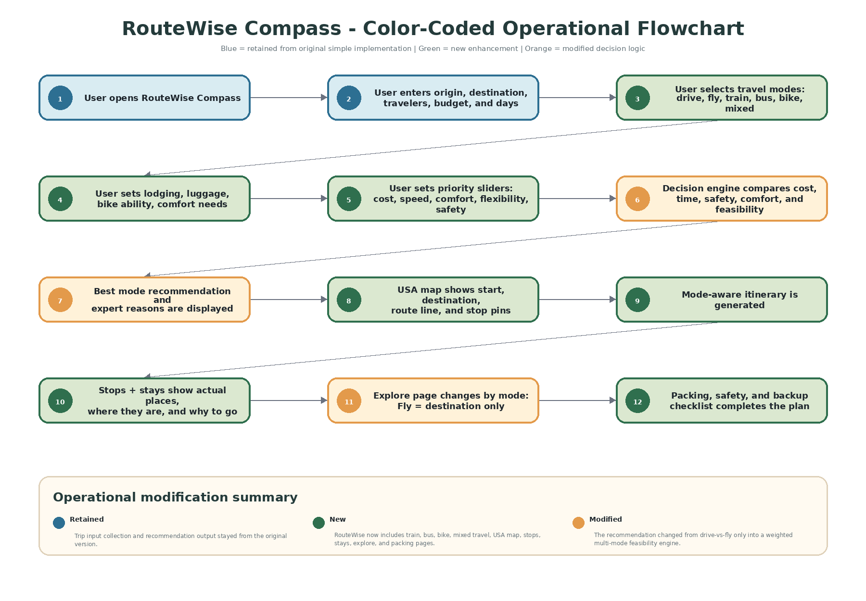

5. Color-Coded Technical Design Flowchart
This flowchart shows how the enhanced website is structured technically. The design now separates page structure, styling, city data, curated route data, scoring logic, map rendering, and the optional backend expansion point.
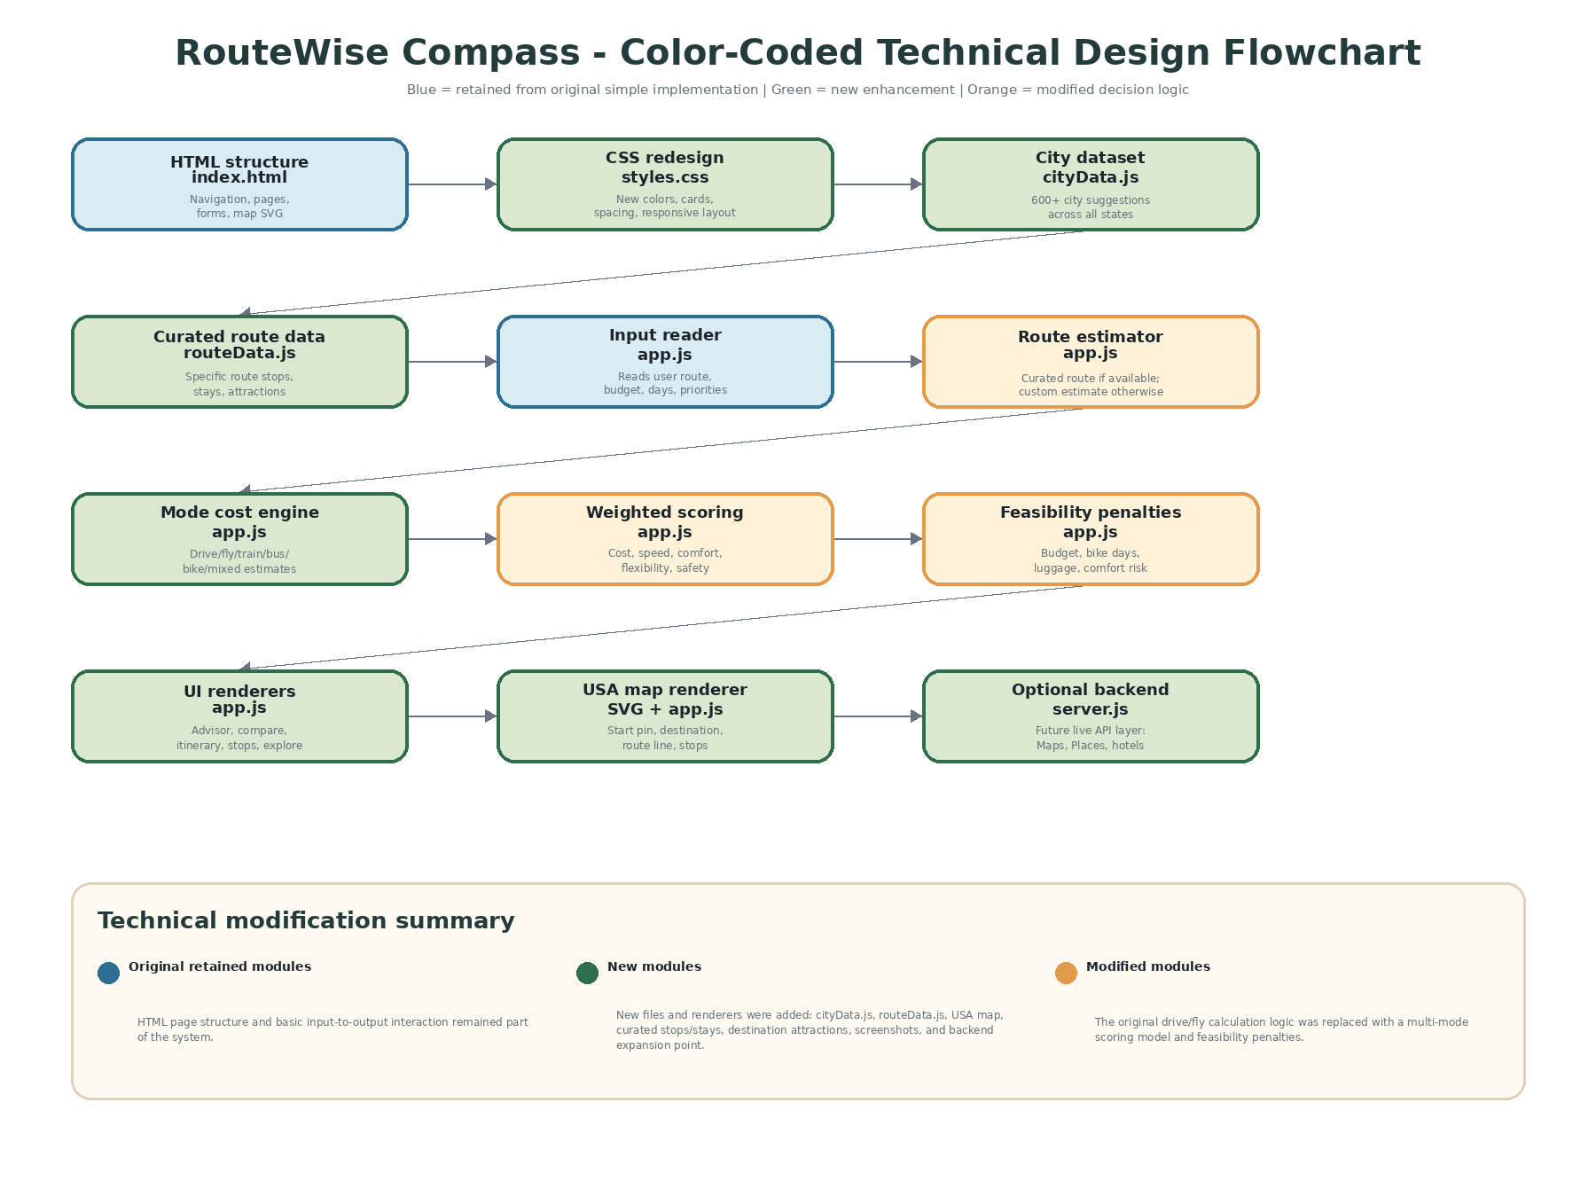

6. Results of the Enhancement
The enhancement result is that RouteWise Compass is now a complete travel planning app instead of a basic calculator. It gives a recommended mode, explains why that mode won, compares all selected options, shows a USA map route preview, generates an itinerary, recommends stops and stays, gives accurate explore suggestions by travel mode, and provides a packing/safety checklist.
For example, on the Philadelphia to Orlando route, the app recommends driving when the user has a five-day vacation, a $1,200 budget, medium luggage, and balanced travel priorities. The app also explains that flying may be faster, but hidden airport costs and local transfer needs reduce its overall value for this input set.
The Explore Nearby page was also corrected. If flying is recommended, it shows only destination attractions after landing because the traveler does not visit road-trip stops. If driving, biking, train, bus, or mixed travel is recommended, the page can show route stops plus destination attractions.
7. Screenshot Evidence
The screenshots below confirm that the enhanced features were implemented successfully.
Screenshot 1: Trip Inputs
Shows the updated input form with state/city selection, budget, days, travel profile, priority sliders, and mode selection.
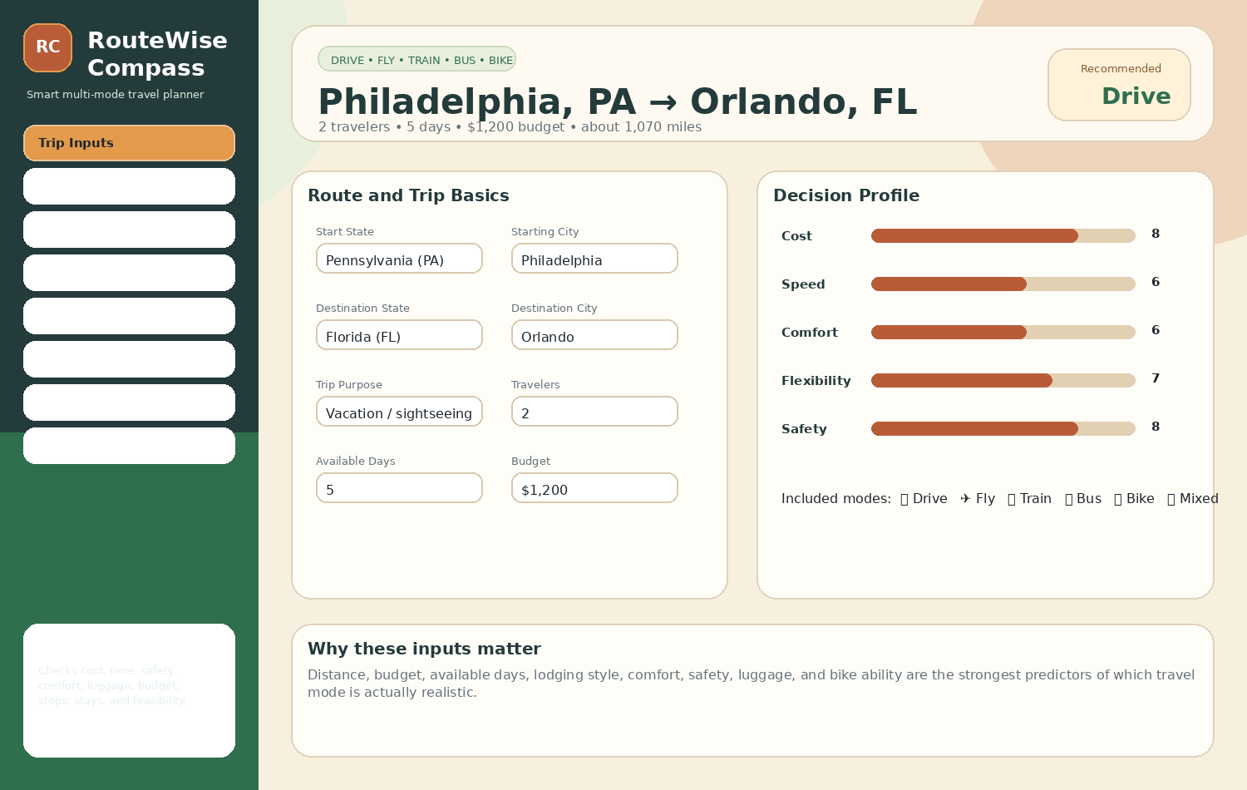
Screenshot 2: Travel Advisor
Shows the recommended travel mode, score, feasibility, and expert reasoning.
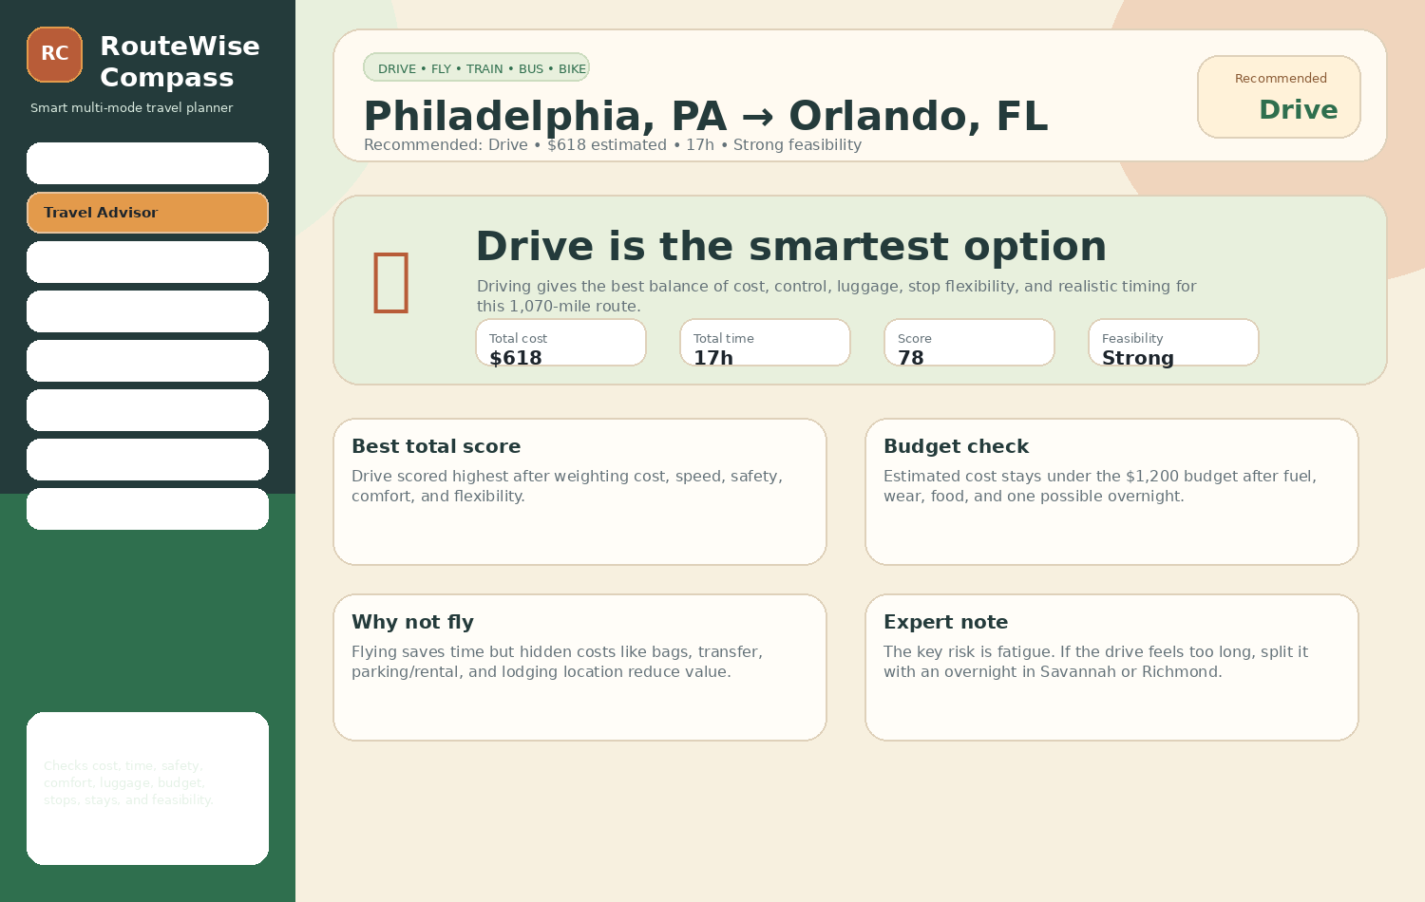

Screenshot 3: USA Map Route
Shows the USA map-style route preview with start, destination, route line, and stops.
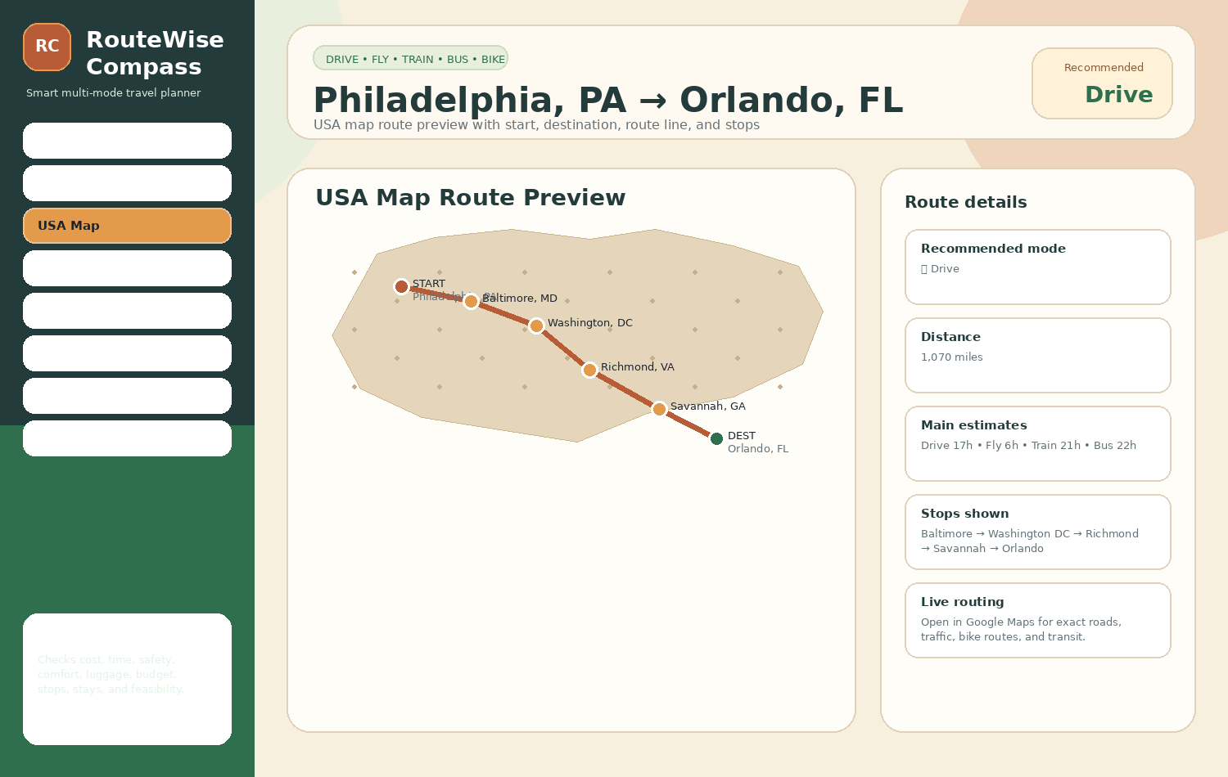
Screenshot 4: Compare Options
Shows drive, fly, train, bus, bike, and mixed travel comparison.
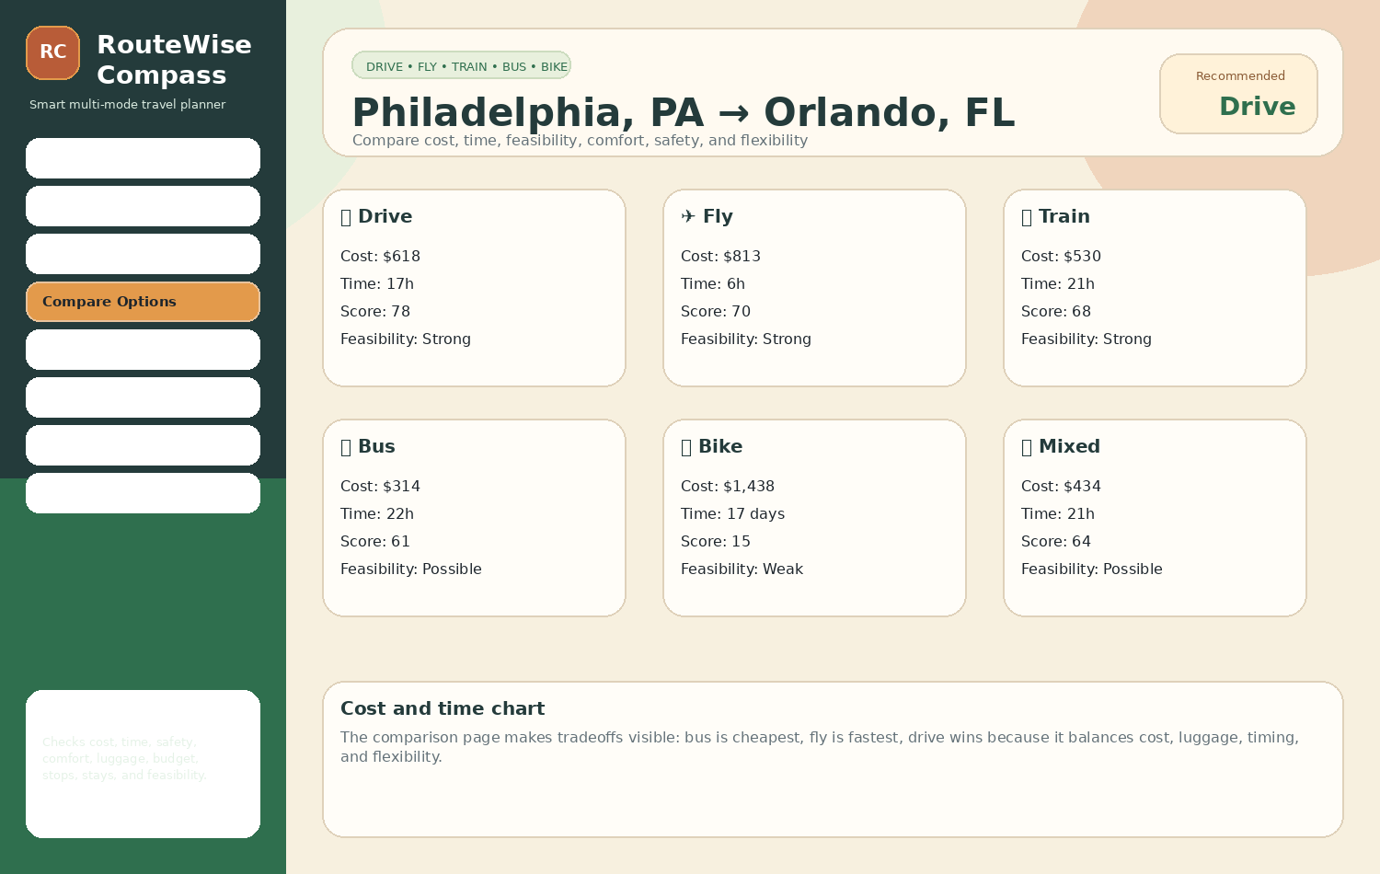

Screenshot 5: Itinerary
Shows the recommended itinerary and step-by-step travel plan.
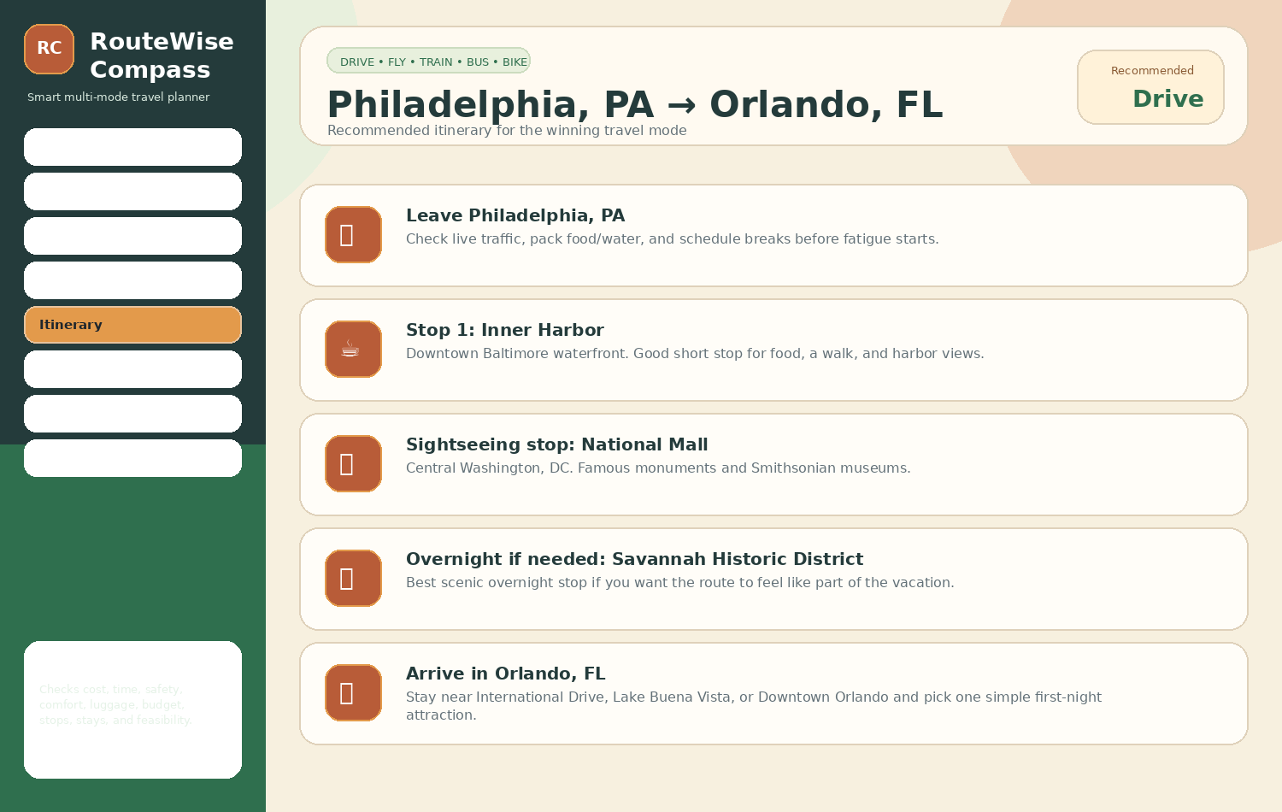
Screenshot 6: Stops + Stays
Shows specific stop and stay suggestions with where they are and why to use them.
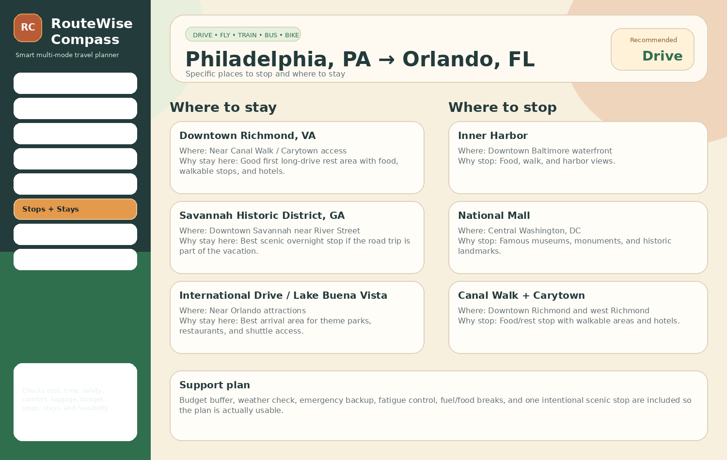

Screenshot 7: Explore Nearby
Shows route and destination attractions, with fly-mode logic corrected to destination-only.
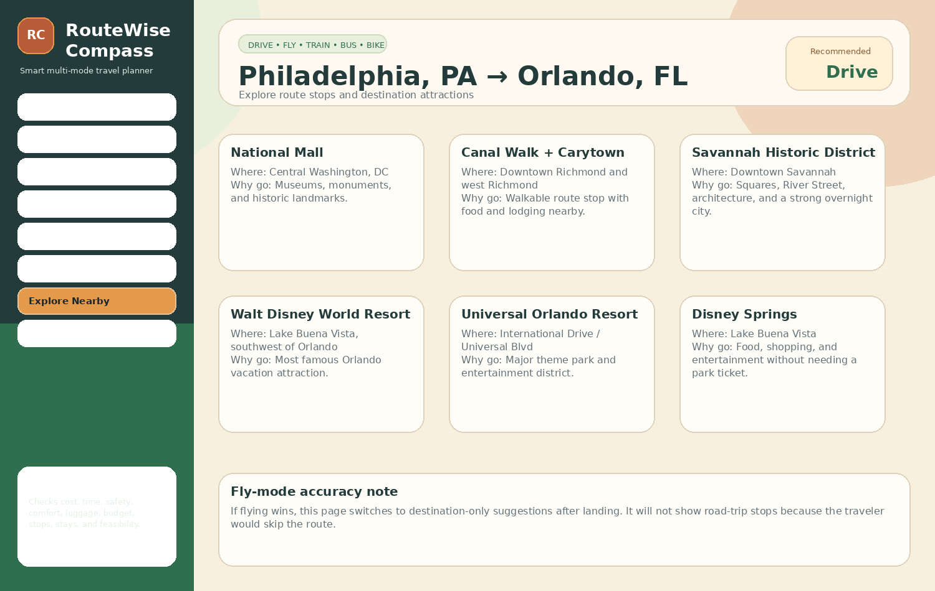
Screenshot 8: Packing + Safety
Shows the final preparation, safety, and backup checklist.
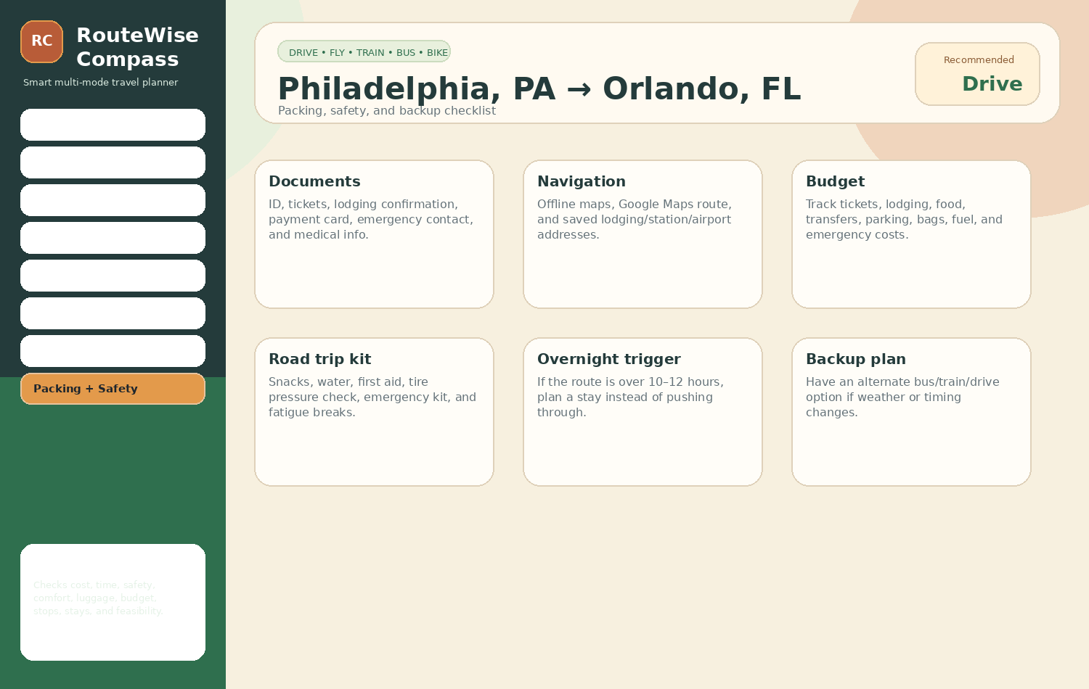
8. Final Completion Status
All requested document elements are included: two color-coded flowcharts, comparison between the simple and enhanced implementation, explanation of results, and screenshot evidence. The updated website, screenshots, Gantt Chart, Critical Path Analysis, and PERT chart are packaged separately for Canvas submission.

