Luminest — System Documentation & Laravel Rebuild Guide
Scope: this documents the current plain-PHP implementation (branch main at commit 4d464db) so it can be rebuilt in Laravel. Every rule below was read from the code, not from the UI or the .docx explainers. Where the code and the apparent intent disagree, both are noted (see §7 Known defects).

Table of contents
- System overview
- Tech stack & project layout
- Roles & access
- Workflows
- Database
- Functions & endpoints reference
- Known defects to fix, not port
- Laravel rebuild blueprint
- Data migration checklist

1. System overview
Luminest is a real-estate management system for a single subdivision (15 blocks, 870 house units, 4 house models). It covers three business processes:
Process | Actors | Summary
House reservation & purchase | Prospect, Property Manager | Prospect reserves a unit (block/lot) → PM accepts/rejects → Prospect “pays” → unit is sold, Prospect becomes Tenant.
Maintenance requests | Tenant, Property Manager, Maintenance Staff | Tenant files a request → PM assigns staff (expertise-matched) → staff works and completes it → Tenant confirms it as resolved.
User administration | Admin | CRUD on all user accounts, including role and staff expertise.
There is no real payment gateway — “Pay Now” immediately marks the reservation paid.

2. Tech stack & project layout
Concern | Current implementation
Language | PHP (procedural scripts + a few classes), no framework
DB | MySQL via PDO (database/db.php)
Migrations/seeds | Phinx (phinx.php, db/migrations, db/seeds) — the only Composer dependency
Frontend | Bootstrap 5 (CDN), jQuery $.ajax (Admin/Tenant/Prospect), vanilla fetch (Property Manager), Font Awesome / Bootstrap Icons
Auth | Native PHP $_SESSION, password_hash/password_verify (bcrypt)
Routing | None — each .php file is a URL. Hard-coded to be served under /luminest/ ($_SERVER['DOCUMENT_ROOT'] . '/luminest/...')
index.php Redirects to welcome.php or view/dashboard.php (latter does not exist)
welcome.php Public marketing landing page (static, placeholder listings)
database/db.php Database/AppDatabase class; also instantiates global $pdo/$conn on include
controllers/
BaseController.php Extends AppDatabase, exposes getDbConnection()
auth/auth_controller.php Login, register, global "must be logged in" guard
auth/profile_controller.php Update profile, change password
auth/reservation_controller.php Reserve, cancel, pay (Prospect)
admin/admin_controller.php Create/update/delete users (Admin)
maintenance/* Tenant + Staff + PM maintenance logic
models/ User, Admin, House, Maintenance (all extend Database → each opens its own PDO connection)
view/<Role>/*.php Pages per role. Property_Manager pages contain their own SQL + AJAX handlers inline
view/house_types/*.php Static detail pages for the 4 house models
view/layout/ header.php (includes auth_controller → acts as auth guard), navbar.php, footer.php
assets/ Images, auth page CSS (luminest.php), PM maintenance JS
db/migrations, db/seeds Phinx schema + seed data
tmp_debug_*.php, *.docx, generate_property_manager_docx.py Debug/explainer leftovers — do not port
Config inconsistency: database/db.php connects on port 3306, phinx.php on 3309. Both use root with an empty password, committed to the repo.

3. Roles & access
Stored in users.role (enum). Session keys set at login: user_id, email, username (= full_name), role, phone_number, expertise, owned_house.
Role | Landing page | Can do
Prospect (default on register) | view/Prospect/dashboard.php | Browse house models, reserve a unit, cancel pending reservation, pay accepted reservation, view reservation history
Tenant | view/Tenant/dashboard.php | File maintenance requests, view own requests, mark completed request as resolved, edit profile
Maintenance_Staff | view/Maintenance_Staff/dashboard.php | View assigned requests, set status in-progress/completed with notes, view history, edit profile/password
Property_Manager | view/Property_Manager/dashboard.php | Dashboard stats, house listings (change unit status), reservations (change status), tenants list, maintenance queue (assign staff), maintenance history, staff list (demote staff)
Admin | view/Admin/dashboard.php | User management CRUD, edit profile/password
Role transitions in code
- Prospect → Tenant: when a reservation becomes paid (by the prospect paying, or by a PM setting status to paid).
- Maintenance_Staff → Prospect: PM “remove staff role” action.
- Any → any: Admin edit user.
How access is enforced today (important: inconsistent — see §7):
- view/layout/header.php includes auth_controller.php, which redirects to login if there is no user_id in session (except on login/register). Pages that include header are therefore login-protected — but only after any code that runs before the include.
- Tenant/Staff controllers check $_SESSION['role'] === '<Role>'.
- Admin controller checks role is admin/administrator (case-insensitive).
- Property Manager pages do not include header.php and use isset(role) && role !== 'Property_Manager', which lets unauthenticated visitors through. reservation_list.php has no check at all.

4. Workflows

4.1 Registration & login
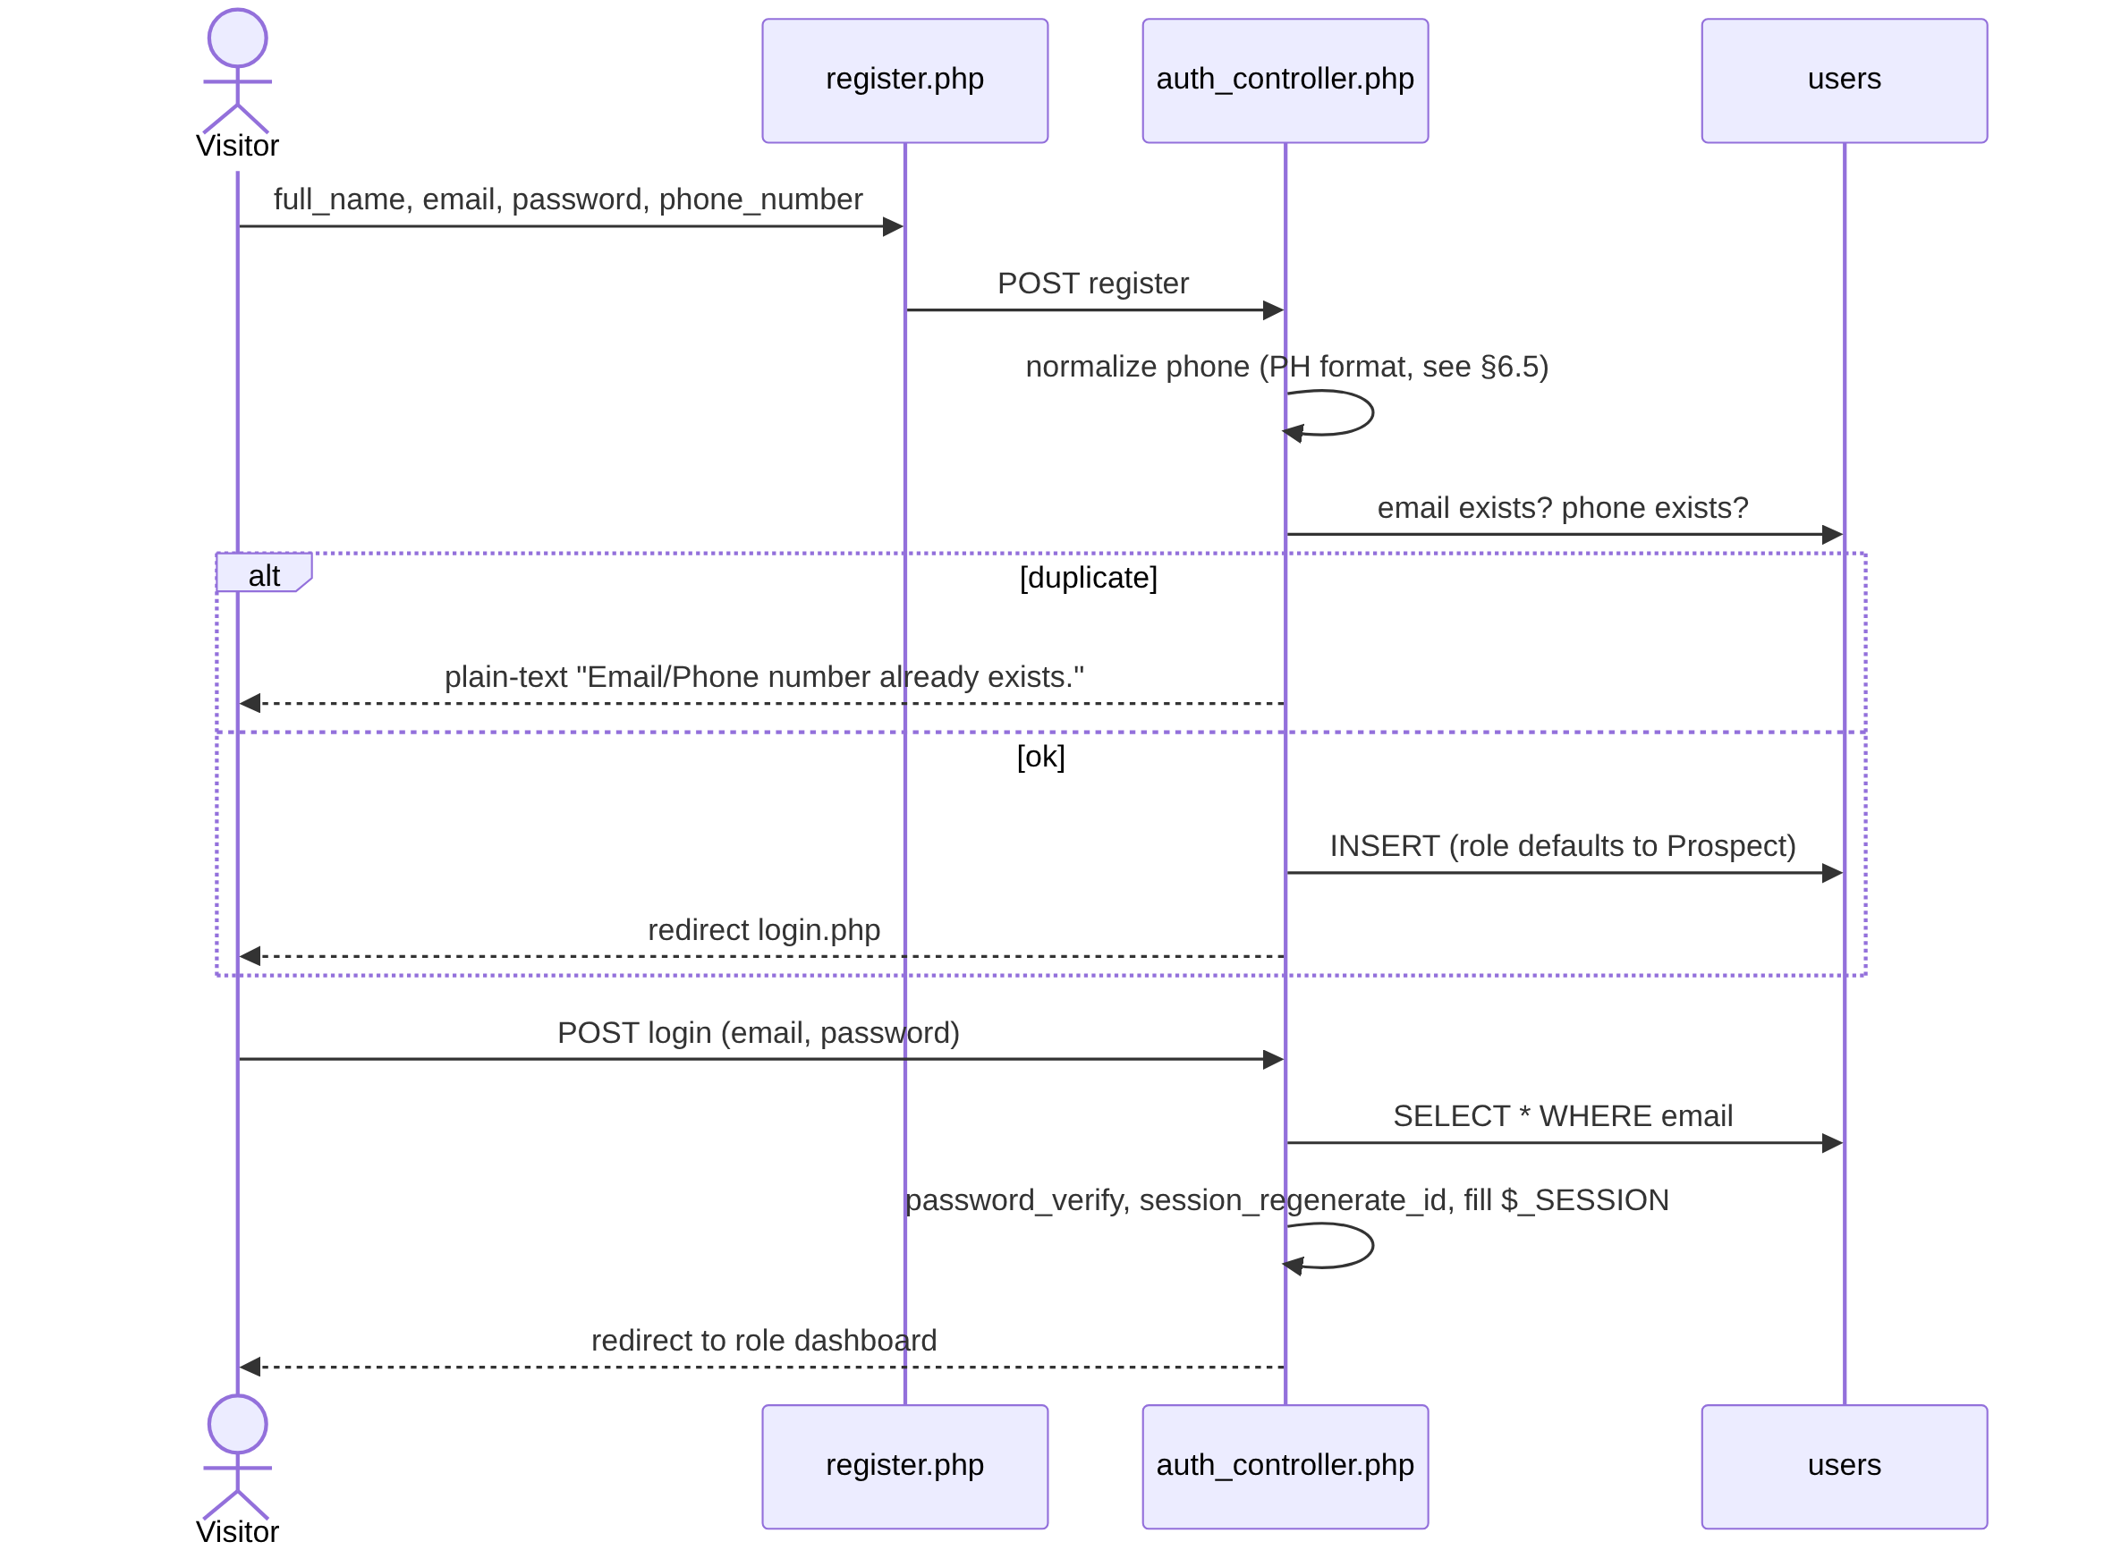
Rules: all four register fields required; email and (normalized) phone must be unique. users.status (Active/Inactive) is not checked on login. Logout = session_unset() + session_destroy() → welcome.php.

4.2 House reservation → purchase
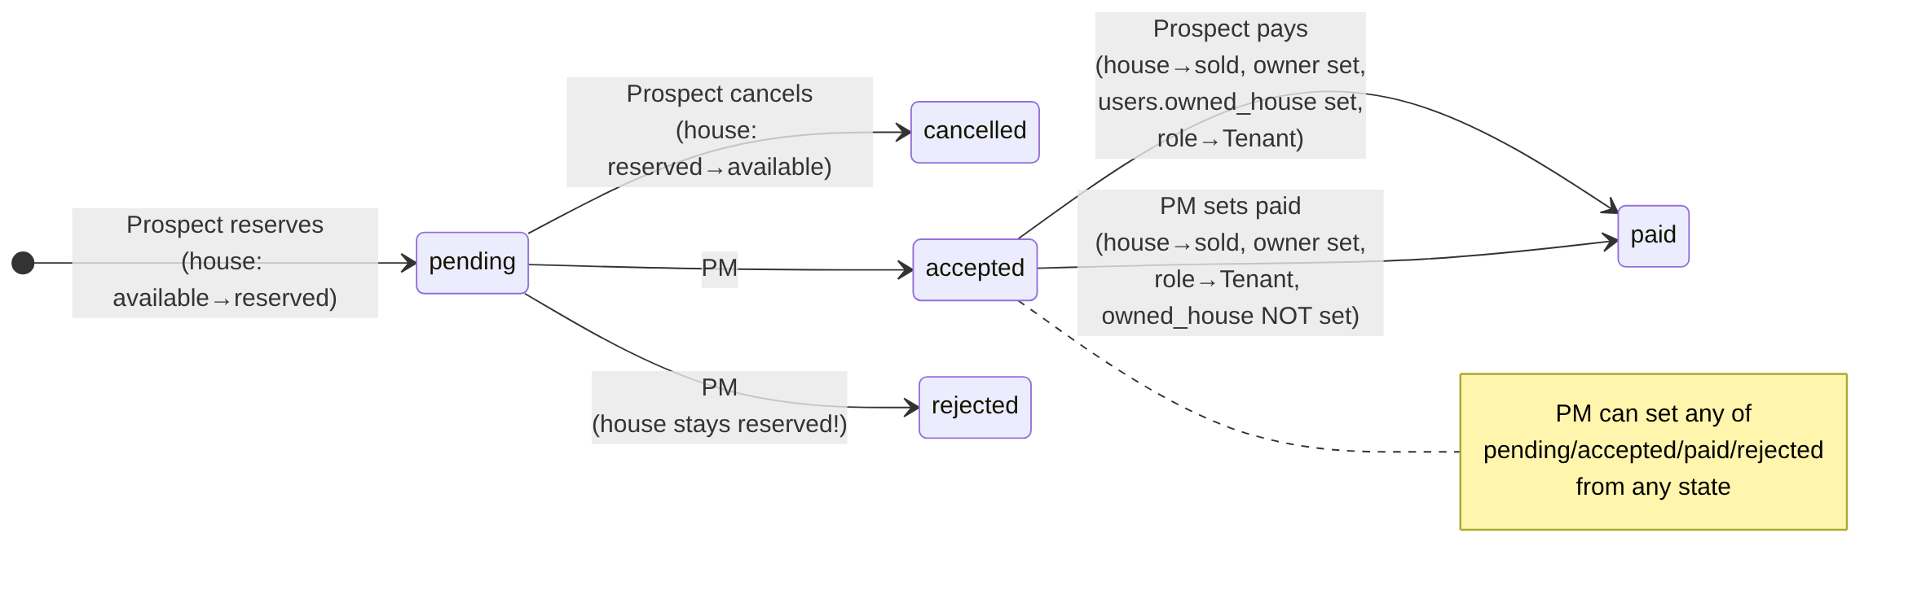
Step detail:
- Browse — Prospect/dashboard.php shows 4 hard-coded house models; detail pages in view/house_types/.
- Pick unit — Prospect/reservation.php?house=<slug>&block=&lot= lists blocks and lots where house.status = 'available' for that model (House::getAvailableBlocks/Lots).
- Reserve (reservation_controller.php, reserve_house):
  - block & lot > 0;
  - user has no other pending reservation (an accepted one does not block a new reservation);
  - unit exists and is available;
  - in a transaction: INSERT house_reservations (pending) + House::markAsReserved (conditional UPDATE WHERE status='available', must affect 1 row → protects against double booking).
- Cancel (cancel_reservation): only own reservation, only when pending. Transaction: reservation → cancelled, unit reserved → available.
- PM decision (Property_Manager/reservation_list.php, action=update_status): sets any of pending|accepted|rejected|paid|cancelled|completed (UI offers the first four). Side effects:
  - accepted → house status='reserved', owner_id = reservation.user_id;
  - paid → house status='sold', owner_id = user; user role Prospect → Tenant;
  - rejected/cancelled/pending → no house change (unit stays reserved forever on reject).
- Pay (pay_reservation): only own reservation, only when accepted. Price shown in modal comes from the hard-coded catalog (JS, window.housePrices). Transaction: reservation → paid; house → sold, owner_id, date_of_purchase = NOW(); users.owned_house = house_id; role Prospect → Tenant; session updated.
The completed reservation status exists in the enum but nothing sets it except the PM endpoint (not offered in the UI).

4.3 Maintenance request lifecycle
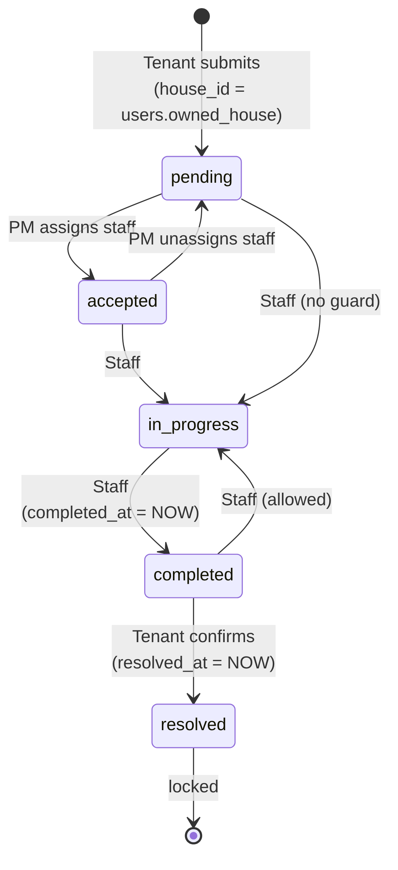
Rules:
- Submit (Tenant): title, category, description required; priority defaults medium. Category must be one of the DB enum values (read live via SHOW COLUMNS). house_id is copied from users.owned_house (NULL if the tenant has none).
- Assign (PM, maintenance.php, action=update_request): staff user must have role Maintenance_Staff; staff expertise must equal the request category, or be general, or be empty. Assigning moves pending → accepted; clearing the assignment moves accepted → pending. PM list hides resolved requests and auto-refreshes every 10 s.
- Work (Staff, maintenance_details.php?id=): status ∈ {in-progress, completed} + optional resolution_notes; completed stamps completed_at. Blocked once resolved.
- Confirm (Tenant): only when completed → resolved, stamps resolved_at.
- History views: Staff = own assigned with status completed|resolved; PM = all completed|resolved.
- Enum values cancelled, rejected, on-hold exist but no code path sets them.

4.4 Admin user management
Admin/user_management.php (list + stats by role/status) → add_user.php, edit_user.php?id=, view_user.php?id=, delete button (AJAX). All post to controllers/admin/admin_controller.php with create_user / update_user / delete_user. Admin can set any role and staff expertise. On update, an empty phone keeps the existing phone. Delete is a hard delete (cascades to reservations and maintenance requests as tenant; nulls staff assignment and house ownership).

4.5 Profile
All roles post to controllers/auth/profile_controller.php:
- update_profile (full_name, email, phone_number) → updates session too.
- change_password (current_password, new_password) → verifies current first. No confirmation/strength rule. Tenant profile page only exposes profile update; Admin and Staff pages expose both. There is no PM profile page, though the controller redirects PMs to one.

4.6 Property Manager dashboard
dashboard.php (and ?ajax=dashboard_data for polling): house counts by status (total/available/reserved/sold), maintenance counts (pending / in-progress / completed+resolved), 5 most recent maintenance requests.

5. Database
MySQL, database luminest. Phinx migration order (by version_order: creation):
# | Migration | Effect
1 | 20260725074539_create_user_table | users
2 | 20260725121630_create_house_reservations_table | house_reservations
3 | 20260725130021_create_house_table | house
4 | 20260725143524_add_paid_status_to_house_reservations_table | adds paid to reservation status
5 | 20260726111749_add_owned_house_to_users_table | users.owned_house FK → house
6 | 20260726115459_create_maintenance_requests_table | maintenance_requests
7 | 20260726115759_add_expertise_to_users_table | users.expertise
8 | 20260726153721_add_date_of_purchase_to_house_table | house.date_of_purchase
9 | 20260727120000_add_unique_index_to_users_phone_number | normalizes phones, unique index
10 | 20260727144840_add_resolved_to_status_in_maintenance_requests_table | adds resolved, on-hold
11 | 20260727145026_add_completed_at_to_maintenance_requests_table | completed_at
12 | 20260728003554_add_status_to_users_table | users.status

5.1 ERD
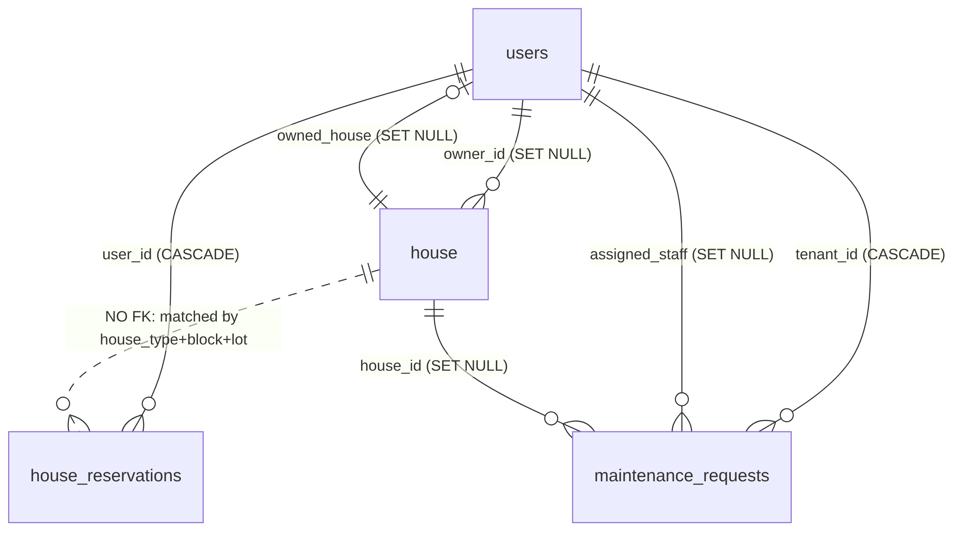

5.2 Tables (final schema after all migrations)

users
Column | Type | Null | Default | Notes
user_id | INT UNSIGNED PK AI | no
full_name | VARCHAR(100) | no |  | stored HTML-escaped (see §7)
email | VARCHAR(150) | no |  | unique
status | ENUM(‘Active’,‘Inactive’) | no | Active | not enforced anywhere
password_hash | VARCHAR(255) | no |  | bcrypt (PASSWORD_DEFAULT)
phone_number | VARCHAR(20) | yes |  | unique (idx_users_phone_number_unique), normalized 09XXXXXXXXX
role | ENUM(‘Admin’,‘Prospect’,‘Property_Manager’,‘Tenant’,‘Maintenance_Staff’) | no | Prospect
expertise | ENUM(‘plumbing’,‘electrical’,‘carpentry’,‘appliance’,‘general’) | yes | NULL | staff only
owned_house | INT UNSIGNED | yes |  | FK → house.house_id ON DELETE SET NULL, ON UPDATE CASCADE (fk_users_owned_house)
created_at, updated_at | TIMESTAMP |  | CURRENT_TIMESTAMP

house (one row per physical unit)
Column | Type | Null | Default | Notes
house_id | INT UNSIGNED PK AI | no
house_type | VARCHAR(255) | no |  | one of Aimee, Angelique_Duplex, Armina_Single, Armina_Duplex (free text, not enforced)
lot | INT | no
block | INT | no |  | no unique (block, lot) constraint
status | ENUM(‘available’,‘sold’,‘reserved’) | no | available
date_of_purchase | DATETIME | yes | NULL | set on prospect payment only
owner_id | INT UNSIGNED | yes |  | FK → users.user_id ON DELETE SET NULL
created_at, updated_at | TIMESTAMP

house_reservations
Column | Type | Null | Default | Notes
reservation_id | INT UNSIGNED PK AI | no
user_id | INT UNSIGNED | no |  | FK → users ON DELETE CASCADE
house_type | VARCHAR(255) | no |  | denormalized copy — no FK to house
block, lot | INT | no
status | ENUM(‘pending’,‘cancelled’,‘rejected’,‘accepted’,‘completed’,‘paid’) | no | pending
created_at, updated_at | TIMESTAMP

maintenance_requests
Column | Type | Null | Default | Notes
id | INT UNSIGNED PK AI | no
tenant_id | INT UNSIGNED | no |  | FK → users ON DELETE CASCADE, indexed
house_id | INT UNSIGNED | yes |  | FK → house ON DELETE SET NULL, indexed
title | VARCHAR(150) | no
description | TEXT | yes
category | ENUM(‘plumbing’,‘electrical’,‘carpentry’,‘appliance’,‘general’) | no | general
priority | ENUM(‘low’,‘medium’,‘high’,‘urgent’) | no | medium | indexed
status | ENUM(‘pending’,‘accepted’,‘in-progress’,‘completed’,‘resolved’,‘cancelled’,‘rejected’,‘on-hold’) | no | pending | indexed
completed_at | DATETIME | yes |  | set by staff
assigned_staff | INT UNSIGNED | yes |  | FK → users ON DELETE SET NULL
resolution_notes | TEXT | yes
resolved_at | TIMESTAMP | yes |  | set by tenant
created_at, updated_at | TIMESTAMP
phinxlog — Phinx bookkeeping, do not migrate.

5.3 Seed data
- UserSeeder — truncates users, creates one account per role, password password123: prospect@, tenant@, staff@, manager@, admin@luminest.com.
- HouseSeeder — truncates house, generates 870 available units:
Blocks | Lots per block | Model
1, 8 | 20 | Angelique_Duplex
2 | 10 | Armina_Single
3 | 20 | Armina_Single
4 | 30 | Armina_Duplex
5, 6, 7 | 80 | Armina_Single
9 | 50 | Aimee
10 | 80 | Aimee
11, 12, 13 | 100 | Aimee
14 | 60 | Aimee
15 | 20 | Aimee

5.4 House model catalog (hard-coded, not in DB)
Defined in models/House.php ($houseTypes) and duplicated in view/Prospect/dashboard.php and view/house_types/*.php.
slug | db_type | Title | Type | Bed | Bath | Carport | Price (PHP)
aimee | Aimee | Aimee Rowhouse | One-Storey Rowhouse | 1 | 1 | 0 | 1,500,000
angelique_duplex | Angelique_Duplex | Angelique Duplex | Two-Storey Duplex | 2 | 1 | 1 | 2,500,000
armina_single | Armina_Single | Armina Single | Two-Storey Single | 3 | 1 | 1 | 3,500,000
armina_duplex | Armina_Duplex | Armina Duplex | Two-Storey Duplex | 3 | 1 | 1 | 4,000,000
Unknown slugs silently fall back to aimee.

6. Functions & endpoints reference

6.1 Models
Database / AppDatabase (database/db.php) — opens a PDO connection (exceptions on, assoc fetch). Including the file also creates globals $db, $pdo, $conn. Every model extends it, so every new Model() opens a new connection.
User (models/User.php)
Method | Purpose
create() | Insert from public props (full_name, email, password, phone_number); role defaults to Prospect
readByEmail($email) / getLoginUserByEmail($email) | Identical: full row by email
emailExists($email) / phoneNumberExists($phone) | Uniqueness checks (phone normalized first)
getByID($id) | Full row
updateProfile($id, $name, $email, $phone) | Update name/email/phone
updatePassword($id, $new) | Re-hash and save
normalizePhoneNumber() (private) | See §6.5
Admin (models/Admin.php) — getAllUsers(), getUserById($id), createUser($name, $email, $password, $role, $expertise, $phone), updateUser($id, $name, $email, $role, $expertise, $phone) (blank phone keeps existing), deleteUser($id), normalizePhoneNumber().
House (models/House.php)
Method | Purpose
all(), getBySlug($slug), exists($slug), getByDbType($type) | Catalog lookups
getAvailableBlocks($type) | Distinct blocks with ≥1 available unit of that model
getAvailableLots($type, $block) | Available lots in a block
getHouseByTypeBlockLot($type, $block, $lot) | Single unit row
markAsReserved($houseId) | available → reserved (atomic, returns true if 1 row changed)
markAsAvailableByUnit($type, $block, $lot) | reserved → available, clears owner/purchase date
Maintenance (models/Maintenance.php)
Method | Purpose
createRequest($tenantId, $title, $category, $description, $priority) | Validates category, links owned_house, inserts pending
getRequestCategoryOptions() | Parses the enum from SHOW COLUMNS
getRequestsByTenant($tenantId) | Tenant list + staff name + formatted address Block X, Lot Y (Type)
getRequestsByStaff($staffId) | Assigned list + tenant name + address
getRequestByIdForStaff($id, $staffId) | Single request — ignores $staffId
getRequestByIdForTenant($id, $tenantId) | Single request owned by tenant
updateRequestStatusByStaff($id, $staffId, $status, $notes) | in-progress/completed only, blocked if resolved — ignores $staffId
markRequestAsResolvedByTenant($id, $tenantId) | completed → resolved
getHistoryByStaff($staffId) | Staff’s completed/resolved requests
PropertyManagerMaintenanceController (controllers/maintenance/property_manager_maintenance_controller.php) — the only OO controller. handleRequest() dispatches POST action=update_request (assign/unassign staff) and GET ajax=search; exposes getRequests(), getStaffList(), badge/label formatters. It introspects the schema at runtime (SHOW TABLES, SHOW COLUMNS) to tolerate id/request_id and assigned_staff/assigned_staff_id variants — pointless now the schema is fixed; drop it in Laravel.

6.2 Endpoint inventory (what each URL accepts)
Current URL | Method / trigger param | Role | Action | Laravel route suggestion
controllers/auth/auth_controller.php | POST login | public | Login | POST /login
〃 | POST register | public | Register | POST /register
view/auth/logout.php | GET | any | Logout | POST /logout
controllers/auth/profile_controller.php | POST update_profile | any | Update profile | PUT /profile
〃 | POST change_password | any | Change password | PUT /profile/password
view/Prospect/reservation.php | GET house, block, lot | logged in | Unit picker | GET /reservations/create?house=
controllers/auth/reservation_controller.php | POST reserve_house (house, block, lot) | logged in | Create reservation | POST /reservations
〃 | POST cancel_reservation (reservation_id) | owner | Cancel | POST /reservations/{r}/cancel
〃 | POST pay_reservation (reservation_id) | owner | Pay | POST /reservations/{r}/pay
view/Prospect/history.php | GET | logged in | My reservations | GET /reservations
controllers/maintenance/maintenance_request_controller.php | POST submit_request | Tenant | New maintenance request | POST /tenant/maintenance
view/Tenant/maintenance_history.php | GET | Tenant | My requests | GET /tenant/maintenance
view/Tenant/maintenance_details.php?id= | GET / POST mark_resolved | Tenant | Show / resolve | GET /tenant/maintenance/{m}, POST …/{m}/resolve
view/Maintenance_Staff/maintenance_requests.php | GET | Staff | Assigned list | GET /staff/maintenance
view/Maintenance_Staff/maintenance_details.php?id= | GET / POST update_request (status, resolution_notes) | Staff | Show / update | GET /staff/maintenance/{m}, PATCH …/{m}
view/Maintenance_Staff/maintenance_history.php | GET | Staff | History | GET /staff/maintenance/history
view/Property_Manager/dashboard.php | GET, ?ajax=dashboard_data | PM | Stats | GET /pm/dashboard (+ JSON)
view/Property_Manager/listings.php | GET ?ajax=search&q&status; POST action=update_status (house_id, status) | PM | Units list / set status | GET /pm/houses, PATCH /pm/houses/{h}
view/Property_Manager/reservation_list.php | POST action=update_status (reservation_id, status) | PM (unchecked!) | Decide reservation | PATCH /pm/reservations/{r}
view/Property_Manager/tenants.php | GET ?ajax_search&q | PM | Tenants + reservations | GET /pm/tenants
view/Property_Manager/maintenance.php | GET ?ajax=search&q&status&priority; POST action=update_request (request_id, assigned_staff_id) | PM | Queue / assign | GET /pm/maintenance, PATCH /pm/maintenance/{m}/assign
view/Property_Manager/maintenance_history.php | GET ?ajax=search&q&status | PM | Closed requests | GET /pm/maintenance/history
view/Property_Manager/maintenance_staff.php | GET ?ajax=search&q; POST action=remove_staff_role (user_id) | PM | Staff list (+active/completed counts) / demote | GET /pm/staff, DELETE /pm/staff/{u}
controllers/admin/admin_controller.php | POST create_user / update_user / delete_user | Admin | User CRUD | Route::resource('admin/users', …)
AJAX convention: request is AJAX if header X-Requested-With is set or ajax=1; responses are {success, message, redirect?, data?} JSON, otherwise a redirect with ?error=<code> / ?success=<code> query flags.

6.3 Search fields (PM pages)
Page | Searched columns
Listings | house_type, block, lot, status, owner name, owner email (+ status filter)
Tenants | name, email, phone, reservation house_type/block/lot/status
Maintenance | title, description, category, status, tenant name, staff name (+ status, priority filters; excludes resolved)
Maintenance history | title, category, tenant name, staff name (+ status filter; only completed/resolved)
Staff | name, email, phone, user_id

6.4 UI badge mappings (keep for visual parity)
- Maintenance status: resolved=success, accepted=primary, in-progress=info, on-hold=warning, cancelled/rejected=danger, else secondary.
- Priority: urgent=danger, high=warning, medium=primary, low=secondary.
- Reservation: pending=warning, accepted=primary/success, paid=success/info, rejected=danger, cancelled=secondary, completed=primary.
- House: available=success, reserved=warning, sold=danger.

6.5 Phone normalization (duplicated in 4 places)
Strip non-digits, then: 63XXXXXXXXXX (12 digits) → 0XXXXXXXXXX; 11 digits starting with 0 → unchanged; 10 digits not starting with 0 → prefix 0; anything else → digits as-is. Empty → ''.

7. Known defects to fix, not port
Ordered by severity. Do not replicate these in Laravel; several also affect how existing data must be migrated.
Security
- Property Manager area is open to anonymous users. view/Property_Manager/{dashboard,listings,tenants,maintenance_history,maintenance_staff}.php:5 and property_manager_maintenance_controller.php:22 only redirect when a role is set and different; no session → full access, including the write actions (change house status, demote staff, assign staff).
- view/Property_Manager/reservation_list.php has no auth check at all — anyone can POST action=update_status&status=paid, which marks a unit sold and promotes the user to Tenant.
- Staff IDOR — Maintenance::getRequestByIdForStaff and updateRequestStatusByStaff accept $staff_id but never filter on it (models/Maintenance.php:107). Any staff member can view and change any request.
- No CSRF protection on any form or AJAX write.
- Raw exception messages ($e->getMessage(), die('Connection failed: …')) are returned to the browser.
- DB root credentials with empty password committed to the repo.
Data integrity / logic
- Passwords are mutated before hashing — htmlspecialchars(strip_tags($password)) in models/User.php:27,133 and models/Admin.php:64, while login uses the raw password. A password containing <, >, &, ", ' either cannot log in or is weakened. See §9 for the migration consequence.
- Names and emails are stored HTML-escaped (O'Brien → O&#039;Brien). Escape on output instead.
- Rejecting a reservation does not release the unit — it stays reserved permanently.
- PM “accepted” sets house.owner_id before payment; PM “paid” does not set users.owned_house or date_of_purchase → that tenant’s maintenance requests get house_id = NULL.
- house_reservations references a unit by (house_type, block, lot) instead of house_id; house has no unique (block, lot) constraint.
- A users.owned_house single column + house.owner_id duplicate the same fact in two places and can drift; a user can only own one house.
- PM dashboard counts in_progress but the DB value is in-progress (view/Property_Manager/dashboard.php:56) → “In progress” is always 0; accepted isn’t counted anywhere.
- Staff can set status on a pending (unassigned) request, and can move completed back to in-progress.
- Admin createUser inserts expertise = '' and phone_number = '' for non-staff/no-phone users — '' is not a valid enum value (fails under strict SQL mode) and a second empty phone violates the unique index.
- Admin can delete their own account; users.status (Inactive) is never enforced at login.
- Priority is not validated server-side on maintenance submit.
- Dead links: index.php:10 → view/dashboard.php, view/auth/register.php:14 → ../dashboard.php, profile redirect → view/Property_Manager/profile.php — none exist. Navbar has no Prospect or PM menu.
- House catalog and prices hard-coded in three places; price shown in the pay modal comes from client-side JS.
- Payment is simulated; there is no payment record (amount, reference, timestamp beyond updated_at).

8. Laravel rebuild blueprint
Opinionated recommendations. The goal is a faithful port of the business rules in §4, not of the file structure.

8.1 Stack
- Laravel 11/12, PHP 8.2+, MySQL 8.
- Auth scaffolding: Laravel Breeze (Blade) — closest to the current server-rendered Bootstrap pages; swap Tailwind for Bootstrap or keep Tailwind. Gives login, register, profile, password change, CSRF, session regeneration for free.
- Interactivity (live search, 10 s polling): Livewire 3 fits the PM tables well; plain Blade + fetch also works. Don’t go SPA unless there is a reason.

8.2 Schema (Laravel migrations)
Keep table names close to the current ones to simplify data import, but normalize:
// users — use Laravel conventions: id, name, email, password, remember_token
Schema::create('users', function (Blueprint $t) {
$t->id();
$t->string('name', 100);
$t->string('email', 150)->unique();
$t->string('phone_number', 20)->nullable()->unique();
$t->string('password');
$t->string('role', 30)->default('prospect')->index(); // backed by App\Enums\Role
$t->string('expertise', 20)->nullable(); // App\Enums\MaintenanceCategory
$t->boolean('is_active')->default(true);
$t->rememberToken();
$t->timestamps();
});
Schema::create('house_types', function (Blueprint $t) { // replaces the hard-coded catalog
$t->id();
$t->string('slug')->unique(); // aimee, angelique_duplex, ...
$t->string('code')->unique(); // Aimee, Angelique_Duplex, ... (legacy value)
$t->string('name'); $t->string('category'); // "Aimee Rowhouse", "One-Storey Rowhouse"
$t->text('description')->nullable(); $t->string('short_description')->nullable();
$t->string('badge')->nullable(); $t->string('image_path')->nullable();
$t->unsignedTinyInteger('bedrooms'); $t->unsignedTinyInteger('bathrooms'); $t->unsignedTinyInteger('carports');
$t->decimal('price', 12, 2);
$t->timestamps();
});
Schema::create('houses', function (Blueprint $t) {
$t->id();
$t->foreignId('house_type_id')->constrained();
$t->unsignedSmallInteger('block');
$t->unsignedSmallInteger('lot');
$t->string('status', 20)->default('available')->index(); // App\Enums\HouseStatus
$t->foreignId('owner_id')->nullable()->constrained('users')->nullOnDelete();
$t->timestamp('purchased_at')->nullable();
$t->timestamps();
$t->unique(['block', 'lot']);
});
Schema::create('reservations', function (Blueprint $t) {
$t->id();
$t->foreignId('user_id')->constrained()->cascadeOnDelete();
$t->foreignId('house_id')->constrained(); // real FK instead of type/block/lot
$t->string('status', 20)->default('pending')->index(); // App\Enums\ReservationStatus
$t->timestamp('decided_at')->nullable();
$t->foreignId('decided_by')->nullable()->constrained('users')->nullOnDelete();
$t->timestamp('paid_at')->nullable();
$t->timestamps();
});
Schema::create('payments', function (Blueprint $t) { // new: record what was paid
$t->id();
$t->foreignId('reservation_id')->constrained();
$t->decimal('amount', 12, 2);
$t->string('method')->default('simulated');
$t->string('reference')->nullable();
$t->timestamps();
});
Schema::create('maintenance_requests', function (Blueprint $t) {
$t->id();
$t->foreignId('tenant_id')->constrained('users')->cascadeOnDelete();
$t->foreignId('house_id')->nullable()->constrained()->nullOnDelete();
$t->foreignId('assigned_staff_id')->nullable()->constrained('users')->nullOnDelete();
$t->string('title', 150);
$t->text('description')->nullable();
$t->string('category', 20)->default('general'); // App\Enums\MaintenanceCategory
$t->string('priority', 10)->default('medium')->index(); // App\Enums\Priority
$t->string('status', 20)->default('pending')->index(); // App\Enums\MaintenanceStatus
$t->text('resolution_notes')->nullable();
$t->timestamp('completed_at')->nullable();
$t->timestamp('resolved_at')->nullable();
$t->timestamps();
});
Notes:
- Use string columns + PHP backed enums instead of MySQL ENUM; adding a value then no longer needs a migration, and Eloquent casts give type safety.
- Drop users.owned_house; derive ownership via $user->houses() (houses.owner_id). If a tenant can only file maintenance for one house, pick it from that relation (or let the tenant choose if they own several).
- Hyphenated in-progress → use in_progress in the enum and map during import.

8.3 Enums (app/Enums)
Enum | Cases
Role | Admin, PropertyManager, MaintenanceStaff, Tenant, Prospect
HouseStatus | Available, Reserved, Sold
ReservationStatus | Pending, Accepted, Rejected, Cancelled, Paid (drop unused completed unless the business needs a post-turnover state)
MaintenanceCategory | Plumbing, Electrical, Carpentry, Appliance, General
Priority | Low, Medium, High, Urgent
MaintenanceStatus | Pending, Accepted, InProgress, Completed, Resolved (+ Cancelled, Rejected, OnHold only if you build the flows that set them)
Put allowed transitions on the enum (e.g. MaintenanceStatus::canTransitionTo()), so the rules in §4 live in one place.

8.4 Models & relationships
User hasMany Reservation; hasMany House (owner_id); hasMany MaintenanceRequest (tenant_id);
hasMany MaintenanceRequest as assignedRequests (assigned_staff_id)
HouseType hasMany House
House belongsTo HouseType; belongsTo User as owner; hasMany Reservation; hasMany MaintenanceRequest
Reservation belongsTo User; belongsTo House; hasOne Payment
MaintenanceRequest belongsTo User as tenant; belongsTo User as staff; belongsTo House
Useful scopes: House::available(), MaintenanceRequest::open() (not resolved), ::closed() (completed|resolved), User::staff(), User::tenants().

8.5 Authorization
- Middleware role:admin, role:property_manager, … on route groups (a small custom EnsureUserHasRole middleware, or spatie/laravel-permission if roles will grow).
- Policies for ownership rules:
  - ReservationPolicy::cancel → owner && status pending; pay → owner && status accepted; decide → PM.
  - MaintenanceRequestPolicy::view → tenant owner, assigned staff, or PM; updateProgress → assigned staff && not resolved; resolve → tenant owner && completed; assign → PM.
- Block login when is_active = false (custom check in the login request).

8.6 Services (business logic, transactional)
Service | Method | Replaces
ReservationService | reserve(User, House) — lock house row (lockForUpdate), require available, require no pending reservation, create reservation, mark reserved | reserve_house
 | cancel(Reservation) — pending → cancelled, house → available | cancel_reservation
 | accept(Reservation, User $pm) / reject(...) — reject must release the house | PM update_status
 | pay(Reservation, ...) — accepted → paid, create Payment, house → sold + owner + purchased_at, prospect → tenant (single code path used by both prospect pay and any PM override) | pay_reservation + PM paid
MaintenanceService | submit(User $tenant, data), assign(MaintenanceRequest, ?User $staff) (expertise rule), updateProgress(...), resolve(...) | maintenance controllers
PhoneNumber (value object / cast) | normalize() | 4 duplicated copies
Wrap each multi-table write in DB::transaction(). Fire events (ReservationAccepted, MaintenanceAssigned, MaintenanceCompleted) if you want notifications later — the current system has none, and it is the most obvious missing feature (tenants and prospects must poll pages to see changes).

8.7 Validation (Form Requests)
Request | Rules
RegisterRequest | name required max:100; email required email unique; phone required, normalized, unique; password required, Password::defaults(), confirmed
StoreReservationRequest | house_id exists, house available (re-checked in service under lock)
StoreMaintenanceRequest | title required max:150; description required; category Rule::enum; priority Rule::enum
UpdateMaintenanceProgressRequest | status in [in_progress, completed]; notes nullable string
AssignStaffRequest | staff_id nullable, exists, role staff, expertise matches category or general
Admin\StoreUserRequest / UpdateUserRequest | role enum; expertise required_if role=staff, else null; email/phone unique ignoring self; cannot demote/delete self

8.8 Controllers & routes (sketch)
Route::view('/', 'welcome');
Route::get('/houses/{houseType:slug}', [HouseTypeController::class, 'show']); // replaces view/house_types/*
Route::middleware('auth')->group(function () {
Route::get('/dashboard', DashboardRedirectController::class); // routes by role
Route::resource('profile', ...); // Breeze
Route::middleware('role:prospect,tenant')->group(function () {
Route::get('/reservations', [ReservationController::class, 'index']);
Route::get('/reservations/create', [ReservationController::class, 'create']);
Route::post('/reservations', [ReservationController::class, 'store']);
Route::post('/reservations/{reservation}/cancel', [ReservationController::class, 'cancel']);
Route::post('/reservations/{reservation}/pay', [ReservationController::class, 'pay']);
Route::get('/houses/{houseType}/blocks/{block}/lots', [AvailabilityController::class, 'lots']); // JSON for the picker
});
Route::prefix('tenant')->middleware('role:tenant')->group(function () {
Route::resource('maintenance', Tenant\MaintenanceController::class)->only(['index','create','store','show']);
Route::post('maintenance/{maintenance}/resolve', [Tenant\MaintenanceController::class, 'resolve']);
});
Route::prefix('staff')->middleware('role:maintenance_staff')->group(function () {
Route::get('maintenance/history', [Staff\MaintenanceController::class, 'history']);
Route::resource('maintenance', Staff\MaintenanceController::class)->only(['index','show','update']);
});
Route::prefix('pm')->middleware('role:property_manager')->group(function () {
Route::get('dashboard', PM\DashboardController::class);
Route::resource('houses', PM\HouseController::class)->only(['index','update']);
Route::resource('reservations', PM\ReservationController::class)->only(['index','update']);
Route::get('tenants', PM\TenantController::class);
Route::get('maintenance/history', [PM\MaintenanceController::class, 'history']);
Route::get('maintenance', [PM\MaintenanceController::class, 'index']);
Route::patch('maintenance/{maintenance}/assign', [PM\MaintenanceController::class, 'assign']);
Route::get('staff', [PM\StaffController::class, 'index']);
Route::delete('staff/{user}', [PM\StaffController::class, 'demote']);
});
Route::prefix('admin')->middleware('role:admin')->group(function () {
Route::resource('users', Admin\UserController::class);
});
});

8.9 Things to decide before building (product questions, not code)
- Should a PM be able to set a reservation to paid directly, or only confirm a real payment? (Today both paths exist and behave differently.)
- Can one user own more than one house? (Schema today says no; the houses.owner_id design above allows yes.)
- Should PM edit house status freely (today: any of available/reserved/sold with no side effects on reservations/owners)? Recommend restricting it to available ↔ reserved holds, with sales only via reservations.
- Who sets cancelled/rejected/on-hold on maintenance? Build the flow or drop the values.
- Is a real payment gateway (e.g. PayMongo/GCash) in scope? If so, pay() becomes “start checkout” + webhook.

8.10 Testing
The current project has no tests. Minimum Pest/PHPUnit feature tests for the rebuild: double-booking under concurrency (two reserves of the same unit), cancel/reject releases unit, pay promotes role and sets ownership, expertise matching on assignment, staff cannot touch unassigned requests, tenant cannot resolve non-completed requests, every PM/Admin route returns 403/redirect for other roles and guests.

9. Data migration checklist
If production data exists, import it with a one-off Artisan command (php artisan luminest:import-legacy) reading from a second DB connection:
- house_types — seed from the §5.4 table.
- users — map user_id → id (keep IDs), full_name → name, password_hash → password (bcrypt $2y$ hashes are directly compatible with Laravel’s Hash::check), role → enum (Property_Manager → property_manager, etc.), status = 'Active' → is_active. html_entity_decode() names and emails (defect #8). Convert '' phone/expertise to NULL.
- Password caveat (defect #7) — users whose original password contained < > & " ' have a hash of the escaped/stripped string. Either force a password reset for all imported users (simplest, safest), or add a temporary fallback in the login flow: on failure, retry Hash::check(htmlspecialchars(strip_tags($pw)), $hash) and re-hash the raw password on success. Remove the fallback after a grace period.
- houses — map house_type string → house_type_id, date_of_purchase → purchased_at. Check for duplicate (block, lot) before adding the unique index.
- reservations — resolve (house_type, block, lot) → house_id. Units that are reserved only because of a rejected reservation (defect #9) should be reviewed and released.
- maintenance_requests — assigned_staff → assigned_staff_id, in-progress → in_progress. Backfill house_id from houses.owner_id where NULL (defect #10).
- owned_house — reconcile against house.owner_id and report mismatches before dropping it.
- Verify counts per table and per status before and after import.

