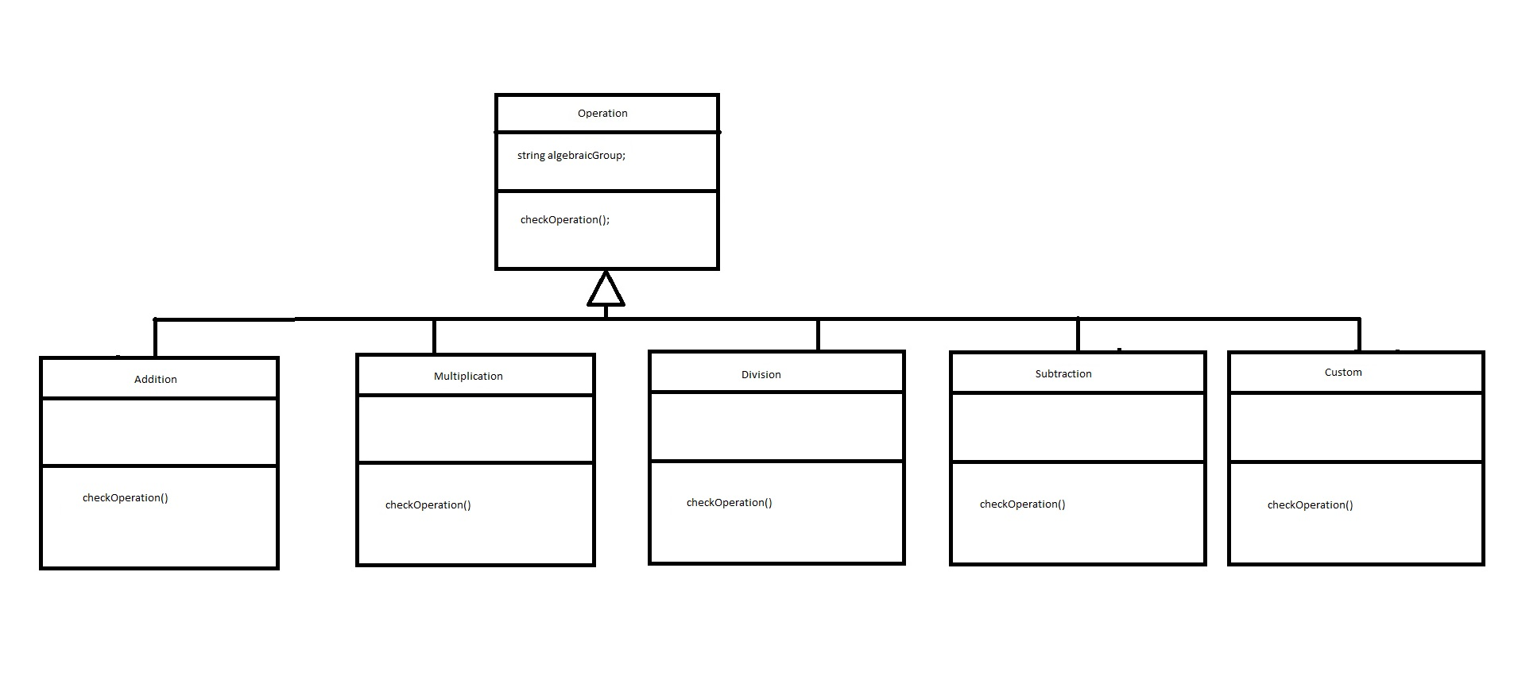

Our project uses a factory pattern to select what operation is being used. We can have the four basic operations or a custom operation given by the user. In the future, we can add to this diagram by counting for more operations. Our operation class will be able to create abstract versions without knowing the concrete implementation of checkOperation(), which will parse through a given string and help form a custom operation given by a user.

**Epic:**

As a user, I want to be able to submit a string of characters and have my program parse through and create a custom Operation class.

As a mathematician, I want to be able to create a document of custom operations and run it through my program to verify whether it is an algebraic group.