Why the Fibonacci Ratio Emerges in Nature: A Stability-Based Explanation from Genesis Field Theory (GenFT)
Josiah Bessler (2025)

Abstract
The Fibonacci sequence and its limiting ratio, the golden ratio φ = 1.618033..., appear ubiquitously in biological growth, phyllotaxis, galaxy morphology, fluid vortices, population dynamics, and harmonic systems. This paper presents a unified explanation within the framework of Genesis Field Theory (GenFT), in which all physical structures arise from nested standing-wave modes of a pre-geometric generative field. I show that the Fibonacci ratio is not an accident or a biological optimization heuristic, but the unique stable attractor of recursive mode subdivision in any harmonic system that must conserve boundary conditions. Its universal appearance constitutes evidence for GenFT’s principle that the universe evolves toward the most stable configuration available.

1. Stability, Eigenmodes, and the Generative Field
GenFT proposes that all physical structures arise from excitations ('modes') of a deeper generative field. These modes behave analogously to standing waves: each must satisfy shared boundaries ('nodes') inherited from the modes beneath it. This ensures stability and prevents destructive interference. When a large-scale mode subdivides into smaller modes, the resulting configuration must minimize energy while preserving the endpoints of the parent mode.

2. Why Fibonacci Appears: The Golden Ratio as the Universal Stability Point
When a system recursively subdivides modes while conserving shared boundaries, the most stable ratio between successive modes is the golden ratio φ. Any deviation produces node mismatches, increased tension, and instability. Thus φ is the fixed point of recursive harmonic subdivision and appears naturally wherever nature optimizes stability.

3. Fibonacci Numbers as Mode Completion Counts
In nested mode systems, the number of stable partitions, extrema, and subdivisions naturally follows 1, 1, 2, 3, 5, 8, 13,... — the Fibonacci sequence. This explains why spiral galaxies, plant phyllotaxis, vortex structures, and quantum probability distributions exhibit Fibonacci patterns: they arise automatically from harmonic mode packing.

4. Evidence for Genesis Field Theory
The ubiquity of φ across biological, physical, and cosmic scales supports GenFT’s principle that the universe evolves toward the most stable configuration allowed by the generative field. If GenFT were incorrect, Fibonacci structure would be rare or nonexistent; instead its recurrence across scales indicates a universal underlying stability law.

5. Conclusion
The Fibonacci sequence emerges inevitably in any system governed by recursive harmonic subdivision under shared boundary conditions. GenFT predicts precisely this structure, making the golden ratio not a coincidence but an expected result of a stability-driven universe.

Figures
Figure 1. Nested smooth harmonic waves.
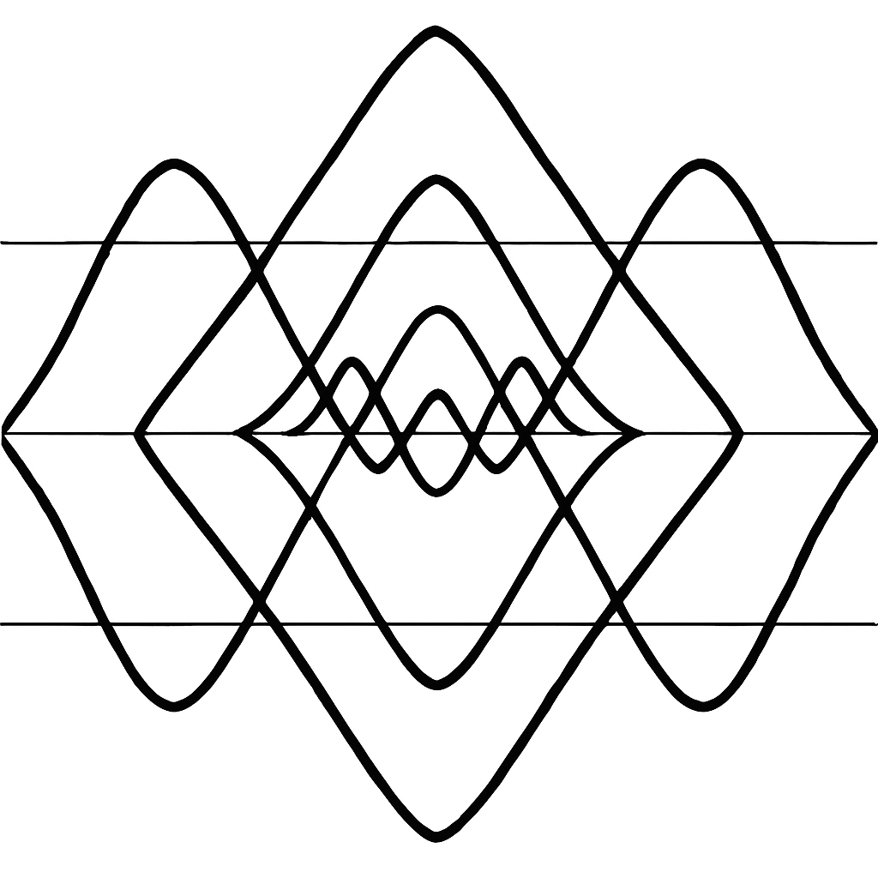
Figure 2. Nested triangle-wave harmonic structure.
