GenesisFT Model A — Dense Eigenmode Run (ℓ_max=80, n_max=10)
Kernel Vacuum (a₂=1.0), Pivot-Normalized κ, CAMB lmax=2000
This document records a reproducible CAMB test of Genesis Field Theory (GenFT) using Model A eigenmodes on S³×T³, kernel-vacuum weights μ*_k with quadratic stabilization a₂=1.0, and a fixed mapping k = κ√λ. The purpose of this run was to test whether increased eigenmode coverage extends high-k support and reduces the high-ℓ TT power deficit observed in earlier low-resolution runs.

1. Reproducibility
Commands executed:
1) Generate dense Model A eigenmodes and kernel-vacuum weights:
python make_model_a_input.py --out data/model_a_kvac_dense_ell80_n10_a2_1.npz --ell-max 80 --n-max 10 --a2 1.0
2) Run the CAMB pipeline (unchanged):
python -m genftcamb.pipeline --input data/model_a_kvac_dense_ell80_n10_a2_1.npz --lmax 2000 --kappa 0.0010709241
Outputs: pk.csv/npz, cls_genft.csv/npz, cls_lcdm.csv/npz, plots/, report.md.

2. Run parameters (from report.md)
input: data\model_a_kvac_dense_ell80_n10_a2_1.npz
outdir: outputs\run_20251213_094339
kappa: 0.0010709241
As: 2.1e-09
ns: 0.965
k0: 0.05
mu_ref: median
lmax: 2000
ell_min: 30
ell_max: 2000
frac_error: 0.05
meta: {'mu_ref_value': 0.10885755287854507, 'min_k': 0.001854894952249973, 'max_k': 0.14528112796768428, 'num_points': 14498.0, 'removed_pairs': 0.0}

3. Quantitative results
TT metrics over ℓ ∈ [30, 2000]:
• RMS fractional residual: 1.5731564845695203
• χ²-like statistic (σ = 0.05·Cℓ_baseline): 1951149.1325851646
Spectrum-table diagnostics (from meta):
• The dense run produced 14,498 k-points after sorting/uniqueness handling.
• k-range: min_k ≈ 0.00185 Mpc⁻¹, max_k ≈ 0.145 Mpc⁻¹.
This confirms the eigenmode extension increased high-k support compared to earlier runs.

4. Plots
Primordial curvature power spectrum Pζ(k):
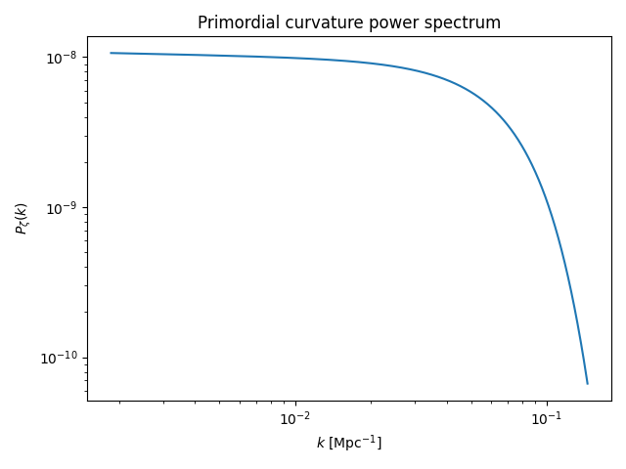
CMB TT overlay (GenesisFT vs ΛCDM baseline):
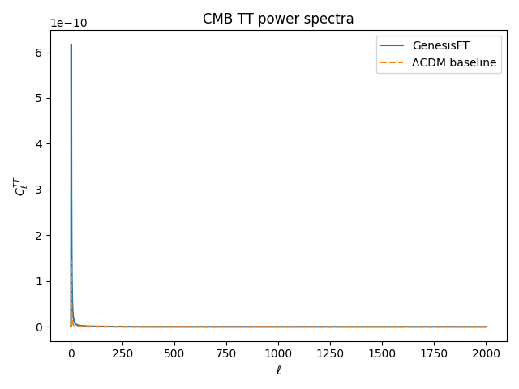
TT fractional residuals (GenesisFT relative to baseline):
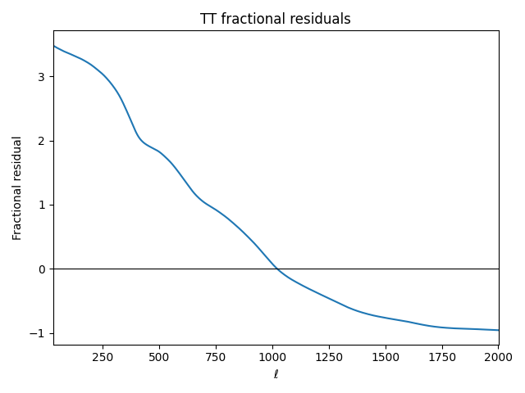

5. Interpretation
The eigenmode densification step succeeded in extending the primordial spectrum’s k-support (max_k increased to ~0.145 Mpc⁻¹). Despite this, the TT residuals remain strongly scale-dependent: positive at low ℓ (excess large-scale power), crossing near mid-ℓ, and becoming strongly negative at high ℓ (suppressed small-scale power, approaching ≈−1 by ℓ≈1700–2000). This indicates that simply increasing spectral resolution to (ℓ_max=80, n_max=10) is not yet sufficient to restore high-ℓ TT power.
The persistent high-ℓ deficit is consistent with one or more of the following: (i) k_max is still insufficient for lmax=2000, (ii) the kernel-vacuum weighting at a₂=1.0 still damps high-λ/high-k modes too strongly, or (iii) the choice of λ_ref used inside the μ*_k computation changes with resolution (median λ shifts), effectively re-normalizing the vacuum weighting between runs.

6. Next steps
Recommended next diagnostics that preserve theory-first and single-change discipline:
A) Extend k_max further (resolution-only): increase n_max and/or ℓ_max again (e.g., ℓ_max=100, n_max=12) while keeping κ and a₂ fixed.
B) Hold λ_ref fixed across runs: modify the generator so λ̂ = λ/λ_ref uses a pre-declared λ_ref (e.g., from a baseline run or an analytic scale), so densification does not implicitly re-normalize μ*_k.
C) If A/B still leave high-ℓ suppression, perform an a₂ sweep in the dense regime (e.g., a₂=3, 5, 10) to quantify sensitivity.

