GenesisFT CAMB Pipeline — Model A Kernel-Vacuum: Extended c Sweep (a2=8000)
This note documents an extended scan over the kernel-vacuum parameter c while holding the other Model A parameters fixed.

Configuration
Fixed settings: ell-max=100, n-max=12 (≈1.58M modes), a2=8000, b=1, a1=0, lmax=2000, kappa=0.0010709241.
Scan: c ∈ {0.0, 0.05, 0.1, 0.15, 0.2, 0.25, 0.3, 0.35, 0.4, 0.5, 0.7, 1.0, 1.5, 2.0, 3.0}.

Reproducible commands
PowerShell:
# Fixed settings
$kappa = 0.0010709241
$a2 = 8000
$ell = 100
$nmax = 12
$lmax = 2000
$cs = @(0.0, 0.05, 0.1, 0.15, 0.2, 0.25, 0.3, 0.35, 0.4, 0.5, 0.7, 1.0, 1.5, 2.0, 3.0)
foreach ($c in $cs) {
$tag = ("a2_{0}_c_{1}" -f $a2, ($c -replace '\.','p'))
$npz = ("data\model_a_kvac_dense_ell{0}_n{1}_{2}.npz" -f $ell, $nmax, $tag)
python make_model_a_input.py --out $npz --ell-max $ell --n-max $nmax --a2 $a2 --c $c
python -m genftcamb.pipeline --input $npz --lmax $lmax --kappa $kappa
}

Outputs per run
Each pipeline run produces:
- • pk.csv / pk.npz: primordial curvature spectrum table (k, Pζ(k)) used by CAMB.
- • cls_genft.csv / cls_genft.npz: CAMB Cℓ spectra for the GenesisFT-derived primordial spectrum.
- • cls_lcdm.csv / cls_lcdm.npz: baseline ΛCDM run using power-law primordial spectrum (As, ns).
- • report.md: parameter echo + basic run metadata.

Quantitative comparison method
We summarize differences using the TT fractional residual r_ℓ = (Cℓ^TT,GenFT − Cℓ^TT,ΛCDM)/Cℓ^TT,ΛCDM for ℓ=2…2000. We report RMS(r_ℓ) and an approximate χ²-like score assuming a fixed fractional error σ_ℓ = 0.02·Cℓ^TT,ΛCDM (for *relative* ranking only; this is not a Planck likelihood).

Results
c | RMS frac residual (TT) | χ²-like (2% frac err) | Notes
0.00 | 2.397e-03 | 2.871e+01 | best (closest to baseline)
0.05 | 9.208e-03 | 4.237e+02
0.10 | 1.841e-02 | 1.693e+03
0.15 | 2.782e-02 | 3.867e+03
0.20 | 3.735e-02 | 6.973e+03
0.25 | 4.701e-02 | 1.104e+04
0.30 | 5.678e-02 | 1.611e+04
0.35 | 6.666e-02 | 2.221e+04
0.40 | 7.666e-02 | 2.937e+04
0.50 | 9.701e-02 | 4.703e+04
0.70 | 1.392e-01 | 9.683e+04
1.00 | 2.065e-01 | 2.132e+05
1.50 | 3.316e-01 | 5.495e+05
2.00 | 4.772e-01 | 1.138e+06
3.00 | 8.658e-01 | 3.746e+06

Trend: increasing c monotonically increases the deviation from the ΛCDM baseline in this setup.
The smallest residuals in this scan occur at c≈0 (nearly flat μ* across modes at large a2), while larger c introduces stronger λ-dependence in μ* and correspondingly a larger tilt/shape change in Pζ(k).

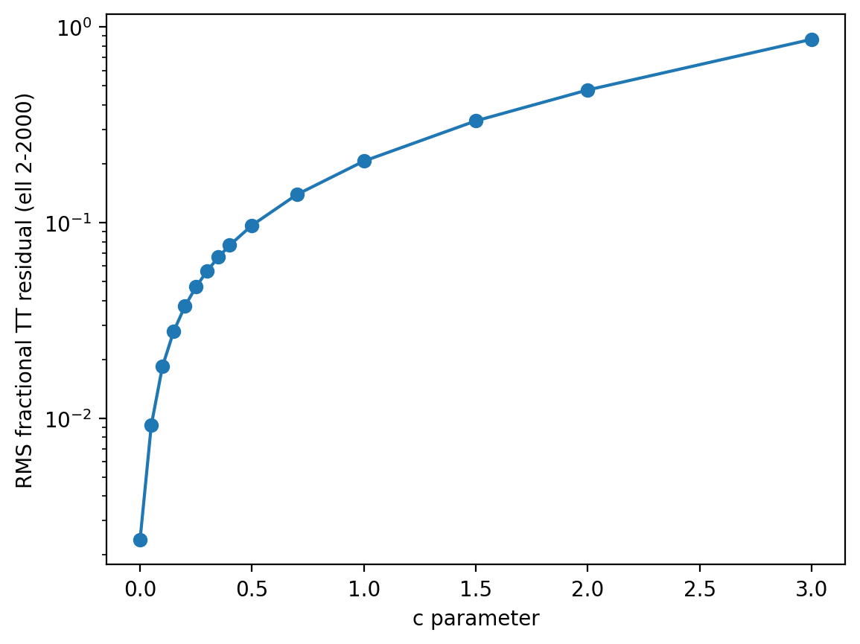

Interpretation
In the kernel-vacuum prescription used here, μ*(λ) is computed independently per eigenmode. For a2 ≫ 1, the quadratic stabilization term strongly suppresses μ*, narrowing its dynamic range. When c=0, μ* becomes nearly constant across λ, making the constructed Pζ(k) close to a smooth power law after normalization by μ_ref. Increasing c reintroduces scale dependence (via λ), which propagates into Pζ(k) and therefore into the CMB TT spectrum.

What’s next
Recommended next steps (in order):
- 1) Lock the best-performing c (from the sweep) and perform a small local search over kappa to align the acoustic peak scale (ℓ≈200).
- 2) Replace the ad-hoc χ²-like ranking with a comparison against actual CMB data (e.g., Planck TT) using a proper likelihood or a downloaded binned spectrum + covariance.
- 3) Expand beyond Model A separable weights by allowing additional kernel parameters (a1, b) or modifying the geometry (R, Lx, Ly, Lz) to change the λ spectrum itself, not just μ*(λ).

