GenesisFT Model A – Kernel-Vacuum a₂ Refinement (a₂=4 vs a₂=6)
This note documents two additional runs in the Model A kernel-vacuum parameter study, targeting a narrower bracket around the previously improving regime. Only the kernel-vacuum stabilization parameter a₂ was changed; the CAMB pipeline and all other inputs were held fixed.

Commands (Reproducibility)
Run a₂ = 4.0
python make_model_a_input.py --out data\model_a_kvac_dense_ell100_n12_a2_4.npz --ell-max 100 --n-max 12 --a2 4.0
python -m genftcamb.pipeline --input data\model_a_kvac_dense_ell100_n12_a2_4.npz --lmax 2000 --kappa 0.0010709241
Run a₂ = 6.0
python make_model_a_input.py --out data\model_a_kvac_dense_ell100_n12_a2_6.npz --ell-max 100 --n-max 12 --a2 6.0
python -m genftcamb.pipeline --input data\model_a_kvac_dense_ell100_n12_a2_6.npz --lmax 2000 --kappa 0.0010709241

Fixed Configuration
- Mode truncation: ell_max=100, n_max=12 (~1.58M raw modes)
- k mapping: k = kappa*sqrt(lambda), kappa = 0.0010709241
- CAMB: linear, unlensed, lmax = 2000
- Spectrum normalization/tilt: As=2.100e-09, ns=0.965
- Table passed via camb.initialpower.SplinedInitialPower.set_scalar_table (version-robust).

Quantitative Summary
Run (a₂) | k-points | k range | mu_ref (median) | RMS frac residual | chi2_like
a₂ = 4.0 | 26259 | [0.001855, 0.1768] | 0.0745446 | 1.05662 | 880212
a₂ = 6.0 | 26259 | [0.001855, 0.1768] | 0.0633097 | 0.916977 | 662924
Scoring uses the pipeline’s TT fractional residual metric over the configured ell-range (see report.md in each output folder). Lower RMS and chi2_like indicate improved agreement with the ΛCDM baseline.

Interpretation
The a₂=6 run improves both summary metrics relative to a₂=4 (lower RMS fractional residual and lower chi2_like). This continues the previously observed trend that increasing the quadratic stabilization strength suppresses excess scale-dependent structure in the derived primordial spectrum and drives the CAMB TT spectrum toward the baseline shape under the fixed mapping k = kappa*sqrt(lambda).
At this stage, the sweep is best interpreted as identifying a stable regime of the kernel-vacuum weighting function (mu*_k) for Model A rather than a claim of a best-fit cosmology: cosmological parameters were not optimized, and the comparison here is to the pipeline’s internal ΛCDM baseline computed under the same CAMB settings.

Key Outputs
For each run, the pipeline produced: pk.csv/pk.npz (primordial spectrum table), cls_genft.*, cls_lcdm.*, plots (pzeta, TT overlay, TT residuals), and report.md.

Run run_20251213_100620
Primordial spectrum Pζ(k)
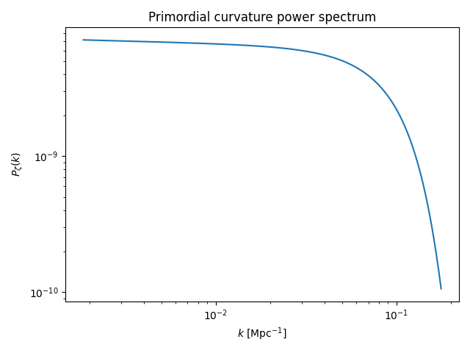
TT overlay (GenFT vs ΛCDM baseline)
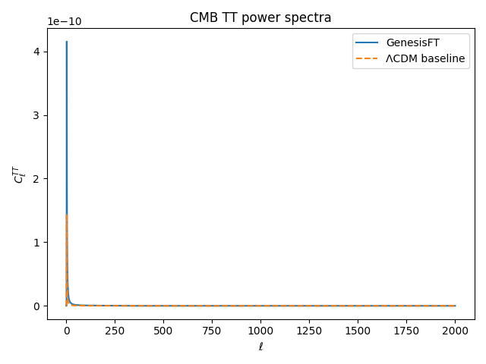
TT fractional residuals
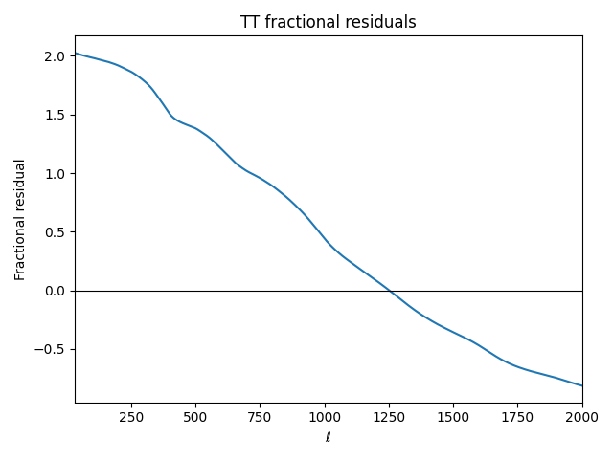

Run run_20251213_100624
Primordial spectrum Pζ(k)
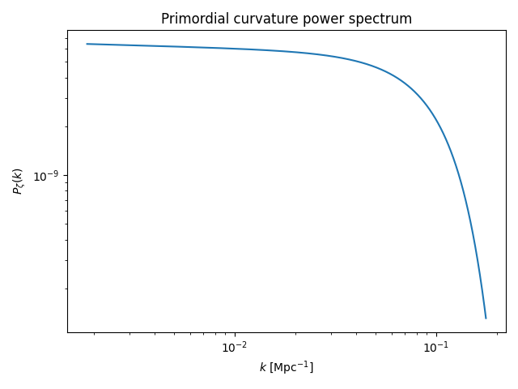
TT overlay (GenFT vs ΛCDM baseline)
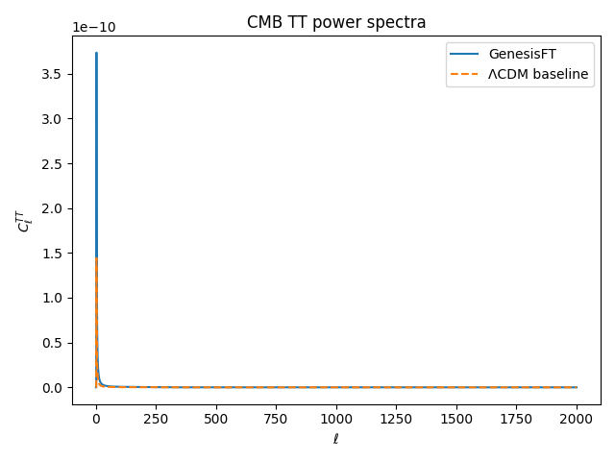
TT fractional residuals
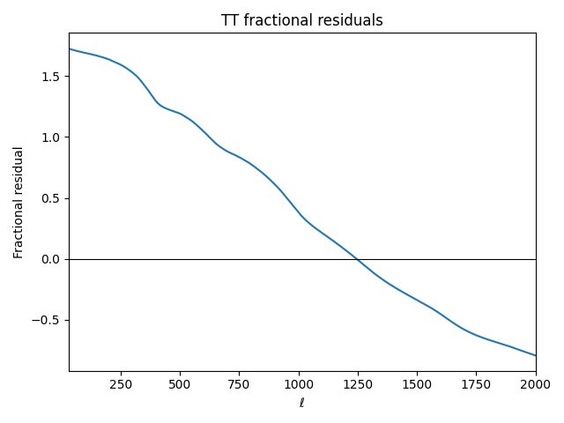

Next Step
Given continued improvement at a₂=6, the next most informative step is a finer local scan around a₂≈6–10 (e.g., a₂=7, 9, 12) and/or introduction of polarization spectra (EE/TE) comparisons. If improvements saturate, this suggests the model has entered a stable kernel-vacuum regime for the chosen operator/geometry.

