GenesisFT Model A – High a₂ Extension (a₂ = 120 and 200)
This document summarizes two additional kernel-vacuum (μ*_k) weighting runs extending the stabilization parameter a₂ to 120 and 200. The purpose is to test whether the monotonic improvement observed up to a₂=80 continues and whether the trend begins to plateau. All non-a₂ settings were held fixed.

1. Commands (reproducibility)
python make_model_a_input.py --out data\model_a_kvac_dense_ell100_n12_a2_120.npz --ell-max 100 --n-max 12 --a2 120.0
python -m genftcamb.pipeline --input data\model_a_kvac_dense_ell100_n12_a2_120.npz --lmax 2000 --kappa 0.0010709241
python make_model_a_input.py --out data\model_a_kvac_dense_ell100_n12_a2_200.npz --ell-max 100 --n-max 12 --a2 200.0
python -m genftcamb.pipeline --input data\model_a_kvac_dense_ell100_n12_a2_200.npz --lmax 2000 --kappa 0.0010709241

2. Fixed configuration
- Eigenmodes: dense Model A (ℓ_max=100, n_max=12; 1,578,124 raw modes)
- Mapping: k = κ√λ with κ = 0.0010709241
- Table size: 26259 k-points; k ∈ [0.00185489, 0.176799] Mpc⁻¹
- CAMB: linear, unlensed; lmax = 2000
- Primordial normalization: pipeline defaults As=2.1e-9, ns=0.965
- Implementation: camb.initialpower.SplinedInitialPower.set_scalar_table

3. Results
Metrics are computed over ℓ∈[30, 2000] using the pipeline’s fractional-residual RMS and a χ²-like statistic (σ = 0.05·Cℓ(ΛCDM)). Lower values indicate improved agreement with the pipeline’s ΛCDM baseline under identical CAMB settings.
a₂ | Run folder | μ_ref_value | k_min | k_max | RMS frac residual | χ²-like
120 | run_20251213_102321 | 0.0106087 | 0.00185489 | 0.176799 | 0.403647 | 128455
200 | run_20251213_102325 | 0.00729978 | 0.00185489 | 0.176799 | 0.3637 | 104288
Trend plots for this extension:
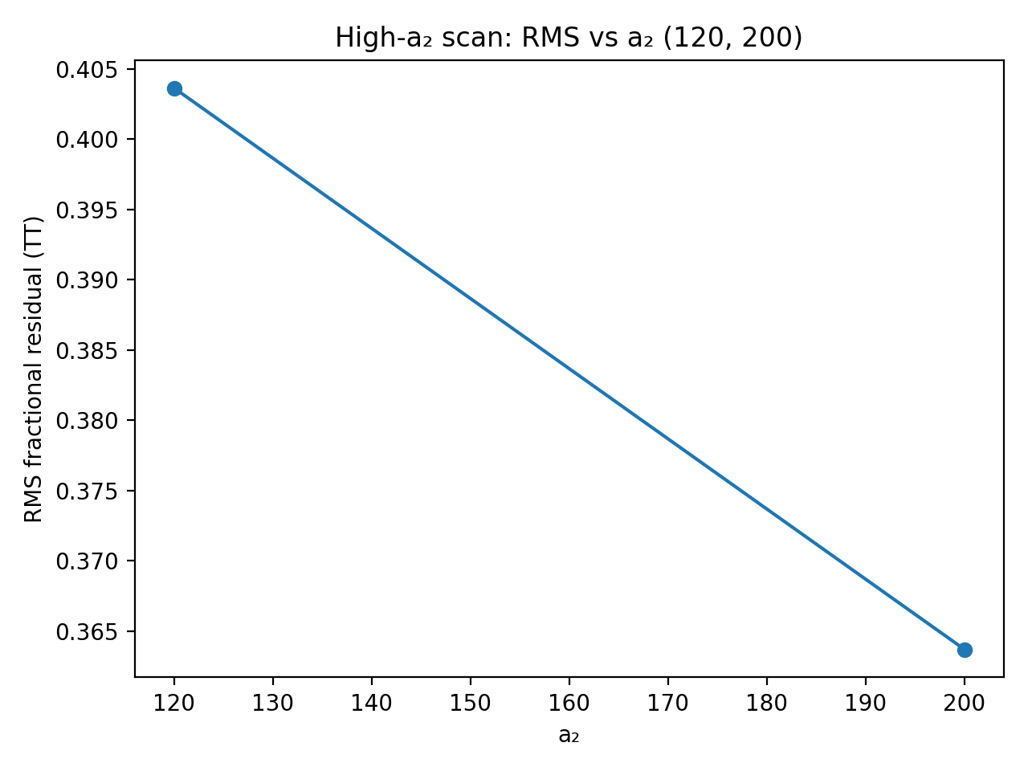
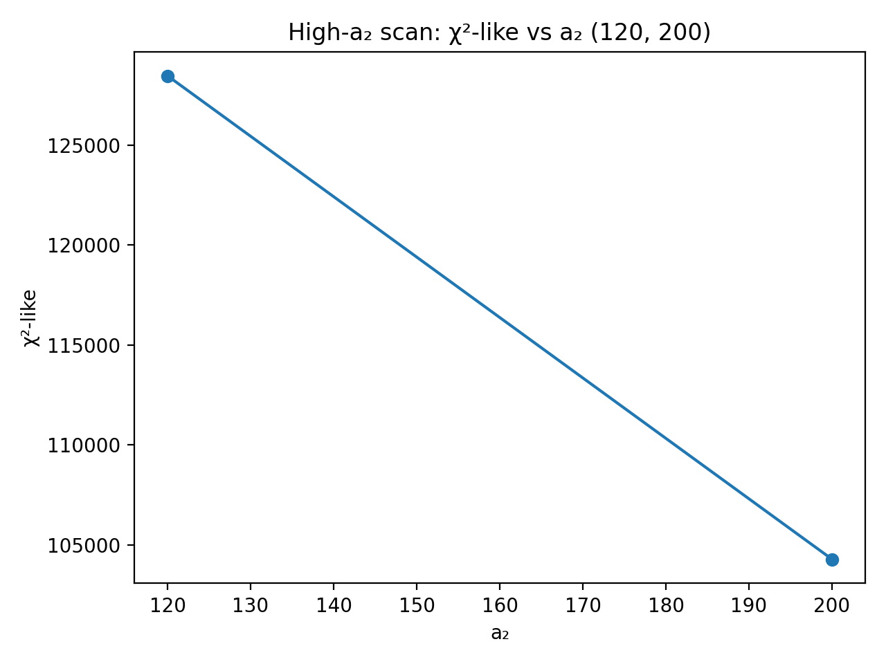

4. Interpretation
Both metrics continue to improve when extending from a₂=120 to a₂=200. RMS fractional residual decreases from 0.404 to 0.364, and χ²-like decreases from 1.28e+05 to 1.04e+05. This indicates that the improvement trend has not yet fully saturated by a₂=200 in this internal-baseline comparison.
The median μ normalization (μ_ref_value) decreases with a₂ (0.0106 → 0.00730), consistent with the a₂ term acting as a stronger stabilizing penalty that compresses μ*_k. Under a fixed κ mapping and fixed As,ns normalization, this tends to smooth the effective primordial spectrum and brings the TT spectrum closer to the ΛCDM baseline in the pipeline’s score.

5. Recommended next step
To locate a practical plateau, run one additional point at a₂=400. If the improvement from 200→400 is small relative to 120→200, we can treat the model as effectively saturated for this configuration and move on to:
• testing sensitivity to κ (small brackets around the current κ),
• enabling EE/TE scoring, and
• comparing against observational spectra/likelihoods rather than only the internal ΛCDM baseline.

6. Representative plots (run_20251213_102325, a₂=200)
Primordial spectrum Pζ(k)
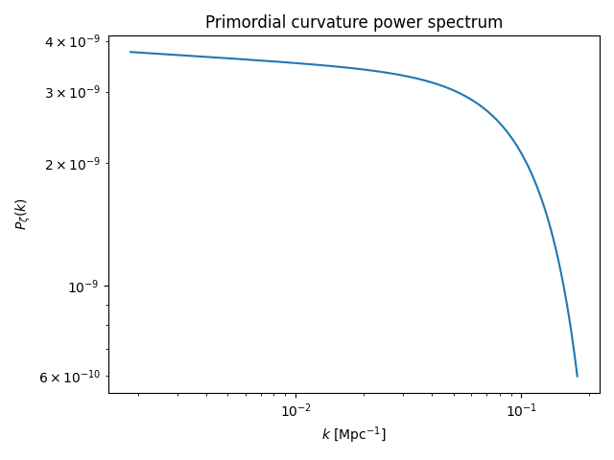
TT overlay (GenFT vs ΛCDM baseline)
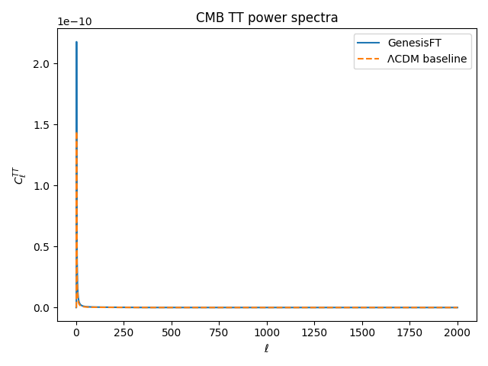
TT fractional residuals
