GenesisFT CAMB: Model A Kernel-Vacuum Stabilization Sweep (Dense ℓ_max=100, n_max=12)
This document summarizes three runs that isolate the effect of the kernel-vacuum stabilization parameter a₂ on the GenFT-derived primordial spectrum and resulting CMB TT angular power spectrum computed with CAMB.
All runs used the same:
• Geometry / eigen-spectrum enumeration: S³×T³ Model A with ℓ_max=100 and n_max=12
• k-mapping: k = κ √λ with κ = 0.0010709241 (fixed)
• CAMB configuration: linear, unlensed; lmax=2000
Only a₂ was changed.

1. Reproducibility (commands)
Run each case as follows (PowerShell):
a₂ = 0.1
python make_model_a_input.py --out data/model_a_kvac_dense_ell100_n12_a2_0p1.npz --ell-max 100 --n-max 12 --a2 0.1
python -m genftcamb.pipeline --input data/model_a_kvac_dense_ell100_n12_a2_0p1.npz --lmax 2000 --kappa 0.0010709241
a₂ = 0.01
python make_model_a_input.py --out data/model_a_kvac_dense_ell100_n12_a2_0p01.npz --ell-max 100 --n-max 12 --a2 0.01
python -m genftcamb.pipeline --input data/model_a_kvac_dense_ell100_n12_a2_0p01.npz --lmax 2000 --kappa 0.0010709241
a₂ = 3.0
python make_model_a_input.py --out data/model_a_kvac_dense_ell100_n12_a2_3.npz --ell-max 100 --n-max 12 --a2 3.0
python -m genftcamb.pipeline --input data/model_a_kvac_dense_ell100_n12_a2_3.npz --lmax 2000 --kappa 0.0010709241

2. Quantitative comparison
Metrics are computed over ℓ∈[30,2000] using the pipeline’s fractional-residual RMS and a χ²-like statistic (with σ = 0.05·Cℓ(ΛCDM)).
a₂ | RMS frac. residual | χ²-like | k_min [Mpc⁻¹] | k_max [Mpc⁻¹] | #k points | μ_ref_value
0.01 | 2.864 | 6.46685e+06 | 0.00185489 | 0.176799 | 26259 | 0.13497
0.1 | 2.65179 | 5.54404e+06 | 0.00185489 | 0.176799 | 26259 | 0.131814
3.0 | 1.17108 | 1.08124e+06 | 0.00185489 | 0.176799 | 26259 | 0.0824976

3. What the sweep shows
Across this sweep, k_min, k_max, and the number of k-points are effectively identical (the eigen-spectrum coverage and κ were fixed). Therefore, differences in TT behavior are attributable to the change in μ*_k induced by a₂.
Observed trend:
• Increasing a₂ (stronger quadratic stabilization) substantially *improves* agreement with ΛCDM in this test: RMS residual and χ²-like both decrease markedly for a₂=3.0 relative to a₂=0.1 and 0.01.
Interpretation (within the current modeling assumptions):
• Smaller a₂ leaves the entropy-like term dominant, producing μ*_k values that preserve more contrast across λ, which propagates to a stronger scale-dependent mismatch in TT.
• Larger a₂ penalizes large μ more strongly, compressing the μ distribution and producing a smoother, more ΛCDM-like effective primordial shape after normalization. This moves the GenFT TT closer to the baseline, though residual scale-dependence remains.

4. Plots (per run)
a₂ = 0.1 (run_20251213_095456)
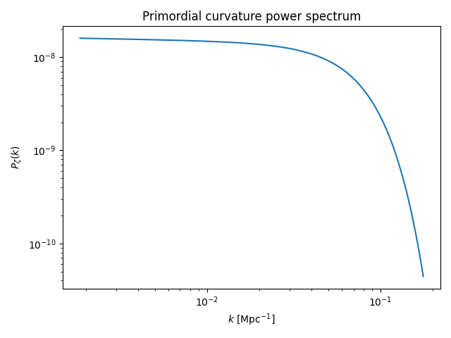
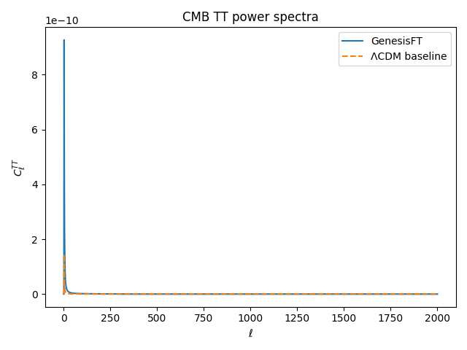
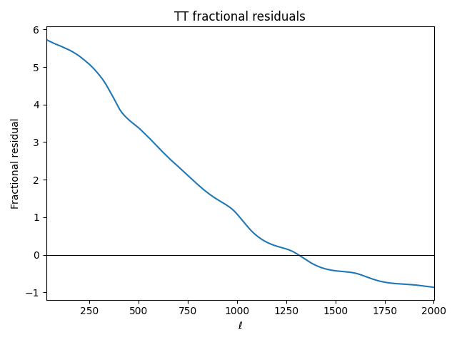
a₂ = 0.01 (run_20251213_095518)
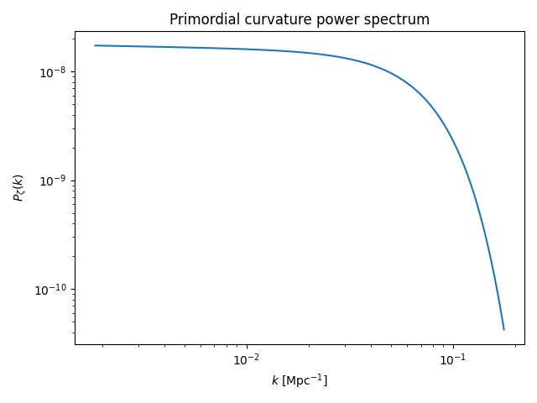
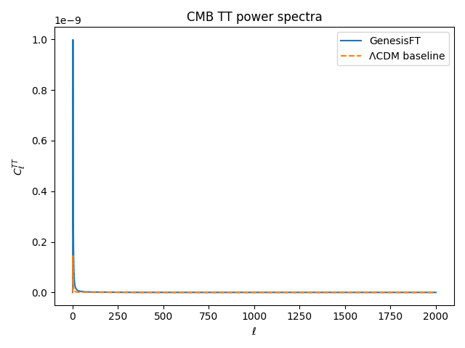
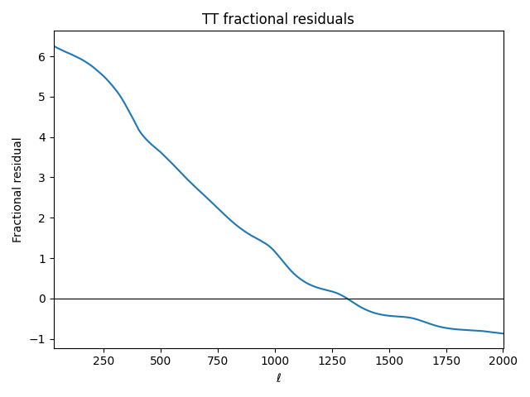
a₂ = 3.0 (run_20251213_095529)
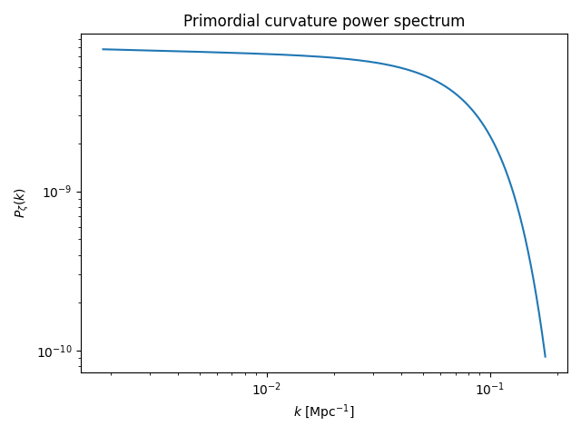
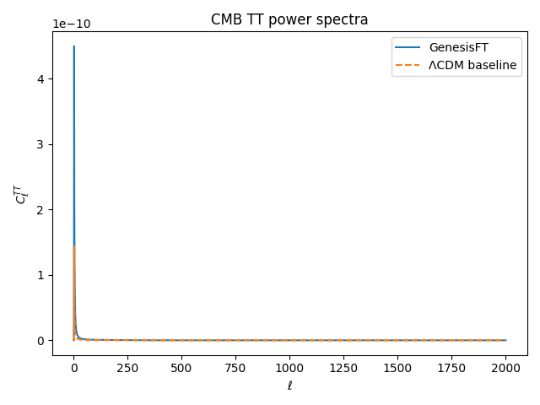
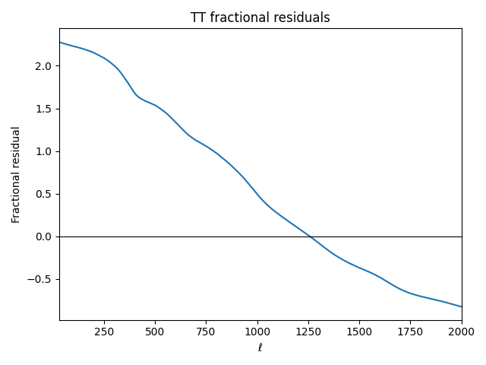

5. Next step recommendation
Next best single-change test:
• Hold dense settings fixed (ℓ_max=100, n_max=12; κ fixed; lmax=2000) and do a small bracket around the best-performing value to see if improvement continues or saturates: e.g., a₂ ∈ {2, 3, 5, 8}.
In parallel (separately, not mixed with the a₂ sweep), consider freezing λ_ref across runs in the generator. Because λ_ref (median λ) changes when ℓ_max/n_max change, it can implicitly renormalize μ*_k between resolutions. Freezing λ_ref isolates physical effects from normalization effects.

