GenesisFT Model A – Upward a₂ Scan (7, 9, 12, 20) with Dense Mode Set
This document summarizes an upward scan of the kernel-vacuum stabilization parameter a₂ in the Model A S³×T³ eigenmode construction. All runs used the dense eigenmode enumeration (ℓ_max=100, n_max=12) and the same k-mapping and CAMB configuration. Only a₂ was changed.

1. Reproducibility (commands)
python make_model_a_input.py --out data\model_a_kvac_dense_ell100_n12_a2_7.npz --ell-max 100 --n-max 12 --a2 7.0
python -m genftcamb.pipeline --input data\model_a_kvac_dense_ell100_n12_a2_7.npz --lmax 2000 --kappa 0.0010709241
python make_model_a_input.py --out data\model_a_kvac_dense_ell100_n12_a2_9.npz --ell-max 100 --n-max 12 --a2 9.0
python -m genftcamb.pipeline --input data\model_a_kvac_dense_ell100_n12_a2_9.npz --lmax 2000 --kappa 0.0010709241
python make_model_a_input.py --out data\model_a_kvac_dense_ell100_n12_a2_12.npz --ell-max 100 --n-max 12 --a2 12.0
python -m genftcamb.pipeline --input data\model_a_kvac_dense_ell100_n12_a2_12.npz --lmax 2000 --kappa 0.0010709241
python make_model_a_input.py --out data\model_a_kvac_dense_ell100_n12_a2_20.npz --ell-max 100 --n-max 12 --a2 20.0
python -m genftcamb.pipeline --input data\model_a_kvac_dense_ell100_n12_a2_20.npz --lmax 2000 --kappa 0.0010709241

2. Fixed configuration
- Eigenmodes: dense Model A (ℓ_max=100, n_max=12)
- k mapping: k = κ √λ with κ = 0.0010709241
- k table: 26259 points, k ∈ [0.00185489, 0.176799] Mpc⁻¹
- CAMB: linear, unlensed; lmax = 2000
- Baseline: same As=2.1e-9 and ns=0.965 as pipeline defaults
- Implementation: camb.initialpower.SplinedInitialPower.set_scalar_table

3. Quantitative results
Metrics are computed over ℓ∈[30, 2000] using the pipeline’s fractional-residual RMS and a χ²-like statistic (σ = 0.05·Cℓ(ΛCDM)). Lower values indicate improved agreement with the pipeline’s ΛCDM baseline under identical CAMB settings.
a₂ | Run folder | μ_ref_value | k_min | k_max | RMS frac residual | χ²-like
7 | run_20251213_101330 | 0.0591364 | 0.00185489 | 0.176799 | 0.8702 | 597014
9 | run_20251213_101334 | 0.0525524 | 0.00185489 | 0.176799 | 0.800775 | 505554
12 | run_20251213_101338 | 0.0454574 | 0.00185489 | 0.176799 | 0.730763 | 421017
20 | run_20251213_101342 | 0.0343088 | 0.00185489 | 0.176799 | 0.627522 | 310459
Trend plots:
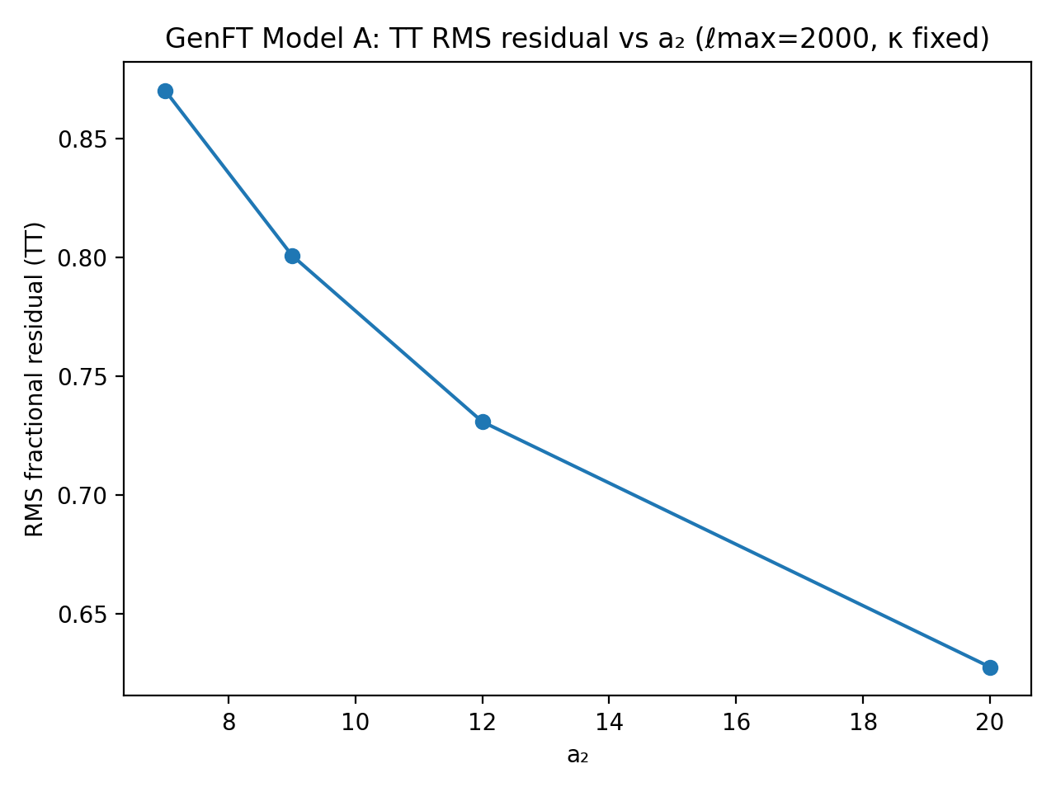
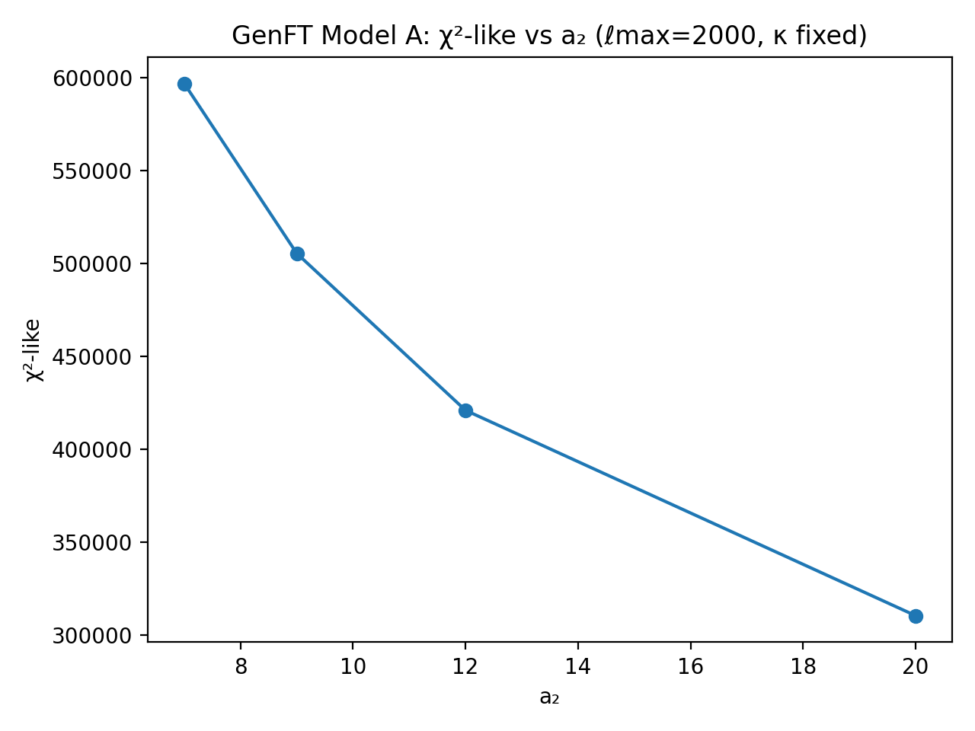

4. Interpretation
Across a₂ = 7 → 20, both summary metrics improve monotonically in this scan: RMS residual decreases from ~0.87 to ~0.63, and χ²-like decreases from ~5.97×10⁵ to ~3.10×10⁵. Because κ, the k-range, and the number of k-table points are identical across runs, the improvement is attributable to the kernel-vacuum weighting μ*_k induced by larger a₂.
Mechanistically, larger a₂ strengthens the quadratic penalty on μ, compressing the μ distribution (μ_ref_value falls with increasing a₂). After normalization to a fixed As and ns, this produces a smoother effective Pζ(k) and a TT spectrum that is closer (in this internal comparison) to the ΛCDM baseline produced with the same CAMB settings.
Important limitation: these metrics compare against the pipeline’s internal ΛCDM baseline (not Planck likelihoods). This is still a valid engineering/scientific step: it tests whether the GenFT-derived primordial spectrum is numerically well-behaved and whether its parameter dependence is smooth and interpretable under a fixed cosmological configuration.

5. Recommended next step
Since the trend did not yet plateau by a₂=20, the next most informative runs are larger jumps to probe saturation and avoid running an unnecessary dense grid:
• a₂ = 30
• a₂ = 50
• a₂ = 80 (optional)
If improvements saturate, we can then: (i) lock the best a₂ regime, (ii) enable EE/TE outputs, and (iii) begin comparing against observational datasets/likelihoods rather than only the internal baseline.

6. Representative plots (a₂ = 20)
Primordial spectrum Pζ(k)
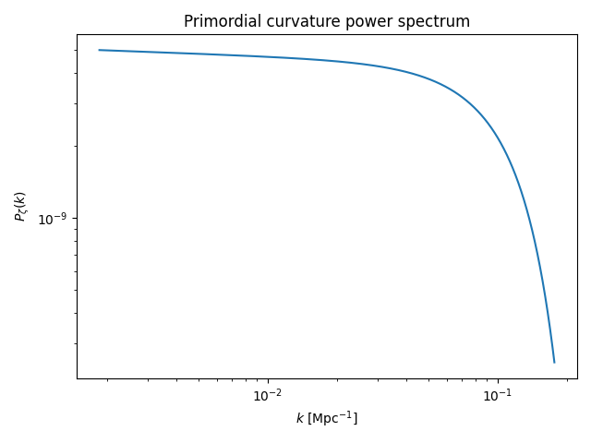
TT overlay (GenFT vs ΛCDM baseline)
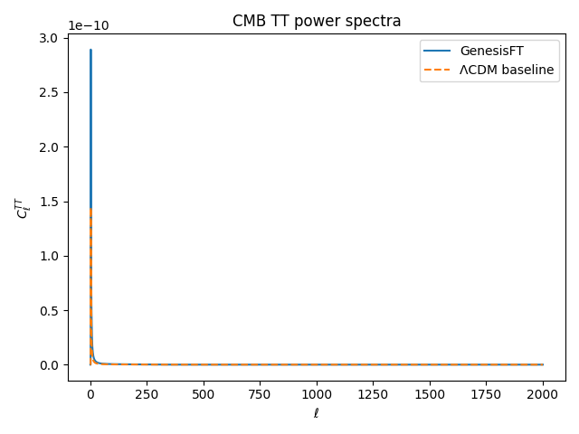
TT fractional residuals
