Genesis Field Theory (GenFT)
Model A + Kernel-Vacuum Weights — CAMB Pipeline Test
This document records the first end-to-end CAMB run in which the Model A eigenvalue spectrum is combined with a kernel-vacuum–motivated per-mode weight μ* (replacing the previous degeneracy-only placeholder μ), and propagated through CAMB using a custom primordial curvature power spectrum table.

1. Goal
Objective: Replace placeholder mode weights μ with kernel-vacuum weights μ*_k (computed as a function of eigenvalue λ_k), while keeping the CAMB pipeline unchanged, to test whether kernel-vacuum weighting qualitatively changes the resulting CMB spectra.

2. Model A Operator and Spectrum Enumeration
Geometry: Xi = S³(R) × T³(Lx, Ly, Lz). Operator: O = −Δ (scalar Laplacian). Eigenvalues separate as λ = λ_S3 + λ_T3.
Run settings used to generate the spectrum:
• ℓ_max = 40 on S³
• n_max = 6 on T³ (i.e., n_x, n_y, n_z ∈ [−6, 6])
• The exact zero-mode (ℓ=0, n_x=n_y=n_z=0) is excluded so λ>0.
Output: 90,076 modes.
λ range: 3 … 5943.67

3. Kernel-Vacuum Weight Model (μ*_k)
Kernel-vacuum weights were generated via a separable per-mode stationarity condition of the form:
a1 + c·λ̂_k + 2·a2·μ + b·(1 + ln μ) = 0,
with μ>0. Here λ̂_k = λ_k / λ_ref is a dimensionless eigenvalue and λ_ref is chosen as the median of λ.
This run used the simplest nontrivial parameter choice:
a1 = 0, a2 = 0, b = 1, c = 1,
giving a closed-form weight:
μ*_k = exp(−1 − λ̂_k).
Reported weight statistics for this run:
• μ range: 0.0240731 … 0.367373
• λ_ref (median): 2179.83

4. Primordial Spectrum Construction
The pipeline constructs a primordial curvature spectrum Pζ(k) from (λ_k, μ*_k) using:
k = κ · √λ
Pζ(k) = A_s · (μ/μ_ref)² · (k/k0)^(n_s − 1)
Parameters used:
• κ = 1.0
• A_s = 2.1×10⁻⁹
• n_s = 0.965
• k0 = 0.05 Mpc⁻¹
• μ_ref = median(μ)
After sorting and averaging duplicate k-values, the k-domain is clamped to [1e−5, 50] for CAMB stability.

5. CAMB Integration (Unchanged Pipeline)
CAMB was run using a splined primordial table to avoid build-dependent issues with set_initial_power_function:
params.InitPower = camb.initialpower.SplinedInitialPower()
params.InitPower.set_scalar_table(k, Pζ)
Run configuration:
• lmax = 800
• lensing disabled
• NonLinear = none
A baseline ΛCDM run (power-law primordial spectrum with A_s and n_s) was computed for comparison.

6. Outputs and Diagnostics
Pipeline outputs (per run directory) include:
• pk.csv / pk.npz : the constructed (k, Pζ(k)) table
• cls_genft.csv / cls_genft.npz : CAMB spectra for GenFT input
• cls_lcdm.csv / cls_lcdm.npz : baseline ΛCDM spectra
• plots/: Pζ(k), TT overlay, TT residuals
• report.md : parameters + summary metrics
Key diagnostic plots from this run:
Primordial curvature spectrum Pζ(k):
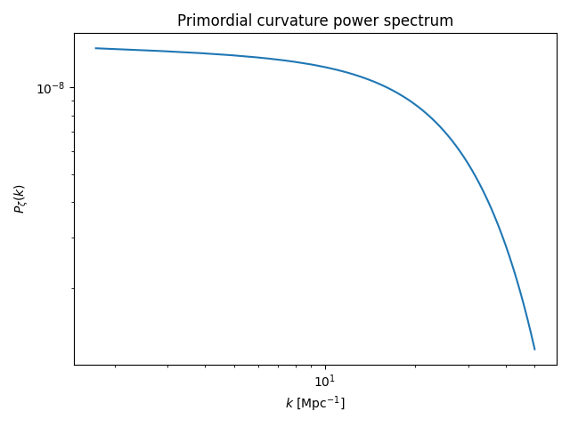
CMB TT power spectra overlay (GenFT vs baseline):
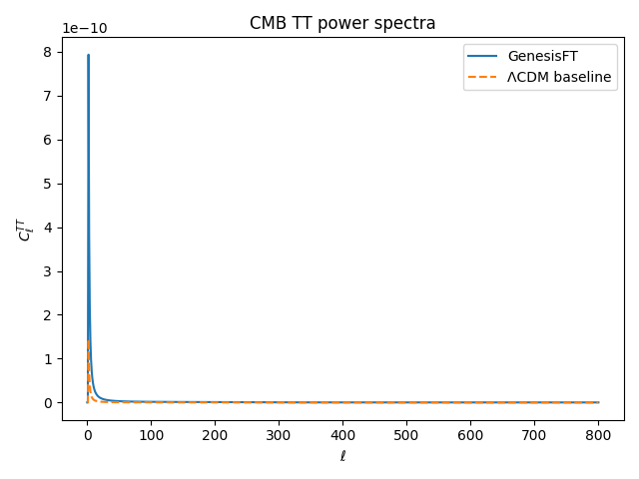
Fractional TT residuals (GenFT relative to baseline):
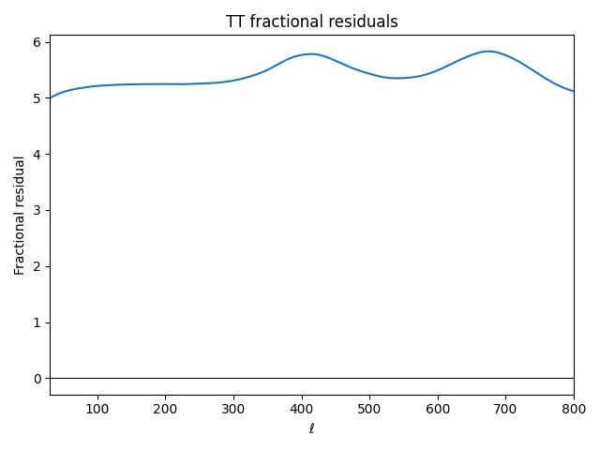

7. Quantitative Results (TT)
From the run report (ℓ range 30–800):
• RMS fractional residual: 5.431899641768031
• χ²-like statistic (σ = 0.05·Cℓ_baseline): 9,099,506.59870511
Interpretation: relative to the baseline, the kernel-vacuum-weighted Model A primordial spectrum produces a TT spectrum with large systematic deviations across the tested multipoles. However, the pipeline remains numerically stable and fully end-to-end reproducible.

8. Reproducibility Recipe
From the repository root, reproduce this run with:
1) Generate Model A inputs with kernel-vacuum μ* weights:
python make_model_a_input.py --out data/model_a_kvac.npz --ell-max 40 --n-max 6
2) Run CAMB pipeline (unchanged):
python -m genftcamb.pipeline --input data/model_a_kvac.npz --lmax 800
Expected console indicators:
• 'Running CAMB with custom scalar table (... points, lmax=800)'
• 'Using camb.initialpower.SplinedInitialPower.set_scalar_table'
• 'Run complete. Outputs stored in outputs/run_YYYYMMDD_HHMMSS'

9. Next Steps (Theory-First, No Data Fitting)
This test establishes that kernel-vacuum weights can be injected without altering the CAMB pipeline. Next steps that preserve theory-first discipline include:
• Examine the (k, Pζ(k)) support range; this run starts at k≈√3≈1.73 Mpc⁻¹, which is high relative to the usual CMB-relevant band.
• Consider whether κ (the mapping k=κ√λ) is physically defined by Model A geometry and units; κ rescales the spectrum along k.
• Introduce a2>0 (quadratic stabilization) and/or alternative λ normalization choices that are justified from the theory.
• Add polarization (EE/TE) diagnostics once TT behavior is characterized.

