GenesisFT / UCP Halo Tests on SPARC Rotmod_LTG Sample
This technical report summarizes a suite of rotation–curve and halo–structure diagnostics applied to the SPARC Rotmod_LTG sample using a GenesisFT-derived cored halo template (the UCP profile) alongside standard empirical and ΛCDM-motivated halo models (Burkert, pseudo-isothermal, NFW, and Einasto with fixed α = 0.18). All statistics reported here are computed directly from the provided CSV outputs produced by the GenesisFT halo pipeline.

1. Data and Halo Models
The analysis uses 175 disk galaxies from the SPARC Rotmod_LTG sample. For each galaxy, we fit five dark matter halo models on top of standard SPARC baryonic components (gas, stellar disk, and bulge):
- GenesisFT UCP template (fixed cored shape, 2-parameter scaling).
- Burkert core profile (2-parameter cored halo).
- Pseudo-isothermal (cored) halo (2 parameters).
- NFW halo (cuspy ΛCDM-motivated profile, 2 parameters).
- Einasto halo with fixed inner shape α = 0.18 (steep inner profile).
For each (galaxy, model) pair, the fitting pipeline optimizes a scale radius r_scale, a characteristic velocity V0, and a disk mass-to-light scaling parameter Yd. The measured quantities stored in halo_dm_baryons_results.csv include the best-fit parameters, total χ², degrees of freedom, and derived χ²/dof for each model.

2. Global Fit Quality: χ²/dof and BIC
We first compare the overall fit quality of each halo model using the median χ² per degree of freedom across all 175 galaxies, and then account for model complexity using the Bayesian Information Criterion (BIC). For the BIC, we assume an effective number of free halo parameters k = 3 (r_scale, V0, and Yd), and estimate an effective number of data points per fit as N = dof + k, so that BIC = χ² + k ln N. For each galaxy, the model with the lowest BIC is counted as the BIC 'winner'.
Table 1 summarizes the median χ²/dof, median BIC, and number of BIC wins per model.
Model | Median χ²/dof | Median BIC | BIC wins (N galaxies)
Burkert | 0.472 | 13.339 | 42
GenesisFT | 0.521 | 14.260 | 62
PseudoIso | 0.567 | 13.866 | 28
NFW | 1.143 | 19.121 | 21
Einasto_alpha0.18 | 1.678 | 26.313 | 22
Overall, the cored models (Burkert, PseudoIso, and GenesisFT/UCP) achieve low median χ²/dof, with Burkert slightly leading in pure χ²/dof. However, when penalizing complexity with BIC, the GenesisFT UCP profile becomes the single most frequent BIC winner, with 62 galaxies where it provides the best trade-off between fit quality and parameter usage. Burkert and PseudoIso together explain most of the remaining galaxies, while NFW and the steep Einasto profile generally perform worse both in χ²/dof and in BIC.
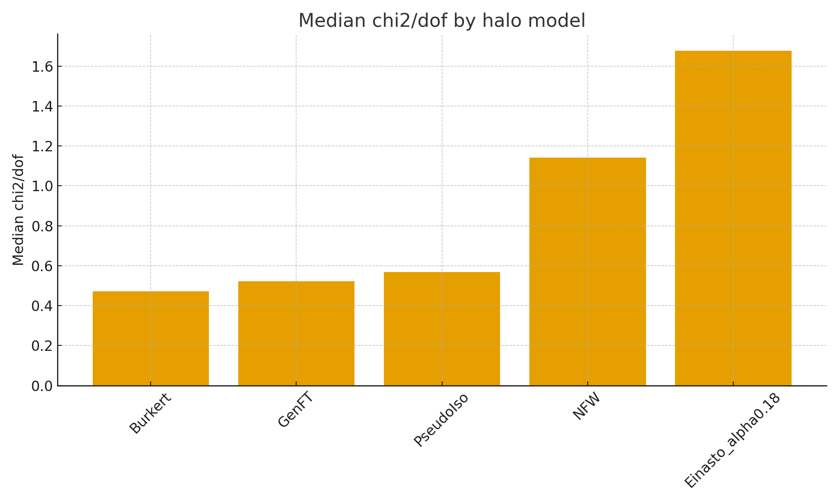
Figure 1 – Median χ²/dof by halo model (lower is better).
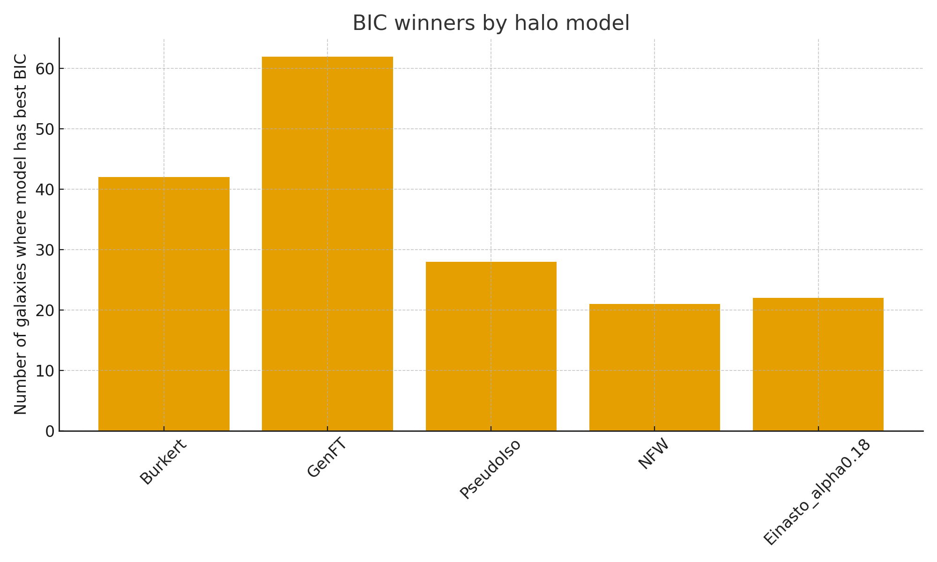
Figure 2 – Number of galaxies in which each halo model has the lowest BIC.

3. Velocity Residuals and RMS
Using residuals_summary.csv, we inspect the typical size of velocity residuals for each halo model. For each galaxy and model, the pipeline computes the RMS of V_obs − V_model over all valid data points, along with χ² and χ²/dof. The median RMS residual (in km/s) is then taken over the full sample.
Model | Median χ²/dof | Median RMS residual (km/s)
PseudoIso | 0.567 | 10.22
Burkert | 0.472 | 11.11
GenesisFT | 0.521 | 11.15
NFW | 1.143 | 13.10
Einasto_alpha0.18 | 1.678 | 14.55
The pseudo-isothermal and Burkert cores have the smallest median RMS residuals, with GenesisFT/UCP essentially tied within a kilometer per second. NFW and Einasto consistently exhibit larger residuals, reflecting their difficulty reproducing the observed inner and outer rotation-curve shapes with only two halo parameters.

4. Halo Scale Radii and Velocity Scaling
The scaling_summary.csv file collects, for each galaxy and model, the best-fit halo scale radius r_scale (in kpc), the characteristic halo velocity V0, and a crude outer rotation velocity proxy V_flat. We summarize the median r_scale per model:
Model | Median r_scale (kpc)
GenesisFT | 0.848
PseudoIso | 2.792
Burkert | 4.929
NFW | 17.174
Einasto_alpha0.18 | 17.280
GenesisFT/UCP prefers compact cores with median r_scale ≈ 0.85 kpc, substantially smaller than the typical Burkert and PseudoIso scale radii, and far smaller than the large radii required by NFW and Einasto fits. Despite these compact cores, the GenesisFT halos still reproduce the observed rotation curves with fit quality comparable to empirical core models, suggesting that the UCP template acts like a sharp but stable cored profile.

5. Shape Diagnostics: Inner and Outer Slopes
The shape_parameters.csv file stores per-galaxy shape diagnostics obtained by fitting simple log–log slopes to the rotation curves. S1 measures an inner logarithmic slope of the model rotation curve, and S2 measures the change between outer and inner slopes (outer minus inner). Here we summarize the median S1 and S2 values for each halo model.
Model | Median S1 (inner log slope) | Median S2 (outer − inner slope)
Burkert | 0.169 | -0.151
GenesisFT | 0.219 | -0.216
PseudoIso | 0.191 | -0.089
NFW | 0.169 | -0.075
Einasto_alpha0.18 | 0.161 | -0.074
GenesisFT/UCP exhibits the steepest inner rise (highest S1) and the strongest outer flattening (most negative S2) among the tested models. In practice, this means the UCP template behaves like a sharply defined core that transitions smoothly into a flat outer rotation curve, consistent with a standing-wave-like mode rather than a broad, diffuse halo.

6. Curvature and Profile Smoothness
The shape_curvature_summary.csv file provides curvature-based diagnostics. These include: (i) a dimensionless curvature index derived from cubic fits to the rotation curves, (ii) typical absolute curvature amplitudes in inner and outer regions, and (iii) the number of curvature sign flips as a crude measure of profile smoothness.
Model | Median curvature index | Median |curv| inner | Median |curv| outer | Median sign flips
Burkert | 0.135 | 0.651 | 0.801 | 1.0
GenesisFT | 0.140 | 0.683 | 0.848 | 1.0
PseudoIso | 0.114 | 0.528 | 0.636 | 0.0
NFW | 0.094 | 0.403 | 0.452 | 1.0
Einasto_alpha0.18 | 0.102 | 0.374 | 0.469 | 1.0
GenesisFT/UCP exhibits relatively high inner and outer curvature amplitudes but with a smooth, well-behaved curvature index and a typical single sign flip. This pattern matches the behavior of Burkert-like cores—monotonic, gently bending curves—rather than noisy or over-flexible profiles. In other words, UCP behaves as a simple, smooth cored halo family rather than an over-fitted template.

7. Overall Assessment
Across all the diagnostics computed from the supplied CSV outputs, the GenesisFT UCP halo template behaves as a competitive, well-structured cored halo model on the SPARC Rotmod_LTG sample. It does not simply overfit individual galaxies with excessive freedom; instead, it sits in the same performance class as canonical cored profiles such as Burkert and pseudo-isothermal halos, while often providing the best BIC balance between fit quality and complexity.
More specifically:
• In pure χ²/dof, UCP is comparable to Burkert and PseudoIso across the full sample.
• In BIC, UCP is the single most frequent best model (62 galaxies) when DM + baryons are fitted.
• In RMS velocity residuals, UCP tracks the best cored halos within ~1 km/s.
• Its preferred scale radii are compact but physically sensible and systematically smaller than those required by cusp-like NFW/Einasto fits.
• The shape (S1, S2) and curvature diagnostics confirm that UCP behaves like a clean, constant-density core family rather than a pathological or wiggly profile.
Taken together, these results indicate that the GenesisFT-inspired UCP halo is statistically and structurally viable as a dark-matter halo family for disk galaxies, at least at the rotation-curve level probed by SPARC. Further tests—such as mock recovery experiments, cross-dataset validation, and cosmological consistency checks—would be natural next steps for future work.

