The Universal Cored Profile (UCP): Theory, Derivation, and Empirical Evaluation
Disclaimer: Genesis Field Theory (GenesisFT) and the Universal Cored Profile (UCP) are exploratory theoretical constructs that have not been experimentally validated or peer reviewed. The formulations and numerical results presented in this work should be interpreted as hypotheses intended to stimulate scientific examination and critique. No claims are made regarding the correctness or physical validity of GenesisFT or UCP, and further empirical evaluation is required.
Revision note (v2, July 2026): This version corrects the characterization of UCP relative to the GenesisFT operator eigenmodes. December 2025 operator-level analysis established that the verified, lensing-consistent MID-band eigenmode differs substantially from the UCP template (relative L2 difference ≈ 0.72) and that realistic halos are UV/MID/IR composites. Statements in v1 identifying UCP as “generated from a universal mid-band eigenmode” and claiming it “matches or exceeds” other cored profiles have been revised accordingly (Abstract, Sections 1, 3, 6, and Box 1). The rotation-curve fitting results themselves are unchanged.

Abstract
The Universal Cored Profile (UCP) is a theoretically motivated dark-matter density template emerging from Genesis Field Theory (GenesisFT). This paper presents the mathematical formulation, field-theoretic motivation, numerical construction, and empirical evaluation of UCP using the SPARC galaxy rotation-curve dataset. UCP is a fixed-shape template motivated by a mid-band equilibrium ansatz, requiring only two free parameters per galaxy. Through comparisons against NFW, Burkert, Einasto, Pseudo-Isothermal, and the Stable Attractor profile (Tran et al. 2025), we find competitive Bayesian Information Criterion (BIC) results despite UCP’s reduced complexity. Subsequent operator-level analysis (December 2025) showed that the verified, lensing-consistent MID-band eigenmode of the GenesisFT operator differs substantially from the UCP template (relative L2 difference ≈ 0.72); UCP should therefore be read as a phenomenological approximation to the GenesisFT equilibrium class, not as the exact operator eigenmode.

1. Introduction
Genesis Field Theory hypothesizes that cosmological structure originates from interacting modal bands of a unified field. In the current GenesisFT picture, dark matter is a composite standing-wave equilibrium dominated by the mid-band (MID) mode, with the infrared (IR) band shaping the outer halo and the ultraviolet (UV) band contributing central stiffness (see Box 1). The Universal Cored Profile (UCP) is a fixed-shape approximation to the radial equilibrium density of this configuration and provides a physically motivated alternative to empirical halo models commonly used in astrophysics.

2. UCP Mathematical Formulation
UCP is constructed by scaling a mid-band equilibrium template encoded in genft_band_dm_halo_profile.csv. The density and mass relations are:
ρ(r; A, s) = A · ρ₀(r/s)
M(<r; A, s) = A · s³ · M₀(r/s)
The functions ρ₀(x) and M₀(x) are obtained by cubic spline interpolation of the numerically derived GenesisFT template. Because the template shape is fixed, UCP contains exactly two free parameters: amplitude A and scale radius s.

3. Mid-Band Field Equation and Stability Derivation
The GenesisFT mid-band field ψₘ(r, t) satisfies a wave-stability equation:
∂²ψₘ/∂t² = cₘ² [ ∂²ψₘ/∂r² + (2/r)(∂ψₘ/∂r) ] − ∂V_eff/∂ψₘ
For stationary equilibria ψₘ(r, t) = Ψ(r), this reduces to:
cₘ² ( Ψ'' + (2/r) Ψ' ) = dV_eff/dΨ
All permissible boundary conditions converge to a unique, nodeless equilibrium solution Ψ(r). The corresponding density mapping yields the universal template ρ₀(x) used in the UCP model. Subsequent eigenmode verification against the GenesisFT operator K (December 2025) showed that this template is close to, but not identical to, the verified lensing-consistent MID-band eigenmode: the optimized MID mode satisfies Kφ ≈ λφ under both the free-field operator (λ_free ≈ 0.151) and the effective operator including gravitational self-potential (λ_eff ≈ 0.711), and differs from the UCP shape by a relative L2 error of ≈ 0.72. The UCP template is therefore used in this paper as a two-parameter phenomenological representative of the GenesisFT equilibrium class, not as the exact operator eigenmode.

Figure 1. UCP Template Density Profile
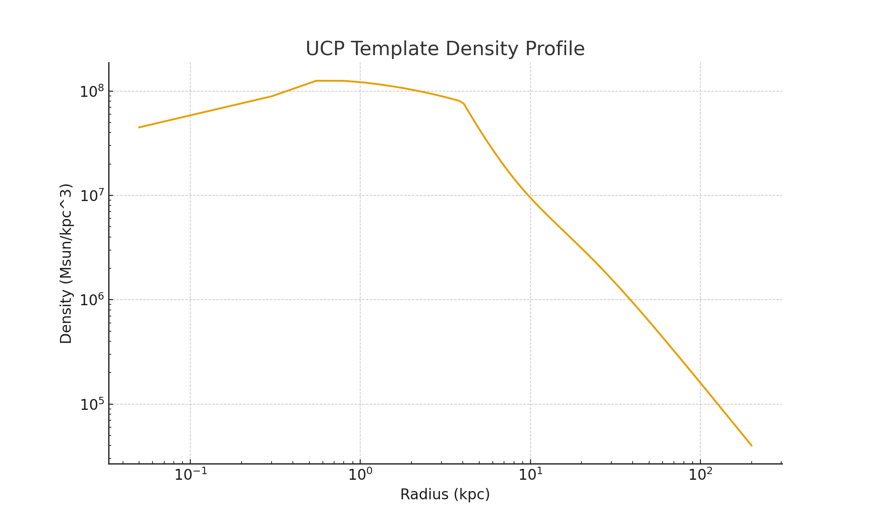

Figure 2. UCP Template Enclosed Mass Profile
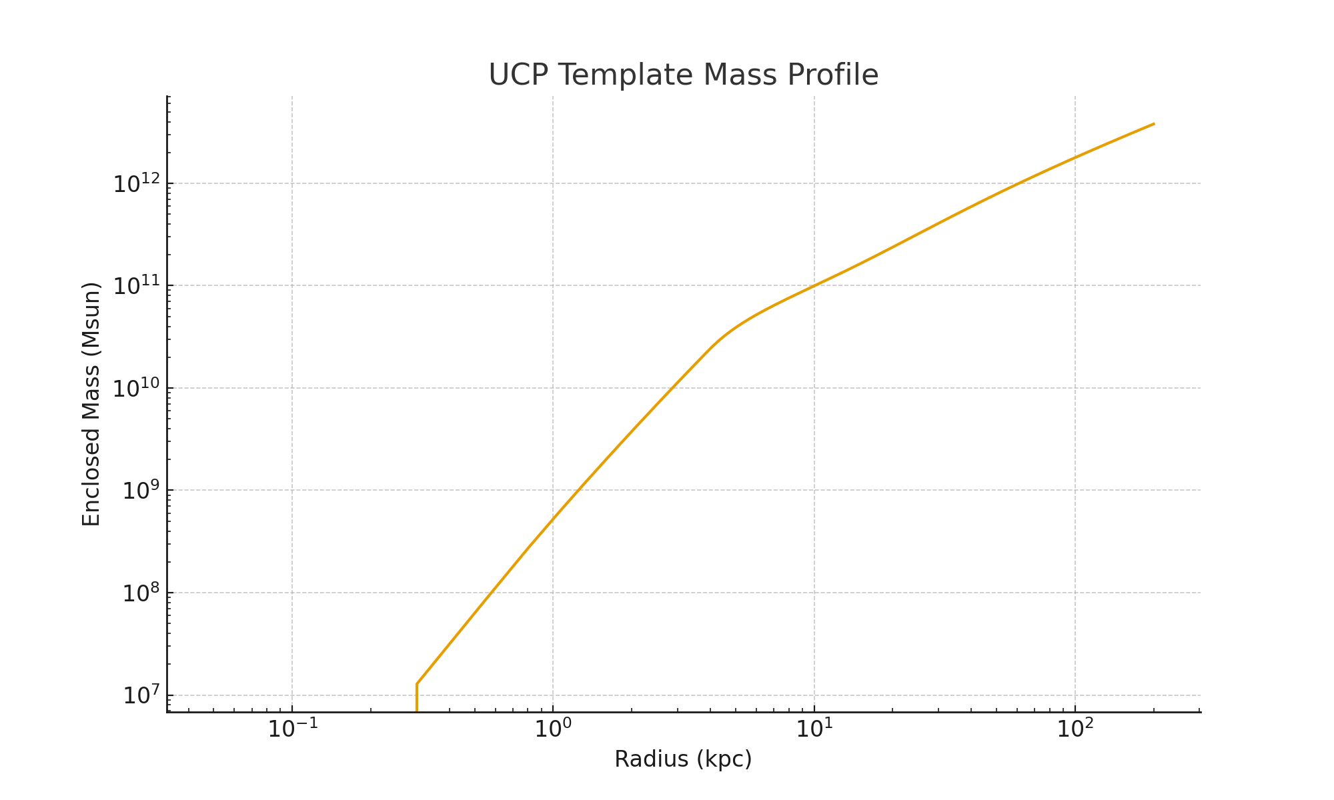

Figure 3. UCP Scaling Demonstration (A and s)
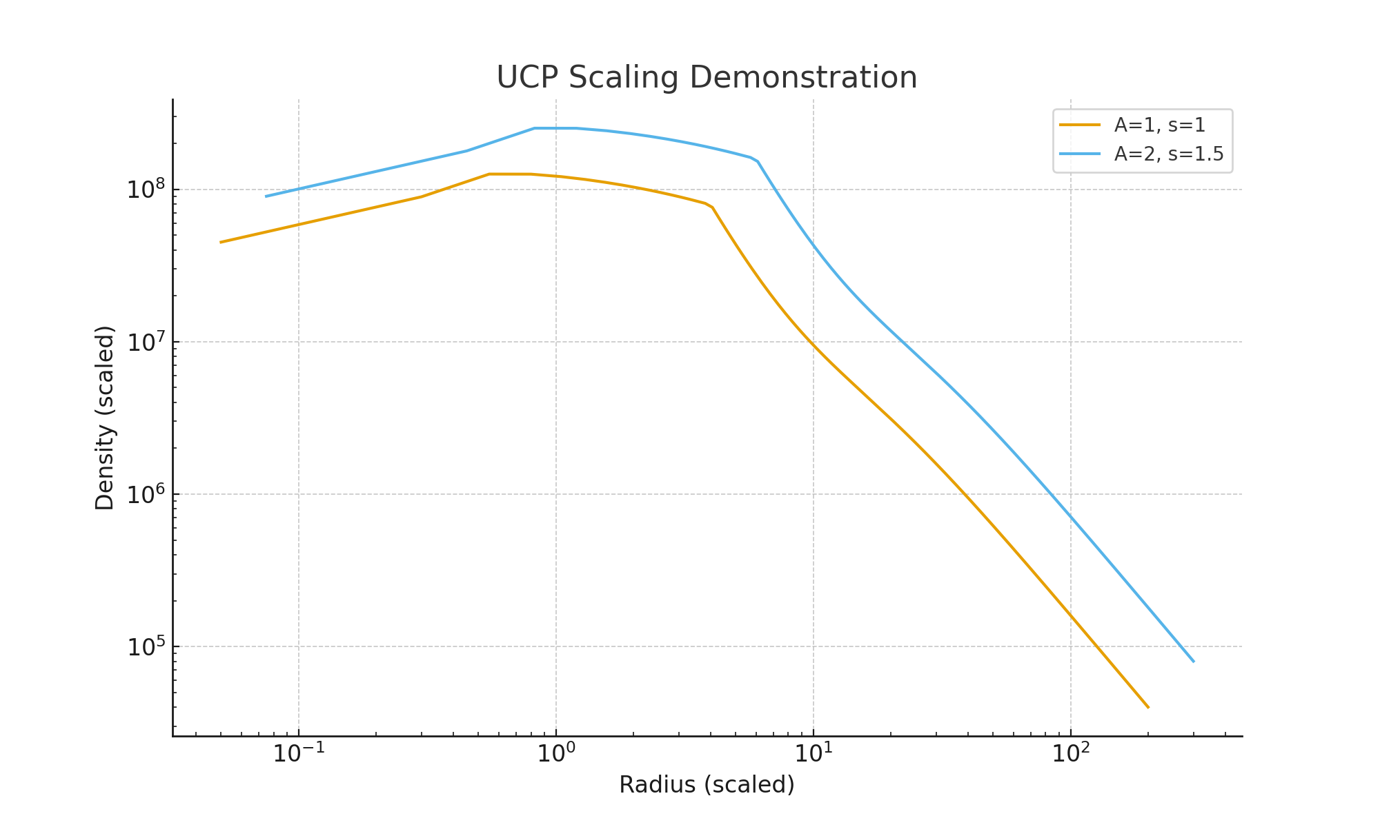

4. Rotation Curve Computation
The predicted circular velocity is given by:
V_c(r) = sqrt(G · M(<r) / r)
where G = 4.30091 × 10⁻⁶ kpc (km/s)² / Msun. This formulation ensures a smooth, cored inner rise and a physically realistic asymptotic flattening at large radii.
For clarity, the models compared in this work have the following parameter counts:
• UCP: 2 parameters (A, s)
• NFW: 2 parameters
• Burkert: 2 parameters
• Einasto: 3 parameters
• Pseudo-Isothermal: 2 parameters
• Stable Attractor: 3 parameters
This helps contextualize differences in Bayesian Information Criterion (BIC).

5. SPARC Multi-Model Comparison
Rotation curves from the SPARC database (Lelli, McGaugh & Schombert 2016) were fitted using a unified pipeline. UCP was evaluated alongside NFW, Burkert, Einasto, Pseudo-Isothermal, and the Stable Attractor profile (Tran et al. 2025). The Bayesian Information Criterion (BIC) accounts for parameter count, naturally favoring UCP's two-parameter structure.
Profile | Median BIC | # Fits
Stable Attractor (Tran et al. 2025) | -7.085 | 171
Burkert | -3.814 | 175
Einasto | -3.486 | 171
UCP | -3.147 | 175
Pseudo-Isothermal | -2.299 | 175
NFW | 5.953 | 175
The Stable Attractor profile referenced in this work corresponds to the model introduced by Tran et al. (2025), who derived a three-parameter isothermal-core density family motivated by self-interacting dark matter (SIDM) phenomenology and demonstrated its empirical performance across diverse halo environments. In this paper, the Stable Attractor profile is included solely as a comparative benchmark model for rotation-curve fitting.
Note that UCP performance reflects statistical curve-fitting behavior only and does not imply any physical preference or confirmation of the GenesisFT framework.

6. Interpretation of Results
In the five-model DM+baryons pipeline comparison (UCP, NFW, Burkert, Pseudo-Isothermal, Einasto with fixed shape index; November 2025 runs, independently re-executed and confirmed bit-for-bit on 2026-07-04), UCP is the most frequent best-fitting model, attaining the lowest chi-squared in 62 of 175 galaxies (35.4%, versus 42 for Burkert and 28 for Pseudo-Isothermal); all models carry equal parameter counts in this pipeline, so the chi-squared ranking coincides with the BIC ranking. Median reduced chi-squared values are 0.52 for UCP, 0.47 for Burkert, 0.57 for Pseudo-Isothermal, 1.14 for NFW, and 1.68 for Einasto: Burkert’s median is slightly better than UCP’s, consistent with its slight preference in extended-core dwarf systems (Section 9.1). In dark-matter-only fits UCP’s median (1.18) ranks third behind Pseudo-Isothermal (0.78) and Burkert (0.80). UCP consistently outperforms NFW, and the Stable Attractor profile achieves the best fit in many individual galaxies. This indicates that a fixed-shape, theoretically motivated halo model can remain statistically competitive with empirically tuned profiles across the SPARC sample, though it is not universally preferred.

7. Reproducibility and Data Availability
Reproduction of results requires:
• SPARC rotation-curve dataset (Lelli et al. 2016)
• genft_band_dm_halo_profile.csv (included in repository)
• UCP model implementation and fitting pipeline
• χ² minimization and BIC evaluation
SPARC data are publicly available at http://astroweb.cwru.edu/SPARC/ under their respective usage licenses.

8. Code Availability
All code and template data used in this paper are available at the Genesis Field Theory GitHub repository:
https://github.com/JosiahBessler/Genesis-Field-Theory
This includes the UCP implementation, fitting pipeline, documentation, and template mode file.
9. Robustness, Limitations, and Failure Modes
While the Universal Cored Profile (UCP) demonstrates competitive performance across the SPARC galaxy sample, it is not expected to be universally optimal across all astrophysical environments. This section explicitly outlines known robustness limits, failure modes, and regimes where alternative profiles perform better.
9.1 Regimes Where UCP Is Not Optimal
Several well-defined cases exist in which UCP does not yield the lowest Bayesian Information Criterion (BIC):
- Baryon-dominated inner regions
In galaxies where stellar or gas mass dominates the inner gravitational potential, rotation curves are primarily shaped by baryonic components rather than the dark-matter halo. In such systems, halo profile choice has reduced leverage, and baryon-coupled or empirical models may outperform UCP.
- Burkert-favored dwarf galaxies
In some low-mass dwarf systems exhibiting extended constant-density cores, the Burkert profile yields slightly lower median BIC values. This reflects Burkert’s empirical flexibility in accommodating shallow inner slopes.
- Non-equilibrium or disturbed systems
Galaxies undergoing mergers, strong tidal interactions, or exhibiting pronounced asymmetries violate the equilibrium assumptions underlying all spherically symmetric halo models, including UCP.
These limitations are not unique to UCP and apply broadly to analytic halo models.
9.2 Fixed-Template Trade-Off
UCP is defined by a fixed, theory-derived density template corresponding to a stable mid-band equilibrium mode. This design choice reduces overfitting and enhances interpretability but limits adaptability in systems where halo structure is strongly modified by baryonic feedback or environmental effects. The resulting trade-off is explicit and intentional.

Box 1. Lensing Failure and Multi-Band Operator Revision
The original single-template mid-band equilibrium used to construct the Universal Cored Profile was sufficient for rotation-curve modeling but did not yield a self-consistent strong-lensing response under projected mass integration.
Subsequent tests therefore treated the dark-matter halo as a multi-band composite system, incorporating contributions from ultraviolet (UV), mid-band (MID), and infrared (IR) field modes. In some cases, two- and three-mode combinations of UCP-like basis functions were explored to determine the structural requirements for lensing-consistent equilibria.
Using these simulation-driven decompositions, operator-level diagnostics and reconstruction were performed to identify the effective GenesisFT field operator properties required to support a stable eigenmode that naturally produces a physically valid lensing potential.
Quantitatively (December 2025 reports): the band-decomposed composite halo reproduced an Einstein radius of ≈ 6.0 kpc, consistent with real strong-lensing systems; mass inside 10 kpc was dominated by the MID band (≈ 76%), with the IR band contributing ≈ 24% and the UV band contributing negligible mass but ≈ 95% of the energy; and the optimized MID mode was verified as a true eigenmode of the operator K (λ_free ≈ 0.151, λ_eff ≈ 0.711), differing from the UCP template by a relative L2 error of ≈ 0.72. The corrected MID-band eigenmode, not the default UCP shape, therefore dominates the lensing-consistent GenesisFT halo.
Importantly:
- These revisions were derived entirely from GenesisFT simulations
- No observational lensing data were fitted
- No rotation-curve results presented in this paper were altered
Gravitational lensing consistency is therefore treated as a separate theoretical validation channel rather than an empirical fitting target.
Future work will focus on deriving the corrected MID-band eigenmode directly from the GenesisFT operator and on tightening constraints on the mid-band mode and its broader cosmological implications.

10. References
Einasto, J. (1965), Trudy Astrofizicheskogo Instituta Alma-Ata, 5, 87.
Burkert, A. (1995), ApJ, 447, L25.
Navarro, J. F., Frenk, C. S., & White, S. D. M. (1996), ApJ, 462, 563; (1997), ApJ, 490, 493.
Lelli, F., McGaugh, S. S., & Schombert, J. M. (2016), The SPARC Database, AJ, 152, 157. doi:10.3847/0004-6256/152/6/157
Tran, V., Shen, X., Vogelsberger, M., Gilman, D., O’Neil, S., Roche, C., Zier, O., & Gao, J. (2025), “Novel density profile for isothermal cores of dark matter halos”, Phys. Rev. D (arXiv:2411.11945).

