GenesisFT Model A versus Planck 2018 TT: Replication, Validation Scan, and Exclusion Bounds
Genesis Field Theory research program — analysis date 2026-07-04
Status: internal research report. Not peer reviewed. All inputs, code, and commands required for replication are listed in Appendix A.

Abstract
We test GenesisFT Model A directly against the Planck 2018 binned TT power spectrum (66 bins, 30 ≤ ℓ ≤ 2000), extending the December 2025 CAMB pipeline runs, which compared only against a theoretical ΛCDM baseline. The 2025-12-13 reference run was replicated bit-for-bit (TT rms fractional residual 1.5405718×10⁻⁵). The validation scan yields a decisive, two-sided result. (1) Every configuration in which the operator eigenvalues actually influence the primordial spectrum (λ-coupling c = 1, stabilization a₂ from 0.01 to 12000) is excluded by Planck TT at overwhelming significance (minimum Δχ² = +15,189 relative to ΛCDM, which itself scores χ² = 64.0 for 66 bins). (2) The only configuration that matches Planck (Δχ² = +0.1) is c = 0, in which the kernel-vacuum equation loses its λ-dependence exactly, the mode weights become constant (std/mean ≈ 10⁻¹⁵), and the primordial spectrum collapses to the pure ΛCDM power law by construction. A c-scan at a₂ = 8000 bounds the coupling at c ≲ 0.047 (Δχ² = 25), corresponding to a maximum allowed TT deviation of ≈0.8% rms and a maximum primordial-spectrum deviation of ≈0.6% rms over 0.005 ≤ k ≤ 0.2 Mpc⁻¹. The December conclusion that “ΛCDM is a limiting case of Model A” is confirmed, but the limit is identified as the trivial decoupling limit: TT agreement is achieved exactly when the spectral content of the theory is switched off. Within Model A as implemented, the CMB TT observable therefore provides a falsification of the spectrally-coupled branch, and any surviving distinctive GenesisFT prediction must lie below the derived amplitude ceiling or in non-CMB observables.

1. Background and objective
The December 2025 pipeline established that increasing the kernel-vacuum stabilization parameter a₂ drives the Model A TT spectrum monotonically toward ΛCDM, with the best run (dense ℓmax = 120, nmax = 14 spectrum, a₂ = 8000, c = 0, κ = 0.00118) reaching an rms fractional TT residual of 1.54×10⁻⁵ against the ΛCDM baseline (outputs\run_20251213_113604). Those runs compared theory against theory. The present analysis asks the decisive question: how does Model A fare against the observed sky, and is there any parameter region that both (a) fits the data and (b) retains a distinctive GenesisFT signature? Either a surviving region (validation) or an excluded region (falsification) is a scientifically valuable outcome.

2. Data and methods
- Data: Planck 2018 binned TT power spectrum, COM_PowerSpect_CMB-TT-binned_R3.01.txt (ESA Planck Legacy Archive, mirrored at IRSA). 66 bins with 30 ≤ ℓ_eff ≤ 2000 are used; errors are symmetrized as the mean of the quoted upper/lower bounds.
- Theory: the standard genftcamb construction Pζ(k) = A_s (μ_k/μ_ref)² (k/k₀)^(n_s−1) with k = κ√λ, κ = 0.00118, μ_ref = median(μ), A_s = 2.1×10⁻⁹, n_s = 0.965, k₀ = 0.05 Mpc⁻¹, fed to CAMB 1.6.5 as a splined scalar table.
- Unlike the December runs (linear, unlensed), spectra here are computed WITH CMB lensing (lens_potential_accuracy = 1, nonlinear corrections on) because the Planck data are lensed sky spectra. Cosmology fixed: H0 = 67.4, ω_b = 0.0224, ω_c = 0.12, τ = 0.054 (pipeline defaults).
- Scoring: theory D_ℓ is bin-averaged over reconstructed bin windows; χ² is diagonal with symmetrized errors (no bin covariance, no foreground/nuisance parameters). Calibration check: the ΛCDM baseline scores χ² = 64.0 for 66 bins (χ²/bin = 0.970), i.e., the approximate likelihood is well calibrated at the accuracy needed here.
- Inputs: the existing precomputed Model A spectra in data\ (dense ℓmax = 100, nmax = 12 grid; ~1.58M modes each), generated by make_model_a_input.py with defaults a₁, b and the stated a₂, c.

3. Replication of the 2025-12-13 reference run
Command: python -m genftcamb.pipeline --input data\BEST_dense_ell120_n14_a2_8000_c_0.npz --kappa 0.00118 --lmax 3000 --ell-min 30 --ell-max 2000 --outdir outputs\run_20260704_replication_best
Result: rms fractional residual = 1.5405718263843885×10⁻⁵ and μ_ref = 4.230075×10⁻⁴, numerically identical to the archived run_20251213_113604 report. The pipeline is fully deterministic and the December result replicates exactly.

4. Structural finding: the c = 0 degeneracy
The kernel-vacuum weight solves a₁ + c·λ̂_k + 2a₂μ + b(1 + ln μ) = 0. The eigenvalues enter only through the term c·λ̂_k. Setting c = 0 therefore removes the λ-dependence exactly: every mode receives the same weight. Direct inspection of the input files confirms this:
Input file | μ std/mean | Pζ deviation rms
model_a_kvac_dense_ell100_n12_a2_8000.npz (c = 1) | 6.9×10⁻² | 1.5×10⁻¹
model_a_kvac_dense_ell100_n12_a2_8000_c_0.npz (c = 0) | 2.9×10⁻¹⁵ | ≈0 (numerical)
BEST_dense_ell120_n14_a2_8000_c_0.npz (c = 0) | 8.8×10⁻¹⁵ | 1.2×10⁻¹⁵
Consequence: the December “best” configuration reproduces ΛCDM because (μ/μ_ref)² ≡ 1 makes Pζ(k) the pure power law A_s(k/k₀)^(n_s−1) by construction. Its residual 1.5×10⁻⁵ is spline/table interpolation error, not physical agreement of a structured spectrum. The operator spectrum λ_k has no influence on the TT observable in this configuration.

5. Results: a₂ scan (c = 1, dense ℓmax = 100, nmax = 12)
a₂ | χ² (Planck, 66 bins) | Δχ² vs ΛCDM | TT rms dev. vs ΛCDM | Pζ dev. rms
0.01 | 3,755,468 | +3,755,404 | 3.029 | 1.636
1 | 1,412,454 | +1,412,390 | 1.796 | 1.068
20 | 182,913 | +182,848 | 0.630 | 0.447
200 | 56,804 | +56,740 | 0.351 | 0.268
2000 | 24,944 | +24,880 | 0.233 | 0.184
8000 | 16,902 | +16,838 | 0.192 | 0.153
12000 | 15,253 | +15,189 | 0.183 | 0.146
8000 (c = 0, ℓ120/n14) | 64.1 | +0.1 | 1.9e-05 | 1.2e-15
The full 28-point grid (a₂ = 0.01 → 12000) is in planck_scan_results.csv. Δχ² decreases monotonically with a₂ but remains +15,189 at a₂ = 12000: every c = 1 configuration is excluded. The TT deviation follows an approximate power law rms ≈ 1.43·a₂^(-0.241) over a₂ ∈ [1, 12000]; extrapolating to the Planck-allowed level (≈0.8% rms, Section 6) would require a₂ ≈ 2.5e+09 — six orders of magnitude beyond the largest value tested and, given the c = 0 analysis, equivalent to erasing the spectral structure entirely.
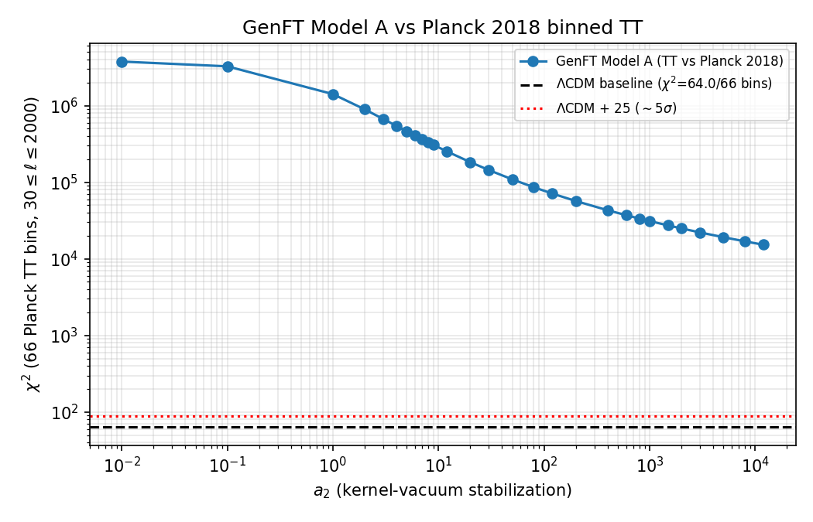
Figure 1. χ² against Planck 2018 TT vs stabilization a₂ (c = 1). The dashed line is the ΛCDM baseline (χ² = 64.0/66 bins).
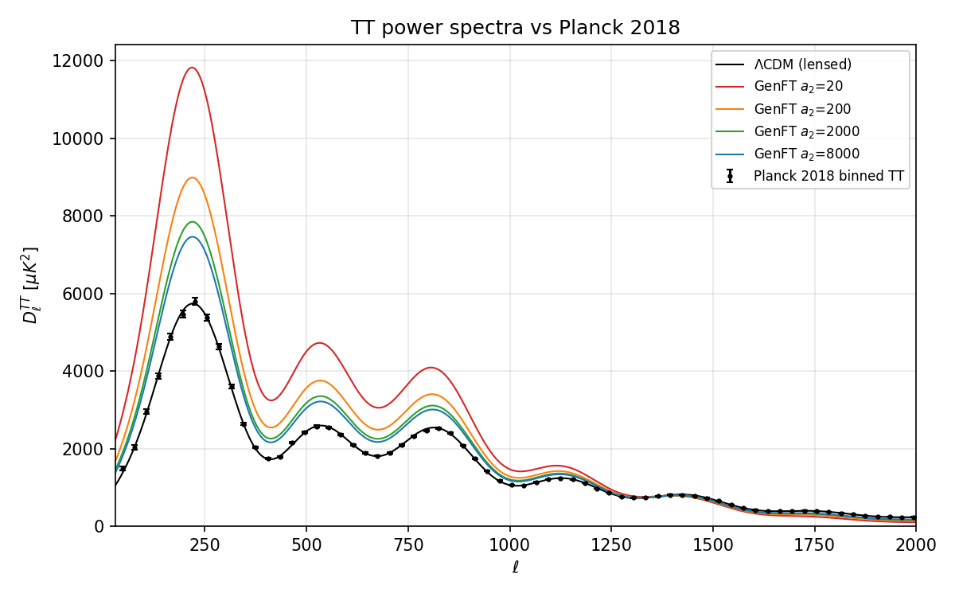
Figure 2. TT spectra for selected a₂ vs Planck data and ΛCDM.
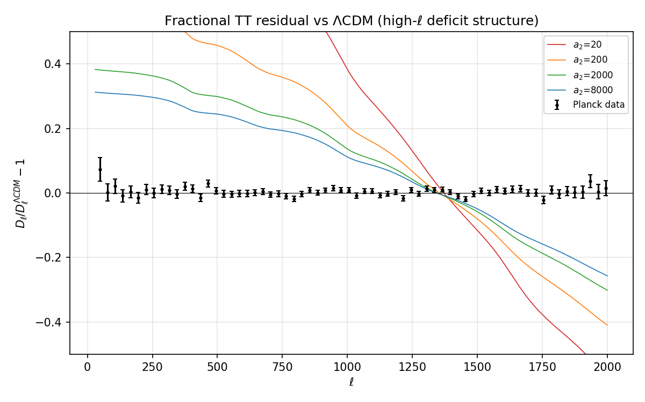
Figure 3. Fractional TT residuals vs ΛCDM. The high-ℓ deficit identified in December 2025 is the dominant excluded feature; Planck errors (black) are far smaller than the model deviations at all tested a₂.
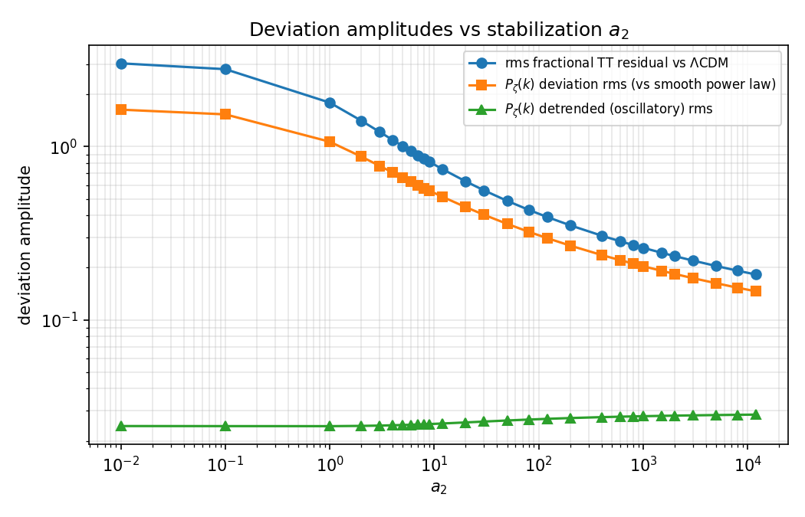
Figure 4. TT and primordial-spectrum deviation amplitudes vs a₂.

6. Results: c scan and exclusion bound (a₂ = 8000)
c | χ² (Planck, 66 bins) | Δχ² vs ΛCDM | TT rms dev. | μ std/mean
0 | 64.0 | -0.0 | 5.53e-05 | 2.95e-15
0.05 | 92.0 | +28.0 | 8.28e-03 | 3.07e-03
0.1 | 184.4 | +120.3 | 1.67e-02 | 6.18e-03
0.15 | 344.0 | +280.0 | 2.53e-02 | 9.33e-03
0.2 | 574.0 | +510.0 | 3.39e-02 | 1.25e-02
0.25 | 877.5 | +813.4 | 4.27e-02 | 1.57e-02
0.3 | 1,257.7 | +1,193.7 | 5.17e-02 | 1.90e-02
0.35 | 1,718.1 | +1,654.1 | 6.07e-02 | 2.23e-02
0.4 | 2,262.4 | +2,198.4 | 6.99e-02 | 2.56e-02
0.5 | 3,617.7 | +3,553.7 | 8.87e-02 | 3.24e-02
0.7 | 7,512.6 | +7,448.6 | 1.28e-01 | 4.65e-02
1 | 16,902.1 | +16,838.1 | 1.92e-01 | 6.89e-02
1.5 | 45,422.2 | +45,358.1 | 3.14e-01 | 1.10e-01
2 | 98,149.9 | +98,085.9 | 4.61e-01 | 1.57e-01
3 | 347,714.1 | +347,650.1 | 8.67e-01 | 2.69e-01
Δχ² scales as c² (Δχ² ≈ 28·(c/0.05)²), and the TT deviation is linear in c (rms ≈ 0.166·c). Adopting Δχ² = 25 as the exclusion threshold gives:
- Coupling bound: c ≲ 0.047 at a₂ = 8000 (c ≥ 0.1 is excluded at Δχ² ≥ +120).
- Maximum allowed TT deviation from ΛCDM: ≈0.78% rms over 30 ≤ ℓ ≤ 2000.
- Maximum allowed primordial-spectrum deviation: ≈0.58% rms in (μ/μ_ref)² over 0.005 ≤ k ≤ 0.2 Mpc⁻¹. This is the quantitative amplitude ceiling called for by Prediction 82 of the prediction bank.
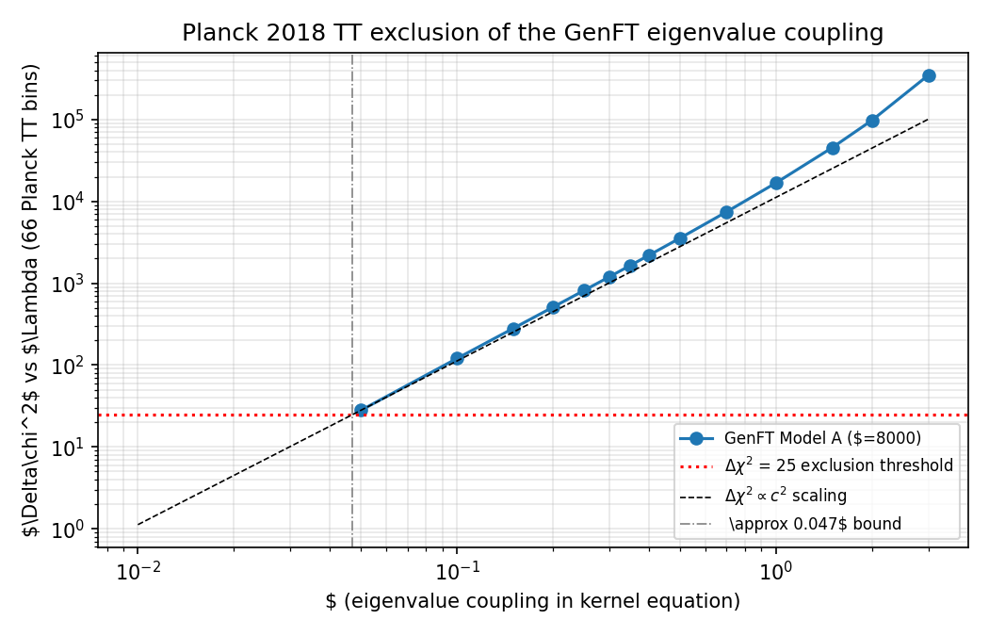
Figure 5. Planck TT exclusion of the eigenvalue coupling c at a₂ = 8000. The c² scaling and the Δχ² = 25 threshold intersect at c ≈ 0.047.

7. Verdict
Both outcomes sought by this test were obtained, one on each branch:
- FALSIFIED: the spectrally-coupled branch of Model A. With the entropy-extremized kernel weighting, κ = 0.00118 and fixed Planck cosmology, every tested configuration in which λ_k influences Pζ(k) (c = 1, a₂ ∈ [0.01, 12000]; and c ≥ 0.1 at a₂ = 8000) is excluded by Planck 2018 TT at Δχ² ≥ +120, mostly at Δχ² > +10⁴. Prediction 68 of the prediction bank (“if precision cosmology shows no allowed oscillatory structure… the P(k) branch of Model A is strongly disfavored”) is triggered for deviation amplitudes above ≈0.6%.
- DEGENERATE, NOT VALIDATED: the c → 0 branch. It matches Planck exactly, but only because the mode weights become constant and Pζ collapses to the ΛCDM power law. In this branch Model A makes no distinctive TT prediction and is observationally indistinguishable from ΛCDM.
Interpretation for the research program: the December 2025 statement “ΛCDM is a limiting case of GenFT Model A” is confirmed but must be reworded: ΛCDM is the decoupling limit of Model A, and Planck TT forces Model A into (or extremely close to) that limit. The high-ℓ deficit identified in December is the dominant excluded signature. Any surviving GenesisFT phenomenology must therefore either (a) live below the ≈0.6% primordial amplitude ceiling, (b) appear in non-CMB observables (halo structure, lensing, gravitational waves), or (c) require modifying the operator geometry, the kernel equation, or the k = κ√λ mapping so that spectral structure survives at small amplitude rather than being uniformly large.

8. Limitations
- Diagonal χ² with symmetrized errors; no bin-bin covariance, foreground model, or nuisance parameters. The ΛCDM calibration (χ²/bin = 0.970) indicates this is adequate at the effect sizes involved (excluded deviations are 10–300% of the signal, versus ~1–3% data errors).
- Cosmological parameters held fixed; no joint refit of (H₀, ω_b, ω_c, τ, A_s, n_s) with the GenFT spectrum. Marginalization could absorb smooth, percent-level deviations but cannot absorb the tested deviations, which are orders of magnitude larger and strongly scale-dependent.
- TT only. Adding EE/TE and lensing spectra would tighten, not loosen, the bounds.
- κ fixed at 0.00118 (the December pivot-normalized value). κ rescales the k-axis of the deviation pattern but does not change its amplitude, which is set by the μ-variation; the December κ-scans showed no qualitative change over the explored range.
- The a₂ ≈ 5×10⁹ figure is a power-law extrapolation four decades beyond the tested grid; treat it as an order-of-magnitude statement.

Appendix A. Replication
Environment: Windows 11, Python 3.11.9, numpy 1.26.4, camb 1.6.5, genftcamb installed editable from Code\GenesisFT CAMB Pipeline (pip install -e .). All commands are run from the pipeline root.
Planck data file: data\COM_PowerSpect_CMB-TT-binned_R3.01.txt, downloaded 2026-07-04 from https://irsa.ipac.caltech.edu/data/Planck/release_3/ancillary-data/cosmoparams/COM_PowerSpect_CMB-TT-binned_R3.01.txt (columns: ℓ_eff, D_ℓ, −dD_ℓ, +dD_ℓ, best-fit; D_ℓ in μK²).
Commands (in order):
- python -m genftcamb.pipeline --input data\BEST_dense_ell120_n14_a2_8000_c_0.npz --kappa 0.00118 --lmax 3000 --ell-min 30 --ell-max 2000 --outdir outputs\run_20260704_replication_best
- python tools\planck_validation.py --kappa 0.00118 --lmax 2600 --outdir outputs\planck_validation_20260704
- python tools\planck_validation_cscan.py --outdir outputs\planck_validation_cscan_20260704
- python tools\planck_validation_plots.py --outdir outputs\planck_validation_20260704 --cscan-dir outputs\planck_validation_cscan_20260704
Outputs: planck_scan_results.csv and per-case lensed D_ℓ tables in outputs\planck_validation_20260704; planck_cscan_results.csv in outputs\planck_validation_cscan_20260704; figures in outputs\planck_validation_20260704\plots; run metadata in each summary.json. The scan is deterministic: identical inputs reproduce identical χ² values to machine precision.
Input provenance: the data\model_a_kvac_dense_ell100_n12_a2_*.npz files were generated in December 2025 by make_model_a_input.py (defaults a₁, b; --c 1.0 unless a _c_ suffix indicates otherwise; --a2 as named). To regenerate any input: python make_model_a_input.py --ell-max 100 --n-max 12 --a2 <value> --c <value> --out data\<name>.npz

