keep mod

Edited by W. Josiah Jack, aka Qmaster.

7/14/2020

What started as an effort to add a few items from both mission packs into one single player level eventually grew over time to be a massive compilation of features from across the Quake community. This mod is primarily a full combination of the following mods’ enemies, weapons, items, traps, and other features in addition to my own features:

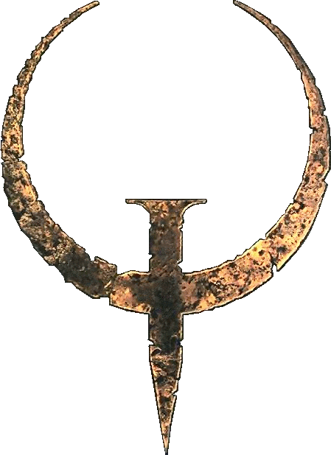

Standard Quake (ID1)



Hipnotic



Rogue

Arcane Dimensions (AD)

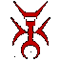

Quoth

Kinn

Soul of Evil (SOE)

Custents

Pox’s Extras (extras_r4)

Arcane Dimensions serves as the primary base for all added content due to its excellent formatting, enhanced enemy infighting code, and excellent structure.

Any conflicts have been resolved in such a manner as to retain the unique features of the primary mods above, for instance by using spawnflags. The entity definition file contains all the necessary fields and spawnflags for accessing these conflict resolving features as well as any Keep specific features that have been added.

All features of this mod are documented below in their various sections. A complete entity list can be found in the appendix. In every section the entities are listed alphabetically by entity name.

ENEMIES

The enemies of Quake, commonly referred to as monsters, are many and varied. Keep contains support for [TODO:recount #] different enemies. Many have alternate skins or upgraded versions such as the ogre family, death knight brigade, grunts, and enforcers.

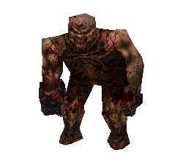

EXAMPLE

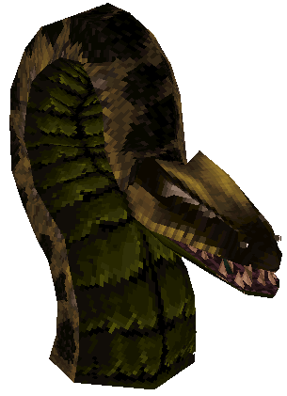

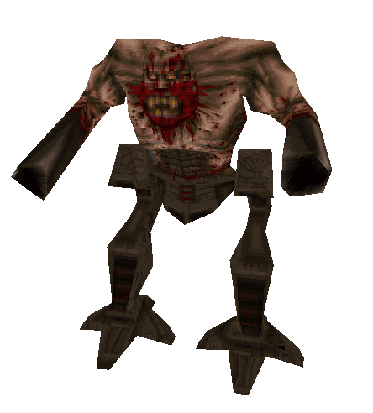

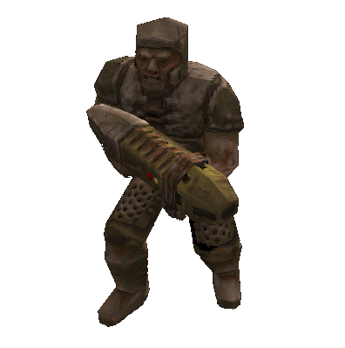

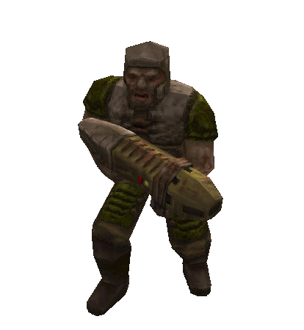

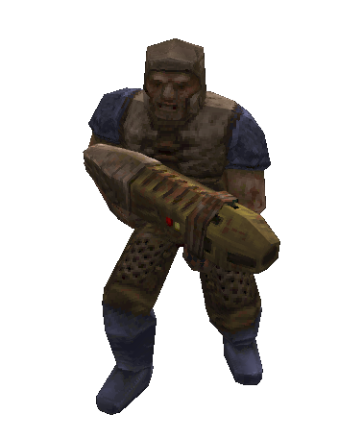

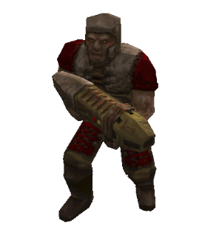

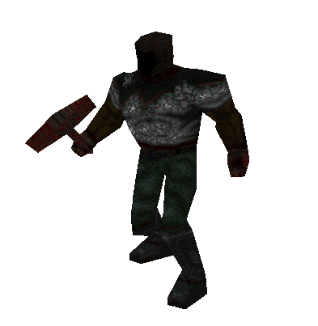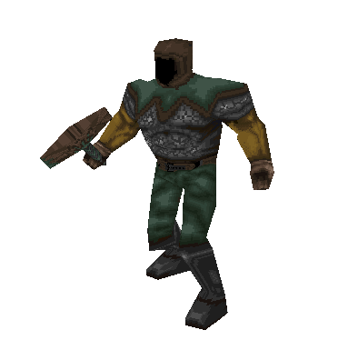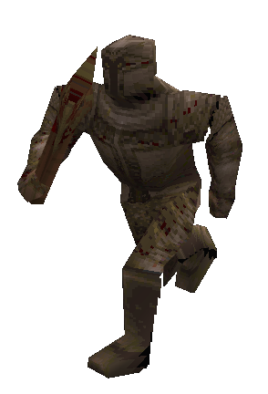

SKIN1

SKIN2

SKIN0

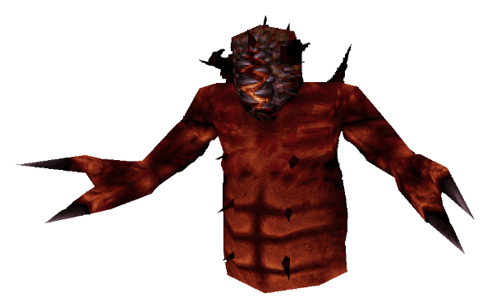

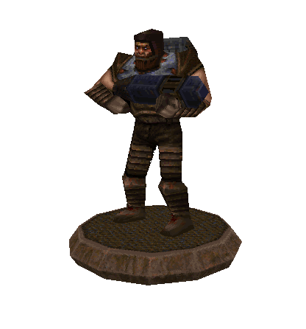

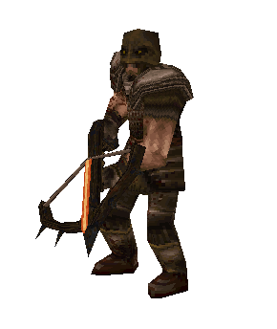

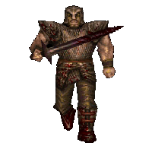

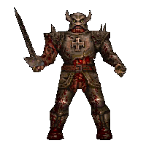

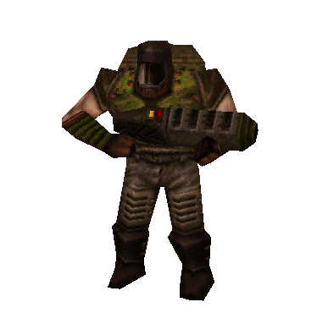

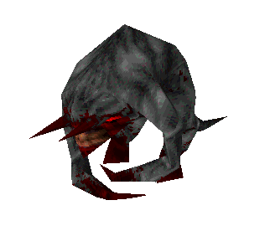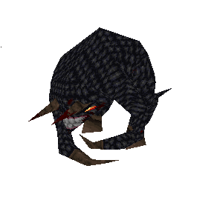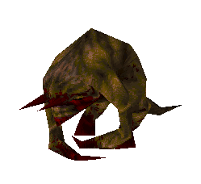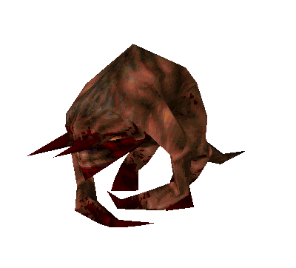

SKIN2

SKIN1

POISONOUS

SKIN3

SKIN0

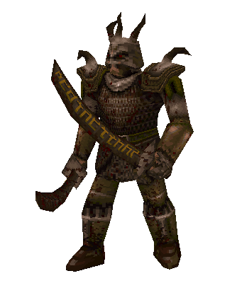

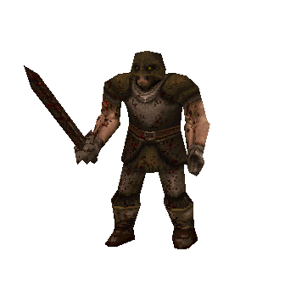

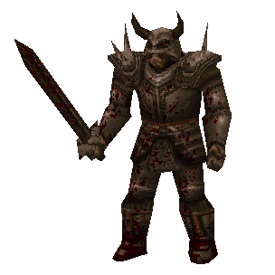

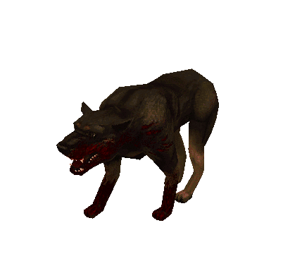

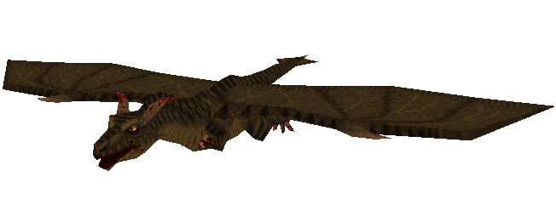

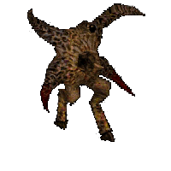

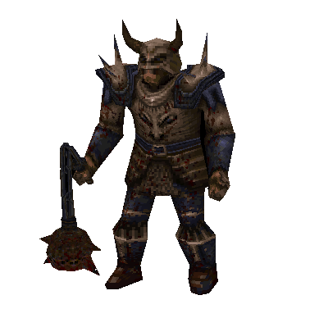

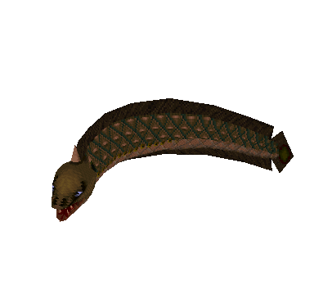

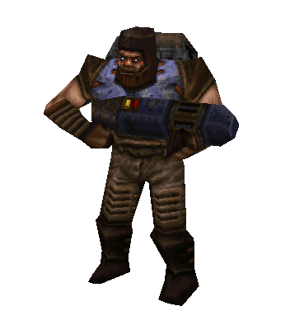

WEAPONS

Name: Axe

Entity: weapon_axe

Damage: 20

Description: Weakest weapon. Simple axe with a few different swing angles.

Mod: ID1

Ammo: None

Impulse: 1

Name: Crossbow

Entity: weapon_crossbow

Damage Normal: 100

Damage Poison: 110

Description: Fires either normal bolts or poison bolts. Poison bolts cause poison debuff. Excellent stealth weapon since enemies can be shot without angering them.

Mod: ITS

Ammo: Bolts

Alternate Ammo: Poison Bolts

Impulse: 178

Name: Grenade Launcher

Entity: weapon_grenadelauncher

Damage: 100-120(120)

Description: Lobs an explosive that explodes in TODO:# seconds

Mod: ID1

Ammo: Rockets

Impulse: 6

Name: Laser Cannon

Entity: weapon_laser_gun

Damage: 18

Description: Fires lasers in a pattern of 2 blasts at once – 1 blast – 2 blasts at once. Lasers can ricochet off walls up to 3 times but lose 10% damage with each ricochet with a 15% chance of not ricocheting. Very rapid fire.

Mod: Hipnotic

Ammo: Cells

Impulse: 9

Name: Lava Nailgun

Entity: weapon_lava_nailgun

Damage: 15

Description: Lava variant of the Nailgun. Fires red hot nails that pierce armor. Cannot hurt Hephaestus (monster_lava_man). Only does 9 damage against players.

Mod: Rogue

Ammo: Lava Nails

Impulse: 60

Name: Lava Super Nailgun

Entity: weapon_lava_super_nailgun

Damage: 30

Description: Lava variant of the Perforator. Fires red hot nails that pierce armor. Cannot hurt Hephaestus (monster_lava_man). Only does 18 damage against players.

Mod: Rogue

Ammo: Lava Nails

Impulse: 61

Name: Thunderbolt

Entity: weapon_lightning

Damage: 30 per 0.1 seconds

Description: Fires a continuous stream of lightning. Discharging in the water drains all cells and causes damage in a (35Xammo_cells) radius.

Mod: ID1

Ammo: Cells

Impulse: 8

Name: Mjolnir’s Hammer

Entity: weapon_mjolnir

Damage Melee: 50, 70 to zombies

Damage Lightning: 80, then 30 every 0.2s after that

Description: More powerful melee weapon that does powerful blunt force but also shoots out lightning at any nearby enemies when hit on the ground. Lightning continues to hurt its target until the target reaches 0 health or moves out of range. Firing in water has the same discharge effect as the lightning gun killing everything in a (35Xammo_cells) radius.

Mod: Hipnotic

Ammo: Cells

Impulse: 177

Name: Multi-Grenade Launcher

Entity: weapon_multi_grenade

Main Grenade Damage: (120)

Mini Grenade Damage: (90)

Description: Fires a yellow grenade that splits into 5 mini-grenades that then explode soon after. If main grenade hits enemy or player before splitting, it does normal grenade damage.

Mod: Rogue

Ammo: Multi-Grenades

Impulse: 62

Name: Multi-Rocket Launcher

Entity: weapon_multi_rocket

Damage: 60-75(75)

Description: Fires 4 rockets at once in a horizontal spread pattern.

Mod: Rogue

Ammo: Multi-Grenades

Impulse: 63

Name: Nailgun

Entity: weapon_nailgun

Damage: 9

Description: Fires nails out rapidly from one barrel and then the other.

Mod: ID1

Ammo: Nails

Impulse: 4

Name: Plasma Gun

Entity: weapon_plasmalightning

Lightning Ball Damage: 80-100(70)

Lightning Damage: 50

Description: Fires a lightning ball that explodes on impact. Lightning ball shoots out lightning at any nearby enemies if there are some.

Mod: Rogue

Ammo: Plasma

Impulse: 64

Name: Proximity Gun

Entity: weapon_proximity_gun

Damage: (95)

Description: Fires a red mine that sticks to walls. The mine explodes only when something moves near it.

Mod: Hipnotic

Ammo: Rockets

Impulse: 176

Name: Rocket Launcher

Entity: weapon_rocketlauncher

Damage: 100-120(120)

Description: Fires a rocket that explodes on impact.

Mod: ID1

Ammo: Rockets

Impulse: 7

Name: Shotgun

Entity: weapon_shotgun

Damage: 4-28

Description: Fires a fairly tight burst of pellets up to long distances. One of the weakest weapons in the game.

Mod: ID1

Ammo: Shells

Impulse: 2

Name: Perforator

Entity: weapon_supernailgun

Damage: 18

Description: Fires nails rapidly for high damage.

Mod: ID1

Ammo: Nails

Impulse: 5

Name: Double-barreled Shotgun

Entity: weapon_supershotgun

Damage: 4-56

Description: Fires a double burst of pellets in a wide spread.

Mod: ID1

Ammo: Shells

Impulse: 3

Name: Shadow Axe

Entity: weapon_upgrade_axe

Damage: 35

Description: Replaces the normal axe. Does more damage and is capable of gibbing corpses or lying zombies.

Mod: AD

Ammo: None

Impulse: 1

Name: Plasma Gun

Entity: weapon_upgrade_lg

Damage: 45(20)

Description: Replaces the lightning gun. Fires a rapid burst of plasma balls. The plasma balls explode on impact causing splash damage.

Mod: AD

Ammo: Cells

Impulse: 8

Name: Widowmaker

Entity: weapon_upgrade_ssg

Damage: 4-84

Description: Replaces the Double-barreled Shotgun. Fires three bursts of bellets in a wide spread.

Mod: AD

Ammo: Shells

Impulse: 3

ITEMS

The

TRAPS

The

BRUSH ENTITIES

The

POINT ENTITIES

The following entities don’t have a particular category and will be listed in alphabetical order. These have many many different uses.

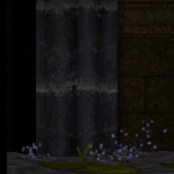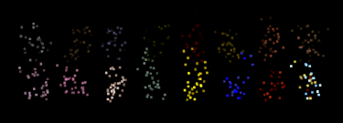

Appendix

Point Entity List:

air_bubbles

ambient_comp_hum

ambient_custom_loop

ambient_custom_sound

ambient_drain

ambient_drip

ambient_drone

ambient_eerie

ambient_factory

ambient_fan_blowing

ambient_flies

ambient_flouro_buzz

ambient_flys

ambient_general

ambient_generalpurpose

ambient_grinder

ambient_highwind

ambient_humming

ambient_lapping

ambient_lapping2

ambient_light_buzz

ambient_machines

ambient_nehum

ambient_rain

ambient_riftpower

ambient_running_lava

ambient_running_water

ambient_rushing

ambient_sizzle

ambient_sound

ambient_stargate_hum

ambient_suck_wind

ambient_swamp1

ambient_swamp2

ambient_swamp3

ambient_teeth

ambient_teleport

ambient_thrum

ambient_thunder

ambient_toggle

ambient_water_fall

ambient_waterfall

ambient_whnoise

ambient_zzxzz

corpse_crucified1

corpse_crucified2

corpse_flayed1

corpse_flayed2

corpse_flayed3

corpse_flayed4

corpse_impaled_back1

corpse_impaled_back2

corpse_impaled_back3

corpse_impaled_front1

corpse_impaled_front2

corpse_impaled_front3

corpse_impaled_horizontal1

corpse_impaled_horizontal2

corpse_impaled_horizontal3

corpse_impaled_horizontal4

corpse_impaled_vertical1

corpse_impaled_vertical2

corpse_impaled_vertical3

corpse_lynched1

corpse_lynched2

corpse_lynched3

custom_item

dragon_corner

earthquake

effect_teleport

event_lightning

func_breakable_spawner

func_clock

func_counter

func_earthquake

func_exploder

func_instance

func_multi_exploder

func_oncount

func_placeholder

func_rotate_door

func_rotate_entity

func_rotate_train

func_rubble

func_rubble1

func_rubble2

func_rubble3

func_teleport_train

info_bomb

info_command

info_command_server

info_command_spawn

info_effect_pulse

info_intermission

info_notnull

info_null

info_overlord_destination

info_particles

info_player_coop

info_player_coop2

info_player_deathmatch

info_player_start

info_player_start2

info_rotate

info_screenshake

info_skullwiz_destination

info_target

info_teleport_destination

item_armor1

item_armor2

item_armorInv

item_artifact_cross

item_artifact_empathy_shields

item_artifact_envirosuit

item_artifact_horn

item_artifact_invisibility

item_artifact_invulnerability

item_artifact_lavasuit

item_artifact_nail_piercer

item_artifact_random

item_artifact_sharp_shooter

item_artifact_super_damage

item_artifact_trinity

item_artifact_wetsuit

item_backpack

item_bolts

item_cells

item_circuitboard

item_custom

item_health

item_key1

item_key2

item_keyx

item_lava_spikes

item_multi_rockets

item_plasma

item_poison

item_powerup_belt

item_powerup_shield

item_random_powerup

item_rockets

item_shells

item_sigil

item_spikes

item_taunt

item_tomeofpower

light

light_beacon

light_candle

light_fixture1

light_flame_brazier_short

light_flame_brazier_tall

light_flame_large_yellow

light_flame_small_white

light_flame_small_yellow

light_fluoro

light_fluorospark

light_globe

light_lantern

light_lantern2

light_marsh

light_postlight

light_torch_long_walltorch

light_torch_small_walltorch

light_tubelight

ltrail_end

ltrail_relay

ltrail_start

mapobject_custom

misc_biobox_l

misc_biobox_s

misc_boom

misc_builtineffects

misc_drip

misc_explobox

misc_explobox2

misc_fireball

misc_misc

misc_model

misc_particle

misc_particle_burst

misc_particletemplate

misc_plasmabox

misc_plasmabox_s

misc_shake

misc_slime_ball

misc_smoke

misc_smokemaker

misc_spark

misc_sparks

misc_splash

misc_targetdummy

misc_targetnumber

misc_teleporttrain

misc_textbook

monster_armagon

monster_army

monster_army_grenade

monster_army_plasma

monster_army_rocket

monster_axeman

monster_bob

monster_boss

monster_centurion

monster_dcrossbow

monster_death_guard

monster_death_lord

monster_defender

monster_dfury

monster_dguard

monster_dknight

monster_dog

monster_dragon

monster_dreadnought

monster_drole

monster_dseargeant

monster_eel

monster_eliminator

monster_enforcer

monster_firetopboss

monster_fish

monster_gargoyle

monster_gaunt

monster_golem

monster_gremlin

monster_gug

monster_hell_knight

monster_hell_knight_champion

monster_hogre

monster_hogreham

monster_hogremac

monster_imp

monster_impling

monster_jim

monster_knight

monster_lava_man

monster_lostsoul

monster_minotaur

monster_morph

monster_mummy

monster_ogre

monster_ogre_flak

monster_ogre_marksman

monster_ogre_multi

monster_ogre_spikeshooter

monster_oldone

monster_polyp

monster_pyro

monster_scorpion

monster_scourge

monster_shalrath

monster_shambler

monster_shuffler

monster_skullwiz

monster_spider

monster_spikemine

monster_super_wrath

monster_sword

monster_tarbaby

monster_tarbaby_mitosis

monster_turret

monster_vermis

monster_voreling

monster_wizard

monster_wraith

monster_wrath

monster_zombie

monster_zombiek

monster_zombiep

random_thunder

path_corner

path_rotate

play_sound

play_sound_looped

play_sound_triggered

trap_gasshooter

trap_gods_wrath

trap_gravity_well

trap_grenadeshooter

trap_lightning

trap_lightning_switched

trap_lightning_triggered

trap_lightningshooter

trap_pendlong

trap_pendlongx

trap_pendshort

trap_pendshortx

trap_rocketshooter

trap_sawbladex

trap_sawbladey

trap_shooter

trap_spike_mine

trap_spikeshooter

trap_switched_shooter

trap_tesla_coil

trap_turret

trigger_counter

trigger_entitystate_disable

trigger_entitystate_off

trigger_entitystate_on

trigger_entitystate_reset

trigger_explode

trigger_monsterbreak

trigger_monstermovespeed

trigger_relay

weapon_axe

weapon_crossbow

weapon_grenadelauncher

weapon_laser_gun

weapon_lava_nailgun

weapon_lava_super_nailgun

weapon_lightning

weapon_mjolnir

weapon_nailgun

weapon_plasma

weapon_proximity_gun

weapon_rocketlauncher

weapon_shotgun

weapon_supernailgun

weapon_supershotgun

weapon_upgrade_axe

weapon_upgrade_lg

weapon_upgrade_ssg

viewthing

Brush Entity List:

exploding_wall

func_bob

func_bobbingobject

func_bobbingwater

func_bossgate

func_breakable

func_breakable_wall

func_breakawaywall

func_button

func_detail

func_door

func_door_button

func_door_secret

func_elvtr_button

func_episodegate

func_explobox

func_explodable

func_exploder

func_group

func_illusionary

func_ladder

func_ladder_toggle

func_laser

func_movewall

func_multi_exploder

func_new_plat

func_particlefield

func_plat

func_pushable

func_skill

func_slidebox

func_togglewall

func_train

func_train2

func_train_inv

func_turret

func_wall

misc_bob

rotate_object

trigger_changelevel

trigger_command

trigger_command_contract

trigger_console

trigger_cvarset

trigger_damagethreshold

trigger_drolejump

trigger_earthquake

trigger_earthquake_kill

trigger_fog

trigger_gravity

trigger_heal

trigger_hurt

trigger_ladder

trigger_monsterjump

trigger_monsterturret

trigger_multiple

trigger_once

trigger_push

trigger_quake

trigger_qtele

trigger_remove

trigger_rune

trigger_secret

trigger_setgravity

trigger_setskill

trigger_teleport

trigger_void

trigger_waterfall