INFO3602 Web Programming and Technologies 2

Noted-Musical-Artiste-Portfolio

Project

Done By:

*Zane Mohammed - 816009832*

*Josiah Jones - 816012886*

*Dillon Morris – 816006550*

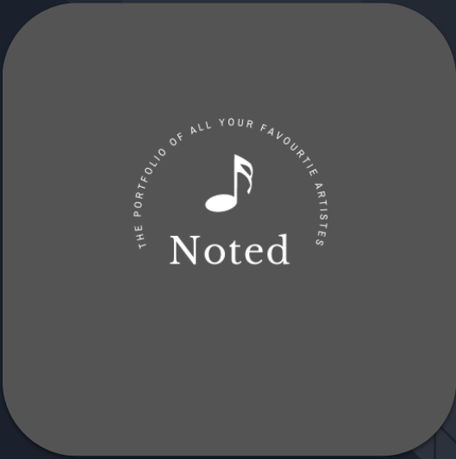

Product Overview

Noted is a musical artiste portfolio that exemplifies progressive ideals showcasing the work and achievements of musical artistes, as well as providing users with news of upcoming events and achievements for these respective artistes. We seek to thrill and enlightening our audience while using stimulating imagery and conspicuous designs to detonate the senses.

Founded in 2021 by Josiah Jones and his business panthers Dillon Morris and Zane Mohammed, we are a startup company that wishes to bring insightful information about musical artistes to our customers whilst maintaining a very reputable, reliable, and user-friendly website that will allow users to view detailed information on all artistes, their albums, their songs, songs they have featured in and their awards / achievements. The website’s home page will display the most recent trending albums and up-coming events hosted by artistes known to the website’s database. The website’s archive of artistes is available for showcase on the website’s “Music Library” page. This “Music Library” page can also be filtered by album/song/artiste via a search feature to present more precise listings to the user, allowing for a more enjoyable user experience. Our site will have a “New Releases” blog page which will be used to allow anonymous users to post news on song/album releases by various artistes as well as additional details such as awards won for these songs/albums/artistes. The website also presents users with an “Upcoming Events” page which displays to the user a list of events hosted by their favorite artistes sorted by date.

Our company is established to make it easy for the public to have knowledge of their favorite artiste and follow along with their events / tours. Noted is anticipated to be an adequately admired platform for its target audience of any individual within the age group of 13+ (13 and up).

Project Team

*This section servers as an indication to which roles were assigned to which team members.*

**Josiah Jones**- Head Software developer & Product Owner [-JJ@noted.co.tt](mailto:-JJ@noted.co.tt)

**Roles**:

* Project Scope Definition
* Functional & Non-Functional Requirements Identification
* Website Development – Converting WP theme template from static to dynamically produced content (laid out the foundation code to allow for ease of website content creation via the dashboard), creation of custom post types & custom queries & functions, creation of php file structure and contents.

**Zane Mohammed**- Secondary Software Developer & Lead System Design Specialist –[zmohommed@noted.co.tt](mailto:zmohommed@noted.co.tt)

**Roles:**

* WP theme research and selection
* System Design – Use Case Diagram, System Sequence Design (diagram), Entity Relation Construction, Site Map / Content Structure Diagram & Construction
* Website Development – Population of all content within Artiste Posts, Album Posts, Event Posts and Creation of all custom fields, all via the WordPress (WP) Admin Dashboard
* User Roles and Permissions Creator / Administrator

**Dillon Morris**- Web Content Manager, Marketing Manager – [dm@noted.tt](mailto:dm@noted.tt)

**Roles:**

* All Project Documentation
* Target Audience Identification
* Project Goals & Objectives Definition
* Use Cases, User Stories and User Scenarios definition
* Weekly Reports and Meetings Coordinator
* Content Creator & Manager – Final Presentation Developer & Coordinator, and Final Video Production and Editing
* Code Review & Debugging

All team members participated in or were present during ALL stages of project development (all project implementation was done over discord calls and zoom meetings) despite main tasks being assigned to different members off the group as shown in the Team Roles and Responsibilities above.

Goals & System Requirements

**Goals**

* Create a responsive user-friendly website interface (easily operated, visually appealing and simple functionality)
* Conform to all present-day performance, security and scalability standards.
* Optimized to perform well across all platforms (compatible on any device / operating system)
* Maintain a level of simplicity within the system’s code structure and design to allow for an easier maintenance process for future work on the system, or, should the system run into any major failures, flaws, or bugs.

**Functional Requirements**

* The system shall have a fully functional home page.
* The system shall have a fully functional “Music Library” page.
* The system shall have a fully functional “Upcoming Releases” page.
* The system shall have a fully functional “New Releases” page.
* Users shall be able to browse a list of their favorite artistes via the “Music Library” page.
* Users shall be able to browse a list of all albums both newly and previously released by their favorite artistes via the “New Releases” page.
* Users shall be able to view a listing of all upcoming events such as concerts, tours and parties being hosted by their favorite artistes via the website’s “Upcoming Events” page.
* The user shall be able to swap between various pages via the navigation bar located at the top of all pages, as well as via forward and Backward facing arrows located at the bottom of every page.
* Users shall be able to filter the website’s content to display specific information specified via a search bar which would be provided at the bottom of each page.
* Users will be able to view news on any newly released albums, songs or upcoming events via the website’s home page.
* The website shall have an “About Us” page that provides users with insight into the system’s scope, team, and functionalities.

Content Structure

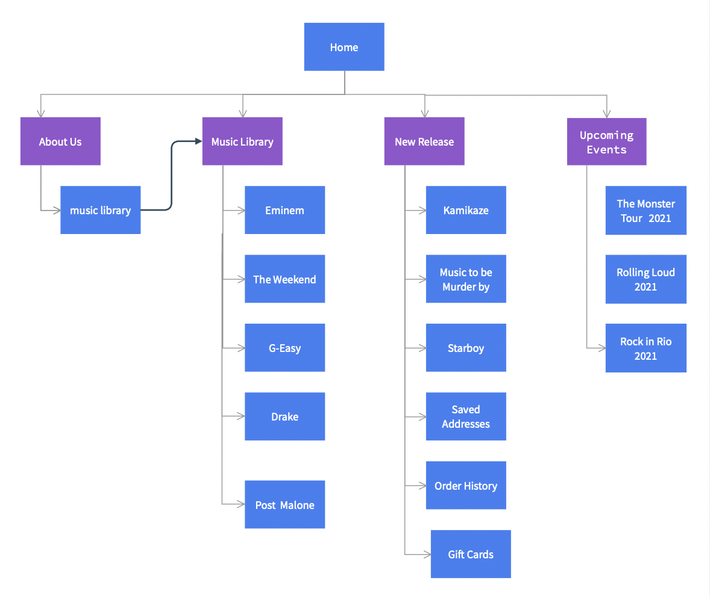

The website was split into 5 major pages:

1. **Home** – This is page is the first page a user comes into visual contact with upon visiting the website. On this page, users will be able to view all information on newly released albums, songs, and news on parties, events, tours and concerts (events) being hosted by all artistes known to the database. (post type(s) generated on this page are ‘artiste’,’album’, and ‘event’)
2. **About Us** – This page gives users an insight to the project’s purpose. (this is a static page)
3. **Music Library** – This page displays a list of all musical artistes known to the database. Each artiste can be selected by the user, which would then lead to a single page detailing the artiste’s background and achievements, as well as all albums produced by that respective artiste. From that point, users may then select an album from the list provided to view the songs which comprise that respective album. (post type generated on this page is ‘artiste’ and is powered by page.php & content.php & content-single-artiste.php)
4. **New Releases** – This page displays a list of all newly released albums published by artistes sorted by date released. A user may select album to view details on the album such as release date, and songs which comprise it. (post type generated on this page is ‘album’ and is powered by page.php & content.php & content-single-album.php)
5. **Upcoming Events** – This page displays a list of all upcoming events being hosted by various artistes. A user may select one of these events to then render another page that would provide the user with detailed information on the respective event. This information comprises details such as the date at which the event will commence, the venue which the event will be held at, the musical artiste hosting the event, and additional auxiliary information such as the event’s premise, the performers / singers at the event, (will there be other artistes performing / attending the event). (post type generated on this page is ‘event’ and is powered by page.php & content.php & content-single-event.php)

**Custom Post Types Used**

**Artiste** - this post type was created to store information on each artiste in the form of a post. Each artiste post would have an artiste name as the Title (this would be the name of the musical artiste) and an artiste bio within the body of the post. An artiste post can also be supplied a featured image / thumbnail image that would be called to display an image of the respective musical artiste. 2 custom fields, "Genre" and "Artiste Album(s)" are tied to an artiste post.

**Album** - this post type was created to hold information on each music album in the form of a post. Each album post would have a Title (this would be the name of the respective album), a featured image / thumbnail image which would display or hold the album's cover photo, and a description of each album within the album post's body. 2 custom fields, "Release Date" and "Songs" are also tied to an album post.

Genre - This custom field is a text field which holds information on the genre of music which a respective musical artiste produces. This field must be filled out for each artiste and cannot be left blank. (some examples of genres include Rap, RnB, Pop, etc.)

**Artiste Album(s)** - This custom field type creates a relationship between an artiste and an album that they produced. This field links a single album, or multiple albums to an artiste. This field must be filled out upon creation of an artiste and cannot be left blank.

Website Design

.

**Theme of Choice** - <https://wordpress.org/themes/portfoliolite/>

**Popularity** – In terms of the themes’ popularity, it was noted that the theme has 700+ active installations and roughly 100+ daily installations.

**Rationale** - Therationale for choosing this theme was due to the fact that it met the team’s requirement of a simple multipurpose portfolio template which was easily customizable and scalable. Another main reason for choosing this theme was of course its lack of cost factor (it was a free WP theme). Another eye-catching factor that sold this theme’s selection was its compatibility with various page builders (although the team did not resort much to the page builder functionality to build the website as it did not present nearly as much flexibility as we had initially hoped). The team resorted to implementing design of the website strictly from altering the website’s root files and utilizing the theme’s multiple html classes.

**User Roles** - The user roles established were that of administrators, editors and subscribers. Admins implemented all website code (php files) and governed all roles, functionalities, content creation and user creation. Editors were responsible for creating events, artistes and albums for the website (added, removed and updated all custom post type and custom field content). subscribers are only allowed to view website content.

Functionality

Custom Fields

**Release Date** - This custom field of type "Date" will set the date which the related album was released. This date can be both a past date or a date in the future [up-coming release]. This field must be filled in when creating a album post and cannot be left blank.

**Songs** - This custom field, as the name implies, is a text area field which holds a list of all songs linked / contained within an album. This field cannot be left blank as an album cannot have less than 1 song.

**Event Date** - This custom field of type "Date" will display the date which the respective up-coming event will be held on. This field cannot be left blank as an event MUST have a future date which it will be held on.

**Event** **Host** - This custom field type creates a relationship between an artiste and an event. It ties an artiste to a respective up-coming event, suggesting that it holds information on the artiste / artistes hosting an event.

**Venue** - This custom field is a short text field used for storing the location or venue at which an up-coming event will be held.

Custom Queries

**MusicLibraryPosts** - A custom query that changes the default post type to be of one of our custom post types, "artiste". This is done so all posts called upon would be pulled from the artiste custom post type which we created (Store of all musical artistes). This query also sets all artiste posts to be displayed per page. Once the html and php code for generating the page content is called via the " get_template_part( 'template-parts/content', get_post_format()); " function, all dynamic content will be sourced / pulled from artiste posts.

**NewReleasesPosts -** A custom query that changes the default post type to be of one of our custom post types, "album". This is done so all posts called upon would be pulled from the album custom post type which we created (Store of all albums tied to a musical artiste post). This query also sets 3 album posts to be displayed per page. Once the html and php code for generating the page content is called via the " get_template_part( 'template-parts/content', get_post_format()); " function, all dynamic content will be sourced / pulled from album posts.

**UpcommingEvents** - A custom query that changes the default post type to be of one of our custom post types, "artiste". This is done so all posts called upon would be pulled from the artiste custom post type which we created (Store of all musical artistes). This query also sets all artiste posts to be displayed per page. Once the html and php code for generating the page content is called via the " get_template_part( 'template-parts/content', get_post_format()); " function, all dynamic content will be sourced / pulled from artiste posts.

**NewReleasesPosts** - A custom query that changes the default post type to be of one of our custom post types, "event". This is done so all posts called upon would be pulled from the event custom post type which we created (Store of all events hosted by musical artistes). This query also sets 3 event posts to be displayed per page. Once the html and php code for generating the page content is called via the " get_template_part( 'template-parts/content', get_post_format()); " function, all dynamic content will be sourced / pulled from event posts.