**Project Title: Revelatory Data Visualization: An Interactive Dashboard for U.S. Federal Campaign Spending**

*Team Member: Josiah Keime*

**Abstract** The role of money in politics is a central and often contentious topic in the United States. While the Federal Election Commission (FEC) provides public data on campaign finance, its existing visualization tools limit deep analysis, particularly regarding trends over time and the specific dynamics of partisan elections. This project addresses these limitations by developing an interactive dashboard for exploring U.S. House, Senate, and Presidential campaign spending from 2008 to 2024. The dashboard integrates choropleth maps and bar charts with comprehensive filtering controls, allowing users to analyze spending by political party, chamber, year, and state. Key insights derived from the dashboard reveal a significant surge in spending in the 2020 election cycle, a recurring four-year spending pattern in Senate races, and the ability to identify nationally significant "battleground" elections through geographic spending spikes. The data visualization improves upon the FEC's existing tools by offering greater interactivity and analytical depth, making complex campaign finance data more transparent and accessible.

**1. Introduction**

**1.1. Motivation**

The political landscape in America is saturated with data, yet meaningful clarity is elusive. The topic of campaign finance, in particular, is frequently obscured by partisan rhetoric and statistical misrepresentation. While several organizations provide valuable data on this topic, their visualizations often focus narrowly on the most recent election cycle or present historical data in dense tables, making it difficult for the audience to explore long-term trends interactively. It is a common retort among political opponents that the other side is backed by "big money," thereby delegitimizing their campaign. These narrative fuels public distrust and highlights the need for accessible, unbiased tools for examining the data directly.

The objective of this project is to provide that clarity by creating a revelatory data visualization tool focused on federal election spending. By empowering users to engage with the data, visualize trends, and dissect spending patterns for themselves, we can foster a more informed understanding of the role money plays in elections.

**1.2. Background and Existing Work**

The Federal Election Commission (FEC) is the U.S. regulatory agency responsible for administering and enforcing federal campaign finance law. The key part of its mission is to provide public disclosure of funds raised and spent to influence federal elections, which includes races for the U.S. House, Senate, and Presidency. The FEC makes this data available for download and provides its own visualization tools on its website. [1]

However, the FEC's standard visualizations (Figure 1), while useful for high-level summaries or looking up a specific politician, are functionally limited. They do not effectively show trends over time, and their filtering options are insufficient for users who want to dig deeper into the data. The ranked-list format, for example, is cumbersome and fails to provide a comprehensive geographical or temporal context.

Other prominent sources for campaign finance data, such as USAFacts and OpenSecrets, also have limitations. For instance, USAFacts offers detailed tracking of the 2024 election but does not provide an integrated, interactive view of trends across multiple past cycles. Similarly, OpenSecrets presents extensive historical data but often relies on static tables and simple charts to show trends. This approach, while rich in statistics, prevents users from dynamically filtering and exploring the data in a visual, map-based interface to uncover nuanced patterns for themselves. [2, 3]

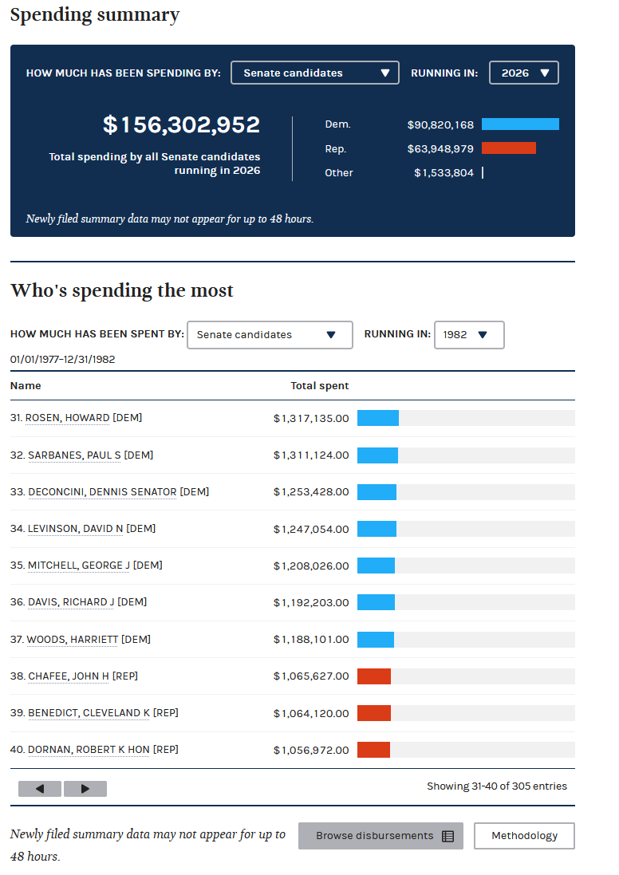

**Figure 1: FEC Spending Visualization** *(Image from original report, showing the FEC's "Spending by the numbers" page)*

**1.3. Project Objectives and Contribution**

This project's primary objective was to create an interactive dashboard that improves upon the FEC's tools. The main contribution is a unified platform that allows users to:

1. Visualize spending data through both a choropleth map and grouped bar charts.
2. Analyze spending trends over multiple election cycles (2008-2024).
3. Filter data by chamber, year, state, and spending metric to uncover specific patterns.
4. Drill down from a high-level national view to see candidate-specific spending in key elections.
5. Select what spending or another finical metric would be visualized.

By providing these enhanced capabilities, the dashboard offers new insights that are not easily attainable from existing data visualizations.

**2. Methodology and Process**

**2.1. Data Analysis and Preparation**

The dataset was sourced from the FEC and encompasses spending data for all federal candidates. The data is composed of numerical (dollars spent), categorical (party, state, office), and identifying (candidate name) fields.

Initial analysis confirmed expected trends that presidential candidates spend the most, and spending is higher in larger states. A key finding was that spending by parties other than the Democratic and Republican parties was "vanishingly small" in comparison, making them statistically insignificant in nationwide visualizations. Therefore, to maintain clarity and focus on the primary drivers of election spending, the visualizations were designed to focus on the two major parties.

**2.2. Design Prototypes and Failed Experiments**

The development process involved several iterations and experiments to find the most effective visualization methods.

* **Prototyping:** Early sketches explored different layouts. The first prototype proposed wide side panels for controls, but this was deemed an inefficient use of space. A second prototype focused on using a map as the primary interface for both visualization and data selection, an idea that was carried into the final design.

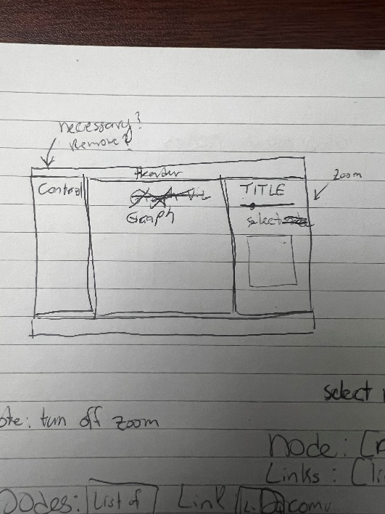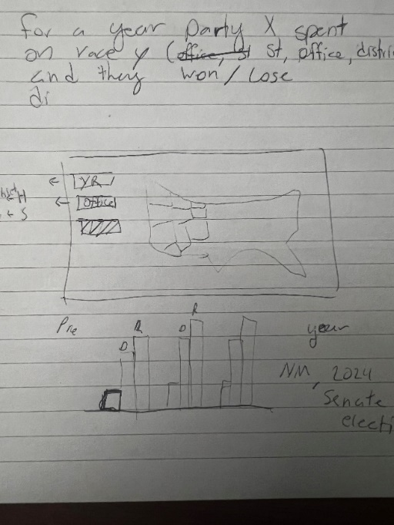

**Image 1: Prototype sketches**

* **Failed Experiments:** Several approaches were attempted and discarded:
  + **Network Visualization:** An attempt to map relationships became convoluted and did not provide a helpful view of the data.
  + **Sequential Pie Charts:** A series of pie charts to show party spending proportions over time was tested. This approach was rejected because it distorted the scale of spending, made text illegible, and obscured the minimal spending of smaller parties. A simple bar chart proved to be far more effective.



**Figure 2: Sequential Pie Charts**

* + **Adding Electoral Outcomes:** An attempt to integrate data on election winners was abandoned due to the difficulty of finding a clean, corresponding dataset.
  + **Party Analysis:** Trying to visualize data for smaller parties became intractable because of the large difference between them and the two major parties.

**3. Results: The Interactive Dashboard**

The final product is a comprehensive, interactive dashboard built with Plotly Dash (Figures 2 & 3). It allows users to explore campaign finance data fluidly. The key components include:

* **Control Panel:** A sidebar allows users to filter the data by Chamber (House, Senate, White House), Year, and Metric (e.g., Total Disbursement, Operating Expenditure). Users can also toggle between graph types.
* **Main Visualization Container:** This central area dynamically displays either a choropleth map or a bar chart. The choropleth (Figure 2) is ideal for visualizing geographic disparities in spending for a given year, while the bar chart (Figure 3) is effective for showing trends over time.
* **Interactive Data Table:** Below the visualization, a data table displays detailed, candidate-level information. This table can be filtered by clicking on a state in the choropleth map, allowing a user to seamlessly move from a macro-level view to a micro-level analysis of a specific race.

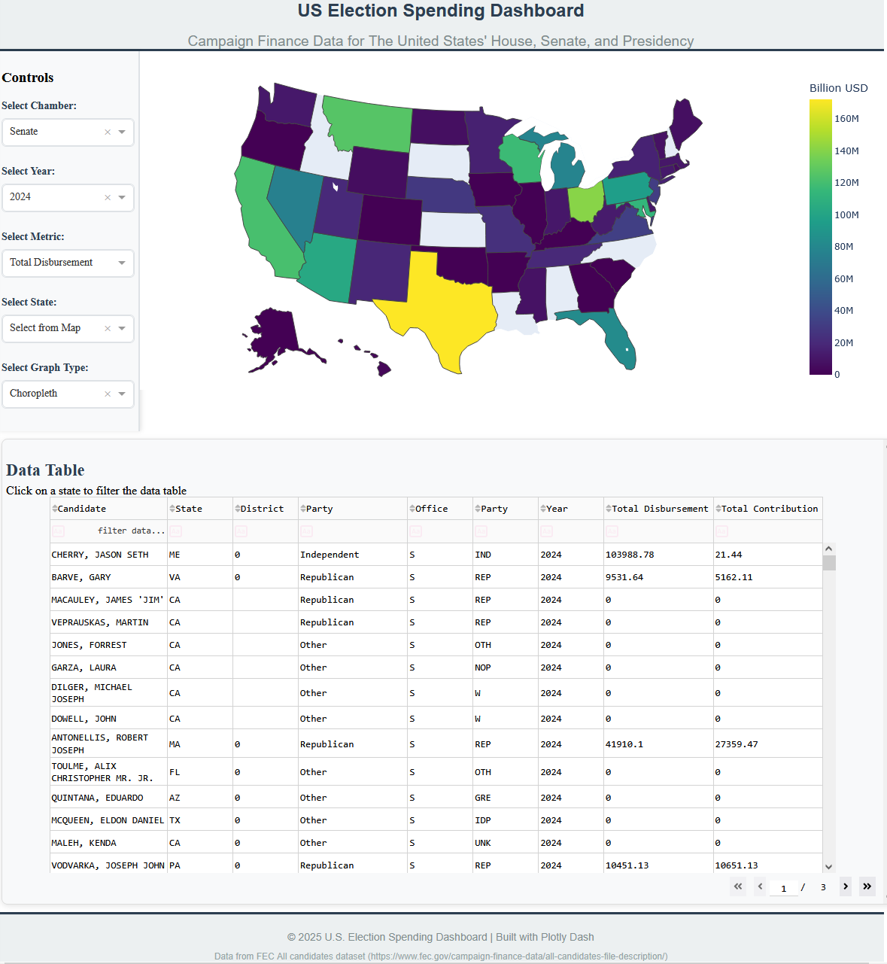

**Figure 3: Full Dashboard with Choropleth View** *(Image of the full dashboard from the original report)*

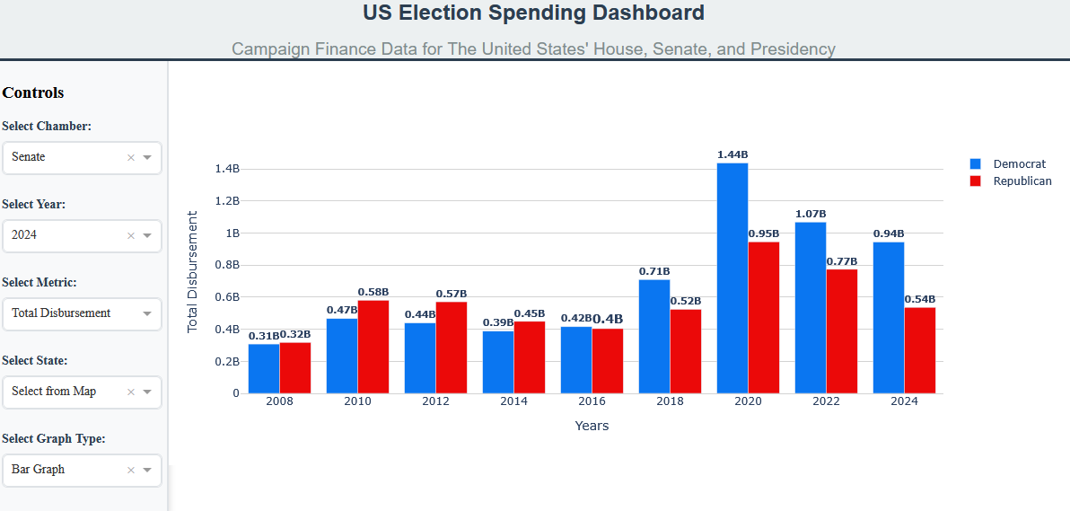

**Figure 4: Dashboard with Bar Graph View (Senate, 2008-2024)** *(Image of the bar graph view from the original report)*

**4. Analysis and Insights**

Using the dashboard revealed several distinct patterns in federal election spending.

**4.1. The 2020 Spending Surge**

Election spending was relatively consistent until 2020, which saw a dramatic increase, particularly in the presidential election. The dashboard shows that spending by the Democratic presidential campaign, in particular, was significantly higher than in any previous cycle.

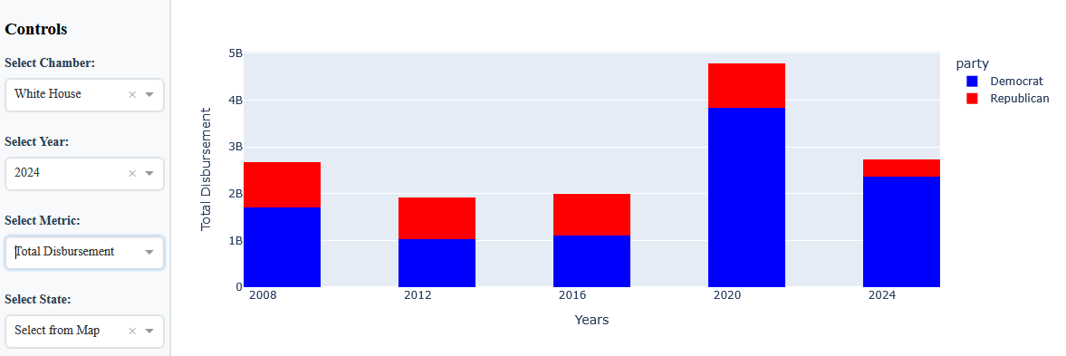

**Figure 4: Total Disbursement for Presidential elections (2008-2024)**

**4.2. Geographic Spikes Reveal Competitive Elections**

The choropleth map is exceptionally effective at highlighting geographic spikes in spending, which invariably correspond to highly competitive and nationally significant elections.

* **Georgia (2020):** The 2020 Senate map shows a massive concentration of spending in Georgia. This was not due to a nationwide increase in Senate spending, but rather the pivotal twin runoff elections in that state, which determined control of the U.S. Senate and drew extraordinary national funding. Reports after the election confirmed that the races shattered spending records, exceeding $800 million [4].
* **Texas (2018):** A spike is visible in Texas in 2018. The data table reveals this was driven by the high-profile race between Beto O'Rourke and Ted Cruz [5].
* **Minnesota (2008):** The 2008 map shows a spike in Minnesota, a result of the extremely close election between Al Franken and Norm Coleman that led to a lengthy and expensive recount and legal battle [6].

This pattern demonstrates the dashboard's power as a visualization tool for discovery, allowing users to identify and explore the dynamics of the country's most contested elections.

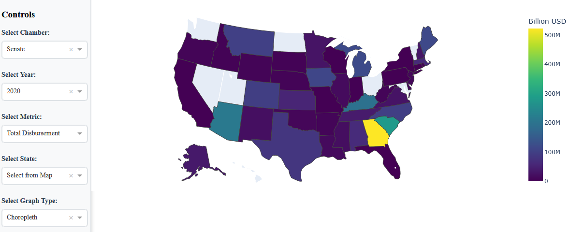

**Figure 4: Total Disbursement for Senate elections by State (2020)**

**4.3. Spending Cycles and Candidate Concentration**

The dashboard also visualizes a recurring four-year cycle in Senate spending, where spending by the party not in the White House tends to rise in the years following a presidential election. Furthermore, the data table consistently shows that in any given race, the vast majority of spending is done by the top one or two candidates, with most other candidates spending very little.

**5. Conclusion**

This project successfully created an effective and insightful dashboard for visualizing U.S. federal election spending. It improves upon the existing work of the FEC by providing superior visualization tools for users to see trends over time, compare spending between parties and states, and identify geographical hotspots of political activity. The dashboard makes up for what it may lack in pure methodological novelty by providing a robust, user-centric platform that makes critical election finance data more accessible, transparent, and interpretable.

**6. Future Work**

The project provides a strong foundation that could be expanded upon in several ways:

* **Integrate Electoral Outcomes:** The most critical next step is to incorporate vote counts and election results. This would allow users to directly analyze the correlation between spending and winning.
* **Increase Granularity:** Future versions could include county-level maps to investigate spending patterns within states.
* **Comparative Analysis:** A fascinating extension would be to investigate the election spending patterns of other countries (e.g., Japan, UK) to provide a global context for U.S. campaign finance.

**7. References**

[1] Federal Election Commission. *All candidates file description*. Retrieved from <https://www.fec.gov/campaign-finance-data/all-candidates-file-description/>

[2] USAFacts. (2024). *Tracking 2024 election contributions and spending*. Retrieved from <https://usafacts.org/articles/tracking-2024-election-contributions-and-spending/>

[3] OpenSecrets. (2022). *Election Trends*. Retrieved from <https://www.opensecrets.org/elections-overview/election-trends?trendscycle=2022>

[4] E. Green, “Georgia’s billion-dollar bonfire,” The Atlantic, https://www.theatlantic.com/politics/archive/2021/01/money-spent-georgia-senate-runoffs/617545/ (accessed Jul. 28, 2025).

[5] P. Svitek, “Ted Cruz defeats Beto O’Rourke in difficult re-election fight,” The Texas Tribune, https://www.texastribune.org/2018/11/06/ted-cruz-beto-orourke-texas-midterm-election-results/ (accessed Jul. 28, 2025).

[6] E. Stawicki and E. Baier, “Franken ‘thrilled’ over victory in Minnesota’s long-running Senate race,” MPR News, https://www.mprnews.org/story/2009/06/30/franken-thrilled-over-victory-in-minnesotas-long-running-senate-race (accessed Jul. 28, 2025).