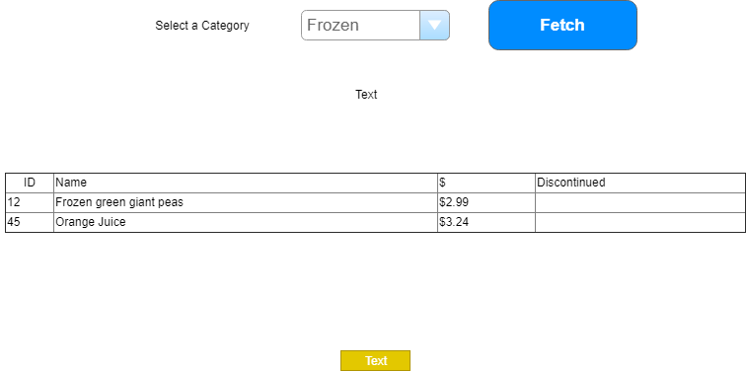

|  |  |  |  |  |  |
| --- | --- | --- | --- | --- | --- |
|  | Control Name | Load/Pos | CRUD | Validation | Event Actions /Notes |
| 1 | CategoryList |  | R |  | Page_Load(!IsPostBack)  Load ddl for query use  Put load in sperate method  Sort on category description |
| 2 | Fetch | 4 | R |  | Validate selection made  BLL method  List<Product>  Products_FindbyCategory(int)  Return data to load GridView |
| 3 | MessageLabel | 4 |  |  | Used for form messages |
| 4 | ProductList | 2 |  |  | Filled by products from fetch query  Customize GridView |
|  |  |  |  |  |  |