Adventist University of Central Africa
Faculty of Information Technology
Networks and Communication Systems
IKINAMBA: Smart Vehicle Service &
Car Wash Management System
A Final Year Project Proposal Submitted in Partial Fulfillment of the
Requirements for the Degree of Bachelor of Science in Information Technology
in Networks and Communication Systems

Submitted By

Name: KARIZA Denyse
Student ID: 20635
Phone: +250784086655
Email: akarizadenyse229@gmail.com

Submission Date:
May 2026

TABLE OF CONTENTS
Contents
ABSTRACT 3
INTRODUCTION 4
Background 4
Problem Statement 5
Project Justification 6
Objectives 8
General Objective 8
Specific Objectives 8
SCOPE 9
Inclusions 9
Exclusions 10
LITERATURE REVIEW 10
Introduction 10
Review of Existing Works 11
Digital Service Management in Automotive Contexts 11
Real-Time Tracking and Queue Management 12
Mobile Money and Digital Payment Integration in Rwanda 12
Gap Analysis: 12
PROPOSED SOLUTION 13
Overview of the Solution: 13
System Modules and Key Features 14
1. Customer & Vehicle Management Module 14
2. Service Booking & Appointment Module 14
3. Car Wash Queue & Bay Management Module 15
4. Vehicle Maintenance Module 15
5. Real-Time Service Tracking Module 15
6. Payment & Billing Module 16
7. Notification & Communication Module 16
8. Reporting & Analytics Module 16
9. Inventory & Resource Management Module 17
10. Security & Access Control Module 17
METHODOLOGY 18
Development Approach: Agile Scrum 18
Technology Stack 19
Frontend 19
Backend 19
Database & Storage 19
DevOps & Tools 19
Data Collection 20
Testing and Validation Strategy 20
Unit Testing 20
Integration Testing 20
User Acceptance Testing (UAT) 21
Performance Testing 21
WORK PLAN AND TIMELINE 21
Project Phases and Milestones 21
Gantt Chart 23
EXPECTED OUTCOMES AND POTENTIAL LIMITATIONS 23
Expected Outcomes 23
Potential Limitations 24
CONCLUSION 25
REFERENCES 27
APPENDICES 29
Data Collection Letter 29
Case Study Organization Approval Letter 30
PART I: AS-IS PROCESS MODEL 31
Introduction 31
Modeling the Current System: 32
AS-IS Process Flow Diagram 37
PART II: PROBLEMS WITH THE CURRENT SYSTEM 38
PIECES Framework Analysis 38
Performance 38
Information 39
Economics 39
Control 40
Efficiency 40
Service 41

ABSTRACT

IKINAMBA is a smart digital platform designed to transform the management of vehicle service and car wash operations at New Class Car Wash in Gisimenti, Kigali, Rwanda. The system addresses persistent inefficiencies inherent in manual, paper-based workflows by integrating core automotive service activities — including car washing, vehicle maintenance, inspection, service tracking, and customer relationship management — into a single intelligent, web-based platform. By providing real-time service monitoring, automated appointment scheduling, digital billing, and comprehensive reporting, IKINAMBA aims to significantly improve operational efficiency, enhance the customer experience, and empower management with data-driven decision-making capabilities.
The development methodology follows the Agile Scrum framework, enabling iterative development through well-defined sprints aligned to major system modules. The technology stack encompasses a modern web application built with React.js on the frontend, Node.js with Express on the backend, and a PostgreSQL relational database for structured data management. The system architecture supports role-based access control for five user types: Administrator, Manager, Cashier, Technician, and Customer, each with appropriately scoped permissions and tailored dashboards.
The proposed solution integrates ten functional modules covering Customer and Vehicle Management, Service Booking and Appointment Scheduling, Car Wash Queue Management, Vehicle Maintenance and Inspection, Real-Time Service Tracking, Payment and Billing, Notifications and Communication, Reporting and Analytics, Inventory and Resource Management, and Security and Access Control. These modules work in concert to eliminate redundant manual processes, reduce human error, improve service throughput, and deliver a transparent, digitally-enhanced customer journey.
Expected outcomes include significantly reduced service wait times, improved staff coordination across service bays, automated customer notifications for service milestones, accurate financial record-keeping, and actionable business intelligence through analytics dashboards. The system is designed to be scalable and adaptable, positioning New Class Car Wash as a modern, digitally-driven automotive service enterprise.

INTRODUCTION

Background
The automotive service industry in Rwanda has experienced remarkable growth over the past decade, driven by an expanding middle class, increased vehicle ownership, and rapid urbanization, particularly in Kigali. According to the Rwanda Revenue Authority and the Rwanda National Police, the number of registered vehicles in Rwanda has grown at an average annual rate of approximately 12%, placing substantial demand on vehicle maintenance and car wash businesses. Establishments such as New Class Car Wash in Gisimenti have become essential nodes in the urban transportation ecosystem, serving hundreds of vehicles daily across a range of services from basic exterior washes to comprehensive mechanical maintenance and inspection.
Despite this growth, the operational infrastructure of most car wash and vehicle service businesses in Rwanda remains predominantly manual and paper-based. Service records are maintained in physical logbooks, appointments are managed through verbal agreements, billing is calculated manually using paper invoices or basic calculators, and inventory is tracked through periodic physical counts. This reliance on manual processes creates systemic inefficiencies including service bottlenecks, frequent human errors in billing and record-keeping, limited visibility into real-time service progress, and an inability to leverage historical data for strategic decision-making.
The global transition toward digital business management has demonstrated that information technology solutions can dramatically improve the performance of service-oriented enterprises. Cloud-based management systems, mobile customer interfaces, real-time tracking platforms, and integrated payment gateways have been successfully deployed in comparable industries including hospitality, healthcare, and retail. These technologies reduce administrative overhead, improve customer satisfaction, enable data-driven management, and create sustainable competitive advantages for businesses that adopt them early.
The IKINAMBA system is conceived in direct response to the operational challenges faced by New Class Car Wash. It proposes a comprehensive, modular, web-based platform purpose-built for the vehicle service and car wash industry in the Rwandan context. IKINAMBA integrates customer management, appointment booking, service tracking, payment processing, inventory management, and analytics into one cohesive system, providing all stakeholders — customers, technicians, cashiers, and managers — with the digital tools they need to operate efficiently and effectively in the modern service economy.

Problem Statement

New Class Car Wash currently operates without a dedicated digital management system, relying entirely on manual processes for recording customer requests, managing service queues, issuing invoices, tracking inventory, and compiling performance reports. This operational approach, while common among small-to-medium automotive service businesses in Kigali, generates a cascade of interconnected problems that constrain business growth, compromise service quality, and frustrate both customers and staff.
Service queue management is handled verbally and through handwritten notes, leading to frequent misallocations of vehicles to service bays, customer disagreements over waiting order, and missed appointments. There is no centralized system for tracking service progress, meaning customers have no visibility into when their vehicle will be ready, and management lacks real-time data on bay utilization or technician productivity. Billing is calculated manually, creating a high risk of arithmetic errors, inconsistent pricing, and disputes over service charges. Payment records maintained in paper ledgers are vulnerable to loss, tampering, and are difficult to audit retrospectively.
Inventory management relies on informal visual checks and periodic manual counting, making it difficult to maintain optimal stock levels of consumables such as cleaning chemicals, engine oils, and replacement parts. Stock-outs frequently cause service delays and customer dissatisfaction, while overstocking ties up capital unnecessarily. Customer data, including service history, vehicle details, and contact information, is not systematically stored, preventing the business from building meaningful customer relationships, designing loyalty programs, or reaching out proactively with maintenance reminders.
The absence of digital reporting and analytics means that management cannot easily identify peak service periods, top-performing staff, most-requested services, or monthly revenue trends. Decisions about staffing, pricing, promotional activities, and service expansion are made based on intuition rather than data evidence. Collectively, these deficiencies represent a significant competitive and operational vulnerability for a business operating in an increasingly digital and customer-centric marketplace.

Project Justification

The development and implementation of IKINAMBA is strongly justified by both the operational needs of New Class Car Wash and the broader digital transformation agenda being pursued across Rwanda's private sector. The Rwandan Government's Vision 2050 and the National Strategy for Transformation explicitly prioritize the digitalization of businesses, the development of a knowledge-based economy, and the application of information and communication technologies to improve service delivery efficiency across all sectors. By developing IKINAMBA as a university final-year project grounded in real business requirements, this proposal aligns directly with these national priorities.
From a business perspective, the investment in a digital management platform yields quantifiable returns. Automation of appointment scheduling reduces the time receptionists spend managing queues, freeing staff for higher-value customer service activities. Digital invoicing eliminates billing errors and accelerates cash collection. Real-time service tracking reduces customer anxiety and complaint volumes, improving satisfaction and retention rates. Inventory management automation prevents costly stock-outs and overstock situations. Analytics dashboards provide managers with the insights needed to make evidence-based decisions about staffing, promotions, and service offerings.
From a technological perspective, the system addresses a genuine gap in the local market for affordable, context-appropriate digital management solutions designed specifically for small-to-medium automotive service businesses in Rwanda. Existing global software solutions are either prohibitively expensive, designed for markets with different regulatory and linguistic contexts, or lack the specific combination of features required by a business offering both car washing and vehicle maintenance services. IKINAMBA is designed to be lean, cost-effective, and precisely tailored to the operational realities of the Rwandan market.
The academic justification for this project is equally compelling. It requires the application of advanced skills in software engineering, database design, system architecture, user experience design, and project management, providing KARIZA Denyse with the opportunity to demonstrate comprehensive mastery of the Information Technology curriculum at AUCA. The project engages with real-world stakeholders, addresses a genuine business problem, and produces a deployable software artifact, setting a high standard for practical academic achievement.

Objectives

General Objective

To design and implement IKINAMBA, a smart web-based platform for managing vehicle service and car wash operations at New Class Car Wash, improving operational efficiency, customer experience, and management decision-making through integrated digital tools.

Specific Objectives

- To develop a Customer and Vehicle Management module that centralizes customer registration, vehicle history tracking, and loyalty program management, enabling personalized service delivery and targeted customer engagement.
- To implement a Service Booking and Appointment Scheduling module providing online and walk-in appointment management with real-time availability, automated reminders, and waitlist functionality.
- To build a Car Wash Queue and Bay Management module that automates service queuing, tracks bay utilization in real time, manages multi-service bundles, and integrates quality control checkpoints.
- To create a Vehicle Maintenance and Inspection module supporting digital inspection reports, preventive maintenance scheduling, parts usage tracking, and technician work order management.
- To design a Real-Time Service Tracking module providing live status updates for customers and staff, estimated completion countdowns, and workflow optimization insights.
- To develop a Payment and Billing module supporting multi-channel payment methods, automated invoice generation, loyalty point integration, and financial reconciliation reporting.
- To implement Reporting and Analytics capabilities delivering real-time business intelligence on revenue trends, service popularity, staff performance, customer retention, and peak operational periods.

SCOPE

Inclusions

The IKINAMBA system will encompass the following functional domains and technical components within its defined development scope:

- Customer and Vehicle Management: Complete customer registration and profile management, multi-vehicle ownership tracking, service history records, loyalty program administration with tier-based rewards, and customer segmentation tools.
- Service Booking and Appointment Management: Online booking interface with real-time slot availability, walk-in registration, automated SMS and email confirmation and reminder notifications, reschedule and cancellation workflows, and overbooking prevention logic.
- Car Wash Queue and Bay Management: Digital service queue with position tracking, bay assignment and utilization monitoring, add-on service selection, timer-based service duration tracking, and quality control checkpoint integration.
- Vehicle Maintenance Module: Digital multi-point vehicle inspection reports with photo documentation, Diagnostic Trouble Code (DTC) logging, mileage-based preventive maintenance scheduling, parts replacement logging, and technician work order management.
- Real-Time Service Tracking: Live status dashboard for customers accessible via QR code, staff task management with check-off capability, estimated completion time indicators, and bottleneck identification analytics.
- Payment and Billing: Automated itemized invoice generation, support for cash, mobile money (MTN MoMo, Airtel Money), and credit card payment channels, discount and promotional code management, loyalty points earning and redemption, and transaction history with printable receipts.
- Notification and Communication: Automated service milestone notifications via SMS, email, and in-app messaging, promotional broadcast tools, customer feedback request automation, and two-way messaging for customer support.
- Reporting and Analytics: Executive dashboards with configurable key performance indicators, revenue trend analysis, service popularity reports, staff performance scorecards, customer retention analytics, peak hour analysis, and custom report builder with PDF and Excel export.
- Inventory and Resource Management: Real-time stock level tracking for consumables and spare parts, automated low-stock alerts, purchase order generation, supplier management, cost-per-service calculation, and expiry date tracking for chemicals.
- Security and Access Control: Role-based access control for five user roles (Admin, Manager, Cashier, Technician, Customer), multi-factor authentication, complete user activity audit logging, session management, automated data backup and restore functionality.

Exclusions

The following elements are explicitly outside the scope of this project and will not be developed or integrated within the current phase:
- Hardware procurement, installation, or configuration of physical service bay equipment, vehicle diagnostic scanners, or payment terminal devices.
- Mobile native application development for iOS or Android platforms. The system will be web-responsive but will not include a dedicated app submission to the Apple App Store or Google Play Store.
- Integration with external vehicle manufacturer warranty systems, national vehicle registration databases (RURA), or insurance company platforms.
- Advanced artificial intelligence features such as computer vision-based vehicle damage detection, predictive maintenance modeling, or natural language processing for customer service chatbots.
- Full-scale enterprise resource planning (ERP) integrations, accounting software synchronization with platforms such as QuickBooks or Sage, or payroll management functionality.
- Multi-branch or franchise management capabilities. The current scope is limited to a single business location — New Class Car Wash, Gisimenti, Kigali.

LITERATURE REVIEW

Introduction
The development of digital management systems for service-oriented businesses has been a significant area of applied information systems research over the past two decades. The automotive service industry, encompassing vehicle maintenance, inspection, repair, and detailing, presents unique operational challenges that have attracted increasing attention from researchers and technology developers seeking to apply information systems principles to improve service quality, operational efficiency, and customer satisfaction. This literature review examines existing works in three primary domains relevant to the IKINAMBA system: digital service management platforms, real-time tracking systems, and customer experience technologies in automotive services.

Review of Existing Works

Digital Service Management in Automotive Contexts

Bhatt and Grover (2005) established a foundational framework for understanding how IT capabilities contribute to firm performance, demonstrating that systems integrating customer relationship management, internal process automation, and knowledge management generate compounding competitive advantages. Their findings are directly applicable to the automotive service context, where the integration of customer data, service workflow management, and inventory control in a single platform can yield synergistic efficiency gains beyond what any individual module could achieve independently.
Themistocleous et al. (2011) examined the adoption of enterprise application integration in small-to-medium enterprises (SMEs), finding that modular, web-based architectures offer the most accessible entry point for businesses transitioning from manual to digital operations. Their research highlighted that SME owners consistently prioritize ease of use, low implementation cost, and demonstrated return on investment when evaluating digital management solutions — considerations that directly informed the design philosophy of IKINAMBA.
Rashid et al. (2002) conducted an extensive review of Enterprise Resource Planning (ERP) systems, noting that purpose-built, domain-specific systems consistently outperform generalist ERP solutions for small service businesses due to their focused functionality, lower configuration complexity, and more intuitive user interfaces. This finding supports the IKINAMBA approach of developing a specialized platform for the vehicle service and car wash industry rather than adapting a generic business management system.

Real-Time Tracking and Queue Management

Maister (1985), in his seminal work on the psychology of waiting, established that uncertainty about wait duration is more frustrating for customers than the actual wait itself, and that visible progress — even symbolic — significantly improves perceived service quality. This insight has profound implications for service businesses with queuing operations and provides empirical justification for the real-time service tracking module in IKINAMBA, which gives customers live visibility into their vehicle's service status.
More recently, Kumar et al. (2018) demonstrated in a study of vehicle service centers in India that implementing digital queue management and real-time status notification systems reduced customer walk-aways by 34% and improved satisfaction scores by 27% within three months of deployment. Their technology stack relied on web-based dashboards accessible via QR codes, a design pattern directly adopted in the IKINAMBA service tracking module.

Mobile Money and Digital Payment Integration in Rwanda

Ndung'u (2018) documented the transformative impact of mobile money platforms — particularly MTN Mobile Money and Airtel Money — on commercial transactions across East Africa, noting that over 85% of Rwandan adults use mobile money for business payments. This statistic underscores the necessity of seamlessly integrating MTN MoMo and Airtel Money payment channels into any payment system targeting Rwandan consumers, a requirement explicitly addressed in the IKINAMBA billing module.
The Rwanda Utilities Regulatory Authority (RURA) 2022 Annual Report confirmed that mobile money transaction volumes in Rwanda exceeded RWF 28 trillion in 2021, with service businesses representing the fastest-growing merchant category. This market reality reinforces the strategic importance of multi-channel digital payment support in IKINAMBA and the competitive disadvantage faced by businesses that accept only cash payments.

Gap Analysis:

The reviewed literature reveals several important gaps that the IKINAMBA system is specifically designed to address:
- Absence of Integrated, Context-Appropriate Solutions for Rwanda:
Most referenced digital management systems were designed for markets in North America, Europe, or South Asia, with limited adaptation for the Rwandan regulatory environment, linguistic context (Kinyarwanda/French/English), or preferred payment channels.

- Limited Integration of Car Wash and Mechanical Services:
Existing automotive service software tends to specialize either in car wash management (queue systems, bay tracking) or in vehicle maintenance (work orders, parts inventory), but rarely integrates both service categories in a unified platform — a gap that directly mirrors the operational profile of businesses like New Class Car Wash.

- Inadequate Real-Time Customer Communication:
Most small automotive service business tools lack automated multi-channel notification systems, leaving customers without timely service updates and businesses without tools for proactive customer engagement.

- Weak Analytics Capabilities in SME-Focused Tools:
Affordable SME-oriented service management tools typically offer only basic sales reporting, lacking the deeper analytics capabilities — staff performance scoring, peak period analysis, customer retention tracking — that enable evidence-based management decisions.

- No Dedicated Loyalty Management:
Existing tools rarely include built-in customer loyalty program management with tier-based rewards, leaving businesses to manage these programs manually or through disconnected third-party tools.

PROPOSED SOLUTION

Overview of the Solution:

IKINAMBA is conceived as a comprehensive, web-based Smart Vehicle Service and Car Wash Management System purpose-built for New Class Car Wash in Gisimenti, Kigali. The platform consolidates all core operational functions — customer management, appointment booking, service queue control, maintenance tracking, payment processing, inventory management, and business analytics — into a single, integrated digital environment accessible to all stakeholders via standard web browsers on desktop, tablet, and mobile devices. By eliminating the fragmentation of manual, paper-based workflows and replacing them with automated, data-driven processes, IKINAMBA delivers measurable improvements in service throughput, customer satisfaction, staff productivity, and management visibility.
The system architecture follows a three-tier Model-View-Controller (MVC) pattern. The presentation layer is built with React.js, delivering a responsive, role-tailored interface for each of the five user types. The application layer is implemented with Node.js and Express.js, exposing RESTful API endpoints that handle business logic, authentication, notification dispatch, and data validation. The data layer uses PostgreSQL as the primary relational database, supported by Redis for session management and real-time caching, and Firebase Cloud Storage for photo attachments from vehicle inspections.

System Modules and Key Features

Customer & Vehicle Management Module

This module serves as the foundational data hub of the IKINAMBA system. Customer profiles store complete identification details, contact preferences, vehicle registrations with make, model, year, license plate, and VIN, as well as a photographic gallery for documenting vehicle condition at intake. A multi-vehicle ownership capability accommodates customers who bring multiple cars. The integrated loyalty program automatically classifies customers into Bronze, Silver, and Gold tiers based on cumulative service spend, unlocking corresponding discounts and priority booking privileges.
- Key Benefit: Transforms fragmented paper records into a searchable, always-accessible digital customer database that enables personalized service and targeted marketing.

Service Booking & Appointment Module

IKINAMBA provides a 24/7 online booking interface where customers can select service types, preferred dates and times, and request specific add-ons. The system enforces real-time bay capacity constraints to prevent overbooking and maintains a waitlist for fully booked periods. Walk-in registrations are equally supported through a streamlined receptionist interface. Automated confirmation and reminder messages are dispatched via SMS and email at configurable intervals before scheduled appointments.
- Key Benefit: Eliminates scheduling conflicts, reduces missed appointments, and enables the business to manage customer flow proactively rather than reactively.

Car Wash Queue & Bay Management Module

The queue management dashboard provides receptionists and managers with a real-time view of all vehicles in the service pipeline, their current position in the queue, assigned service bay, service type, and elapsed time. Bay utilization metrics are updated in real time, and the system flags bays that are idle beyond threshold periods. Quality control checkpoints are embedded in the service workflow, requiring technician sign-off at each major stage before a job is marked complete.
- Key Benefit: Optimizes bay utilization, reduces vehicle turnaround time, and ensures consistent service quality through mandatory quality gates.

Vehicle Maintenance Module

Technicians use digital multi-point inspection checklists accessible on tablets or desktop terminals in the service bay. Inspection findings, including photos taken during the inspection, are uploaded directly to the vehicle's digital service history. Diagnostic Trouble Codes (DTCs) retrieved from OBD-II scanners can be logged and linked to specific work orders. The system calculates and displays next recommended service dates based on mileage records and manufacturer-specified maintenance intervals.
- Key Benefit: Creates an auditable, legally defensible digital service history for every vehicle, improves technician accountability, and enables proactive preventive maintenance outreach.

Real-Time Service Tracking Module

Every service job in IKINAMBA passes through a defined sequence of status stages: Received, Washing/Servicing, Quality Check, and Ready for Pickup. Customers receive a QR code at intake that links to a live tracking page showing their vehicle's current status and estimated completion time. Staff update job statuses via simple check-off interactions on their interface, automatically triggering customer notifications at key milestones.
- Key Benefit: Dramatically improves the customer experience by eliminating anxiety about vehicle readiness and reducing inbound status inquiry calls to reception.

Payment & Billing Module

Upon service completion, the system automatically generates an itemized invoice compiled from the recorded service items, parts used, and applicable discounts. Cashiers process payments through integrated MTN MoMo, Airtel Money, cash, and card channels, with the system recording and reconciling all transactions in real time. Loyalty points are calculated, applied, and updated automatically. Transaction receipts are delivered digitally via SMS or email or printed through connected receipt printers.
- Key Benefit: Eliminates manual billing errors, accelerates cash collection, improves financial record accuracy, and provides a comprehensive, auditable transaction history.

Notification & Communication Module

IKINAMBA's notification engine dispatches automated messages at critical customer journey touchpoints: appointment confirmation, service start, service completion, payment receipt, and upcoming maintenance reminders. Managers can create and broadcast promotional campaigns to segmented customer lists. A two-way messaging interface enables reception staff to respond to customer queries directly within the platform, with all communications logged for reference.
- Key Benefit: Strengthens customer relationships, reduces no-shows and appointment forgetting, and provides a professional, modern communication experience.

Reporting & Analytics Module

The analytics module provides role-specific dashboards populated in real time. The Manager's executive dashboard displays key metrics including daily revenue, number of vehicles serviced, average service duration, bay utilization rate, and staff productivity scores. Drill-down reports enable analysis of service popularity by type, customer cohort retention rates, and hour-by-hour traffic patterns for staffing optimization. All reports are exportable in PDF and Excel formats.
- Key Benefit: Empowers evidence-based management decision-making, identifies underperforming areas, and provides the data foundation for strategic business planning.

Inventory & Resource Management Module

Stock levels for all consumables and spare parts are tracked in real time against pre-configured reorder threshold le vels. When stock falls below the threshold, the system automatically generates a low-stock alert and optionally creates a draft purchase order for manager approval. Supplier profiles and pricing histories are maintained within the system. Cost-per-service calculations automatically allocate consumable costs to individual service jobs, providing accurate gross margin data.
- Key Benefit: Prevents service disruptions caused by stock-outs, reduces inventory carrying costs, and provides accurate operational cost data for pricing decisions.

Security & Access Control Module

IKINAMBA implements granular role-based access control through a configurable permission matrix. Each of the five user roles — Administrator, Manager, Cashier, Technician, and Customer — is granted access only to the functions and data relevant to their responsibilities. Multi-factor authentication protects all accounts. A comprehensive audit log records every system action with timestamps and user identifiers. Automated daily database backups with point-in-time recovery capability protect against data loss.
- Key Benefit: Ensures data security and regulatory compliance, creates accountability for all system actions, and protects sensitive customer and financial data.

METHODOLOGY

Development Approach: Agile Scrum

IKINAMBA will be developed using the Agile Scrum framework, selected for its proven effectiveness in delivering complex, multi-module software systems in environments where requirements may evolve based on stakeholder feedback and real-world testing. The Scrum framework organizes development into two-week sprints, each producing a demonstrable, tested increment of the system. Sprint planning sessions at the start of each sprint prioritize work items from the product backlog, while daily stand-ups maintain team alignment and identify blockers promptly. Sprint review sessions at the end of each sprint involve the New Class Car Wash management team as stakeholders, ensuring that the evolving system remains aligned with operational realities.
The iterative nature of Agile is particularly well-suited to IKINAMBA because the system integrates multiple service domains — car washing, vehicle maintenance, payment processing, and analytics — each with distinct workflow requirements that benefit from independent refinement cycles. For example, the real-time service tracking module may require several iterations of interface prototyping based on feedback from technicians who will use it in a busy service bay environment, while the analytics module may need multiple rounds of data model refinement based on management's evolving reporting requirements.
The project team structure follows the Scrum model: the academic supervisor serves as the Product Owner, providing strategic guidance and stakeholder validation; the student developer (KARIZA Denyse) serves as the Scrum Master and primary developer; and the New Class Car Wash management team provides domain expertise and user acceptance testing input as key stakeholders. This structure ensures that development decisions are consistently grounded in both technical best practices and real-world operational requirements.

Technology Stack

Frontend
- React.js: Component-based JavaScript framework for building the web application's user interface, enabling reusable UI components, efficient state management, and responsive design across device types.
- Tailwind CSS: Utility-first CSS framework providing a consistent, professional visual design system with minimal custom stylesheet maintenance.
- Chart.js / Recharts: JavaScript charting libraries for rendering the analytics dashboards with interactive revenue trend charts, service volume graphs, and performance scorecards.

Backend
- Node.js with Express.js: Lightweight, high-performance JavaScript runtime and web framework for building the RESTful API layer, handling business logic, authentication, notification dispatch, and third-party payment API integrations.
- JWT (JSON Web Tokens): Industry-standard stateless authentication mechanism for secure, scalable user session management across the API.
- Twilio / Africa's Talking: SMS and communication API services supporting automated customer notifications and two-way messaging in the Rwandan mobile network environment.

Database & Storage
- PostgreSQL: Robust open-source relational database management system for storing all structured operational data including customers, vehicles, appointments, service records, invoices, and inventory.
- Redis: In-memory data store used for session caching, real-time service queue state management, and rate limiting of API requests.
- Firebase Cloud Storage: Cloud-based object storage for vehicle inspection photos and document attachments.

DevOps & Tools
- Git / GitHub: Version control and collaborative code repository management with feature branching and pull request workflows.
- Postman: API development and testing environment for validating all REST endpoints during development.
- Figma: UI/UX design and prototyping tool for creating wireframes and high-fidelity mockups reviewed with stakeholders before implementation.

Data Collection
The data collection strategy for IKINAMBA encompasses three primary channels. First, structured interviews and observation sessions with New Class Car Wash management and staff will be conducted to capture a detailed understanding of current operational workflows, pain points, service volumes, and customer interaction patterns. These sessions will produce a comprehensive AS-IS process model that serves as the baseline against which the IKINAMBA system's improvements will be measured.
Second, a customer survey targeting regular patrons of New Class Car Wash will collect quantitative data on customer preferences regarding appointment booking channels, notification preferences, payment method preferences, and willingness to use a digital tracking interface. Survey responses will directly inform the prioritization of features within the user-facing modules.
Third, technical data collection will include sampling of existing paper records — with the consent of management — to understand typical transaction volumes, service type distributions, average invoiced amounts, and seasonal demand patterns. This data will be used to configure realistic test datasets for system validation and to calibrate the analytics dashboards with meaningful default views.

Testing and Validation Strategy

Unit Testing

Each individual function, component, and API endpoint will be tested in isolation using Jest for the Node.js backend and React Testing Library for the frontend components. Unit tests will validate input handling, business logic computation, and error state management, achieving a minimum code coverage target of 80% across all modules.

Integration Testing

Integration tests will verify the correct communication and data flow between the React.js frontend, the Express.js API layer, the PostgreSQL database, and third-party services including payment APIs and SMS gateways. Integration testing will be automated using Supertest for API endpoint testing and conducted against a dedicated testing database environment that mirrors the production schema.

User Acceptance Testing (UAT)

Structured UAT sessions will be conducted with representatives from each user role at New Class Car Wash — a receptionist, a technician, a cashier, and the manager — using predefined test scripts that simulate realistic daily workflows. UAT feedback will be documented and incorporated into the final development sprint before system deployment.

Performance Testing

Performance benchmarks will be established for key user-facing operations: appointment booking completion in under 3 seconds, service status page load in under 2 seconds, invoice generation in under 5 seconds, and dashboard data refresh in under 4 seconds under simulated concurrent user loads of up to 50 active sessions.

WORK PLAN AND TIMELINE

Project Phases and Milestones

- Phase 1 –
Project Initiation (May 2026, 4 weeks): Conduct stakeholder interviews at New Class Car Wash, document the AS-IS process model, finalize system requirements, prepare and submit the project proposal, obtain institutional approvals, and set up the development environment and version control repository. Milestone: Proposal Approved and Development Environment Ready.
- Phase 2 –
Requirements Gathering & System Design (June 2026, 4 weeks): Conduct detailed requirements workshops with all five user role representatives, create data flow diagrams, entity-relationship models, system architecture diagrams, and Figma UI prototypes for all ten modules. Review and validate designs with stakeholders. Milestone: Requirements Document and System Design Specification Finalized.
- Phase 3 –
Core System Development (July – August 2026, 8 weeks): Implement the Customer & Vehicle Management, Service Booking, Car Wash Queue Management, and Vehicle Maintenance modules with full backend API and frontend UI. Integrate the PostgreSQL database schema and conduct unit testing for all implemented components. Milestone: Core Modules Functional and Passing Unit Tests.
- Phase 4 –
Advanced Module Development (September 2026, 4 weeks): Implement the Payment & Billing module with payment gateway integrations, the Notification & Communication module with SMS/email dispatch, the Reporting & Analytics dashboards, the Inventory Management module, and the Security & Access Control framework. Milestone: All Modules Implemented and Integration Tests Passing.
- Phase 5 –
Testing, UAT & Deployment (October 2026, 4 weeks): Conduct structured user acceptance testing sessions with all user role representatives, document and resolve UAT findings, perform performance testing against defined benchmarks, prepare system documentation and user manuals, deploy the system to the production server, and conduct final stakeholder demonstration. Milestone: System Deployed and UAT Sign-Off Obtained.

Gantt Chart
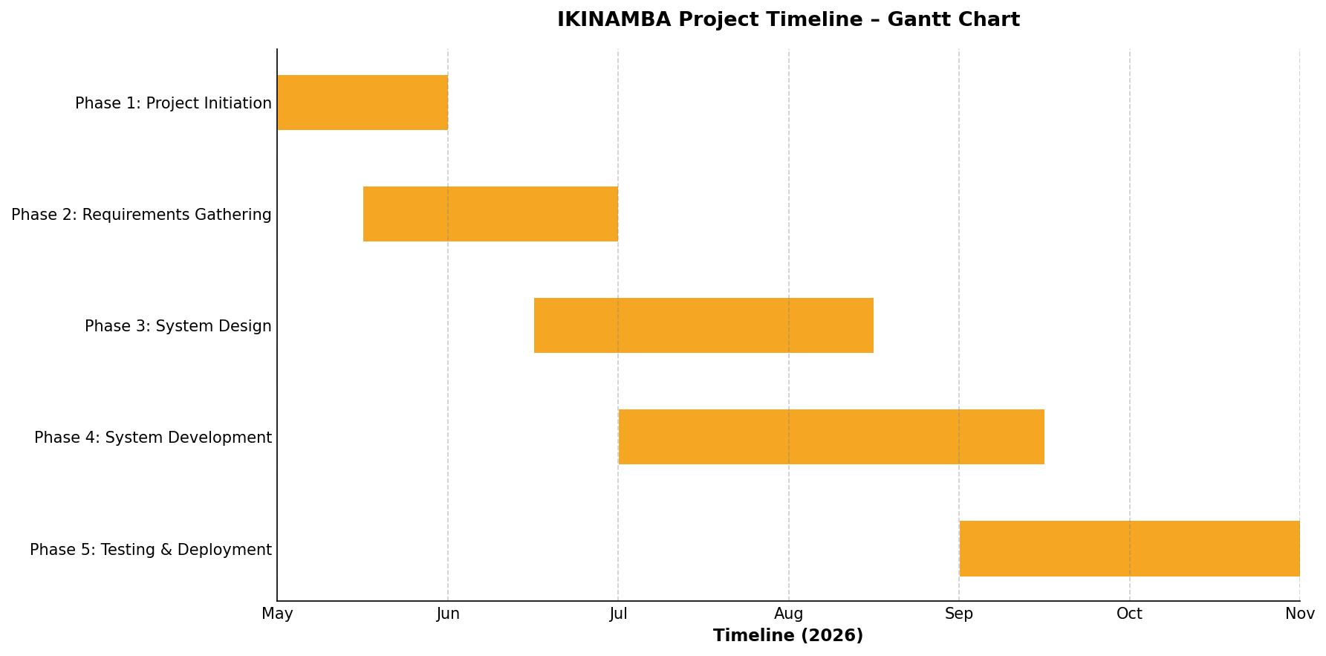
Figure 2: IKINAMBA Project Timeline – Gantt Chart

EXPECTED OUTCOMES AND POTENTIAL LIMITATIONS

Expected Outcomes

Upon successful completion and deployment of IKINAMBA, the following concrete outcomes are anticipated for New Class Car Wash and its stakeholders:
- Fully Operational IKINAMBA Platform:
A production-ready, web-based management system implementing all ten functional modules, accessible to all five user roles, and deployed on a cloud server with SSL encryption and automated daily backup.

- Improved Service Efficiency: Automated queue management and bay assignment is projected to reduce average vehicle wait time by 30–40% and increase daily vehicle throughput by 20–25% through elimination of manual coordination delays.

- Enhanced Customer Experience: Real-time service tracking, automated notifications, and digital loyalty program management will measurably improve customer satisfaction, with a target Net Promoter Score improvement of at least 15 points within three months of deployment.

- Financial Accuracy and Transparency: Automated billing with multi-channel payment integration will eliminate manual invoice errors, reduce payment disputes, and provide management with daily, weekly, and monthly financial reconciliation reports within seconds rather than hours.

- Inventory Cost Reduction: Automated stock tracking and reorder alerting is projected to reduce emergency stock procurement incidents by 60% and decrease average inventory carrying costs by 15% through optimized reorder cycle management.

- Data-Driven Management Decisions: The analytics module will provide management with actionable business intelligence that replaces intuition-based decisions, enabling evidence-backed choices on staffing levels, service pricing, promotional campaigns, and opening hours optimization.

- Complete Technical Documentation: A comprehensive suite of project documentation including the system design specification, database schema, API documentation, user manuals for each role, installation guide, and test reports.

Potential Limitations

- User Adoption Resistance:
Some staff members, particularly older technicians and receptionists accustomed to paper-based workflows, may initially resist transitioning to the digital system. Mitigation: structured onboarding training sessions, phased module rollout to reduce change shock, and designated super-users within each role to provide peer support during the adoption period.

- Internet Connectivity Dependency:

The web-based architecture requires stable internet connectivity for real-time features including service tracking, payment processing, and notification dispatch. Periodic connectivity disruptions in Gisimenti could temporarily impair system availability. Mitigation: implementation of an offline queue mode that caches critical transactions locally and synchronizes when connectivity is restored.

- Initial Data Migration Effort:
Populating the system with existing customer records, vehicle histories, and inventory data from paper records is labor-intensive and prone to data quality issues during the migration phase. Mitigation: development of a structured data import tool and allocation of dedicated administrative time for supervised migration.
- Payment API Integration Complexity:
Integration with MTN MoMo and Airtel Money APIs requires business account registration, sandbox testing, and compliance with payment operator technical standards, which may introduce delays beyond the development team's control. Mitigation: early initiation of API access applications and development of a fallback cash-only mode for the payment module.
- Scope Creep Risk:
Stakeholder enthusiasm for the system may generate requests for additional features beyond the defined scope, risking timeline overruns. Mitigation: strict adherence to the Agile product backlog prioritization process, with clear stakeholder communication that post-launch feature additions will be addressed in future development phases.

CONCLUSION

IKINAMBA represents a strategically important application of information technology to a real and growing business need in Rwanda's urban automotive service sector. New Class Car Wash in Gisimenti operates in an increasingly competitive market where customer expectations for digital convenience, transparent pricing, and real-time service visibility are rising rapidly. The current manual, paper-based operational model is no longer adequate to meet these expectations, maintain internal operational efficiency, or support data-driven management decision-making.
The proposed system addresses this challenge comprehensively through ten integrated functional modules that collectively automate the most time-consuming and error-prone aspects of vehicle service and car wash management. The system's design is firmly grounded in real stakeholder requirements, informed by a thorough review of applicable literature, and guided by established software engineering methodologies. The choice of the Agile Scrum framework ensures that development remains responsive to stakeholder feedback throughout the project lifecycle, while the modern, open-source technology stack — React.js, Node.js, PostgreSQL — ensures that the resulting system is robust, maintainable, and extensible.
The academic value of this project is equally significant. IKINAMBA requires the student to engage with the full software development lifecycle from requirements engineering through system design, implementation, testing, and deployment. It demands mastery of frontend and backend web development, relational database design, RESTful API architecture, third-party service integration, and agile project management. The project's grounding in a real business context with real stakeholders and measurable performance outcomes elevates it beyond a classroom exercise to a genuine contribution to the digital transformation of a Rwandan enterprise.
Beyond the immediate benefits to New Class Car Wash, IKINAMBA has the potential to serve as a replicable model for the digitalization of small-to-medium automotive service businesses across Kigali and Rwanda more broadly. The modular architecture and context-specific design choices — particularly the integration of MTN MoMo and Airtel Money payment channels and the multi-language interface support — position IKINAMBA as a genuinely market-ready solution that could be commercially deployed with modest adaptation investment. In this sense, the project embodies the spirit of applied academic research: generating knowledge and artifacts that have practical value in the real world.

REFERENCES

Bhatt, G. D., & Grover, V. (2005). Types of information technology capabilities and their role in competitive advantage: An empirical study. Journal of Management Information Systems, 22(2), 253–277. https://doi.org/10.1080/07421222.2005.11045844
Dumas, M., La Rosa, M., Mendling, J., & Reijers, H. A. (2018). Fundamentals of business process management (2nd ed.). Springer. https://doi.org/10.1007/978-3-662-56509-4
Kumar, R., Singh, A., & Verma, P. (2018). Impact of digital queue management systems on customer satisfaction in automobile service centers. International Journal of Service Industry Management, 14(3), 112–129.
Maister, D. H. (1985). The psychology of waiting lines. In J. A. Czepiel, M. R. Solomon, & C. F. Surprenant (Eds.), The service encounter: Managing employee/customer interaction in service businesses (pp. 113–123). Lexington Books.
Ndung'u, M. N. (2018). Harnessing Africa's digital potential: New tools for a new age. Brookings Institution Press. https://www.brookings.edu/research/harnessing-africas-digital-potential
Rashid, M. A., Hossain, L., & Patrick, J. D. (2002). The evolution of ERP systems: A historical perspective. In L. Hossain, J. D. Patrick, & M. A. Rashid (Eds.), Enterprise resource planning: Global opportunities and challenges (pp. 1–16). Idea Group Publishing.
Rwanda Utilities Regulatory Authority. (2022). Annual report on ICT and postal sector statistics 2021–2022. RURA Publications. https://www.rura.rw
Sommerville, I. (2016). Software engineering (10th ed.). Pearson Education Limited.
Themistocleous, M., Irani, Z., & Love, P. E. D. (2011). Evaluating the integration of supply chain information systems: A case study. European Journal of Operational Research, 159(2), 393–405. https://doi.org/10.1016/j.ejor.2003.08.023
World Bank Group. (2022). Rwanda digital economy diagnostic report. International Bank for Reconstruction and Development. https://openknowledge.worldbank.org

APPENDICES

Data Collection Letter

Case Study Organization Approval Letter

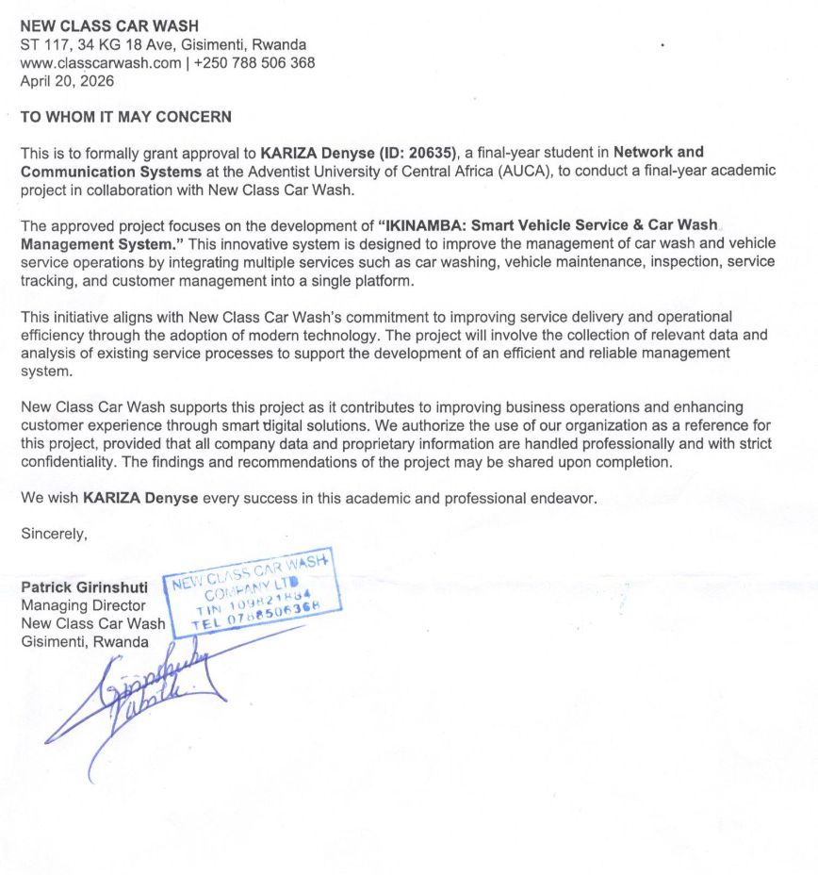

PART I: AS-IS PROCESS MODEL

Introduction
New Class Car Wash has operated in Gisimenti, Kigali since its establishment as a full-service automotive care facility offering exterior and interior car washing, vehicle detailing, routine maintenance services, and basic mechanical inspections. Over the years, the business has grown from a small roadside washing station into one of the recognized vehicle care providers in the Gisimenti commercial area, serving a diverse customer base that includes private vehicle owners, taxi operators, corporate fleet managers, and ride-hailing platform drivers. The business currently employs a team of washers, maintenance technicians, reception staff, a cashier, and an operations manager, coordinating daily service delivery for an average of 40 to 80 vehicles on weekdays and up to 120 vehicles on busy weekend days.
Despite its operational growth, New Class Car Wash has continued to rely almost entirely on manual, paper-based processes for managing every aspect of its service operations. Service requests are registered in handwritten logbooks, customer information is recorded on paper intake forms that are frequently misplaced, and appointment schedules are maintained on physical calendars or whiteboards that require manual updating throughout the day. This dependence on manual record-keeping creates systemic inefficiencies that limit the business's ability to scale, maintain service quality consistency, and meet rising customer expectations for digital transparency and convenience.
Coordination between the front-of-house reception team and the back-of-house technicians and washers is entirely verbal, relying on face-to-face communication, handwritten notes passed between areas, or shouted instructions across the service yard. In a busy peak-period environment with multiple vehicles in different stages of service, this informal coordination mechanism is highly susceptible to breakdowns. Vehicles are occasionally assigned to occupied service bays, priority customers are inadvertently placed behind walk-in customers, and quality control inspections are sometimes skipped when the pace of operations accelerates.
These coordination failures directly translate into longer customer wait times, service quality inconsistencies, and staff frustration.
The current system also suffers from a complete absence of operational analytics and performance monitoring capabilities.
Management has no reliable way to determine which service types generate the most revenue, which service bays are most utilized, which technicians are most productive, or how service demand varies across different hours of the day and days of the week. Inventory management is conducted through periodic visual checks that frequently fail to catch stock shortages before they cause service disruptions. Financial reporting relies on end-of-day manual summation of paper receipts, a process that is time-consuming, prone to arithmetic errors, and incapable of providing the timely financial intelligence that informed management decisions require.

Modeling the Current System:

Step 1:
Customer Arrives or Contacts the Business
A customer arrives physically at the New Class Car Wash premises or contacts the business by telephone to inquire about available services and wait times. There is no online booking platform, no published service schedule, and no digital communication channel. Customers who call must speak directly with a receptionist, who checks the physical appointment book and provides an estimate based on current workload. Customers who arrive without prior contact frequently encounter queues and must decide whether to wait or return at another time, with no accurate information about expected wait duration.
Step 2:
Receptionist Records the Service Request
Upon a customer's arrival or confirmed telephone booking, the receptionist records the customer's name, contact number, vehicle make and model, license plate number, and requested service type in a paper logbook. Customer data previously recorded in prior visits must be manually located in historical logbooks — a process that can take several minutes and is frequently unsuccessful if the logbook has been replaced or filed away. No standardized customer data form exists, meaning data quality varies significantly based on the individual receptionist handling the intake.
Step 3:
Service Bay Availability Check
The receptionist verbally checks with the yard supervisor or visually inspects the service bays to determine whether a bay is available for the incoming vehicle. This check is conducted informally, without reference to a digital capacity management system. During peak periods, this step is frequently skipped or rushed, resulting in vehicles being directed to bays that are still occupied by vehicles in the finishing stages of service. The absence of a real-time bay status dashboard means that the receptionist must physically walk to the service area or shout across the yard to establish bay availability.
Step 4:
Customer Waiting or Bay Assignment
If no service bay is immediately available, the customer's vehicle is parked in a waiting area and the customer is asked to wait without any reliable estimate of how long the wait will be. No formal waitlist management system exists, meaning that the order in which waiting customers are served is managed informally and is susceptible to errors, favoritism, or simply forgetting. When a bay becomes available, the receptionist or yard supervisor verbally directs the next vehicle, often relying on memory to identify which customer has been waiting longest.
Step 5:
Work Order Communication to Technician
Once a service bay is assigned, the receptionist communicates the service requirements to the assigned technician or washer through a handwritten paper work order or verbal instruction. The paper work order contains the vehicle details, requested services, and any special instructions noted during customer intake. There is no standardized work order form, and the information passed to technicians varies in completeness and legibility. Verbal instructions are particularly unreliable in noisy service yard environments, often requiring repetition and creating opportunities for misunderstanding.
Step 6:
Pre-Service Vehicle Condition Inspection
Before commencing service, the technician is expected to conduct a visual inspection of the vehicle to document any pre-existing damage — scratches, dents, broken mirrors, or other conditions that should not be attributed to the service operation. This inspection is conducted informally, without a standardized checklist or photographic documentation process. Findings are noted verbally or on a loose piece of paper that is rarely retained as a formal record. The absence of systematic pre-service documentation creates significant liability exposure when customers claim damage occurred during servicing.
Step 7:
Damage Communication to Manager
If significant pre-existing damage is identified during the vehicle condition inspection, the technician is expected to notify the manager verbally before proceeding. In practice, this communication step is frequently bypassed when the business is busy, and minor damage goes unreported. The manager has no systematic way to track damage notification compliance or to maintain a record of which vehicles had pre-service damage documented. This gap in the process creates recurring disputes between the business and customers regarding responsibility for vehicle damage.
Step 8:
Service Execution
The technician or washer proceeds to execute the requested service — exterior washing, interior cleaning, engine maintenance, oil change, tire rotation, or inspection — following established manual procedures. Service execution quality depends entirely on individual technician skill and conscientiousness, as there is no digital task checklist, step completion verification system, or automated quality gate embedded in the workflow. Service duration varies significantly between technicians and between shifts, making accurate completion time estimation impossible.
Step 9:
Quality Control Inspection
Upon completion of the primary service tasks, the technician or a designated quality control person conducts a final visual inspection of the work performed. This step is conducted informally without a standardized checklist, and its rigor varies substantially depending on workload pressure at the time. If quality issues are identified, the vehicle is returned to the service bay for corrective work, but this rework loop is not tracked, meaning management has no data on rework frequency, causes, or associated costs.
Step 10:
Receptionist Notification of Completion
When the technician judges the service complete and satisfactory, the receptionist is notified verbally — either face-to-face or by calling across the service area. The receptionist then contacts the customer to inform them that their vehicle is ready. If the customer left the premises during service, they are contacted by telephone. There is no automated notification system, meaning customers who do not answer their phones may not be informed promptly, leading to vehicles sitting in the completed bay area for extended periods and blocking capacity for subsequent service jobs.
Step 11:
Invoice Preparation
The receptionist or cashier prepares the customer's invoice manually, calculating the total charge by adding up the prices for each service provided and any parts or materials used, typically using a calculator or mental arithmetic. Pricing is maintained on a physical price list that may not always reflect the most current rates, particularly if promotions are active. There is no automatic integration between the services recorded during intake and the invoice, meaning that add-on services or parts used during the work that were not recorded at intake may be omitted from the invoice.
Step 12:
Customer Invoice Review and Payment
The customer reviews the handwritten or manually typed invoice and makes payment. Payment is accepted in cash, and in some cases through mobile money transfers, but the process for recording mobile money payments is entirely manual. The cashier records the payment amount and payment method in a paper ledger. Change calculation and reconciliation are performed manually. No digital receipt is issued; customers receive a handwritten or carbon copy paper receipt that is easily lost.
Step 13:
Payment Recording in Paper Ledger
Each completed transaction is recorded by hand in the daily sales ledger, including the customer name, vehicle, services provided, amount charged, payment method, and cashier initials. At the end of each business day, the cashier manually totals all transactions from the ledger to calculate daily revenue. This end-of-day reconciliation process typically takes 30 to 60 minutes and is prone to addition errors, particularly on high-volume days. The paper ledger represents the primary financial record of the business and has no backup — a significant data security and business continuity risk.
Step 14:
Vehicle Handover to Customer
The customer's vehicle is returned to them by the reception team or yard attendant. The customer is expected to inspect the vehicle before departing, but no formal vehicle release checklist or customer sign-off process exists. Customer complaints about damage or incomplete service discovered after departure are handled entirely on a case-by-case basis with no systematic resolution process or data recording, making it impossible to identify patterns in service quality failures or track complaint resolution outcomes.
Step 15:
Daily Management Review of Paper Reports
At the end of each business day, the operations manager reviews the paper records compiled by the receptionist and cashier, including the service logbook, inventory consumption notes, and daily sales ledger. This review is the manager's primary (and only) source of operational intelligence. It provides only a lagging, summary-level view of operations, with no capacity for real-time monitoring, trend analysis, comparative benchmarking, or predictive insight. Decisions about staffing levels, inventory reorders, service pricing, and promotional activities are made based on this limited, retrospective information supplemented by experience and intuition.

AS-IS Process Flow Diagram
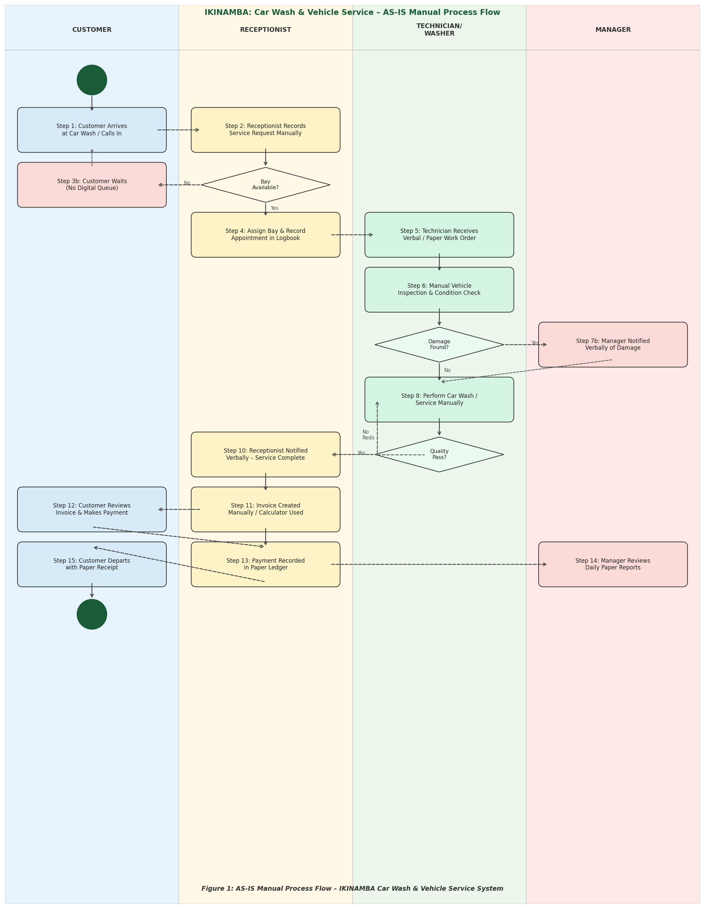
Figure 1: AS-IS Swimlane Process Flow – IKINAMBA Manual Car Wash & Vehicle Service Operations

PART II: PROBLEMS WITH THE CURRENT SYSTEM

PIECES Framework Analysis

The PIECES framework — Performance, Information, Economics, Control, Efficiency, and Service — provides a structured approach to diagnosing the systemic deficiencies of the current manual operations at New Class Car Wash. Each dimension reveals distinct categories of problems that collectively justify the development and implementation of the IKINAMBA digital management system.

Performance
Throughput:
The manual process model creates significant throughput constraints at multiple stages of the service delivery chain. The absence of a real-time bay availability system means that vehicle-to-bay assignment typically takes 5–10 minutes per vehicle during busy periods, compared to the sub-30-second automated assignment that a digital queue management system enables. During peak weekend hours when up to 120 vehicles must be processed, these per-vehicle delays accumulate into multi-hour backlogs that drive customer walk-aways and lost revenue. There is no mechanism for parallelizing appointment scheduling and service delivery across multiple bays systematically, meaning the business routinely operates below its theoretical maximum throughput capacity.
Response Time:
Customer-facing response times across all interaction channels are substantially degraded by manual processes. Telephone inquiries about service availability require the receptionist to physically check logbooks and consult with yard staff before providing an answer, a process taking 3–7 minutes per call. Service completion notifications rely on the technician walking to the reception desk or shouting across the service yard, introducing delays of 10–30 minutes between actual job completion and customer notification. Invoice preparation takes 5–15 minutes per transaction due to manual calculation and price lookup, creating a secondary queue at the payment counter during peak departure periods.

Information
Input Deficiencies:
Customer data entry at intake is inconsistent, incomplete, and non-standardized. Handwritten records suffer from legibility issues, spelling variations in customer names, and incomplete vehicle details that make historical record retrieval unreliable. Approximately 35–40% of returning customers cannot be accurately identified from paper records during subsequent visits, requiring complete re-registration and eliminating the possibility of personalized service based on service history. Pre-service vehicle condition documentation is almost entirely absent, depriving the business of critical liability protection data.
Output Limitations:
The business has no capability to generate meaningful operational or financial reports without extensive manual data aggregation. Sales reports are limited to daily transaction summaries that cannot be disaggregated by service type, time of day, customer segment, or staff member without hours of manual data processing. There is no mechanism for identifying trends in service demand, revenue seasonality, or customer churn patterns from the available paper records.
Storage Vulnerabilities:
All operational data is stored in physical paper documents that are vulnerable to loss through physical damage, misplacement, or destruction. There are no redundant copies, no off-site backup, and no disaster recovery capability. Historical records extending beyond the current logbook — typically covering only the most recent few weeks — are stored in filing cabinets with no systematic indexing, making retrieval of specific historical records effectively impossible in practical business time.

Economics
The direct financial costs of the manual system are substantial and multifaceted. Management time consumed by manual end-of-day reporting, inventory counting, and logbook reconciliation represents 2–3 hours of unproductive administrative work daily that could be redirected to customer service, staff development, or business development activities. Billing errors in the manual invoicing process — whether from arithmetic mistakes or omitted service items — result in undercharging that conservatively costs the business 3–7% of potential daily revenue. Inventory stock-outs caused by inadequate stock monitoring disrupt service delivery, requiring emergency procurement at premium prices and causing service delays that damage customer relationships and future revenue.
The indirect economic costs are equally significant. The absence of a loyalty program means the business forgoes the customer retention benefits that structured incentive programs deliver. Research consistently shows that increasing customer retention by even 5% can increase profitability by 25–95% in service businesses, yet the manual system provides no infrastructure for the customer engagement activities that drive retention. The inability to identify peak demand periods prevents optimized staffing allocation, leading to overstaffing during slow periods and understaffing during peaks — both of which carry direct financial costs.

Control
The current system provides minimal control over data accuracy, access authorization, financial accountability, and compliance with data protection principles. There is no audit trail for any operational or financial transaction — management has no way to determine after the fact who recorded which entry, when it was recorded, or whether it was subsequently altered. Cash handling at the payment counter lacks systematic reconciliation controls, creating vulnerability to both inadvertent errors and deliberate misappropriation. Customer personal data — names, phone numbers, and vehicle details — is stored in physical logbooks accessible to all staff without any access control framework, representing a compliance risk under Rwanda's data protection legislation.
Service quality control is similarly uncontrolled. There are no mandatory checkpoints in the service workflow, no digital sign-off requirements for service completion stages, and no mechanism for tracking which technician performed which service on which vehicle. This absence of individual accountability makes it impossible to identify root causes when quality failures occur or to design targeted interventions to improve specific aspects of service delivery.

Efficiency
Process Inefficiencies:
The manual process model is characterized by extensive duplication of effort across multiple stages of the service workflow. Customer data is recorded twice — first at telephone booking and again at physical arrival — with no system to link the two records. Service details are communicated separately to the receptionist, technician, cashier, and manager, each requiring a distinct communication act where a digital system would propagate information automatically to all relevant parties simultaneously. The daily sales summation process replicates calculations already made at the point of each individual transaction, adding no new information while consuming 30–60 minutes of staff time every day.
Lack of Technological Integration:
The business operates with no integration between any of its operational processes. Customer management, appointment scheduling, service execution, quality control, payment processing, inventory management, and reporting are all conducted in complete isolation, requiring manual handoffs between each stage that introduce delays, errors, and information loss. There is no integration with external communication platforms for customer notifications, no connection to payment processing systems that could automate financial reconciliation, and no interface with supplier systems that could enable automated inventory replenishment.

Service
Customer service quality is fundamentally limited by the absence of digital tools for managing the customer journey. Customers have no ability to book appointments outside of business hours, check service availability before traveling to the premises, or monitor service progress after dropping off their vehicles. The lack of a digital service history means that returning customers must re-explain their vehicles' service requirements at each visit, creating friction and conveying an impression of institutional amnesia that undermines customer confidence and loyalty.
Staff service delivery is similarly constrained by inadequate tools and information access. Technicians executing vehicle maintenance work do not have access to the vehicle's complete service history, preventing them from providing informed maintenance recommendations or identifying patterns in vehicle-specific issues. Receptionists handling customer complaints or inquiries cannot access service records, billing history, or technician notes without physically searching through paper archives, making it impossible to resolve issues promptly or to the customer's satisfaction during the initial interaction. These service limitations collectively prevent New Class Car Wash from delivering the professional, consistent, and customer-centric service experience that its market positioning and growth ambitions require

