MACHINE LEARNING PRACTICAL.
- Machine learning with Python ecosystem.
Components of Python Machine learning Ecosystem.
- Jupyter notebook.
Installation and execution.
Starting a notebook server at localhost:8888.
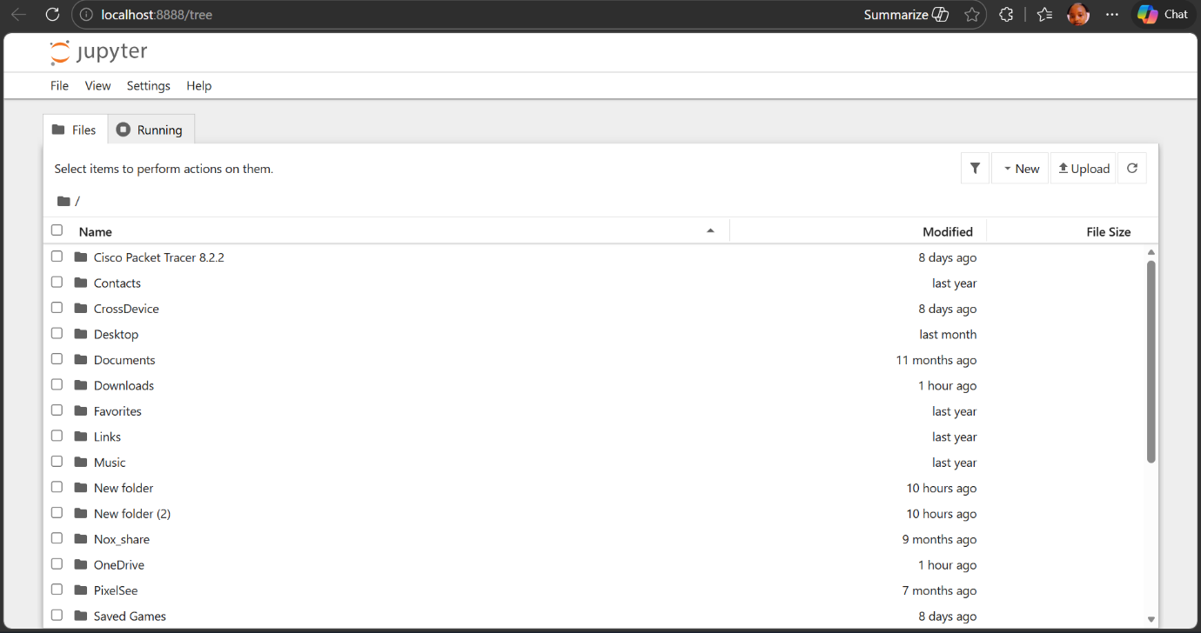

Select Python 3 under, New tab which goes to a new notebook for start working in it.
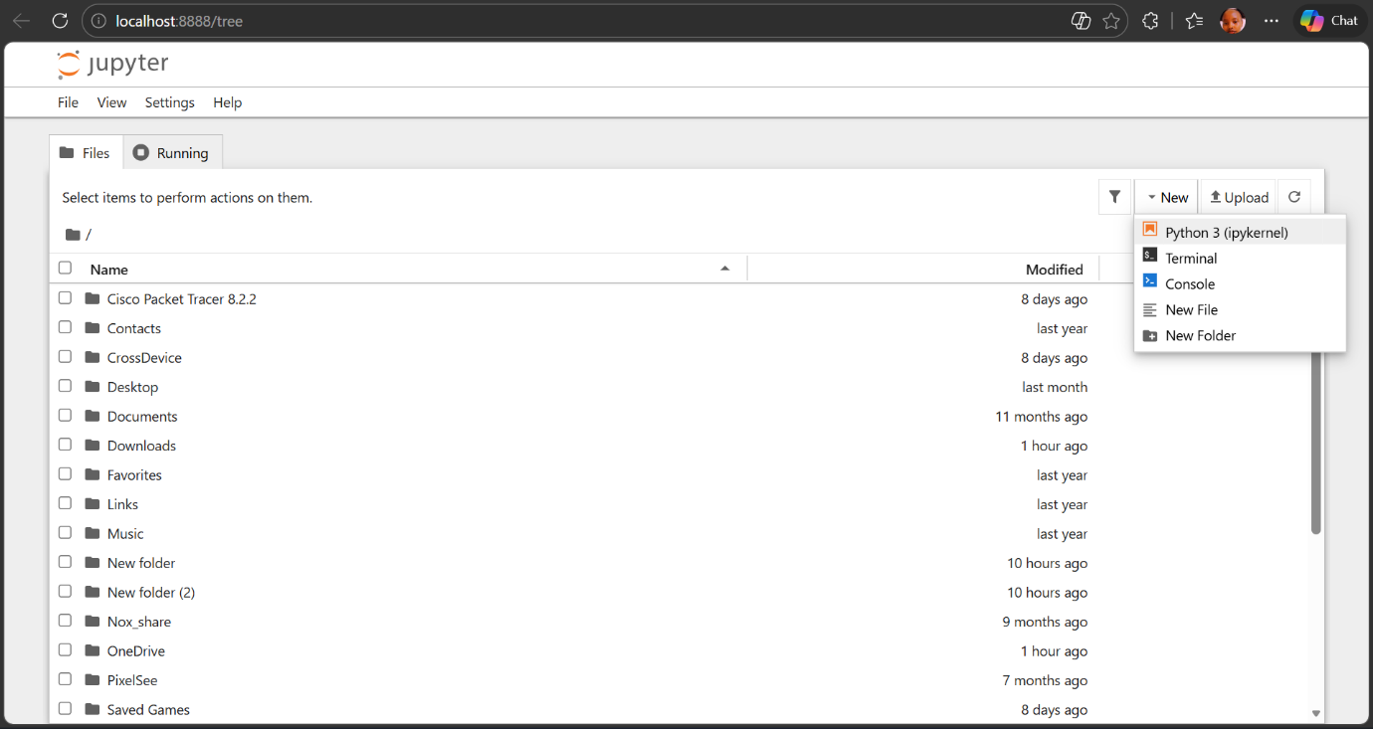

The new notebook.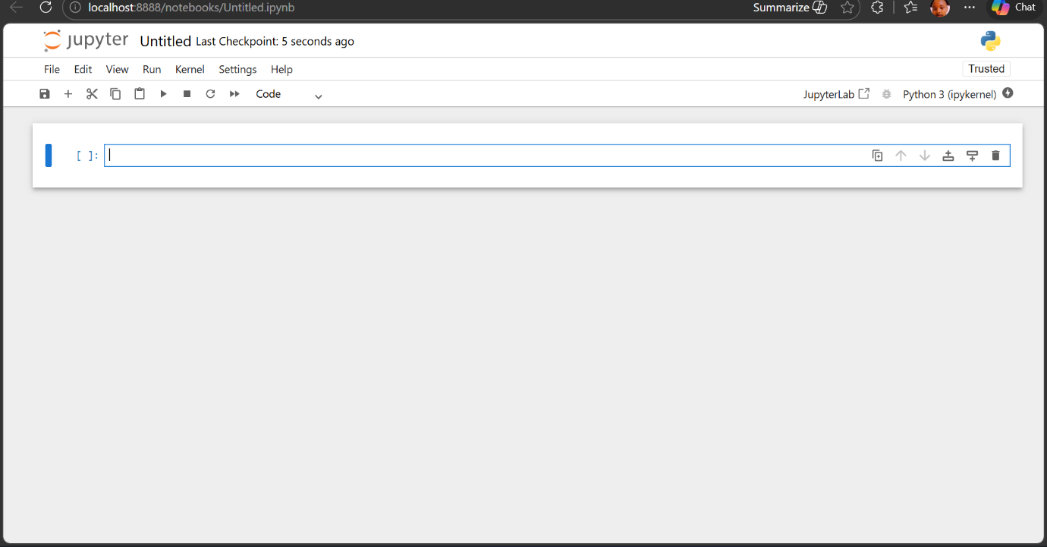

- NumPy.
Installation and execution.
- Pandas.
Installation and execution.
Creating a series of ndarray by using Pandas and the output.
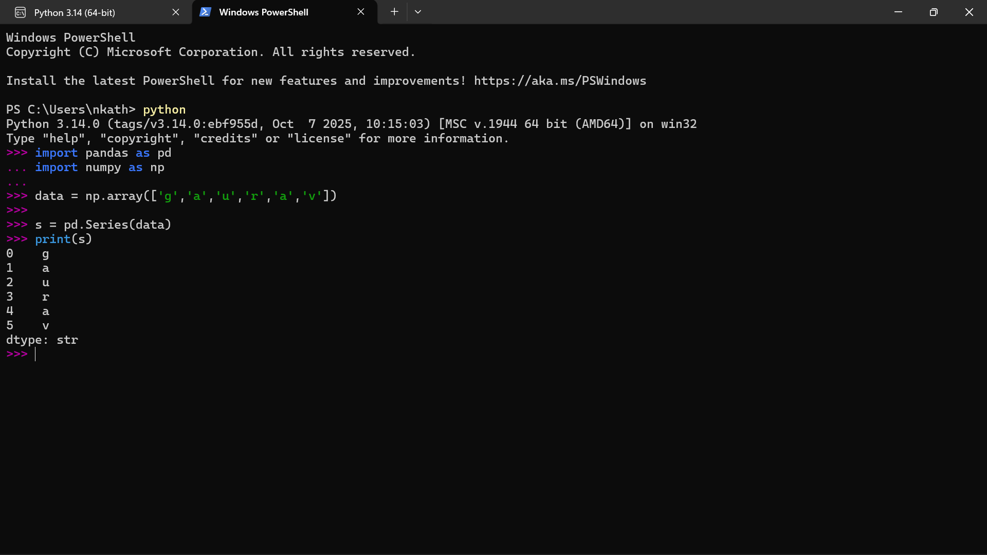

- Data loading for machine learning projects.
- Consideration while loading CSV data.
Loading CSV with python standard library.

