

**TECHNICAL UNIVERSITY OF MALAYSIA MALACCA**

FACULTY OF INFORMATION COMMUNICATION AND TECHNOLOGY

W O R K S H O P 1

R E P O R T

|  |  |
| --- | --- |
| **Name** | **: Pang Jia Mei** |
| **Matric Number** | **: B031910436** |
| **Course** | **: BITS (S1G2)** |
| **Project Title** | **: Goat Farm Management System** |
| **Supervisor Name** | **: Ts. Dr. Raja Rina Bt. Raja Ikram** |
| **Supervisor Signature** | **:** |
| **Evaluator Name** | **: Dr. Nor Hafeizah Bt. Hassan** |
| **Evaluator Signature** | **:** |

**TABLE OF CONTENTS**

***Page***

|  |  |
| --- | --- |
| **Chapter 1 : Introduction** |  |
| 1.1 Background | 3 |
| 1.2 Problem Statement | 3 |
| 1.3 Objective | 3 |
| 1.4 Scope | 3 |
| 1.5 Project Significance | 4 |
| **Chapter 2 : Analysis of Problem** |  |
| 2.1 Problem Decomposition Description | 5 |
| 2.2 Structure Chart | 5 |
| **Chapter 3 : Design** |  |
| 3.1 Flowchart | 6 |
| 3.2 ERD | 15 |
| 3.3 Data Dictionary | 16 |
| 3.4 Interface Design | 17 |
| **Chapter 4 : Conclusion** |  |
| 4.1 Constraint | 19 |
| 4.2 Future Improvement | 19 |
| **Chapter 5 : Bibliography** | 20 |

**Chapter 1 - Introduction**

**1.1 Background**

More and more farmers are willing to invest money for a simple herd control program that guarantee long term profitability in the future. They believe ineffective record keeping practice makes risk and loss management impossible. The demand for goat milk is on the rise, thus farmer should take the opportunity to increase the yield of dairy goat.

**1.2 Problem Statement**

* Farms having inconsistent milk yield due to unreliable feeding practice and health records.
* Farms having difficulty tracking milk production causing loss in profit.
* Difficulty in determining working personnel or machine error.

**1.3 Objective**

* To develop a system that will surely maintained goat milk production and good health.
* To analyze milk production performance of each goat herd to enable the goat farm owner secure the profits.
* To ensure the farm worker perform his duties on goat feeding and help identify the causes to affect the quality and milk yield of goat such as due to machine error.

**1.4 Scope**

*(a) Module to be developed*

Milk Production Management

To track the milk produced per goat per month or per annum and data collected can be generated into table analysis to give an overview of milk yield performance.

Staff Management

Track the person in charge of each task performed (feeding, milk collection et cetera) to identify personnel problem.

Feeding Management

Track the nutrition intake of each goat and identify problem such as deficiency to aid in feeding plan. Necessary feed intake in each growth stage (lactation, pregnancy) is important for the supply of high quality proteins in goat’s milk.

*(b) Target User*

Administrator – Goat and farmer data management

Supervisor – View data report and feeding planning

Veterinarian – View goat’s health status

Farmer – Goat’s location, add feeding record, add milk collection record, and view recent feeding record

**1.5 Project Significance**

* The introduction of an all-in-one computerized system allows data analysis from a wider perspective with more data, which makes it easier to identify problems in production processes.
* Manual record keeping is often tedious work, hence the computerize system could saves time on record keeping and data analysis which will free up employee for other tasks and saves personnel cost.
* Through data analysis, we may have a predictive model, which allow preventive action especially during crisis.

**Chapter 2 – Analysis of Problem**

**2.1 Problem Decomposition Description**

* The exact milk production record may be unclear due to human mistake in manual keeping record or calculation error.
* Goat’s feed intake may not according to their nutritional needs at each stage and susceptible to common diseases. The goat kids may also born underweight.
* Production error is difficult to be detected due to unreliable manual record and difficulty in data analyzation.

**2.2 Structure Chart**

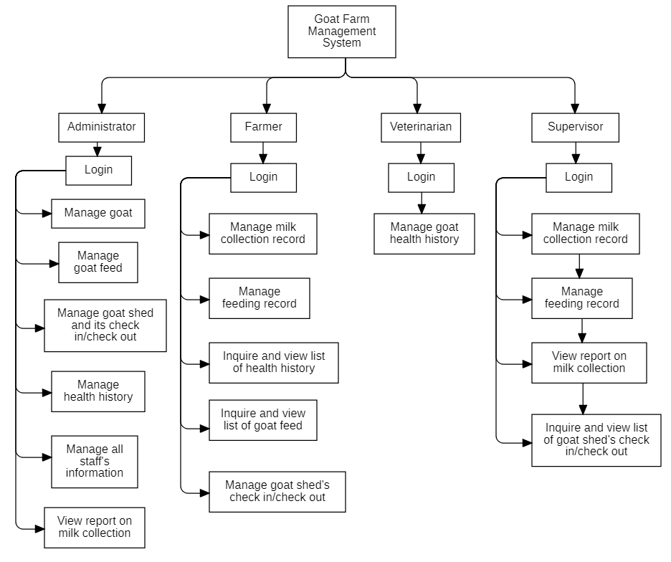

**Chapter 3 – Design**

**3.1 Flowchart**

**3.1.1 Main Program**

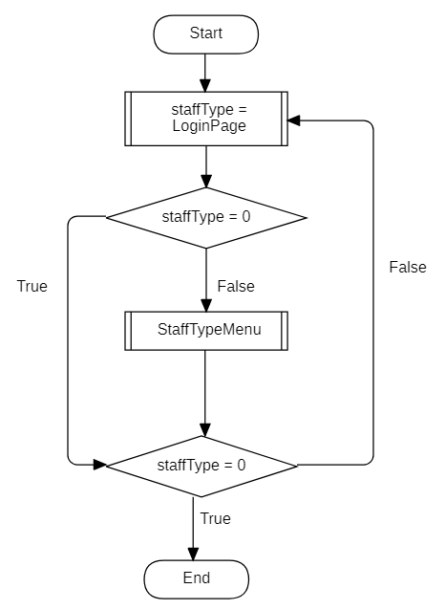

**3.1.2 Login Page**

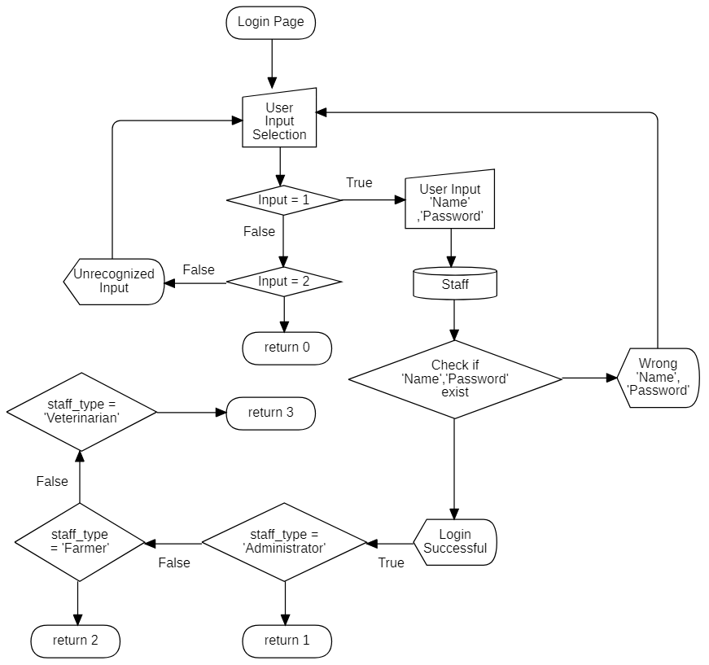

**3.1.3 Staff Type Menu**

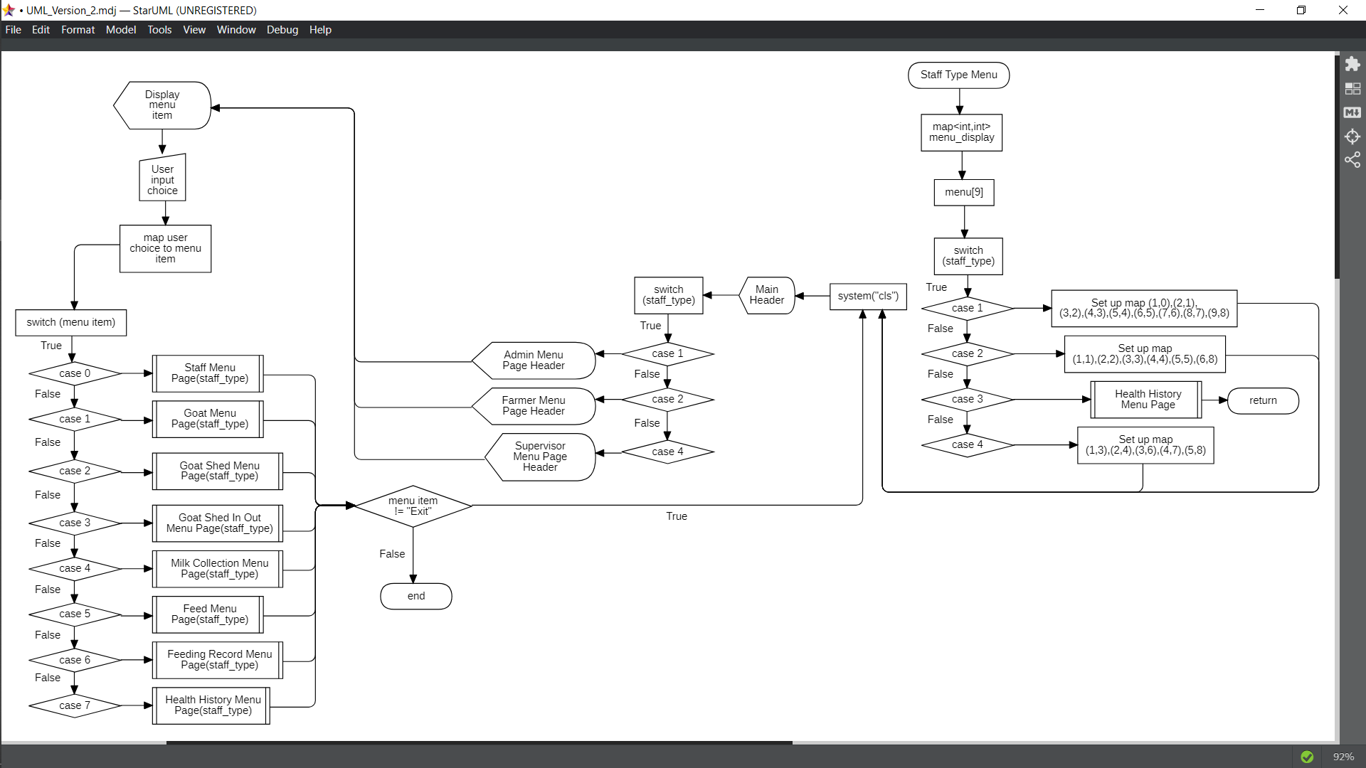

**3.1.4 Menu Display**

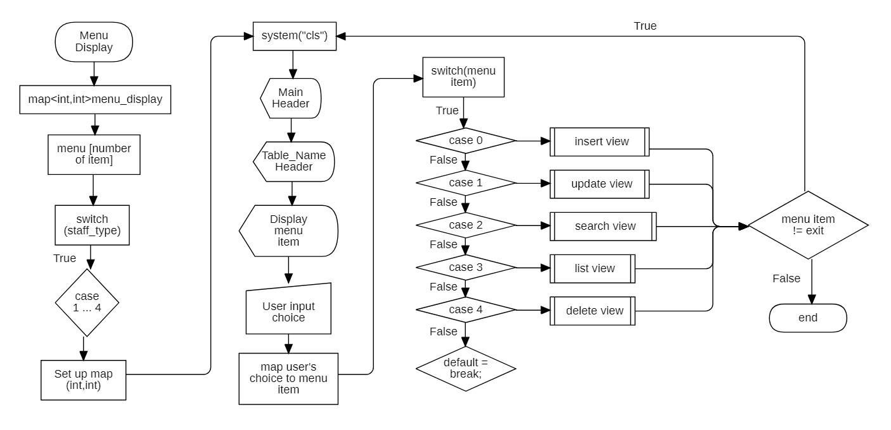

**3.1.5 Class Manager**

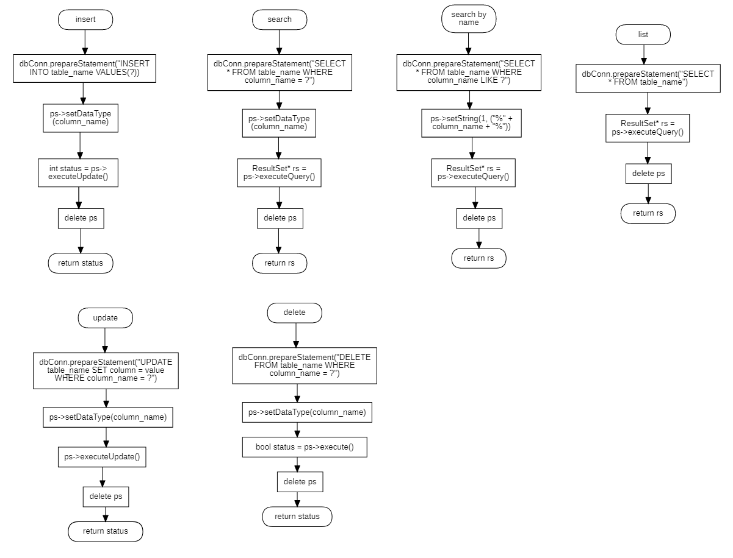

**3.1.6 Screen Class – Insert View**

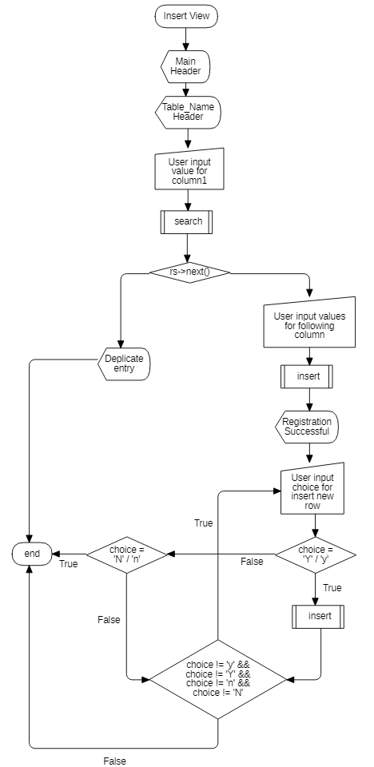

**3.1.7 Screen Class – Search View**

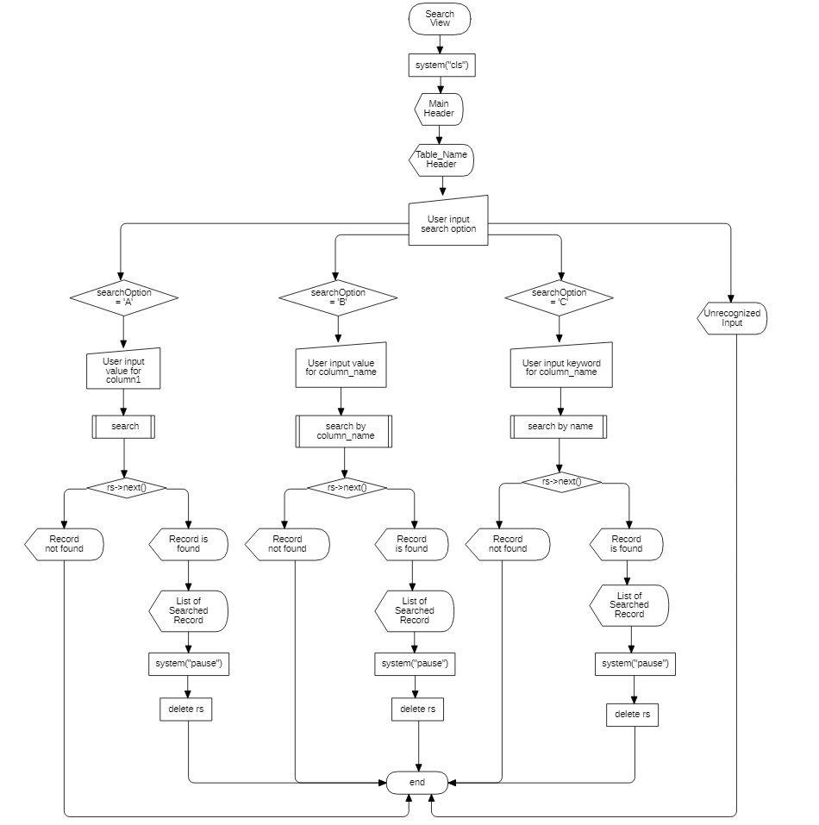

**3.1.8 Screen Class – Update View**

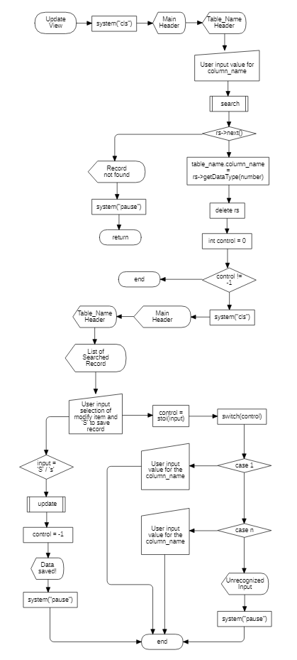

**3.1.9 Screen Class – Delete View**

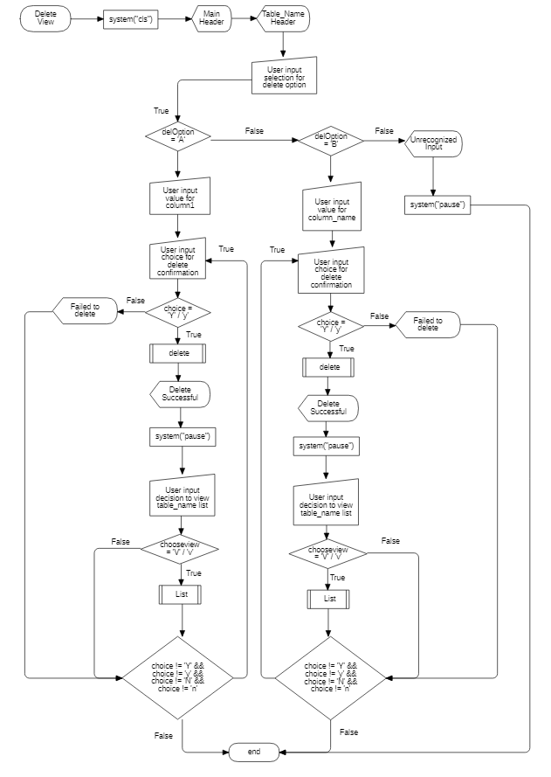

**3.1.10 Screen Class – List View**

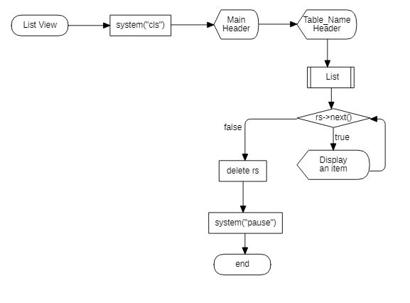

**3.1.11 Time Utility**

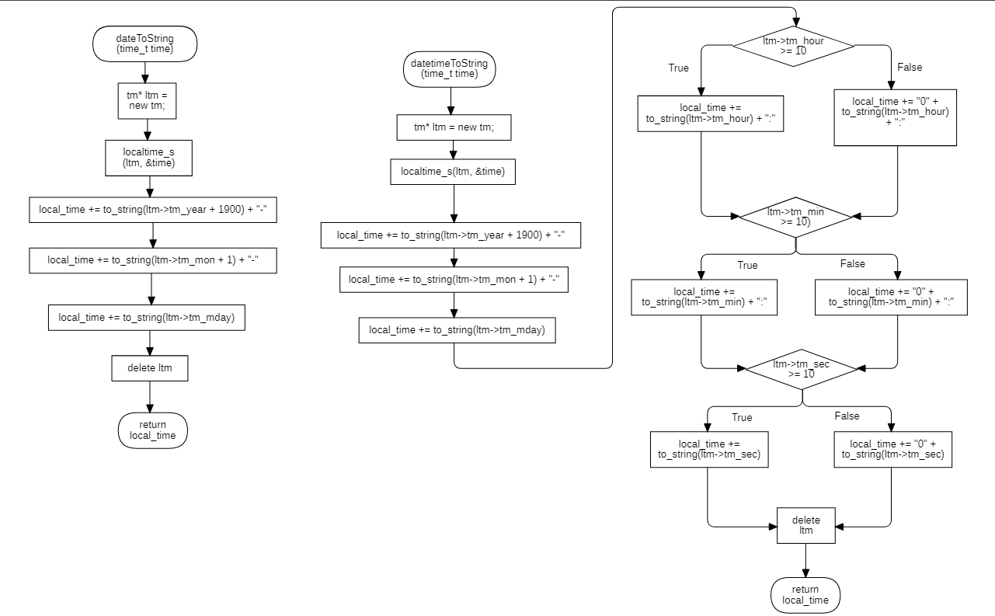

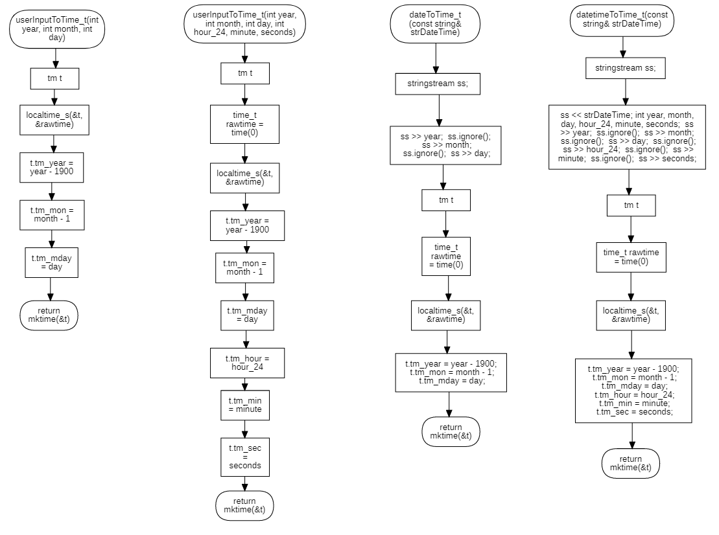

**3.2 ERD**

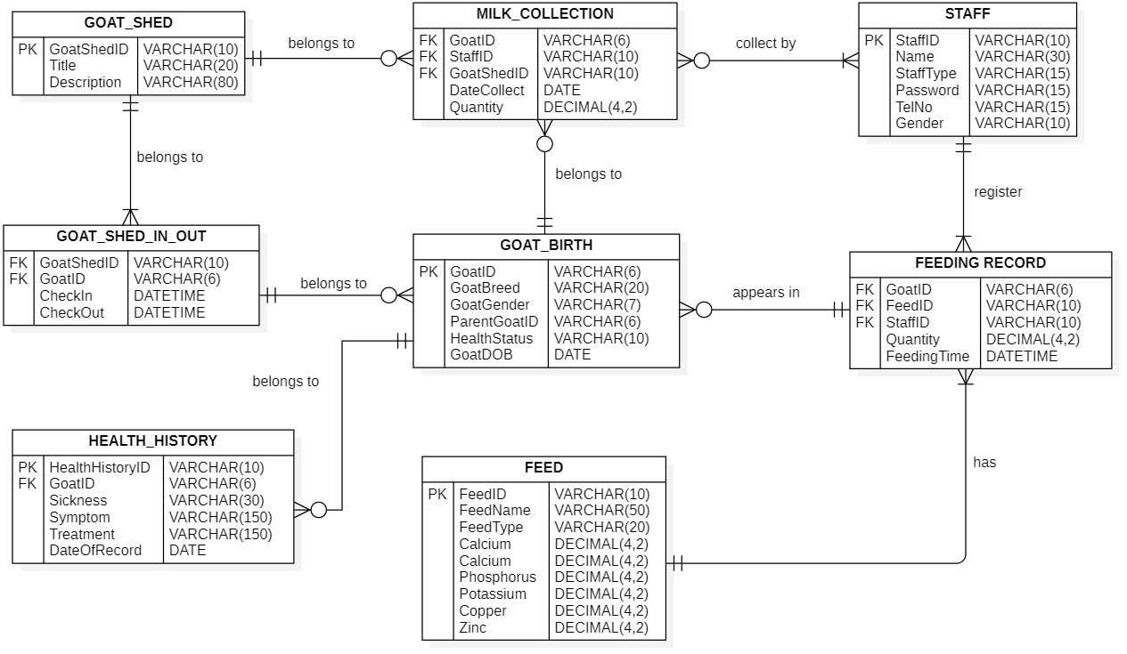

**3.3 Data Dictionary**

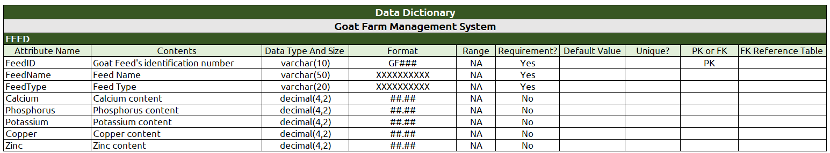

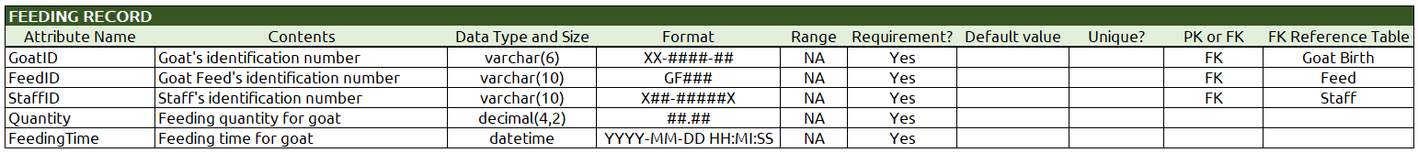

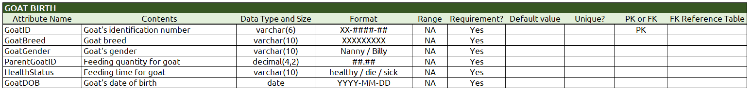





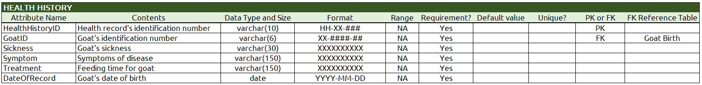

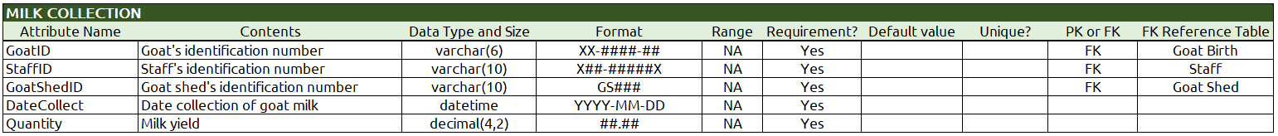

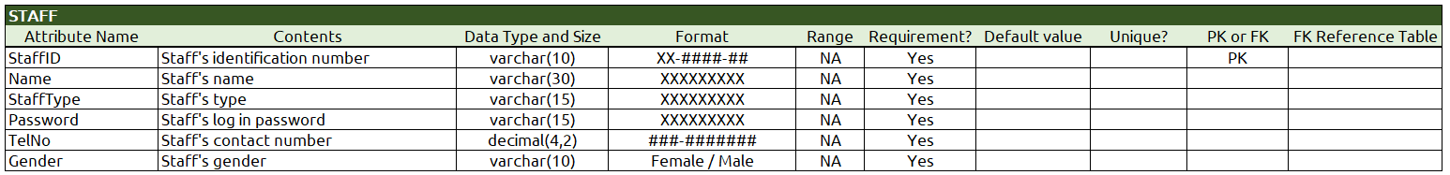

**3.4 Interface Design**

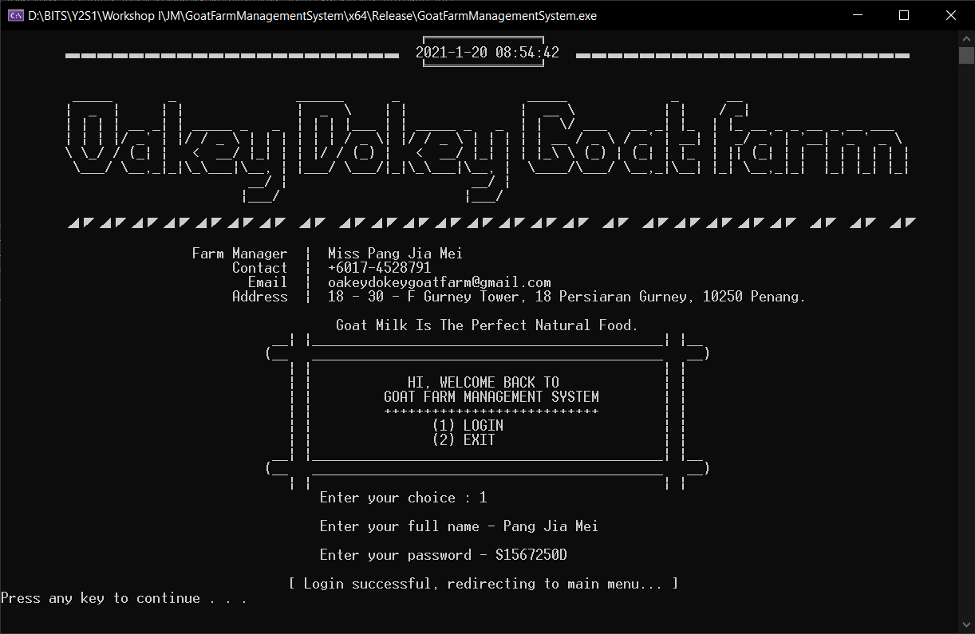

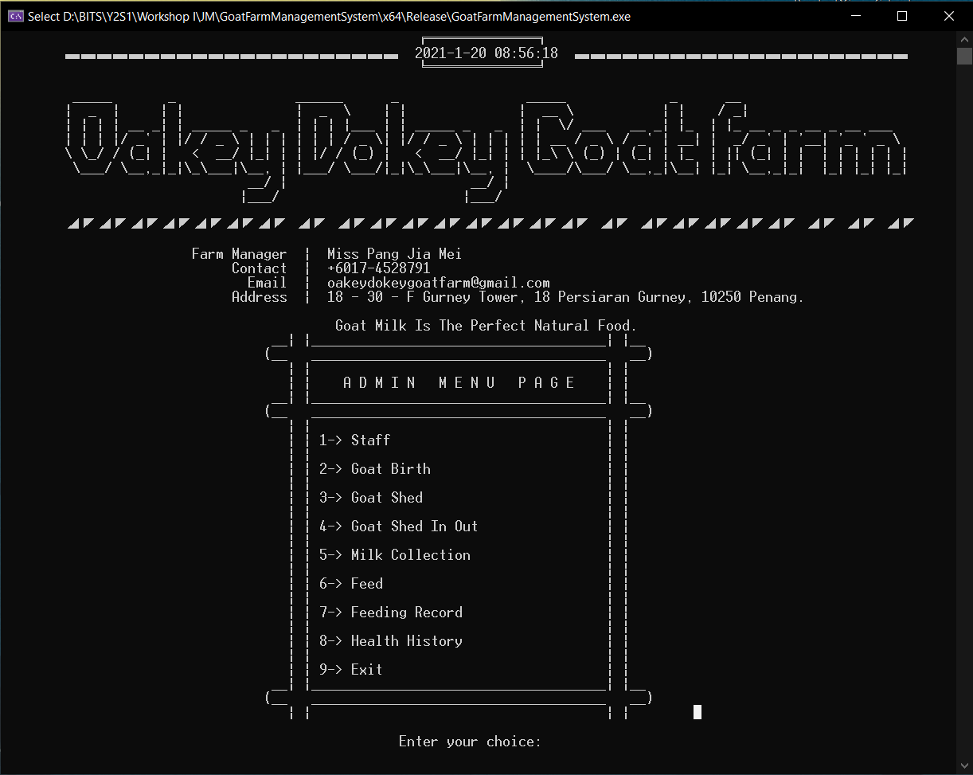

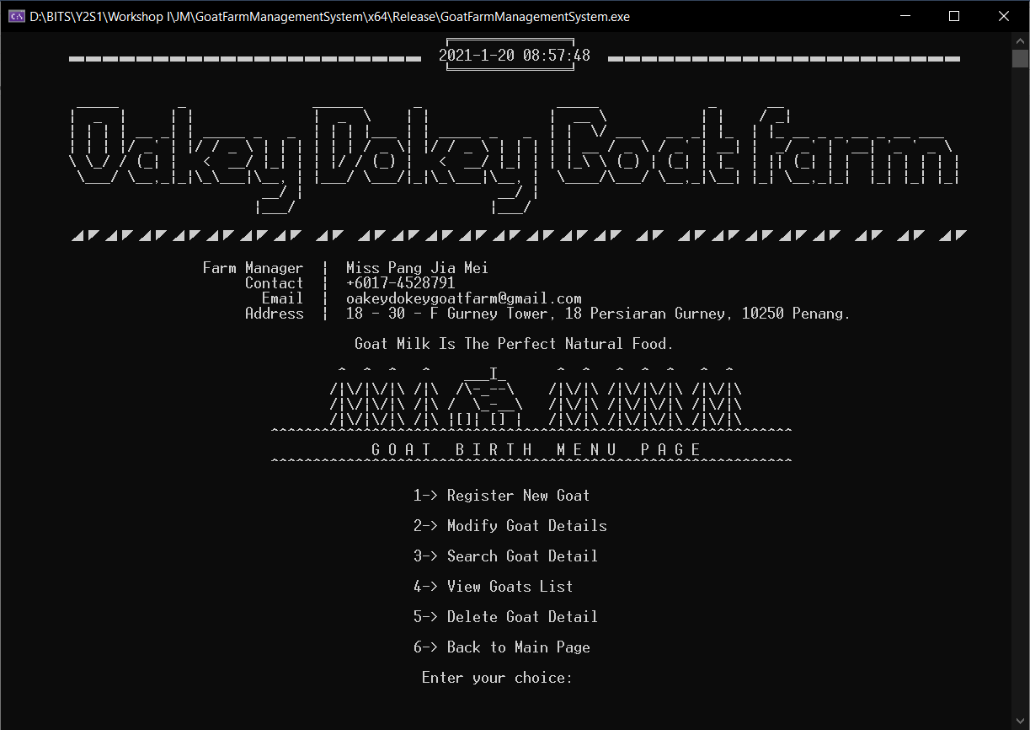

**Chapter 4 – Conclusion**

**4.1 Constraint**

* There are many repeated codes for each function
* User interface may not pleasant looking
* Did not actually check SQL query is successful executed

**4.2 Future Improvement**

* Archive old data – Maintaining history of time-variant data

“How do the current milk production compare to those of previous years?”

“What are milk production of goat shed’s trends?”

* Report on graph analysis
* Default generate current timestamp, identification number

**Chapter 5 – Bibliography**

1. MySQL :: MySQL Connector/C++ 8.0 Developer Guide

Dev.mysql.com: <https://dev.mysql.com/doc/connector-cpp/8.0/en/>

1. Malik, D. S. (2011). C++ Programming: From Problem Analysis to Program Design (MindTap Course List) (8th ed., Vol. 1) [E-book]. Cengage Learning. <http://index-of.co.uk/Programming/C++%20Programming%20From%20Problem%20Analysis%20to%20Program%20Design%20-%20D.%20S.%20Malik%20-%202011.pdf>