**Part 1: SVG Logo**



In the previous assignment on Web Application Development, you used the SVG logo, shown here, of the *Dunedin Dairy*.

The logo consists of a machine-generated SVG <path> to represent simple shapes. This is not ideal. Not only this <path> is difficult to comprehend, but also it makes changes difficult (can you see any other cons?). Consequently, you are asked to re-do the logo using appropriate high-level SVG objects other than <path>s (e.g., <rect>s, <circle>s). Your revised logo should be almost identical to the current logo.

You need to do the logo by hand — that is, you are not allowed to use a design tool such as *Inkscape*.

**Part 2: Secret Research at Dunedin Dairy**

Professor Willow discovered that Dunedin Dairy is conducting some secret research. He spotted an undocumented endpoint in their backend and wants your help in his investigation. The endpoint is this: <http://redsox.uoa.auckland.ac.nz/ds/DairyService.svc/g>. Professor Willow thinks it is an adjaceny matrix of a graph, and wants you to help visualize the graph.

To this end, write a single-page web application that consumes this adjaceny matrix, and renders the corresponding graph in SVG format. For verification, include the source matrix below the graph.

Your application might look like this:

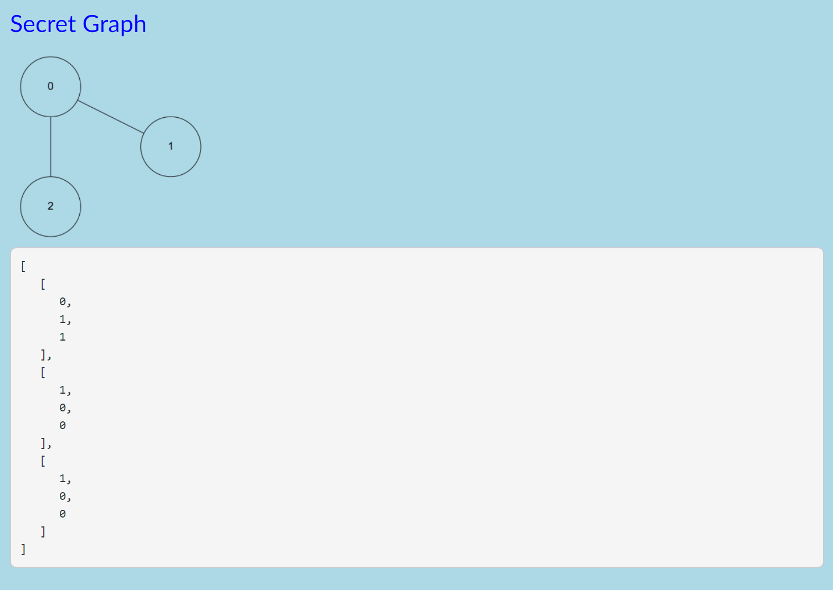

**Bonus Part: A brand new SVG Logo**

The current logo is widely perceived to be ugly. Therefore, you are asked to design and create a brand new logo. For this, you are allowed to use a design tool such as *Inkscape*.

Provide a brief note in your SVG file explaining why you think the logo you designed is appropriate. This note should be inserted as a comment in your SVG file.

**Submission**

Your SVGs should render in any modern browser and should scale. Otherwise, you may not get any marks.

Please submit to the [Assignment Dropbox](https://adb.auckland.ac.nz/) the following items.

1. The revised logo SVG file for Part 1 (called *UPI.svg* where *UPI* is your UPI).
2. The HTML file for Part 2 (called *UPI.html* where *UPI* is your UPI).
3. The JavaScript file for Part 2 (called *UPI.js* where *UPI* is your UPI).
4. Optional bonus — the newly designed logo SVG file (called *UPI-bonus.svg* where *UPI* is your UPI).