Overview
For this assignment, I created a website dedicated to Little Women, a book and film that holds a very special place in my heart. My goal was to capture the warm, nostalgic feeling that the story evokes, both through Louisa May Alcott's original novel and specifically Greta Gerwig’s film adaptations. I wanted visitors to experience that same sense of comfort and timelessness that I feel when I revisit this story. The color palette, typography, and overall design were all chosen to reflect the cozy, literary atmosphere of the March family's world. Through multiple pages, including a home page with quotes, an about section, a gallery of film stills, and an interactive favorites form, I aimed to create a space that felt inviting and personal, much like sitting down with a beloved book.
What worked
I'm most proud of my aesthetic choices and use of color for visual hierarchy throughout the site. I especially liked my choice to use a dark brown on my navigation links toolbar, as it also stays stuck to the top of the screen. This addition, along with the contrasting color, makes the visual hierarchy clear to the user. The warm tones create that vintage feel I was aiming for, and they work well on the gallery page with the film stills from the 2019 adaptation. The images feel cohesive against the background, and the layout allows each still to stand out while maintaining visual harmony. The use of Google Fonts reinforced the classic book aesthetic I wanted. My flexbox image grid turned out better than I expected. The 3x3 layout creates a balanced, organized presentation that doesn't feel cluttered.
What challenged
Throughout this project, I encountered several technical issues that required problem-solving and outside help. Initially, I struggled with getting my navigation to display properly at the top of the page and stretch across the full width of the screen. I had to adjust the margin and width properties to get it right. I also ran into issues with my video element not displaying correctly; it appeared small and wouldn't play, which required troubleshooting the file path and ensuring the video format was compatible with browsers. I used forums and various websites to help me identify these issues and apply solutions step by step. Next time, I'd like to be more confident in troubleshooting these layout issues independently, but this experience taught me the value of outside sources.

User Experience
Navigating my own site felt smooth and intuitive once I fixed the technical issues. The sticky navigation makes it easy to jump between pages, and the consistent design across all sections creates a cohesive experience. However, I recognize that the site could benefit from more visual depth, as right now, everything feels a bit flat. That said, I think the minimalist approach works in favor of the aesthetic I'm going for. Little Women has a simplicity and earnestness to it, and I wanted the website to reflect that rather than feeling overly complicated or busy. Still, adding subtle shadows, layering, or texture could enhance the design without sacrificing that clean feel.
Technical Reflection
The skill I feel most improved in is connecting my stylesheet to my HTML pages and maintaining organization across multiple files. At the beginning of the semester, I found it confusing to keep track of class names, file paths, and CSS rules. Now, I feel much more confident in my ability to structure my code clearly, which helps me make changes to my code much faster. Understanding how to properly link external resources like Google Fonts and how CSS cascades across pages has made the entire development process smoother and less frustrating.
Next Steps
If I had one more week to work on this project, I would just add a lot more depth to my site. We learned many features that I implemented in a way that I like, but I would have loved to use them in more creative ways. Like maybe a page more in detail about behind the scenes of filming various parts of Little Women, with embedded videos of said scenes. Or with a community section where users can comment and discuss about analysis, compliments, and comparisons with one another.
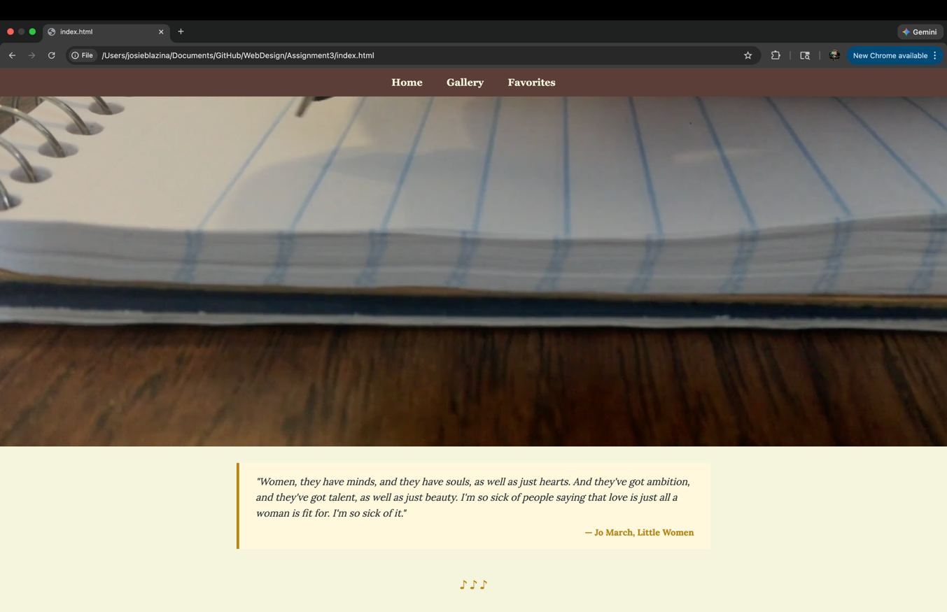
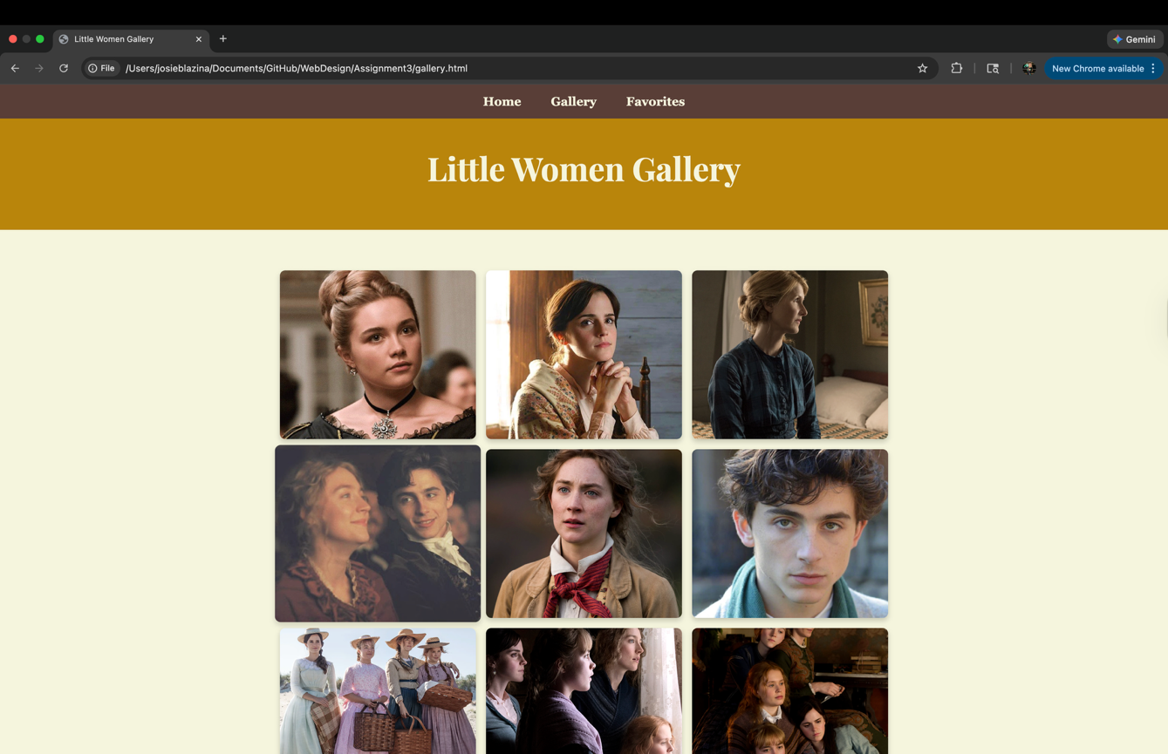
- I really liked the small music notes I used for dividers and I like how I tied the color back into the quote citation
- I liked the hovering feature when the mouse passes over an image
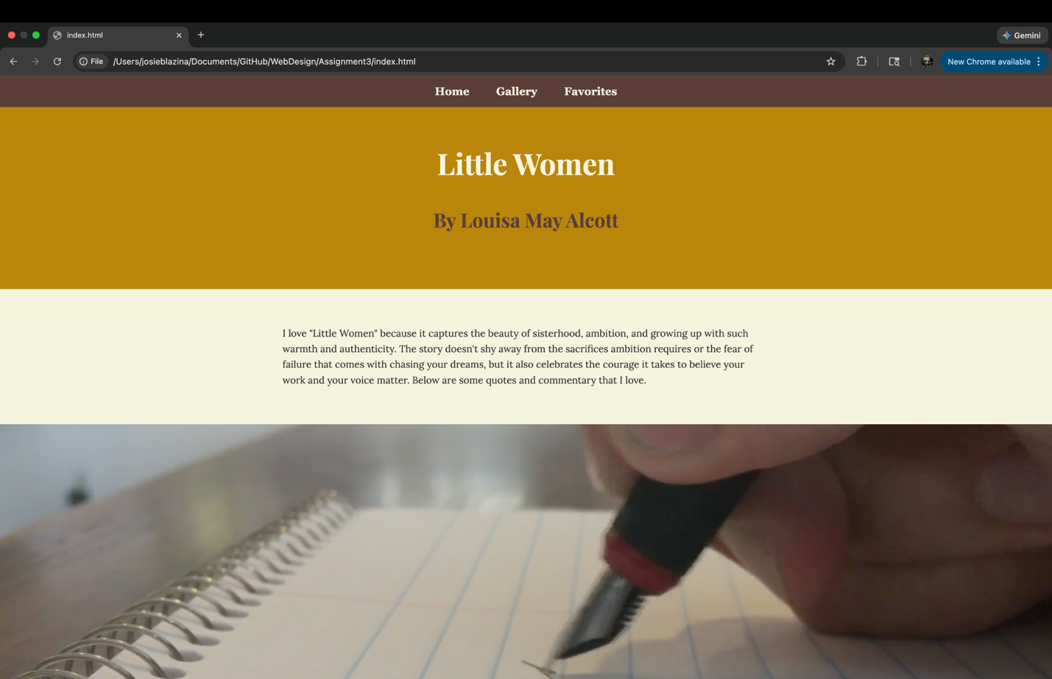
- The sticky feature on the dashboard helped user navigation and overall appearance

