* “Esc” toets moet ingedrukt worden.
  + [https://support.hp.com/gb-en/document/ish_3912651-2318005-16#:~:text=Turn%20off%20the%20computer%20and,open%20the%20BIOS%20Setup%20Utility.](https://support.hp.com/gb-en/document/ish_3912651-2318005-16%23:~:text=Turn%20off%20the%20computer%20and,open%20the%20BIOS%20Setup%20Utility.)

# Boot priority

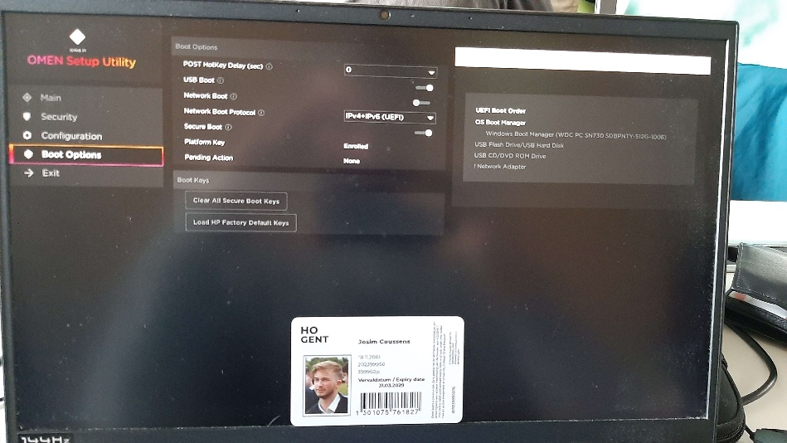

# TPM aan-/uitzetten

# Legacy BIOS aan-/uitzetten (niet beschikbaar)

# Partities bekijken/maken

type partition table: Master Boot Record (MBR)

