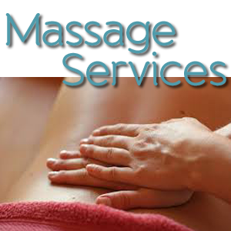

# **Table and Chair Massage**

### (Most Insurance Accepted)

### Church, Home, Business and Special Events.

### With Purchase of Massage you get a Free Chair Massage.

M. Nicole Josecite

Massage Favor For Health

njosecite@yahoo.com

(407) 601-3712

#### M. Nicole Josecite

(407) 803-1847

#### M. Nicole Josecite

(407) 601-3712

#### M. Nicole Josecite

(407) 803-1847

#### M. Nicole Josecite

(407) 601-3712

#### M. Nicole Josecite

(407) 803-1847

#### M. Nicole Josecite

(407) 601-3712

#### M. Nicole Josecite

(407) 803-1847

(407) 601-3712

#### M. Nicole Josecite

#### M. Nicole Josecite