**Question 1:**

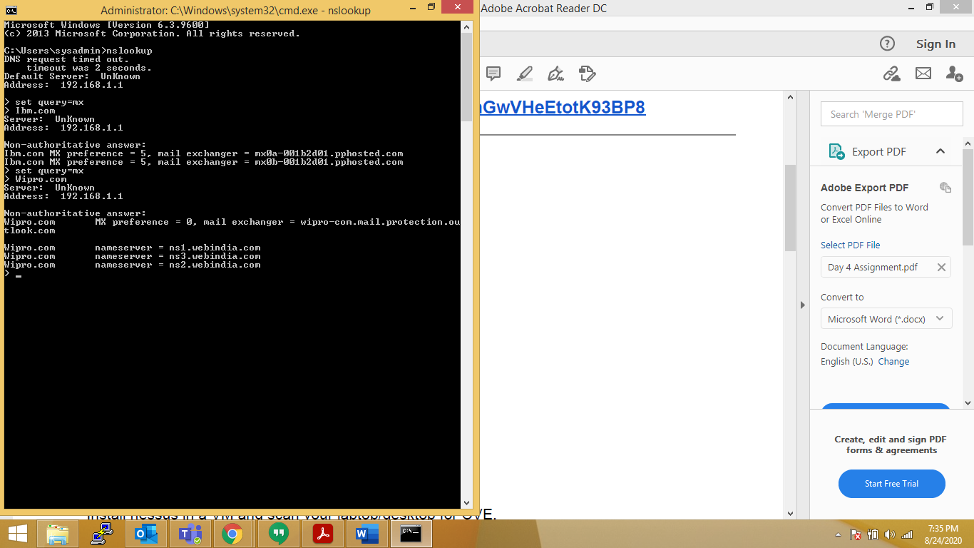

**Question 2:**

**C:\Users\sysadmin>nslookup mx0a-001b2d01.pphosted.com**

**DNS request timed out.**

**timeout was 2 seconds.**

**Server: UnKnown**

**Address: 192.168.1.1**

**Non-authoritative answer:**

**Name: mx0a-001b2d01.pphosted.com**

**Address: 148.163.156.1**

**C:\Users\sysadmin>nslookup mx0b-001b2d01.pphosted.com**

**DNS request timed out.**

**timeout was 2 seconds.**

**Server: UnKnown**

**Address: 192.168.1.1**

**Non-authoritative answer:**

**Name: mx0b-001b2d01.pphosted.com**

**Address: 148.163.158.5**

**C:\Users\sysadmin>**

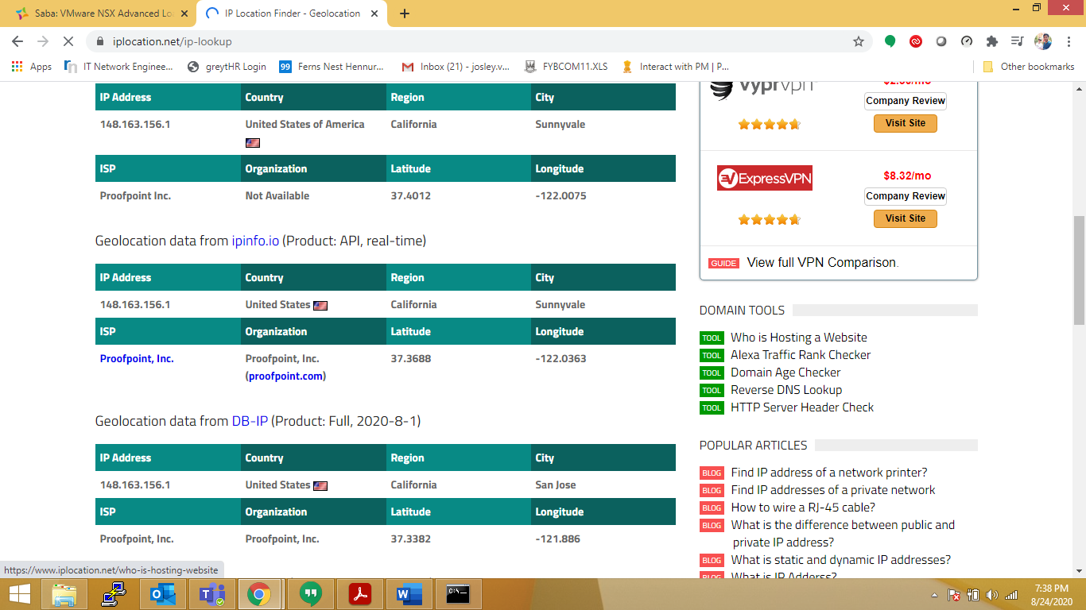

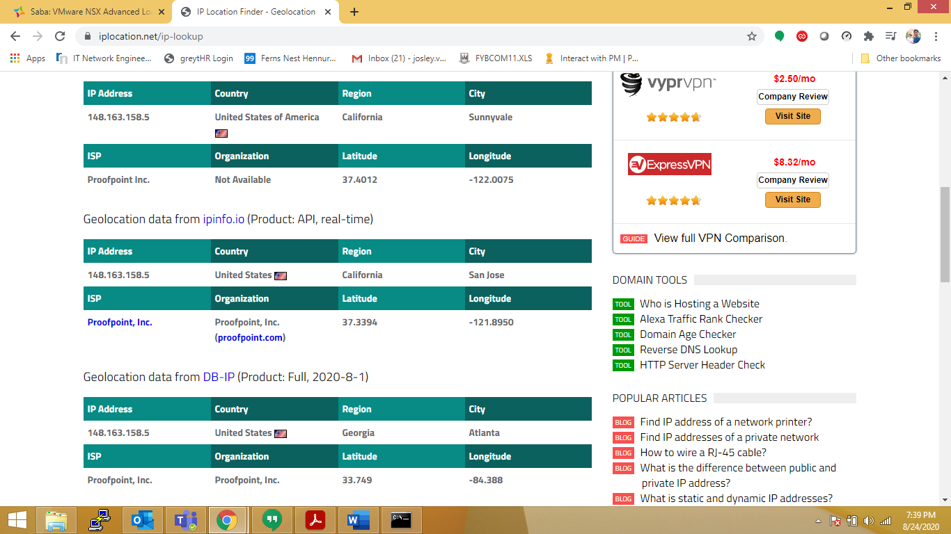

**Question 3:**

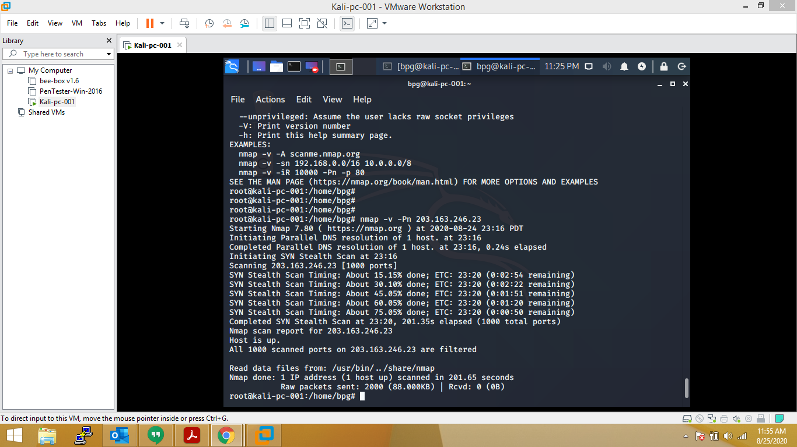

**Question 4:**

