**ReactJS Hands-On Labs**

**Exercise 1 :  
Week 9**

**Prerequisites Setup**

1. **Install Node.js and NPM**: https://nodejs.org/
2. **Install Visual Studio Code**: https://code.visualstudio.com/
3. **Create React App**:

bash

npx create-react-app cricketapp

cd cricketapp

npm start

**Project Structure**

Inside src/, create two components:

* ListofPlayers.js
* IndianPlayers.js

Update App.js to conditionally render these components.

**Step-by-Step Implementation**

1. **ListofPlayers Component**

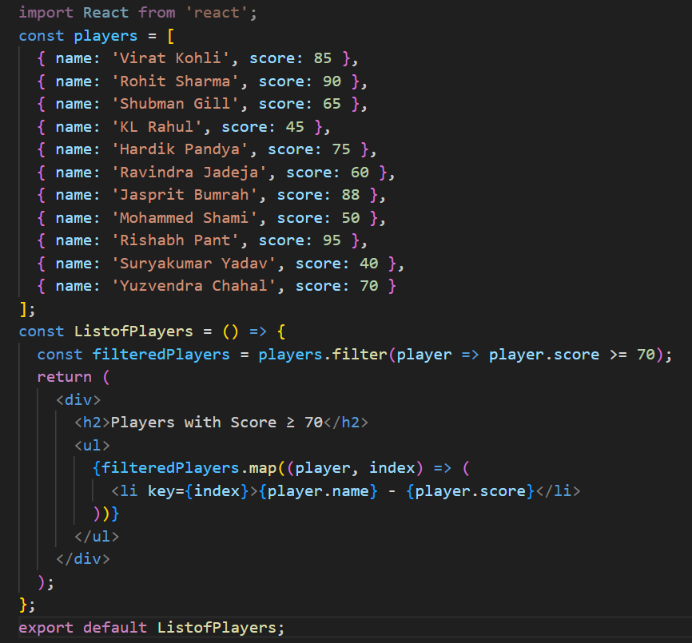

1. **IndianPlayers Component**

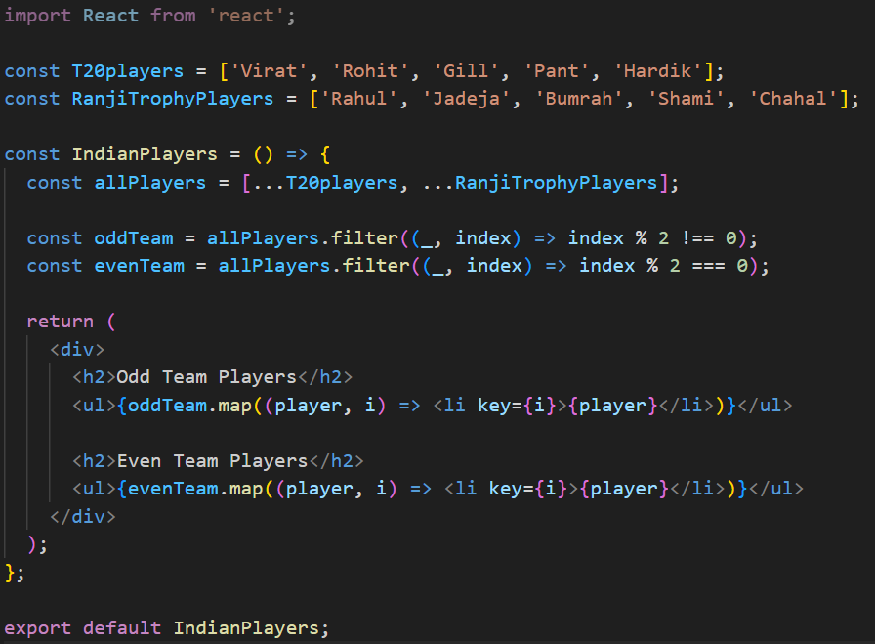

1. **App Component with Flag Logic**

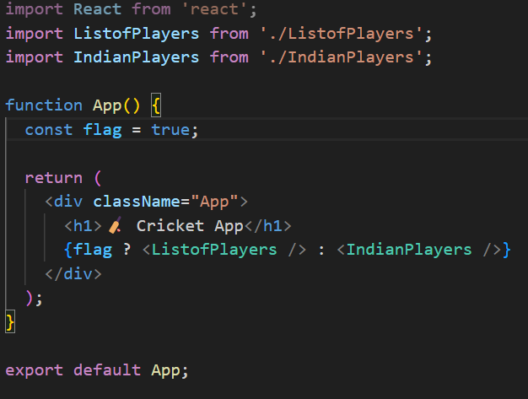

**Output**

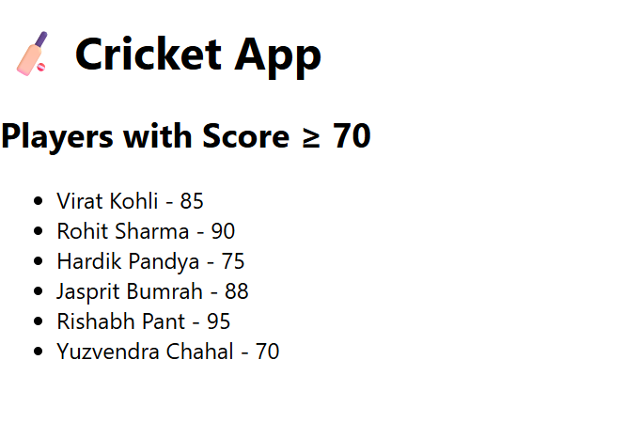

**Exercise 2:  
Week 10**

**Prerequisites Setup**

1. **Install Node.js and NPM**: https://nodejs.org/
2. **Install Visual Studio Code**: https://code.visualstudio.com/
3. **Create React App**:

bash

npx create-react-app officespacerentalapp

cd officespacerentalapp

npm start

**Project Structure**

We'll work mainly in src/App.js. You can optionally create a separate component like OfficeList.js for better structure.

**Step-by-Step Implementation**

1. **Create JSX Elements**

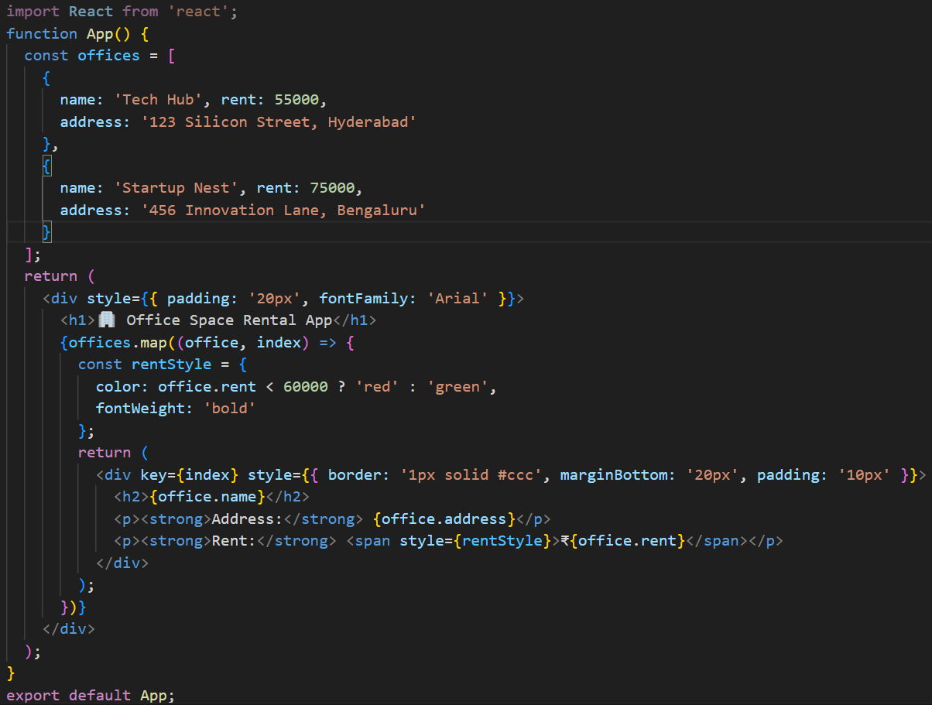

**Output**

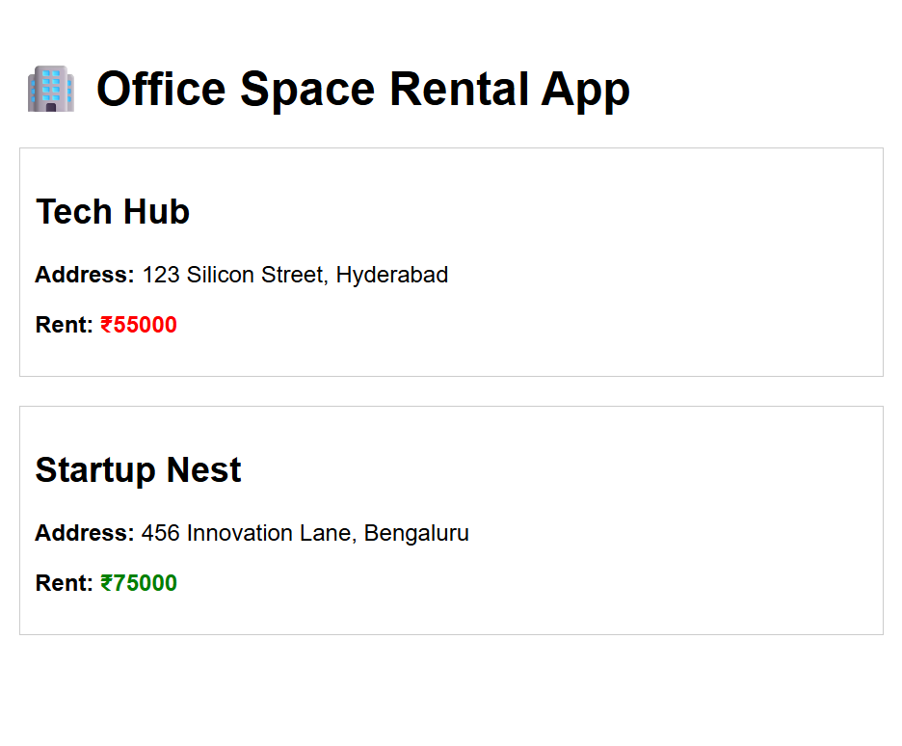

**Exercise 3:  
Week 11**

**Prerequisites Setup**

1. **Install Node.js and NPM**: https://nodejs.org/
2. **Install Visual Studio Code**: https://code.visualstudio.com/
3. **Create React App**:

bash

npx create-react-app eventexamplesapp

cd eventexamplesapp

npm start

**Project Structure**

Create the following components inside src/:

* Counter.js
* WelcomeButton.js
* SyntheticEventButton.js
* CurrencyConvertor.js

Update App.js to include all components.

**Step-by-Step Implementation**

1. **Counter Component**

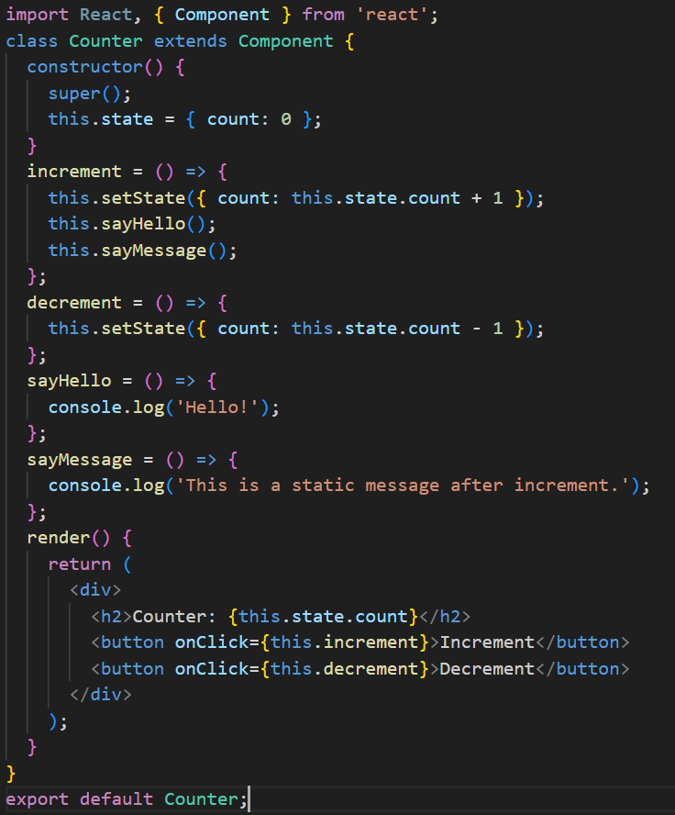

1. **Welcome Button Component**

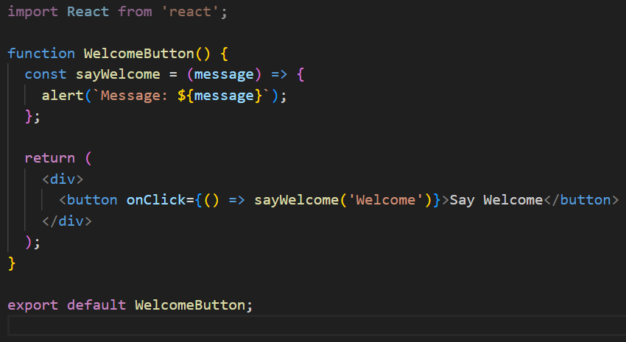

1. **Synthetic Event Button**

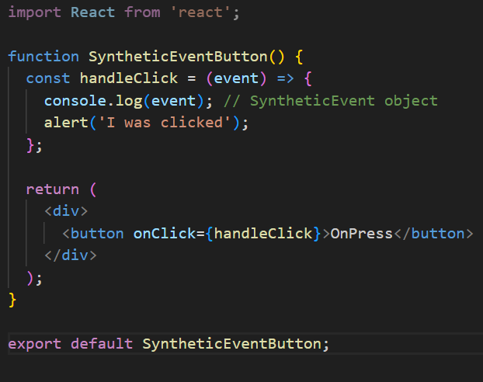

1. **CurrencyConvertor Component**

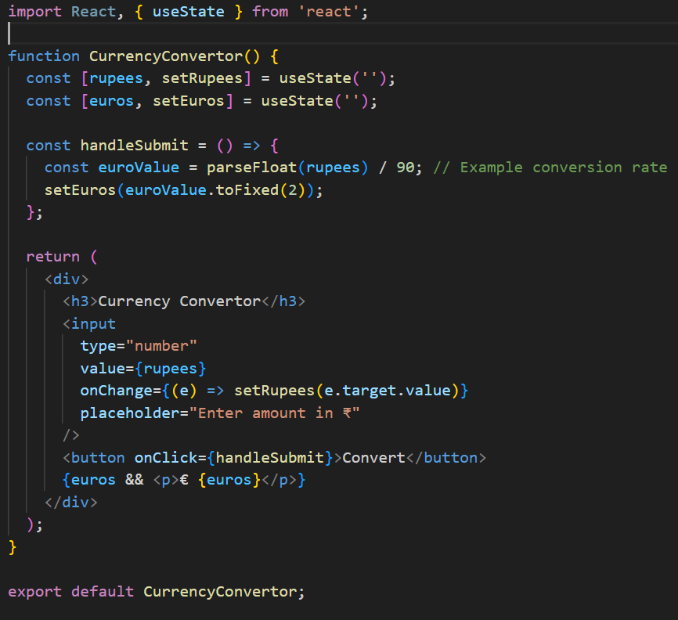

1. **App Component**

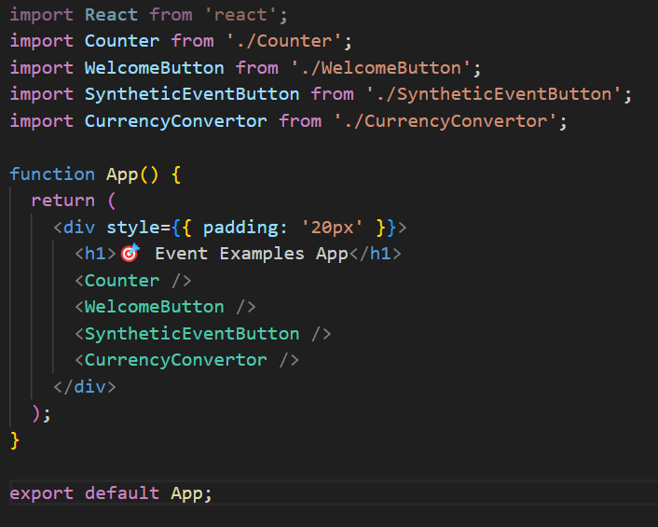

**Output**

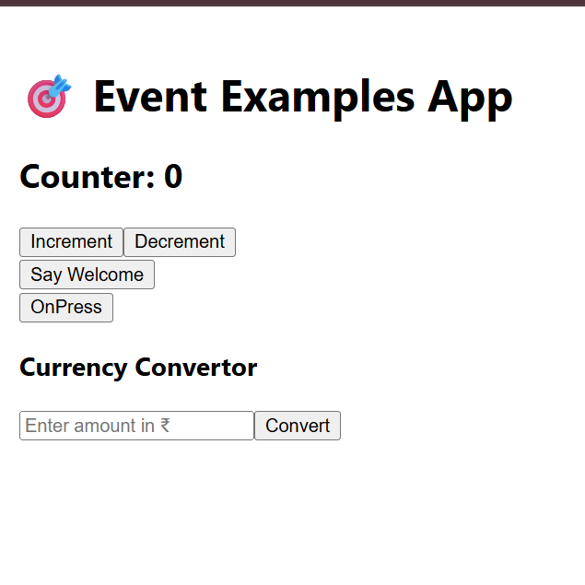

**Exercise 4:  
Week 12**

**Prerequisites Setup**

1. **Install Node.js and NPM**: https://nodejs.org/
2. **Install Visual Studio Code**: https://code.visualstudio.com/
3. **Create React App**:

bash

npx create-react-app ticketbookingapp

cd ticketbookingapp

npm start

**Project Structure**

Inside src/, create:

* GuestPage.js
* UserPage.js
* LoginControl.js

Update App.js to render LoginControl.

**Step-by-Step Implementation**

1. **GuestPage Component**

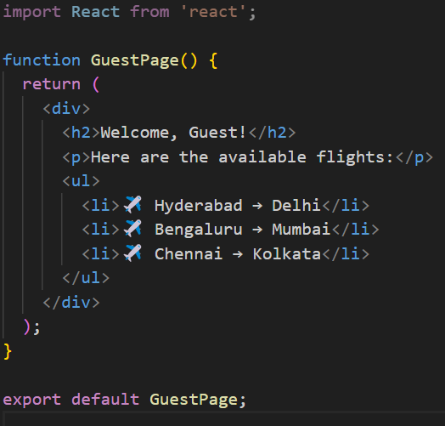

1. **UserPage Component**

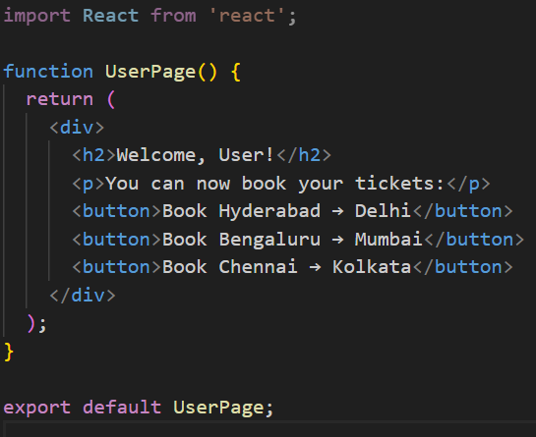

1. **LoginControl Component**



1. **App Component**

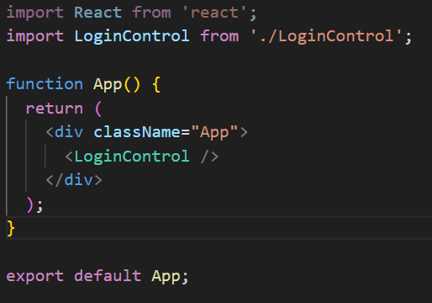

**Output**

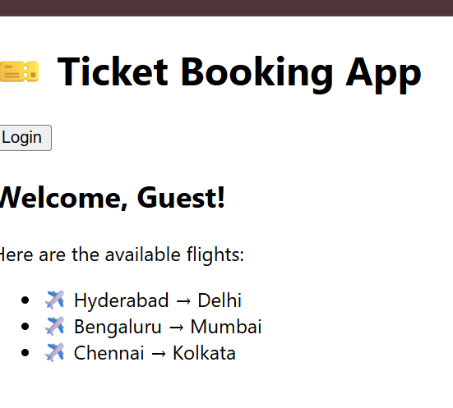

**Exercise 5:  
Week 13**

**Prerequisites Setup**

1. **Install Node.js and NPM**: https://nodejs.org/
2. **Install Visual Studio Code**: https://code.visualstudio.com/
3. **Create React App**:

bash

npx create-react-app bloggerapp

cd bloggerapp

npm start

**Project Structure**

Inside src/, create:

* BookDetails.js
* BlogDetails.js
* CourseDetails.js

Update App.js to render everything.

**Step-by-Step Implementation**

1. **BookDetails Component**

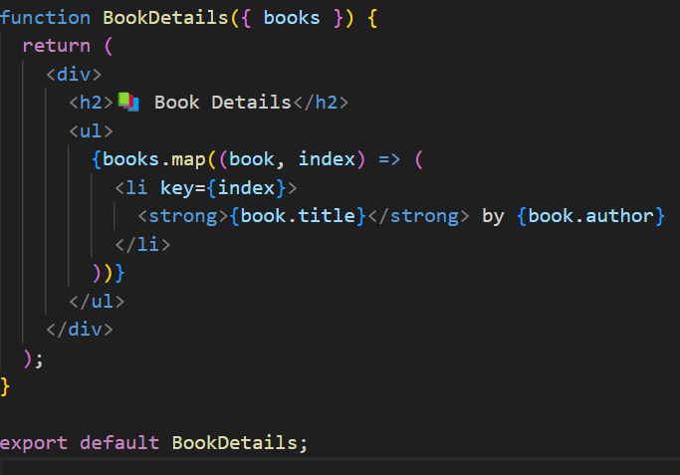

1. **BlogDetails Component**

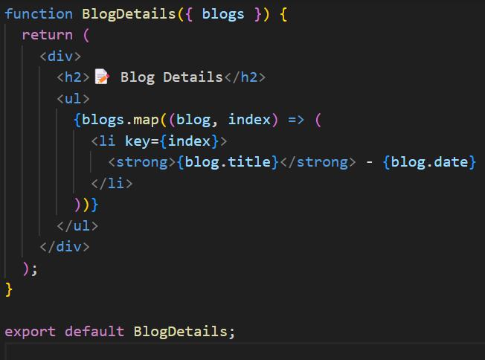

1. **CourseDetails Component**

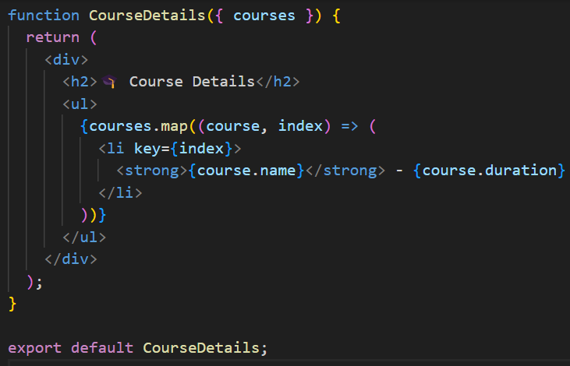

1. **App Component with Multiple Conditional Rendering Techniques**

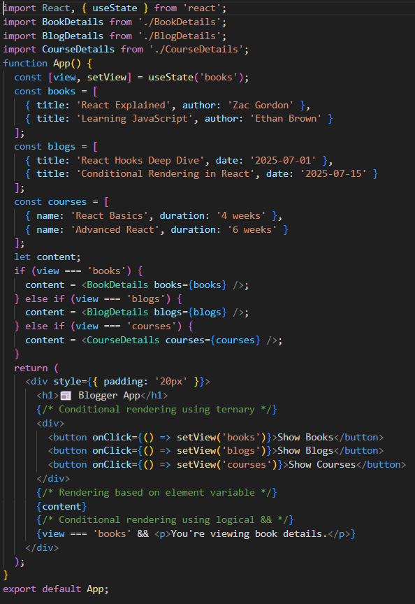

**Output**

