## **Project Title:**

**AI-Powered Resume Generator**

## **Team Name:**

SynthMind

## **Team Members:**

* Chaganti Josmietha
* Polampally Bhargavi
* Rincy Roy
* Sritika Bhagavatula
* T Devi Priyanka

## **Phase-1: Brainstorming & Ideation**

### **Objective:**

Develop an **AI-powered resume generator** that enables users to create **professional, industry-optimized resumes** effortlessly using **Generative AI**. The solution eliminates the need for manual formatting and offers **real-time AI-driven suggestions, voice input, and intelligent UI enhancements**.

### **Key Points:**

1. **Problem Statement:**
   * Many job seekers, especially **students and fresh graduates**, struggle to craft professional resumes that effectively highlight their skills and experiences.
   * Existing resume builders rely on **rigid templates**, require **manual input**, and often lack **AI-driven personalization**. Additionally, users face challenges in **optimizing their resumes for specific industries**, leading to missed job opportunities.
2. **Proposed Solution:**

An **AI-powered Resume Generator** that:

* + Uses **OpenAI’s GPT-4** to generate **tailored, professional resumes** based on user input.
  + Offers **voice-based input** for easy data entry.
  + Provides **real-time AI suggestions** for resume sections (Experience, Skills, Education, etc.).
  + Generates **industry-specific resumes** optimized for Finance, Engineering, Marketing, and more.
  + **Automatically formats** resume and exports them as **professionally structured PDFs**.

1. **Target Users:**
   * **Students & Fresh Graduates** – Need polished resumes to secure job interviews.
   * **Job Seekers & Professionals** – Want AI-driven improvements for their resumes.
   * **Universities & Career Services** – Can provide the tool as a **career development resource**.
2. **Expected Outcome:**
   * A **functional AI-powered resume generator** that helps job seekers create **polished, ATS-friendly resumes** effortlessly while **reducing the time and effort** needed for resume building.

## **Phase-2: Requirement Analysis**

### **Objective:**

Define the **technical and functional requirements** for the AI-powered Resume Generator.

### **Key Points:**

1. **Technical Requirements:**
   * Programming Language: **Python**
   * Backend: **OpenAI’s GPT-4 API**
   * Frontend: **Streamlit Web Framework**
   * Database: **Not required initially (API-based queries)**
   * PDF Generation: **FPDF**
2. **Functional Requirements:**
   * User inputs personal & career details (manual entry or voice input).
   * AI generates structured, industry-optimized resume content.
   * Users can preview, edit, and customize the resume in real time.
   * AI offers automatic formatting and PDF export capabilities.
   * Conversational AI assistant provides resume improvement tips.
3. **Constraints & Challenges:**
   * Ensuring accurate, ATS-friendly resume formatting using AI.
   * Handling API rate limits and optimizing AI calls for real-time performance.
   * Providing a smooth UI/UX experience with Streamlit.

## **Phase-3: Project Design**

### **Objective:**

Develop the architecture and user flow of the application.

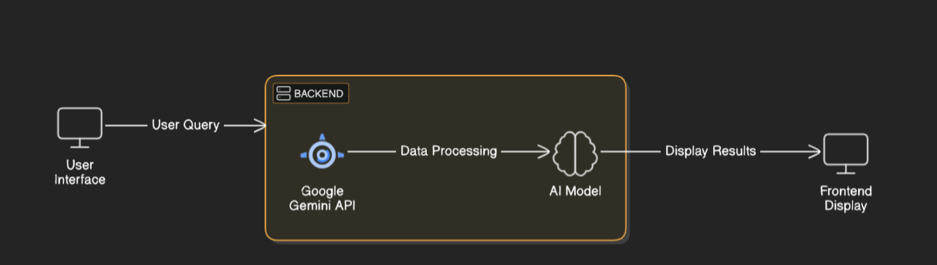

### **Key Points:**

1. **System Architecture:**
   * User enters **resume details** (via text or voice input).
   * AI processes the input using **OpenAI’s GPT-4 API**.
   * AI generates a **structured, industry-optimized resume**.
   * The UI displays a **real-time resume preview**.
   * User can **download the resume as a professionally formatted PDF**.
2. **User Flow:**
   * **User provides details** (Name, Experience, Skills, Education, Career Goals).
   * **AI suggests improvements** based on industry best practices.
   * **User selects a resume format and customizes the structure**.
   * **AI auto-formats and previews the resume** in real-time.
   * **User downloads the final resume as a polished PDF**.
3. **UI/UX Considerations:**
   * **Minimalist, AI-enhanced interface** for easy interaction.
   * **Voice input support** for hands-free resume creation.
   * **Customizable resume templates** for different industries.

## 

## **Phase-4: Project Planning (Agile Methodologies)**

### **Objective:**

Break down development tasks for efficient completion.

|  |  |  |  |  |  |  |  |
| --- | --- | --- | --- | --- | --- | --- | --- |
| **Sprint** | **Task** | **Priority** | **Duration** | **Deadline** | **Assigned To** | **Dependencies** | **Expected Outcome** |
| Sprint 1 | Environment Setup & API Integration | 🔴 High | 3 hours (Day 1) | End of Day 1 | Chaganti Josmietha & Sritika Bhagavatula | OpenAI API Key, Streamlit | API connection established |
| Sprint 1 | UI Development | 🟡 Medium | 2 hours (Day 1) | End of Day 1 | Rincy Roy | UI layout & input fields ready | Basic AI-powered UI ready |
| Sprint 2 | Resume Generation Logic | 🔴 High | 2 hours (Day 2) | Mid-Day 2 | Polampally Bhargavi & Devi Priyanka | OpenAI API Integration | AI-generated resume sections |
| Sprint 2 | AI Suggestions & Formatting | 🔴 High | 1 hour (Day 2) | Mid-Day 2 | Sritika Bhagavatula | AI-generated content | Real-time formatting enabled |
| Sprint 3 | PDF Export & Resume Download | 🟡 Medium | 40 minutes (Day 2) | Mid-Day 2 | Rincy Roy & Sritika | Resume text finalized | Professional PDF export ready |
| Sprint 3 | Testing & UI Enhancements | 🟢 Low | 30 minutes (Day 2) | End of Day 2 | Devi Priyanka & Polampally Bhargavi | Resume preview & testing | Responsive UI, bug-free functionality |

### 

## **Phase-5: Project Development**

### **Objective:**

Implement **core features** of the AI-powered Resume Generator.

### **Key Points:**

1. **Technology Stack Used:**
   * **Frontend:** Streamlit
   * **Backend:** OpenAI GPT-4 API
   * **Programming Language:** Python
   * **PDF Generation:** FPDF
2. **Development Process:**
   * Set up virtual environment & install dependencies.
   * Develop AI-powered resume generation logic.
   * Implement auto-formatting & real-time preview.
   * Build PDF export & voice input features.
3. **Challenges & Fixes:**
   * **Challenge:** Trouble with activating virtual environment.  
      **Fix:** Changed the execution policy to allow scripts by running.
   * **Challenge:** Handling API limits  
      **Fix:** Use caching for repeated queries.

## **Phase-6: Functional & Performance Testing**

### **Objective:**

Ensure that the AI-Resume builder works as expected.

|  |  |  |  |  |  |
| --- | --- | --- | --- | --- | --- |
| **Test Case ID** | **Category** | **Test Scenario** | **Expected Outcome** | **Status** | **Tester** |
| TC-001 | Functional Testing | AI generates a resume with input details | Resume should be structured properly. | ✅ Passed | Bhargavi |
| TC-002 | Functional Testing | Voice input for resume creation | AI captures and processes voice input. | ✅ Passed | Devi Priyanka |
| TC-003 | Performance Testing | API response time under 500ms | AI should generate responses quickly | ⚠ Needs Optimization | Rincy |
| TC-004 | Bug Fixes & Improvements | Fixed incorrect formatting | Resume formatting improved | ✅ Fixed | Josmietha & Rincy |
| TC-005 | Final Validation | UI is responsive across devices | Should work on mobile & desktop. | ❌ Failed - UI needs improvement | Sritka |
| TC-006 | Deployment Testing | Host the app using Streamlit Sharing | App should be accessible online. | 🚀 Deployed | All Team |