

**ASSIGNMENT – 1**

COURSE: DEVOPS

TRAINER: Mr. MADHUKAR

Name: Rayana Josna Deepa

Email: josnadeeparayana@gmail.com

1. **CREATE A S3 BUCKET AND ENABLE CROSS REGION REPLICATION FOR ANY TWO BUCKETS IN DIFFERENT REGION?**

* **CREATING SOURCE AND DESTINATION BUCKETS :**
* Go to S3 Dashboard and Select **Buckets**. We can find the **create bucket** option.
* Specify the name of the bucket along with the region, Enable the bucket versioning and then click on create bucket.
* Likewise create two buckets each belonging to two different regions.

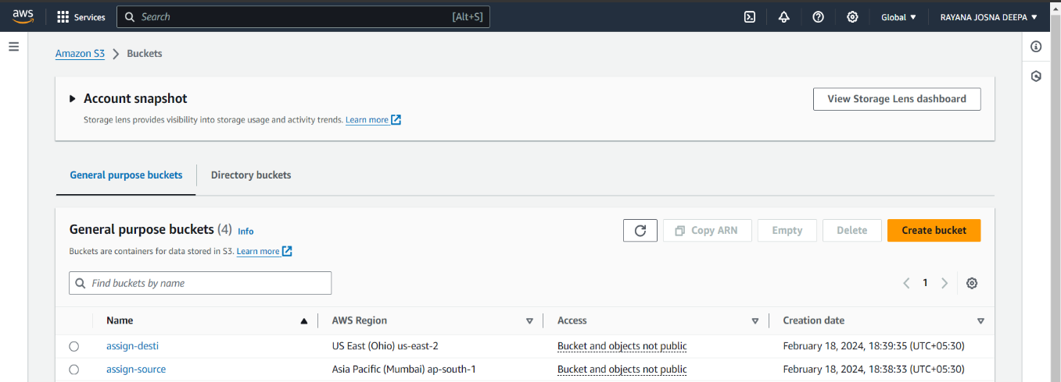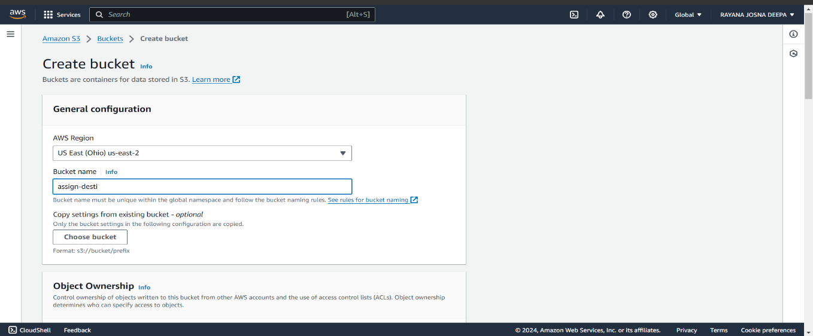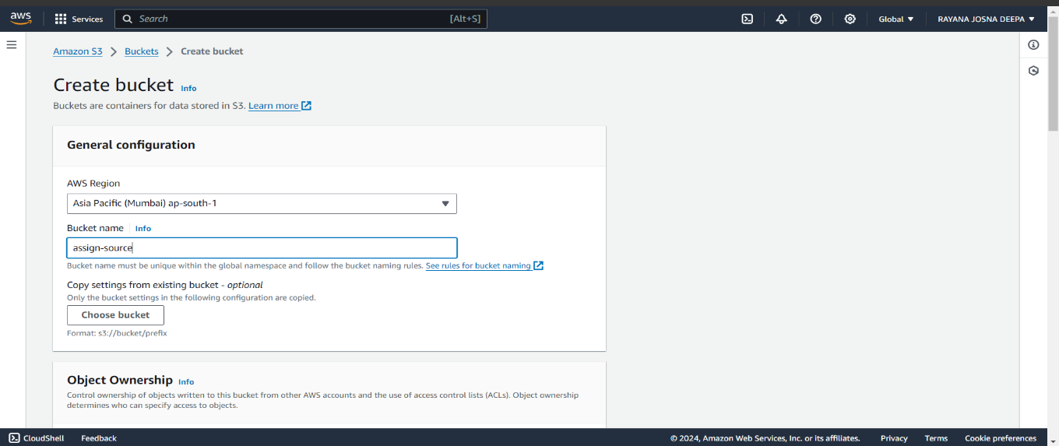

* The source bucket is used to upload and add files and foldrers that are replicated in destination bucket which are shown as objects.
* Add files or folders by using **upload** option and select **add files** to upload files from the device.
* 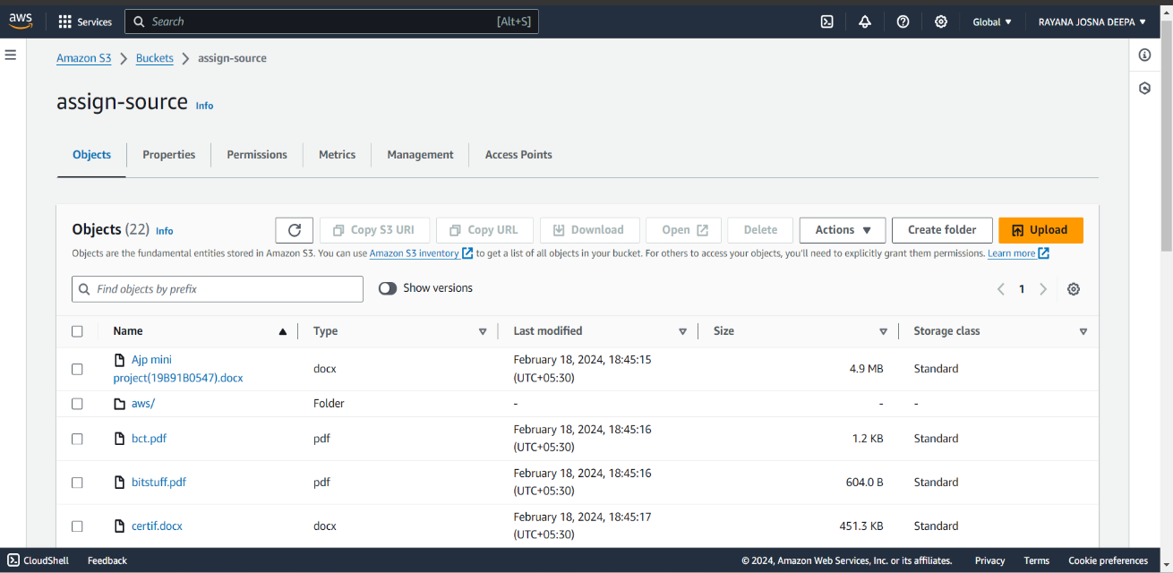A new folder can be created using **create folder** option also.
* **CREATING A CROSS REPLICATION RULE:**
* Go to source bucket and click on **Management** scroll down and **create replication rule** will be shown.
* Click on create replication rule and specify the rule name and change the rule scope to Apply to all objects in the bucket.
* 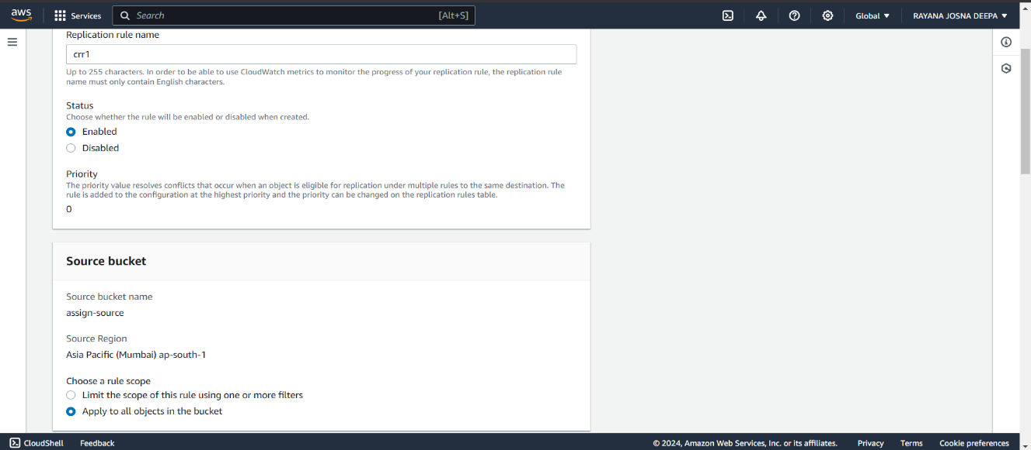Select the destination bucket and choose the IAM role as create new role and then submit.

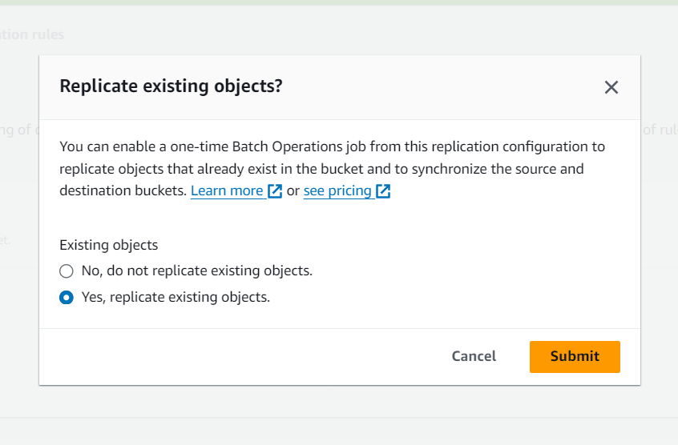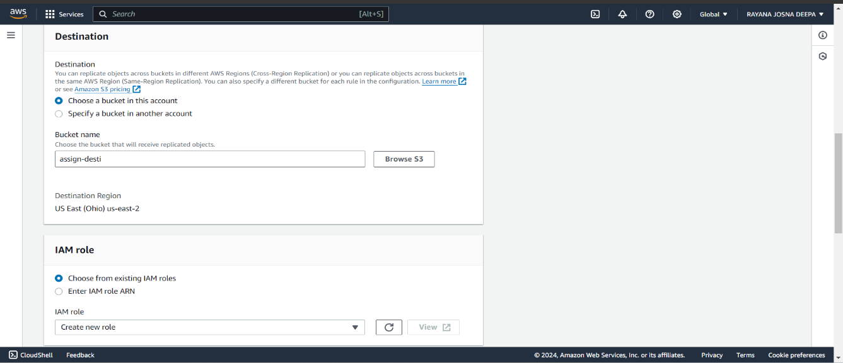

* 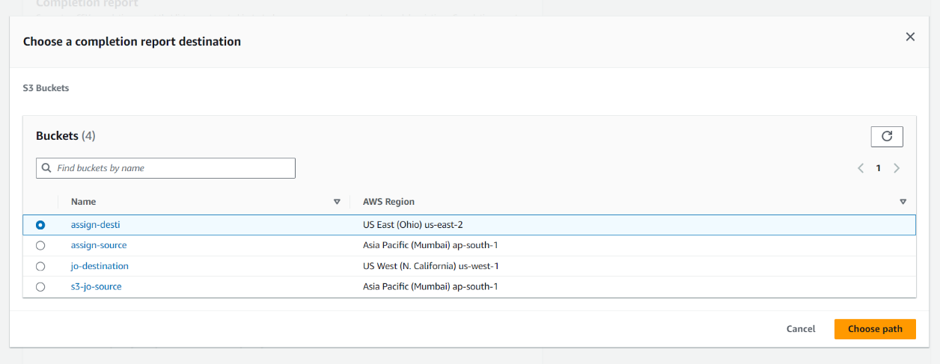It will confirm the destination again before created a new job to replicate objects.
* 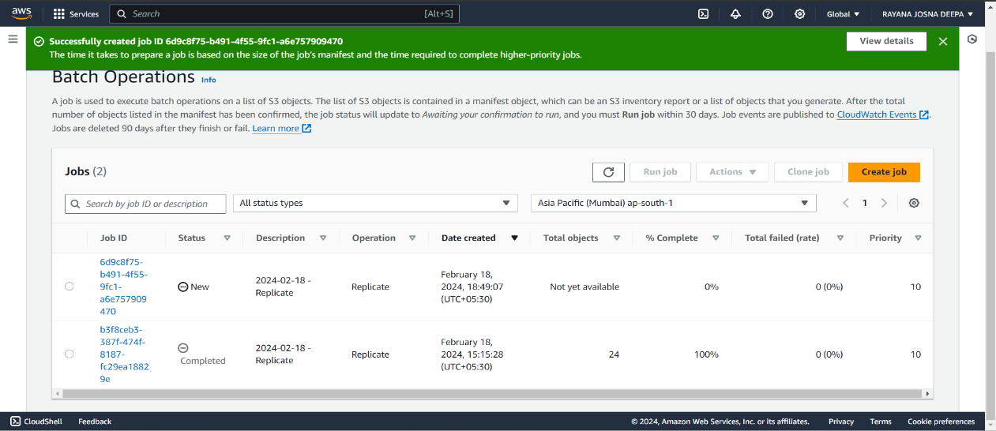A new job is successfully created to replicate the objects from source bucket to destination bucket.
* 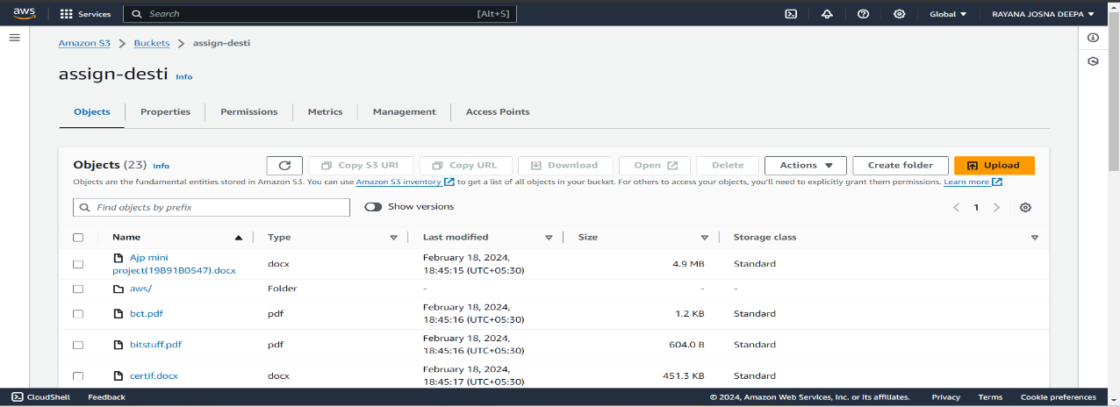The destination bucket displays the job created along the objects replicated into the bucket from source bucket.
* Whenever a new object is uploaded or added to the source bucket it will be replicated into the destination bucket.

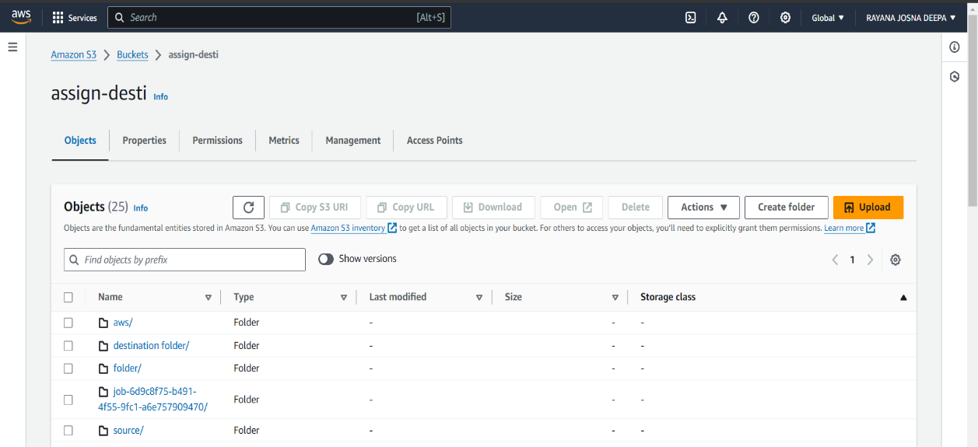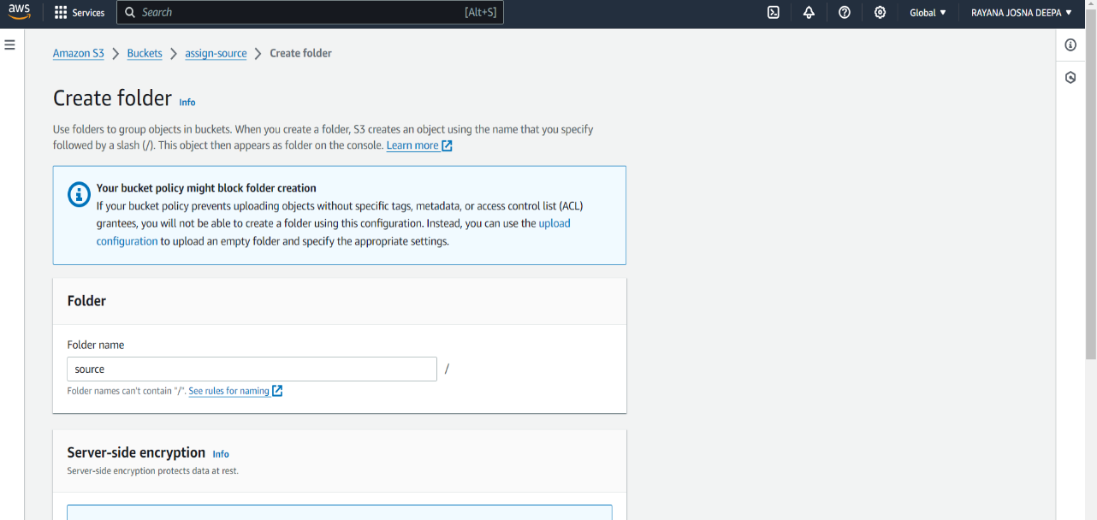

1. **CREATE EBS AND ATTACH VOLUME TO AN INSTANCE AND UNMOUNT THE VOLUME AND ATTACH TO ANOTHER INSTANCE?**

* Go to EC2 dashboard and then to **Instances** and click on **launch instance** option.
* Specify the name of instance, AMI and then click on launch instance.

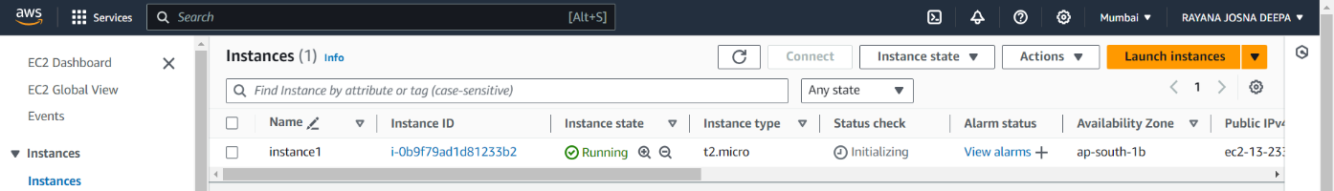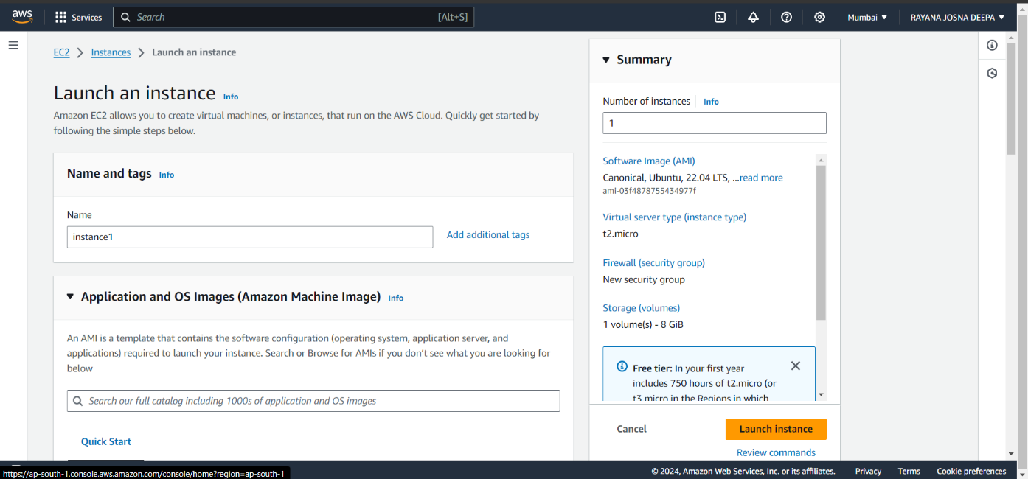

* 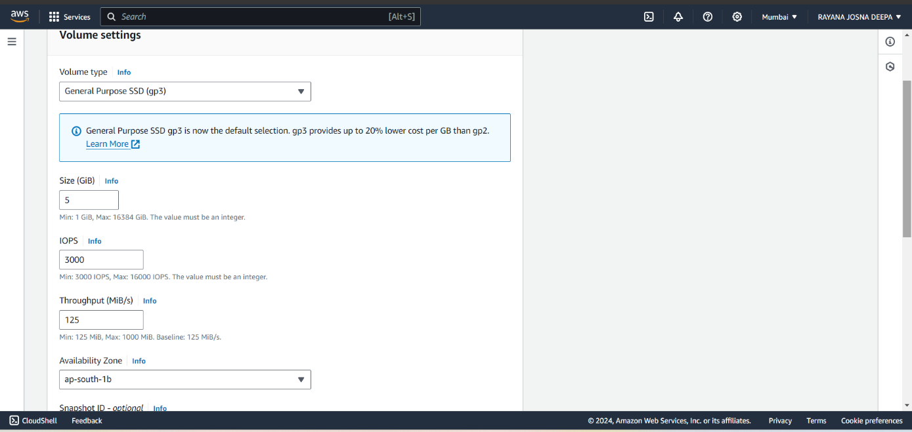Go to Elastic Block Store and then to Volumes and click on **create volume**.
* Once the volume turn to active state, attach the instance to the instance created using **attach volume** option from **actions** menu.

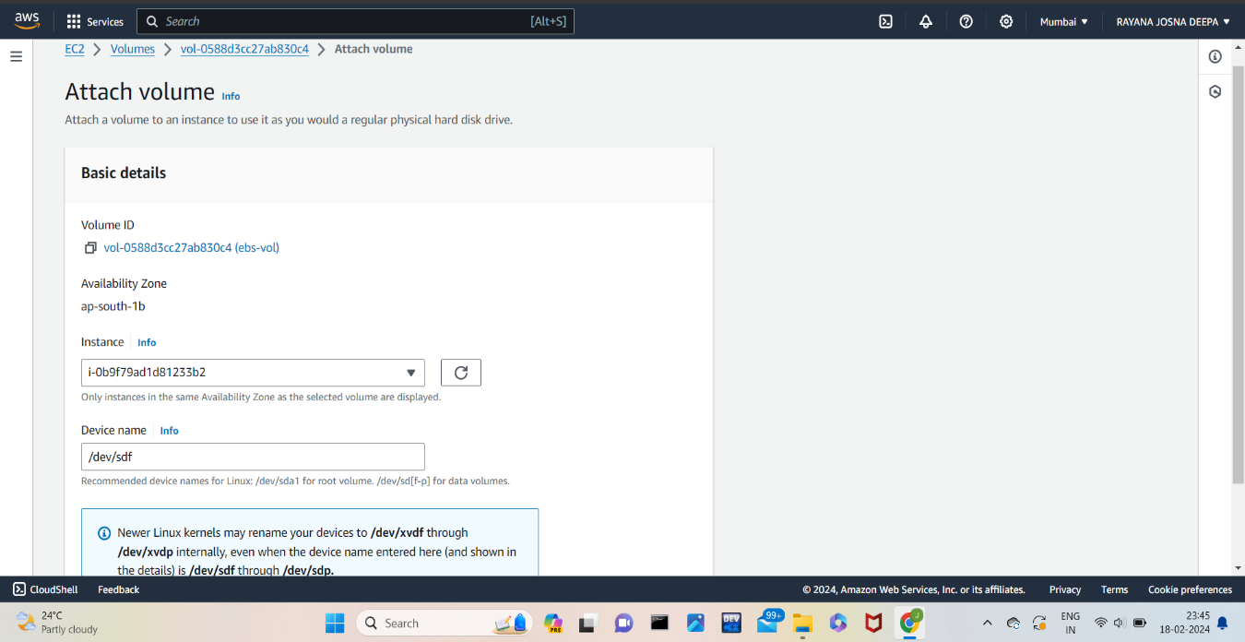

* Connect the instance to the web server through connect option and it will be directed to web to access the instance using commands.

**Sudo -i** :- to connect as a root user

**df -h** :- to display the disk storage

**lsblk** :- to list all block devices

**file -s /dev/xvdf** :- to check whether there is a present in the volume.

If the file system is not created/ present then create a new file system using the command **mkfs -t xfs /dev/xvdf**

* 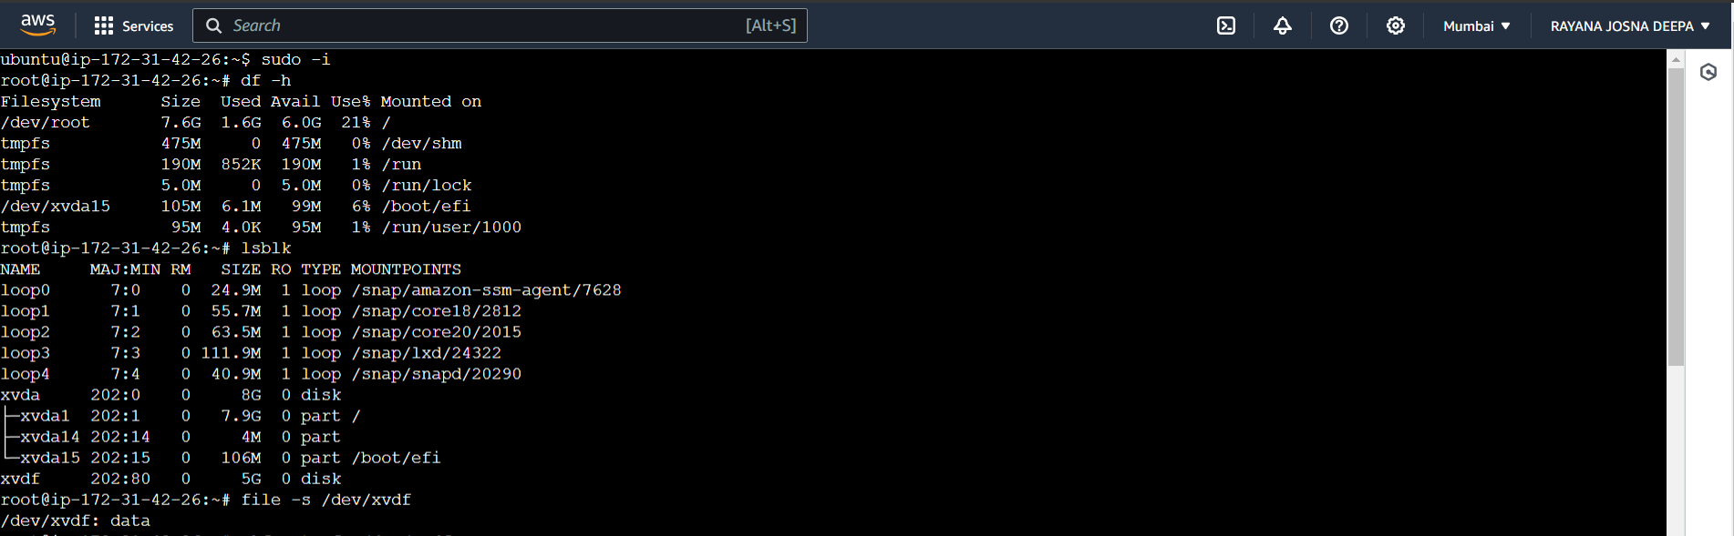Create a directory using the command **mkdir -p parent dir/child dir** to create new files/folder which we will store in the ebs volume created in the disk.

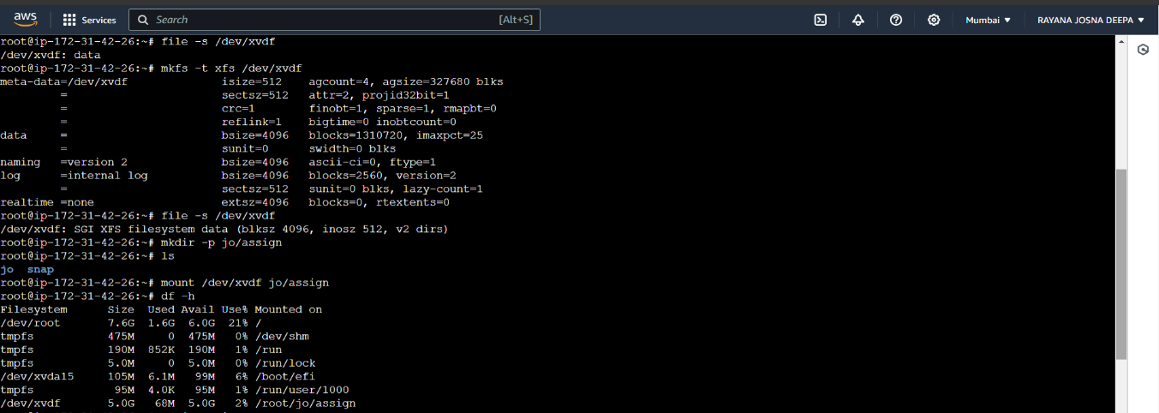

* Mount the directory created with the /dev/xvdf that has space created by ebs using command **mount /dev/xvdf parent dir/child dir .** Using df -h command we can see that ebs storage is stored under the name of newly created directory.
* 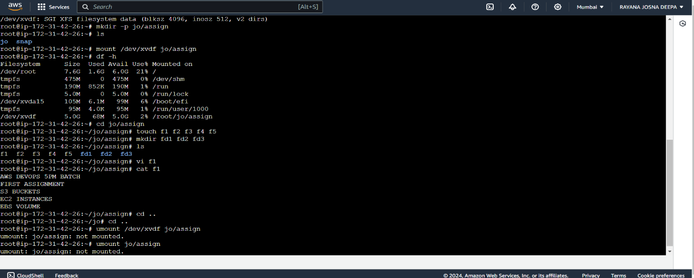Create some content in the new directory in the form of files and folders.
* 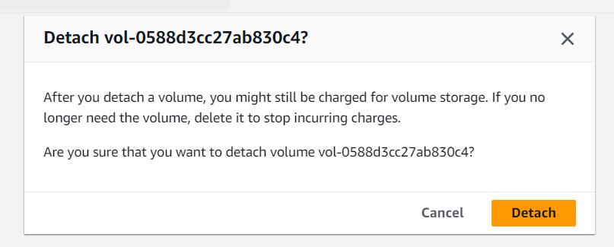Now detach the ebs volume from the instance through **detach volume** option in actions menu in ebs volumes.
* 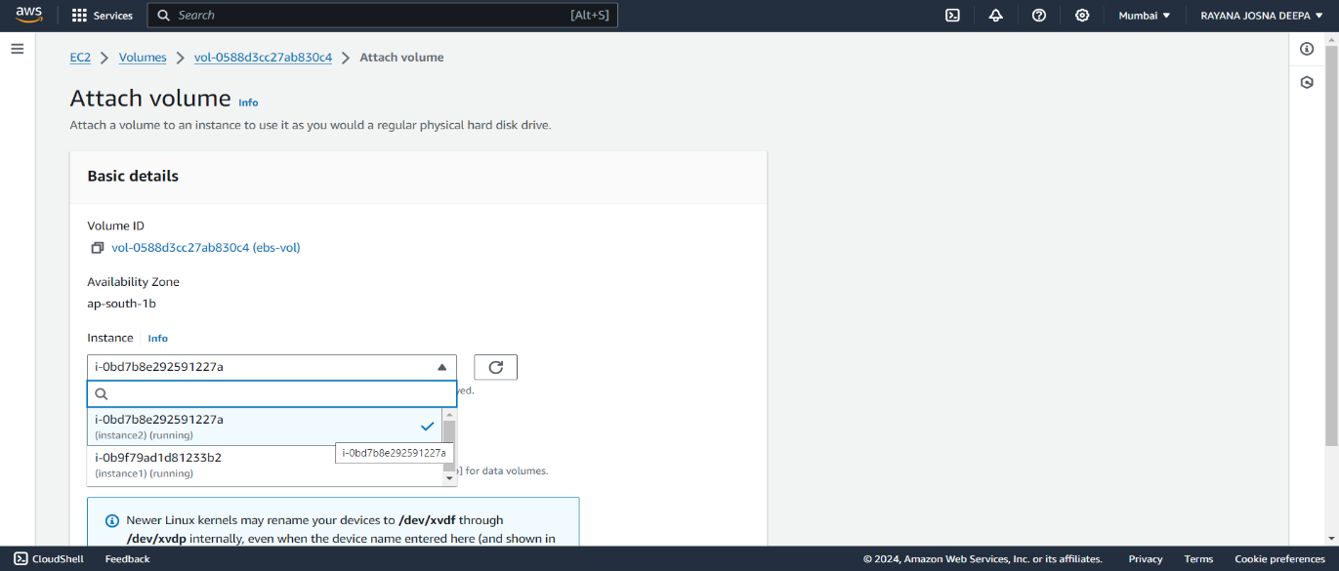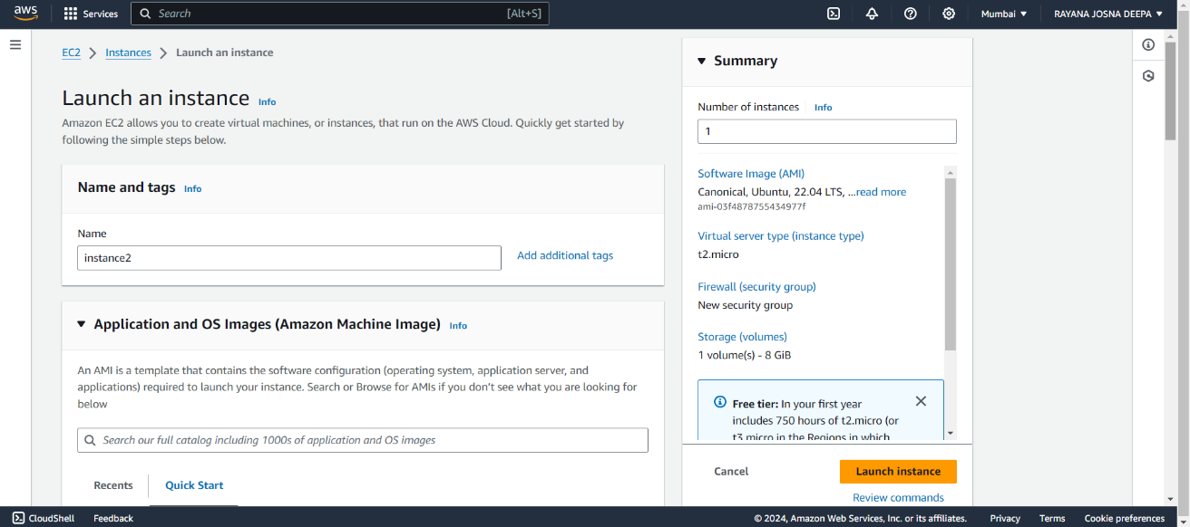Create another instance in EC2 instances and attach the same ebs volume to this newly created instance.
* Connect the instance to host and check whether the extra disk space is attached using **lsblk**. Check if any filesystem exists in the attached disk storage and then it will recognize whether the existing file system in the volume using **file -s /dev/xvdf.**
* Create a new directory to store the data from the volume and mount the directory to the disk using **mount /dev/xvdf newdirectory**.
* Check for directory and files using **ls** command and also check the contents of the file using **cat filename** to display the contents of the file.

