

**ASSIGNMENT – 2**

COURSE: DEVOPS

TRAINER: Mr. MADHUKAR

Name: Rayana Josna Deepa

Email: josnadeeparayana@gmail.com

1. **CREATE TRANSIT GATEWAY IN TWO DIFFERENT ACCOUNT?**

* Go to account-1 AWS console and go to VPC dashboard and then select **Your VPCs** and **Create VPC**.
* 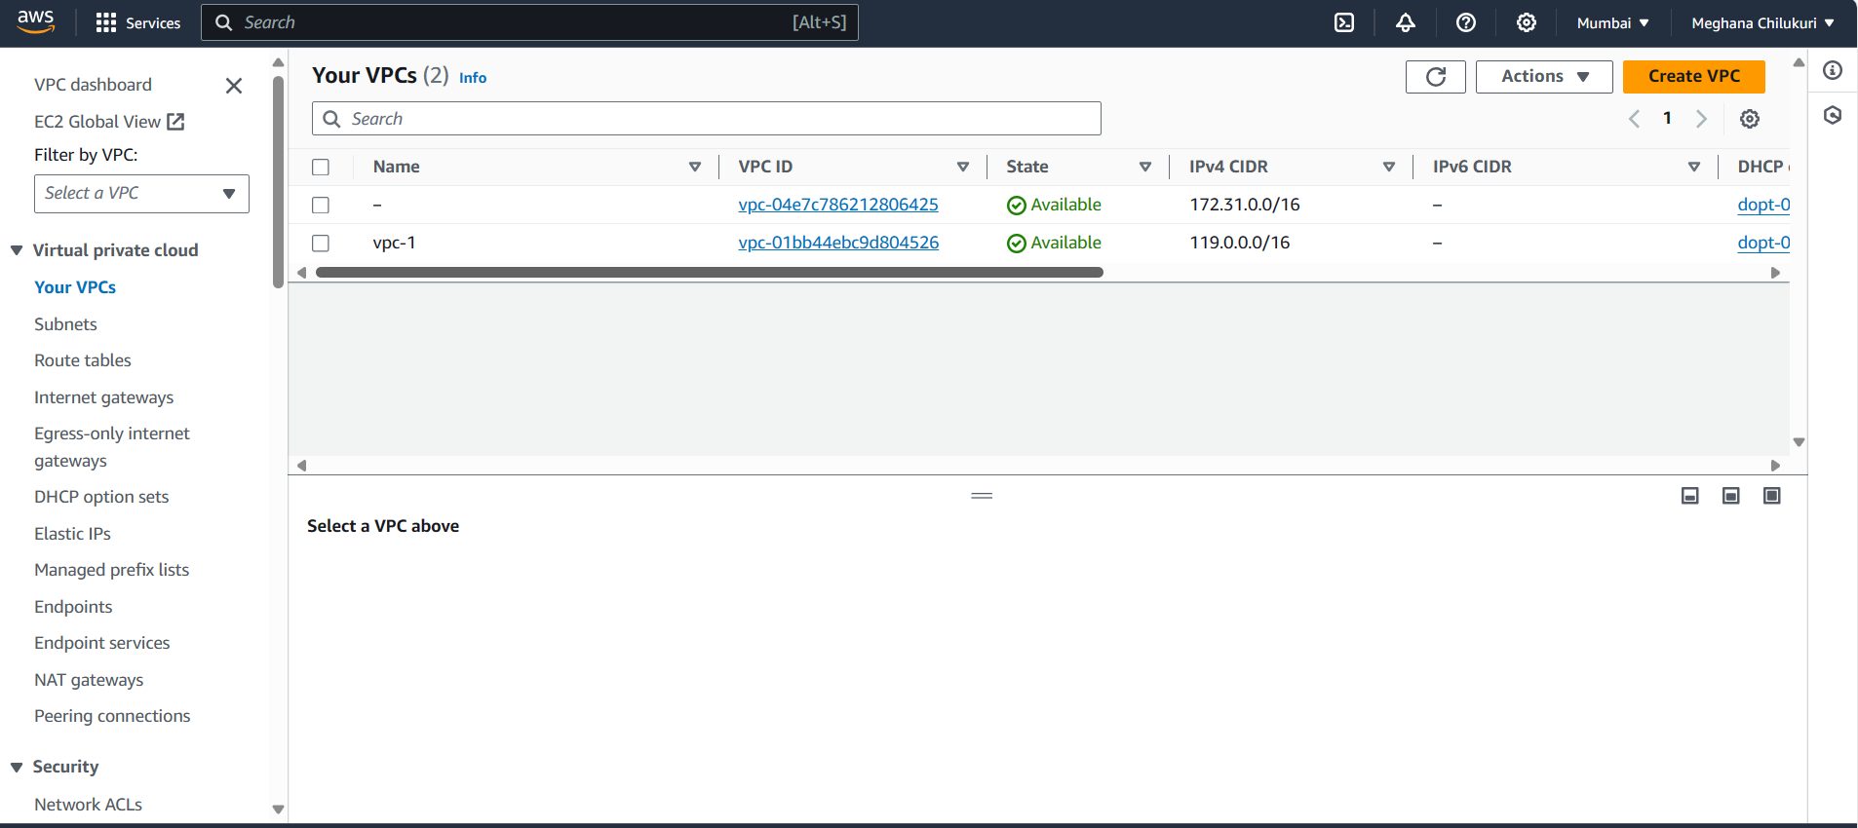Create a vpc by specifying a name tag and IPv4 CIDR block with an IP address .

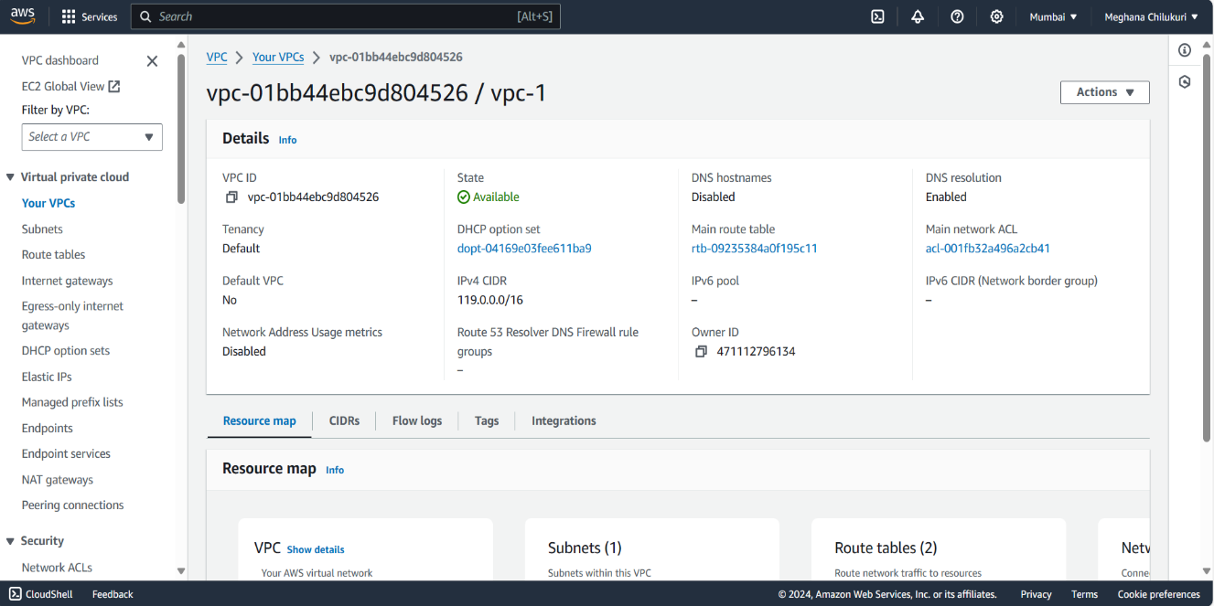

* Create a subnet from **Subnets** and select **Create subnet** option.
* 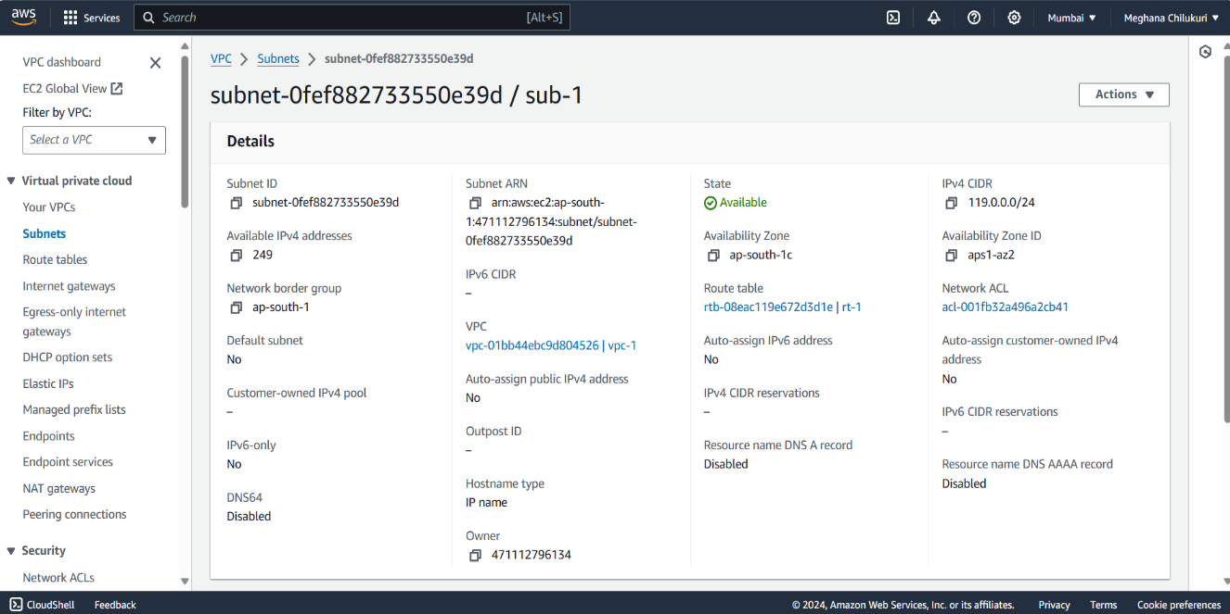Select the VPC ID and specify the subnet name and IPv4 subnet CIDR block.
* Create an Internet gateway and attach the vpc created to the Internet gateway.
* 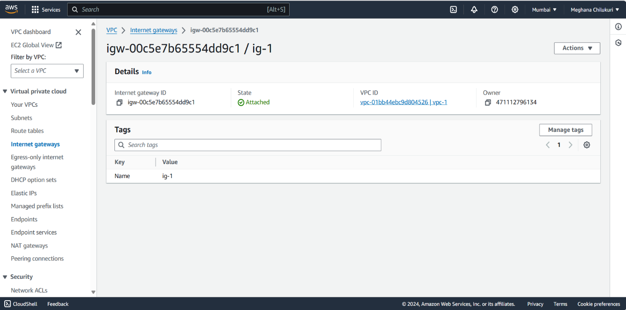Create a route table and edit the routes from **Edit routes** and connect to subnet from **Subnet associations**.
* 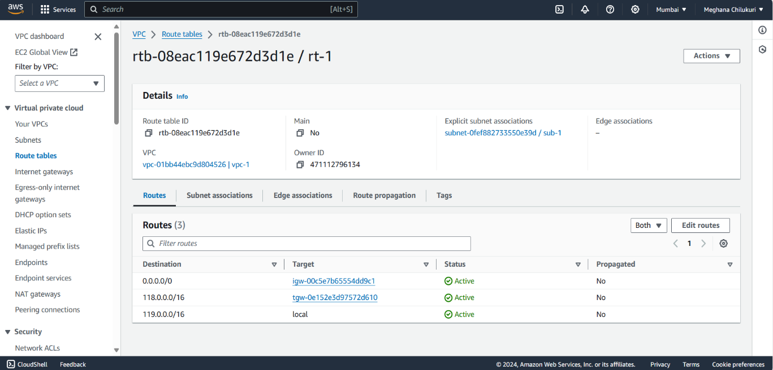In the edit routes add the route to connect internet gateway with IP as 0.0.0.0/0 if it is a public subnet and not connect to igw if it is private subnet.
* In Subnet associations select the subnet created before to the route table.
* 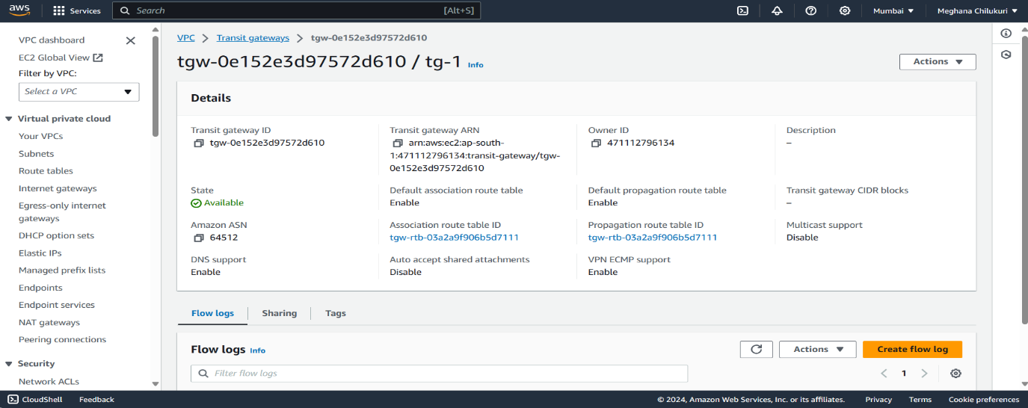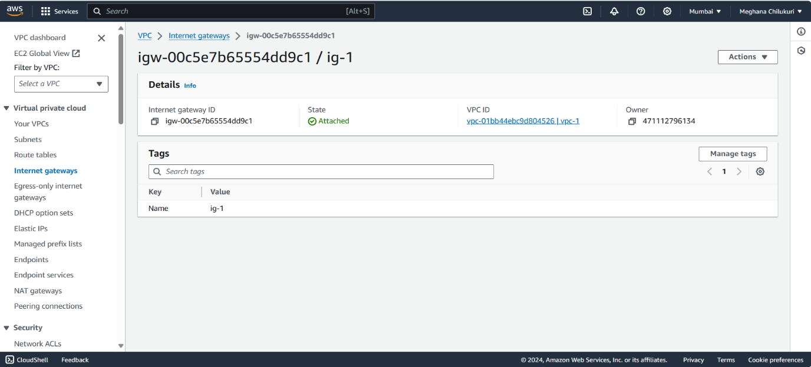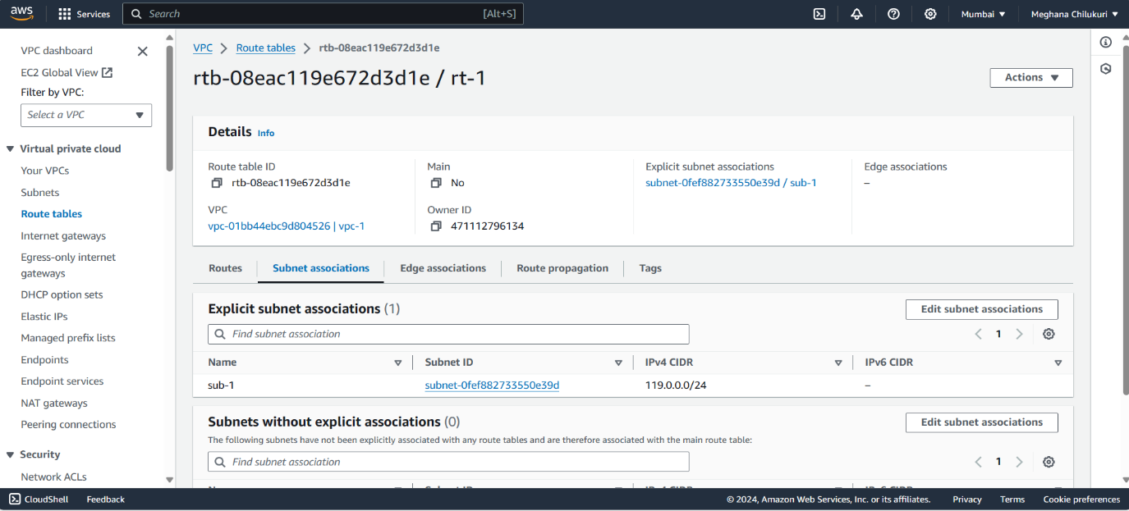create a transit gateway and a transit gateway attachment with the created vpc.
* 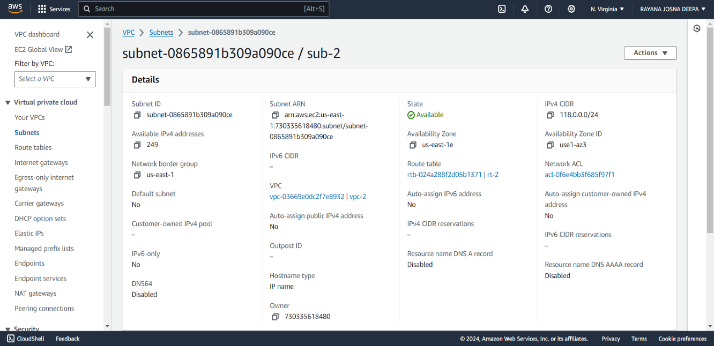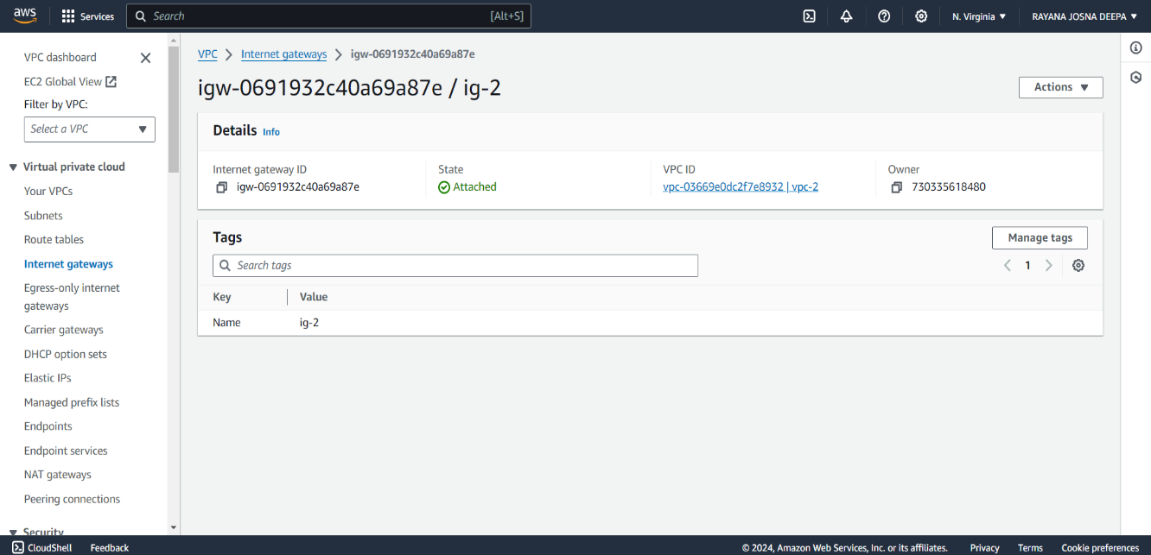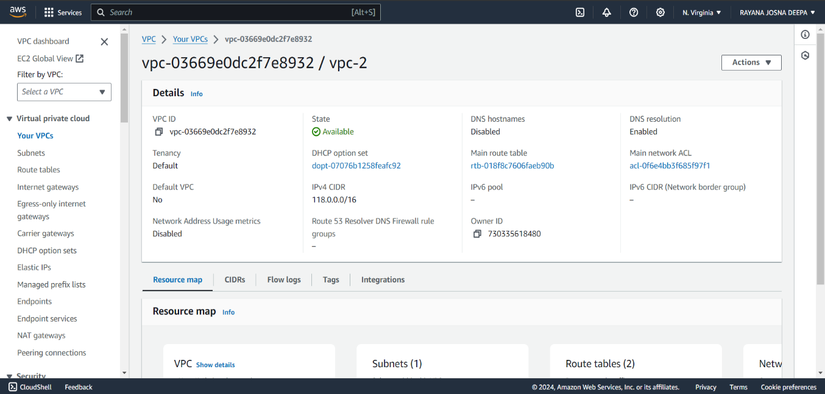Create another vpc, subnet, internet gateway and route table in account-2 like account-1 along with a transit gateway and transit gateway attachment.

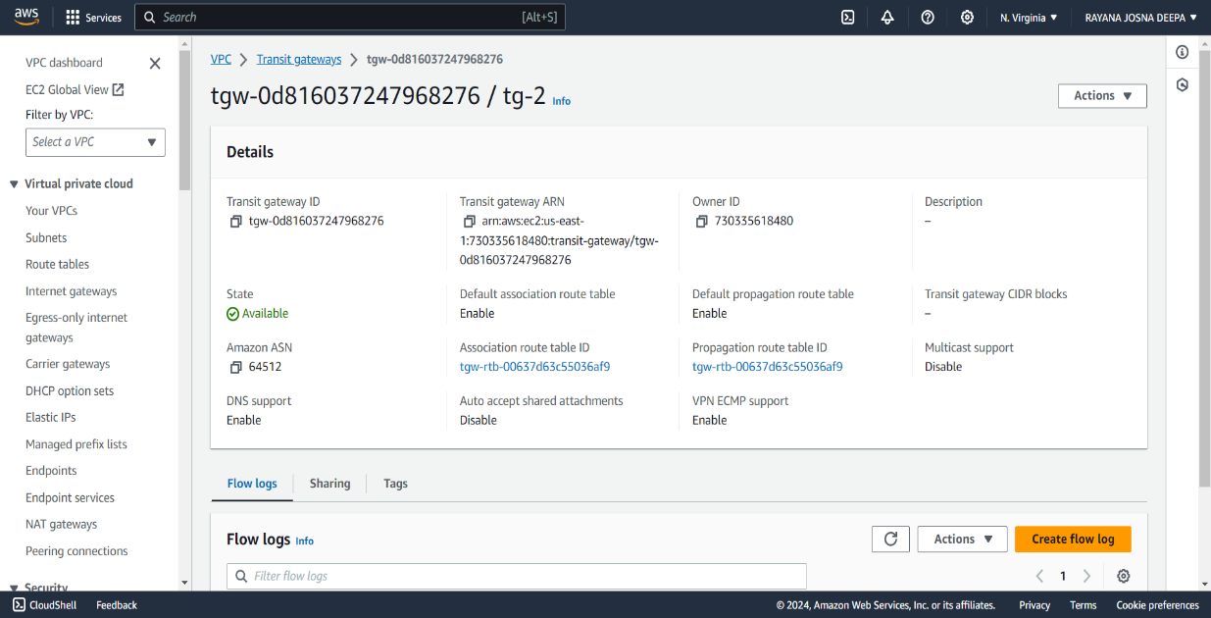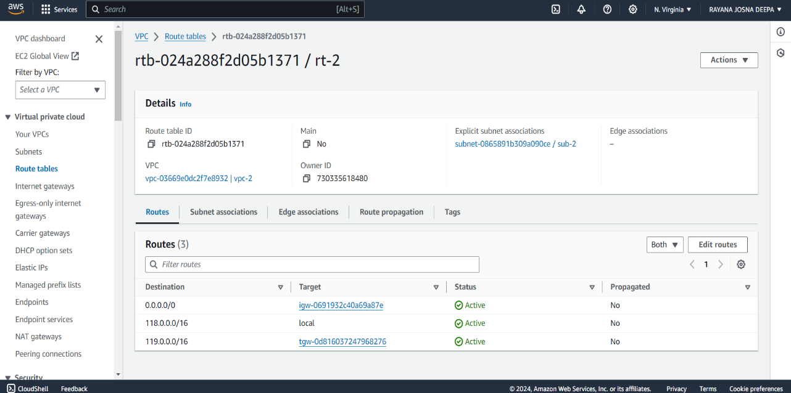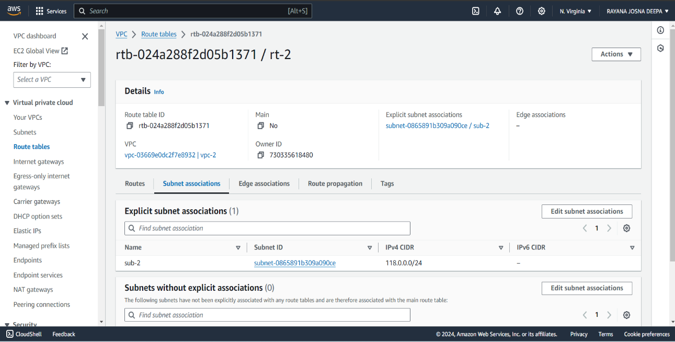

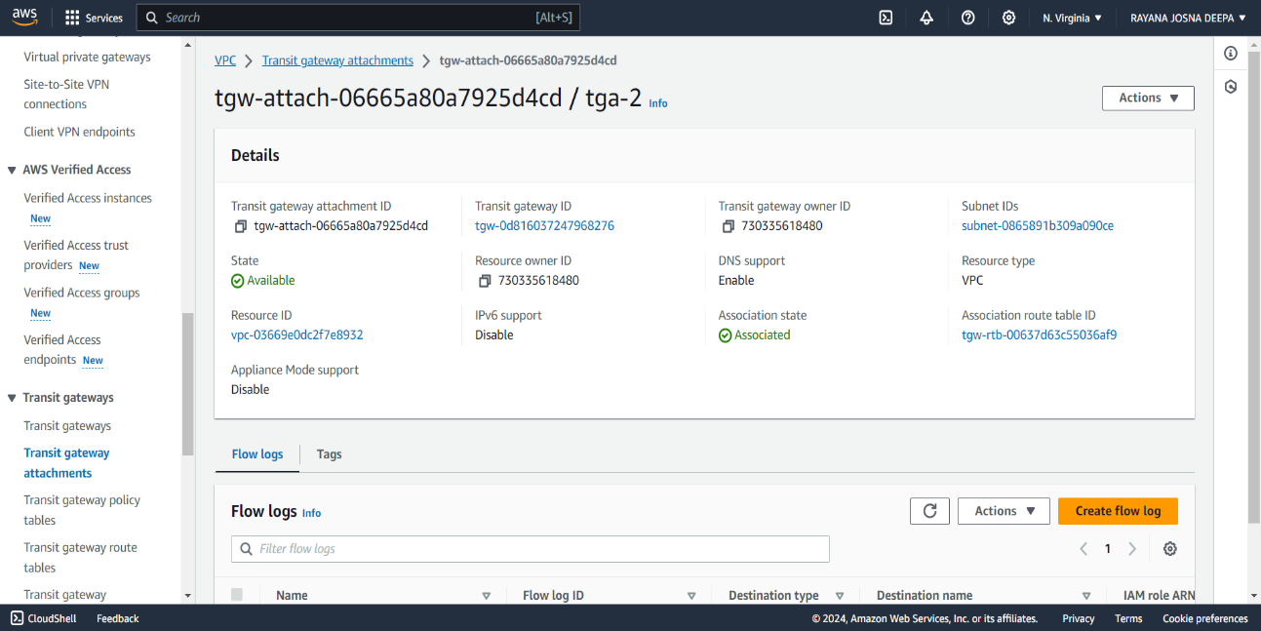

* Now, create a transit gateway attachment from account-1 to connect to account-2 using peering connection.
* Select another account in peering and give the details of account id, region and transit gateway id and send a request to the other account.
* The request created will be appeared at the account-2 transit gateway attachments.
* 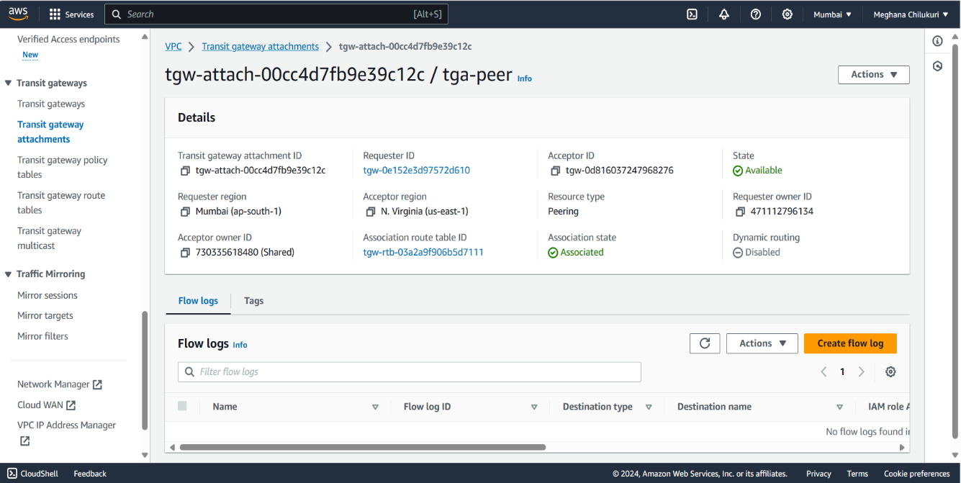Accept the transit gateway request in account-2.
* 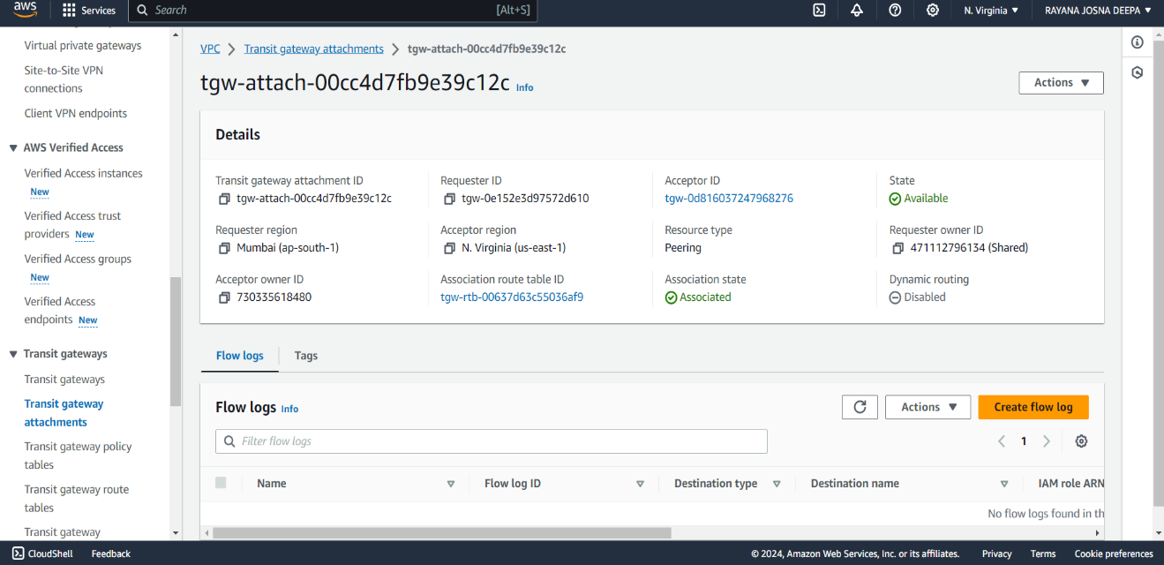Go to transit route table and and select on the route table created and select associations and create static route.
* Create a static route association with the IPv4 CIDR created by another account.
* 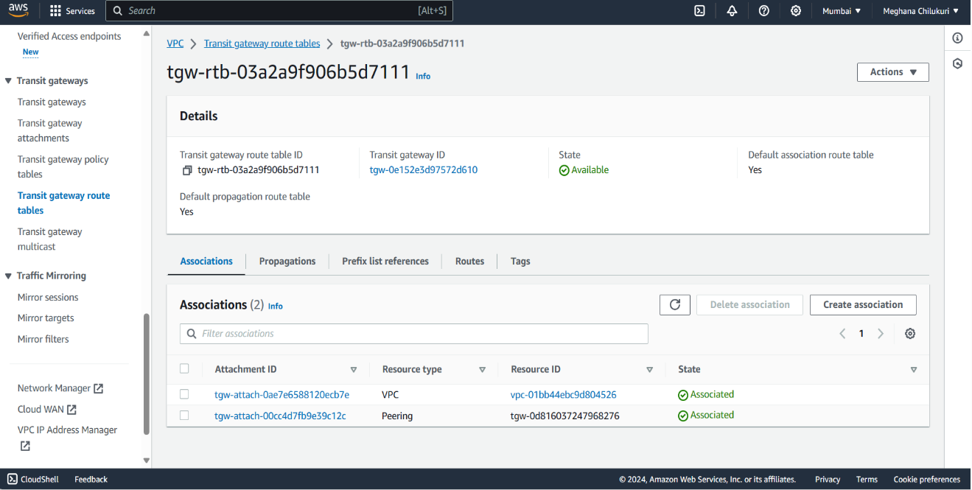Create the static route association in another account transit gateway rote table too.

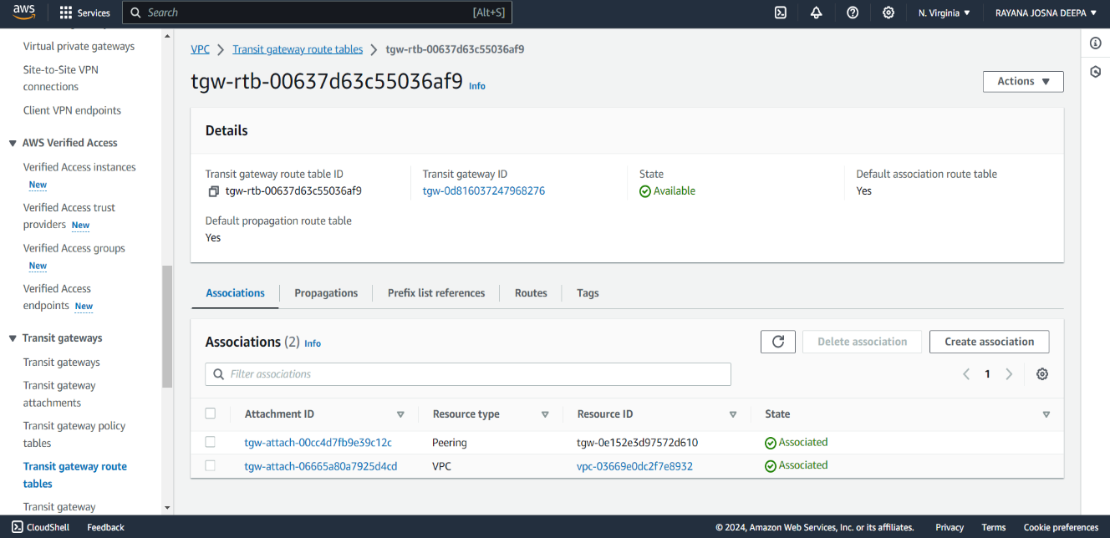

* 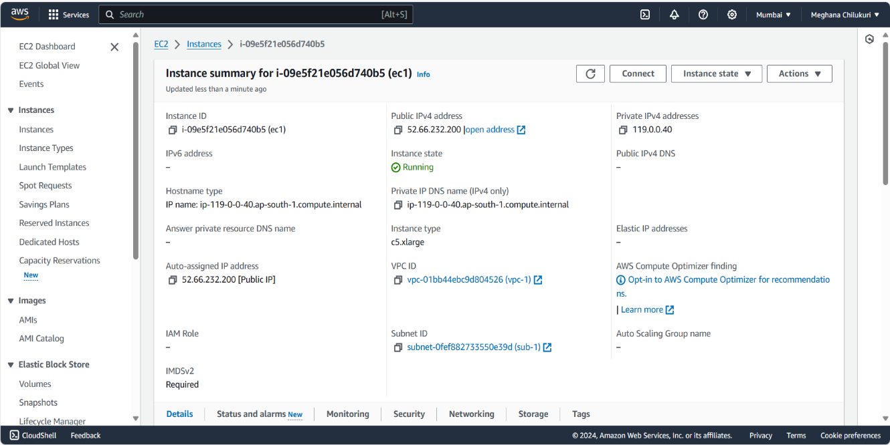Create the EC2 instance by setting the network to the vpc created in that account and adding security rule allowing to connect to HTTP with anywhere and the IP of other account vpc.
* 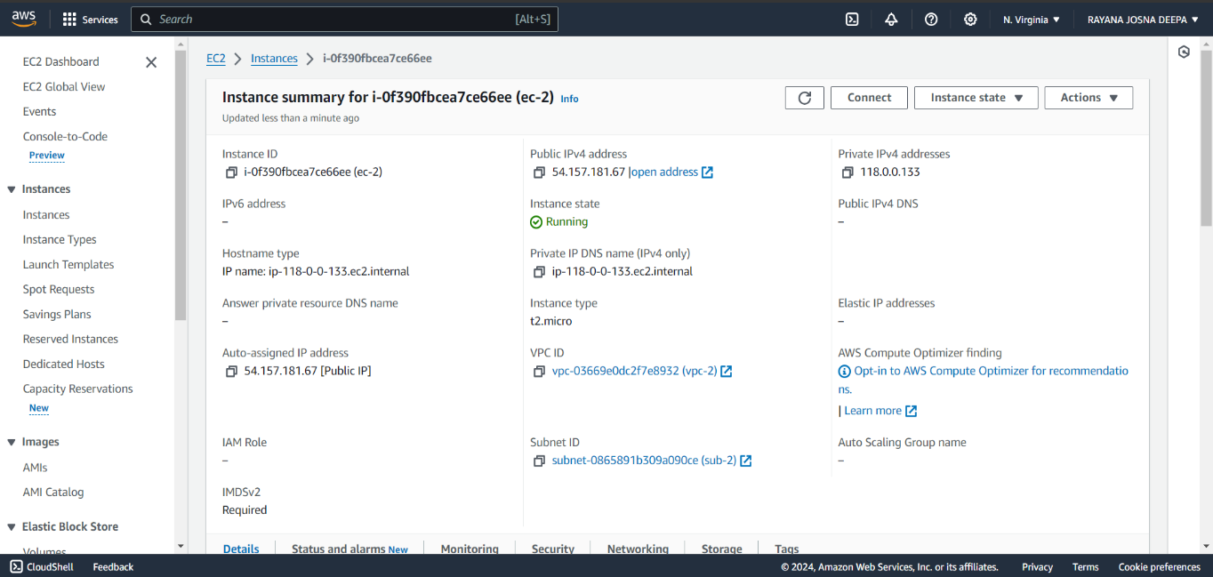Connect the instances to web and use the commands.

sudo -i : To connect as root user.

As the amazon linux is choosed the commands used are:

yum update : to update if any available.

yum install nginx -y : to install nginx.

Check the content using the private ip of the ec2 using “curl privateip:80”.

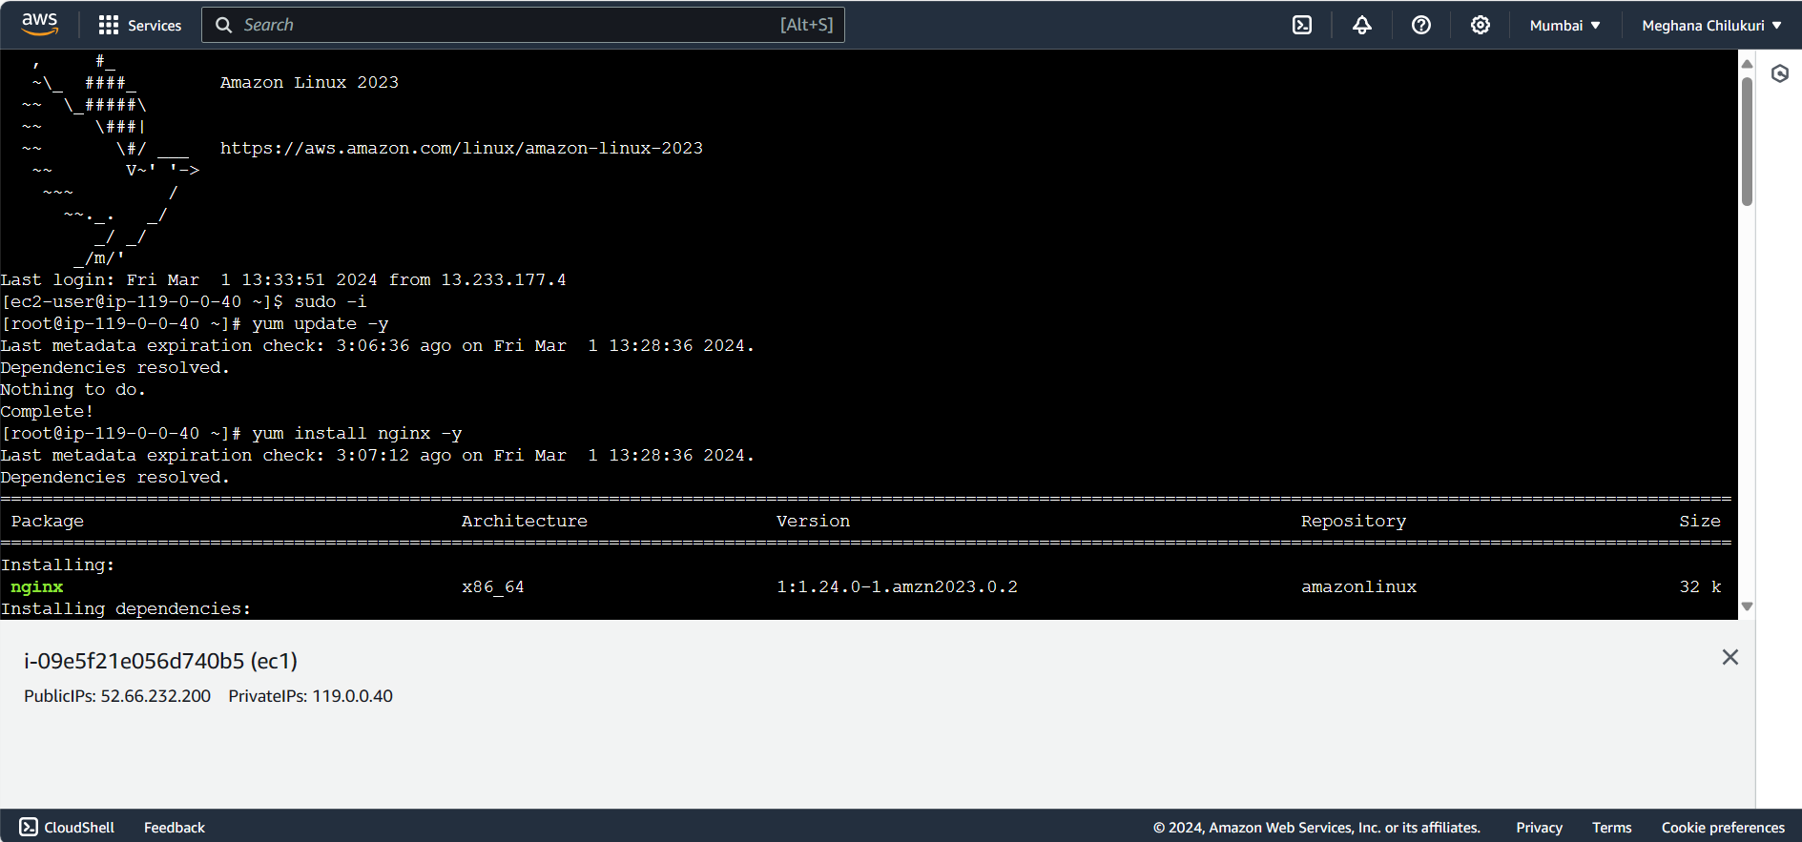

* 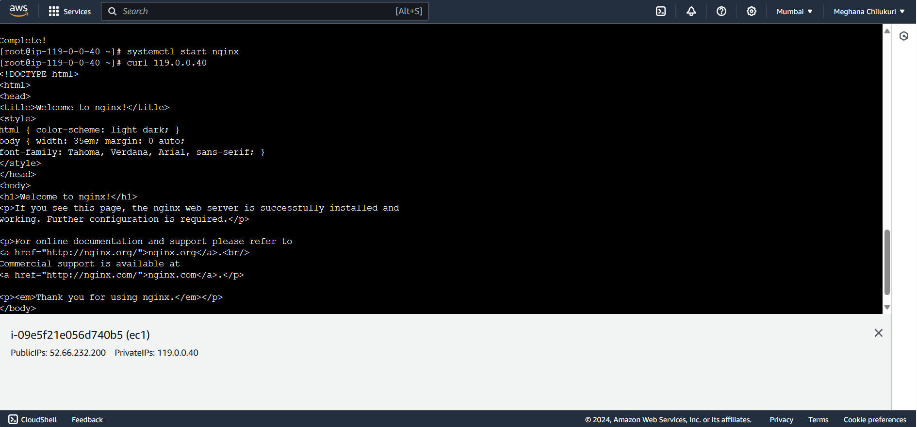Connect instance in another account and use command:

sudo -i and curl privateip of account-1 .

* 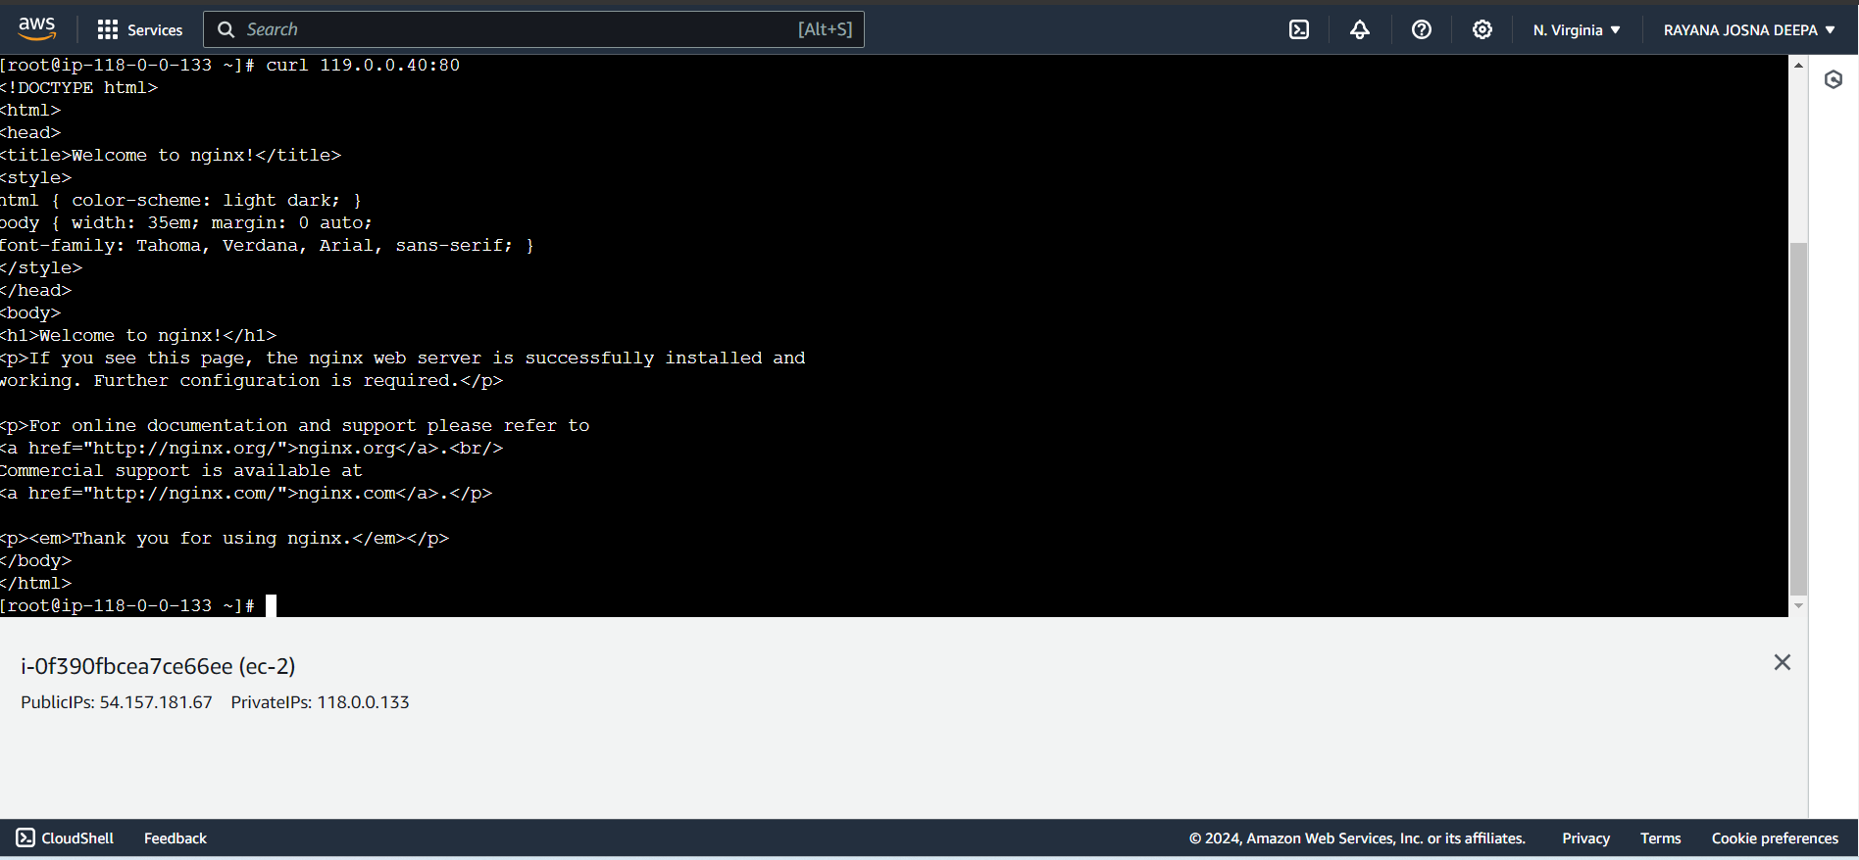If both the vpcs are connected successfully then without installing nginx it will display the content while curl command is used.