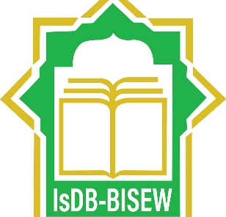

**IsDB-BISEW**

**IT SCHOLARSHIP PROGRAMME**

**ROUND-49**

**HOSPIAL MANAGEMENT SYSTEM**   
OBJECT – ORIENTED SYSTEMS ANALYSIS AND DESIGN USING UML

**PRESENTED BY:**

**JOSNA AKTER ALLO**

**BATCH: CS/PNTL-M/49/01**

**ID: 1266163**

TO: Syed Zahidul Islam

20 February 2022