**Unified Medical System (UMS) for India with Early Disease Outbreak Detection**

*Project Report Submitted by*

**Devadethan R**

**Reg. No.: AJC20MCA-I029**

*In Partial fulfillment for the Award of the Degree Of*

**MASTER OF COMPUTER APPLICATIONS**

**(INTEGRATED MCA)**

**APJ ABDUL KALAM TECHNOLOGICAL UNIVERSITY**



**AMAL JYOTHI COLLEGE OF ENGINEERING**

**KANJIRAPPALLY**

[Affiliated to APJ Abdul Kalam Technological University, Kerala. Approved by AICTE, Accredited by NAAC with ‘A’ grade. Koovappally, Kanjirappally, Kottayam, Kerala – 686518]

# 2024-2025

## DEPARTMENT OF COMPUTER APPLICATIONS

### AMAL JYOTHI COLLEGE OF ENGINEERING

**KANJIRAPPALLY**



**CERTIFICATE**

This is to certify that the Project report, “**Digital Commerce Empowerment Ecosystem (DCEE)”** is the bona fide work of **DEVADETHAN R (Regno: AJC20MCA-I029)** in partial fulfillment of the requirements for the award of the Degree of Master of Computer Applications under APJ Abdul Kalam Technological University during the year 2024-25.

**Ms. Jetty Benjamin Mr. Binumon Joseph**

**Internal Guide Coordinator**

**Rev. Fr. Dr. Rubin Thottupurathu Jose**

**Head of the Department**

**DECLARATION**

I hereby declare that the project report **“Unified Medical System (UMS)”** is a bona fide work done at Amal Jyothi College of Engineering, towards the partial fulfilment of the requirements for the award of the Master of Computer Applications (MCA) from APJ Abdul Kalam Technological University, during the academic year 2024-2025.

**Date: DEVADETHAN R**

**KANJIRAPPALLY Reg: AJC20MCA-I029**

# ACKNOWLEDGEMENT

First and foremost, I thank God almighty for his eternal love and protection throughout the project. I take this opportunity to express my gratitude to all who helped me in completing this project successfully. It has been said that gratitude is the memory of the heart. I wish to express my sincere gratitude to our Manager **Rev. Fr. Roy Abraham Pazhayaparampil** and Principal **Dr. Lillykutty Jacob** for providing good faculty for guidance.

I owe a great depth of gratitude towards our Head of the Department **Rev.Fr.Dr. Rubin Thottupurathu Jose** for helping us. I extend my whole hearted thanks to the project coordinator **Mr. Binumon Joseph (Assistant Professor)** for his valuable suggestions and for overwhelming concern and guidance from the beginning to the end of the project. I would also express sincere gratitude to my guide **Ms. Jetty Benjamin (Assistant Professor)** for her inspiration and helping hand.

I thank our beloved teachers for their cooperation and suggestions that helped me throughout the project. I express my thanks to all my friends and classmates for their interest, dedication, and encouragement shown towards the project. I convey my hearty thanks to my family for the moral support, suggestions, and encouragement to make this venture a success.

DEVADETHAN R

# ABSTRACT

The Unified Medical System (UMS) for India is a transformative digital healthcare platform aimed at advancing patient access, streamlining provider interactions, and reinforcing public health monitoring through a single, integrated system. UMS centralizes core healthcare services, allowing patients to book appointments, access and manage personal medical records, log symptoms for real-time surveillance, and interact with a supportive AI chatbot that provides basic medical guidance. Designed to tackle the challenges of disease outbreak management, UMS applies machine learning to detect abnormal patterns in patient symptoms from various regions, allowing for early identification and alerting of potential outbreaks. This capability enables public health authorities to take timely action, reducing the spread of infectious diseases and enhancing community health resilience.

The platform’s tech stack—comprising Vue.js with Vuetify for a responsive web interface, Flutter for mobile accessibility, Flask for backend processes, and MongoDB for secure data storage—ensures scalability, security, and ease of use. Additionally, UMS is designed with a patient-centric philosophy, giving users secure control over their health data while enabling healthcare providers to exchange data seamlessly, in line with data privacy regulations. The platform supports a range of users, from patients and healthcare providers to public health officials, enabling each to access or share relevant health information for improved coordination and efficiency.

Through features like an AI-powered chatbot for patient support and real-time data analytics for outbreak detection, UMS prioritizes accessible, informed, and proactive healthcare for India’s diverse population. The project’s unique integration of disease surveillance and patient-centered design aims to strengthen the healthcare infrastructure and drive positive health outcomes nationwide.

**CONTENT**

|  |  |  |  |  |
| --- | --- | --- | --- | --- |
| **SL. NO** | | **TOPIC** | **PAGE NO** | |
| **1** | | **INTRODUCTION** |  | |
| **1.1** | | **PROJECT OVERVIEW** |  | |
| **1.2** | | **PROJECT SPECIFICATION** |  | |
| **2** | | **SYSTEM STUDY** |  | |
| **2.1** | | **INTRODUCTION** |  | |
| **2.2** | | **EXISTING SYSTEM** |  | |
| **2.3** | | **DRAWBACKS OF EXISTING SYSTEM** |  | |
| **2.4** | | **PROPOSED SYSTEM** |  | |
| **2.5** | | **ADVANTAGES OF PROPOSED SYSTEM** |  | |
| **3** | | **REQUIREMENT ANALYSIS** |  | |
| **3.1** | | **FEASIBILITY STUDY** |  | |
| **3.1.1** | | **ECONOMICAL FEASIBILITY** |  | |
| **3.1.2** | | **TECHNICAL FEASIBILITY** |  | |
| **3.1.3** | | **BEHAVIORAL FEASIBILITY** |  | |
| **3.1.4** | | **FEASIBILITY STUDY QUESTIONNAIRE** |  | |
| **3.2** | | **SYSTEM SPECIFICATION** |  | |
| **3.2.1** | | **HARDWARE SPECIFICATION** |  | |
| **3.2.2** | | **SOFTWARE SPECIFICATION** |  | |
| **3.3** | | **SOFTWARE DESCRIPTION** |  | |
| **3.3.1** | | **PHP** |  | |
| **3.3.2** | | **MYSQL** |  | |
| **4** | | **SYSTEM DESIGN** |  | |
| **4.1** | | **INTRODUCTION** |  | |
| **4.2** | | **UML DIAGRAM** |  | |
| **4.2.1** | | **USE CASE DIAGRAM** |  | |
| **4.2.2** | | **SEQUENCE DIAGRAM** |  | |
| **4.2.3** | | **STATE CHART DIAGRAM** |  | |
| **4.2.4** | | **ACTIVITY DIAGRAM** |  | |
| **4.2.5** | | **CLASS DIAGRAM** |  | |
| **4.2.6** | | **OBJECT DIAGRAM** |  | |
| **4.2.7** | | **COMPONENT DIAGRAM** |  | |
| **4.2.8** | | **DEPLOYMENT DIAGRAM** |  | |
| **4.2.9** | | **COLLABORATION DIAGRAM** |  | |
| **4.3** | | **USER INTERFACE DESIGN USING FIGMA** |  | |
| **4.4** | | **DATA BASE DESIGN** |  | |
| **5** | | **SYSTEM TESTING** |  | |
| **5.1** | | **INTRODUCTION** |  | |
| **5.2** | | **TEST PLAN** |  | |
| **5.2.1** | **UNIT TESTING** | |  |
| **5.2.2** | **INTEGRATION TESTING** | |  |
| **5.2.3** | **VALIDATION TESTING** | |  |
| **5.2.4** | **USER ACCEPTANCE TESTING** | |  |
| **5.2.5** | **AUTOMATION TESTING** | |  |
| **5.2.6** | **SELENIUM TESTING** | |  |
| **6** | **IMPLEMENTATION** | |  |
| **6.1** | **INTRODUCTION** | |  |
| **6.2** | **IMPLEMENTATION PROCEDURE** | |  |
| **6.2.1** | **USER TRAINING** | |  |
| **6.2.2** | **TRAINING ON APPLICATION SOFTWARE** | |  |
| **6.2.3** | **SYSTEM MAINTENANCE** | |  |
| **7** | **CONCLUSION & FUTURE SCOPE** | |  |
| **7.1** | **CONCLUSION** | |  |
| **7.2** | **FUTURE SCOPE** | |  |
| **8** | **BIBLIOGRAPHY** | |  |
| **9** | **APPENDIX** | |  |
| **9.1** | **SAMPLE CODE** | |  |
| **9.2** | **SCREEN SHOTS** | |  |

## List of Abbreviation

# CHAPTER 1

# INTRODUCTION

### PROJECT OVERVIEW

The Unified Medical System (UMS) for India is a digital healthcare platform that seeks to streamline access to medical services, empower patients, and enhance public health surveillance. Designed to support efficient healthcare delivery across India, UMS integrates essential functions like appointment booking, medical record management, and a patient support chatbot, creating a cohesive system for patients, healthcare providers, and public health authorities. The platform uses machine learning to detect potential disease outbreaks by analyzing real-time symptom data from patients across regions, allowing early intervention and control measures. This unified approach aims to strengthen healthcare accessibility, patient education, and data-driven disease monitoring.

### PROJECT SPECIFICATION

The UMS platform is built on a robust tech stack that includes bootstrap for web applications, Flutter for mobile apps, Flask for backend services, and MongoDB for secure data storage. Key modules include:

* Patient Portal: Patients can register, book appointments, access medical records, log symptoms for disease surveillance, and receive guidance from an AI-powered chatbot.
* Healthcare Provider Portal: Enables providers to securely access patient records (with consent), manage appointments, and share data within the system for streamlined patient care.
* Unified Health Data Platform: Standardizes and securely stores medical data, supporting efficient data sharing between users with strict privacy protocols.
* Disease Outbreak Detection Module: Utilizes machine learning for real-time analysis of patient symptoms, allowing the system to detect and alert health authorities to potential disease outbreaks early.
* Patient Support Chatbot: Assists patients by answering frequently asked medical questions, guiding them through the system, and providing self-care information.

Unique Features: The UMS platform stands out with its early disease outbreak detection capability, seamless health data exchange among healthcare providers, and patient-centered design that empowers individuals to manage their health information. The AI-powered chatbot further enhances patient accessibility by providing guidance and support within the platform, contributing to a comprehensive healthcare experience in India.

# CHAPTER 2

# SYSTEM STUDY

### INTRODUCTION

The healthcare landscape in India faces numerous challenges, including fragmented service delivery, inadequate access to medical information, and the pressing need for timely disease outbreak detection. In response to these challenges, the Unified Medical System (UMS) emerges as an innovative solution that aims to revolutionize healthcare accessibility and enhance public health outcomes across the country. This digital healthcare platform integrates essential services such as appointment scheduling, secure medical record management, and a patient support chatbot, creating a cohesive ecosystem for patients, healthcare providers, and public health authorities.

UMS leverages cutting-edge technology, including machine learning algorithms, to analyze patient-reported symptoms in real time, enabling early identification of potential disease outbreaks. This proactive approach not only facilitates timely interventions but also strengthens the overall public health infrastructure. By centralizing health data and promoting seamless communication among users, UMS empowers patients to take control of their health information while ensuring healthcare providers can deliver coordinated care.

Built on a scalable tech stack, UMS is designed to be user-friendly and compliant with data privacy regulations, ensuring that sensitive health information is securely managed. By fostering a patient-centric environment and enhancing disease surveillance capabilities, the Unified Medical System aims to transform healthcare delivery in India, ultimately contributing to improved health outcomes and a more resilient healthcare system.

### EXISTING SYSTEM

### The current healthcare system in India is characterized by a fragmented approach, where services are often siloed, leading to inefficiencies in patient care and communication among healthcare providers. Many patients face challenges in accessing timely medical services, managing their health records, and obtaining crucial health information. Traditional appointment scheduling methods are often cumbersome, and the lack of a centralized database results in missed opportunities for early disease outbreak detection. Additionally, many healthcare providers lack efficient tools to share patient data securely, hindering collaboration and continuity of care. This disjointed system limits the ability of public health authorities to monitor disease trends and respond proactively to emerging health threats, thereby compromising overall health outcomes.

**2.2.1 NATURAL SYSTEM STUDIED**

In contrast to the existing healthcare system, the natural healthcare ecosystem functions through interconnected networks of information, where various stakeholders collaborate to address health issues comprehensively. This ecosystem encompasses patients, healthcare providers, public health authorities, and research institutions that work together to promote wellness and disease prevention. Effective communication channels and data-sharing practices facilitate timely responses to health emergencies, such as disease outbreaks. Furthermore, natural systems often leverage technology to enhance patient engagement, using mobile health applications and telemedicine to improve accessibility. By fostering a holistic approach to health management, these natural systems demonstrate the potential for improved patient outcomes through coordinated care and early intervention strategies.

**2.2.2 DESIGNED SYSTEM STUDIED**

The Unified Medical System (UMS) is designed to address the shortcomings of the existing healthcare framework by creating an integrated digital platform that centralizes essential healthcare services. UMS incorporates features such as a patient portal for appointment booking and medical record management, a healthcare provider portal for secure data exchange, and a disease outbreak detection module utilizing machine learning algorithms for real-time analysis of patient symptoms. By facilitating seamless communication among patients, healthcare providers, and public health officials, UMS enables a coordinated response to health issues. Additionally, the inclusion of an AI-powered patient support chatbot enhances user engagement and accessibility, providing immediate assistance and health information. The designed system emphasizes a patient-centric approach, ensuring that individuals have control over their health data while empowering healthcare providers with the tools needed to deliver efficient and effective care. Through these innovations, UMS aims to transform healthcare delivery in India, improving public health outcomes and fostering a resilient healthcare infrastructure.

### DRAWBACKS OF EXISTING SYSTEM

* Fragmentation of Services: Healthcare delivery is often disjointed, with various providers operating in silos. This fragmentation makes it challenging for patients to navigate the system, leading to delays in care and incomplete treatment histories.
* Limited Access to Health Information: Patients frequently lack access to their medical records, making it difficult for them to understand their health status and engage in informed decision-making regarding their care.
* Inefficient Appointment Scheduling: Traditional methods of booking appointments are often cumbersome, leading to long wait times and difficulty in securing timely care. Patients may struggle to find available slots with their preferred healthcare providers.
* Inadequate Disease Surveillance: The existing system lacks robust mechanisms for monitoring and responding to disease outbreaks. Without real-time data collection and analysis, public health authorities may be slow to identify and contain emerging health threats.
* Data Privacy Concerns: With the growing amount of health data being collected, concerns regarding data privacy and security are prevalent. Patients may be hesitant to share their information, fearing it may not be adequately protected.

### PROPOSED SYSTEM

The proposed Unified Medical System (UMS) is designed to address the fragmentation and inefficiencies in India’s current healthcare system by providing a centralized, patient-centric digital platform. UMS allows patients to manage their health profiles, book appointments, and securely access their medical records, empowering them to make informed health decisions. Healthcare providers can securely access and share patient information (with consent), ensuring continuity of care and fostering collaborative treatment. A key innovation is the integration of machine learning for real-time analysis of patient symptoms across regions, enabling early detection of disease outbreaks and timely alerts to public health authorities. Additionally, an AI-powered chatbot offers patients basic health guidance, directs them to relevant services, and assists with appointment scheduling, enhancing user engagement and accessibility. Built with robust security and data privacy protocols, UMS ensures a seamless, coordinated healthcare experience that improves patient outcomes and strengthens public health resilience in India.

### ADVANTAGES OF PROPOSED SYSTEM

* Integrated and streamlined care.
* Enhanced patient empowerment.
* Early disease outbreak detection.
* Improved accessibility and support.
* Secure data sharing and privacy compliance.
* Efficient resource utilization.
* Scalable and flexible architecture.

# CHAPTER 3

# REQUIREMENT ANALYSIS

## FEASIBILITY STUDY

The feasibility study for the Unified Medical System (UMS) assesses the technical, operational, and economic viability of developing a centralized healthcare platform for India. It examines India’s current healthcare infrastructure, data security regulations, and challenges in existing systems, alongside the potential acceptance by stakeholders. Through interviews, data collection, and research analysis, the study identifies the strengths and challenges associated with implementing the UMS. Technical feasibility is supported by growing internet infrastructure and cloud technology; operational feasibility relies on user training and system integration; and economic feasibility indicates long-term benefits, including reduced healthcare costs and improved outcomes. This assessment highlights the UMS’s potential, with careful planning and phased implementation recommended.

### Economical Feasibility

The economic feasibility of the Unified Medical System (UMS) focuses on its potential to deliver long-term financial benefits that outweigh the costs of development, implementation, and maintenance. By streamlining healthcare processes, reducing administrative burdens, and enabling early disease detection, the UMS promises cost savings for healthcare providers and improved outcomes for patients. A sustainable funding model could be established through a mix of public and private investments, with possible user fees for advanced services. While initial costs may be significant, the anticipated return on investment (ROI) from enhanced healthcare efficiency and better resource allocation makes the UMS economically promising.

### Technical Feasibility

The technical feasibility of the Unified Medical System (UMS) is supported by India’s growing internet infrastructure, especially in urban areas, and scalable cloud computing options for data storage and access. Implementing strong data security protocols, such as encryption, and aligning with data privacy standards ensures patient data protection. Integrating UMS with existing healthcare systems using standardized formats (e.g., HL7 FHIR) promotes interoperability.

Key components include:

• Infrastructure **Availability**: Urban internet connectivity supports UMS; phased rollout can address rural access challenges.

• Cloud **and Data Storage**: Scalable cloud solutions enable secure and accessible data storage.

• Data **Security**: Encryption and compliance with privacy regulations ensure patient data protection.

• System **Interoperability**: Standardized formats (e.g., HL7 FHIR) allow seamless data exchange with existing systems.

• Skilled **Development Team**: Expertise in healthcare IT, cybersecurity, and cloud infrastructure is essential.

• Scalability: Modular architecture (Vue.js, Flask, MongoDB) supports system growth and high user traffic.

### Behavioral Feasibility

The behavioral feasibility of the Unified Medical System (UMS) examines the willingness and ability of users—including patients, healthcare providers, and administrative staff—to adopt and effectively utilize the new platform. Key considerations include:

* User Acceptance: The success of UMS largely depends on its acceptance by stakeholders. Patients and healthcare providers must recognize the system's benefits, such as improved access to medical records, streamlined appointment scheduling, and enhanced communication.
* Training and Support: Comprehensive training programs will be crucial to ensure users are comfortable with the new system. Ongoing support and resources can help users navigate the platform effectively, reducing resistance to change.
* Usability and Interface Design: A user-friendly interface tailored to diverse user groups (patients, doctors, hospital staff) will facilitate easy navigation and engagement. Positive user experiences are critical for long-term adoption.
* Cultural Factors: Understanding cultural attitudes towards technology and healthcare is vital. Tailoring communication and training to address these factors can improve acceptance and engagement.

Overall, addressing these behavioral aspects is essential for the successful implementation and sustained use of the Unified Medical System.

**3.1.4 Questionnaire**

Current Practices and Challenges:

1. Do you currently utilize a digital system for patient appointment booking and management? (Yes/No)

Yes, we use a basic online system, and integrate with all departments in a single hospital.

1. How often do you share patient medical records with other healthcare providers (e.g., specialists, hospitals)? (Always/Sometimes/Rarely/Never)

We share records occasionally with specialists, typically by physical records and emails, which are insecure.

1. In your experience, what are the biggest challenges related to managing patient medical records in the current system? (e.g., data fragmentation, accessibility, security)

Fragmentation is a big issue. Labs and specialists often have separate systems, making it time-consuming to get a complete picture of a patient's history.

1. How much time on average do you spend per day searching for or retrieving patient medical records? (Minutes/Hours)

On average, 5-10 minutes per patient, searching through different systems and paper charts.

Perceptions on a Unified Medical System:

1. How beneficial do you believe a national Unified Medical System (UMS) would be for improving patient care in India? (Very beneficial/Somewhat beneficial/Neutral/Not beneficial)

I believe a UMS could be very beneficial for patient care. Streamlined records and easier data sharing would improve efficiency and continuity of care.

1. What functionalities within a UMS would be most valuable to you in your daily practice? (e.g., secure data sharing, appointment scheduling, patient portal access)

Secure data sharing, online appointment scheduling, and a patient portal for accessing medical history would be most valuable.

1. Would you be comfortable using a UMS for accessing patient information from other hospitals or clinics? (Yes/No)

Yes, I would be comfortable using a UMS to access patient information from other hospitals, as long as it's secure and reliable.

Security and Privacy:

1. What security measures are most important to you regarding patient data stored within a UMS? (e.g., encryption, access control, audit logs)

Encryption, access control based on user roles, and a strong audit log to track data access are crucial.

1. How can a UMS ensure patient privacy while still facilitating data exchange for improved healthcare delivery?

A UMS should ensure privacy through strong authentication, clear patient consent for data sharing, and anonymized data for research and outbreak detection.

Looking Ahead:

1. Do you have any suggestions or specific requirements for a UMS that would be helpful in your practice?

A user-friendly interface for doctors and patients would be essential. Additionally, the system should be designed with offline functionality in case of internet disruptions.

## SYSTEM SPECIFICATION

### Hardware Specification

Processor - Intel Core i3

RAM - 8 GB

Hard disk - 256 GB SSD or higher

### Software Specification

Front End - BOOTSTRAP v 5.2, Daisy UI

Backend - FLASK, Cloud Mongo

Client on PC - Windows 7 and above.

Technologies used - JS, HTML5, AJAX, J Query, PHP, CSS

## SOFTWARE DESCRIPTION

### Eg. FLASK

Flask is a lightweight and flexible web framework written in Python, designed for creating web applications quickly and with minimal overhead. It follows a modular approach, offering only essential tools and allowing developers to add extensions as needed for database connections, form handling, authentication, and more. Flask operates on the WSGI (Web Server Gateway Interface) standard and uses Jinja2 for templating, providing robust tools for rendering dynamic HTML with minimal effort.

Being “micro,” Flask is unopinionated, meaning it does not enforce any project structure or dependency requirements, giving developers control over the app’s architecture and behavior. Its simplicity and adaptability make it ideal for small to medium-sized applications, while its scalability supports more complex setups when combined with additional components. As a "micro-framework," Flask includes only the essential components for handling requests, routing, and templating, making it exceptionally lightweight and flexible. It leverages WSGI (Web Server Gateway Interface) for handling web requests and Jinja2, a fast and expressive templating engine, for creating dynamic HTML responses.

One of Flask’s standout features is its extensibility—developers can choose specific libraries or extensions for functionalities like database integration, form validation, and authentication without carrying any unnecessary dependencies. This "plug-and-play" approach allows developers to build both simple applications and scalable, production-level systems. Flask is also highly compatible with other Python libraries, making it popular for projects that include machine learning, data visualization, or complex business logic. Its straightforward syntax and clear documentation make Flask a top choice for beginners, while its flexibility and powerful extensions appeal to experienced developers who need a tailored, high-performing application stack.

### Eg. MongoDB

### MongoDB is a NoSQL database known for its scalability, flexibility, and document-based structure. Unlike traditional relational databases that store data in tables with rows and columns, MongoDB stores data in BSON (Binary JSON) documents, allowing it to handle unstructured or semi-structured data efficiently. Each document is a self-contained data unit, making MongoDB well-suited for applications that require rapid data integration, real-time analytics, and frequent updates to data structure without disrupting the entire system.

### MongoDB’s schema-less nature allows developers to add or modify fields easily without predefined data schemas. This flexibility makes it ideal for projects that evolve quickly or handle large volumes of diverse data types. It also supports a rich query language, indexing, aggregation, and powerful features like horizontal scaling (sharding) and replication for high availability, which enhances its performance and fault tolerance. MongoDB integrates well with modern tech stacks, making it a popular choice for full-stack developers and organizations adopting cloud-native, distributed application architectures.

# CHAPTER 4

# SYSTEM DESIGN

* 1. **INTRODUCTION**

Design is the first step into the development phase for any engineered product or system. Design is a creative process. A good design is the key to effective system. The term “design” is defined as “the process of applying various techniques and principles for the purpose of defining a process or a system in sufficient detail to permit its physical realization”. It may be defined as a process of applying various techniques and principles for the purpose of defining a device, a process, or a system in sufficient detail to permit its physical realization. Software design sits at the technical kernel of the software engineering process and is applied regardless of the development paradigm that is used. The system design develops the architectural detail required to build a system or product. As in the case of any systematic approach, this software too has undergone the best possible design phase fine tuning all efficiency, performance, and accuracy levels. The design phase is a transition from a user-oriented document to a document to the programmers or database personnel. System design goes through two phases of development: Logical and Physical Design.

## UML DIAGRAM

UML is a standard language for specifying, visualizing, constructing, and documenting the artifacts of software systems. UML was created by the Object Management Group (OMG) and UML 1.0 specification draft was proposed to the OMG in January 1997. UML stands for Unified Modeling Language. UML is different from the other common programming languages such as C++, Java, COBOL, etc. UML is a pictorial language used to make software blueprints. UML can be described as a general-purpose visual modeling language to visualize, specify, construct, and document software system. Although UML is generally used to model software systems, it is not limited within this boundary. It is also used to model non-software systems as well. For example, the process flow in a manufacturing unit, etc. UML is not a programming language but tools can be used to generate code in various languages using UML diagrams. UML has a direct relation with object-oriented analysis and design. After some standardization, UML has become an OMG standard. All the elements, relationships are used to make a complete UML diagram and the diagram represents a system. The visual effect of the UML diagram is the most important part of the entire process. All the other elements are used to make it complete. UML includes the following nine diagrams.

* Class diagram
* Object diagram
* Use case diagram
* Sequence diagram
* Activity diagram
* State chart diagram
* Deployment diagram
* Component diagram

## USE CASE DIAGRAM

## A Use Case Diagram is a visual representation of a system's functionality, highlighting the interactions between users (actors) and the system itself. It serves as a high-level overview, showing how users achieve their goals by utilizing the system's various functions, represented as "use cases." These diagrams are commonly used in the early stages of software design to communicate system requirements, focusing on what the system does rather than how it does it.

## In a Use Case Diagram:

## Actors represent the users or external systems that interact with the system, such as admins, customers, or third-party services.

## Use Cases represent specific functionalities or actions the system performs, such as "Login," "Register," "Purchase Product," or "View Orders."

## Associations are the lines connecting actors and use cases, indicating interactions or relationships.

## System Boundary is a rectangle that encapsulates all the use cases, defining the scope of the system.

## Use Case Diagrams are useful for understanding user requirements, identifying main functionalities, and defining roles within a system. They also serve as a basis for further detailed analysis and design, helping ensure the system aligns with user needs.

## 

## SEQUENCE DIAGRAM

## A sequence diagram is a type of interaction diagram in Unified Modeling Language (UML) that shows how objects interact in a particular sequence within a system. It visually represents the flow of messages or events between objects over time, illustrating how and in what order operations are carried out.

## Key components of a sequence diagram include:

## Actors: Represent users or external systems interacting with the system.

## Objects or Classes: Represent entities within the system that perform actions.

## Lifelines: Vertical lines showing the life span of an object during the sequence.

## Activation Bars: Rectangles on the lifelines indicating the period when an object is active.

## Messages: Arrows between objects indicating communication; they can be synchronous or asynchronous.

## Return Messages: Dashed lines that show the return or response after a message is processed.

## Use and Advantages:

## Sequence diagrams are integral to modelling the dynamic aspects of systems and are especially useful during the design phase for:

## Clear Communication: They provide a visual, step-by-step breakdown of processes, improving communication among team members.

## Requirement Validation: Diagrams help validate requirements by demonstrating how processes should flow and helping stakeholders confirm intended functionality.

## System Design and Debugging: Developers use sequence diagrams to refine system architecture, identify bottlenecks, and troubleshoot issues by understanding exact message flow.

## Sequence diagrams support collaboration by showing the workflow in a way that is easy to understand and highly detailed. They help developers, stakeholders, and testers confirm requirements and understand how different components should interact, assisting in debugging, performance optimization, and overall design clarity.

## 

## 4.2.2 State Chart Diagram

A state chart diagram, or state diagram, illustrates the various states an object or system component can undergo throughout its lifecycle, along with the transitions between those states triggered by events. Each state is represented as a rounded rectangle, while transitions are shown as arrows connecting the states, labeled with the events that cause the transitions.

**Key Elements:**

**States**: Conditions an object can be in (e.g., Idle, Processing).

**Transitions**: Arrows indicating changes between states, triggered by events.

**Events and Actions**: Triggers for state changes and activities that occur during transitions.

**Entry and Exit Actions**: Actions taken when entering or leaving a state.

**Composite States**: Hierarchical states that contain sub-states for complex behaviors.

**Use and Benefits:**

State chart diagrams model dynamic behavior, simplify complex systems, and validate that all expected states and transitions are covered. They are commonly used in applications with state-dependent behavior, such as user interfaces and workflow management systems, providing a clear view of how an object responds to various events.

## Activity Diagram

An activity diagram is a behavioral diagram in Unified Modeling Language (UML) that illustrates the flow of activities or actions within a system, highlighting the dynamic aspects of processes. It features key elements such as activities, represented by rounded rectangles, which indicate tasks performed within the system. The diagram begins with a start node, depicted as a filled circle, and concludes with an end node, a circle encased within another circle, marking the process's completion. Transitions, represented by arrows, connect activities to demonstrate the flow from one task to another. Decision nodes, illustrated as diamonds, indicate points where the flow can diverge based on specific conditions, while forks and joins (depicted as bars) represent parallel activities. Activity diagrams are particularly valuable for modeling complex workflows, use case scenarios, and business processes, as they clarify the sequence of operations, identify potential bottlenecks, and facilitate communication among stakeholders by visualizing activities and their interdependencies.

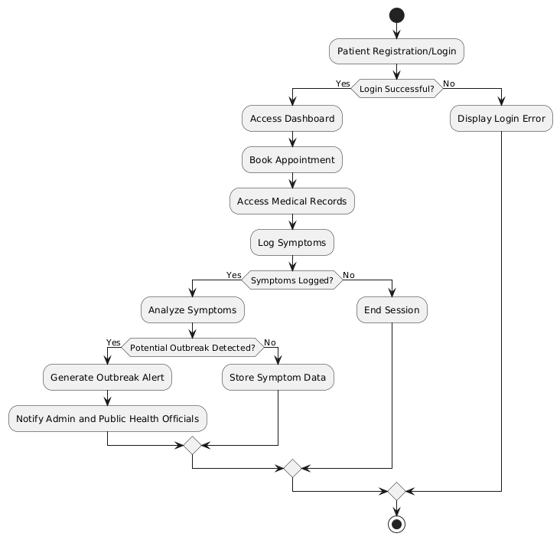

## Class Diagram

A class diagram is a static structure diagram in Unified Modeling Language (UML) that represents the system's classes, their attributes, methods, and the relationships among them. It provides a visual blueprint of the system's architecture, highlighting how different classes interact and how data is organized. Each class is depicted as a rectangle divided into three sections: the top section contains the class name, the middle section lists its attributes, and the bottom section shows its methods (or operations). Relationships between classes are illustrated through lines, with various notations to indicate the type of relationship, such as inheritance (generalization), associations, aggregations, and compositions. Class diagrams are essential for object-oriented design, as they help in understanding the system's structure, guiding the implementation of classes, and ensuring that all components interact correctly. They also serve as a communication tool among developers, designers, and stakeholders by providing a clear representation of the system's data model and its relationships.

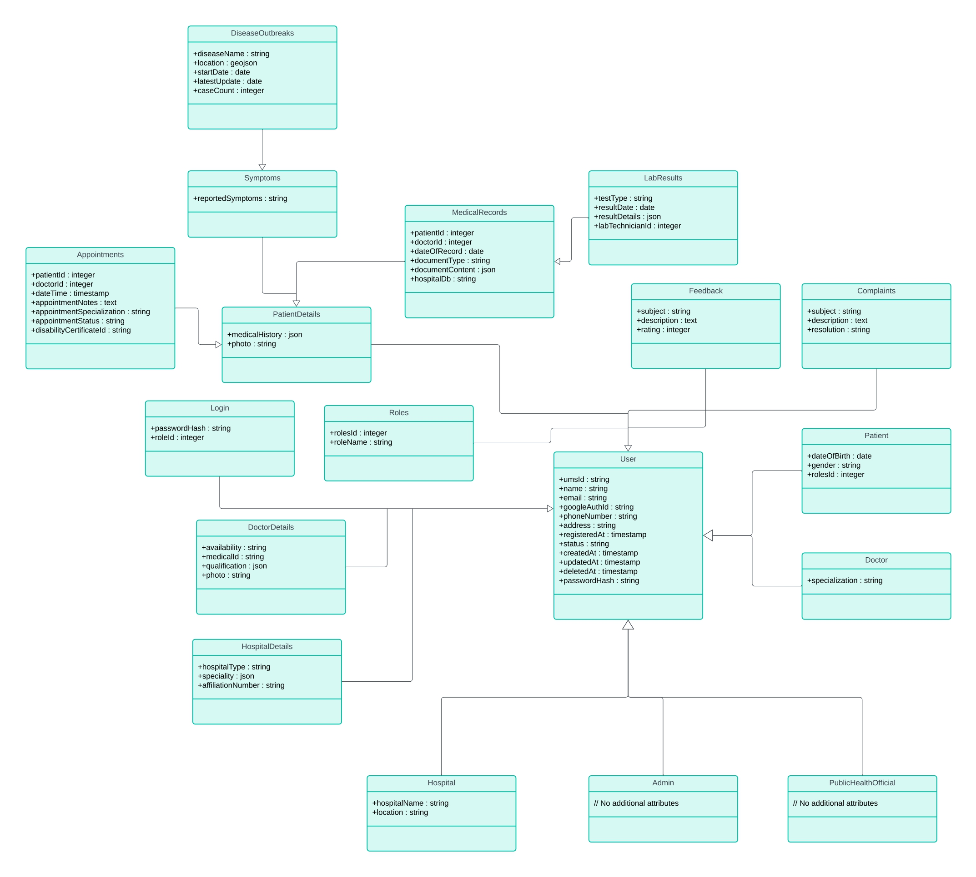

## Object Diagram

An object diagram is a type of static structure diagram in Unified Modeling Language (UML) that provides a snapshot of the instances of classes (objects) and their relationships at a specific moment in time. Unlike class diagrams, which focus on the blueprint of classes and their relationships, object diagrams emphasize the concrete examples of those classes in a particular state.

Each object is represented by a rectangle, similar to a class in a class diagram, but it includes the object's name and its current state or attribute values. Lines connecting the objects illustrate their relationships, such as associations, aggregations, or compositions. Object diagrams are particularly useful for visualizing complex relationships and interactions among objects in a system, demonstrating how they collaborate to perform tasks or represent data.

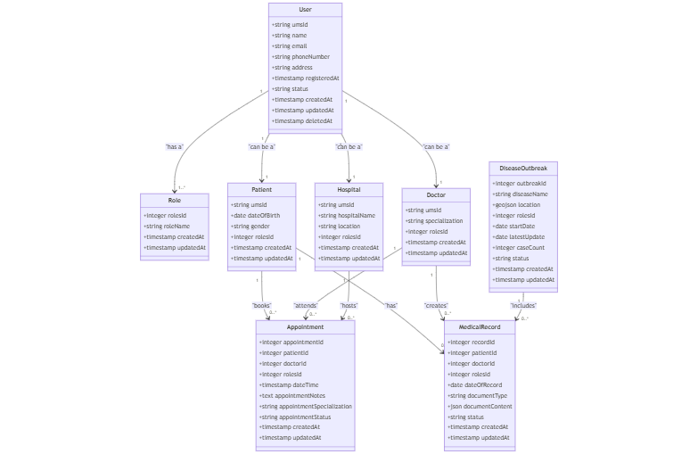

## Component Diagram

A component diagram is a type of structural diagram in Unified Modeling Language (UML) that represents the physical components in a system, such as software applications, libraries, and packages. It illustrates how these components interact with one another and their dependencies, providing a high-level view of the system's architecture.

Components are depicted as rectangles with two smaller rectangles on the left side, indicating that they can be independently developed and deployed. They may also include interfaces that define the operations available for other components to use. Component diagrams are particularly useful for modeling complex systems, as they help to visualize the relationships between various software components, their functionalities, and how they fit into the overall system architecture. This aids in understanding the system’s modular structure, facilitates better planning for system integration, and enhances the communication between developers.

**4.2.8 Deployment Diagram**

A deployment diagram is another type of UML diagram that shows the physical deployment of artifacts on nodes. It illustrates how software is distributed across hardware and how different components communicate within the system infrastructure. Deployment diagrams are particularly useful in visualizing the physical arrangement of software components in a distributed system, such as client-server architectures or cloud-based applications.

In a deployment diagram, nodes represent physical devices (like servers, computers, or mobile devices), and artifacts (such as executables, libraries, or database schemas) represent the software deployed on those nodes. Connections between nodes depict communication paths, showing how information flows within the system. This diagram is essential for understanding the system’s architecture and can help in assessing performance, scalability, and reliability.

**4.2.9 Collaboration Diagram**

A collaboration diagram, or communication diagram, is a type of UML diagram that illustrates the interactions between objects in a system. It emphasizes the relationships and associations among objects while depicting the messages exchanged between them. Each object is represented as a rectangle, and lines connect these objects to indicate their relationships.

Messages are numbered to show the sequence of interactions, providing a clear view of how different components work together to achieve a specific task. Collaboration diagrams help visualize dynamic behavior, clarify roles, and enhance communication among team members during development, making them a valuable tool in system design.

## 4.3 USER INTERFACE DESIGN USING FIGMA

**Form Name: abcc**

Screenshot

**Form Name: abcc**

Screenshot

All Forms

## 4.4 DATABASE DESIGN

### 4.4.1 Relational Database Management System (RDBMS)

A table is a relation. The rows in a table are called tuples. A tuple is an ordered set of n elements. Columns are referred to as attributes. Relationships have been set between every table in the database. This ensures both Referential and Entity Relationship Integrity. A domain D is a set of atomic values. A common method of specifying a domain is to specify a data type from which the data values forming the domain are drawn. It is also useful to specify a name for the domain to help in interpreting its values. Every value in a relation is atomic, that is not decomposable.

**Relationships**

* Table relationships are established using Key. The two main keys of prime importance are Primary Key & Foreign Key. Entity Integrity and Referential Integrity Relationships can be established with these keys.
* Entity Integrity enforces that no Primary Key can have null values.
* Referential Integrity enforces that no Primary Key can have null values.
* Referential Integrity for each distinct Foreign Key value, there must exist a matching Primary Key value in the same domain. Other key are Super Key and Candidate Keys

### 4.4.2 Normalization

Data are grouped together in the simplest way so that later changes can be made with minimum impact on data structures. Normalization is formal process of data structures in manners that eliminates redundancy and promotes integrity. Normalization is a technique of separating redundant fields and breaking up a large table into a smaller one. It is also used to avoid insertion, deletion, and updating anomalies. Normal form in data modelling use two concepts, keys, and relationships. A key uniquely identifies a row in a table. There are two types of keys, primary key and foreign key. A primary key is an element or a combination of elements in a table whose purpose is to identify records from the same table. A foreign key is a column in a table that uniquely identifies record from a different table. All the tables have been normalized up to the third normal form. As the name implies, it denotes putting things in the normal form. The application developer via normalization tries to achieve a sensible organization of data into proper tables and columns and where names can be easily correlated to the data by the user. Normalization eliminates repeating groups at data and thereby avoids data redundancy which proves to be a great burden on the computer resources. These include:

* Normalize the data
* Choose proper names for the tables and columns.
* Choose the proper name for the data.

**First Normal Form**

The First Normal Form states that the domain of an attribute must include only atomic values and that the value of any attribute in a tuple must be a single value from the domain of that attribute. In other words, 1NF disallows “relations within relations” or “relations as attribute values within tuples”. The only attribute values permitted by 1NF are single atomic or indivisible values. The first step is to put the data into First Normal Form. This can be donor by moving data into separate tables where the data is of similar type in each table. Each table is given a Primary Key or Foreign Key as per requirement of the project. In this we form new relations for each non-atomic attribute or nested relation. This eliminated repeating groups of data.

**Second Normal Form**

According to Second Normal Form, for relations where primary key contains multiple attributes, no non-key attribute should be functionally dependent on a part of the primary key. In this we decompose and setup a new relation for each partial key with its dependent attributes. Make sure to keep a relation with the original primary key and any attributes that are fully functionally dependenton it. This step helps in taking out data that is only dependent on a part of the key. A relation is said to be in second normal form if and only if it satisfies all the first normal form conditions for the primary key and every non-primary key attribute of the relation is fully dependent on its primary key alone.

**Third Normal Form**

According to Third Normal Form, Relation should not have a non-key attribute functionally determined by another non-key attribute or by a set of non-key attributes. That is, there should be no transitive dependency on the primary key. In this we decompose and set up relation that includes the non-key attributes that functionally determines other non-key attributes. This step is taken to get rid of anything that does not depend entirely on the Primary Key. A relation is said to be in third normal form if only if it is in second normal form and more over the non key attributes of the relation should not be depend on another non-key attribute.

**Fourth Normal Form**

The fourth normal form (4NF) is a database normalization rule that further refines data modeling by addressing multi-valued dependencies. When a table contains multiple independent sets of repeating data, we can break it down into smaller tables, with each table containing only one set of related data.

This reduces data redundancy and improves data consistency by ensuring that each table represents a single, well-defined concept or entity. To achieve 4NF, we need to ensure that all multi-valued dependencies are removed from the table, and that each table contains only attributes that are functionally dependent on the primary key.

**Fifth Normal Form**

5NF is indeed the highest level of normalization in relational database design, and it deals with complex data models that involve multiple overlapping multi-valued dependencies. In 5NF, tables are decomposed into smaller tables in order to eliminate any possible redundancy caused by overlapping dependencies, while ensuring that there is no loss of data.

The goal of 5NF is to ensure that each table represents a single entity or relationship, and that the data is organized in a way that minimizes redundancy, eliminates anomalies, and improves data integrity. By breaking down tables into smaller, more specialized tables, 5NF helps to eliminate potential issues with update anomalies, insertion anomalies, and deletion anomalies, which can occur when data is not properly normalized.

### 4.4.3 Sanitization

### An automated procedure called "sanitization" is used to get a value ready for use in a SQL query. This process typically involves checking the value for characters that have a special significance for the target database. To prevent a SQL injection attack, you must sanitize(filter) the input string while processing a SQL query based on user input. For instance, the user and password input is a typical scenario. In that scenario, the server response would provide access to the 'target user' account without requiring a password check.

**4.4.4 Indexing**

By reducing the number of disk accesses needed when a query is completed, indexing helps a database perform better. It is a data structure method used to locate and access data in a database rapidly. Several database columns are used to generate indexes. The primary key or candidate key of the table is duplicated in the first column, which is the Search key. To make it easier to find the related data, these values are kept in sorted order. Recall that the information may or may not be kept in sorted order.

### 4.5 TABLE DESIGN

**1.Tbl_users_login**

Eg.Primary key: **loginid**

Eg.Foreign key: **loginid** references table **Tbl_users_login**

|  |  |  |  |  |
| --- | --- | --- | --- | --- |
| No: | Fieldname | Datatype (Size) | Key Constraints | Description of the Field |
|  |  |  |  |  |
|  |  |  |  |  |
|  |  |  |  |  |
|  |  |  |  |  |

# CHAPTER 5

# SYSTEM TESTING

* 1. **INTRODUCTION**

Software Testing is the process of executing software in a controlled manner, in order to answer the question - Does the software behave as specified? Software testing is often used in association with the term’s verification and validation. Validation is the checking or testing of items, includes software, for conformance and consistency with an associated specification. Software testing is just one kind of verification, which also uses techniques such as reviews, analysis, inspections, and walkthroughs. Validation is the process of checking that what has been specified is what the user wanted.

Other activities which are often associated with software testing are static analysis and dynamic analysis. Static analysis investigates the source code of software, looking for problems and gathering metrics without executing the code. Dynamic analysis looks at the behavior of software while it is executing, to provide information such as execution traces, timing profiles, and test coverage information.

Testing is a set of activity that can be planned in advanced and conducted systematically. Testing begins at the module level and work towards the integration of entire computers-based system. Nothing is complete without testing, as it vital success of the system testing objectives, there are several rules that can serve as testing objectives. They are:

Testing is a process of executing a program with the intent of finding an error.

* A good test case is one that has high possibility of finding an undiscovered error.
* A successful test is one that uncovers an undiscovered error

If a testing is conducted successfully according to the objectives as stated above, it would uncover errors in the software. Also testing demonstrate that the software function appear to be working according to the specification, that performance requirement appear to have been met. There are three ways to test program.

* For correctness
* For implementation efficiency
* For computational complexity

Test for correctness are supposed to verify that a program does exactly what it was designed to do. This is much more difficult than it may at first appear, especially for large programs.

## TEST PLAN

A test plan implies a series of desired course of action to be followed in accomplishing various testing methods. The Test Plan acts as a blue print for the action that is to be followed. The software engineers create a computer program, its documentation, and related data structures. The software developers is always responsible for testing the individual units of the programs, ensuring that each performs the function for which it was designed. There is an independent test group (ITG) which is to remove the inherent problems associated with letting the builder to test the thing that has been built. The specific objectives of testing should be stated in measurable terms. So that the mean time to failure, the cost to find and fix the defects, remaining defect density or frequency of occurrence and test work-hours per regression test all should be stated within the test plan.

The levels of testing include:

* Unit testing
* Integration Testing
* Data validation Testing
* Output Testing

### Unit Testing

Unit testing focuses verification effort on the smallest unit of software design – the software component or module. Using the component level design description as a guide, important control paths are tested to uncover errors within the boundary of the module. The relative complexity of tests and uncovered scope established for unit testing. The unit testing is Whitebox oriented, and step can be conducted in parallel for multiple components. The modular interface is tested to ensure that information properly flows into and out of the program unit under test. The local data structure is examined to ensure that data stored temporarily maintains its integrity during all steps in an algorithm’s execution. Boundary conditions are tested to ensure that all statements in a module have been executed at least once. Finally, all error handling paths are tested.

Tests of data flow across a module interface are required before any other test is initiated. If data do not enter and exit properly, all other tests are moot. Selective testing of execution paths is an essential task during the unit test. Good design dictates that error conditions be anticipated and error handling paths set up to reroute or cleanly terminate processing when an error does occur. Boundary testing is the last task of unit testing step. Software often fails at its boundaries.

Unit testing was done in Sell-Soft System by treating each module as separate entity and testing each one of them with a wide spectrum of test inputs. Some flaws in the internal logic of the modules were found and were rectified. After coding each module is tested and run individually. All unnecessary code were removed and ensured that all modules are working, and gives the expected result.

### Integration Testing

Integration testing is systematic technique for constructing the program structure while at the same time conducting tests to uncover errors associated with interfacing. The objective is to take unit tested components and build a program structure that has been dictated by design. The entire program is tested as whole. Correction is difficult because isolation of causes is complicated by vast expanse of entire program. Once these errors are corrected, new ones appear and the process continues in a seemingly endless loop. After performing unit testing in the System all the modules were integrated to test for any inconsistencies in the interfaces. Moreover, differences in program structures were removed and a unique program structure was evolved.

### Validation Testing or System Testing

This is the final step in testing. In this the entire system was tested with all forms, code, modules, and class modules. This form of testing is popularly known as Black Box testing or System tests.

Black Box testing method focuses on the functional requirements of the software. That is, Black Box testing enables the software engineer to derive sets of input conditions that will fully exercise all functional requirements for a program.

Black Box testing attempts to find errors in the following categories; incorrect or missing functions, interface errors, errors in data structures or external data access, performance errors and initialization errors and termination errors.

### Output Testing or User Acceptance Testing

The system considered is tested for user acceptance; here it should satisfy the firm’s need. The software should keep in touch with perspective system; user at the time of developing and making changes whenever required. This done with respect to the following points:

* Input Screen Designs.
* Output Screen Designs

The above testing is done taking various kinds of test data. Preparation of test data plays a vital role in the system testing. After preparing the test data, the system under study is tested using that test data. While testing the system by which test data errors are again uncovered and corrected by using above testing steps and corrections are also noted for future use.

* + 1. **Automation Testing**

A test case suite is executed using specialized automated testing software tools as part of the software testing technique known as automation testing. The test stages are meticulously carried out by a human performing manual testing while seated in front of a computer. Additionally, the automation testing software may generate thorough test reports, compare expected and actual findings, and enter test data into the System Under Test. Software test automation necessitates significant financial and material inputs. Repeated execution of the same test suite will be necessary during subsequent development cycles. This test suite can be recorded and replayed as needed using a test automation tool. No further human involvement is needed once the test suite has been automated.

* + 1. **Selenium Testing**

Selenium is a free and open-source tool for testing web applications across multiple browsers and operating systems. Selenium Test Scripts can be written in different programming languages, including Java, C#, JavaScript, Python, etc. Automation performed using the Selenium framework is referred to as Selenium Automation testing.

**Example:**

**Test Case 1**

**Code**

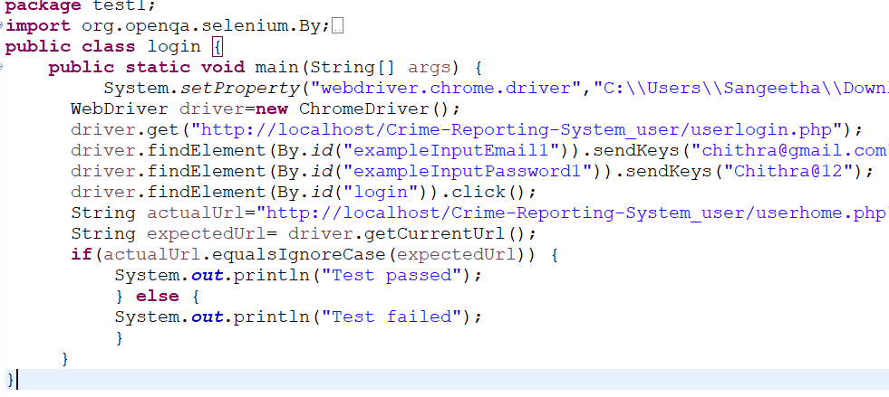

**Eg.Screenshot**

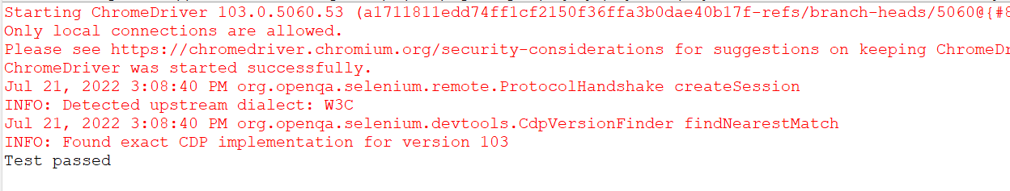

**Eg.Test Report**

|  |  |  |  |  |  |
| --- | --- | --- | --- | --- | --- |
| **Test Case 1** | | | | | |
| **Project Name:** | | | | | |
| **Login Test Case** | | | | | |
| **Test Case ID: Test_1** | | | **Test Designed By:** | | |
| **Test Priority(Low/Medium/High):** | | | **Test Designed Date:** | | |
| **Module Name**: | | | **Test Executed By :** | | |
| **Test Title :** | | | **Test Execution Date:** | | |
| **Description:** | | |  | | |
| **Pre-Condition :**User has valid username and password | | | | | |
| **Step** | **Test Step** | **Test Data** | **Expected Result** | **Actual Result** | **Status(Pass/**  **Fai l)** |
| 1 |  |  |  |  |  |
| 2 |  |  |  |  |  |
| 3 |  |  |
| 4 |  |  |
| 5 |  |  |  |  |  |
|  |  |  |  |  |  |
| 6 |  |  |
| 7 |  |  |  |  |  |
|  |  |  |  |  |
| **Post-Condition:** | | | | | |

**Test Case 2:**

**Code**

**Screenshot**

**Test report**

**Minimum 4 test cases (1 login 3 functionalities)**

# CHAPTER 6

# IMPLEMENTATION

## INTRODUCTION

Implementation is the stage of the project where the theoretical design is turned into a working system. It can be the most crucial stage in achieving a successful new system gaining the users confidence that the new system will work and will be effective and accurate. It is primarily concerned with user training and documentation. Conversion usually takes place about the same time the user is being trained or later. Implementation simply means convening a new system design into operation, which is the process of converting a new revised system design into an operational one.

At this stage the main work load, the greatest upheaval and the major impact on the existing system shifts to the user department. If the implementation is not carefully planned or controlled, it can create chaos and confusion.

Implementation includes all those activities that take place to convert from the existing system to the new system. The new system may be a totally new, replacing an existing manual or automated system or it may be a modification to an existing system. Proper implementation is essential to provide a reliable system to meet organization requirements. The process of putting the developed system in actual use is called system implementation. This includes all those activities that take place to convert from the old system to the new system. The system can be implemented only after through testing is done and if it is found to be working according to the specifications. The system personnel check the feasibility of the system. The more complex the system being implemented, the more involved will be the system analysis and design effort required to implement the three main aspects: education and training, system testing and changeover. The implementation state involves the following tasks:

* Careful planning.
* Investigation of system and constraints
* Design of methods to achieve the changeover.

## IMPLEMENTATION PROCEDURES

Implementation of software refers to the final installation of the package in its real environment, to the satisfaction of the intended uses and the operation of the system. In many organizations someone who will not be operating it, will commission the software development project. In the initial stage people doubt about the software but we must ensure that the resistance does not build up, as one must make sure that:

* The active user must be aware of the benefits of using the new system. Their confidence in the software is built up.
* Proper guidance is imparted to the user so that he is comfortable in using the application.

Before going ahead and viewing the system, the user must know that for viewing the result, the server program should be running in the server. If the server object is not up running on the server, the actual process will not take place

### User Training

User training is designed to prepare the user for testing and converting the system. To achieve the objective and benefits expected from computer-based system, it is essential for the people who will be involved to be confident of their role in the new system. As system becomes more complex, the need for training is more important. By user training the user comes to know how to enter data, respond to error messages, interrogate the database, and call up routine that will produce reports and perform other necessary functions.

### Training on the Application Software

After providing the necessary basic training on computer awareness the user will have to be trained on the new application software. This will give the underlying philosophy of the use of the new system such as the screen flow, screen design type of help on the screen, type of errors while entering the data, the corresponding validation check at each entry and the ways to correct the date entered. It should then cover information needed by the specific user/ group to use the system or part of the system while imparting the training of the program on the application. This training may be different across different user groups and across different levels of hierarchy.

### System Maintenance

System maintenance is an effective component such that System maintenance refers to the ongoing activities required to ensure that a system or application operates effectively and efficiently after it has been implemented. It involves regular updates, bug fixes, and performance optimizations to keep the system running smoothly and securely.

System maintenance is essential to ensure that a system remains operational and effective after implementation. By establishing maintenance procedures and following them consistently, project teams can ensure that the system operates smoothly, remains secure, and continues to meet the needs of the end-users.

# CHAPTER 7

# CONCLUSION AND FUTURE SCOPE

## CONCLUSION

## 

## In conclusion, the Unified Medical System (UMS) presents a transformative solution for healthcare delivery in India, centralizing services such as appointment booking, medical record access, data sharing, and early disease outbreak detection within a secure, user-friendly platform. By leveraging modern technologies, the UMS not only enhances healthcare accessibility and efficiency but also empowers patients to manage their health information actively and promotes proactive public health measures. Though challenges exist in infrastructure, data privacy, and user adoption, a phased implementation, combined with robust data security protocols and comprehensive user training, ensures the system’s technical, economic, and behavioral feasibility. The UMS holds significant potential to improve healthcare outcomes, optimize resource allocation, and support India’s vision for a more integrated, responsive, and resilient healthcare system.

* 1. **FUTURE SCOPE**

The future scope of the Unified Medical System (UMS) holds immense potential for transforming healthcare in India. As infrastructure develops, the UMS can be expanded into rural areas, ensuring equitable access to healthcare resources nationwide. Telemedicine integration offers patients the convenience of remote consultations, making healthcare accessible from any location, especially beneficial for those in remote areas. With advanced data analytics, the system can leverage machine learning to predict healthcare needs, allowing for better resource allocation and proactive care. The UMS could also integrate data from wearable devices to enable real-time monitoring, early intervention for chronic diseases, and preventive healthcare measures. Additionally, aggregated health data from the UMS can aid public health officials in tracking trends, forecasting disease outbreaks, and creating evidence-based policies, improving public health outcomes. AI-driven diagnostics and personalized care solutions based on patient history will also empower healthcare providers to offer targeted, efficient care. With these advancements, the UMS has the potential to become a model for healthcare systems globally, facilitating international collaboration and contributing to a more resilient, interconnected healthcare framework.

.

# CHAPTER 8

# BIBLIOGRAPHY

### REFERENCES:

* + - ..
    - ..
    - ..
    - ..
    - ...

### WEBSITES:

* + - [..](http://www.w3schools.com/)
    - [..](http://www.jquery.com/)
    - [..](http://homepages.dcc.ufmg.br/%7Erodolfo/es-1-03/IEEE-Std-830-1998.pdf)
    - [..](http://www.agilemodeling.com/artifacts/useCaseDiagram.html)

# CHAPTER 9

# APPENDIX

## Sample Code

Main functionalities

## Screen Shots