**INTRODUCTION**

A Query Reply System known as Chat Bot is often designed to convincingly simulate how a human would behave as a conversational partner. Chat Bot programs are usually used in dialogue systems for various practical reasons .A Chat Bot is an artificial entity which holds conversations with humans. This could be a text based conversation, a spoken conversation or even a non-verbal conversation. Chat Bot can run on local computers and phones, though most of the time it is accessed through the internet. Chat Bot is typically perceived as engaging software entity which humans can talk to. It appears everywhere, from old ancient HTML pages to modern advanced social networking websites, and from standard computers to fashionable smart mobile devices. Chat Bots talk in almost every major language. Their language (Natural Language Processing, NLP) skills vary from extremely poor to very clever intelligent, helpful and funny. The same counts for their graphic design sometimes it feels like a cartoon-ish character drawn by a child and on the other hand there are photo-realistic 3D animated characters available which are hard to distinguish from humans. And, they are all referred to as Chat Bots.

**Problem Definition:**

The project involves creating an image recognition system using IBM Cloud Visual Recognition. The goal is to develop a platform where users can upload images and the system accurately classifies and describes the image contents .This will enable users to craft engaging visual stories with the help of Al-generated captions enhancing their connection with the audience through captivating visuals and compelling narratives.

**Design Thinking:**

1.Image Recognition Setup Set up the IBM Cloud Visual Recognition service and

obtain the necessary API keys.

2.User Interface: Design a user-friendly interface for user to upload image and

view the AI-generated captions.

3.Image Classification: Implement the image classification process using the IBM

Cloud Visual Recognition API.

4.Al-Generated Captions :Integrate natural language generation to create

captions for the recognized images.

5.User engagement :Design features to allow user to explore. Save. And share

their Al enhanced images

**Objectives and Final Outcome**

The high-level view of the final objective is to design a scalable and easily maintainable multilingual Chat Bot solution that can interface with the organization’s existing web pages or in different web platform. It should serve as the first communication layer in the user or customer service and provide a way for users to send free-form text messages to help them with the most common issues they encounter regarding the organization. In short, it should replicate the menial tasks performed by the admin or customer service agents on a daily basis. In this project, the case of a user experience has taken to be considered. The developed cloud based Chat Bot should assist The goal is to develop a virtual guide that assists users on messaging platforms like Facebook Messenger and Slack.

Main Objectives with specific aims:

* The chat bot should provide helpful information, answer frequently asked questions (FAQs), and offer a friendly conversational experience.
* To ensuring a seamless user experience.

The Final outcome of this project is a cloud-based interactive query reply system suitable for friendly conversation experience.

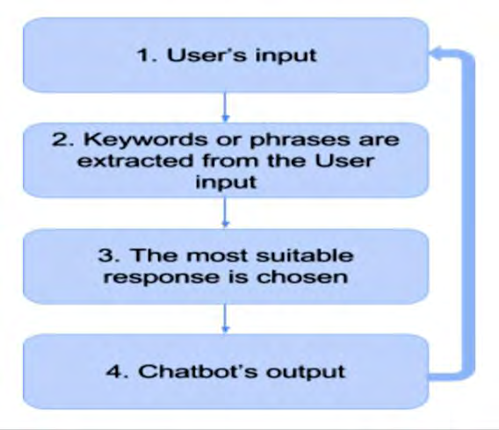

**Creating a Chat Bot :**

To create the Chat Bot, it is necessary to follow a principle and then setup the methodology to build the application. Also, choosing the platform to develop the program is mandatory to give most priority.

**Principles of Chat Bot Design :**

1. Don’t pretend to be a human

2. Keep it incredibly simple

3. Respect the chat medium

4. Optimize for the end user

**Conclusion:**

A chat bot is one of the simple ways to transport data from a computer without having to think for proper keywords to look up in a search or browse several web pages to collect information; users can easily type their query in natural language and retrieve information.