NAME: JOSSANA MARIE J. BUSQUIT
Subject: ISY120
Task 1: Descriptive Analytics
Number of GENDER | Column Labels
Row Labels | Female | Male | Grand Total
AB English | 6 | 3 | 9
2020 | 3 | 1 | 4
2021 | 2 | 1 | 3
2022 | 1 | 1 | 2
AB Philosophy | 15 | 12 | 27
2020 | 6 | 6 | 12
2021 | 5 | 4 | 9
2022 | 3 | 2 | 5
2023 | 1 |  | 1
BA Philosophy | 212 | 54 | 266
2020 | 34 | 10 | 44
2021 | 67 | 14 | 81
2022 | 65 | 14 | 79
2023 | 46 | 16 | 62
BA Psychology | 139 | 30 | 169
2020 | 13 | 5 | 18
2021 | 34 | 13 | 47
2022 | 58 | 8 | 66
2023 | 34 | 4 | 38
BS Agriculture (Major in Animal Science) | 328 | 119 | 447
2020 | 44 | 13 | 57
2021 | 82 | 32 | 114
2022 | 121 | 46 | 167
2023 | 81 | 28 | 109
Grand Total | 700 | 218 | 918

- Enrollment Summary
Academic Year | Program | Total enrollment | Male | Female | Remarks/Observation
2020 | AB English | 4 | 1 | 3 | Enrollment is very small, with more female than male students.
2020 | AB Philosophy | 12 | 6 | 6 | Low enrollment, with an equal number of male and female students.
2020 | BA Philosophy | 44 | 4 | 34 | Has a relatively high number of enrollees, mostly female.
2020 | BA Psychology | 18 | 5 | 13 | Small to moderate enrollment, dominated by female students.
2020 | BS Agriculture (Major in Animal Science) | 57 | 13 | 44 | Highest enrollment among programs, with more female students than male.
2021 | AB English | 3 | 1 | 2 | Enrollment slightly decreased compared to 2020 and remains female-dominated.
2021 | AB Philosophy | 9 | 4 | 5 | Enrollment declined, but gender distribution remains balanced.
2021 | BA Philosophy | 81 | 14 | 67 | Enrollment increased significantly, with females still comprising the majority.
2021 | BA Psychology | 47 | 13 | 34 | Enrollment increased, with female students outnumbering males.
2021 | BS Agriculture (Major in Animal Science) | 114 | 32 | 82 | Enrollment increased sharply and continues to have a strong female majority.
2022 | AB English | 2 | 1 | 1 | Enrollment continued to decrease, with equal numbers of male and female students.
2022 | AB Philosophy | 5 | 2 | 3 | Enrollment further declined and remains very low.
2022 | BA Philosophy | 79 | 14 | 65 | Enrollment slightly decreased compared to 2021 but is still relatively high.
2022 | BA Psychology | 66 | 8 | 58 | Enrollment increased, largely driven by female students.
2022 | BS Agriculture (Major in Animal Science) | 167 | 46 | 121 | Enrollment reached its peak, with females forming the majority.
2023 | AB English | 0 | 0 | 0 | No recorded enrollment for the year.
2023 | AB Philosophy | 1 | 0 | 1 | Only one student enrolled, indicating critical low demand.
2023 | BA Philosophy | 62 | 16 | 46 | Enrollment declined but remains one of the larger programs.
2023 | BA Psychology | 38 | 4 | 34 | Enrollment decreased compared to 2022 but remains active.
2023 | BS Agriculture (Major in Animal Science) | 109 | 28 | 81 | Enrollment declined but still has the highest number of students among programs.

- Visualization: Insert or sketch 2 charts below (use excel or any BI tool):

Chart 1: Enrollment trend per program -- Chart 2: Gender Distribution per academic year
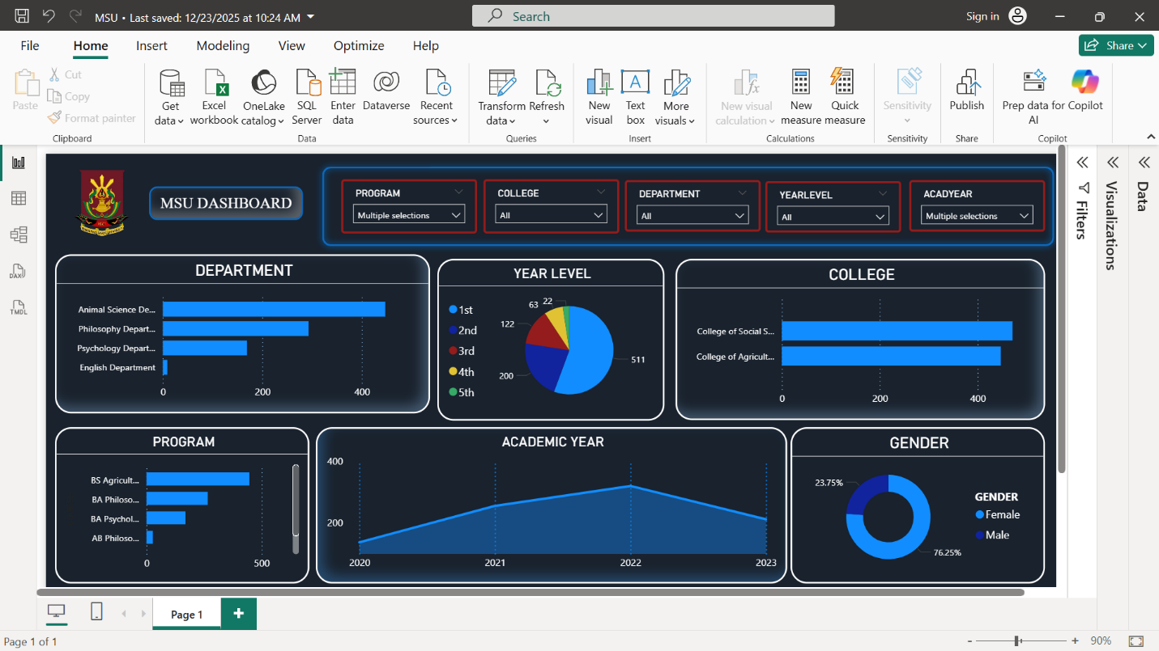

Brief Interpretation (3-5 Sentences)
- The data indicates that BS Agriculture Major in Animal Science has the highest enrollment in all academic years, followed by BA Philosophy. On the other hand, AB English and AB Philosophy have always had the lowest enrollment. In fact, AB English had zero enrollees in 2023. For most of the programs over these years, female students dominate. Most of the programs had growth between 2020 and 2022, with a considerable decline in 2023. This might suggest possible retention or external factors affecting enrollment in the most recent year.

Task 2: Predictive Analytics
Estimate future enrollment for AY 2025-2026.
Program | 2020-2021 | 2021-2022 | 2022-2023 | Predicted 2025-2026 | Trend Description (↑/ ↓/ Stable)
AB Philosophy | 21 | 14 | 6 | 3–5
  ↓ Decreasing
BA Philosophy | 125 | 160 | 141 | 135–145 | ↓ Slight Decline / Stable
BS Psychology | 65 | 113 | 104 | 100–110 | ↓ Slight Decline / Stable
AB English | 7 | 5 | 2 | 1–2
  ↓ Sharp Decline
BS Agriculture (Major in Animal Science) | 171 | 281 | 276 | 280-300 | ↑ Increasing / Stable High

Interpretation (3-5 sentences):
- These data indicate that BS Agriculture, majoring in Animal Science, has always been the leading program across all academic years, followed by BA Philosophy. On the contrary, AB English and AB Philosophy have always had very low enrollment, with the former having no enrollees in 2023. In most programs, female students dominate throughout the observed years. Most programs saw growth between 2020 and 2022, before a noticeable decline in 2023. This suggests possible retention or external factors that may have affected enrollment for this past year.

Provide recommendations based on your findings.
Issued Identified | Data-Based Insight | Recommend Strategy
Extremely low enrollment in AB English | Enrollment steadily declined and reached zero in 2023 | Strengthen program promotion by highlighting career opportunities, improving curriculum relevance, and conducting student outreach activities
Critically low enrollment in AB Philosophy | Enrollment decreased to only one student in 2023 | Review the program’s curriculum and relevance, introduce interdisciplinary options, and increase awareness of career paths linked to the program
Declining enrollment in BA Philosophy | Enrollment peaked in 2021 and declined in 2022 and 2023 | Implement retention programs such as academic mentoring and student engagement activities to reduce dropouts
Sharp decline in BS Agriculture (Major in Animal Science) | Enrollment peaked in 2022 but dropped significantly in 2023 | Investigate causes of decline (e.g., academic difficulty, resources, or student concerns) and enhance student support and program visibility
Overall female-dominated enrollment across programs | Female students outnumber males in all programs | Promote gender-inclusive campaigns and highlight successful graduates of underrepresented genders to encourage balanced enrollment

Reflection Questions:
- Which programs should be prioritized for marketing or intervention?
- Based on the data, AB English and AB Philosophy should be prioritized for immediate intervention due to extremely low and declining enrollment, including zero enrollment for AB English in 2023. BS Agriculture (Major in Animal Science) should also be monitored closely due to its sharp decline after peaking in 2022, despite remaining the largest program.
- How can gender balance or year-level progression be improved?
- Gender balance may be improved by promoting inclusivity through outreach activities that highlight opportunities for all genders across programs. Since female students dominate all programs, strategies encouraging male participation may help balance enrollment. Year-level progression can be improved through academic support programs, early advising, and retention initiatives to reduce dropout rates, especially after peak enrollment years.

- In what ways can analytics continue to support enrollment planning?
- Analytics can help identify enrollment trends, detect early declines, and guide program-level interventions. By regularly monitoring enrollment data, the institution can evaluate the effectiveness of recruitment and retention strategies. Predictive analytics can also assist administrators in planning resources and adjusting program offerings based on future enrollment expectations.

