English Prompt:
Calculate Shipping Charges
Create a procedure called calcular_cargo_envio that takes four input parameters:
- peso_paquete (in kilograms)
- tipo_paquete (string: 'express' or 'standard')
- distancia (in kilometers)
- total_salida (output parameter for the total shipping charge)
The procedure must return the total shipping charge according to the following rules:
- For packages weighing 10 kg or less, the shipping charge is $1 per kilometer for express and $0.5 per kilometer for standard.
- For packages weighing between 11 kg and 50 kg, the shipping charge is $3 per kilometer for express and $2 per kilometer for standard.
- For packages weighing more than 50 kg, the shipping charge is $10 per kilometer for express and $5 per kilometer for standard.
Include a procedure to test the cases. Tell the AI that you DO want it to program using an ELSE clause. Also tell it to generate test cases starting at 9 kilograms, increasing by 0.25 kilograms up to 12 kilograms, and starting at 48 kilograms, increasing by 0.5 kilograms up to 53 kilograms, for both package types.
Include a call to that procedure and the output of the call as an image.
Check what the AI-generated code does with the gap that exists between 10 kg and 11 kg and document it. Include a call using 10.5 kilograms.
Afterward, tell the AI to correct that gap using a rule defined by you.
Make sure the generated code does not include duplicate handling for the boundary values.
---------------------------------
Code:
SET SERVEROUTPUT ON;

CREATE OR REPLACE PROCEDURE calcular_cargo_envio (
peso_paquete IN NUMBER,
tipo_paquete IN VARCHAR2,
distancia IN NUMBER,
total_salida OUT NUMBER
)
AS
v_tipo_paquete VARCHAR2(20);
BEGIN
v_tipo_paquete := LOWER(TRIM(tipo_paquete));

IF v_tipo_paquete NOT IN ('express', 'standard') THEN
RAISE_APPLICATION_ERROR(-20001, 'tipo_paquete debe ser express o standard');
END IF;

IF peso_paquete <= 10 THEN
IF v_tipo_paquete = 'express' THEN
total_salida := distancia * 1;
ELSE
total_salida := distancia * 0.5;
END IF;
ELSIF peso_paquete <= 50 THEN
IF v_tipo_paquete = 'express' THEN
total_salida := distancia * 3;
ELSE
total_salida := distancia * 2;
END IF;
ELSE
IF v_tipo_paquete = 'express' THEN
total_salida := distancia * 10;
ELSE
total_salida := distancia * 5;
END IF;
END IF;
END;
/

CREATE OR REPLACE PROCEDURE probar_calcular_cargo_envio
AS
v_peso NUMBER;
v_total NUMBER;
v_distancia CONSTANT NUMBER := 10;
BEGIN
DBMS_OUTPUT.PUT_LINE('PRUEBAS DE calcular_cargo_envio');
DBMS_OUTPUT.PUT_LINE('Distancia usada en todas las pruebas: ' || v_distancia || ' km');
DBMS_OUTPUT.PUT_LINE(RPAD('PESO(kg)', 12) || RPAD('TIPO', 12) || 'TOTAL');
DBMS_OUTPUT.PUT_LINE(RPAD('-', 40, '-'));

v_peso := 9;
WHILE v_peso <= 12.0001 LOOP
calcular_cargo_envio(v_peso, 'express', v_distancia, v_total);
DBMS_OUTPUT.PUT_LINE(
RPAD(TO_CHAR(v_peso, 'FM990.00'), 12) ||
RPAD('express', 12) ||
TO_CHAR(v_total, 'FM9990.00')
);

calcular_cargo_envio(v_peso, 'standard', v_distancia, v_total);
DBMS_OUTPUT.PUT_LINE(
RPAD(TO_CHAR(v_peso, 'FM990.00'), 12) ||
RPAD('standard', 12) ||
TO_CHAR(v_total, 'FM9990.00')
);

v_peso := v_peso + 0.25;
END LOOP;

v_peso := 48;
WHILE v_peso <= 53.0001 LOOP
calcular_cargo_envio(v_peso, 'express', v_distancia, v_total);
DBMS_OUTPUT.PUT_LINE(
RPAD(TO_CHAR(v_peso, 'FM990.00'), 12) ||
RPAD('express', 12) ||
TO_CHAR(v_total, 'FM9990.00')
);

calcular_cargo_envio(v_peso, 'standard', v_distancia, v_total);
DBMS_OUTPUT.PUT_LINE(
RPAD(TO_CHAR(v_peso, 'FM990.00'), 12) ||
RPAD('standard', 12) ||
TO_CHAR(v_total, 'FM9990.00')
);

v_peso := v_peso + 0.5;
END LOOP;
END;
/

DECLARE
v_total NUMBER;
BEGIN
calcular_cargo_envio(9, 'express', 10, v_total);
DBMS_OUTPUT.PUT_LINE('Llamada individual: peso=9, tipo=express, distancia=10 -> total=' || TO_CHAR(v_total, 'FM9990.00'));
END;
/

BEGIN
probar_calcular_cargo_envio;
END;
/

------------------------------------------------------------
Creation Output:
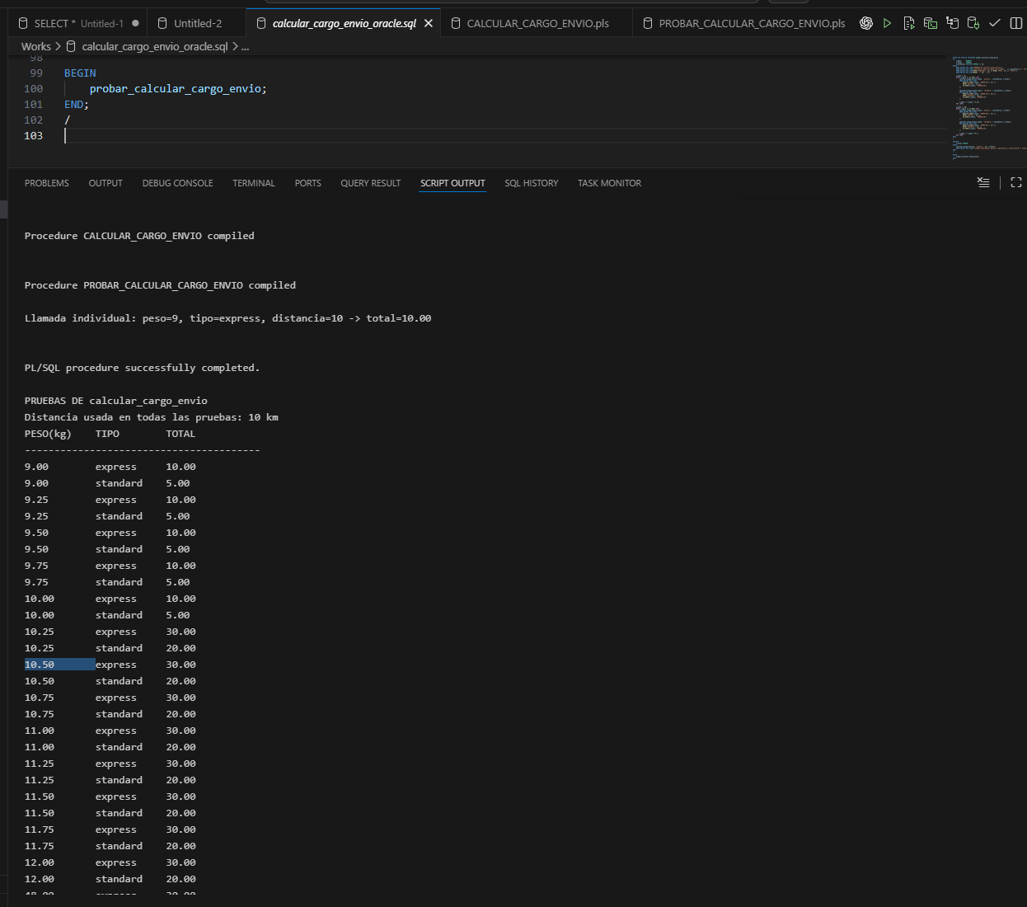
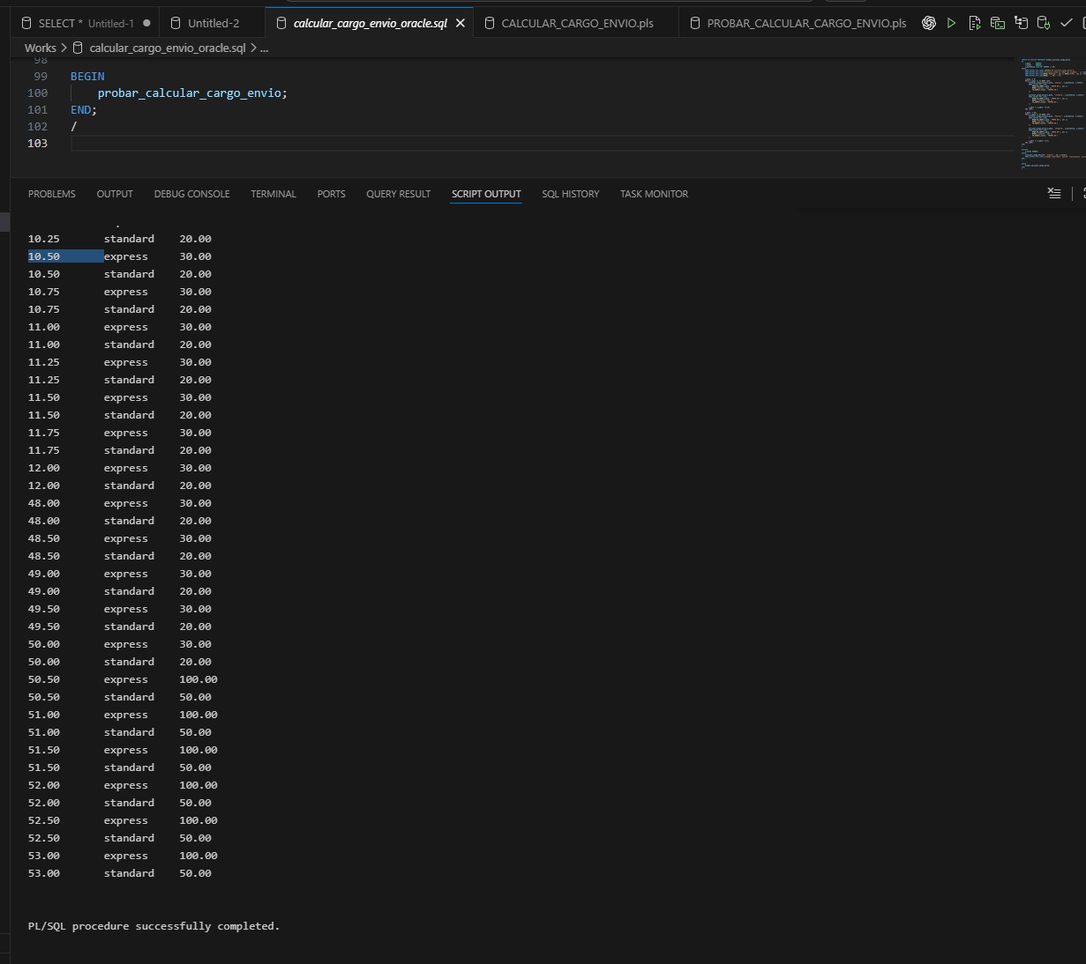

Para el hueco entre 10 y 11, asume 10.5 como si fuera mayor a 10 solamente, es decir que se clasifica en el sector entre 11 y 50.
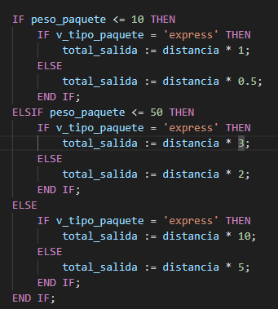
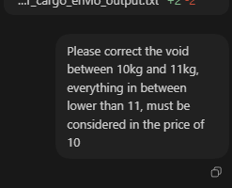
Updated Code:
SET SERVEROUTPUT ON;

CREATE OR REPLACE PROCEDURE calcular_cargo_envio (
peso_paquete IN NUMBER,
tipo_paquete IN VARCHAR2,
distancia IN NUMBER,
total_salida OUT NUMBER
)
AS
v_tipo_paquete VARCHAR2(20);
BEGIN
v_tipo_paquete := LOWER(TRIM(tipo_paquete));

IF v_tipo_paquete NOT IN ('express', 'standard') THEN
RAISE_APPLICATION_ERROR(-20001, 'tipo_paquete debe ser express o standard');
END IF;

IF peso_paquete < 11 THEN
IF v_tipo_paquete = 'express' THEN
total_salida := distancia * 1;
ELSE
total_salida := distancia * 0.5;
END IF;
ELSIF peso_paquete <= 50 THEN
IF v_tipo_paquete = 'express' THEN
total_salida := distancia * 3;
ELSE
total_salida := distancia * 2;
END IF;
ELSE
IF v_tipo_paquete = 'express' THEN
total_salida := distancia * 10;
ELSE
total_salida := distancia * 5;
END IF;
END IF;
END;
/

CREATE OR REPLACE PROCEDURE probar_calcular_cargo_envio
AS
v_peso NUMBER;
v_total NUMBER;
v_distancia CONSTANT NUMBER := 10;
BEGIN
DBMS_OUTPUT.PUT_LINE('PRUEBAS DE calcular_cargo_envio');
DBMS_OUTPUT.PUT_LINE('Distancia usada en todas las pruebas: ' || v_distancia || ' km');
DBMS_OUTPUT.PUT_LINE(RPAD('PESO(kg)', 12) || RPAD('TIPO', 12) || 'TOTAL');
DBMS_OUTPUT.PUT_LINE(RPAD('-', 40, '-'));

v_peso := 9;
WHILE v_peso <= 12.0001 LOOP
calcular_cargo_envio(v_peso, 'express', v_distancia, v_total);
DBMS_OUTPUT.PUT_LINE(
RPAD(TO_CHAR(v_peso, 'FM990.00'), 12) ||
RPAD('express', 12) ||
TO_CHAR(v_total, 'FM9990.00')
);

calcular_cargo_envio(v_peso, 'standard', v_distancia, v_total);
DBMS_OUTPUT.PUT_LINE(
RPAD(TO_CHAR(v_peso, 'FM990.00'), 12) ||
RPAD('standard', 12) ||
TO_CHAR(v_total, 'FM9990.00')
);

v_peso := v_peso + 0.25;
END LOOP;

v_peso := 48;
WHILE v_peso <= 53.0001 LOOP
calcular_cargo_envio(v_peso, 'express', v_distancia, v_total);
DBMS_OUTPUT.PUT_LINE(
RPAD(TO_CHAR(v_peso, 'FM990.00'), 12) ||
RPAD('express', 12) ||
TO_CHAR(v_total, 'FM9990.00')
);

calcular_cargo_envio(v_peso, 'standard', v_distancia, v_total);
DBMS_OUTPUT.PUT_LINE(
RPAD(TO_CHAR(v_peso, 'FM990.00'), 12) ||
RPAD('standard', 12) ||
TO_CHAR(v_total, 'FM9990.00')
);

v_peso := v_peso + 0.5;
END LOOP;
END;
/

DECLARE
v_total NUMBER;
BEGIN
calcular_cargo_envio(10.5, 'express', 10, v_total);
DBMS_OUTPUT.PUT_LINE('Llamada individual: peso=10.5, tipo=express, distancia=10 -> total=' || TO_CHAR(v_total, 'FM9990.00'));
END;
/

BEGIN
probar_calcular_cargo_envio;
END;
/

------------------------------------------------------------------------------
Updated Result:
